Attachment G. Process-Mapping Protocol
OMB No. 0584-[NEW]
Job Search as a Supplemental Nutrition Assistance Program (SNAP) Employment and Training (E&T) Component
February 6, 2020
Project Officer: Danielle Deemer
Office of Policy Support
Food and Nutrition Service
U.S. Department of Agriculture
1320 Braddock Place
Alexandria, VA 22314
703.305.2952
danielle.deemer@usda.gov

Process-Mapping Protocol
OMB Number: 0584-XXXX
Expiration Date: XX/XX/XXXX
My name is [name], and I’m a researcher at Insight Policy Research. As you may know, Insight is conducting a study for the U.S. Department of Agriculture’s Food and Nutrition Service (FNS) about the role of job search and job search training as SNAP E&T components. The study seeks to better understand the overall role of these activities in serving SNAP E&T participants and examine whether certain approaches to these activities are more effective than others in leading SNAP participants to self-sufficiency.
My colleagues and I are currently visiting local SNAP offices and E&T providers here and in three other States to collect information from a wide range of stakeholders involved in operating a SNAP E&T program. I want to start by thanking you for taking time to speak with us today. Your perspective and insights on these issues will be very helpful to the study.
Your participation in this process-mapping exercise is voluntary, and your responses will be kept private to the extent provided by law. We will not share the information you provide with anyone outside the study team. You may refuse to answer any question, and you may stop the discussion at any time. There will be no penalties if you choose not to participate in a part or the entirety of this interview. We will take notes over the course of the exercise and would like to audio record the conversation to help us remember the information we collect. The recording will not be shared with anyone outside the study team. The information you share with us today will be summarized and combined with information gathered from other people we interview. Nothing you say will ever be linked to your name. However, because of the relatively small number of SNAP offices participating in the study, it is possible a response could be attributed to you.
I expect our discussion will take about one and a half hours. First, do you have any questions for me about the project in general or what we will be discussing today?
Do I have your permission to record our discussion? You may stop the recording at any time.
[Confirm permission before recording starts. Do not record without respondent permission.]
[Note to moderator: Some of the questions in this protocol can be addressed through information available in States’ E&T plans. These questions should still be asked to ensure the information in the plan is accurate and to obtain more detail.
Several of the questions and probes in this protocol can also be found in the Local SNAP Office Director and Staff Interview Protocol. The general answers to these questions should be provided during this process-mapping exercise. After the process-mapping protocol, the interviewer should determine if there are any gaps in understanding from this exercise or if any clarifying questions are needed. These questions should be noted and then asked in Section D of the Local SNAP Office Director and Staff Interview Protocol.]
According to the Paperwork Reduction Act of 1995, an agency may not conduct or sponsor, and a person is not required to respond to, a collection of information unless it displays a valid OMB control number. The valid OMB control number for this information collection is 0584-xxxx. The time required to complete this information collection is estimated to average 1.5 hours per response, including the time for reviewing instructions, searching existing data sources, gathering and maintaining the data needed, and completing and reviewing the collection of information. Send comments regarding this burden estimate or any other aspect of this collection of information, including suggestions for reducing this burden, to the following address: U.S. Department of Agriculture, Food and Nutrition Services, Office of Policy Support, 1320 Braddock Place, Alexandria, VA 22314, ATTN: PRA (0584-xxxx). Do not return the completed form to this address.

- Abstracted SNAP E&T Process
Note to moderator: Include a flow chart of the basic SNAP E&T process, on a white board or easel sheets, showing details abstracted from the E&T State plan. After showing the flow chart to the group, confirm whether all applicable agencies and providers are included in the flow chart. If possible, write participant’s responses to each step in the flow on the same chart or whiteboard. Take a photo for reference purposes prior to erasing after requesting and receiving permission from the participants
At the beginning of the discussion, emphasize that you’re here to talk about job search and job search training activities, including [activities listed in State plan]. Ask if there are any other activities that fall into these categories that are not listed in the State plan. If space allows, write the activities on the whiteboard and refer back to them throughout the mapping.
Figure 1. Example Flow Chart
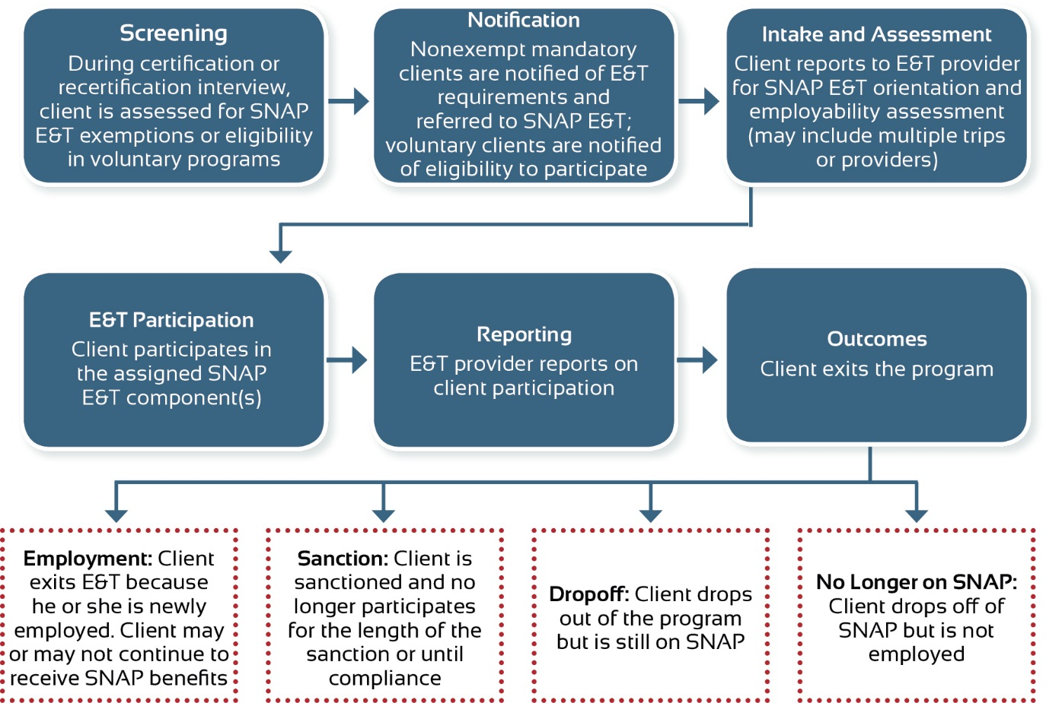
- Screening
First, I want to discuss the screening process for SNAP E&T.
- Can you tell me how your office screens new and recertifying SNAP applicants for participation in the SNAP E&T program? Please walk me through this process.
  - [Probe] When are SNAP applicants screened for E&T during the intake process?
  - [Probe] Who conducts the screening?
  - [Probe for mandatory States] How do you identify possible exemptions from E&T? Do you walk through the list of possible exemptions with the client? Do you ask clients to identify any barriers that might exempt them?
  - [Probe] What information is provided to the participant at the time of the screening?
  - [Probe] What information is given to ABAWDs about job search activities and how these activities do not satisfy work requirements unless combined with a qualifying activity?
- Notification
I want to move on to the notification process for SNAP E&T participants.
Mandatory States
- Can you describe how a SNAP participant is notified that he or she must participate in E&T?
  - [Probe] How is the participant notified? What information is included in the notification?
  - [Probe] What additional information is provided to clients at that time, aside from letting them know they must participate in E&T? Do you direct them to a particular office, provide them with a phone number to call, or give them a list of E&T providers?
- What can clients do if they are referred to E&T but believe they meet one or more exemptions?
- How is a client paired with an appropriate E&T provider?
  - [Probe if State selects provider] How do you determine what E&T provider to refer a client to?
    - [Probe] Do participants interact with multiple providers? If so, why?
  - [Probe if client selects provider] What information is given to clients about available providers?
- Once a client learns he or she is required to participate in E&T, what happens next?
  - [Probe] How long does a client have to report to a provider?
- What are the next steps for the E&T provider?
Voluntary States
- How do clients learn about E&T services and activities? Does this differ for ABAWDs versus non-ABAWDs?
- How is a client paired with an appropriate E&T provider?
  - [Probe if State selects provider] How do you determine what E&T provider to refer a client to?
    - [Probe] Do participants interact with multiple providers? If so, why?
  - [Probe if client selects provider] What information is given to clients about available providers?
- What are the next steps for the E&T provider?
- Intake and Assessment
Let’s discuss the next step after a client is referred to SNAP E&T.
- Can you walk me through the intake process?
  - [Probe] Once a client is notified and/or referred to E&T, when does the intake process happen?
  - [Probe] How is the intake appointment scheduled? Can the client change the appointment day/time if he or she did not pick the date and time? What happens if the client does not show up to the appointment?
  - [Probe] Who does the client interact with during the intake process?
  - [Probe] What activities or assessments does a client complete? Please describe.
  - [Probe] Does your office or the provider complete an individualized employment plan (IEP) for clients? What does that entail?
  - [Probe for mandatory States] Is there a process in place if a provider thinks someone should be exempt?
  - [Probe] Does your office or a provider offer a SNAP E&T orientation? If so, please describe.
    - [Probe] Where does the orientation happen (local office, provider’s site, online)? What information is provided? What information is provided about job search activities and [if mandatory State] requirements?
    - [Probe] Is the orientation mandatory? If so, who must attend? Do recertifying clients need to attend?
    - [Probe] How is the orientation scheduled? When is it typically offered?
    - [Probe if orientation is mandatory] How much time does a client have to attend the orientation after being notified he or she must participate? What happens if a client cannot attend or needs to reschedule?
- How do clients learn about available support services?
  - How do clients learn about participant reimbursements?
  - What is the process for obtaining support services and reimbursements?
- How are clients assigned to [or how do they select] a job search activity?
  - [Probe] Can they choose among various E&T components, or do they get placed or assigned to a particular one?
  - [Probe] What factors or considerations go into deciding whether to assign someone to each job search activity?
    - [Probe] To what extent are assessment results and/or IEPs used in selecting a job search activity?
  - [Probe] How do you integrate job search activities with other components? What proportion of SNAP job search participants are also assigned to other E&T components?
- What information do clients receive about job search activities and their requirements? When do they receive this information? How do they receive it? [Request any documentation.]
- [Mandatory States] When are clients assigned to other programs and/or components in addition to job search activities? How do you decide to assign a client to multiple components?
  - [Probe] What other components are job search participants typically assigned to?
  - [Probe] Are these other components run by the same provider/agency? Are clients assigned to WIOA or other programs? What proportion of job search participants would you say are assigned to WIOA or other programs too?
  - [Probe] Do participants ever drop out of a job search activity but remain in another component or program? How often does it happen?
- Do ABAWDs have the same provider selections as non-ABAWDs?
- What is the next step after a client completes intake and assessment?
  - [Probe] How is the client notified of next steps?
- E&T Participation
The next step in our process is participation in the SNAP E&T components. Let’s discuss how E&T providers report information to the local SNAP office.
- How long does a client have to begin participating in a job search activity after completing intake? Does this differ for ABAWDs? [If relevant] For mandatory versus voluntary clients?
- What are the job search participation requirements for clients to remain compliant?
  - [Probe for each activity] How many days or hours are they required to participate? What steps are they required to take?
  - [Probe] How do participant requirements differ for ABAWDs versus non-ABAWDs?
- Reporting
- How do you track whether clients participate? [If mandatory] And are meeting their E&T requirements?
  - How do you know if a client reported to a provider or engaged in job search activities for the requisite hours? [Note to moderator: probe as needed to determine how tracking occurs at each step of the intake process and how it may differ, if at all, for each job search activity]
- How do these processes differ, if at all, for tracking ABAWDs?
  - [Probe] How do you track ABAWDs over a 3-year continuous period? How do you assess that they work and/or participate in E&T for 80 hours a month? How do you ensure job search activities are combined with another eligible component for ABAWDs? How do you track that ABAWDs spend less than 40 hours per month on job search activities?
- To your knowledge, how does the E&T provider track and log participation?
- How do you communicate with E&T providers about a client’s participation in job search activities [and (in mandatory States) compliance with requirements]?
- What information do providers report to your office? [Note this could include: What component the client is enrolled in; if he or she completes the program, receives a credential or certificate, enrolls in another component, gets a job]
  - [Probe] How often are the data sent? By whom?
  - [Probe] Are the data sent manually, or is the process automated? What systems are used?
  - [Probe] How are the data processed and used? [Mandatory States] Does the system manually or automatically identify clients who are noncompliant? How are you alerted of a client’s noncompliant status?
- [Mandatory States] How are nonparticipation and noncompliance defined, logged, and reported? What is the timeframe for reporting noncompliance? [Note to moderator: According to FNS policy, the E&T provider has 10 days to report noncompliance to the State.]
  - [Probe] Does this vary depending on the component or E&T provider?
  - [Probe] How and when is the client notified?
  - [Probe] What happens if the client provides good cause? What happens if the client does not?
  - [Probe] How do you track noncompliance?
- Client Outcomes
Now I would like to discuss SNAP E&T client outcomes.
- Can you describe how and why most clients exit the SNAP E&T program, and job search in particular?
  - [Probe] How often do SNAP clients leave because they found employment?
  - [Probe, mandatory State] How often are SNAP job search clients sanctioned? What are the most common reasons for these sanctions?
  - [Probe] How often do SNAP clients drop out of the program? What do you think are their reasons for doing so? Do these reasons differ by job search or job search training activity? By component?
  - [Probe] What are other reasons, if any, for SNAP clients leaving E&T?
- At what step in the process do participants most often drop off (for example, between screening and intake, between intake and participation in activities, during participation in activities)? What are the reasons for dropoff at this step?
- How would you define a SNAP client successfully leaving the program? How often does it happen? What makes these clients more successful?
  - [Probe] What, if anything, could be done to help clients succeed?
  - [Probe] What is it about your SNAP job search program that promotes client success?
  - [Probe] Is there anything you would change about your SNAP job search program to increase client success?
- Overall, how frequently do SNAP job search clients who have exited E&T re-enter the program?
  - [Probe] How long does it usually take for these clients to re-engage? Where in the process do they re-enter (for example, intake, screening)? How does this vary for clients who did or did not remain on SNAP the entire time?
  - [Probe] Do re-entering clients resume their previous activities? If not, how are they assigned to E&T activities?
  - [Probe] What are the reasons these clients re-enter E&T?
- Wrap-Up
Lastly, while we are here in a group, I wanted to learn your thoughts regarding the SNAP E&T process in your State.
- Is there anything else you would like to share with us?
- Is there anything we did not ask about that you think is important for us to know?
That completes our questions for the process-mapping exercise. Thank you very much for speaking with us.

