Attachment V. Description of
Scheduling Tool
OMB No. 0584-[NEW]
Job Search as a Supplemental Nutrition Assistance Program (SNAP) Employment and Training (E&T) Component
March 12, 2020
Project Officer: Danielle Deemer
Office of Policy Support
Food and Nutrition Service
U.S. Department of Agriculture
1320 Braddock Place
Alexandria, VA 22314
703.305.2952
danielle.deemer@usda.gov

- Landing Page
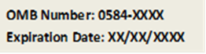
The following link will be included in the advance letter to SNAP E&T participants: https://calendly.com/snapjobsearch

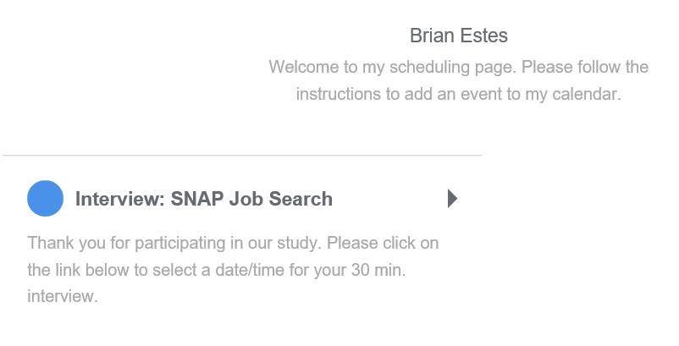
According to the Paperwork Reduction Act of 1995, an agency may not conduct or sponsor, and a person is not required to respond to, a collection of information unless it displays a valid OMB control number. The valid OMB control number for this information collection is 0584-xxxx. The time required to complete this information collection is estimated to average 3 minutes per response, including the time for reviewing instructions, searching existing data sources, gathering and maintaining the data needed, and completing and reviewing the collection of information. Send comments regarding this burden estimate or any other aspect of this collection of information, including suggestions for reducing this burden, to the following address: U.S. Department of Agriculture, Food and Nutrition Services, Office of Policy Support, 1320 Braddock Place, Alexandria, VA 22314, ATTN: PRA (0584-xxxx*). Do not return the completed form to this address.

- Scheduling Page

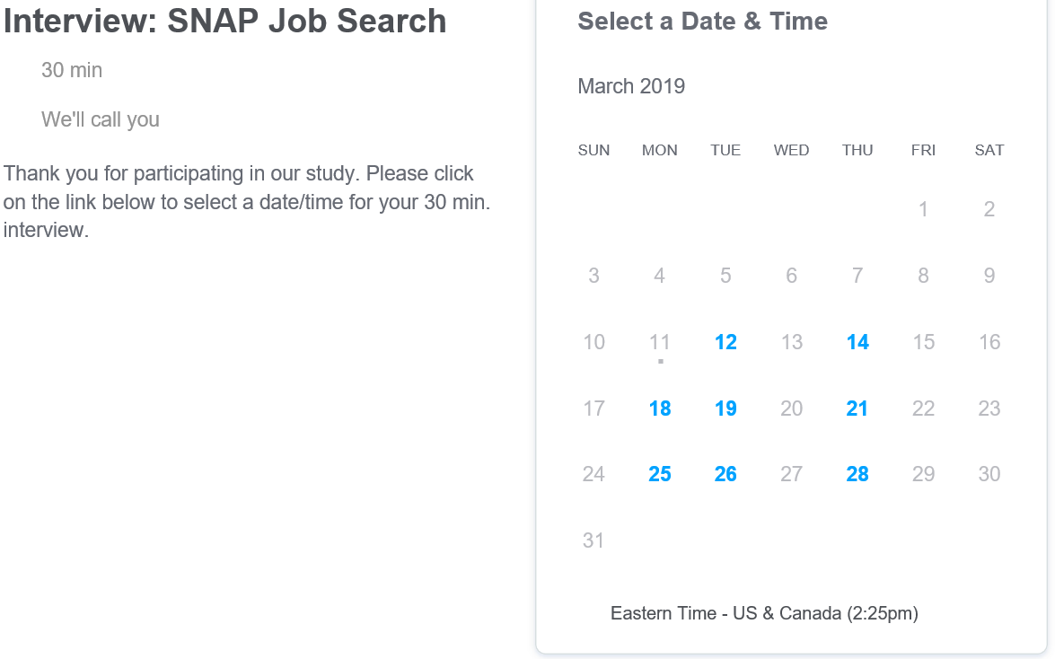

- Participant Details
Calendly requires each participant to enter his or her name, email address, and telephone number to schedule an interview. We will require the participant’s name to confirm the individual is listed as a SNAP E&T participant within the administrative data. A telephone number is required to contact the respondent. An email address is required by Calendly. Participants will automatically receive an email confirmation. Participants may also elect to receive an email reminder.
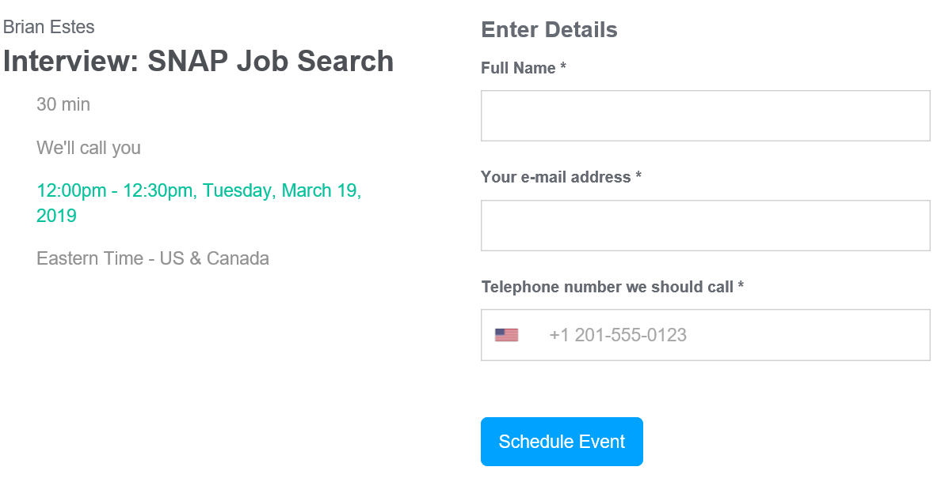

- Confirmation Page
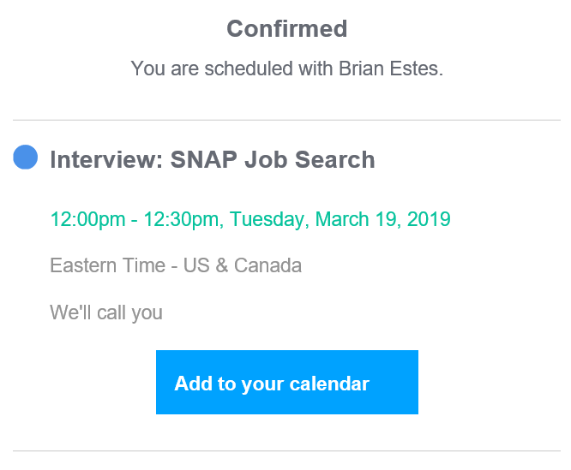

- Email Confirmation

