**SUPPORTING STATEMENT**

**U.S. Department of Commerce**

**National Oceanic & Atmospheric Administration**

**Estimating the Economic Burden of *Vibrio parahaemolyticus* in Washington State Aquaculture**

**OMB Control No. 0648-xxxx**

**PART B**

COLLECTIONS OF INFORMATION EMPLOYING STATISTICAL METHODS

1. **Describe (including numerical estimate) the potential respondent universe and any sampling or other respondent selection methods to be used. Data on the number of entities (e.g., establishments, State and local government units, households, or persons) in the universe covered by the collection and in the corresponding sample are to be provided in the tabular form for the universe as a whole and for each of the strata in the proposed sample. Indicate expected response rates for the collection as a whole. If the collection had been conducted previously, include the actual response rates achieved during the last collection.**

From our project partners, we have developed a contact list of 90 growers, 18 managers (including project partners), and 20 restaurants. This is all oyster growers registered with either or both Pacific Coast Shellfish Growers Association or the Department of Natural Resources, all managers that deal with Vibrio as part of their job description, and all restaurants who have had Vibrio traceback investigations in the last year. We plan to include the whole respondent universe, and expect a 75% response rate based on previous interviews and surveys with a similar population (studies by Jonathan van Senten and Stephanie Moore, as described in part A, question 4). The universe will be divided as follows:

|  |  |  |
| --- | --- | --- |
| Managers | Washington State agencies | 4 individuals, 2 agencies |
|  | County agencies | 14 individuals, 6 counties |
| Growers | X-small (<10 acres) | 55 individuals |
|  | Small (10 to <100 acres) | 25 individuals |
|  | Medium (100 to <500 acres) | 8 individuals |
|  | Large (>= 500 acres) | 2 individuals |
| Restaurants/Retail |  | 20 individuals |

1. **Describe the procedures for the collection of information including:**

* **Statistical methodology for stratification and sample selection**
* **Estimation procedure**
* **Degree of accuracy needed for the purpose described in the justification**
* **Unusual problems requiring specialized sampling procedures, and**
* **Any use of periodic (less frequent than annual) data collection cycles to reduce burden**

This collection will be a census because the overall target population is well-defined and small and a census rather than sampling will reduce sample bias.

The strata listed in question 1 mirror work by Jonathan van Senten and will be used to contextualize our findings in other regulatory and industry costs calculated as part of his study. The count per category among growers will also be confirmed by the first question in the interview, as farm size is under-reported in official documentation. This is also mirrors the Van Senten study, and was recommended by the Pacific Shellfish Growers Association as a preferred methodology. The strata also correspond to industry-relevant thresholds, each of which represents a scale of business requiring more training, equipment, and staff, which has implications for the costs associated with dealing with Vibrio. For example, an extra-small operation will have a single boat and is generally a two-person, household-based business, so costs would be restricted to a smaller set of possible purchases.

We understand that there are other ways that nonresponse bias may be introduced but it is the one we are choosing to control for because the larger businesses are likely to have many more ways of responding to Vibrio. For example, they may have more equipment at hand to choose from, multiple oyster leases on which to place their crop or relay infected oysters in order to avoid bacterial growth, or enough distributors to choose from that one case won’t disrupt the product chain. Given our relatively small sample size, it is only practical to stratify along one metric in order to have enough respondents per category. We will follow up with nonresponders or ask at the time of refusal their business size and why they chose not to participate to detect potential nonresponse bias (e.g. if farms dealing with Vibrio tracebacks state they do not have time to participate).

1. **Describe methods to maximize response rates and to deal with issues of non-response. The accuracy and reliability of information collected must be shown to be adequate for intended uses. For collections based on sampling, a special justification must be provided for any collections that will not yield “reliable” data that can be generalized to the universe studied.**

In order to maximize response rates, we are offering phone or in-person options for participation, which members of the respondent pool have told us are the preferred form of contact, so that they can continue with daily activities while answering questions. This flexibility has been shown to boost response rates in a variety of settings[1]. In addition, we will tell respondents the topics of the questions and that we will be asking about expenses so that they can adequately prepare beforehand, either by referencing purchase records or taking time to remember.

We are planning a census of the relevant population. For unit non-response cases, we will impute the average cost of their sampling strata. For example, if a medium-sized farmer does not participate, we will calculate that farm’s expenses based on the average costs for each expense category in the other medium-sized farms. For item non-response (where a respondent skips a question), we will use multiple imputation[2], taking into account the answers that the respondent did give to estimate the missing value.

1. **Describe any tests of procedures or methods to be undertaken. Testing is encouraged as an effective means of refining collection of information to minimize burden and improve utility. Tests must be approved if they call for answers to identical questions from 10 or more respondents. A proposed test or set of tests may be submitted for approval separately or in combination with the main collection of information.**

We consulted with someone for each of the modules who works in that field as part of the interview guide creation process, performing the interview and then asking for feedback after completion. Two staff from the Phillips Wharf Environmental Center (who are part of a grower’s education program), one restaurant manager from a seafood restaurant, one former restaurant supplier, and one member of a surveillance program laboratory all reviewed the interview guide. Each suggested minor wording changes to the relevant portion of the interview guide, confirmed the timing was reasonable, and that the topic was relevant to current concerns.

1. **Provide the names and telephone number of individuals consulted on statistical aspects of the design and the name of the agency unit, contractor(s), grantee(s), or other person(s) who will actually collect and/or analyze the information for the agency.**

Our conceptual model of costs of Vibrio was thoroughly reviewed during a workshop at the 2018 Pacific Coast Shellfish Growers Association. We used a conceptual modeling approach because it is a good way for stakeholders from multiple sectors to put their ideas in a shared model[3]. The model parallels the calculation of health costs using a causal chain established by USDA scientists[4] with factors included in economic studies of the HACCP regulations for food safety[5]. Workshop attendees then amended the model to fit the oyster industry of Washington and more recent regulatory context. The workshop was attended by about 40 people, including shellfish managers, growers, distributors, and researchers. We provided a draft model and facilitated a participatory model-building exercise to add components to the model and restructure it according to their perceptions of how costs are laid out. They suggested a two-part model to be able to compare the costs of a successful year of Vibrio management (i.e., no cases reported) with the costs of a year where a consumer gets sick with Vibrio. These completed models are shown in Figures 1 and 2; these are additive models.

Figure 1 Cost model part A: daily prevention practices and expenses. Colors represent respondent pools: green is managers, orange is growers, dark blue is restaurants (each of which has a corresponding module in the interview guide). Numbers in each bubble correspond to the question number that will collect data for that piece of the supply chain impacts.

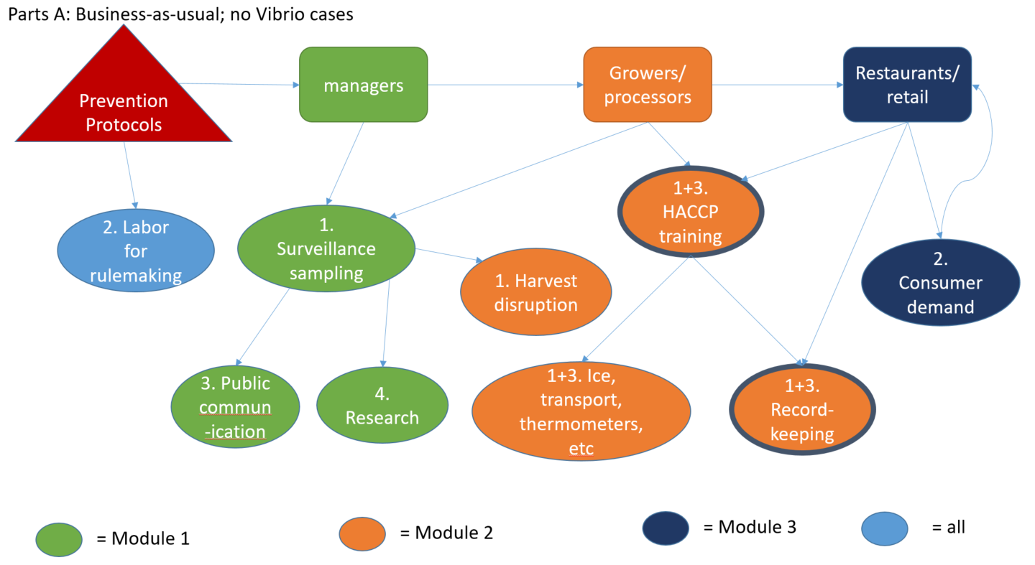

Figure 2 Cost model part 2: traceback and investigation when a Vibrio case reported (each of which has a corresponding module in the interview guide). Numbers in each bubble correspond to the question number that will collect data for that piece of the supply chain impacts.

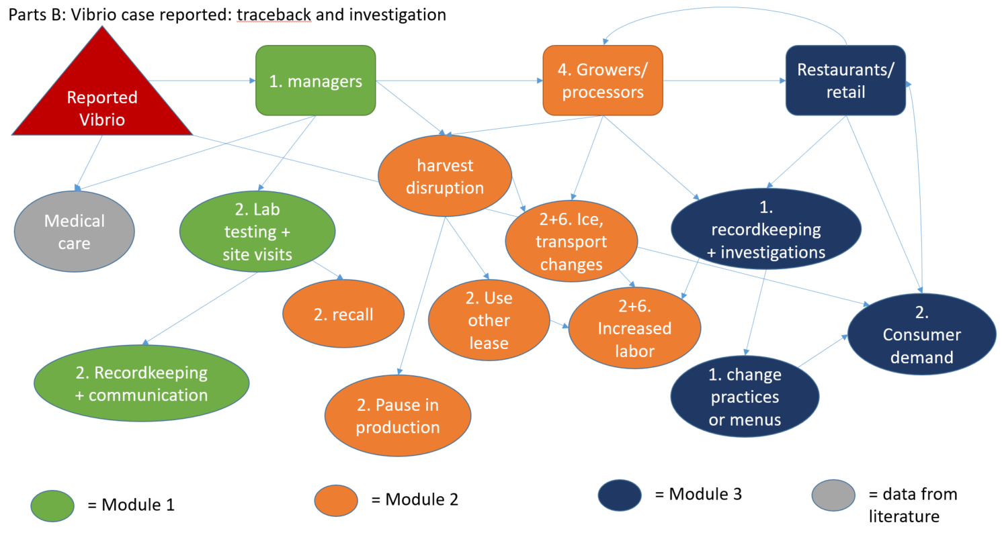

We had a number of NOAA project partners and social science team members each review the interview guide, conceptual model, and analytical methods, including Leif Anderson, PhD (Northwest Fisheries Science Center), Chloe Fleming (NCCOS), Seann Regan (NCCOS), Jarrod Loerzel (NCCOS), Matt Gorstein (NCCOS), and Sarah Gonyo (NCCOS). Each suggested minor wording changes to questions, and splitting a few of the questions for easier understanding.

We also requested external review of the draft interview guide and this supporting statement by to methods experts. Jonathan van Senten, PhD (Virginia Tech, jvansenten@vt.edu) has direct experience with our desired respondent pool, as he has conducted a survey in the region on the economic burden of regulation. His review suggested a number of wording changes to help with specificity of answers as well as emphasizing the importance of the flexibility in the question order in order to accommodate non-sequential lines of thought. The second reviewer, Luke Fairbanks, PhD (Colorado State University, 774-644-1425), has a research portfolio focusing on aquaculture policy and economic development. His biggest overall comment was about the level of recall required for a few of the questions, and that a heads up that we’ll be asking such things might be useful in the invitation so they can be prepared. Other comments were about question specificity and possibly breaking them apart to be several, shorter, questions rather than one bigger one. Both thought expected burden seemed reasonable, given options for response format and promises of confidentiality.

The interviews will be conducted by the project team:

* John Jacobs, PhD: NCCOS, Cooperative Oxford Laboratory
* Amy Freitag, PhD: NCCOS, Biogeography Branch, CSS Inc.
* Leif Anderson, PhD: Northwest Fisheries Science Center
* TBD student under Leif Anderson, Northwest Fisheries Science Center

In order to ensure consistency across interviewers, we will follow the training protocol of the Northwest Fisheries Science Center (author Stephanie Moore) and have regular team check-ins to address issues as they arise and ensure consistent methodology over the course of the project. Leif will be the local point-person for questions that need addressing between check-ins. This same team will analyze the data, bringing in project partner Erika Atherly (Washington Department of Health).

**Appendix 1: Literature review of economic burden of Vibrio parahaemolyticus, by topic.**

|  |  |  |  |  |  |  |  |  |  |  |  |  |  |  |  |  |
| --- | --- | --- | --- | --- | --- | --- | --- | --- | --- | --- | --- | --- | --- | --- | --- | --- |
| **authors** | **year** | **journal** | supply chain economics | health losses | care costs | infection rates | genetics | ecology | medical | climate change | legal | gear/product testing | economics in shrimp | not about Vibrio | recognizes Vibrio health costs but no numbers | cost of prevention justification for research |
| Scharff | 2012 | Journal of food protection |  | 1 |  |  |  |  |  |  |  |  |  |  |  |  |
| Kubota et al | 2008 | Foodborne Pathogens and Disease |  |  |  | 1 |  |  |  |  |  |  |  |  |  |  |
| Hoffman et al | 2015 | Economic Information Bulletin |  | 1 | 1 | 1 |  |  |  |  |  |  |  |  |  |  |
| Hoffman et al | 2012 | Journal of food protection |  | 1 |  |  |  |  |  |  |  |  |  |  |  |  |
| Buzby and Roberts | 1997 | World health statistics quarterly |  |  |  |  |  |  |  |  |  |  |  |  | 1 |  |
| Chen et al | 2017 | Frontiers in Microbiology |  |  |  |  |  |  |  |  |  |  |  |  | 1 | 1 |
| Todd | 1989 | Journal of food protection |  | 1 | 1 | 1 |  |  |  |  |  |  |  |  |  |  |
| Hossain et al | 2013 | Journal of applied microbiology |  |  |  |  |  |  |  |  |  |  |  |  | 1 | 1 |
| Larsen et al | 2015 | International journal of food microbiology |  |  |  |  |  | 1 |  |  |  |  |  |  |  | 1 |
| Majowicz | 2010 | Clinical infectious disease |  |  |  |  |  |  |  |  |  |  |  | 1 |  |  |
| Archer and Kvenberg | 1985 | Journal of food protection |  | 1 |  | 1 |  |  |  |  |  |  |  |  |  | 1 |
| Chen et al | 2012 | Epidemiology and Infection |  |  |  |  |  |  |  | 1 |  |  |  | 1 |  |  |
| Kubota et al | 2011 | Journal of food protection |  | 1 | 1 |  |  |  |  |  |  |  |  |  |  |  |
| Sockett | 1993 | Food Policy |  |  |  |  |  |  |  |  |  |  |  | 1 | 1 |  |
| Lee et al | 2007 | Journal of pediatrics and child health |  |  |  |  |  |  |  |  |  |  |  | 1 |  |  |
| Ralston | 2011 | Journal of water and health |  | 1 | 1 | 1 |  |  |  |  |  |  |  |  |  |  |
| Christou | 2011 | Clinical Microbiology and Infection |  |  |  | 1 |  |  |  |  |  |  |  |  |  |  |
| Thomas et al | 2013 | Foodborne Pathogens and Disease |  |  |  | 1 |  |  |  |  |  |  |  |  |  |  |
| Han et al | 2015 | Frontiers in Microbiology |  |  |  |  | 1 |  |  |  |  |  |  |  | 1 |  |
| Di Pinto et al | 2012 | Letters in applied microbiology |  |  |  |  | 1 |  |  |  |  |  |  |  |  |  |
| Minor et al | 2015 | Risk Analysis |  |  | 1 | 1 |  |  |  |  |  |  |  |  |  |  |
| Kinsey et al | 2015 | Journal of food protection |  |  |  |  |  | 1 |  |  |  |  |  |  |  |  |
| WHO | 2015 | WHO publications |  |  |  | 1 |  |  |  |  |  |  |  |  |  |  |
| Batz et al | 2014 | Foodborne Pathogens and Disease |  | 1 | 1 | 1 |  |  |  |  |  |  |  |  |  |  |
| Aji et al | 2013 | International journal of environmental research |  |  |  |  |  |  |  |  |  |  |  | 1 |  |  |
| Okeke et al | 2005 | Lancet |  |  |  |  |  |  |  |  |  |  |  | 1 |  |  |
| Snowdon et al | 2002 | Foodborne Diseases (book) |  |  |  |  |  |  |  |  |  |  |  | 1 |  |  |
| Epstein and Mills | 2005 | Climate change futures: health, ecological and economic dimensions (book) |  |  |  |  |  |  |  |  |  |  |  | 1 |  |  |
| Lafferty et al | 2015 | Annual review of marine science |  |  |  |  |  |  |  |  |  |  |  |  |  | 1 |
| Weaver and Ehrenkranz | 1975 | Archives of internal medicine |  |  | 1 |  |  |  | 1 |  |  |  |  |  | 1 |  |
| Aranda et al | 2015 | Foodborne Pathogens and Disease |  |  |  |  |  | 1 |  |  |  |  |  |  |  | 1 |
| Stewart and Elliott | 2015 | Trends in food science and technology |  |  |  |  |  |  |  | 1 |  |  |  |  | 1 | 1 |
| Ebi | 2009 | Current Opinion in Environmental Sustainability |  |  |  |  |  |  |  | 1 |  |  |  |  | 1 |  |
| Wesley | 2009 | Microbiologically safe foods |  |  |  |  |  |  |  |  |  |  |  |  | 1 | 1 |
| Muth et al | 2000 | Research Triangle Institute Project 7466.000 | 1 |  |  |  |  |  |  |  |  | 1 |  |  |  |  |
| Legat et al | 2016 | Journal of the Marine Biological Association of the United Kingdom |  |  |  |  |  | 1 |  |  |  |  |  |  |  | 1 |
| Riewpaiboon et al | 2008 | Journal of health, population, and nutrition |  |  | 1 |  |  |  |  |  |  |  |  |  |  |  |
| Grodner and Land | 1991 | FL Sea Grant Program |  |  |  |  |  |  |  |  |  | 1 |  |  |  |  |
| Henson et al | 2000 |  |  |  |  |  |  |  |  |  |  |  |  |  |  | 1 |
| Pal | 2005 | Indian Journal of Animal Sciences |  |  |  |  |  |  |  |  |  |  |  |  | 1 | 1 |
| Fening and Edoh | 2009 | International Journal of Epidemiology |  |  |  |  |  |  | 1 |  |  |  |  |  |  |  |
| Paranjype et al | 2015 | FEMS Microbiology |  |  |  |  |  | 1 |  | 1 |  |  |  |  |  |  |
| Bartsch et al | 2018 | Public Health Reports | 1 |  |  |  |  |  |  |  |  |  |  | 1 |  | 1 |
| Glasgow et al | 2013 | Journal of health, population, and nutrition |  |  |  | 1 |  |  |  |  |  |  |  |  |  |  |
| Akhtar et al | 2014 | Critical reviews in microbiology |  |  |  |  |  |  |  |  |  |  |  |  | 1 | 1 |
| Cato | 1998 | Seafood safety: economics of hazard analysis and critical control point (HACCP) programs (book) | 1 |  |  |  |  |  |  |  |  | 1 |  |  |  | 1 |
| Buzby and Frenzen | 1999 | Food Policy |  |  |  |  |  |  |  |  | 1 |  |  |  |  |  |
| Bonnin-Jusserand et al | 2019 | Critical reviews in food science and nutrition |  |  |  |  | 1 |  |  |  |  |  |  |  |  |  |
| Odeyemi and Sani | 2016 | Future Science |  |  |  | 1 |  |  | 1 |  |  |  |  |  |  |  |
| Henson et al | 2004 | Agriculture and the New Trade Agenda: Creating a Global Trading Environment for Development (book) |  |  |  |  |  |  |  |  |  |  |  |  |  | 1 |
| Leyton et al | 2011 | Marine drugs |  |  |  |  |  |  |  |  |  | 1 |  |  |  |  |
| Shinn et al | 2018 | Asian Fisheries |  |  |  |  |  |  | 1 |  |  | 1 |  |  |  |  |
| WHO | 2003 | Foodborne Disease in OECD Countries Present State and Economic Costs (book) |  | 1 | 1 | 1 |  |  |  |  |  |  |  |  |  | 1 |
| Scallan et al | 2011 | Emerging Infectious Diseases |  |  |  | 1 |  |  |  | 1 |  |  |  |  |  |  |
| Toyofuku | 2014 | Elsevier journal (Japanese) |  |  |  | 1 |  |  |  |  |  |  |  |  |  |  |
| Campa-Cordova et al | 2017 | Journal of fish diseases |  |  |  |  |  | 1 |  |  |  | 1 |  |  |  |  |
| Gonzalez-Escalona et al | 2005 | Emerging Infectious Diseases |  |  |  |  | 1 |  | 1 |  |  |  |  |  |  |  |
| Henson et al | 2003 | FAO ESA Working Paper No 03-19 |  |  |  |  |  |  |  |  |  |  |  |  | 1 | 1 |
| On and Rahayu | 2017 | Asia_Pacific Journal of Food Safety and Security |  | 1 | 1 | 1 |  |  |  |  |  |  |  |  |  |  |
| Hua and Apun | 2013 | Research Journal of Microbiology |  |  |  |  |  | 1 |  |  |  | 1 |  |  |  |  |
| Shinn et al | 2018 | Asian Fisheries Science S |  |  |  |  |  |  |  |  |  |  | 1 |  |  |  |
| Chae | 2007 | Low-temperature post-harvest processing for reducing Vibrio parahaemolyticus and Vibrio vulnificus in raw oysters (dissertation) |  |  |  |  |  |  |  |  |  | 1 |  |  |  | 1 |
| Minguez-Rodriguez | 2010 | Vibrios in the environment Biloxi, Mississippi, USA (book) |  |  |  |  | 1 | 1 |  |  |  |  |  |  |  |  |
| Caminade et al | 2010 | Annals of the New York Academy of Sciences |  |  |  |  |  |  |  | 1 |  |  |  |  |  |  |
| Capalbo et al | 2010 | The Oregon Climate Assessment Report (book) |  |  |  |  |  |  |  | 1 |  |  |  |  |  |  |
| Stentiford et al | 2017 | PLoS |  |  |  |  |  |  |  | 1 |  |  | 1 |  |  |  |
| Red and Coast | 2000 | A Practical Guide for Materials Managers and Supply Chain Managers to Reduce Costs and Improve Environmental Performance﻿. (book) |  |  |  |  |  |  |  |  |  |  |  | 1 |  |  |
| Forsythe | 2011 | The microbiology of safe food (book) |  |  |  | 1 |  |  |  |  |  |  |  |  |  |  |
| Supakankunti et al | 2001 | Valuing Health and Economic Costs of Water Pollution in Thailand (report) |  | 1 | 1 | 1 |  |  |  |  |  |  |  |  |  |  |
| Praveen et al | 2013 | Applied Environmental Microbiology |  |  |  |  |  |  |  |  |  |  |  | 1 |  |  |
| Provincial et al | 2013 | International journal of food microbiology |  |  |  |  |  |  |  |  |  | 1 |  |  |  |  |
| Groner et al | 2016 | Transactions of the Royal Society B |  |  |  |  |  |  |  | 1 |  |  | 1 |  |  |  |
| Lin | 2006 | Chinese Journal of Public Health Management |  |  |  |  |  |  |  |  |  |  |  | 1 |  |  |
| Wang et al | 2015 | Frontiers in Microbiology |  |  |  |  | 1 |  |  |  |  |  |  |  |  |  |
| Reddington et al | 2014 | Biomolecular detection and quantification |  |  |  |  | 1 |  | 1 |  |  |  |  |  |  |  |
| Jones | 2011 | US Patent 7905154 |  |  |  |  |  |  |  |  |  | 1 |  |  |  |  |
| Molins et al | 2001 | Food control |  |  |  |  |  |  |  |  |  | 1 |  |  |  | 1 |
| Wright et al | 2009 | Current Opinion in Biotechnology |  |  |  |  |  |  |  |  |  | 1 |  |  |  | 1 |
| Sanchez-Ortega et al | 2014 | The Scientific World Journal |  |  |  |  |  |  |  |  |  | 1 |  |  |  |  |
| Bondad-Reantaso et al | 2001 | Report of a Workshop held in Bangkok, Thailand. |  |  |  |  |  | 1 |  |  |  |  |  |  |  |  |
| Morin et al | 2018 | Current Environmental Health Reports |  |  |  |  |  | 1 |  | 1 |  |  |  |  |  |  |
| Sudershan et al | 2014 | Epidemiology Research International |  |  |  | 1 |  |  |  |  |  |  |  |  |  |  |
| Blintsis | 2017 | AIMS microbiology |  |  |  |  |  |  | 1 |  |  |  |  |  |  |  |
| Semensza et al | 2012 | Critical reviews in environmental science and technology |  |  |  |  |  |  |  | 1 |  |  |  |  |  |  |
| Lang and Sothea | 2016 | Addressing Acute Hepatopancreatic Necrosis Disease (AHPND) and Other Transboundary Diseases for Improved Aquatic Animal Health in Southeast Asia (book) |  |  |  |  |  |  |  |  |  |  | 1 |  |  |  |
| Mateus et al | 2014 | Aquaculture |  |  |  |  |  |  |  |  |  | 1 |  |  |  |  |
| Bagshaw et al | 2018 | Future Medicine |  |  |  |  |  |  |  |  |  |  |  | 1 |  |  |
| Roland | 1979 | JAMA |  |  | 1 | 1 |  |  |  |  |  |  |  |  |  |  |
| Batz et al | 2011 | University of Florida |  |  |  |  |  |  | 1 |  |  |  |  |  |  |  |
| Coly et al | 2013 | Foodborne Pathogens and Disease |  |  |  | 1 |  |  |  |  | 1 | 1 |  |  |  |  |
| Guthrie | 1976 | JAMA |  |  |  |  |  |  | 1 |  |  |  |  |  |  |  |
| Spinu et al | 2018 | InTech |  |  |  |  |  |  | 1 | 1 |  |  |  |  |  |  |
| Allnutt et al | 2018 | Frontiers in Microbiology |  |  |  |  | 1 |  |  |  |  |  |  |  |  |  |
| Zheng et al | 2013 | Zheijian Journal of Preventive Medicine |  |  |  | 1 |  |  |  |  |  |  |  |  |  |  |
| Hall | 2002 | Protecting the US food supply in a global economy: an expert gap analysis (book) |  |  |  |  |  |  |  |  |  |  |  |  | 1 | 1 |
| Cashin et al | 2002 | ABT Technical Report |  |  | 1 |  |  |  |  |  |  |  |  |  |  |  |
| Lavilla-Pitogo | 1991 | Fisheries Research Society of the Phillipines |  |  |  |  |  | 1 |  |  |  |  | 1 |  |  |  |
| Khan et al | 2001 | Public Health Reports |  |  |  |  |  |  | 1 |  | 1 |  |  |  |  |  |
| **totals** |  |  | **3** | **11** | **13** | **22** | **8** | **11** | **11** | **12** | **3** | **15** | **5** | **13** | **13** | **21** |

1. De Leeuw, E. 2005. To Mix or Not to Mix Data Collection Modes in Surveys. *Journal of Official Statistics* 21(2): 233-255.
2. Multiple Imputation in a Nutshell. [available online: <https://www.theanalysisfactor.com/multiple-imputation-in-a-nutshell/>]
3. Freitag, A., H. Townsend, J. Vasslides. 2019. Are you thinking what I’m thinking? A conceptual modeling approach to understand stakeholders’ assessment of the fate of Chesapeake Oysters. *Marine Policy* 99: 99-110.
4. Hoffman, S., B. Maculloch, M. Batz. 2015. Economic Burden of Major Foodborne Illnesses Acquired in the United States, EIB-140, US Department of Agriculture, Economic Research Service, May 2015.
5. Cato, J. 1998. Economic values associated with seafood safety and implementation of seafood Hazard Analysis Critical Control Point (HACCP) programmes. *FAO Fisheries Technical Paper* No 381. Rome, FAO. 70p.