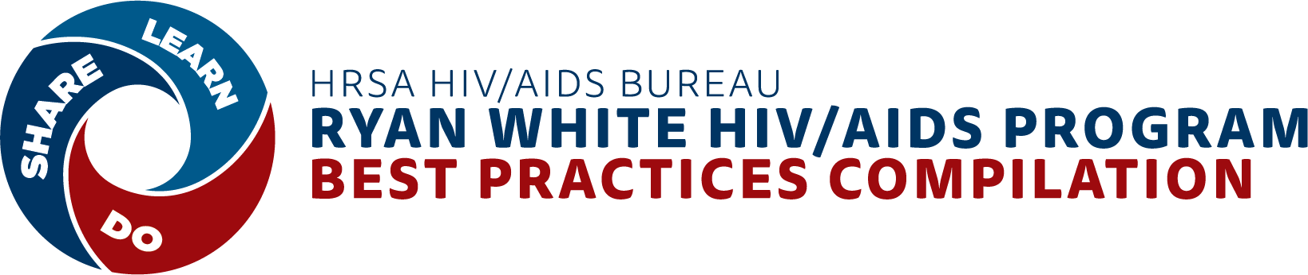

draft Emerging Strategies PRE Submission Form SCREENING QUESTIONS
Purpose of Document
The HRSA HAB Ryan White HIV/AIDS Program (RWHAP) Compilation of Best Practice Strategies and Interventions (Best Practices Compilation), housed on TargetHIV.org, will allow recipients and sub-recipients to share emerging strategies for replication.
To support the development of this Best Practices Compilation, JSI has developed a two-part submission process to identify emerging strategies to include in the compilation: a four question screening form and an emerging strategy submission form.
The screening questions will appear on the best practices landing page on TargetHIV.org for recipients and subrecipients to complete to see if they are eligible to complete the full submission form on their emerging strategy. If they answer yes on all four questions, they will automatically be invited to complete the online submission form. If they answer no to any of the questions, the screening form will end (need to develop thank you script, including email to contact us for more information).
This document includes the pre-submission form screening questions.

- LANDING PAGE DESCRIPTION
This is the information that users will see when they arrive on the emerging strategies page on TargetHIV.org. It describes the purpose of the Best Practices Compilation and invites users to submit their emerging strategy. Note that this landing page will be edited at a later date to incorporate language on evidence-based and evidence-informed interventions.
Do you have an innovative strategy that you have implemented in your HRSA HIV/AIDS Bureau (HAB) Ryan White HIV/AIDS Program (RWHAP) that is showing success or has the potential to improve the lives of your clients? We want to learn more!

HRSA HAB is looking to document and share new strategies that improve the quality of life of people with HIV and can be implemented by RWHAPs. These strategies do not require rigorous evaluation or published evidence, but must work for the RWHAP care and treatment setting.

Our goal is to share information on the TargetHIV.org website on these emerging strategies that support the HIV care continuum with other RWHAP-funded programs looking to achieve similar outcomes.

Emerging strategies meet the following criteria:
- The strategy has been implemented in a RWHAP-funded setting for at least 12 months.
- Your agency has evaluated or is evaluating this strategy and has seen improvements in one or more HIV care continuum outcomes - either directly or indirectly.
An example of a strategy that directly influences an HIV care continuum outcome is an innovative peer model that links newly diagnosed clients to medical care.
An example of a strategy that indirectly influences an HIV care continuum outcome is one that focuses on a practice or social determinant of health, such as housing, that in turn results in an improved HIV care continuum outcome.

- Your evaluation results are not published or you are not planning to publish in a peer-reviewed journal, because we are looking for new or novel approaches that may not have been widely implemented or rigorously evaluated.
- Your agency is willing to share this practice with the RWHAP via the TargetHIV.org website.

Please complete this online submission form- it should take (add total time when we can better estimate it) to describe your strategy, the clients reached, and the effect on your RHWAP clients. We will be reviewing the submissions and following up with sites in [add timeline].
Please note that some of the information provided will be used to review the strategy for inclusion into the online compilation, while other information will be used to develop an online profile of your strategy. You will have the opportunity to review and approve any information that will be shared publicly in the online compilation.
Please contact bestpractices@jsi.com with any questions about this project.

- EMERGING STRATEGY PRE-SUBMISSION FORM SCREENING QUESTIONS
- Was this strategy implemented in a RWHAP setting for at least 12 months?
- Yes Continue to Q2
- None End form [need to develop thank you and explanation script]
- Does your strategy influence a HIV care continuum outcome(s) either directly or indirectly by focusing on an intermediate outcome shown to influence care continuum outcomes? An example of directly influencing HIV care continuum outcomes is a peer model that links clients to HIV treatment. Examples of influencing an intermediate outcome shown to influence HIV care continuum outcomes includes strategies focused on increasing placement of people with HIV in permanent housing, enrollment in health insurance, or provision of trauma-informed care.
HIV Care Continuum Outcomes
- HIV diagnosis
- Linkage to HIV medical care
- Retention and engaged in HIV medical care
- Prescription of antiretroviral therapy (ART)
- Viral Suppression

- Yes Continue to Q3
- No End form [need to develop thank you and explanation script]

- Have you published (or are planning to publish) any evaluation findings from your strategy in a peer-reviewed journal? (Select only one below)
- Yes, published or planning to publish evaluation findings in peer reviewed journal End form [need to develop explanation script about focus of these programs on ES, pending decision by HAB on where to route EBIs/EIIs*]
- Evaluation findings not published/not planning on publishing in peer-reviewed journal Continue to Q4
- This strategy has not yet been evaluated or is not being evaluated End form [need to develop thank you and explanation script]

- Are you interested in describing and sharing your strategy with the RWHAP community via a website link on TargetHIV.org?
- Yes Continue with Emerging Strategy Submission form below
- No End form [need to develop thank you and explanation script]

*Note: this is where strategies and interventions will be triaged for EBI and EII review.

