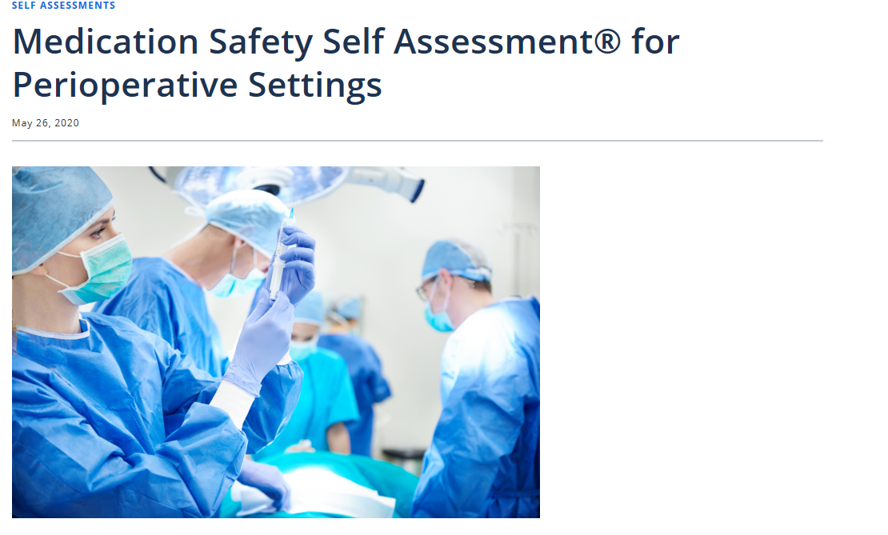
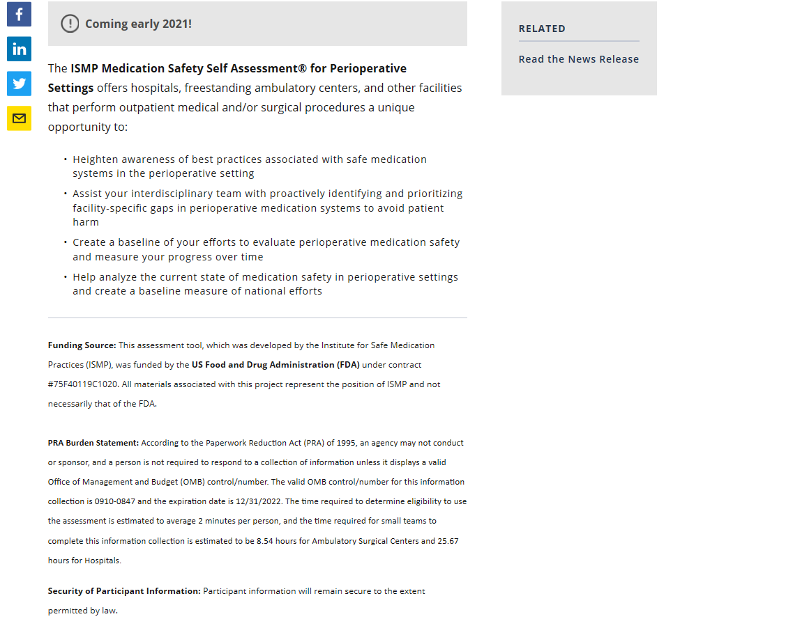

https://ismp.org/resources/medication-safety-self-assessmentr-perioperative-settings

