CBER: Screenshots of communications on vaccines, including reference to age and gender
https://www.fda.gov/biologicsbloodvaccines/vaccines/default.htm
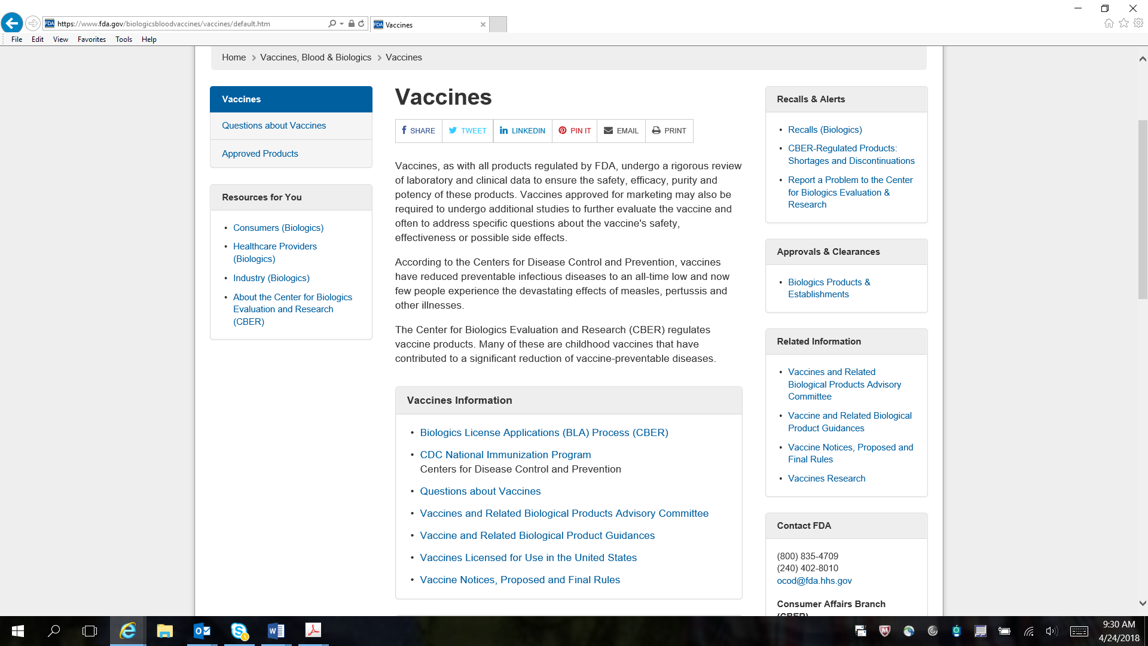

https://www.fda.gov/BiologicsBloodVaccines/ResourcesforYou/Consumers/default.htm
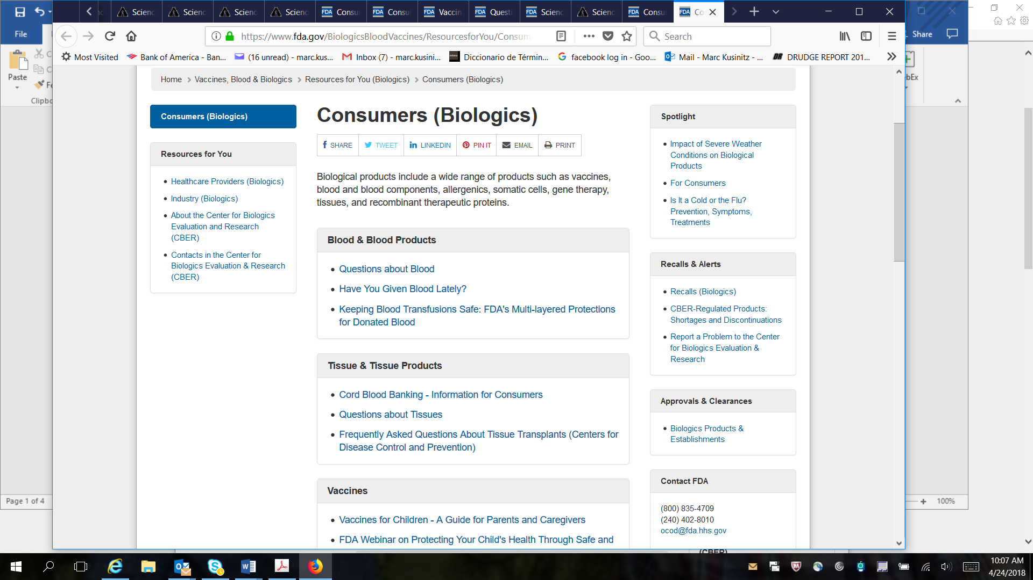
https://www.fda.gov/BiologicsBloodVaccines/SafetyAvailability/VaccineSafety/ucm110288.htm
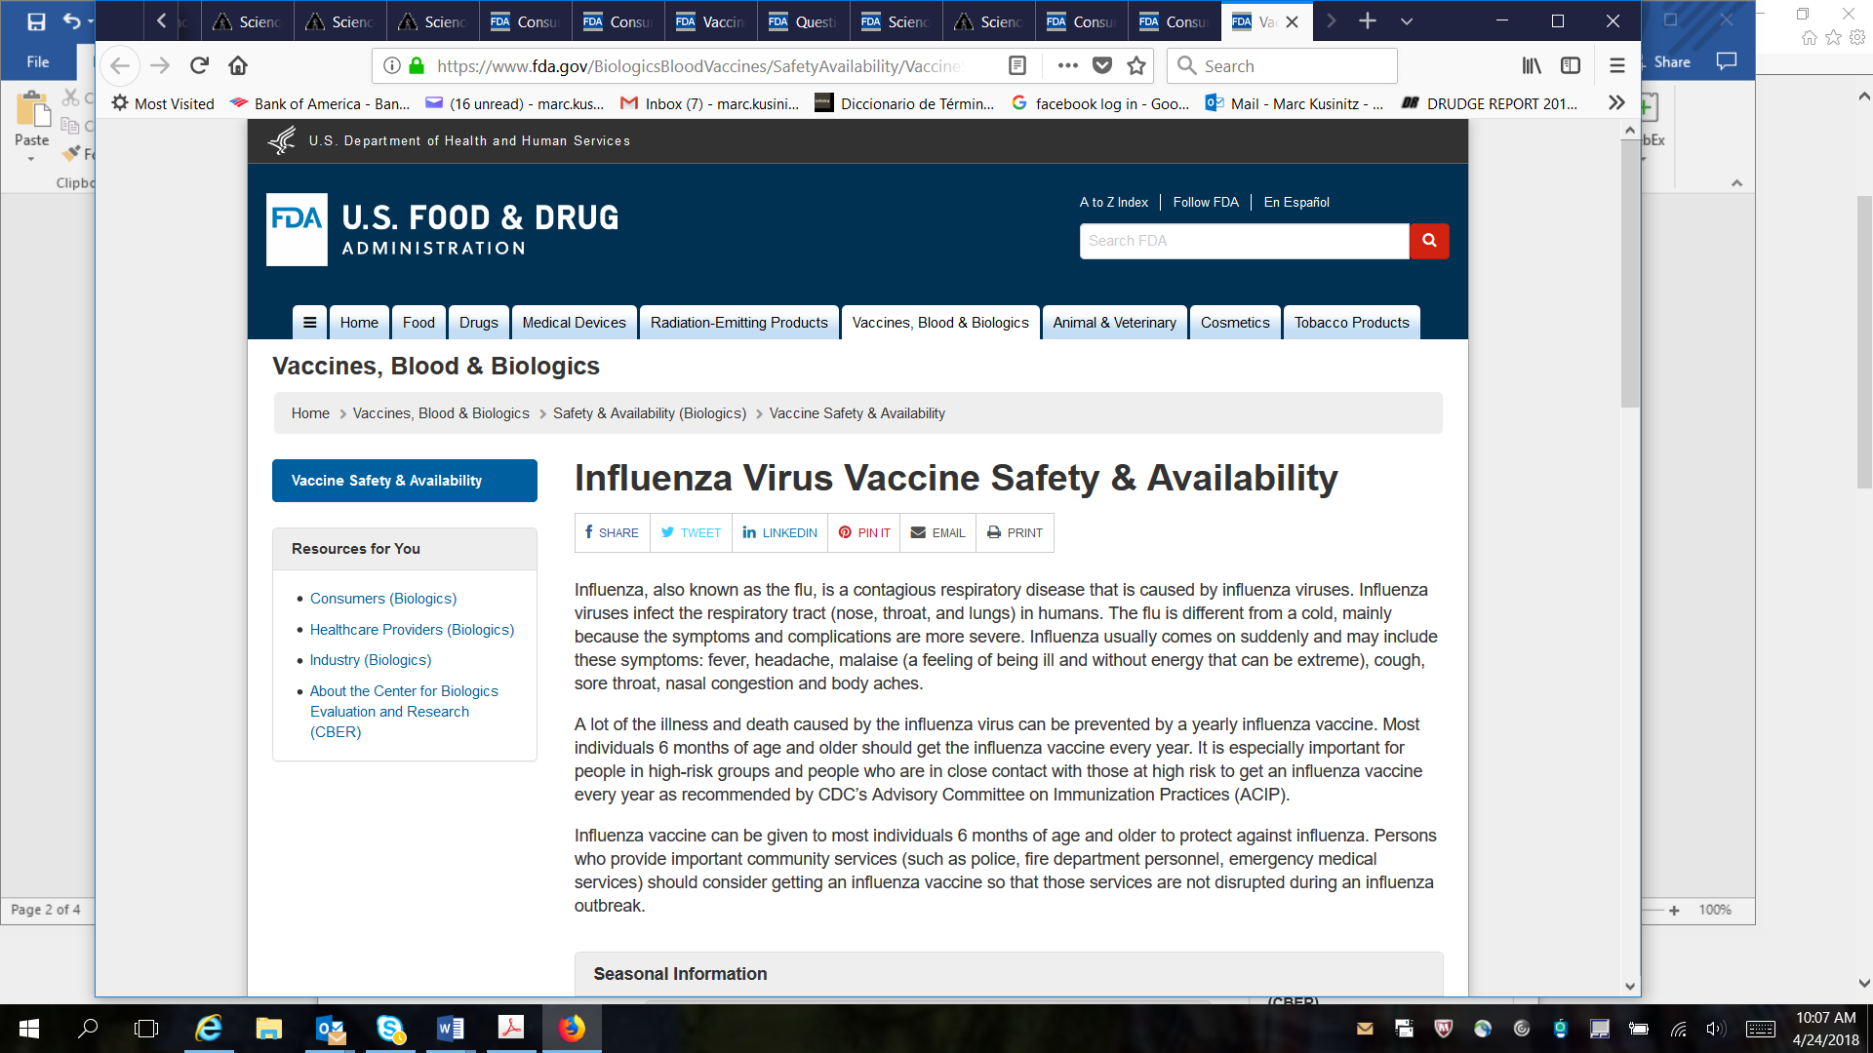

https://www.fda.gov/BiologicsBloodVaccines/Vaccines/QuestionsaboutVaccines/ucm070418.htm
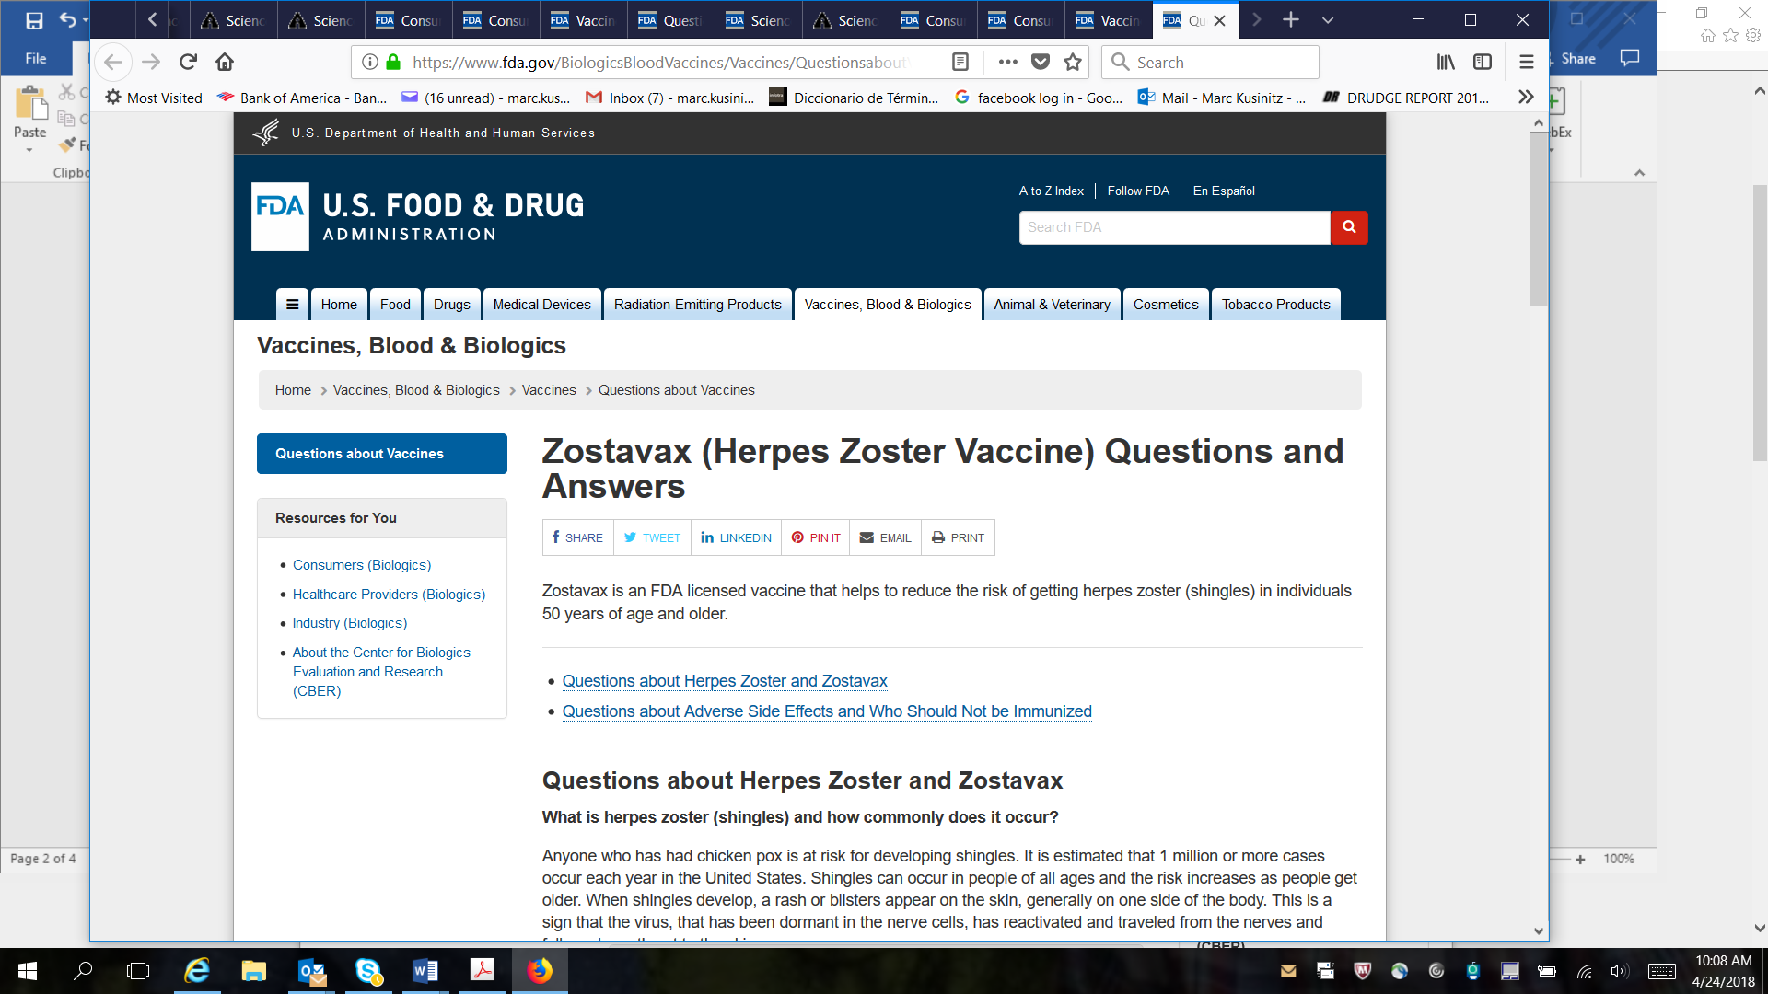
https://www.fda.gov/BiologicsBloodVaccines/ScienceResearch/ucm562601.htm
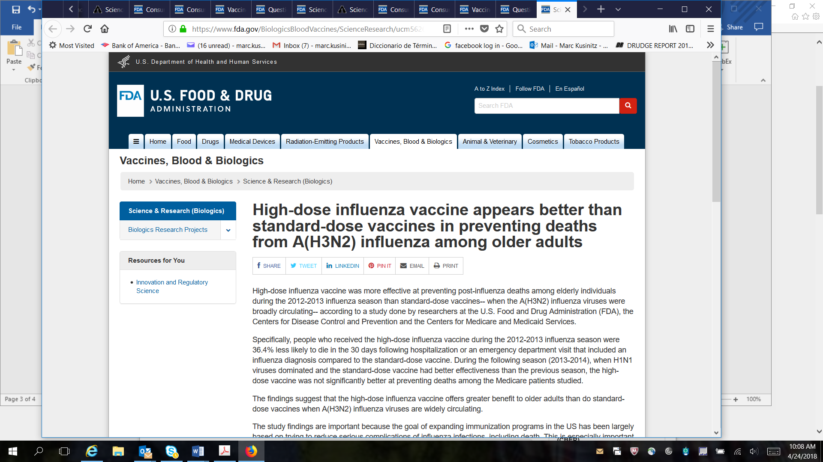

https://wayback.archive-it.org/7993/20171101214516/https:/www.fda.gov/BiologicsBloodVaccines/ScienceResearch/ucm278625.htm
