Attachment 15.b.



**The**

**XX SEED Visit**

**C:\Documents and Settings\vertucci\Local Settings\Temporary Internet Files\Content.IE5\L3VOS14B\MCj03121460000[1].wmfC:\Documents and Settings\vertucci\Local Settings\Temporary Internet Files\Content.IE5\L3VOS14B\MCj04247460000[1].wmf**

**Study to Explore Early Development (SEED)**

Sarah is going to the clinic to visit some nice people. Sarah will play games and visit a nurse. Here is a picture of the clinic.

(OPTIONAL) Sometimes, the nice grown-up and nurse will visit us at home instead.

Photo of adults at the doorway of a home.

Sarah plays while Mom talks to a nice grown-up. When they are done talking, it’s play time!

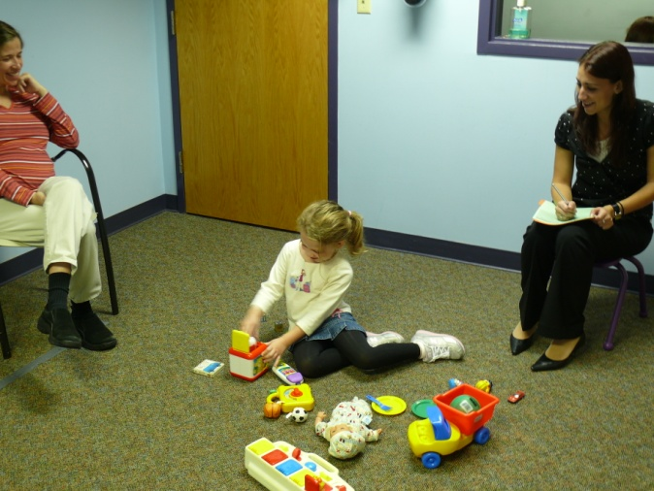

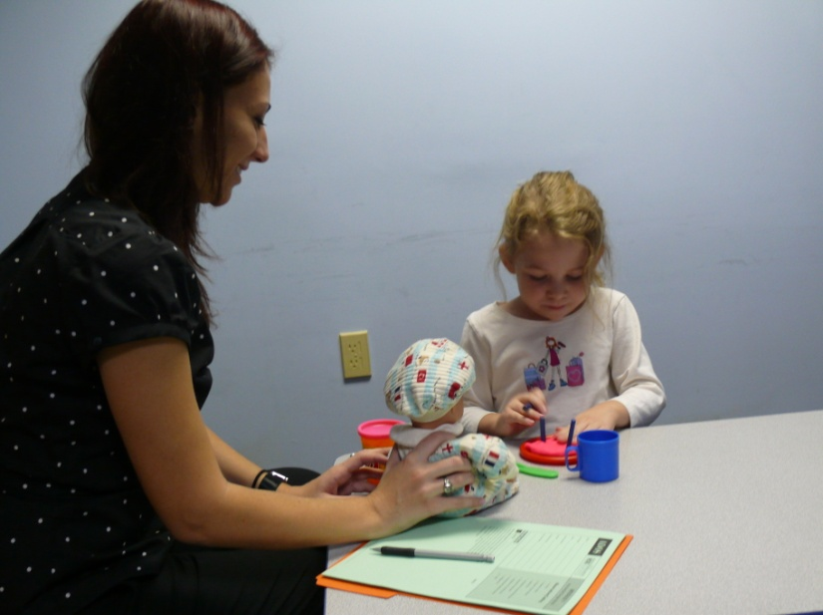

The nice person has lots of fun toys out for Sarah to play with. She asks her to do fun things like build with blocks and play pretend games. Mommy is nearby while Sarah plays.

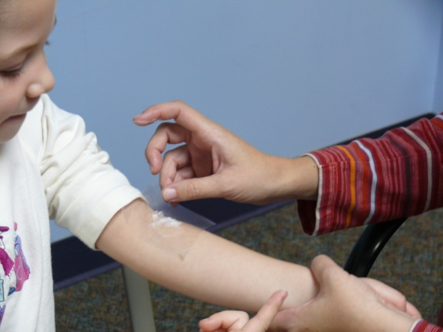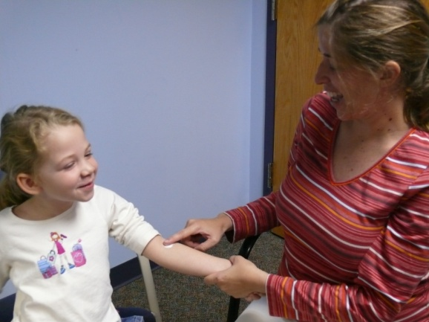Now, it’s time for magic lotion! The nurse will get blood from Sarah’s arm later. If Mommy wants to, she puts magic lotion on Sarah’s arm so it doesn’t hurt.

She covers it with a special bandage so it doesn’t get on Sarah’s clothes. Sarah keeps the magic lotion on her arm until she has her blood taken.

It’s time to see how big Sarah is! A nice person will measure how tall Sarah is and how much she weighs. First Sarah takes off her shoes! Then, we see how big she is. How big is Sarah?

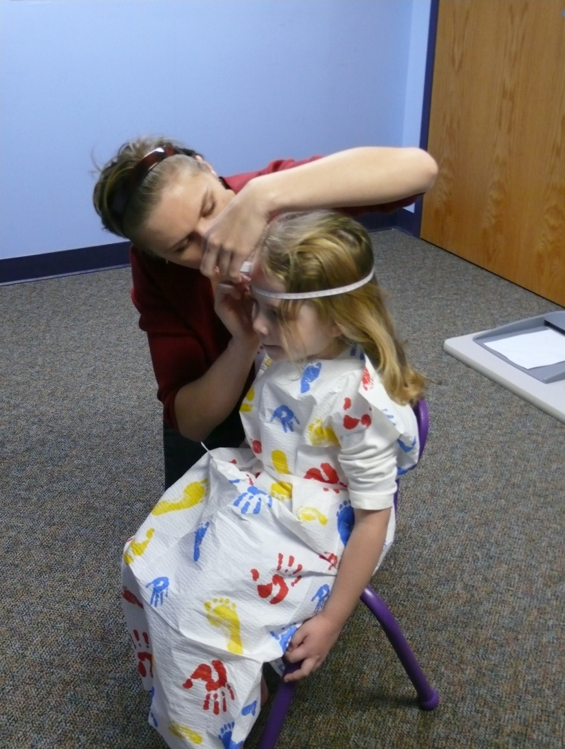

Next, we see how big Sarah’s head is. Then, we will see how big Mommy’s is. Whose head will be bigger, Sarah’s or her Mom’s?

Next, it is spit in a tube time!

Photo of mother spitting into the saliva collection tube.

Mommy shows us how it is done!

Photo of child with sponge in mouth with mouth closed.

If Sarah does not want to spit, then the nice person places a soft sponge inside. Sarah holds it in her mouth. She will hold this in her mouth for several minutes. The nice person will place the sponge in Sarah’s mouth a few more times.

Now it is nurse time! 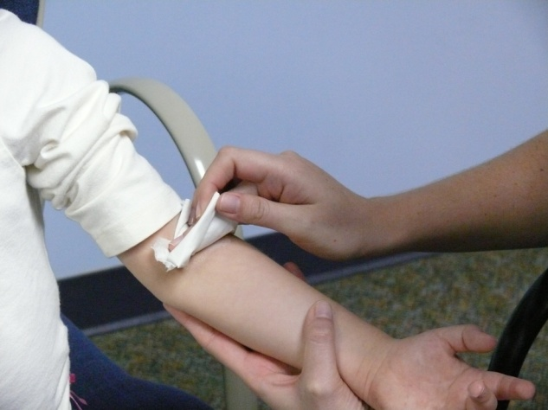

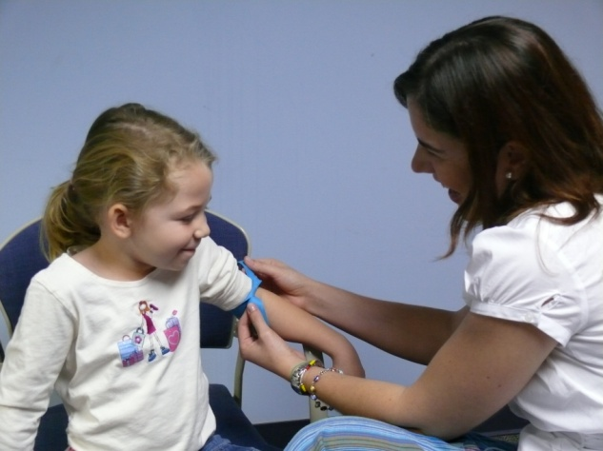The nurse takes off the clear bandage and looks at Sarah’s arms.

The nurse puts a big rubber band around Sarah’s arm. She ties it tight so it doesn’t move. Mommy is there to hold Sarah’s hand.

Next, the nurse wipes Sarah’s arm with a small sponge. The sponge feels a bit cold and wet.

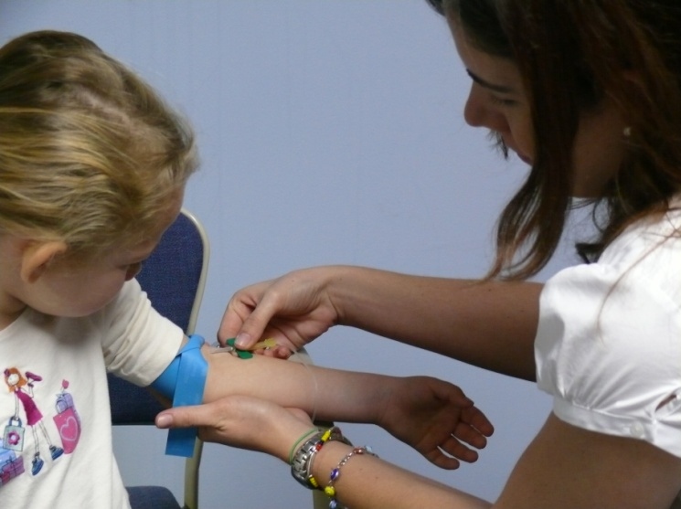

The nurse tells Sarah to look at her Mommy. Sarah feels a little pinch in her arm. Then the nurse puts a piece of cotton and a bandage on Sarah’s arm. Sarah has to leave the bandage alone until Mommy tells her she can take it off.

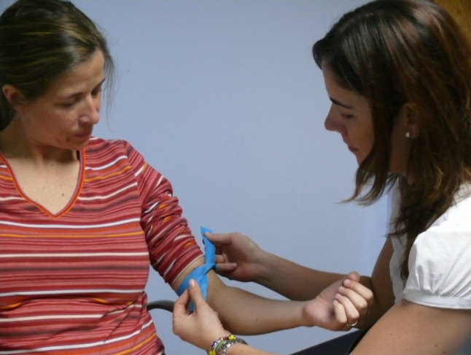Now it’s Mommy’s turn!

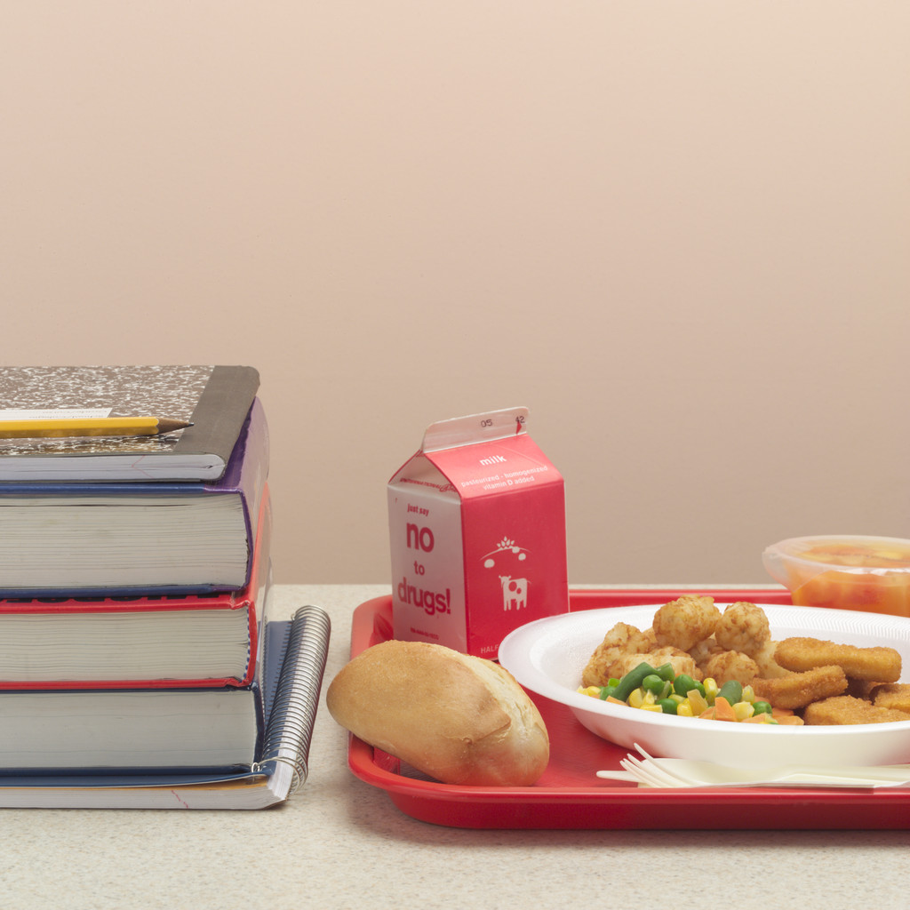

(OPTIONAL) Next, Sarah and Mom take a break for lunch.

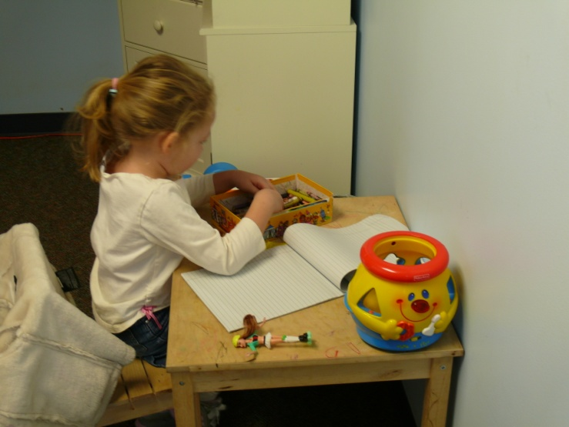

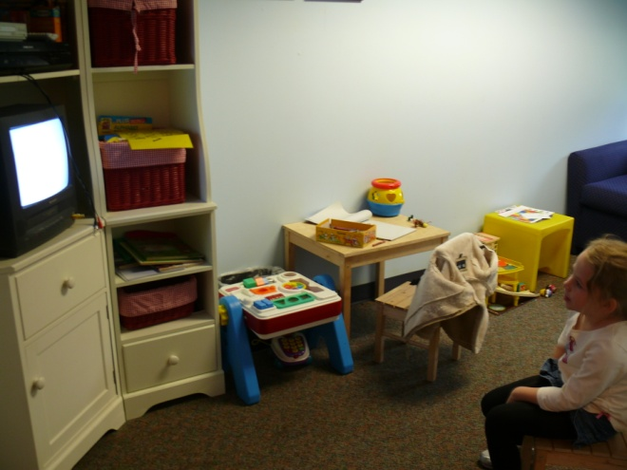

Sarah plays and watches a movie while Mom talks to a nice grown-up. There are lots of toys for Sarah to play with.

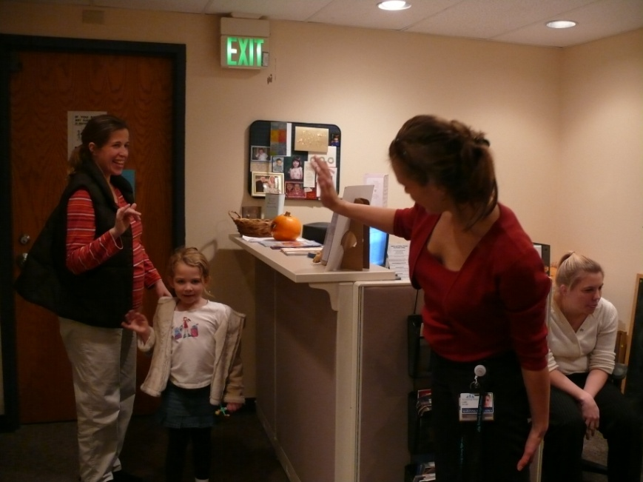

Sarah is all done playing with the nice person. Nice job, Sarah! Sarah and Mommy wave

good-bye!.

**COLLECT A STICKER FOR EACH**

**FINISHED TASK**

Word

Games

Listening Games

Drawing

Games

Matching Games

Nurse

Time!

Saliva

Time!

How Big?

Time

Magic Lotion Time!

**Special Reward Stickers:**

Great Job!

Working

Hard!

Being a Great Helper!

Sitting

Still!

Good Listening!