Head Start Connects

Appendix A: Conceptual Map

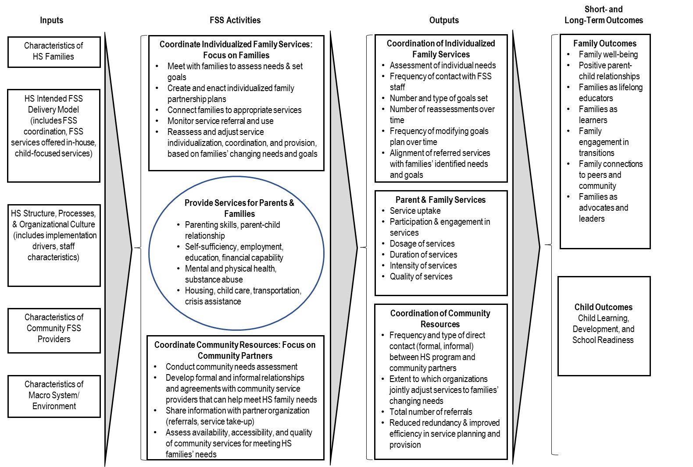
A. Conceptual Map

