Glen Canyon National Recreation Area Backcountry Visitor Experience Survey

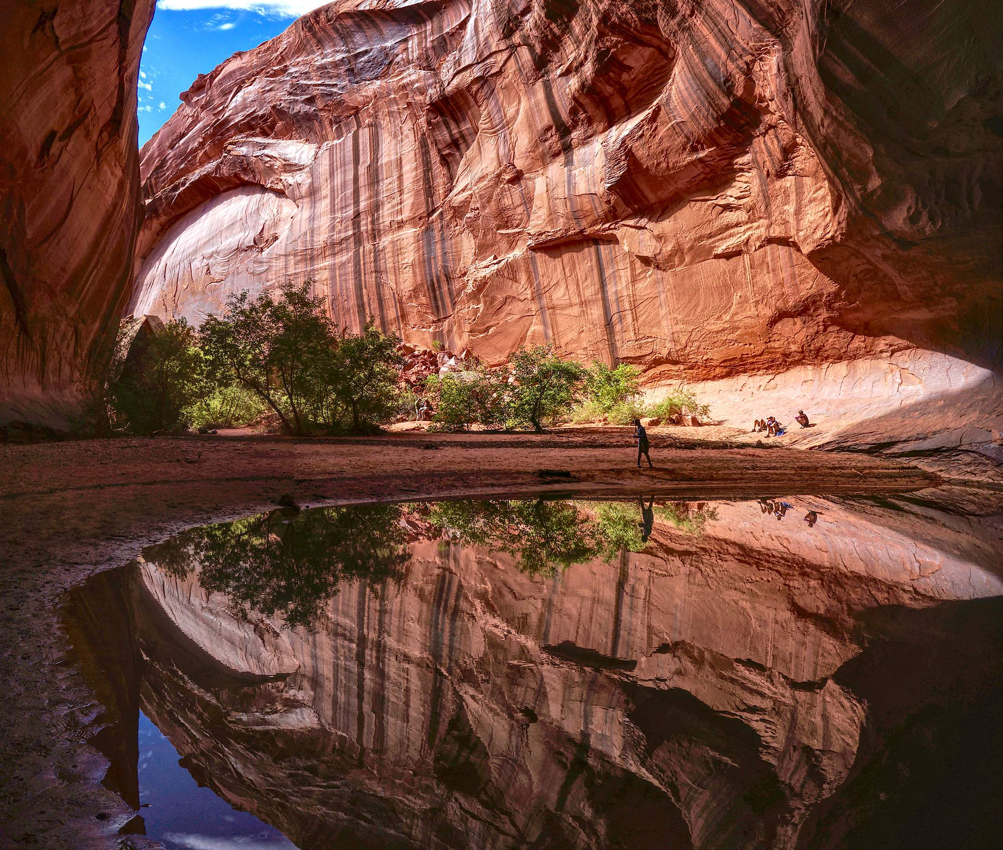

PAPERWORK REDUCTION and PRIVACY ACT STATEMENT: The Paperwork Reduction Act requires us to tell you why we are collecting this information, how we will use it, and whether or not you have to respond. We are authorized by the National Park Service Protection Interpretation and Research in System (54 USC §100702) to collect this information. The routine uses of this information will be for the benefit of NPS Managers and Planning staff at Glen Canyon National Recreation Area (GLCA) in future initiatives related to the visitor use and backcountry management. The data collected will be summarized to evaluate visitor uses and expectations during their visit at GLCA. Your responses to this collection are completely voluntary and will remain anonymous. You can end the process at any time and will not be penalized in any way for choosing to do so. Your participation poses only minimal risks. Data collected will only be reported in aggregates and no individually identifiable responses will be reported. A Federal agency may not conduct or sponsor, and you are not required to respond to, a collection of information unless it displays a currently valid OMB Control Number (1024-0224). We estimate that it will take about 10 minutes to complete and return this short survey. You may send comments concerning the burden estimates or any aspect of this information collection to: Dr. Zach Miller, Assistant Professor, zachary.miller@usu.edu; or Phadrea Ponds NPS Information Collection Coordinator at pponds@nps.gov.

- Are you a first-time visitor to [CANYON NAME]? (Select one)
NO YES

- Are you a first-time visitor to the Escalante District (orange in the map below) of Glen Canyon National Recreation Area?
NO YES

- Was [CANYON NAME] your intended destination on this trip? (Select one)
NO YES

[IF NO TO QUESTION 2 ABOVE] What was your intended destination?
___________________________

- [IF NO TO QUESTION 3 ABOVE] What was the primary reason you did not go to your intended destination?

Not enough time | Too crowded at intended destination | Road or trail closure | Bad weather
Unsafe road | Inadequate display of safety information | Liked this place better than intended destination | Other (please specify)

- Which of the following activities did you participate in during this trip to [CANYON NAME]? (Select all that apply)
Day hiking | Car camping | Backpacking | General sight-seeing
Other (please specify): _____________________________

- From the activities you participated in at [CANYON NAME], which was your primary activity? (Select one) (this item will only carry forward the items selected in the question above for visitors to select)
Day hiking | Car camping | Backpacking | General sight-seeing
Other (please specify): _____________________________

- We would like to know what sources of information you used to get information about planning your trip to the Escalante District. We would also like to know when you obtained each type of information (Select all that apply)
Source | Did not use | Used before arriving to the Escalante District of Glen Canyon National Recreation Area | Used after arriving to the Escalante District of Glen Canyon National Recreation Area
Personal communication with a National Park Service ranger
Park map or brochure
Personal communication with another employee in the Escalante District of Glen Canyon National Recreation Area
Word of mouth (talking with other visitors or friends)
Social media
News article, either in print or online
A National Park Service website
Another website
Please specify __________________________________________________________________

- During this trip, did you visit the Escalante Interagency Visitor Center in Escalante, Utah? (select one)
NO YES

- Did you experience any of the following during this trip to [CANYON NAME]? (Select one for each experience)

Experience | NO – Did not experience | YES – Did experience
Encounters with other groups
Seeing cairns (rock piles) placed by other visitors
Seeing trash
Seeing campfire rings
Smelling campfire smoke
Seeing graffiti
Hearing loud voices, crying, or yelling from other visitors
Hearing sounds from vehicles
Hearing sounds from airplanes or helicopters
Crowding
Dogs off-leash
Signs of visitor-created trails
Seeing or smelling human waste
Evidence of tree cutting from visitors
- From the experiences you had on this trip to [CANYON NAME], please rate how the following items decreased or increased the quality of your experience. (Please rate each item) (this item will only carry forward the items selected in the question above for visitors to rate)

Experience | Greatly decreased | Decreased | Slightly decreased | Neither | Slightly increased | Increased | Greatly increased
Encounters with other visitors | -3 | -2 | -1 | 0 | +1 | +2 | +3
Seeing cairns (rock piles) placed by other visitors | -3 | -2 | -1 | 0 | +1 | +2 | +3
Seeing trash | -3 | -2 | -1 | 0 | +1 | +2 | +3
Seeing campfire rings | -3 | -2 | -1 | 0 | +1 | +2 | +3
Smelling campfire smoke | -3 | -2 | -1 | 0 | +1 | +2 | +3
Seeing graffiti on rock surfaces | -3 | -2 | -1 | 0 | +1 | +2 | +3
Hearing loud voices, crying, or yelling from other visitors | -3 | -2 | -1 | 0 | +1 | +2 | +3
Hearing sounds from vehicles | -3 | -2 | -1 | 0 | +1 | +2 | +3
Hearing sounds from airplanes or helicopters | -3 | -2 | -1 | 0 | +1 | +2 | +3
Crowding | -3 | -2 | -1 | 0 | +1 | +2 | +3
Dogs off-leash | -3 | -2 | -1 | 0 | +1 | +2 | +3
Signs of visitor-created trails | -3 | -2 | -1 | 0 | +1 | +2 | +3
Seeing or smelling human waste | -3 | -2 | -1 | 0 | +1 | +2 | +3
Evidence of tree cutting from visitors | -3 | -2 | -1 | 0 | +1 | +2 | +3

- Please indicate how inappropriate or appropriate you think each of the following behaviors are for a visitor to [CANYON NAME]? (Please rate each item)

Activity | Completely inappropriate | Inappropriate | Slightly inappropriate | Neither | Slightly appropriate | Appropriate | Completely appropriate
Leave solid human waste in the backcountry | -3 | -2 | -1 | 0 | +1 | +2 | +3
Have a campfire in the backcountry | -3 | -2 | -1 | 0 | +1 | +2 | +3
Build rock cairns (rock piles) in the backcountry | -3 | -2 | -1 | 0 | +1 | +2 | +3
Hike on hard rock/slick rock surfaces or trails | -3 | -2 | -1 | 0 | +1 | +2 | +3
Post specific location information about the area on social media | -3 | -2 | -1 | 0 | +1 | +2 | +3
Draw, paint, or scratch on rock surfaces | -3 | -2 | -1 | 0 | +1 | +2 | +3
Have a dog off leash while hiking | -3 | -2 | -1 | 0 | +1 | +2 | +3

- Are you or a member of your group carrying a portable toilet or a specifically engineered bag waste containment system?
NO YES

- How would you describe your current knowledge of LNT practices? (Please select one)
No knowledge | Limited knowledge | Average knowledge | Advanced knowledge | Expert knowledge
1 | 2 | 3 | 4 | 5

- What was your primary source of information for learning about “Leave No Trace?” (Please respond below)
__________________________________________________________________

- Please indicate the degree to which you oppose or support the following hypothetical management scenarios related to recreating in [CANYON]. (Select one for each management action)
Management scenario | Completely oppose | Strongly oppose | Oppose | Neutral | Support | Strongly support | Completely support
Require visitors to pack out all solid human waste using a portable waste containment bag | -3 | -2 | -1 | 0 | +1 | +2 | +3
Increase communications and visitor education to reduce resource impacts | -3 | -2 | -1 | 0 | +1 | +2 | +3
Increase the presence of rangers through patrols on trails and surrounding areas | -3 | -2 | -1 | 0 | +1 | +2 | +3
Allow overnight camping only in designated campsites | -3 | -2 | -1 | 0 | +1 | +2 | +3
Require a reservation-based permit for overnight use, but not for day use | -3 | -2 | -1 | 0 | +1 | +2 | +3
Require a reservation-based permit for overnight use and day use. | -3 | -2 | -1 | 0 | +1 | +2 | +3
Require a first-come, first serve permit for overnight use, but not for day use | -3 | -2 | -1 | 0 | +1 | +2 | +3
Require a first-come, first serve permit for overnight use, and for day use | -3 | -2 | -1 | 0 | +1 | +2 | +3

- Please list the number of nights you [and your personal group] planned to stay in the Escalante District of Glen Canyon National Recreation Area and in the surrounding area away from your permanent residence.
_______ Number of nights in the Escalante District of Glen Canyon National Recreation Area
_______ Number of nights in other locations inside Glen Canyon National Recreation Area or Grand Staircase Escalante National Monument
_______Number of nights in the area but outside of Glen Canyon National Recreation Area or Grand Staircase Escalante National Monument

- Are you a permanent resident or citizen of the United States? (Please select one)
NO - What is your country of origin? _______________________
YES - What is your primary zip code Zip code ______________

- Please select the choice below that best describes your traveling party. (Please select one)
Individual | Family only | Friends only
Family plus friends | Tour or other group

- How many people were in your personal group, including you? (only displayed to people who did not select individual in question18) ______ Number of people

- In what year were you born? (Please respond in the blank below) _______________________

- What is your gender? (Please fill in below) _____________

