OMB CONTROL NUMBER: 1024-0224

ZION Visitor Survey

Intercept survey

Intercept opening script
“Hello, I am working with Zion National Park conducting a 5-minute survey to improve visitor experiences in the park. May I ask you questions about your Zion experience?
➔ If the visitor says YES: [continue by showing the following statement regarding the Paperwork Reduction and Privacy Act.]
➔ If NO - interviewer will thank the visitor and ask non-response bias question. [The surveyor will ask the three non-response bias questions below and record them in the survey]
1. “Are you a permanent resident of the United States?”
2. “Are you a permanent or seasonal resident of the local area around Zion National Park?”
3. “On this trip, did you [and your personal group] stay overnight away from your permanent residence either inside Zion National Park or within the local area?”

PAPERWORK REDUCTION and PRIVACY ACT STATEMENT: The Paperwork Reduction Act requires us to tell you why we are collecting this information, how we will use it, and whether or not you have to respond. We are authorized by the National Park Service Protection Interpretation and research in System (54 USC §100702) to collect this information. The routine uses of this information will be for the benefit of NPS Managers and Planning staff in Zion National Park (ZION) in future initiatives related to the visitor use and resource management within the site. The data collected will be summarized to evaluate visitor uses and expectations during their visit at ZION. Your responses to this collection are completely voluntary and will remain anonymous. You can end the process at any time and will not be penalized in any way for choosing to do so. All contact information collected for the purpose of the follow-up survey will be destroyed at the end of the collection period and no personal identifiable records will be maintained or stored for any purposes. Data collected will only be reported in aggregates and no individually identifiable responses will be reported. A Federal agency may not conduct or sponsor, and you are not required to respond to, a collection of information unless it displays a currently valid OMB Control Number (1024-0224). We estimate that it will take about 5 minutes to complete this on-site questionnaire. You may send comments concerning the burden estimates or any aspect of this information collection to: Dr. Jeremy Sage, Associate Director, Institute for Tourism and Recreation Research, 32 Campus Dr. #1234, Missoula, MT 59803; 406-243-5552 (phone) jeremy.sage@umontana.edu(email); or Phadrea Ponds NPS Information Collection Coordinator at pponds@nps.gov (email).

Local Area Map
(to be provided for viewing while answering tablet questions)
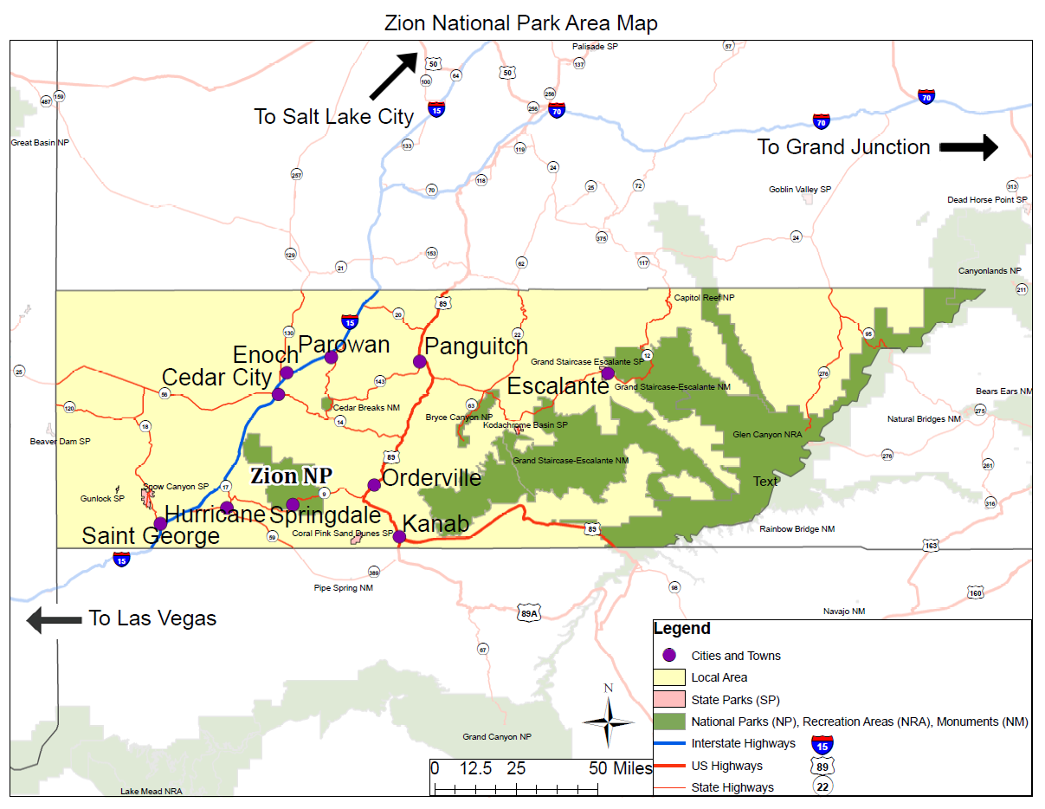

First, we’d like to ask some questions about your trip away from home during this visit to Zion National Park and the time you might have spent/will spend in the local area. (Interviewer provide maps of local area and park -- 2–sided and laminated)
The local area around Zion National Park includes Iron, Washington, Garfield, and Kane Counties. Within these counties, the communities of [A, B, C, and D] are shown, along with and major roadways and other features within about a one-hour drive of the park. The local area is shown on the map below.
- Are you a permanent or seasonal resident of the local area around Zion? (Show map) Please mark (●) one
  - Yes, I am a permanent resident
  - Yes, I am a seasonal resident
  - No
- (If seasonal or permanent resident) What is your zip code in the local area? ________zip code

- (If not local) Are you a permanent resident of the United States? Please mark (●) one
  - No What is your country of origin?__________ (Drop Down)
  - Yes What is your zip code? _________zip code
- (If not local) Was your visit to Zion the primary purpose for your overall trip away from home?
Please mark (●) one

Yes No

- (If not primary) Was your visit to Zion…? Please mark (●) one
  - The primary reason you came to the local area
  - One of two or more equally important reasons you came to the local area
  - An incidental or spontaneous stop to the local area

- About how long ago did you plan your visit to Zion? Please mark (●) one
  - On the same day of the visit
  - A week before the visit
  - 1 month before the visit
  - 2-6 months before the visit
  - More than 6 months but less than a year before the visit
  - A year or more before the visit
  - Don’t know/can’t recall
  - Other

- On this trip away from home, have you stayed, or will you stay overnight in Zion National Park and/or within the local area? (Show Map) Please mark (●) one
Yes No
- On this trip, what type of accommodations do you expect to use while in Zion and/or the local area? Please mark (●) all that apply
- Back Country Camping in Zion  - Camping in Zion  - Camping outside Zion in the local area  - Lodging in Zion (e.g., hotels, cabins) | - Lodging outside Zion in local area (e.g., hotels, cabins, vacation rentals)  - Unpaid accommodations (e.g., family and friends)

- (If Camping in Zion selected) What is the name of the campground where you stayed?
- Lava Point campground
- South Campground
- Watchman Campground

- (For each accommodation selected above) How many nights have you or do you plan to spend [accommodation selection from above (e.g., camping in Zion)]
_____# of nights

- (If a Zion accommodation site selected) What time of day did you arrive in Zion? Please mark (●) one
- Early morning (before 9 am)  - Mid-morning (9am-12pm)  - Mid-day (12pm-3pm) | - Afternoon (3pm-6pm)  - Evening (after 6pm)

- (If a Zion accommodation site selected) What time of day do you plan to leave Zion at on the last day of your stay? Please mark (●) one
- Early morning (before 9 am)  - Mid-morning (9am-12pm)  - Mid-day (12pm-3pm) | - Afternoon (3pm-6pm)  - Evening (after 6pm)

- (If non-NPS sites selected for nights stayed) What communities are closest to where you stayed or are staying at your [accommodation selection from above]

- Cedar City
- Enoch
- Escalante
- Hurricane
- Kanab
- Panguitch
- Parowan
- St. George
- Springdale
- Rockville
- LaVerkin
- Virgin
- Mt Carmel Junction

- Including yourself, how many people are in your personal group as you visit Zion National Park?
Note: Your personal group is you and companions with whom you visited [NPS site] on this trip, such as a spouse, family, friends, etc. This does not include the larger group that you might have traveled with, such as a school, church, scout, or tour group.
______ Adults (18 years or older)
______ Children (under 18 years)
- On this trip, do you plan to visit Zion National Park for more than one day? Please mark (●) one

Yes No
- (If = 1 day) How many hours do you plan to spend within Zion on this trip? ___hours

- (If > 1 day) How many days do you plan to spend within Zion on this trip? ___days

- [VSE Question] (If >1 day) On how many different days do you expect to enter the park?

___ Different Days Entered Zion

- Did you, or do you, plan to leave and re-enter the park today? Please mark (●) one
  - Yes How many times? ______________
  - No
- Which was the most recent entrance you used to enter the park? (Show Map) Please mark (●) one
  - South Entrance, nearest to Springdale, UT
  - Pedestrian Entrance at Springdale
  - East Entrance, nearest to Mt Carmel Junction, UT
  - North Entrance at Kolob Canyons
  - Kolob Terrace Road

- Visitors have different reasons for visiting Zion. How important to you are each of the following reasons for your visit?
 | Not at all important | Somewhat important | Moderately important | Very  Important | Extremely Important
To experience quiet and contemplation | 1 | 2 | 3 | 4 | 5
To experience the sounds of nature | 1 | 2 | 3 | 4 | 5
To appreciate the scenic beauty | 1 | 2 | 3 | 4 | 5
To spend time outdoors | 1 | 2 | 3 | 4 | 5
To experience a sense of challenge | 1 | 2 | 3 | 4 | 5
To spend time with family/friends | 1 | 2 | 3 | 4 | 5

The next several questions pertain specifically to the Zion Canyon Shuttle within the park. Note, this is not the shuttle that originates in Springdale, UT.

- Have you [and your personal group] used the Zion Canyon shuttle during this visit?
Yes No
- (If shuttle use = yes) How long did you wait for the Zion Canyon shuttle entering the canyon?
- Less than 5 minutes  - 5-10 minutes  - 11-20 minutes  - 21-30 minutes | - 31-44 minutes  - 45-60 minutes  - More than 1 hour

- (If shuttle use = yes) How long did you wait for the Zion Canyon shuttle leaving the canyon?
- Less than 5 minutes  - 5-10 minutes  - 11-20 minutes  - 21-30 minutes | - 31-44 minutes  - 45-60 minutes  - More than 1 hour

- (If shuttle use = no) Do you [and your personal group] plan to use the Zion Canyon shuttle during this visit?
Yes No
- In your opinion, at what point is the wait time for a shuttle no longer acceptable?
  - _____ Number of minutes
  - The wait time does not matter to me
- Which of the following forms of transportation did you personally use to enter Zion National Park today? Please mark (●) one
- Car, truck, or SUV [Skip to Q35]  - Recreational vehicle/motorhome [Skip to Q35]  - Commercial tour bus [Skip to Q30]  - Commercial tour van [Skip to Q30]  - Private tour van [Skip to Q30] | - Shuttle (local Shuttle) [Skip to Q36]  - Church, school, or similar group bus/van[Skip to Q30]  - Motorcycle [Skip to Q36]  - Bicycle [Skip to Q36]  - Walk/hike [Skip to Q36]

- (If bicycle was selected) Is the bike an electric bike?
Yes No
- (If bicycle was selected) Is the bike a rental?
Yes No
- (If tour bus or tour van selected = Yes) Was your commercial tour bus or tour van booked as a package vacation? Please mark (●) one
Yes No
- (If Package = yes) What is the total cost of the package vacation for your personal group? $______

- (If Package = yes) What is the total length of your package vacation? _________days

- (If Package = yes) Where did your package vacation start? _________

- (If Package =yes) Where will your package vacation end? _________

- (If POV selected) How many people are travelling in your vehicle with you, including yourself? _____ people

- Are you a first-time visitor to Zion National Park? Please mark (●) one
Yes No
- (If not first time) Including the current trip, how many visits have you made to Zion National Park over the past 12 months? _____visits

- [Travel Cost Question] (If not first time) Including the current trip, how many visits have you made to Zion National Park over the past three years? _____visits

- How acceptable was the number of people you encountered during your current visit to Zion so far at the following sites?

 | Totally unacceptable | Slightly Unacceptable |  | Neutral | Slightly acceptable | Perfectly acceptable | Not  Applicable/  Have not  visited
Information desks or kiosks | 1 | 2 | 3 |  | 4 | 5 | O
While waiting to board the Zion Canyon shuttle | 1 | 2 | 3 |  | 4 | 5 | O
While riding the Zion Canyon shuttle | 1 | 2 | 3 |  | 4 | 5 | O
Angels Landing Trail | 1 | 2 | 3 |  | 4 | 5 | O
The Narrows Trail | 1 | 2 | 3 |  | 4 | 5 | O
Emerald Pools | 1 | 2 | 3 |  | 4 | 5 | O

Interviewer script following completion of on-site survey:
Thank you for your time. We would like to ask you to take this follow-up survey and complete it after your trip. You can participate either by completing the paper form and mailing it in the postage-paid envelope, or online through a password-protected website. The website information and survey ID is provided on a slip of paper inside the survey packet.
Because your opinion is important to us, we will send replacement surveys if you lost your survey and reminders if you forgot to complete it when you returned home. Would you be willing to share your home address or email to send a reminder or replacement survey in the following weeks? This information will only be used for the purposes of providing reminders and replacement surveys.
First name: __________________________________________
Address:_____________________________________________
Email: ______________________________________________

