OMB CONTROL NUMBER: 1024-0224
Expiration Date: XX/XX/20XX

ZION Visitor Survey
PAPERWORK REDUCTION and PRIVACY ACT STATEMENT: The Paperwork Reduction Act requires us to tell you why we are collecting this information, how we will use it, and whether or not you have to respond. We are authorized by the National Park Service Protection Interpretation and research in System (54 USC §100702) to collect this information. The routine uses of this information will be for the benefit of NPS Managers and Planning staff in Zion National Park (ZION) in future initiatives related to the visitor use and resource management within the site. The data collected will be summarized to evaluate visitor uses and expectations during their visit at ZION. Your responses to this collection are completely voluntary and will remain anonymous. You can end the process at any time and will not be penalized in any way for choosing to do so. All contact information collected for the purpose of the follow-up survey will be destroyed at the end of the collection period and no personal identifiable records will be maintained or stored for any purposes. Data collected will only be reported in aggregates and no individually identifiable responses will be reported. A Federal agency may not conduct or sponsor, and you are not required to respond to, a collection of information unless it displays a currently valid OMB Control Number 1024-0224 We estimate that it will take about 15 minutes to complete this on-site questionnaire. You may send comments concerning the burden estimates or any aspect of this information collection to: Dr. Jeremy Sage, Associate Director, Institute for Tourism and Recreation Research, 32 Campus Dr. #1234, Missoula, MT 59803; 406-243-5552 (phone) jeremy.sage@umontana.edu(email); or Phadrea Ponds NPS Information Collection Coordinator at pponds@nps.gov (email).

Cover Letter
Dear [Name],
On your recent trip to Zion National Park, we asked you to participate in an on-site visitor survey. First, we would like to thank you for your participation in the first phase of this study.
The second phase, is this mail-back questionnaire which we kindly ask you to fill out at the end of your visit and send back to us in the pre-paid envelope provided. You can also fill out these questions online, if it is easier for you [Survey URL]. We selected only a small number of visitors to participate in this study; therefore, the return of each questionnaire is very important. The information you provide will help us better understand visitor spending details, travel patterns, and perceptions of your visit. It will also help us manage Zion National Park our visitors.
If you have any questions regarding this questionnaire, please contact the Social Science Branch Chief, National Park Service, Natural Resource Stewardship & Science, Environmental Quality Division, Social Science Program, 1201 Oakridge Drive, Fort Collins, CO, 80525.
Thank you for your help with this important study. Your opinions matter, and we appreciate you sharing them with us. They will help us improve the management of the National Park Service.

Sincerely,

Mail-back Reminder Letter
Dear [Name],
About a month ago, after your recent trip to Zion National Park, we asked you to participate in the second phase of the survey by filling out a mail-back questionnaire. We selected a small number of visitors to participate in this study; therefore, the return of each questionnaire is very important. The information you provide will help us better understand visitor spending details, travel patterns, and perceptions of your visit. It will also help us manage Zion National Park and other units of the National Park Service, and better serve you, our visitor.
If you have already returned this questionnaire, we would like to thank you. However, if you have not, we are asking you to please return it by mail as soon as possible. Since we have not received yours as of the date we mailed this letter, we have included a replacement questionnaire for your convenience, along with a postage paid envelope.
If you have any questions regarding this questionnaire, please contact the Social Science Branch Chief, National Park Service, Natural Resource Stewardship & Science, Environmental Quality Division, Social Science Program, 1201 Oakridge Drive, Fort Collins, CO, 80525.
Thank you for your help with this important study. Your opinions matter, and we appreciate you sharing them with us. They will help us improve the management of the National Park Service.

Sincerely,

Postcard
Respondents from the United States
Dear National Park Visitor,
About two weeks ago we contacted you to participate in a visitor use survey for the National Park Service. On your recent trip to Zion National Park, you spoke with one of our survey administrators and received a survey questionnaire with a postage-paid envelope. If you have already sent in your survey or completed it online using the provided online link, we thank you!
However, if you have not yet had the opportunity to complete the survey we would greatly appreciate you doing so. A select number of people were contacted for this study, so your opinions are very important to us! Please complete the survey online or return the questionnaire at your earliest convenience. If you have lost the questionnaire and wish to complete a paper copy of the survey, another questionnaire will be mailed to you in approximately two weeks.
Thank you,
The National Park Service

International Respondents
Dear National Park Visitor,
About two weeks ago we contacted you to participate in a visitor use survey for the National Park Service. On your recent trip to Zion National Park, you spoke with one of our survey administrators and received a survey questionnaire with a postage-paid envelope. If you have already sent in your survey or completed it online using the provided online link, we thank you!
However, if you have not yet had the opportunity to complete the survey we would greatly appreciate you doing so. A select number of people were contacted for this study, so your opinions are very important to us! Please complete the survey online or return the questionnaire at your earliest convenience. If you have lost the questionnaire and wish to complete a paper copy of the survey or need additional postage to mail it to the US, another questionnaire will be mailed to you in approximately two weeks and will include a return envelope with international postage.
Thank you,
The National Park Service
Mail Back Based Questions
Trip Description
First, we’d like to ask some questions about your trip away from home when you visited Zion National Park.
- Prior to your most recent trip, how did you obtain information about Zion?
Please mark (●) all that apply

  - Did not obtain information prior to this visit
  - Previous visits
  - Friends/relatives/word of mouth
  - Inquiry to park via phone, mail, or email
  - Official Zion website
  - Other website (Please specify)
  - Local businesses (hotels, restaurants, etc.)
  - Maps/brochures
  - Newspaper/magazine articles
  - Other units of the national park system (NPS)
  - School class/program
  - Social media (such as Facebook, Twitter, etc.)
  - State welcome center/visitor bureaus/chamber of commerce
  - Television/radio programs/DVDs
  - Travel guides/tour books (such as AAA, etc.)
  - Online travel agent
  - Live here/ Grew up here
  - Other (Please specify)

- Did you have the information about Zion you needed on this trip?
Please mark (●) one

  - Yes
  - No (Please specify information you needed but didn’t have on this trip)

- From the list below, select all forms of transportation you personally used to travel from your home to Zion on this trip. Please mark (●) all that apply

  - Car, truck, or SUV
  - RV or motorhome
  - Airplane
  - Commercial tour bus
  - Commercial tour van
  - Private tour van
  - Church, school, or similar group bus/van
  - Taxi/Other rideshare options (e.g., Uber, Lyft, etc.)
  - City bus or subway
  - Train or long-distance passenger bus
  - Water-based transportation (mark all that apply)
- Cruise ship  - Ferry  - Tour boat  - Personal boat | - Motor boat  - Sail boat  - Canoe/kayak  - Other ______________
  - Bicycle
  - Electric bicycle
  - Motorcycle
  - Walk/hike
  - Other (Please specify)

- What type of group were you with, during your visit to Zion on the day you were contacted for this survey?
Please mark (●) one

  - Alone
  - Significant other/spouse
  - Friends
  - Family
  - Family and friends
  - Other (Please specify)

Expenditures

The National Park Service is interested in the relationship between parks and their local economies. In this section, we ask about goods and services that you and your personal group purchased in both Zion’s local area and elsewhere in the US (outside Zion’s local area) during this trip away from home.

Throughout this section, please refer to the following map when asked about the local area around Zion. The local area includes all communities within the highlighted region
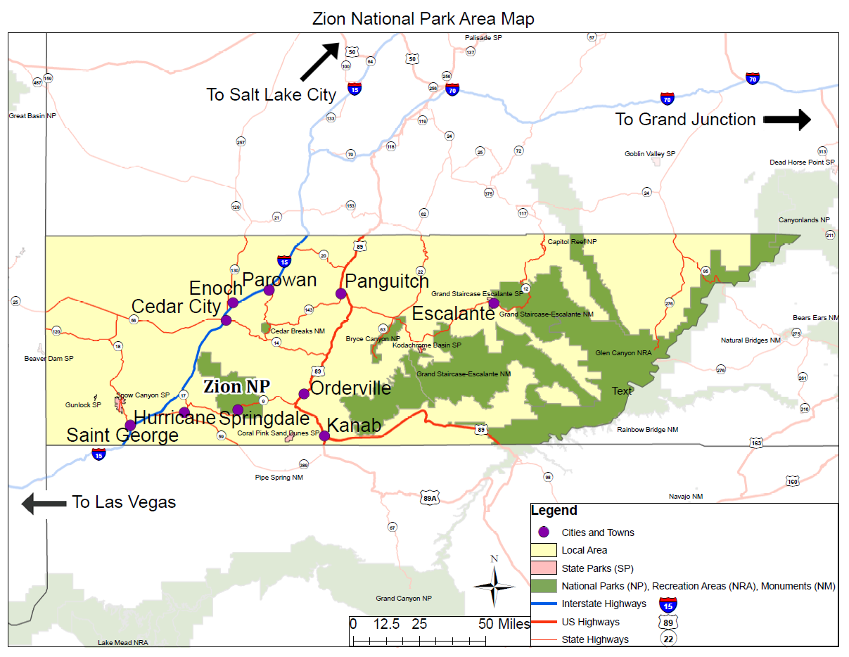
- How many days did you spend away from home (or your local/seasonal residence) on this trip that included your visit to Zion?
__________number of days

- Including yourself, how many people in your personal group did you share expenses with (or cover expenses for) on your trip to Zion? This could include your full personal group (e.g., entire family) or a smaller set of people (e.g., your partner only).

__________number of people (adults and children)

- Please estimate how much money the group you shared expenses with (or covered expenses for) spent in the following areas during your trip away from home: (1) Zion and the local communities surrounding Zion, and (2) elsewhere in the U.S. outside Zion’s local area. If you did not spend anything in a category, please enter “0”.
Local Area Residents: If you are a permanent or seasonal resident, please only include local area expenditures that were directly related to your trip to [NPS site] when you received this survey.
Package vacationers: For this question, don’t include any expenditures that were included as part of your package vacation cost (that you reported when interviewed at Zion).
Expenses | Amount spent in Zion and nearby communities (shown on map) | Amount spent elsewhere in US during your trip to the Zion area (expenses outside local area)
National Park entrance fee or annual parks pass
Gas and oil (e.g., auto, RV, boat, etc.)
Rental car
Taxis, ride shares, shuttles, parking, and public transportation
Restaurants and bars
Groceries and convenience foods
Hotels, motels, resorts
Specialty lodging (e.g., B&Bs, hostels, cabins, vacation rentals)
Camping fees (tent, RV)
Recreation and entertainment expenses (e.g., movies, bowling, miniature golf, etc.)
Souvenirs, clothing, supplies, other retail
Equipment rental
Guides and tour fees
Other expenditures (Please describe below)
_______________________________________________
Airline tickets from home
(Which airport did you fly into?) ________________________

- If you did not list your expenditures, please indicate why you did not answer.
Please mark (●) one

  - Did not spend any money on this trip
  - Do not know how much money was spent (don’t remember / didn’t keep track)
  - Prefer to not answer the question

- On this trip to Zion, which one of the following entrance fees applied to you personally?
Please mark (●) one

  - Did not pay a fee or use a pass to enter the park
  - 7-day entrance pass
  - Annual pass for Zion
  - America the Beautiful-National Parks and Federal Recreation Lands
  - Senior Pass, Access Pass, or Military Pass
  - Fee included in Tour Package
  - One-day fee (e.g., single-day entry fee)
  - Don’t know/Unsure
  - Other (Please specify)

- On how many different days did you enter Zion on this trip?

___ Different Days Entered Zion

- Did you visit any of the following parks on this trip away from home?
Please mark (●) all that apply

  - Arches National Park
  - Bryce Canyon National Park
  - Canyonlands National Park
  - Capitol Reef National Park
  - Cedar Breaks National Monument
  - Glen Canyon National Recreation Area
  - Grand Canyon National Park – North Rim
  - Grand Staircase-Escalante National Monument
  - Pipe Spring National Monument
  - Utah State Parks (e.g., Coral Pink Sand Dunes, Kodachrome Basin, Sand Hollow, Snow Canyon)

- On this trip, in which of the following activities did you personally participate in while visiting the park? Please mark (●) all that apply
- Riding the Zion Canyon shuttle  - Viewing wildlife  - Viewing scenery, natural features, scenery, wildflowers, etc.  - Creative arts (photography, drawing, painting, writing)  - Visiting a cultural or historic site  - Nature study  - Driving for pleasure  - Walking short distance (less than 1 hour)  - Day hiking (1 hour or more)  - Bicycling | - Running/jogging  - Camping in developed sites  - Overnight backpacking  - Overnight in resort, cabin, or other accommodation in Zion  - Family gathering (e.g., reunion, wedding)  - Picnicking  - Rock climbing/bouldering  - Mountaineering  - Commercial filming  - Other (Please specify)
- Of the activities listed in Question 12, which was your primary activity during your visit to Zion on the day you were contacted for this survey?
#_______
Or
- I did not have a primary activity on this trip to Zion

- On this trip, in which of the following programs and services did you personally participate in during your visit to the park? Please mark (●) all that apply

  - Attending a ranger-led activity, such as a tour or talk
  - Talking informally with a ranger
  - Viewing outdoor exhibits
  - Viewing indoor exhibits
  - Attending a cultural demonstration or performance
  - Reading the park brochure or newspaper
  - Going to the visitor center
  - Watching movies or videos about the park
  - Participating with a child in your group in the Junior Ranger program
  - Obtaining a National Park passport stamp
  - Listening to an audio tour or podcast
  - Using a smart phone app specific to Zion
  - Other (Please specify)

- Considering your most recent trip to Zion, did you visit any of the following locations: Please mark (●) all that apply
- Kolob Canyons  - Kolob Terrace Road  - Zion Canyon Scenic Drive | - Zion Mt Carmel Highway (east of the long tunnel)  - Side slick rock areas (east of the long tunnel)  - Backcountry slot canyons

- Did you use a personal electronic device while in [NPS Site] to do any of the following actions? Please mark (●) one box per row
 | Yes | No | Don’t know
Make/receive cell phone call
Send/receive text message
Search the internet / email
GPS/Navigation
Share pics/videos/audio via social media
Listen to/use an NPS podcast
Other (Please specify) _____________________________________
- How important to you was it during your visit to Zion to use personal electronic devices to do each of the following, and how would you rate the quality of the service to do each? For each item, please mark (●) one for importance and one for quality of service.
. | A) IMPORTANCE |  |  |  |  |  |  | B) QUALITY OF SERVICE
 |  | Extremely Important | Very Important | Moderately Important | Slightly Important | Not at all Important |  |  | Very Good | Good | Average | Poor | No Service at All | Not Applicable
Make/receive cell phone call
Send/receive text message
Search the internet / email
GPS/Navigation
Share pics/videos/audio via social media
Listen to/use an NPS podcast
Other (Please specify)

- A) Did anyone on your personal group have a physical condition that made it difficult to access or participate in park activities or services, during your visit to Zion? Please mark (●) one

  - Yes
  - No ->Go to Question 19

B) What activities, services, or facilities did the person(s) have difficulty participating in or accessing? Please be specific.

Please describe______________
C) Because of the physical condition, which specific difficulties did the person(s) have. Please mark (●) all that apply
  - Hearing (difficulty hearing ranger programs, bus drivers, audio-visual exhibits or programs, or information desk staff even with hearing aid)
  - Visual (difficulty seeing exhibits, directional signs, visual aids that are part of programs even with prescribed glasses due to blindness)
  - Mobility (difficulty in accessing facilities, services, or programs even with walking aid and/or wheelchairs)
The following two questions identify the strengths and weaknesses in the site’s visitor experience. Zion managers rely on this information to make decisions that benefit the general public.
- What did you like most about your visit to Zion?
1.________________________________________________________________________________2.________________________________________________________________________________
  - Not applicable

- What did you like least about your visit to Zion?
1._______________________________________________________________________________2._______________________________________________________________________________
  - Not applicable

- Did your visit to Zion meet your expectations?
  - Yes
  - Not entirely (Please explain)
____________________________________________________________________________________________________________________________________________________________

Not at all (Please explain)
____________________________________________________________________________________________________________________________________________________________

NPS Site Management
- To what extent do you agree or disagree with each of the following statements?
 | Strongly Disagree | Somewhat Disagree | Neither agree nor Disagree | Somewhat Agree | Strongly Agree
Zion is a safe place to visit | 1 | 2 | 3 | 4 | 5
Zion is too crowded | 1 | 2 | 3 | 4 | 5
Natural resources in Zion are in pristine condition | 1 | 2 | 3 | 4 | 5
The entrance fee for Zion is too high | 1 | 2 | 3 | 4 | 5
Zion is not accessible to persons with physical disabilities | 1 | 2 | 3 | 4 | 5
Historical and cultural features in Zion are well maintained/preserved | 1 | 2 | 3 | 4 | 5
- Please select one answer for each statement that best describes how problematic each of the following issues was for you at this site.
 | Not a problem | Small problem | Moderate problem | Big problem | N/A
Wait time to enter Zion | 1 | 2 | 3 | 4
Availability of parking | 1 | 2 | 3 | 4
Shuttle wait times at Visitor Center | 1 | 2 | 3 | 4
Shuttle wait times within Zion Canyon (e.g., Zion Lodge, The Grotto, etc.) | 1 | 2 | 3 | 4
Shuttle wait times leaving Zion Canyon | 1 | 2 | 3 | 4
People walking on, across, or along the road | 1 | 2 | 3 | 4
Too many people in the park | 1 | 2 | 3 | 4
Traffic congestion | 1 | 2 | 3 | 4
Feeling safe on walkways and trails around other people | 1 | 2 | 3 | 4
Wait times to use restrooms | 1 | 2 | 3 | 4
Cleanliness of restrooms | 1 | 2 | 3 | 4

- On average, approximately how many minutes did you and your personal group have to wait in traffic at the entrance station of Zion?
- Less than 5 minutes  - 5-10 minutes  - 11-20 minutes  - 21-30 minutes | - 30-44 minutes  - 46-60 minutes  - More than 1 hour  - N/A
- How acceptable is the amount of time you spent waiting in traffic to enter Zion National Park?
  - Not at all acceptable
  - Slightly acceptable
  - Moderately acceptable
  - Very acceptable
  - Extremely acceptable
  - N/A

- For the places you visited on this trip, please rate how crowded you felt by the number of people present at the following locations:
 | Not at all crowded | Somewhat crowded | Moderately crowded | Very crowded | Extremely crowded | N/A
Zion National Park Visitor Center | 1 | 2 | 3 | 4 | 5
Kolob Canyons Visitor Center | 1 | 2 | 3 | 4 | 5
Shuttle stop at Zion National Park Visitor Center | 1 | 2 | 3 | 4 | 5
Shuttle stops within Zion Canyon (e.g., Zion Lodge, The Grotto, etc.) | 1 | 2 | 3 | 4 | 5
Shuttle stop leaving Zion Canyon | 1 | 2 | 3 | 4 | 5
While riding the shuttle | 1 | 2 | 3 | 4 | 5
Park Entrance | 1 | 2 | 3 | 4 | 5
Zion Lodge | 1 | 2 | 3 | 4 | 5
Angels Landing | 1 | 2 | 3 | 4 | 5
The Narrows | 1 | 2 | 3 | 4 | 5
Emerald Pools | 1 | 2 | 3 | 4 | 5
On walks/hikes that lasted less than one hour | 1 | 2 | 3 | 4 | 5
On walks/hikes that lasted more than one hour | 1 | 2 | 3 | 4 | 5

- If you used the Zion Canyon Shuttle, how would you rate your overall travel experience on your trip?

Excellent | Good | Fair | Poor | Very Poor | N/A

- Overall, how did the number of people you have encountered during your visit compare with what you expected? Please mark (●) one
  - A lot less than what I expected
  - A little less than what I expected
  - About what I expected
  - A little more than what I expected
  - A lot more than what I expected
  - I did not have any expectations

- Overall, how acceptable was the number of people you have encountered on your trip to Zion? Please mark (●) one
  - Not at all acceptable
  - Slightly Acceptable
  - Moderately acceptable
  - Very acceptable
  - Completely acceptable

- For each statement below, please rate how much you agree or disagree with the following statement:

The following planning tool or service, if available, would help me better plan a future trip to Zion NP.
 | Strongly disagree | Somewhat disagree |  | Neutral | Somewhat agree |  | Strongly agree | Don’t know/not sure
Ability to reserve a specific day(s) and time(s) to visit the park | 1 | 2 | 3 |  | 4 | 5 |  | o
Ability to obtain permits for popular trails or destinations | 1 | 2 | 3 |  | 4 | 5 |  | o
Ability to obtain tickets for a seat on the shuttle | 1 | 2 | 3 |  | 4 | 5 |  | o
Availability of a guided, fee based, interpretive commercial tour | 1 | 2 | 3 |  | 4 | 5 |  | o
Online itinerary builder for Zion | 1 | 2 | 3 |  | 4 | 5 |  | o
Information about busy times of the year and/or days of the week and/or times of the day | 1 | 2 | 3 |  | 4 | 5 |  | o
Information about other ​recreation areas​ and historic sites throughout the region | 1 | 2 | 3 |  | 4 | 5 |  | o
Other tools that could improve your planning (please specify):

Background/Demographics

- What is your zip code, or home country if not US?
OR ________________________________________
- What is your age? ________

- What is your gender? _______________

- Are you of Hispanic, Latino or Spanish Origin? Please mark (●) one
  - Yes
  - No
- What is your race? Please mark (●) all that apply
  - American Indian or Alaska Native
  - Asian
  - Black or African American
  - Native Hawaiian or other Pacific Islander
  - White

- What is the highest degree or level of school you have completed? Please mark (●) one.
  - Less than high school/some high school
  - High school graduate
  - Vocational/trade school certificate
  - Some college
  - Associate Degree (AA, AS, etc.)
  - Bachelor’s Degree (BA, BS, AB, etc.)
  - Master’s Degree (MS, MA, MEd, etc.)
  - Professional Degree (MD, DD, etc.)
  - Doctorate Degree (PhD, EdD, etc.)

- Which category best represents your annual household income? Please mark (●) one.
- Less than $25,000  - $25,000 to $49,999  - $50,000 to $74,999  - $75,000 to $99,999 | - $100,000 - $149,999  - $150,000 - $199,999  - $200,000 or more  - Do not wish to answer

- Including yourself, how many people contribute to your annual household income?
_______ People

- Including yourself, how many people are in your household?
_______ People
- When visiting an area such as Zion, what language do you prefer to use? Please mark (●) one for speaking and one for reading.
 | Speaking | Reading
English
Spanish
Other (Please specify: ____________________________)

- Is there anything else you would like to tell us about Zion’s facilities, services, or recreational opportunities?
______________________________________________________________________________________________________________________________________________________________________________________________________________________________________________________

