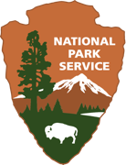
OMB Number: 1024- 0224
Expires: XX/XX/XXXX

Glacier National Park
VISITOR SURVEY
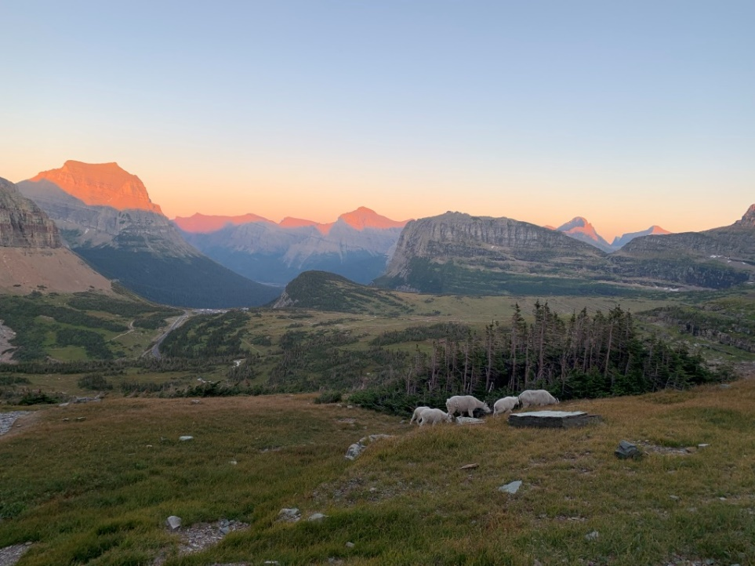
PAPERWORK REDUCTION ACT STATEMENT: The National Park Service is authorized by 54 U.S.C. 100701 to collect this information. This information will be used by park managers to understand the visitor use and the perceptions of recreation management at Glacier National Park. Responses to this request are voluntary and anonymous. Your name will never be associated with your answers, and all contact information will be destroyed when the data collection is concluded. No action may be taken against you for refusing to supply the information requested. An agency may not conduct or sponsor, and a person is not required to respond to, a collection of information unless it displays a currently valid OMB control number and expiration date.

BURDEN ESTIMATE STATEMENT: Public reporting burden for this form is estimated to average 15 minutes per response. Direct comments regarding the burden estimate or any other aspect of this form to: Mary Riddle, Glacier National Park; P.O. Box 128 West Glacier, MT 59936; Mary_Riddle@nps.gov (email).

Paperwork Reduction Act Statement –

Your input is important to park management. Response to this request is voluntary. While you are not required to respond, your cooperation is needed to make survey results comprehensive, accurate, and timely. This survey is sponsored by the National Park Service, and the information will be used to understand the visitor use and the perceptions of recreation management at Glacier National Park. Our results will be summarized so that the answers you provide cannot be associated with you or anyone in your group or household.

Introductory Script

Hello. My name is _________. I am working for the University of Montana to conduct research for Glacier National Park. We are surveying visitors to help park managers better understand your experiences and thoughts about park management. Would you be willing to answer some questions? In total, it will take 10-15 minutes to participate. All of your answers are voluntary, and you will remain completely anonymous.

Thank you.

First, we would like to ask you about your trip and trip planning to visit Glacier National Park.

- Is this your first visit to Glacier National Park?
No
Yes

- Did you fly on any part of your trip to reach Glacier National Park?
No
Yes (Which airport did you fly into? _____________________________)

- How would you describe your planning for this trip? (Please select only one response).
Carefully planned
Some pre-planning
Very little pre-planning
Spontaneous; no planning

- During the planning process for your visit to Glacier, how did the possibility of crowding affect your trip plans? (Please select ALL that apply).
It did not affect my plans
I planned to visit at a time of day I thought would be less crowded
I planned to visit Glacier on a day of the week I thought would be less crowded
I planned to visit during the off-season when I thought would be less crowded

- What was the main source that you used for planning your Glacier trip? Please select one.
National Park Service website
Official Glacier National Park publications
Commercial tour group
Hotel concierge
Glacier National Park official social media websites (e.g., Facebook, Twitter, Instagram)
Unofficial or private social media websites
Word-of-mouth
Other (please specify): _____________________________________

Now we would like to ask you some questions about your experience at Glacier National Park.

- For each item below, please indicate how important the experience is to your visit to the park?
 | Not at all important | Somewhat important | Moderately important | Very important | Extremely important
To experience solitude | 1 | 2 | 3 | 4 | 5
To be close to nature | 1 | 2 | 3 | 4 | 5
To see wildlife | 1 | 2 | 3 | 4 | 5
To get away from noise/experience natural sounds | 1 | 2 | 3 | 4 | 5
To get away from crowds of people | 1 | 2 | 3 | 4 | 5
To view scenery | 1 | 2 | 3 | 4 | 5
To see glaciers and glacial features | 1 | 2 | 3 | 4 | 5
To experience a wild place | 1 | 2 | 3 | 4 | 5

- Please rate the quality of services you received during your most recent visit.
 | Very Poor | Poor | Average | Good | Very Good | Did Not Use
Developed campgrounds | 1 | 2 | 3 | 4 | 5 | 6
Visitor Centers | 1 | 2 | 3 | 4 | 5 | 6
Restroom Facilities | 1 | 2 | 3 | 4 | 5 | 6
Trail Signage | 1 | 2 | 3 | 4 | 5 | 6
Ranger Presence | 1 | 2 | 3 | 4 | 5 | 6
Information Boards | 1 | 2 | 3 | 4 | 5 | 6
Trail Conditions | 1 | 2 | 3 | 4 | 5 | 6

- Did you stop at any of the locations during your trip? (check ALL that apply).
Apgar Village | Logan Pass | Many Glacier
Avalanche | Sunrift Gorge | Two Medicine
The Loop | St Mary Falls | North Fork (Bowman Lake/Kintla Lake)

- So far on this trip, were you able to visit all of the locations in Glacier that you planned to visit?
Yes (Skip)
No (Answer next question) (Please specify location from the drop-down menu.)
Menu options include Avalanche, The Loop, Logan Pass, Sunrift Gorge, St Mary Falls, Many Glacier, Two Medicine, North Fork (Bowman Lake/Kintla Lake)

- If you were unable to visit a location that you had planned to visit, what prevented you from visiting it? (Check all that apply).
Not enough time | Trail closure | Bad weather
Could not find a place to park | Road closure | Inadequate display of road/map signs
Travel times inside the park greater than expected | long wait at entrance gate or long lines | Inadequate display of safety information
Travel times outside the park greater than expected | Entrance gate closure | Other (please specify) ________________

- How acceptable was the amount of time you spent looking for parking?
Not at all acceptable | Slightly acceptable | Moderately acceptable | Very acceptable | Extremely acceptable
1 | 2 | 3 | 4 | 5

- Overall, compared to what you expected, how much traffic congestion did you experience during your visit to Glacier? (Please select one).
I didn’t know what to expect | About the same as I expected
Less traffic congestion than I expected | More traffic congestion than I expected

- Did you bike or do you plan to bike the Going-to-the-Sun Road during your time at Glacier? .
No (if no, skip to question 17)
Yes

- Is biking the Going-to-the-Sun Road your primary reason for visiting Glacier?
No
Yes

- Do you bike the Going-to-the-Sun Road only when it is closed to vehicles?
No
Yes. If yes, why? ___________________________________.

- How many people were in your group biking the Going-to-the-Sun Road, including you?
___ Number of people

- Did you hike or do you plan to hike during your time at Glacier?
No (if no, skip to question 21)
Yes

- How did the number of people you encountered while on the trail compare to what you expected?
A lot less than what I expected | About what I expected | A lot more than I expected
A little less than what I expected | A little more than what I expected | I did not have any expectations

- Please indicate how much you agree or disagree with the following statement regarding your concerns while using the trails. Please mark [X] only once for each item.
 | Strongly Disagree | Disagree | Neutral | Agree | Strongly Agree
There are too many other hikers
There is adequate information and signs at the trailhead
It is easy to find the trailhead
Adequate information about trails before arriving at the trailhead
There is adequate parking at the trailhead
The actions or behaviors of other hikers is concerning
Litter on the trail is concerning
Informal (visitor-created) trails is concerning
Other (please specify):
_____________________________

- Did you stay or do you plan to stay overnight in Glacier’s backcountry?
No (If no, skip to question 22)
Yes (If yes, answer question 21)

- Please select the number that best describes the degree to which you agree or disagree with each statement below. Please note that “technology” refers to cell phones, satellite phones, and other personal mobile devices.
 | Strongly Disagree | Disagree | Neither | Agree | Strongly Agree
Technology creates a genuine sense of safety for wilderness users | 1 | 2 | 3 | 4 | 5
I would feel safer by having technology with me on a wilderness trip | 1 | 2 | 3 | 4 | 5
I would be more likely to use technology to request rescue when I could make it out on my own, but the process of self-rescue would be long and uncomfortable | 1 | 2 | 3 | 4 | 5
I would be more likely to take chances that could increase risk if I had technology with me in the wilderness | 1 | 2 | 3 | 4 | 5
Technology creates a false sense of safety for wilderness users | 1 | 2 | 3 | 4 | 5
Technology in the wilderness makes people feel that their safety is not their personal responsibility | 1 | 2 | 3 | 4 | 5
Technology in the wilderness can successfully substitute for skill/ experience/ knowledge | 1 | 2 | 3 | 4 | 5

Now we would like to ask your opinions about management of Glacier National Park.

- Please indicate the extent to which you agree or disagree with each of the following statements. (Check one box for each statement, or select DK if you don’t know)
 | Strongly Disagree | Disagree | Neutral | Agree | Strongly Agree | Don’t Know
To reduce wildlife impacts, a limit should be placed on the number of people on the trails at one time
To improve the experience, the park should manage the number of vehicles and people in the park
To improve the experience, a ticketed entry system should be implemented in the park
To maintain opportunities for solitude, a limit should be placed on the number of people who can use certain trails at one time
To reduce congestion on trails, shuttles should not stop at all trailheads

- Please indicate how INAPPROPRIATE or APPROPRIATE you think each of the following activities is for a visitor to do in Glacier. Select the number of your response for each statement.
 | Very Inappropriate | Inappropriate | Neutral | Appropriate | Very Appropriate
Travel off trail | 1 | 2 | 3 | 4 | 5
Walk around muddy spots on the trail | 1 | 2 | 3 | 4 | 5
Use the bathroom along the shore of a lake, river, or stream if there are no public facilities | 1 | 2 | 3 | 4 | 5
Avoid approaching, feeding, or following wildlife | 1 | 2 | 3 | 4 | 5
Carry all litter back out, leaving only food scraps behind | 1 | 2 | 3 | 4 | 5
Keep a single item like a rock, plant, stick or feather as a souvenir | 1 | 2 | 3 | 4 | 5
Move rocks and/or logs to make a resting location more comfortable | 1 | 2 | 3 | 4 | 5
Drop food on the ground to provide wildlife a food source | 1 | 2 | 3 | 4 | 5
Approach wildlife to take a photo | 1 | 2 | 3 | 4 | 5
Take a break along the edge of the trail | 1 | 2 | 3 | 4 | 5
Play music on a speaker while hiking | 1 | 2 | 3 | 4 | 5
Geo-tag photos of your trip in social media posts | 1 | 2 | 3 | 4 | 5

Now we would like to learn about your knowledge and experiences with Glacier’s protected resources like wildlife and night skies.

- Please indicate with an [x] if you encountered the wildlife species on your trip
Encountered
Grizzly bears
Black bears
Mountain goats
Bighorn sheep
Rodents (e.g., ground squirrels, marmots)
Birds (e.g., ravens, crows, magpies)

- What was the main source that you used for learning about wildlife at Glacier [or learning how to behave around wildlife in Glacier]? Please select one.
National Park Service website
Unofficial or external websites (e.g., personal websites, blogs, various organization websites)
National Park Service publications (e.g., Park Newspaper, brochures)
Official Glacier National Park social media websites (e.g., Facebook, YouTube, Twitter, Instagram)
Unofficial or private social media websites
Interpretive or Ranger-led Program
Word of mouth
Other (please specify): _____________________________________

- How much do you disagree or agree with the following statements regarding your most used information source about viewing wildlife?
Statement | Strongly disagree | Disagree | Neutral | Agree | Strongly agree
The information changed my behavior regarding viewing wildlife. | 1 | 2 | 3 | 4 | 5
The information made me aware of the appropriate behaviors while viewing wildlife. | 1 | 2 | 3 | 4 | 5

- Have you spent time, or do you plan on spending time in Glacier at night?
No (If no, skip to question 29)
Yes

- Please indicate the degree to which you agree or disagree with the following statements. (Select one number for each statement).

 | Strongly Disagree | Disagree | Neither | Agree | Strongly Agree
Viewing the night sky (“stargazing”) is important to me | 1 | 2 | 3 | 4 | 5
One of the reasons I chose to visit this park is to view the night sky | 1 | 2 | 3 | 4 | 5
This park has a good reputation as a place to view the night sky | 1 | 2 | 3 | 4 | 5
I expected to see a “starry night” in this park | 1 | 2 | 3 | 4 | 5
Observing the night sky is an important part of my experience in this park | 1 | 2 | 3 | 4 | 5
The night sky in this park is pristine (i.e., free of light pollution) | 1 | 2 | 3 | 4 | 5

The following questions are about Glacier and its role in your social media use patterns.

- How frequently have you participated in any of the following interactions with Glacier’s social media pages within the last month?
Interaction | Never | Rarely | Sometimes | Frequently | Very Frequently
I look at postings from Glacier | 1 | 2 | 3 | 4 | 5
I look at comments from other users on Glacier’s postings | 1 | 2 | 3 | 4 | 5
I comment on photos/videos that are posted on the page by Glacier | 1 | 2 | 3 | 4 | 5
I share Glacier’s posts with friends | 1 | 2 | 3 | 4 | 5
I tag photos I’ve taken during a recent visit with Glacier’s page | 1 | 2 | 3 | 4 | 5
I use the Glacier webpage and not social media for information | 1 | 2 | 3 | 4 | 5

- Have you ever posted, or do you plan to post photographs of Glacier on any of the following social media pages? (Check all that apply).
Twitter | YouTube | Facebook
Instagram | Snapchat | YouTube
Pinterest | Flickr | Tiktok
I do not use social media outlets | I have not posted/I do not plan to post photographs of Glaciers

- Have you ever geo-tagged or do you plan to geo-tag photographs of Glacier on any social media pages?
No
Yes

- Please indicate how strongly your DISAGREE or AGREE with the following statements.
(Select the number of your response for each statement)

Activities | Strongly Disagree | Disagree | Somewhat Disagree | Neither Agree nor Disagree | Somewhat Agree | Agree | Strongly Agree
Being able to hike in Glacier means a lot to me. | 1 | 2 | 3 | 4 | 5 | 6 | 7
I enjoy hiking in Glacier more than any other place | 1 | 2 | 3 | 4 | 5 | 6 | 7
I feel no commitment to Glacier | 1 | 2 | 3 | 4 | 5 | 6 | 7
I am very attached to Glacier | 1 | 2 | 3 | 4 | 5 | 6 | 7
I identify strongly with Glacier | 1 | 2 | 3 | 4 | 5 | 6 | 7

We would like to know a little about you. Please answer the following questions about you and your personal group. Your personal group refers to members of your immediate travel party, such as spouse, family, friends, etc. This does not include larger organized groups you may be traveling with such as school, church, scouts, and tour groups.

- What is your age? _______

- What is the highest level of formal education you have completed? Please select only one response.
Less than high school or some high school | Some college | Master’s degree (MA, MS, MEd, MSW, MBA, etc.)
High school graduate | Associate degree (AA, AS, etc) | Professional degree (MD, DDS, DVM, LLB, JD, etc.)
Vocational/trade school certificate | Bachelor’s degree (BA, AB, BS, etc.) | Doctorate degree (PhD, EdD, etc.)

- What is your gender? Please select one.
Male
Female
Self-identify as ______________
Prefer not to respond

- For you only, are you Hispanic or Latino?
No
Yes

- Which of these categories best indicates your race? Answer only for yourself. Please select one or more.
American Indian, Alaska Native, or First Nations
Asian
Black or African American
Native Hawaiian or other Pacific Islander
White
Identify as ________________________.

- Do you live in the United States or Canada?
- Yes.
What is your home state/province? (Drop-down menu of states)
What is your zip code/postal code? _______
- No
What country do you live in? ____________

- On this visit, how many people are in your personal group, including yourself?
__________ number of people.

Thank you for your participation!
Please use the back of this page to make further comments.

