Your address is among those selected for a survey called the 2020 Census Opinion Survey. Your participation is vital, as this survey will help us evaluate the 2020 Census and plan for the 2030 Census. Westat, a private research firm, is conducting the survey for us.

In the next few weeks, an interviewer will contact you to participate in the survey. This survey is voluntary and will take about 10 minutes.

Sincerely,

Steven D. Dillingham

Para obtener más información sobre esta encuesta, puede llamar gratis en inglés o español al 1-855-782-3193.

D-NR-PC(E) OMB No. 0607-0971: Approval Expires 02/28/2023

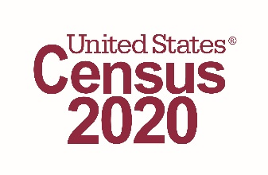

<<RETURN ADDRESS >>

Resident

<<ADDRESS LINE 1>>

<<ADDRESS LINE 2>>

<<CITY>>, <<STATE>> <<ZIP>>

**Privacy Act Statement**

The U.S. Census Bureau is required by law to protect your information. The Census Bureau is not permitted to publicly release your responses in a way that could identify you. We are conducting this survey under the authority of Title 13, United States Code, Sections, 6(c), 141 and 193. Federal law protects your privacy and keeps your answers confidential (Title 13, United States Code, Section 9). Your voluntary response will be used to study privacy and confidentiality concerns related to the 2020 Census.

Your privacy is protected by the Privacy Act. The information provided may be shared with other Census Bureau staff for the work-related purposes identified in this statement. For more information on this collection, see SORN “CENSUS-5, Decennial Census Programs” by visiting our website at census.gov and click on "Data Protection and Privacy Policy" at the bottom of the home page.