# Social Network Analysis In-Person Survey Questionnaire

READ PRIVACY ACT STATEMENT: This study is being conducted in accordance with the Privacy Act of 1974. You are not required to answer any question that you consider to be an invasion of your privacy.

NOAA Fisheries is conducting this voluntary survey about saltwater recreational fishing, recreational fisheries management, and fisheries data collection. This survey will help us better understand different types of angler opinions and attitudes on fisheries management and data collection, and how different types of anglers gather and share information on saltwater fishing issues. Another survey goal is to interview anglers who have different levels of involvement in fisheries management and data collection issues. When answering these questions, please only focus on saltwater recreational fishing and saltwater recreational fisheries management and data collection. Saltwater refers to open ocean or any portion of a bay, sound, or river that is saltwater or slightly salty, as is the mixture of river water and seawater in estuaries.

**Screening Questions**

1. Are you a resident of [interviewing state]?

If Yes, continue.

If No, thank them for their time and terminate the interview.

1. Do you derive any income from fishing, either as a commercial fisherman or for-hire fishing vessel operator or mate?

If Yes, thank them for their time and terminate the interview.

If No, continue.

1. Are you a licensed saltwater recreational angler?

If Yes, continue.

If No, thank them for their time and terminate the interview.

**Saltwater Recreational Fishing Habits**

1. During the past 12 months, how many days did you go saltwater recreational fishing?

__________________ Number of days

1. Where do you go saltwater recreational fishing?

___________ State waters (≤ 3 miles offshore, except FL west coast ≤ 9 miles offshore)

___________ Federal waters (> 3 miles offshore, except FL west coast > 9 miles offshore)

___________ Both State and Federal waters

___________ Don’t Know

1. For this question, please use one of the following options to answer. (Provide handout #1, which lists Always, Often, Sometimes, Rarely, Never.)

When you go saltwater recreational fishing, how often do you fish from ...

… the shore? (Interviewer Prompt: If the respondent asks about what constitutes fishing from shore, explain that the shore includes docks, bridges, causeways, beaches, banks, or any other shore-based place where you saltwater fish.)

_____ Always _____Often _____Sometimes _____Rarely _____Never

… a for-hire boat?

_____ Always _____Often _____Sometimes _____Rarely _____Never

… a private boat?

_____ Always _____Often _____Sometimes _____Rarely _____Never

1. I am going to name a few ways you might be involved in issues related to saltwater recreational fisheries management and data collection. For each activity, please answer “Yes” or “No.”

Have you ever:

* Attended a public hearing or other public meeting about a fisheries management issue?

_____Yes _____No

* Contacted a fisheries management agency to discuss a management or data collection issue important to you?

_____Yes _____No

* Commented on a fisheries management or data collection proposal?

_____Yes _____No

* Conducted your own research on issues related to fisheries management or data collection?

_____Yes _____No

**Saltwater Recreational Fishing Information Sharing**

The next set of questions will ask about other people with whom you discuss saltwater recreational fishing. The information I collect will help us conduct a social network analysis. Our goal is to evaluate how you and other anglers gather and share information about fishing issues so fisheries scientists and managers can improve the way they communicate with the recreational fishing community. Here is an example of a social network of recreational anglers (provide handout #2). The dots indicate recreational anglers and lines between them indicates they talk with each other about recreational fishing issues. Notice how there are no names or other personal information included with this illustration. The information you provide will be used to create a similar social network.

1. About how many other anglers have you discussed saltwater recreational fishing with during the past 12 months, topics to consider include fishing techniques, fishing locations, fishing regulations, and fisheries data collection. ___________ Number of Anglers

The next questions are about the [XX] anglers you discussed saltwater recreational fishing with during the past 12 months. (*Interviewer: Provide handout # 6.) Will you please write their names on this sheet? **You will keep this sheet and please do not show it to me – I will not have access to the names you write down. This is how we keep information you provide on your angler contacts anonymous.**

1. How do you know angler #____?
2. Does angler #___ live in the local area (prompt: within approximately 50 miles of you)?

_______Yes _______No

1. How frequently do you discuss saltwater recreational fishing issues with angler #___?

* Once a week
* A couple of times a month
* Once a month
* Once every few months or less

1. Where do you discuss saltwater recreational fishing with angler #___? (Prompt if asked: Is it while fishing, while hanging out with them, at fishing club meetings, at the tackle shop, at work, or somewhere else) **(If they say fishing club meetings or at the tackle shop, ask for the club and/or shop name.)**

1. For this question we want you to think about saltwater recreational fisheries management and data collection issues. Please look at the following so you are clear on what we are talking about (show handout #3). Do you discuss saltwater recreational fisheries management and data collection with angler #___?

(DO NOT READ ALOUD: RECORD ALL ANGLER #’S PROVIDED IN QUESTION 13 AND ONLY ASK ABOUT THOSE ANGLERS IN QUESTION 14 – IF NO ANGLERS #s ARE PROVIDED SKIP TO QUESTION 15).

1. Which of the following best describes your discussions regarding saltwater recreational fisheries management and data collection with angler #___?

* I provide angler #___ with more information and/or opinions on saltwater recreational fisheries management and data collection issues than they provide me.
* Angler #___ provides me with more information and/or opinions on saltwater recreational fisheries management and data collection issues than I provide them.
* Generally, information sharing on saltwater recreational fisheries management and data collection issues between angler #___ and me is a two-way street where both of us share information and opinions equally.

1. Earlier, I asked about your level of engagement with issues related to saltwater recreational fisheries management and data collection. I would also like to know how engagedthe members of your fishing network (the people you named) are. To the best of your knowledge, does angler #___ do any of the following (provide handout #4)?
2. Next, I am going to ask if any of the people you just mentioned are connected to one another. In other words, do any of them talk to each other about fishing stories, fishing techniques, or fisheries management and data collection? (SHOW RESPONDENT HANDOUT #7) This sheet is for me to use to draw lines indicating which of your contacts talk to each other about saltwater recreational fishing issues. For instance, if you tell me 1 and 6 talk to each other about saltwater recreational fishing issues I will draw a line between them indicating the connection. Ok, who is connected? (INTERVIEWER: DRAW LINES INDICATING CONNECTIONS.)

**Sources for Saltwater Recreational Fishing Information**

1. Now, I would like to discuss the different sources that you use to gather information on saltwater recreational fisheries management and data collection. These sources can include newspapers; fishing magazines; government agency fishing websites or regulation guides; fishing websites, blogs, message boards, or television or radio shows; bait and tackle shops or stands; recreational fishing clubs or groups; social media; or fishing apps. Please name the 5 sources you most frequently use to gather information on saltwater recreational fisheries data collection and management issues.

Interviewer Prompt: If they name an information source where the type of source is unclear (such as an acronym or a title that could be the name of a fishing magazine or fishing website and they don’t specify please ask them to describe the source and include their answer next to the source’s name)

1. How frequently do you get information on saltwater recreational fisheries management and data collection issues from (information source)?

* Once a week or more.
* Twice a month.
* Once a month.
* Once every few months or less.

1. Which of the following best describes the importance of (information source) as a source of information on saltwater recreational fisheries management and data collection issues: very important, somewhat important, or not very important?

**Attitudes and Perceptions Regarding Fishery Management Agencies**

**My** next few questions are about saltwater recreational fisheries management, data collection, and fisheries agencies. First, I would like to remind you what I mean when I use these terms (show handout #3).

1. I am going to provide you with a series of statements regarding the [insert state regulatory agency]. For each statement, please indicate your level of agreement using this card (provide handout #5).

I trust the [state regulatory agency] to:

* Collect accurate data on saltwater recreational landings and fishing activity.
* Produce accurate estimates of saltwater recreational landings and fishing activity.
* Manage saltwater fisheries in a way that ensures healthy fish populations.
* Manage saltwater fisheries in a way that maximizes recreational fishing opportunities.

1. What could the [insert state regulatory agency] do to increase the trust levels you just provided? (Free response.)
2. Does the [insert state regulatory agency] facilitate two-way communication with saltwater recreational anglers like you about issues related to saltwater recreational fisheries management and data collection?
   1. (If NO on Q23 skip to Q24, if yes ask - How does the [state regulatory agency] facilitate two-way communication with saltwater recreational anglers like you?
3. Now, I will provide you with a series of statements regarding NOAA Fisheries—the agency responsible for federal fisheries management. For each statement, please indicate your level of agreement using this card (provide handout #5).

I trust NOAA Fisheries to:

* Produce accurate estimates of saltwater recreational landings and fishing activity.
* Manage fisheries in a way that ensures healthy fish populations.
* Manage fisheries in a way that maximizes recreational fishing opportunities.

1. What could NOAA Fisheries do to increase the trust levels you just provided? (Free response.)
2. Does NOAA Fisheries facilitate two-way communication with saltwater recreational anglers like you about issues related to saltwater recreational fisheries management and data collection?
   1. (If NO on Q26 skip to Q27, if yes ask - How does NOAA Fisheries facilitate two-way communication with saltwater recreational anglers like you?
3. What do you think NOAA Fisheries could do to improve two-way communication with anglers like you about these issues? (Free response.)
4. What year were you born? ______________________
5. What is the highest level of education you have completed?

__________ 12th grade or less

__________ High school graduate or GED

__________ Associate or technical school degree

__________ Bachelor’s degree

__________ Advanced, professional, or doctoral degree or coursework

1. Do you think any of the people you mentioned discussing fishing issues with would be willing to take our survey? If so, would you share my contact information with them?

Yes ___

No____

I have some final questions if you are a smartphone user. These questions should take less than 10 minutes …

1. Do you have a smartphone [provide example or definition]? (Yes/No)

**If Yes, continue. If No, terminate the interview and thank the respondent.**

1. What kind of smartphone do you have (if more than one, what phone do you use the most during your personal or free time)?
   1. iPhone
   2. Android phone (Samsung, Google, Motorola, etc.)
   3. Other (Blackberry, Windows Phone, etc.)
2. Do you regularly use any of the following apps on your smartphone (check all that apply)?
   1. Social media
      1. Facebook
      2. Twitter
      3. Instagram
      4. YouTube
      5. Other social media:________________
   2. Maps/navigation
      1. Google Maps
      2. Waze
      3. Apple Maps
      4. Other maps/navigation:_________________
   3. Fitness tracker
      1. Fitbit
      2. MyFitnessPal
      3. S Health (Samsung)
      4. Other fitness tracker:___________________
   4. Weather apps
      1. Accuweather
      2. Weather Channel
      3. Weather Underground
      4. Other weather apps: ___________________
   5. Angler apps
      1. Fishbrain
      2. Fishidy
      3. GoFree Hooked
      4. iAngler
      5. Fish Rules
      6. Other angler app:___________________
3. Should NOAA Fisheries offer an app for reporting information on recreational saltwater fishing trips? Would you say … ?

1. Yes, and using it should be required.

2. Yes, but using it should be voluntary.

3. No, NOAA Fisheries should not offer an app.

1. If NOAA Fisheries were to start collecting information on saltwater recreational fishing through smartphone apps, how would you prefer to provide your information?
   1. Through an add-on/new feature in an app I already use on my phone.
   2. Using a new app that I would need to download and install on my phone.
   3. No preference.
   4. Neither, I do not want to provide fishing information using my phone.
2. If NOAA Fisheries were to start collecting information on saltwater recreational fishing through smartphone apps, would you prefer ...
   1. An app that collected limited data automatically with little or no effort.
   2. An app that asked me specific details about each fishing trip.
   3. I don’t have a preference.
   4. Neither, I do not want to provide fishing information using my phone.
3. If NOAA Fisheries were to start collecting information on saltwater recreational fishing through smartphone apps, how often would you report through an app?
   1. I would report information for every fishing trip I take.
   2. I would report information for some trips - if I had a really good trip, really bad trip, or caught something interesting.
   3. I would report information for a couple of trips and then probably get tired of doing it or forget about it and stop.
   4. None of the above, I do not want to provide fishing information using my phone.
4. If NOAA Fisheries were to start collecting information on saltwater recreational fishing through smartphone apps, do you think the information reported by anglers would be …
   1. Very reliable since all/almost all anglers would report accurately on all of their fishing trips.
   2. Generally reliable since most anglers would report accurately on most of their fishing trips.
   3. Somewhat reliable since anglers would report accurately on some of their fishing trips but not on others.
   4. Not reliable since most anglers would not want to report their fishing trips.

Public reporting burden for this collection of information is estimated to average XX minutes per response, including the time for reviewing instructions, searching existing data sources, gathering and maintaining the data needed, and completing and reviewing the collection of information. Send comments regarding this burden estimate or any other suggestions for reducing this burden to Adam Rettig, NOAA Fisheries, 1315 East West Highway, Silver Spring, Maryland 20910. This survey is voluntary. Information submitted will be treated as confidential in accordance with NOAA Administrative Order 216-100. Notwithstanding any other provisions of the law, no person is required to respond to, nor shall any person be subjected to a penalty for failure to comply with, a collection of information subject to the requirements of the Paperwork Reduction Act, unless that collection of information displays a currently valid OMB Control Number. NOAA Fisheries requires this information to enhance its communications and outreach activities. These data will be used to help NOAA Fisheries more effectively engage with its audiences by identifying key influencers and information pathways, and identifying the areas of greatest need and greatest opportunity for relationship-building.

# Handout #1

Always

Often

Sometimes

Rarely

Never

# Handout #2

# A Social Network

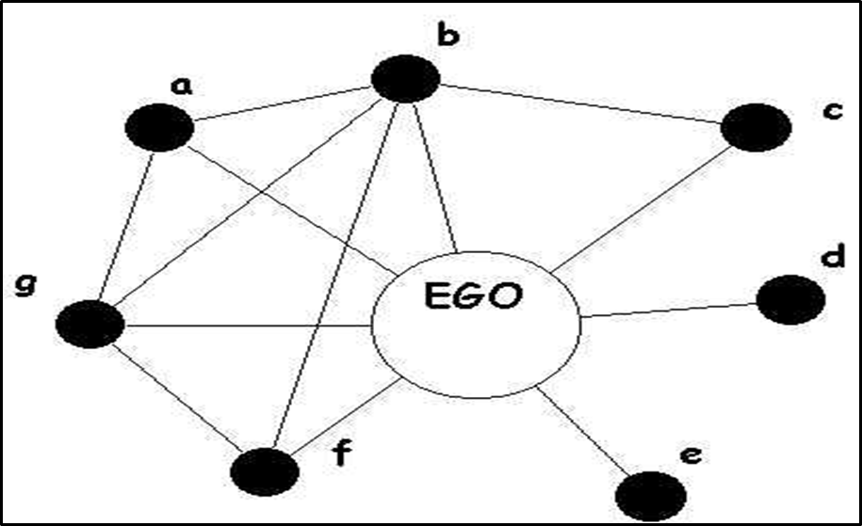

# Handout #3

Saltwater recreational fisheries management involves establishing fishing regulations to prevent overfishing and ensure the health of fish stocks.

Saltwater recreational fisheries data collection involves the collection and analysis of catch and effort data (such as how many fish they catch per trip and how many fishing trips anglers take) to inform science and management.

Fisheries managers include representatives from NOAA Fisheries, state marine resource and fisheries management agencies, and regional fishery management councils who establish fishing regulations to adhere to scientifically established catch limits.

Fisheries managers are **NOT** law enforcement agents.

# Handout #4

* Attend public hearings or other public meetings about recreational saltwater fisheries management issues
* Contact fisheries management agencies to discuss recreational saltwater fisheries issues
* Comment on proposals regarding recreational saltwater fisheries management and/or data collection

# Handout #5

Strongly agree

Somewhat agree

Neither agree nor disagree

Somewhat disagree

Strongly disagree

# Handout #6 Angler Contacts

1. ______________________

2. ______________________

3. ______________________

4. ______________________

5. ______________________

6. ______________________

7. ______________________

8. ______________________

9. ______________________

10. _____________________

# Handout #7 Angler Contact Connections

1 6

2 7

3 8

4 9

5 10