THRIVE health department grantees
Eligible state and local health departments included those with a metropolitan statistical area (MSA) or metropolitan division (MD) with at least 2000 black and/or Hispanic MSM living with HIV infection, or those with a metropolitan statistical area or metropolitan division with at least 1000 black and/or Hispanic MSM living with HIV infection in a U.S. state in the 4th quartile for mortality rates. The following health department grantees were selected to conduct THRIVE demonstration projects:

THRIVE health department grantees and jurisdictions of operation
Health Department grantee | Metropolitan statistical area or metropolitan division
Alabama Department of Public Health | Birmingham-Hoover
Baltimore City Health Department | Baltimore-Towson
District of Columbia Department of Health | Washington Division
Louisiana Department of Health | New Orleans-Metairie-Kenner
New York City Department of Health and Mental Hygiene | New York–White Plains–Wayne Division
City of Philadelphia Public Health Department | Philadelphia Division
Virginia State Department of Health | Virginia Beach-Norfolk-Newport News

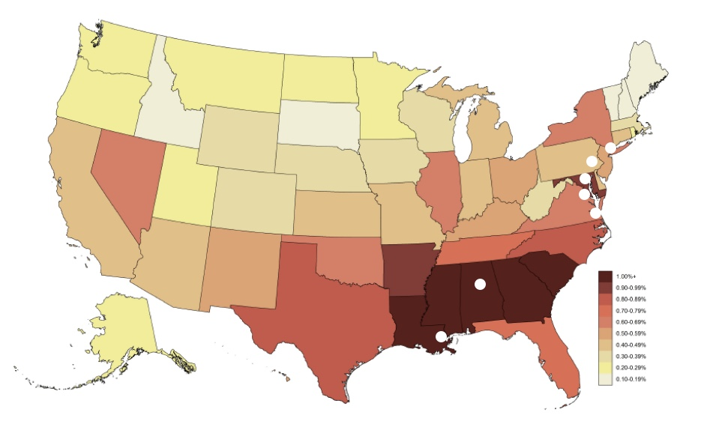
THRIVE locations on map of United States stratified by state rates of new HIV diagnoses among men who have sex with men (MSM) per 100 MSM in 2012-2013 (Rosenberg et al., JMIR Public Health and Surveillance, 2016)

