Fellowship Management System (FMS)
FMS Alumni Tracking Module
2020
Privacy Act and Public Burden Information
Privacy Act Information
The Privacy Act applies to this information collection. Information collected will be kept private as noted in the System of Records Notice is 09-20-0112, Fellowship Program and Guest Researcher Records.

Public Burden Information
Form Approved
OMB No. 0920-0765
Exp. Date 01/31/2021

Public reporting burden of this collection of information is an estimated average of 25 minutes per response, including the time for reviewing instructions, searching existing data sources, gathering and maintaining the data needed, and completing and reviewing the collection of information. An agency may not conduct or sponsor, and a person is not required to respond to a collection of information unless it displays a currently valid OMB control number. Send comments regarding this burden estimate or any other aspect of this collection of information, including suggestions for reducing this burden to CDC/ATSDR Reports Clearance Officer; 1600 Clifton Road NE, MS D-74, Atlanta, Georgia 30333; ATTN: PRA (0920-0765).

Table of Contents
Table of Contents 2
1. Introduction 4
1.1 Document Structure 5
2. Sign-In & Sign-Up Pages 6
2.1 Sign-In Page 6
2.2 Sign-Up Page (For New Users) 8
3. eFMS System Help Desk Ticket 9
4. Alumni Tracking Welcome Page 11
5. Alumni Tracking Profile 12
5.1 General Information 12
5.2 Current Residence 14
5.3 Fellowship Information 15
6. Post-Fellowship Education, Board Certifications, and Licenses 17
7. Post-Fellowship Work Experience 19
7.1 Employer Information 19
7.2 Position Information 21
8. Surveys 22
8.1 Fellowship Alumni Survey 22
8.1.1 Career Progression 22
8.1.2 Leadership Roles 24
8.1.3 Use of Fellowship Competencies/Skills in Post-Fellowship Positions 28
8.1.4 Extent to which fellowship training helped prepare alumni for post-fellowship jobs 29
8.1.5 Alumni Engagement 33
8.2 EEP Alumni Survey 36
8.3 ELI Alumni Survey 42
8.4 LLS Alumni Survey 43
8.5 SAF Alumni Survey 69
8.6 Alumni Survey Email 71
Appendix 72
I. (PENDING) Field Value Tables 72
II. (PENDING) Lookup Tables 74

Introduction
The purpose of this document is to list all the data elements collected online from alumni through the Fellowship Management System (FMS). The FMS online alumni directory module is a self-service connection to allow alumni of the Centers for Disease Control and Prevention (CDC) fellowships to update their personal information including current addresses, contact, and education information. The FMS is a robust, flexible framework and is successfully tailored for various fellowships.
The following fellowships currently use the FMS Alumni Directory to collect information from fellowship alumni:
1. Epidemic Intelligence Service (EIS)
2. CDC E-learning Institute (ELI)
3. Epidemiology Elective Program (EEP)
4. Future Leaders in Infections and Global Health Threats (FLIGHT)
5. Laboratory Leadership Service (LLS)
6. CDC Steven M. Teutsch Prevention Effectiveness (PE) Fellowship
7. Presidential Management Fellowship (PMF)
8. Public Health Associate Program (PHAP)
9. Public Health Informatics Fellowship Program (PHIFP)
10. Science Ambassador Fellowship (SAF)
11. Preventive Medicine Residency and Fellowship (PMR/F)
12. Population Health Training in Place Program (PH-TIPP)

Document Structure
This document is broken down by the major pages of the FMS Alumni Directory. In this document, each page of the FMS Alumni Directory has sections and some sub-sections. In addition, instructions, login, and registration pages are included. Following the screenshots in each section is a table that shows the status of the collection of data elements by each CDC fellowships. The following labels indicate the status of the collection:
- “Yes” indicates that the fellowship collects the information and that alumni are required to submit this information.
- “No” indicates that the fellowship does not collect this information.
- “-“ indicates open text field
In addition, the table shows the data values of each data element, and for ones that have a list of dropdown values, the data value category is hyperlinked to its list located in the Appendix.

Sign-In & Sign-Up Pages

Sign-In Page

Figure 2.1-a. Sign-In Page
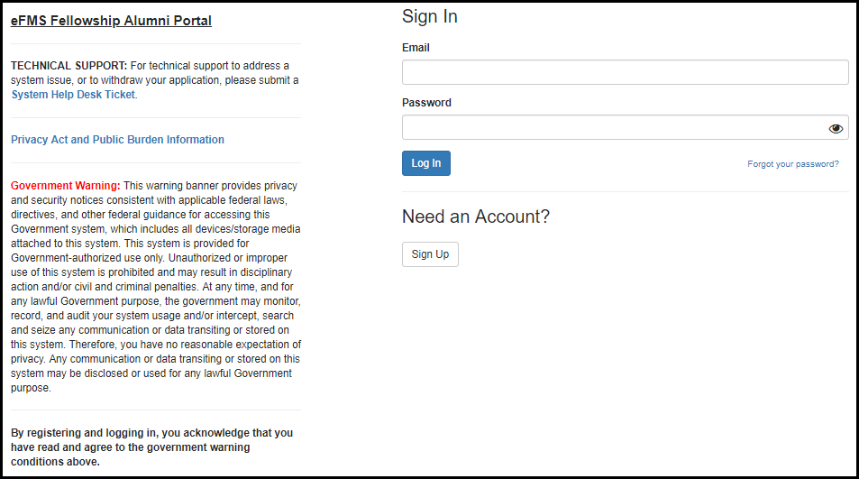

Figure 2.1-b. Privacy Act and Public Burden Information
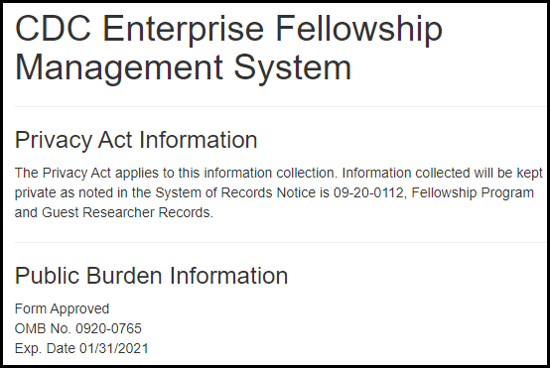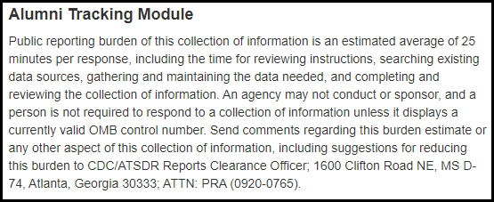
Table 2.1-a. Sign-In Fields
Field | Values | EIS | LLS | FLIGHT | EEP | SAF | PMR/F | PH-TIPP | PHIFP | PE | ELI | PHAP
Email | - | Yes | Yes | Yes | Yes | Yes | Yes | Yes | Yes | Yes | Yes | Yes
Password | - | Yes | Yes | Yes | Yes | Yes | Yes | Yes | Yes | Yes | Yes | Yes

Sign-Up Page (For New Users)

Figure 2.2-a. Sign-Up Fields
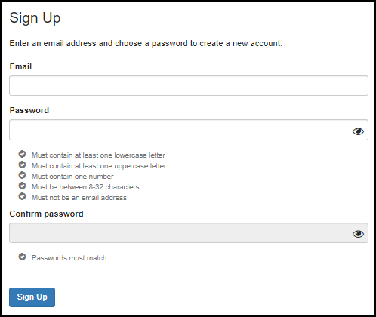
Table 2.2-a. Sign-Up Fields
Field | Values | EIS | LLS | FLIGHT | EEP | SAF | PMR/F | PH-TIPP | PHIFP | PE | ELI | PHAP
Email | - | Yes | Yes | Yes | Yes | Yes | Yes | Yes | Yes | Yes | Yes | Yes
Password | - | Yes | Yes | Yes | Yes | Yes | Yes | Yes | Yes | Yes | Yes | Yes
Confirm Password | - | Yes | Yes | Yes | Yes | Yes | Yes | Yes | Yes | Yes | Yes | Yes

eFMS System Help Desk Ticket

Figure 3-a. eFMS System Help Desk Ticket Fields
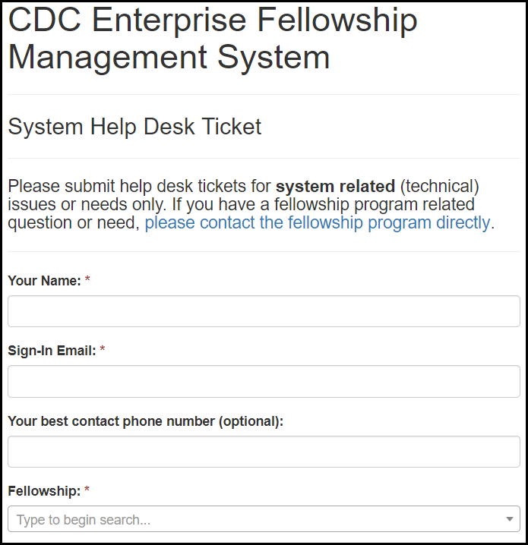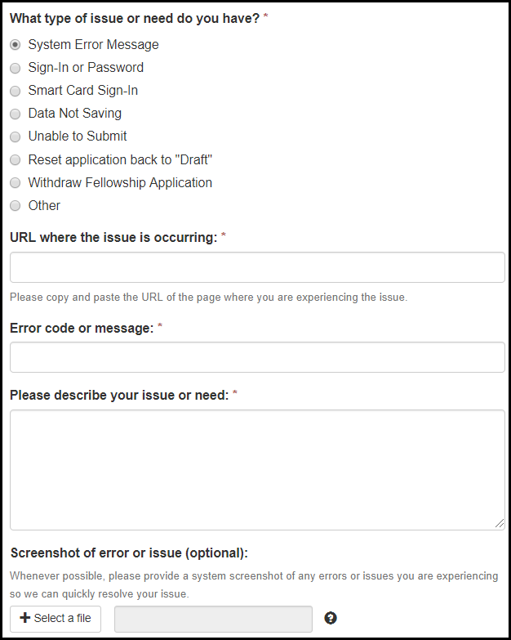

Table 3-a. eFMS System Help Desk Ticket Fields
Field | Values | EIS | LLS | FLIGHT | EEP | SAF | PMR/F | PH-TIPP | PHIFP | PE | ELI | PHAP
Your Name: | - | Yes | Yes | Yes | Yes | Yes | Yes | Yes | Yes | Yes | Yes | Yes
Sign-In Email: | - | Yes | Yes | Yes | Yes | Yes | Yes | Yes | Yes | Yes | Yes | Yes
Contact Phone Number: | - | Yes | Yes | Yes | Yes | Yes | Yes | Yes | Yes | Yes | Yes | Yes
Fellowship: | Fellowship Lookup Table | Yes | Yes | Yes | Yes | Yes | Yes | Yes | Yes | Yes | Yes | Yes
What type of issue or need do you have? | 1. System Error Message  2. Sign-In or Password  3. Smart Card Sign-In  4. Data Not Saving  5. Unable to Submit  6. Reset application back to "Draft"  7. Withdraw Fellowship Application  8. Other | Yes | Yes | Yes | Yes | Yes | Yes | Yes | Yes | Yes | Yes | Yes
URL where the issue is occurring: | - | Yes | Yes | Yes | Yes | Yes | Yes | Yes | Yes | Yes | Yes | Yes
Error code message: | - | Yes | Yes | Yes | Yes | Yes | Yes | Yes | Yes | Yes | Yes | Yes
Please describe your issue or need: | - | Yes | Yes | Yes | Yes | Yes | Yes | Yes | Yes | Yes | Yes | Yes
Screenshot of error or issue (optional): | - | Yes | Yes | Yes | Yes | Yes | Yes | Yes | Yes | Yes | Yes | Yes

Alumni Tracking Welcome Page

Figure 4-a. Application Welcome Page
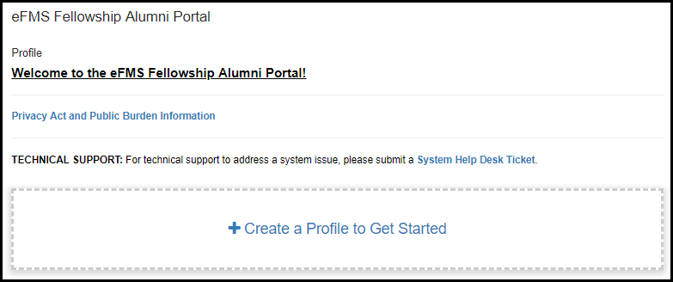

Alumni Tracking Profile

General Information

Figure 5.1-a. General Information Fields
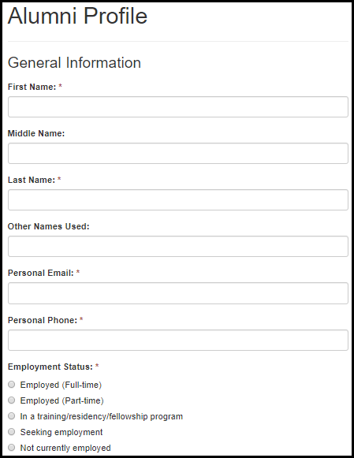

Table 5.1-a. General Information Fields
Field Name | Values | EIS | LLS | FLIGHT | EEP | SAF | PMR/F | PH-TIPP | PHIFP | PE | ELI | PHAP
First Name: | - | Yes | Yes | Yes | Yes | Yes | Yes | Yes | Yes | Yes | Yes | Yes
Middle Name: | - | Yes | Yes | Yes | Yes | Yes | Yes | Yes | Yes | Yes | Yes | Yes
Last Name: | - | Yes | Yes | Yes | Yes | Yes | Yes | Yes | Yes | Yes | Yes | Yes
Other Names Used: | - | Yes | Yes | Yes | Yes | Yes | Yes | Yes | Yes | Yes | Yes | Yes
Personal Email: | - | Yes | Yes | Yes | Yes | Yes | Yes | Yes | Yes | Yes | Yes | Yes
Personal Phone: | - | Yes | Yes | Yes | Yes | Yes | Yes | Yes | Yes | Yes | Yes | Yes
Employment Status: | 1. Employed (Full-time)  2. Employed (Part-time)  3. In a training/residency/fellowship program  4. Seeking employment  5. Not currently employed | Yes | Yes | Yes | Yes | Yes | Yes | Yes | Yes | Yes | Yes | Yes

Current Residence

Figure 5.2-a. Current Residence Fields
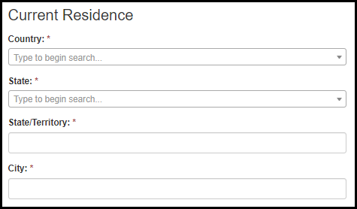
Table 5.2-a. Current Residence Fields
Field Name | Values | EIS | LLS | FLIGHT | EEP | SAF | PMR/F | PH-TIPP | PHIFP | PE | ELI | PHAP
Country: | Country Lookup | Yes | Yes | Yes | Yes | Yes | Yes | Yes | Yes | Yes | Yes | Yes
State: | State Lookup | Yes | Yes | Yes | Yes | Yes | Yes | Yes | Yes | Yes | Yes | Yes
State/Territory: | - | Yes | Yes | Yes | Yes | Yes | Yes | Yes | Yes | Yes | Yes | Yes
City: | - | Yes | Yes | Yes | Yes | Yes | Yes | Yes | Yes | Yes | Yes | Yes

Fellowship Information

Figure 5.3-a. Fellowship Information Fields
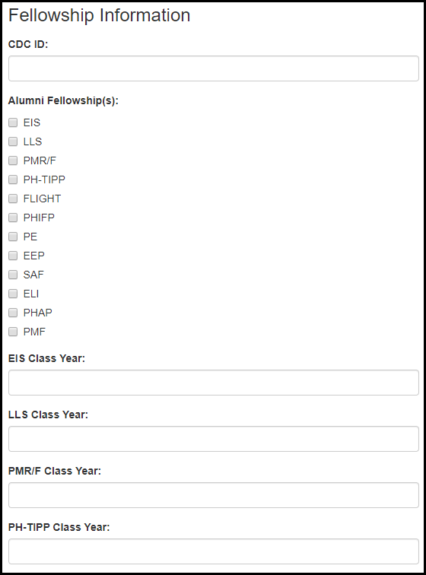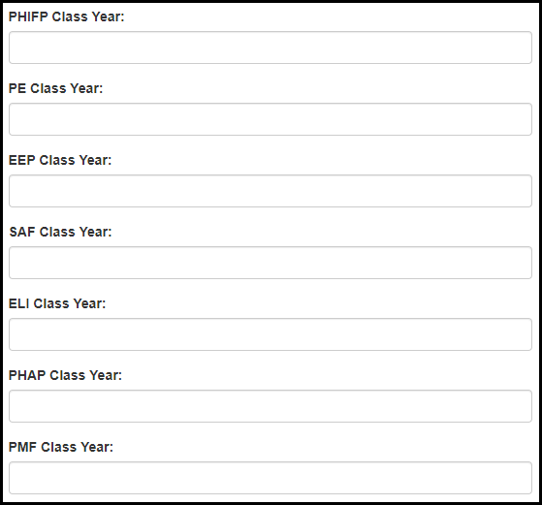

Table 5.3-a. Fellowship Information Fields
Field Name | Values | EIS | LLS | FLIGHT | EEP | SAF | PMR/F | PH-TIPP | PHIFP | PE | ELI | PHAP | PMF
CDC ID: | - | Yes | Yes | Yes | Yes | Yes | Yes | Yes | Yes | Yes | No | Yes | No
Alumni Fellowship(s): | 1. EIS  2. LLS  3. PMR/F  4. PH-TIPP  5. FLIGHT  6. PHIFP  7. PE  8. EEP  9. SAF  10. ELI  11. PHAP  12. PMF | Yes | Yes | Yes | Yes | Yes | Yes | Yes | Yes | Yes | Yes | Yes | Yes
EIS Class Year: | - | Yes | No | No | No | No | No | No | No | No | No | No | No
LLS Class Year: | - | No | Yes | No | No | No | No | No | No | No | No | No | No
PMR/F Class Year: | - | No | No | No | No | No | Yes | No | No | No | No | No | No
FLIGHT Class Year: | - | No | No | Yes | No | No | No | No | No | No | No | No | No
PH-TIPP Class Year: | - | No | No | No | No | No | No | Yes | No | No | No | No | No
PHIFP Class Year: | - | No | No | No | No | No | No | No | Yes | No | No | No | No
PE Class Year: | - | No | No | No | No | No | No | No | No | Yes | No | No | No
EEP Class Year: | - | No | No | No | Yes | No | No | No | No | No | No | No | No
SAF Class Year: | - | No | No | No | No | Yes | No | No | No | No | No | No | No
ELI Class Year: | - | No | No | No | No | No | No | No | No | No | Yes | No | No
PHAP Class Year: | - | No | No | No | No | No | No | No | No | No | No | Yes | No
PMF Class Year: |  | No | No | No | No | No | No | No | No | No | No | No | Yes

6. Post-Fellowship Education, Board Certifications, and Licenses

Figure 6.-a. Fellowship Information Fields
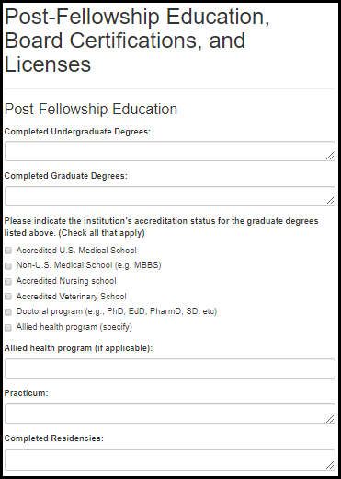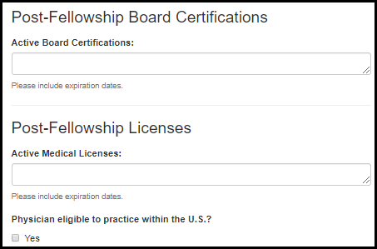

Table 6.-a. Fellowship Information Fields
Field Name | Values | EIS | LLS | FLIGHT | EEP | SAF | PMR/F | PH-TIPP | PHIFP | PE | ELI | PHAP
Completed Undergraduate Degrees: | Undergraduate Degree List | Yes | Yes | Yes | Yes | Yes | Yes | Yes | Yes | Yes | Yes | Yes
Completed Graduate Degrees: | Graduate Degree List | Yes | Yes | Yes | Yes | Yes | Yes | Yes | Yes | Yes | Yes | Yes
Please indicate the institution’s accreditation status for the graduate degrees listed above. (Check all that apply) | 1. Accredited U.S. Medical School  2. Non-U.S. Medical School (e.g. MBBS)  3. Accredited Nursing school  4. Accredited Veterinary School  5. Doctoral program (e.g., PhD, EdD, PharmD, SD, etc)  6. Allied health program | Yes | Yes | Yes | Yes | Yes | Yes | Yes | Yes | Yes | Yes | Yes
Practicum: | - | Yes | Yes | Yes | No | No | Yes | Yes | Yes | Yes | Yes | Yes
Completed Residencies: | - | Yes | Yes | Yes | Yes | Yes | Yes | Yes | Yes | Yes | Yes | Yes
Active Board Certifications: | - | Yes | Yes | Yes | Yes | Yes | Yes | Yes | Yes | Yes | Yes | Yes
Active Medical Licenses: | -
Physician eligible to practice within the U.S.? | 1. Yes | Yes | Yes | Yes | Yes | Yes | Yes | Yes | Yes | Yes | Yes | Yes

7. Post-Fellowship Work Experience

7.1 Employer Information
Figure 7.1-a. Employer Information Fields
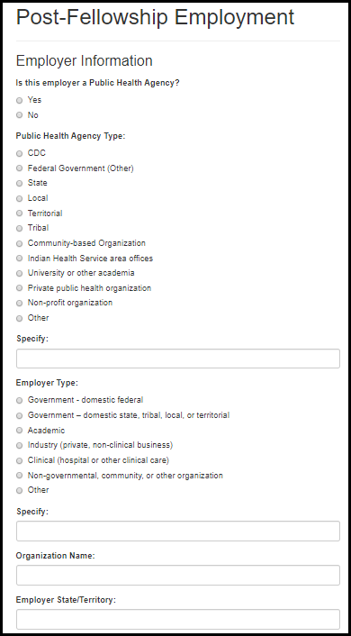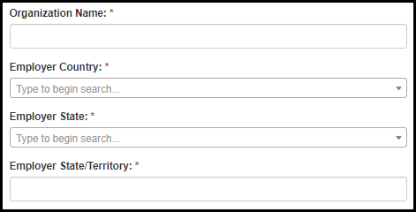

Table 7.1-a. Employer Information Fields
Field Name | Values | EIS | LLS | FLIGHT | EEP | SAF | PMR/F | PH-TIPP | PHIFP | PE | ELI | PHAP | PMF
Is this employer a Public Health Agency? | 1. Yes  2. No | Yes | Yes | Yes | Yes | No | Yes | Yes | Yes | Yes | Yes | Yes | Yes
Public Health Agency Type: | 1. CDC  2. Federal Government (Other)  3. State  4. Local  5. Territorial  6. Tribal  7. Community-based Organization  8. Indian Health Service area offices  9. University or other academia  10. Private public health organization  11. Non-profit organization  12. Other | Yes | Yes | Yes | Yes | No | Yes | Yes | Yes | Yes | Yes | Yes | Yes
Specify: | - | Yes | Yes | Yes | Yes | No | Yes | Yes | Yes | Yes | Yes | Yes | Yes
CDC Center/Division/Branch: | Center/Division/Branch Lookup | Yes | Yes | Yes | Yes | No | Yes | Yes | Yes | Yes | Yes | Yes | Yes
Employer Type: | 1. Government - domestic federal  2. Government – domestic state, tribal, local, or territorial  3. Academic  4. Industry (private, non-clinical business)  5. Clinical (hospital or other clinical care)  6. Non-governmental, community, or other organization  7. Other | Yes | Yes | Yes | Yes | No | Yes | Yes | Yes | Yes | Yes | Yes | Yes
Specify: | - | Yes | Yes | Yes | Yes | No | Yes | Yes | Yes | Yes | Yes | Yes | Yes
Organization Name: | - | Yes | Yes | Yes | Yes | No | Yes | Yes | Yes | Yes | Yes | Yes | Yes
Employer Country: | - | Yes | Yes | Yes | Yes | No | Yes | Yes | Yes | Yes | Yes | Yes | Yes
Employer State/Territory: | State Lookup | Yes | Yes | Yes | Yes | No | Yes | Yes | Yes | Yes | Yes | Yes | Yes
Employer State/Territory: | - | Yes | Yes | Yes | Yes | No | Yes | Yes | Yes | Yes | Yes | Yes | Yes

7.2 Position Information

Figure 7.2-a. Position Information Fields
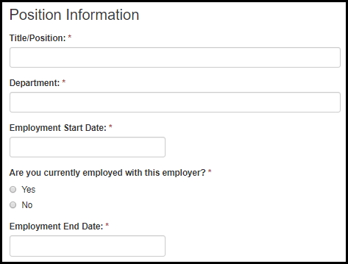
Table 7.2-a. Position Information Fields
Field Name | Values | EIS | LLS | FLIGHT | EEP | SAF | PMR/F | PH-TIPP | PHIFP | PE | ELI | PHAP | PMF
Title/Position: | - | Yes | Yes | Yes | Yes | Yes | Yes | Yes | Yes | Yes | Yes | Yes | Yes
Department: | - | Yes | Yes | Yes | Yes | Yes | Yes | Yes | Yes | Yes | Yes | Yes | Yes
Employment Start Date: | - | Yes | Yes | Yes | Yes | Yes | Yes | Yes | Yes | Yes | Yes | Yes | Yes
Are you currently employed with this organization? | 1. Yes  2. No | Yes | Yes | Yes | Yes | Yes | Yes | Yes | Yes | Yes | Yes | Yes | Yes
Employment End Date: | - | Yes | Yes | Yes | Yes | Yes | Yes | Yes | Yes | Yes | Yes | Yes | Yes

8. Surveys

8.1 Fellowship Alumni Survey

8.1.1 Career Progression

Figure 8.1.1-a. Career Progression Fields
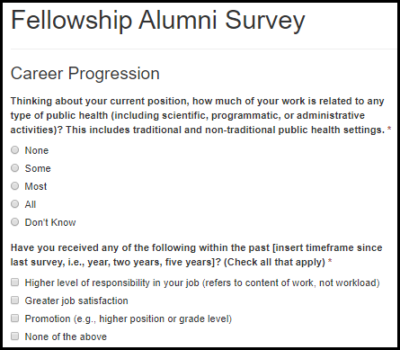

Table 8.1.1-a. Career Progression Fields
Field Name | Values | EIS | LLS | FLIGHT | EEP | SAF | PMR/F | PH-TIPP | PHIFP | PE | ELI | PHAP | PMF
Thinking about your current position, how much of your work is related to any type of public health (including scientific, programmatic, or administrative activities)? This includes traditional and non-traditional public health settings. | 1. None  2. Some  3. Most  4. All  5. Don’t Know | Yes | Yes | Yes | Yes | No | Yes | Yes | Yes | Yes | Yes | Yes | Yes
Have you received any of the following within the past [insert timeframe since last survey, i.e., year, two years, five years]? (Check all that apply) | 1. Higher level of responsibility in your job (refers to content of work, not workload)  2. Greater job satisfaction  3. Promotion (e.g., higher position or grade level)  4. None of the above | Yes | Yes | Yes | Yes | No | Yes | Yes | Yes | Yes | Yes | Yes | Yes

8.1.2 Leadership Roles

Figure 8.1.2-a. Leadership Roles Fields
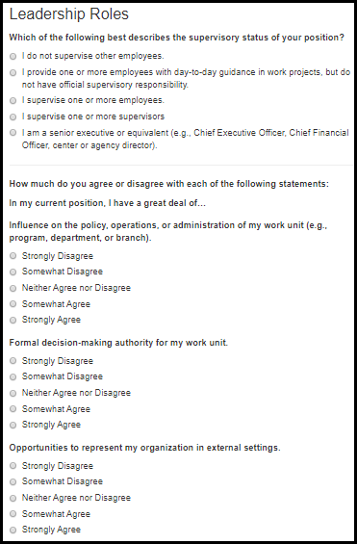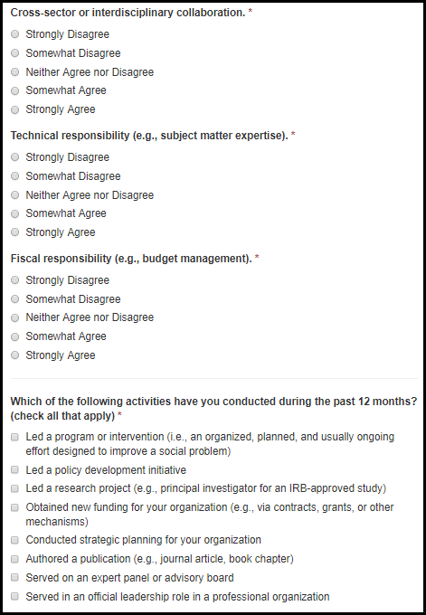

Table 8.1.2-a. Leadership Roles Fields
Field Name | Values | EIS | LLS | FLIGHT | EEP | SAF | PMR/F | PH-TIPP | PHIFP | PE | ELI | PHAP | PMF
Which of the following best describes the supervisory status of your position? | 1. I do not supervise other employees.  2. I provide one or more employees with day-to-day guidance in work projects, but do not have official supervisory responsibility.  3. I supervise one or more employees.  4. I supervise one or more supervisors.  5. I am a senior executive or equivalent (e.g., Chief Executive Officer, Chief Financial Officer, center or agency director). | Yes | Yes | Yes | Yes | No | Yes | Yes | Yes | Yes | Yes | Yes | Yes
Influence on the policy, operations, or administration of my work unit (e.g., program, department, or branch). | 1. Strongly Disagree  2. Somewhat Disagree  3. Neither Agree nor Disagree  4. Somewhat Agree  5. Strongly Agree | Yes | Yes | Yes | Yes | No | Yes | Yes | Yes | Yes | No | Yes | Yes
Formal decision-making authority for my work unit. | 1. Strongly Disagree  2. Somewhat Disagree  3. Neither Agree nor Disagree  4. Somewhat Agree  5. Strongly Agree | Yes | Yes | Yes | Yes | No | Yes | Yes | Yes | Yes | No | Yes | Yes

Table 8.1.2-b. Leadership Roles Fields
Field Name | Values | EIS | LLS | FLIGHT | EEP | SAF | PMR/F | PH-TIPP | PHIFP | PE | ELI | PHAP | PMF
Opportunities to represent my organization in external settings. | 1. Strongly Disagree  2. Somewhat Disagree  3. Neither Agree nor Disagree  4. Somewhat Agree  5. Strongly Agree | Yes | Yes | Yes | Yes | Yes | Yes | Yes | Yes | Yes | No | Yes | Yes
Cross-sector or interdisciplinary collaboration. | 1. Strongly Disagree  2. Somewhat Disagree  3. Neither Agree nor Disagree  4. Somewhat Agree  5. Strongly Agree | Yes | Yes | Yes | Yes | Yes | Yes | Yes | Yes | Yes | No | Yes | Yes
Technical responsibility (e.g., subject matter expertise). | 1. Strongly Disagree  2. Somewhat Disagree  3. Neither Agree nor Disagree  4. Somewhat Agree  5. Strongly Agree | Yes | Yes | Yes | Yes | No | Yes | Yes | Yes | Yes | Yes | Yes | Yes
Fiscal responsibility (e.g., budget management). | 1. Strongly Disagree  2. Somewhat Disagree  3. Neither Agree nor Disagree  4. Somewhat Agree  5. Strongly Agree | Yes | Yes | Yes | Yes | No | Yes | Yes | Yes | Yes | No | Yes | Yes

Table 8.1.2-c. Leadership Roles Fields
Field Name | Values | EIS | LLS | FLIGHT | EEP | SAF | PMR/F | PH-TIPP | PHIFP | PE | ELI | PHAP | PMF
Which of the following activities have you conducted during the past 12 months? (check all that apply) | 1. Led a program or intervention (i.e., an organized, planned, and usually ongoing effort designed to improve a social problem or improve social conditions)  2. Led a policy development initiative  3. Led a research project (e.g., principal investigator for an IRB-approved study)  4. Obtained new funding for your organization (e.g., via contracts, grants, or other mechanisms)  5. Conducted strategic planning for your organization  6. Authored a publication (e.g., journal article, book chapter)  7. Served on an expert panel or advisory board  8. Served in an official leadership role in a professional organization | Yes | Yes | Yes | Yes | No | Yes | Yes | Yes | Yes | No | Yes | Yes

8.1.3 Use of Fellowship Competencies/Skills in Post-Fellowship Positions

Figure 8.1.3-a. Use of Fellowship Competencies Fields
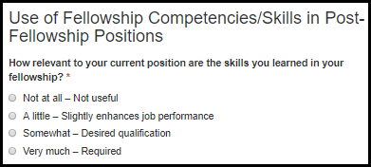
Table 8.1.3-a. Use of Fellowship Competencies Fields
Field Name | Values | EIS | LLS | FLIGHT | EEP | SAF | PMR/F | PH-TIPP | PHIFP | PE | ELI | PHAP | PMF
How relevant to your current position are the skills you learned in your fellowship? | 1. Not at all – Not useful  2. A little – Slightly enhances job performance  3. Somewhat – Desired qualification  4. Very much – Required | Yes | Yes | Yes | Yes | Yes | Yes | Yes | Yes | Yes | Yes | Yes | Yes

8.1.4 Extent to which fellowship training helped prepare alumni for post-fellowship jobs
Figure 8.1.4.-a. Preparing Alumni for Post-Fellowship Job Fields
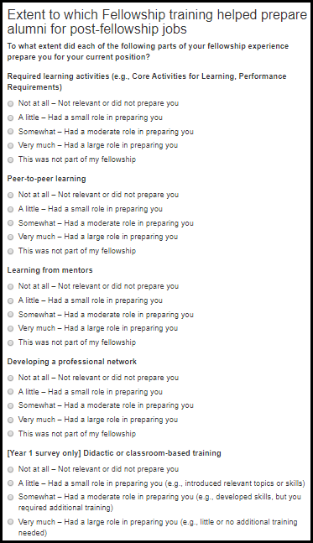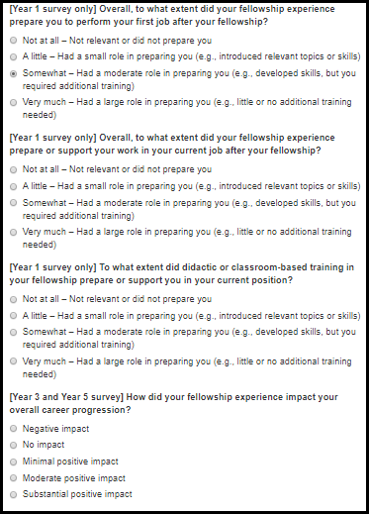

Table 8.1.4.-a. Preparing Alumni for Post-Fellowship Job Fields
Field Name | Values | EIS | LLS | FLIGHT | EEP | SAF | PMR/F | PH-TIPP | PHIFP | PE | ELI | PHAP | PMF
Required learning activities (e.g., Core Activities for Learning, Performance Requirements) | 1. Not at all – Not relevant or did not prepare you  2. A little – Had a small role in preparing you  3. Somewhat – Had a moderate role in preparing you  4. Very much – Had a large role in preparing you  5. This was not part of my fellowship | Yes | Yes | Yes | Yes | Yes | Yes | Yes | Yes | Yes | Yes | Yes | Yes
Peer-to-peer learning | 1. Not at all – Not relevant or did not prepare you  2. A little – Had a small role in preparing you  3. Somewhat – Had a moderate role in preparing you  4. Very much – Had a large role in preparing you  5. This was not part of my fellowship | Yes | Yes | Yes | Yes | Yes | Yes | Yes | Yes | Yes | Yes | Yes | Yes
Learning from mentors | 1. Not at all – Not relevant or did not prepare you  2. A little – Had a small role in preparing you  3. Somewhat – Had a moderate role in preparing you  4. Very much – Had a large role in preparing you  5. This was not part of my fellowship | Yes | Yes | Yes | Yes | Yes | Yes | Yes | Yes | Yes | Yes | Yes | Yes

Table 8.1.4.-b. Preparing Alumni for Post-Fellowship Job Fields
Field Name | Values | EIS | LLS | FLIGHT | EEP | SAF | PMR/F | PH-TIPP | PHIFP | PE | ELI | PHAP | PMF
Developing a professional network | 1. Not at all – Not relevant or did not prepare you  2. A little – Had a small role in preparing you  3. Somewhat – Had a moderate role in preparing you  4. Very much – Had a large role in preparing you  5. This was not part of my fellowship | Yes | Yes | Yes | Yes | Yes | Yes | Yes | Yes | Yes | Yes | Yes | Yes
[Year 1 survey only] Didactic or classroom-based training | 1. Not at all – Not relevant or did not prepare you  2. A little – Had a small role in preparing you  3. Somewhat – Had a moderate role in preparing you  4. Very much – Had a large role in preparing you  5. This was not part of my fellowship | Yes | Yes | Yes | Yes | Yes | Yes | Yes | Yes | Yes | No | Yes | Yes
[Year 1 survey only] Overall, to what extent did your fellowship experience prepare you to perform your first job after your fellowship? | 1. Not at all – Not relevant or did not prepare you  2. A little – Had a small role in preparing you (e.g., introduced relevant topics or skills)  3. Somewhat – Had a moderate role in preparing you (e.g., developed skills, but you required additional training)  4. Very much – Had a large role in preparing you (e.g., little or no additional training needed) | Yes | Yes | Yes | Yes | Yes | Yes | Yes | Yes | Yes | Yes | Yes | Yes
[Year 1 survey only] Overall, to what extent did your fellowship experience prepare or support your work in your current job after your fellowship? | 1. Not at all – Not relevant or did not prepare you  2. A little – Had a small role in preparing you (e.g., introduced relevant topics or skills)  3. Somewhat – Had a moderate role in preparing you (e.g., developed skills, but you required additional training)  4. Very much – Had a large role in preparing you (e.g., little or no additional training needed) | No | No | No | No | No | No | No | No | No | Yes | No | No
[Year 1 survey only] To what extent did didactic or classroom-based training in your fellowship prepare or support you in your current position? | 1. Not at all – Not relevant or did not prepare you  2. A little – Had a small role in preparing you (e.g., introduced relevant topics or skills)  3. Somewhat – Had a moderate role in preparing you (e.g., developed skills, but you required additional training)  4. Very much – Had a large role in preparing you (e.g., little or no additional training needed) | No | No | No | No | No | No | No | No | No | Yes | No | No
[Year 3 and Year 5 survey] How did your fellowship experience impact your overall career progression? | 1. Negative impact  2. No impact  3. Minimal positive impact  4. Moderate positive impact  5. Substantial positive impact | Yes | Yes | Yes | Yes | Yes | Yes | Yes | Yes | Yes | Yes | Yes | Yes

8.1.5 Alumni Engagement

Figure 8.1.5.-a. Alumni Engagement Fields
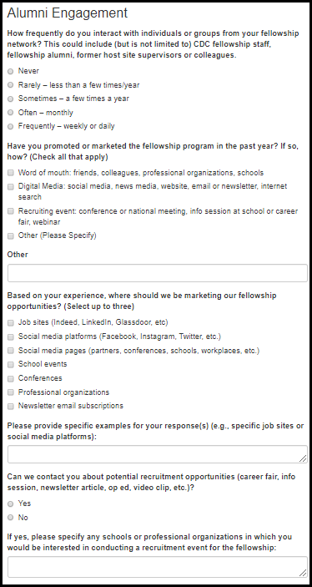
Table 8.1.5.-a. Alumni Engagement Fields
Field Name | Values | EIS | LLS | FLIGHT | EEP | SAF | PMR/F | PH-TIPP | PHIFP | PE | ELI | PHAP | PMF
How frequently do you interact with individuals or groups from your fellowship network? This could include (but is not limited to) CDC fellowship staff, fellowship alumni, former host site supervisors or colleagues. | 1. Never  2. Rarely – less than a few times/year  3. Sometimes – a few times a year  4. Often – monthly  5. Frequently – weekly or daily | Yes | Yes | Yes | Yes | Yes | Yes | Yes | Yes | Yes | Yes | Yes | Yes
Have you promoted or marketed the fellowship program in the past year? If so, how? (Check all that apply) | 1. Word of mouth: friends, colleagues, professional organizations, schools  2. Digital Media: social media, news media, website, email or newsletter, internet search  3. Recruiting event: conference or national meeting, info session at school or career fair, webinar  4. Other (please specify) | Yes | Yes | Yes | Yes | Yes | Yes | Yes | Yes | Yes | Yes | Yes | Yes
Based on your experience, where should we be marketing our fellowship opportunities? (Select up to three) | 1. Job sites (Indeed, LinkedIn, Glassdoor, etc.)  2. Social media platforms (Facebook, Instagram, Twitter, etc.)  3. Social media pages (partners, conferences, schools, workplaces, etc.)  4. School events  5. Conferences  6. Professional organizations  7. Newsletter email subscriptions | Yes | Yes | Yes | Yes | Yes | Yes | Yes | Yes | Yes | Yes | Yes | Yes
Please provide specific examples for your response(s) (e.g., specific job sites or social media platforms): | - | Yes | Yes | Yes | Yes | Yes | Yes | Yes | Yes | Yes | Yes | Yes | Yes
Can we contact you about potential recruitment opportunities (career fair, info session, newsletter article, op ed, video clip, etc.)? | 1. Yes  2. No | Yes | Yes | Yes | Yes | Yes | Yes | Yes | Yes | Yes | Yes | Yes | Yes
If yes, please specify any schools or professional organizations in which you would be interested in conducting a recruitment event for the fellowship: | - | Yes | Yes | Yes | Yes | Yes | Yes | Yes | Yes | Yes | Yes | Yes | Yes

8.2 EEP Alumni Survey

Figure 8.2.-a. EEP Alumni Fields
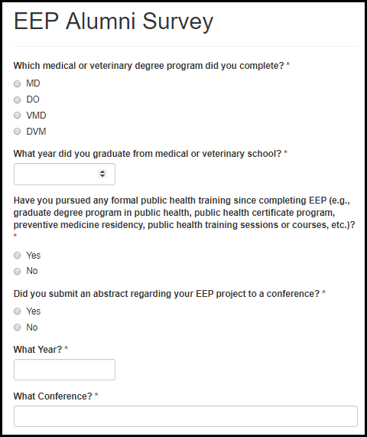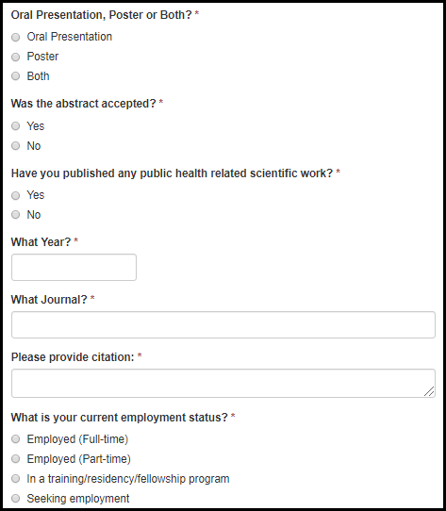

Table 8.2.-a. EEP Alumni Fields
Field Name | Values | EIS | LLS | FLIGHT | EEP | SAF | PMR/F | PH-TIPP | PHIFP | PE | ELI | PHAP
Which medical or veterinary degree program did you complete? | 1. MD  2. DO  3. VMD  4. DVM | No | No | No | Yes | No | No | No | No | No | No | No
What year did you graduate from medical or veterinary school? | - | No | No | No | Yes | No | No | No | No | No | No | No
Have you pursued any formal public health training since completing EEP (e.g., graduate degree program in public health, public health certificate program, preventive medicine residency, public health training sessions or courses, etc.)? | 1. Yes  2. No | No | No | No | Yes | No | No | No | No | No | No | No
Did you submit an abstract regarding your EEP project to a conference? | 1. Yes  2. No | No | No | No | Yes | No | No | No | No | No | No | No
What year? | - | No | No | No | Yes | No | No | No | No | No | No | No
What conference? | - | No | No | No | Yes | No | No | No | No | No | No | No
Oral Presentation, Poster or Both? | 1. Orall Presentation  2. Poster  3. Both | No | No | No | Yes | No | No | No | No | No | No | No
Was the abstract accepted? | 1. Yes  2. No | No | No | No | Yes | No | No | No | No | No | No | No
Have you published any public health related scientific work? | 1. Yes  2. No | No | No | No | Yes | No | No | No | No | No | No | No
What year? | - | No | No | No | Yes | No | No | No | No | No | No | No
What journal? | - | No | No | No | Yes | No | No | No | No | No | No | No
Please provide citation: | - | No | No | No | Yes | No | No | No | No | No | No | No
What is your current employment status? | 1. Employed (Full-time)  2. Employed (Part-time)  3. In a training/residency/fellowship program  4. Seeking employment | No | No | No | Yes | No | No | No | No | No | No | No

Figure 8.2.-b. EEP Alumni Fields
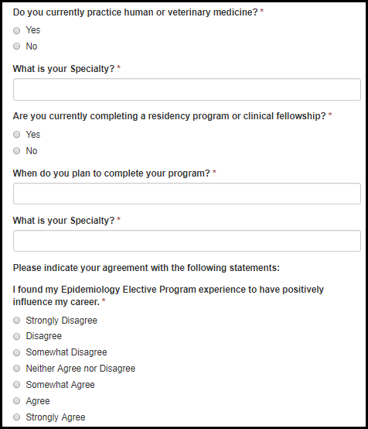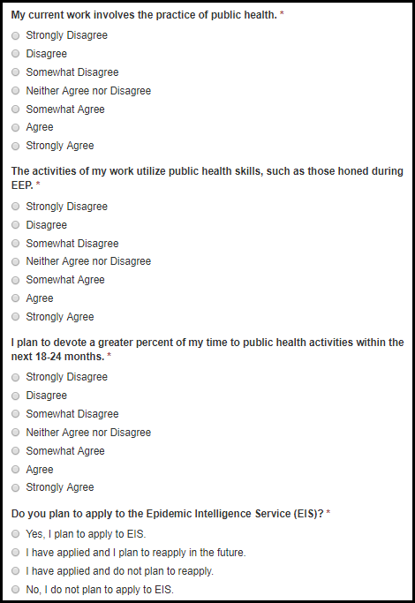

Table 8.2.-b. EEP Alumni Fields
Field Name | Values | EIS | LLS | FLIGHT | EEP | SAF | PMR/F | PH-TIPP | PHIFP | PE | ELI | PHAP
Do you currently practice human or veterinary medicine? | 1. Yes  2. No | No | No | No | Yes | No | No | No | No | No | No | No
What is your specialty? | - | No | No | No | Yes | No | No | No | No | No | No | No
Are you currently completing a residency program or clinical fellowship? | 1. Yes  2. No | No | No | No | Yes | No | No | No | No | No | No | No
When do you plan to complete your program? | - | No | No | No | Yes | No | No | No | No | No | No | No
What is your specialty? | - | No | No | No | Yes | No | No | No | No | No | No | No
I found my Epidemiology Elective Program experience to have positively influenced my career. | 1. Strongly Disagree  2. Disagree  3. Somewhat Disagree  4. Neither Agree nor Disagree  5. Somewhat Agree  6. Agree  7. Strongly Agree | No | No | No | Yes | No | No | No | No | No | No | No
My current work involves the practice of public health. | 1. Strongly Disagree  2. Disagree  3. Somewhat Disagree  4. Neither Agree nor Disagree  5. Somewhat Agree  6. Agree  7. Strongly Agree | No | No | No | Yes | No | No | No | No | No | No | No

Table 8.2.-d. EEP Alumni Fields
Field Name | Values | EIS | LLS | FLIGHT | EEP | SAF | PMR/F | PH-TIPP | PHIFP | PE | ELI | PHAP
The activities of my work utilize public health skills, such as those honed during EEP. | 1. Strongly Disagree  2. Disagree  3. Somewhat Disagree  4. Neither Agree nor Disagree  5. Somewhat Agree  6. Agree  7. Strongly Agree | No | No | No | Yes | No | No | No | No | No | No | No
I plan to devote a greater percent of my time to public health activities within the next 18-24 months. | 1. Strongly Disagree  2. Disagree  3. Somewhat Disagree  4. Neither Agree nor Disagree  5. Somewhat Agree  6. Agree  7. Strongly Agree | No | No | No | Yes | No | No | No | No | No | No | No
Do you plan to apply to the Epidemic Intelligence Service (EIS)? | 1. Yes, I plan to apply to EIS.  2. I have applied and I plan to reapply in the future.  3. I have applied and do not plan to reapply.  4. No, I do not plan to apply to EIS. | No | No | No | Yes | No | No | No | No | No | No | No

Figure 8.2.-c. EEP Alumni Fields
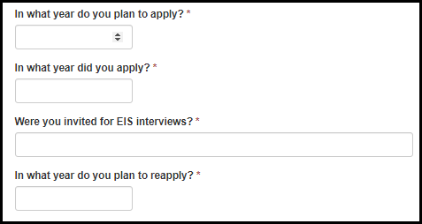
Table 8.2.-d. EEP Alumni Fields
Field Name | Values | EIS | LLS | FLIGHT | EEP | SAF | PMR/F | PH-TIPP | PHIFP | PE | ELI | PHAP
In what year do you plan to apply? | - | No | No | No | Yes | No | No | No | No | No | No | No
In what year did you apply? | - | No | No | No | Yes | No | No | No | No | No | No | No
Were you invited for EIS interviews? | - | No | No | No | Yes | No | No | No | No | No | No | No
In what year do you plan to reapply? | - | No | No | No | Yes | No | No | No | No | No | No | No

8.3 ELI Alumni Survey

Figure 8.3-a. ELI Alumni Fields
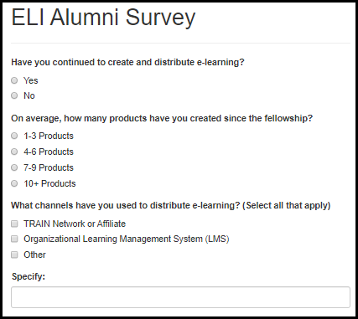
Table 8.3-a. ELI Alumni Fields
Field Name | Values | EIS | LLS | FLIGHT | EEP | SAF | PMR/F | PH-TIPP | PHIFP | PE | ELI | PHAP
Have you continued to create and distribute e-learning? | 1. Yes  2. No | No | No | No | No | No | No | No | No | No | Yes | No
On average, how many products have you created since the fellowship? | 1. 1-3 Products  2. 4-6 Products  3. 7-9 Products  4. 10+ Products | No | No | No | No | No | No | No | No | No | Yes | No
What channels have you used to distribute e-learning? (Select all that apply) | 1. TRAIN Network or Affiliate  2. Organizational Learning Management System (LMS)  3. Other | No | No | No | No | No | No | No | No | No | Yes | No

8.4 LLS Alumni Survey

Figure 8.4-a. LLS Alumni Fields
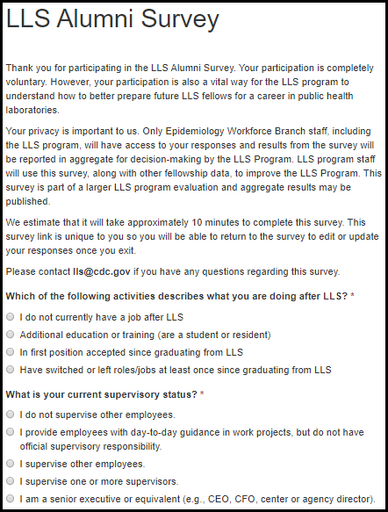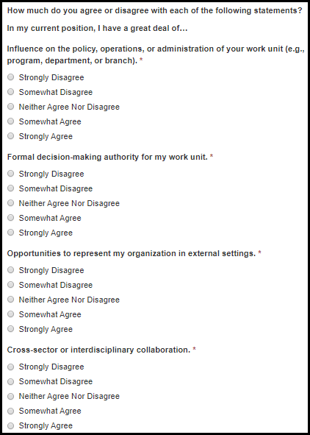

Table 8.4-a. LLS Alumni Fields
Field Name | Values | EIS | LLS | FLIGHT | EEP | SAF | PMR/F | PH-TIPP | PHIFP | PE | ELI | PHAP
Which of the following activities describes what you are doing after LLS? | 1. I do not currently have a job after LLS  2. Additional education or training (are a student or resident)  3. In first position accepted since graduating from LLS  4. Have switched or left roles/jobs at least once since graduating from LLS | No | Yes | No | No | No | No | No | No | No | No | No
What is your current supervisory status? | 1. I do not supervise other employees.  2. I provide employees with day-to-day guidance in work projects, but do not have official supervisory responsibility.  3. I supervise other employees.  4. I supervise one or more supervisors.  5. I am a senior executive or equivalent (e.g., CEO, CFO, center or agency director). | No | Yes | No | No | No | No | No | No | No | No | No
Influence on the policy, operations, or administration of your work unit (e.g., program, department, or branch). | 1. Strongly Disagree  2. Somewhat Disagree  3. Neither Agree Nor Disagree  4. Somewhat Agree  5. Strongly Agree | No | Yes | No | No | No | No | No | No | No | No | No
Formal decision-making authority for my work unit. | 1. Strongly Disagree  2. Somewhat Disagree  3. Neither Agree Nor Disagree  4. Somewhat Agree  5. Strongly Agree | No | Yes | No | No | No | No | No | No | No | No | No
Opportunities to represent my organization in external settings. | 1. Strongly Disagree  2. Somewhat Disagree  3. Neither Agree Nor Disagree  4. Somewhat Agree  5. Strongly Agree | No | Yes | No | No | No | No | No | No | No | No | No
Cross-sector or interdisciplinary collaboration. | 1. Strongly Disagree  2. Somewhat Disagree  3. Neither Agree Nor Disagree  4. Somewhat Agree  5. Strongly Agree | No | Yes | No | No | No | No | No | No | No | No | No

Figure 8.4-b. LLS Alumni Fields
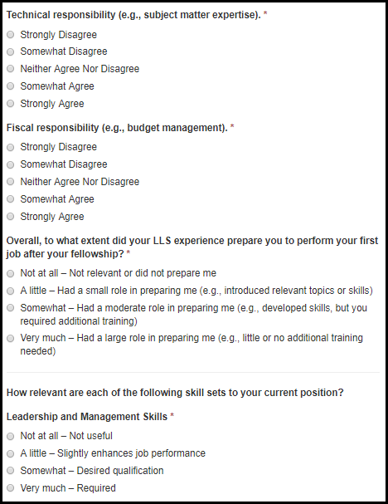

Table 8.4-b. LLS Alumni Fields
Field Name | Values | EIS | LLS | FLIGHT | EEP | SAF | PMR/F | PH-TIPP | PHIFP | PE | ELI | PHAP
Technical responsibility (e.g., subject matter expertise). | 1. Strongly Disagree  2. Somewhat Disagree  3. Neither Agree Nor Disagree  4. Somewhat Agree  5. Strongly Agree | No | Yes | No | No | No | No | No | No | No | No | No
Fiscal responsibility (e.g., budget management). | 1. Strongly Disagree  2. Somewhat Disagree  3. Neither Agree Nor Disagree  4. Somewhat Agree  5. Strongly Agree | No | Yes | No | No | No | No | No | No | No | No | No
Overall, to what extent did your LLS experience prepare you to perform your first job after your fellowship? | 1. Not at all – Not relevant or did not prepare me  2. A little – Had a small role in preparing me (e.g., introduced relevant topics or skills)  2. Somewhat – Had a moderate role in preparing me (e.g., developed skills, but you required additional training)  3. Very much – Had a large role in preparing me (e.g., little or no additional training needed) | No | Yes | No | No | No | No | No | No | No | No | No
Leadership and Management Skills | 1. Not at all – Not useful  2. A little – Slightly enhances job performance  3. Somewhat – Desired qualification  4. Very much – Required | No | Yes | No | No | No | No | No | No | No | No | No

Figure 8.4-c. LLS Alumni Fields
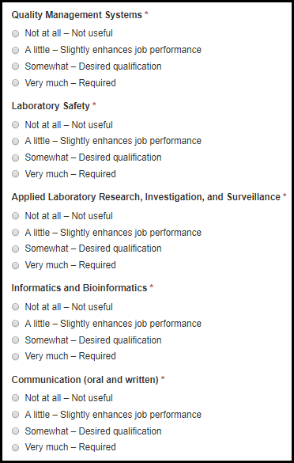

Table 8.4-c. LLS Alumni Fields
Field Name | Values | EIS | LLS | FLIGHT | EEP | SAF | PMR/F | PH-TIPP | PHIFP | PE | ELI | PHAP
Quality Management Systems | 1. Not at all – Not useful  2. A little – Slightly enhances job performance  3. Somewhat – Desired qualification  4. Very much – Required | No | Yes | No | No | No | No | No | No | No | No | No
Laboratory Safety | 1. Not at all – Not useful  2. A little – Slightly enhances job performance  3. Somewhat – Desired qualification  4. Very much – Required | No | Yes | No | No | No | No | No | No | No | No | No
Applied Laboratory Research, Investigation, and Surveillance | 1. Not at all – Not useful  2. A little – Slightly enhances job performance  3. Somewhat – Desired qualification  4. Very much – Required | No | Yes | No | No | No | No | No | No | No | No | No
Informatics and Bioinformatics | 1. Not at all – Not useful  2. A little – Slightly enhances job performance  3. Somewhat – Desired qualification  4. Very much – Required | No | Yes | No | No | No | No | No | No | No | No | No
Communication (oral and written) | 1. Not at all – Not useful  2. A little – Slightly enhances job performance  3. Somewhat – Desired qualification  4. Very much – Required | No | Yes | No | No | No | No | No | No | No | No | No

Figure 8.4-d. LLS Alumni Fields
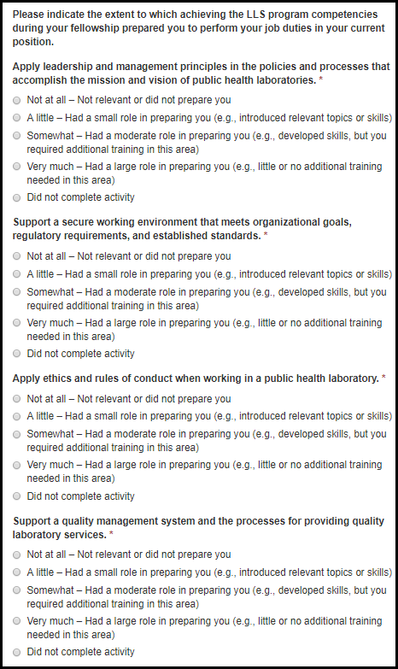

Table 8.4-d. LLS Alumni Fields
Field Name | Values | EIS | LLS | FLIGHT | EEP | SAF | PMR/F | PH-TIPP | PHIFP | PE | ELI | PHAP
Apply leadership and management principles in the policies and processes that accomplish the mission and vision of public health laboratories. | 1. Not at all – Not relevant or did not prepare you  2. A little – Had a small role in preparing you (e.g., introduced relevant topics or skills)  3. Somewhat – Had a moderate role in preparing you (e.g., developed skills, but you required additional training in this area)  4. Very much – Had a large role in preparing you (e.g., little or no additional training needed in this area)  5. Did not complete activity | No | Yes | No | No | No | No | No | No | No | No | No
Support a secure working environment that meets organizational goals, regulatory requirements, and established standards. | 1. Not at all – Not relevant or did not prepare you  2. A little – Had a small role in preparing you (e.g., introduced relevant topics or skills)  3. Somewhat – Had a moderate role in preparing you (e.g., developed skills, but you required additional training in this area)  4. Very much – Had a large role in preparing you (e.g., little or no additional training needed in this area)  5. Did not complete activity | No | Yes | No | No | No | No | No | No | No | No | No
Apply ethics and rules of conduct when working in a public health laboratory. | 1. Not at all – Not relevant or did not prepare you  2. A little – Had a small role in preparing you (e.g., introduced relevant topics or skills)  3. Somewhat – Had a moderate role in preparing you (e.g., developed skills, but you required additional training in this area)  4. Very much – Had a large role in preparing you (e.g., little or no additional training needed in this area)  5. Did not complete activity | No | Yes | No | No | No | No | No | No | No | No | No
Support a quality management system and the processes for providing quality laboratory services. | 1. Not at all – Not relevant or did not prepare you  2. A little – Had a small role in preparing you (e.g., introduced relevant topics or skills)  3. Somewhat – Had a moderate role in preparing you (e.g., developed skills, but you required additional training in this area)  4. Very much – Had a large role in preparing you (e.g., little or no additional training needed in this area)  5. Did not complete activity | No | Yes | No | No | No | No | No | No | No | No | No

Figure 8.4-e. LLS Alumni Fields
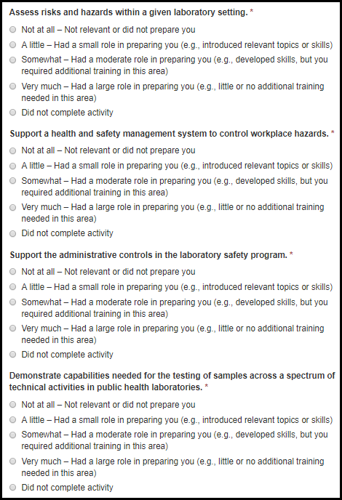

Table 8.4-e. LLS Alumni Fields
Field Name | Values | EIS | LLS | FLIGHT | EEP | SAF | PMR/F | PH-TIPP | PHIFP | PE | ELI | PHAP
Assess risks and hazards within a given laboratory setting. | 1. Not at all – Not relevant or did not prepare you  2. A little – Had a small role in preparing you (e.g., introduced relevant topics or skills)  3. Somewhat – Had a moderate role in preparing you (e.g., developed skills, but you required additional training in this area)  4. Very much – Had a large role in preparing you (e.g., little or no additional training needed in this area)  5. Did not complete activity | No | Yes | No | No | No | No | No | No | No | No | No
Support a health and safety management system to control workplace hazards. | 1. Not at all – Not relevant or did not prepare you  2. A little – Had a small role in preparing you (e.g., introduced relevant topics or skills)  3. Somewhat – Had a moderate role in preparing you (e.g., developed skills, but you required additional training in this area)  4. Very much – Had a large role in preparing you (e.g., little or no additional training needed in this area)  5. Did not complete activity | No | Yes | No | No | No | No | No | No | No | No | No
Support the administrative controls in the laboratory safety program. | 1. Not at all – Not relevant or did not prepare you  2. A little – Had a small role in preparing you (e.g., introduced relevant topics or skills)  3. Somewhat – Had a moderate role in preparing you (e.g., developed skills, but you required additional training in this area)  4. Very much – Had a large role in preparing you (e.g., little or no additional training needed in this area)  5. Did not complete activity | No | Yes | No | No | No | No | No | No | No | No | No
Demonstrate capabilities needed for the testing of samples across a spectrum of technical activities in public health laboratories. | 1. Not at all – Not relevant or did not prepare you  2. A little – Had a small role in preparing you (e.g., introduced relevant topics or skills)  3. Somewhat – Had a moderate role in preparing you (e.g., developed skills, but you required additional training in this area)  4. Very much – Had a large role in preparing you (e.g., little or no additional training needed in this area)  5. Did not complete activity | No | Yes | No | No | No | No | No | No | No | No | No

Figure 8.4-f. LLS Alumni Fields
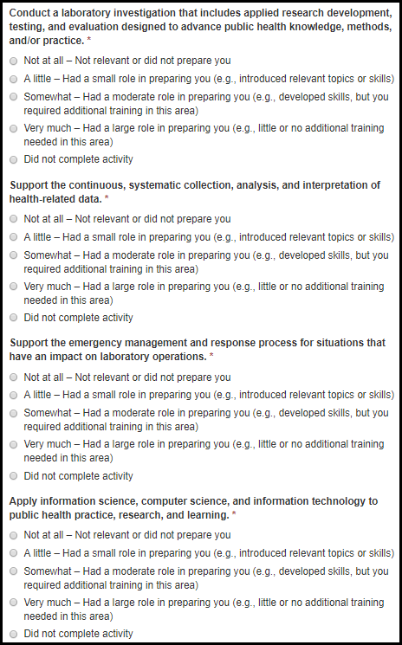

Table 8.4-f. LLS Alumni Fields
Field Name | Values | EIS | LLS | FLIGHT | EEP | SAF | PMR/F | PH-TIPP | PHIFP | PE | ELI | PHAP
Conduct a laboratory investigation that includes applied research development, testing, and evaluation designed to advance public health knowledge, methods, and/or practice. | 1. Not at all – Not relevant or did not prepare you  2. A little – Had a small role in preparing you (e.g., introduced relevant topics or skills)  3. Somewhat – Had a moderate role in preparing you (e.g., developed skills, but you required additional training in this area)  4. Very much – Had a large role in preparing you (e.g., little or no additional training needed in this area)  5. Did not complete activity | No | Yes | No | No | No | No | No | No | No | No | No
Support the continuous, systematic collection, analysis, and interpretation of health-related data. | 1. Not at all – Not relevant or did not prepare you  2. A little – Had a small role in preparing you (e.g., introduced relevant topics or skills)  3. Somewhat – Had a moderate role in preparing you (e.g., developed skills, but you required additional training in this area)  4. Very much – Had a large role in preparing you (e.g., little or no additional training needed in this area)  5. Did not complete activity | No | Yes | No | No | No | No | No | No | No | No | No
Support the emergency management and response process for situations that have an impact on laboratory operations. | 1. Not at all – Not relevant or did not prepare you  2. A little – Had a small role in preparing you (e.g., introduced relevant topics or skills)  3. Somewhat – Had a moderate role in preparing you (e.g., developed skills, but you required additional training in this area)  4. Very much – Had a large role in preparing you (e.g., little or no additional training needed in this area)  5. Did not complete activity | No | Yes | No | No | No | No | No | No | No | No | No
Apply information science, computer science, and information technology to public health practice, research, and learning. | 1. Not at all – Not relevant or did not prepare you  2. A little – Had a small role in preparing you (e.g., introduced relevant topics or skills)  3. Somewhat – Had a moderate role in preparing you (e.g., developed skills, but you required additional training in this area)  4. Very much – Had a large role in preparing you (e.g., little or no additional training needed in this area)  5. Did not complete activity | No | Yes | No | No | No | No | No | No | No | No | No

Figure 8.4-g. LLS Alumni Fields
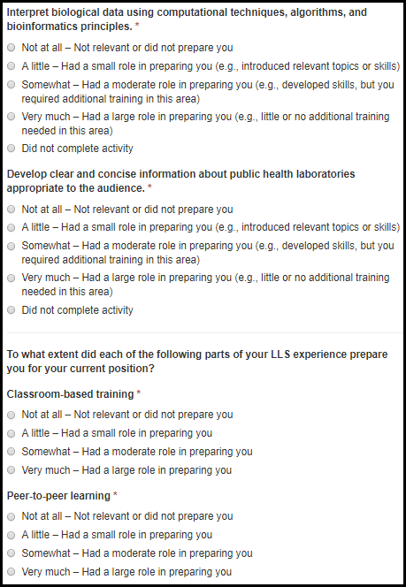

Table 8.4-g. LLS Alumni Fields
Field Name | Values | EIS | LLS | FLIGHT | EEP | SAF | PMR/F | PH-TIPP | PHIFP | PE | ELI | PHAP
Interpret biological data using computational techniques, algorithms, and bioinformatics principles. | 1. Not at all – Not relevant or did not prepare you  2. A little – Had a small role in preparing you (e.g., introduced relevant topics or skills)  3. Somewhat – Had a moderate role in preparing you (e.g., developed skills, but you required additional training in this area)  4. Very much – Had a large role in preparing you (e.g., little or no additional training needed in this area)  5. Did not complete activity | No | Yes | No | No | No | No | No | No | No | No | No
Develop clear and concise information about public health laboratories appropriate to the audience. | 1. Not at all – Not relevant or did not prepare you  2. A little – Had a small role in preparing you (e.g., introduced relevant topics or skills)  3. Somewhat – Had a moderate role in preparing you (e.g., developed skills, but you required additional training in this area)  4. Very much – Had a large role in preparing you (e.g., little or no additional training needed in this area)  5. Did not complete activity | No | Yes | No | No | No | No | No | No | No | No | No
Classroom-based training | 1. Not at all – Not relevant or did not prepare you  2. A little – Had a small role in preparing you  3. Somewhat – Had a moderate role in preparing you  4. Very much – Had a large role in preparing you | No | Yes | No | No | No | No | No | No | No | No | No
Peer-to-peer learning | 1. Not at all – Not relevant or did not prepare you  2. A little – Had a small role in preparing you  3. Somewhat – Had a moderate role in preparing you  4. Very much – Had a large role in preparing you | No | Yes | No | No | No | No | No | No | No | No | No

Figure 8.4-h. LLS Alumni Fields
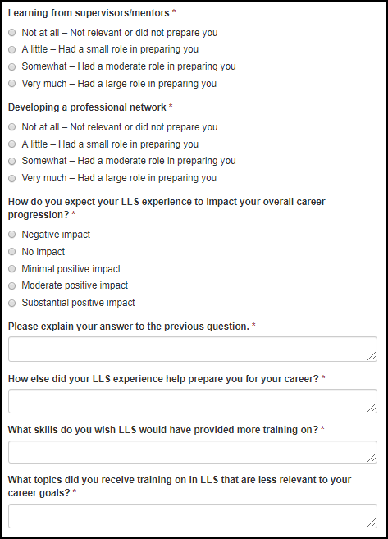

Table 8.4-h. LLS Alumni Fields
Field Name | Values | EIS | LLS | FLIGHT | EEP | SAF | PMR/F | PH-TIPP | PHIFP | PE | ELI | PHAP
Learning from supervisors/mentors | 1. Not at all – Not relevant or did not prepare you  2. A little – Had a small role in preparing you  3. Somewhat – Had a moderate role in preparing you  4. Very much – Had a large role in preparing you | No | Yes | No | No | No | No | No | No | No | No | No
Developing a professional network | 1. Not at all – Not relevant or did not prepare you  2. A little – Had a small role in preparing you  3. Somewhat – Had a moderate role in preparing you  4. Very much – Had a large role in preparing you | No | Yes | No | No | No | No | No | No | No | No | No
How do you expect your LLS experience to impact your overall career progression? | 1. Negative impact  2. No impact  3. Minimal positive impact  4. Moderate positive impact  5. Substantial positive impact | No | Yes | No | No | No | No | No | No | No | No | No
Please explain your answer to the previous question. | - | No | Yes | No | No | No | No | No | No | No | No | No
How else did your LLS experience help prepare you for your career? | - | No | Yes | No | No | No | No | No | No | No | No | No
What skills do you wish LLS would have provided more training on? | - | No | Yes | No | No | No | No | No | No | No | No | No
What topics did you receive training on in LLS that are less relevant to your career goals? | - | No | Yes | No | No | No | No | No | No | No | No | No

Figure 8.4-i. LLS Alumni Fields
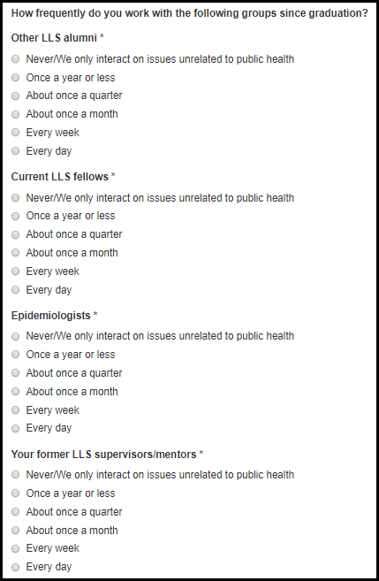

Table 8.4-i. LLS Alumni Fields
Field Name | Values | EIS | LLS | FLIGHT | EEP | SAF | PMR/F | PH-TIPP | PHIFP | PE | ELI | PHAP
Other LLS alumni | 1. Never/We only interact on issues unrelated to public health  2. Once a year or less  3. About once a quarter  4. About once a month  5. Every week  6. Every day | No | Yes | No | No | No | No | No | No | No | No | No
Current LLS fellows | 1. Never/We only interact on issues unrelated to public health  2. Once a year or less  3. About once a quarter  4. About once a month  5. Every week  6. Every day | No | Yes | No | No | No | No | No | No | No | No | No
Epidemiologists | 1. Never/We only interact on issues unrelated to public health  2. Once a year or less  3. About once a quarter  4. About once a month  5. Every week  6. Every day | No | Yes | No | No | No | No | No | No | No | No | No
Your former LLS supervisors/mentors | 1. Never/We only interact on issues unrelated to public health  2. Once a year or less  3. About once a quarter  4. About once a month  5. Every week  6. Every day | No | Yes | No | No | No | No | No | No | No | No | No

Figure 8.4-j. LLS Alumni Fields
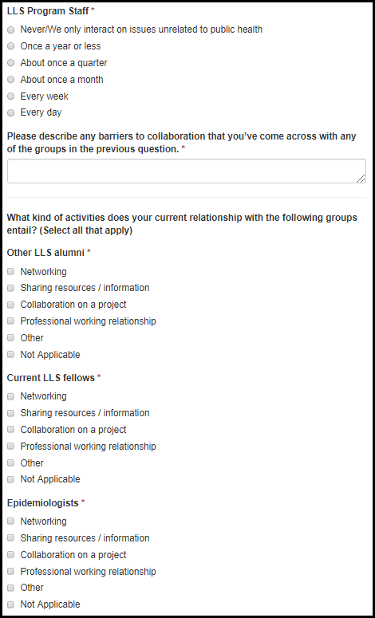

Table 8.4-j. LLS Alumni Fields
Field Name | Values | EIS | LLS | FLIGHT | EEP | SAF | PMR/F | PH-TIPP | PHIFP | PE | ELI | PHAP
LLS Program Staff | 1. Never/We only interact on issues unrelated to public health  2. Once a year or less  3. About once a quarter  4. About once a month  5. Every week  6. Every day | No | Yes | No | No | No | No | No | No | No | No | No
Please describe any barriers to collaboration that you’ve come across with any of the groups in the previous question. | - | No | Yes | No | No | No | No | No | No | No | No | No
Other LLS alumni | 1. Networking  2. Sharing resources / information  3. Collaboration on a project  4. Professional working relationship  5. Other  6. Not Applicable | No | Yes | No | No | No | No | No | No | No | No | No
Current LLS fellows | 1. Networking  2. Sharing resources / information  3. Collaboration on a project  4. Professional working relationship  5. Other  6. Not Applicable | No | Yes | No | No | No | No | No | No | No | No | No
Epidemiologists | 1. Networking  2. Sharing resources / information  3. Collaboration on a project  4. Professional working relationship  5. Other  6. Not Applicable | No | Yes | No | No | No | No | No | No | No | No | No

Figure 8.4-k. LLS Alumni Fields
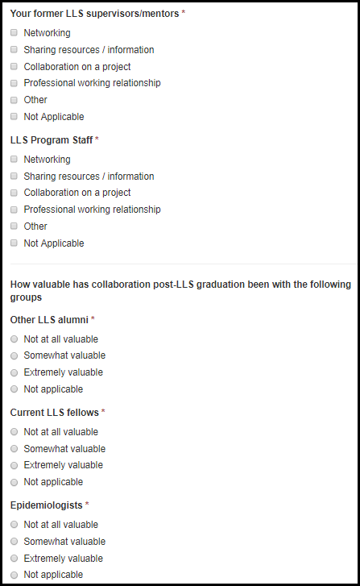

Table 8.4-k. LLS Alumni Fields
Field Name | Values | EIS | LLS | FLIGHT | EEP | SAF | PMR/F | PH-TIPP | PHIFP | PE | ELI | PHAP
Your former LLS supervisors/mentors | 1. Networking  2. Sharing resources / information  3. Collaboration on a project  4. Professional working relationship  5. Other  6. Not Applicable | No | Yes | No | No | No | No | No | No | No | No | No
LLS Program Staff | 1. Networking  2. Sharing resources / information  3. Collaboration on a project  4. Professional working relationship  5. Other  6. Not Applicable | No | Yes | No | No | No | No | No | No | No | No | No
Other LLS alumni | 1. Not at all valuable  2. Somewhat valuable  3. Valuable  4. Extremely valuable  5. Not applicable | No | Yes | No | No | No | No | No | No | No | No | No
Current LLS fellows | 1. Not at all valuable  2. Somewhat valuable  3. Valuable  4. Extremely valuable  5. Not applicable | No | Yes | No | No | No | No | No | No | No | No | No
Epidemiologists | 1. Not at all valuable  2. Somewhat valuable  3. Valuable  4. Extremely valuable  5. Not applicable | No | Yes | No | No | No | No | No | No | No | No | No

Figure 8.4-l. LLS Alumni Fields
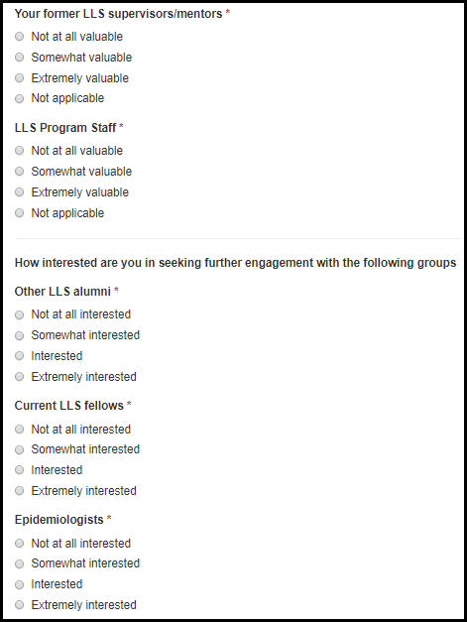

Table 8.4-l. LLS Alumni Fields
Field Name | Values | EIS | LLS | FLIGHT | EEP | SAF | PMR/F | PH-TIPP | PHIFP | PE | ELI | PHAP
Your former LLS supervisors/mentors | 1. Not at all valuable  2. Somewhat valuable  3. Valuable  4. Extremely valuable  5. Not applicable | No | Yes | No | No | No | No | No | No | No | No | No
LLS Program Staff | 1. Not at all valuable  2. Somewhat valuable  3. Valuable  4. Extremely valuable  5. Not applicable | No | Yes | No | No | No | No | No | No | No | No | No
Other LLS alumni | 1. Not at all interested  2. Somewhat interested  3. Interested  4. Extremely interested | No | Yes | No | No | No | No | No | No | No | No | No
Current LLS fellows | 1. Not at all interested  2. Somewhat interested  3. Interested  4. Extremely interested | No | Yes | No | No | No | No | No | No | No | No | No
Epidemiologists | 1. Not at all interested  2. Somewhat interested  3. Interested  4. Extremely interested | No | Yes | No | No | No | No | No | No | No | No | No

Figure 8.4-m. LLS Alumni Fields
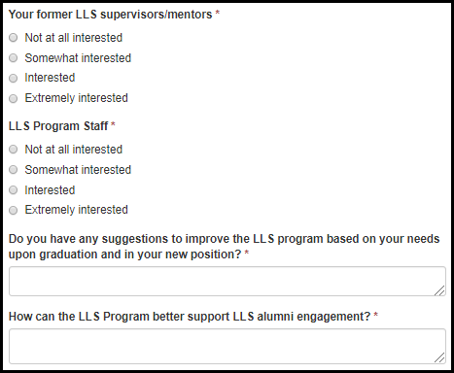

Table 8.4-m. LLS Alumni Fields
Field Name | Values | EIS | LLS | FLIGHT | EEP | SAF | PMR/F | PH-TIPP | PHIFP | PE | ELI | PHAP
Your former LLS supervisors/mentors | 1. Not at all interested  2. Somewhat interested  3. Interested  4. Extremely interested | No | Yes | No | No | No | No | No | No | No | No | No
LLS Program Staff | 1. Not at all interested  2. Somewhat interested  3. Interested  4. Extremely interested | No | Yes | No | No | No | No | No | No | No | No | No
Do you have any suggestions to improve the LLS program based on your needs upon graduation and in your new position? | - | No | Yes | No | No | No | No | No | No | No | No | No
How can the LLS Program better support LLS alumni engagement? | - | No | Yes | No | No | No | No | No | No | No | No | No

8.5 SAF Alumni Survey

Table 8.5-a SAF Alumni Fields
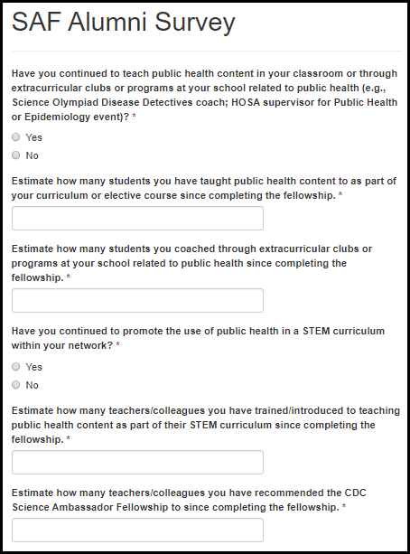

Table 8.5-a SAF Alumni Fields
Field Name | Values | EIS | LLS | FLIGHT | EEP | SAF | PMR/F | PH-TIPP | PHIFP | PE | ELI | PHAP
Have you continued to teach public health content in your classroom or through extracurricular clubs or programs at your school related to public health (e.g., Science Olympiad Disease Detectives coach; HOSA supervisor for Public Health or Epidemiology event)? | 1. Yes  2. No | No | No | No | No | Yes | No | No | No | No | No | No
Estimate how many students you have taught public health content to as part of your curriculum or elective course since completing the fellowship. | - | No | No | No | No | Yes | No | No | No | No | No | No
Estimate how many students you coached through extracurricular clubs or programs at your school related to public health since completing the fellowship. | - | No | No | No | No | Yes | No | No | No | No | No | No
Have you continued to promote the use of public health in a STEM curriculum within your network? | 1. Yes  2. No | No | No | No | No | Yes | No | No | No | No | No | No
Estimate how many teachers/colleagues you have trained/introduced to teaching public health content as part of their STEM curriculum since completing the fellowship. | - | No | No | No | No | Yes | No | No | No | No | No | No
Estimate how many teachers/colleagues you have recommended the CDC Science Ambassador Fellowship to since completing the fellowship. | - | No | No | No | No | Yes | No | No | No | No | No | No

8.6 Alumni Survey Email

Figure 8.6-a. Alumni Survey Email
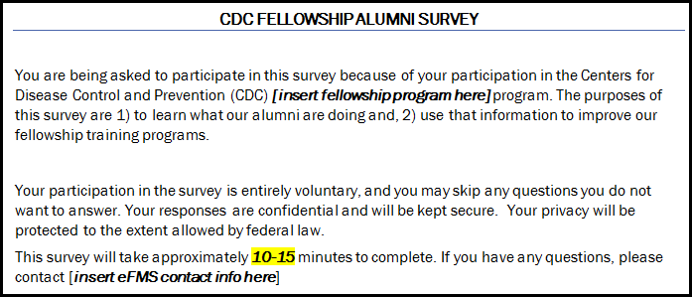

Appendix

I. (PENDING) Field Value Tables

Appendix of Field Value Tables
Field Name | Application Locations | Values  1 | Values  2 | Values  3 | Values  4
Undergraduate Degree List | 6. Post-Fellowship Education, Board Certifications, and Licenses | AB  AM  BA  BS  BS/BA  BSc  DHS  DHSc  DNSc  DPH  DPhil  DrPH  DrS  DrSc  EdD  MA  Med  MHS  MHSc  MHSE  MN  MPH  MPhil  MPHTM  MPVM  MS  MSVPH  MSc  MScPH  MSPH  MTM&H  PhD  SB  ScB  ScD  ScM  SM  Other
Graduate Degree List | 6. Post-Fellowship Education, Board Certifications, and Licenses | AB  AM  BA  BS  BS/BA  BSc  DHS  DHSc  DNSc  DPH  DPhil  DrPH  DrS  DrSc  EdD  MA  Med  MHS  MHSc  MHSE  MN  MPH  MPhil  MPHTM  MPVM  MS  MSVPH  MSc  MScPH  MSPH  MTM&H  PhD  SB  ScB  ScD  ScM  SM  Other

II. (PENDING) Lookup Tables

Appendix of Lookup Tables
Lookup Table Name | Application Locations | Values  1 | Values  2 | Values  3 | Values  4 | Values  5
Fellowship Lookup | 3. eFMS System Help Desk Ticket | CDC E-learning Institute Fellowship Program (ELI)  CDC Steven M. Teutsch Prevention Effectiveness (PE) Fellowship  Epidemic Intelligence Service (EIS)  Epidemiology Elective Program (EEP)  Future Leaders in Infections and Global Health Threats (FLIGHT)  Laboratory Leadership Service (LLS)  Population Health Training in Place Program (PH-TIPP)  Population Health Workforce Initiative (PHWI)  Preventive Medicine Residency and Fellowship (PMR/F)  Public Health Associate Program (PHAP)  Public Health Informatics Fellowship Program (PHIFP)  Science Ambassador Fellowship (SAF)
Country Lookup | 5.2 Current Residence | United States  Afghanistan  Albania  Algeria  Andorra  Angola  Anguilla (U.K.)  Antigua and Barbuda  Argentina  Armenia  Aruba  Australia  Austria  Azerbaijan  Azores  Bahamas, The  Bahrain  Bangladesh  Barbados  Belarus  Belgium  Belize  Benin  Bermuda (U.K.)  Bhutan  Bolivia  Bosnia and Herzegovina  Botswana  Brazil  British Indian Ocean Territory (U.K.)  British Virgin Islands  Brunei  Bulgaria  Burkina Faso  Burma (Myanmar)  Burundi  Cambodia  Cameroon  Canada | Canary Islands (Spain)  Cape Verde  Cayman Islands (U.K.)  Central African Republic  China  Chad  Christmas Island (Australia)  Chile  Cocos (Keeling) Islands (Australia)  Colombia  Comoros  Congo, Democratic Republic of the  Congo, Republic of the  Cook Islands (New Zealand)  Costa Rica  Cote d'Ivoire  Djibouti  Croatia  Cuba  Dominica  Cyprus  Dominican Republic  Czech Republic  Easter Island (Chile)  Denmark  Ecuador  Egypt  El Salvador  Equatorial Guinea  Eritrea  Estonia  Ethiopia  Falkland Islands (Malvinas)  Finland  Falkland Islands (U.K.)  Faroe Islands (Denmark)  France  Fiji | French Guiana (France)  French Polynesia (France)  Gabon  Gambia, The  Georgia  Germany  Ghana  Gibraltar (U.K.)  Greece  Guinea  Greenland (Denmark)  Grenada  Guinea-Bissau  Guadeloupe  Guyana  Guatemala  Haiti  Honduras  Hong Kong SAR (China)  Hungary  Iceland  India  Indonesia  Iran  Jamaica  Iraq  Japan  Ireland  Jordan  Israel  Kazakhstan  Italy  Kenya  Kiribati  Korea, North  Korea, South  Kosovo  Kuwait  Kyrgyzstan  Laos | Liberia  Latvia  Libya  Lebanon  Liechtenstein  Lesotho  Lithuania  Luxembourg  Macau SAR (China)  Macedonia  Madagascar  Madeira Islands (Portugal)  Malawi  Malaysia  Martinique (France)  Maldives  Mauritania  Mali  Mauritius  Malta  Mayotte (France)  Marshall Islands  Mexico  Moldova  Monaco  Mongolia  Montenegro  Montserrat (U.K.)  Morocco  Mozambique  Netherlands Antilles  Namibia  Nauru  Netherlands, The  Nepal  New Caledonia (France)  New Zealand  Nicaragua  Niger  Nigeria  Niue (New Zealand)  Northfolk Island (Australia)  Northern Mariana Islands (U.S.)  Panama  Norway  Papua New Guinea  Oman | Paraguay  Other  Peru  Pakistan  Philippines  Palau  Pitcairn Islands (U.K.)  Poland  Portugal  Qatar  Reunion (France)  Romania  Russia  Rwanda  Saint Lucia  Saint Helena (U.K.)  Saint Pierre and Miquelon (France)  Saint Kitts and Nevis  Saint Vincent and the Grenadines  Samoa  San Marino  Sao Tome and Principe  Saudi Arabia  Senegal  Serbia  Seychelles  Somalia  Sierra Leone  Singapore  South Africa  Slovakia  Spain  Slovenia  Sri Lanka  Solomon Islands  Sudan  Suriname  Swaziland  Sweden  Switzerland  Syria  Taiwan  Tajikistan  Tanzania  Togo  Thailand  Timor-Leste (East Timor)  Tokelau (New Zealand)  Tonga  Trinidad and Tobago  Tunisia  Turkey  Turkmenistan  Turks and Caicos Islands (U.K.)  Tuvalu  Vanuatu  Uganda  Venezuela  Ukraine  Vietnam  United Arab Emirates  Western Sahara  United Kingdom  Yemen  Uruguay  Zambia  Uzbekistan  Zimbabwe
State/Territory Lookup | 5.2 Current Residence  7.1 Employer Information | Alabama  Alaska  Arizona  Arkansas  California  Colorado  Connecticut  Delaware  Washington, DC  Florida  Georgia  Hawaii  Idaho  Illinois  Indiana  Iowa  Kansas  Kentucky  Louisiana  Maine  Maryland  Massachusetts  Michigan  Minnesota  Mississippi  Missouri  Montana  Nebraska | Nevada  New Hampshire  New Jersey  New Mexico  New York  North Carolina  North Dakota  Ohio  Oklahoma  Oregon  Pennsylvania  Rhode Island  South Carolina  South Dakota  Tennessee  Texas  Utah  Vermont  Virginia  Washington  West Virginia  Wisconsin  Wyoming  Puerto Rico  Pacific Islands  U.S. Virgin Islands  Guam  Northern Mariana Islands
Center/Division/Branch Lookup | 7.1 Employer Information | NIOSH / Office of the Director / Administrative Svcs Branch (Cincinnati)  NIOSH / Office of the Director / Administrative Svcs Branch (Morgantown)  NIOSH / Office of the Director / Administrative Svcs Branch (Spokane)  NIOSH / Office of the Director / Administrative Svrcs Branch (Pittsburgh)  NCHS / Office of Analysis & Epidemiology / Aging & Chronic Disease Statistics Branch  NIOSH / Health Effects Laboratory Division / Allergy & Clinical Immunology Branch  NCHS / Division of Health Care Statistics / Ambulatory and Hospital Care Statistics Branch  NIOSH / Division of Safety Research / Analysis & Field Branch  NCHS / Division of Health & Nutrition Examination Surveys / Analysis Branch  NCHS / Office of Analysis & Epidemiology / Analytic Studies Branch  NCEZID / Division of Scientific Resources / Animal Resources Branch  NCCDPHP / Division for Heart Disease and Stroke Prevention / Applied Research and Evaluation Branch  NCCDPHP / Division of Population Health / Applied Research and Translation Branch  CPR / Division of State and Local Readiness / Applied Science and Evaluation Branch  NCCDPHP / Division of Reproductive Health / Applied Sciences Branch  NCEZID / Division of Vector-Borne Diseases / Arboviral Diseases Branch  NCEZID / Division of Preparedness and Emerging Infections / Arctic Investigations Program  NCCDPHP / Division of Population Health / Arthritis, Epilepsy and Well-Being Branch  NCIRD / Immunization Services Division / Assessment Branch  NCEH / Division of Environmental Health Science and Practice / Asthma and Community Health Branch  NCEZID / Division of Vector-Borne Diseases / Bacterial Diseases Branch  NCEZID / Division of High Consequence Pathogens & Pathology / Bacterial Special Pathogens Branch  NCHHSTP / Division of HIV/AIDS Prevention Surveillance & Epidemiology / Behavioral And Clinical S...  NIOSH / Division of Applied Research & Technology / Biomonitoring & Health Assessment Branch  NIOSH / Health Effects Laboratory Division / Biostatistics & Epidemiology Branch  NCEZID / Division of Foodborne, Waterborne and Environmental Diseases / Biostatistics and Informa...  NCEZID / Division of Scientific Resources / Biotechnology Core Facility Branch  NCBDDD / Division of Congenital and Developmental Disorders / Birth Defects Branch  NCHS / Office of Management & Operations / Building Operations & Services Staff  NCHS / Office of Management & Operations / Business Logistics Staff  NCCDPHP / Division of Cancer Prevention and Control / Cancer Surveillance Branch  NCHHSTP / Division of HIV/AIDS Prevention-Intervention & Support / Capacity Building Branch  CPR / Division of State and Local Readiness / Capacity Building Branch  ATSDR / Division of Community Health Investigations / Central Branch  NIOSH / Division of Applied Research & Technology / Chemical Exposure & Monitoring  NCBDDD / Division of Human Development and Disability / Child Development and Disability Branch  NCEZID / Division of High Consequence Pathogens & Pathology / Chronic Viral Diseases Branch  NCHS / Classification & Public Health Data Standards Staff / Classification & Public Health Data ...  NCEZID / Division of Healthcare Quality Promotion / Clinical & Environmental Microbiology Branch  NCEH / Division of Laboratory Science / Clinical chemistry branch  NCHHSTP / Division of Tuberculosis Elimination / Clinical Research Branch  NCHS / Division of Research & Methodology / Collaborating Center for Questionnaire Design & Evalu...  NCHS / Division of Research & Methodology / Collaborating Center for Statistical Research & Surve...  NCIRD / Immunization Services Division / Communication and Education Branch  NCHHSTP / Division of Tuberculosis Elimination / Communications, Education, and Behavioral Studie...  CSELS / Division of Public Health Information and Dissemination / Community Guide Branch  NCCDPHP / Division of Cancer Prevention and Control / Comprehensive Cancer Control Branch  ATSDR / Division of Toxicology and Human Health Sciences / Computational Toxicology and Methods D...  NIOSH / Education & Information Division / Document Development Branch  NIOSH / National Personal Protective Technology Laboratory / Conformity Verification & Standards ...  NCCDPHP / Division of Population Health / Coordinated State Support Branch  NIOSH / Pittsburgh Mining Research Division / Dust, Ventilation & Toxic Substances Branch  CGH / Division of Global Health Protection / Country Strategy and Implementation Branch  ATSDR / Division of Community Health Investigations / Eastern Branch  NCHS / Division of Vital Statistics / Data Acquisition, Classification & Evaluation Branch  CGH / Division of Global HIV and TB / Economics and Health Services Research Branch | NCHS / Division of Health Interview Statistics / Data Analysis & Quality Assurance Branch  CSELS / Division of Scientific Education and Professional Development / Education and Training Se...  NCHHSTP / Division of Tuberculosis Elimination / Data Management and Statistics Branch  NIOSH / Pittsburgh Mining Research Division / Electrical & Mechanical Systems Safety Branch  NCHS / Division of Health Interview Statistics / Data Production & Systems Branch  CPR / Division of Emergency Operations / Emergency and Risk Communications Branch  NCEZID / Division of Vector-Borne Diseases / Dengue Branch  NCEH / Division of Environmental Health Science and Practice / Emergency Management, Radiation, a...  NCBDDD / Division of Congenital and Developmental Disorders / Developmental Disabilities Branch  NCEZID / Division of Preparedness and Emerging Infections / Emergency Preparedness and Response B...  NCBDDD / Division of Human Development and Disability / Disability and Health Branch  CGH / Division of Global Health Protection / Emergency Response and Recovery Branch  NIOSH / Division of Compensation Analysis & Support / Division of Compensation Analysis & Support  NCEH / Division of Laboratory Science / Emergency response branch  NCCDPHP / Division of Oral Health / Division of Oral Health  ATSDR / Division of Toxicology and Human Health Sciences / Emergency Response Program  NIOSH / Health Effects Laboratory Division / Engineering & Control Branch  NIOSH / Division of Applied Research & Technology / Engineering & Physical Hazards Branch  NCEZID / Division of Foodborne, Waterborne and Environmental Diseases / Enteric Diseases Epidemio...  NCEZID / Division of Foodborne, Waterborne and Environmental Diseases / Enteric Diseases Laborato...  CGH / Division of Parasitic Diseases and Malaria / Entomology Branch  ATSDR / Division of Toxicology and Human Health Sciences / Environmental Epidemiology Branch  NCCDPHP / Division of Population Health / Epidemiology and Surveillance Branch  NCEH / Division of Emergency and Environmental Health Services / Environmental Health Services Br...  ATSDR / Division of Toxicology and Human Health Sciences / Environmental Health Surveillance Branch  NCHHSTP / Division of Viral Hepatitis / Epidemiology and Surveillance Branch  ATSDR / Division of Toxicology and Human Health Sciences / Environmental Medicine Branch  NCHHSTP / Division of HIV/AIDS Prevention Surveillance & Epidemiology / Epidemiology Branch  NCEH / Division of Emergency and Environmental Health Services / Environmental Public Health Read...  NCCDPHP / Office on Smoking and Health / Epidemiology Branch  ATSDR / Division of Toxicology and Human Health Sciences / Environmental Toxicology Branch  NCEZID / Division of Healthcare Quality Promotion / Epidemiology Research and Innovations Branch  NCCDPHP / Division of Cancer Prevention and Control / Epidemiology and Applied Research Branch  CSELS / Division of Scientific Education and Professional Development / Epidemiology Workforce Br...  NCIRD / Influenza Division / Epidemiology and Prevention Branch  CGH / Division of Global Health Protection / Epidemiology, Informatics, Surveillance and Lab Branch  NCCDPHP / Division of Diabetes Translation / Epidemiology and Statistics Branch  NIOSH / National Personal Protective Technology Laboratory / Evaluation & Testing Branch  NCHHSTP / Division of Sexually Transmitted Disease Prevention / Epidemiology and Statistics Branch  NIOSH / Health Effects Laboratory Division / Exposure Assessment Branch  NCCDPHP / Division for Heart Disease and Stroke Prevention / Epidemiology and Surveillance Branch  NCHHSTP / Division of Sexually Transmitted Disease Prevention / Field Services Branch  NCBDDD / Division of Blood Disorders / Epidemiology and Surveillance Branch  CPR / Division of State and Local Readiness / Field Services Branch  CGH / Division of Global HIV and TB / Epidemiology and Surveillance Branch  NCHHSTP / Division of Tuberculosis Elimination / Field Services Branch  NIOSH / Respiratory Health Division / Field Studies Branch  NCCDPHP / Division of Reproductive Health / Field Support Branch | NIOSH / Pittsburgh Mining Research Division / Fires and Explosions Branch  NCEZID / Division of Foodborne, Waterborne and Environmental Diseases / Food Safety Office  NCEZID / Division of Global Migration and Quarantine / Geographic Medicine and Health Promotion B...  NCHS / Office of Analysis & Epidemiology / Health Promotion Statistics Branch  ATSDR / Division of Toxicology and Human Health Sciences / Geospatial Research, Analysis, and Ser...  CGH / Division of Global Health Protection / Global Non-communicable Disease Branch  NCCDPHP / Office on Smoking and Health / Global Tobacco Control Branch  NCHHSTP / Division of Sexually Transmitted Disease Prevention / Health Services Research and Eval...  CGH / Division of Global HIV and TB / Global Tuberculosis Branch  NCIPC / Division of Unintentional Injury Prevention / Health Systems and Trauma Systems Branch  NIOSH / Pittsburgh Mining Research Division / Ground Control Branch  NCEH / Division of Emergency and Environmental Health Services / Healthy Community Design Initiative  NIOSH / Division of Surveillance, Hazard Evaluations & Field Studies / Hazard Evaluations & Techn...  NCEH / Division of Emergency and Environmental Health Services / Healthy Homes and Lead Poisoning...  NIOSH / Health Effects Laboratory Division / Health Communication Research Branch  NCBDDD / Division of Blood Disorders / Hemostasis Laboratory Branch  NCCDPHP / Office of the Director / Health Communication Science Office  NCHHSTP / Office of the Director / Health Communication Science Office  CGH / Division of Global HIV and TB / HIV Care and Treatment Branch  NCBDDD / Office of the Director / Health Communication Science Office  NCHHSTP / Division of HIV/AIDS Prevention Surveillance & Epidemiology / HIV Incidence and Case Su...  NIOSH / Pittsburgh Mining Research Division / Health Communication, Surveillance, Research Suppor...  CGH / Division of Global HIV and TB / HIV Prevention Branch  NCCDPHP / Office on Smoking and Health / Health Communications Branch  NCIPC / Division of Unintentional Injury Prevention / Home, Recreation, and Transportation Branch  CGH / Division of Global HIV and TB / Health Informatics, Data Management, and Statistics Branch  NIOSH / Pittsburgh Mining Research Division / Human Factors Branch  NCEZID / Division of Global Migration and Quarantine / Immigrant, Refugee, and Migrant Health Branch  NCIRD / Immunization Services Division / Immunization Information System Support Branch  NCEZID / Division of Healthcare Quality Promotion / Immunization Safety Office  CGH / Global Immunization Division / Immunization System Branch  NCIRD / Influenza Division / Immunology and Pathogenesis Branch  NIOSH / Division of Surveillance, Hazard Evaluations & Field Studies / Industrywide Studies Branch  NCHS / Office of Analysis & Epidemiology / Infant, Child, & Women?s Health Statistics Branch  NCEZID / Division of High Consequence Pathogens & Pathology / Infectious Diseases Pathology Branch  NCIRD / Office of the Director / Influenza Coordination Unit  CGH / Division of Global HIV and TB / International Laboratory Branch  NCHS / Division of Health & Nutrition Examination Surveys / Informatics Branch  CSELS / Division of Public Health Information and Dissemination / Informatics Innovation Unit  NCHHSTP / Division of HIV/AIDS Prevention Surveillance & Epidemiology / Laboratory Branch  NCHHSTP / Office of the Director / Informatics Office  NCHHSTP / Division of Tuberculosis Elimination / Laboratory Branch  NCHS / Office of Information Services / Information Design & Publishing Staff  NCHHSTP / Division of Viral Hepatitis / Laboratory Branch  NCHS / Office of Information Services / Information Dissemination Staff  NIOSH / Education & Information Division / Information Resources and Dissemination Branch  CSELS / Division of Laboratory Systems / Laboratory Practice Standards Branch  NCEZID / Division of Preparedness and Emerging Infections / Laboratory Preparedness and Response ...  CSELS / Division of Health Informatics and Surveillance Systems / Information Systems Branch  NCHHSTP / Division of Sexually Transmitted Disease Prevention / Laboratory Reference and Research...  NCHS / Division of Vital Statistics / Information Technology Branch  NCHS / Office of Information Technology / Information Technology Solutions & Services Staff  CSELS / Division of Laboratory Systems / Laboratory | Research and Evaluation Branch  NCEH / Division of Laboratory Science / Inorganic and radiation analytical toxicology branch  CSELS / Division of Laboratory Systems / Laboratory Training and Services Branch  NCEH / Division of Environmental Health Science and Practice / Lead Poisoning Prevention and Envi...  CSELS / Division of Public Health Information and Dissemination / Library Science Branch  CPR / Division of Strategic National Stockpile / Logistics Branch  CPR / Division of Emergency Operations / Logistics Support Branch  NCHS / Division of Health Care Statistics / Long-Term Care Statistics Branch  CGH / Division of Parasitic Diseases and Malaria / Malaria Branch  CGH / Division of Global HIV and TB / Management and Operations Branch  NIOSH / Office of the Director / Management Systems Branch  CGH / Division of Global HIV and TB / Maternal and Child Health Branch  NCCDPHP / Division of Reproductive Health / Maternal and Infant Health Branch  NCIRD / Division of Bacterial Branch / Meningitis and Vaccine Preventable Diseases Branch  CGH / Division of Global HIV and TB / Monitoring, Evaluation, and Data Analysis Branch  NIOSH / Office of the Director / Office of Extramural Coordination & Special Projects  NCHS / Division of Vital Statistics / Mortality Statistics Branch  NCEZID / Division of Foodborne, Waterborne and Environmental Diseases / Mycotic Diseases Branch  NCEH / Office of the Director / Office of Financial, Administrative, and Information Services  NCEH / Division of Laboratory Science / Newborn screening and molecular biology branch  NCIRD / Office of the Director / Office of Health Communication Science  NCCDPHP / Division of Nutrition, Physical Activity, & Obesity / Nutrition Branch  NCHHSTP / Office of the Director / Office of Health Equity  NCEH / Division of Laboratory Science / Nutritional biomarkers branch  NCIRD / Office of the Director / Office of Informatics  NCCDPHP / Division of Nutrition, Physical Activity, & Obesity / Obesity Prevention and Control Br...  NCIRD / Office of the Director / Office of Laboratory Science  NIOSH / Office of the Director / Office of Administrative & Management Svcs  NCIRD / Office of the Director / Office of Management and Operations  NCEH / Office of the Director / Office of Communication  NCHHSTP / Office of the Director / Office of Management and Program Support  NCIPC / Office of the Director / Office of Communication  NCHS / Office of Planning Budget and Legislation / Office of Planning Budget and Legislation  NCIRD / Office of the Director / Office of Policy  NCIPC / Office of the Director / Office of Policy and Partnerships  NCEH / Office of the Director / Office of Policy, Planning, and Evaluation  NCIPC / Office of the Director / Office of Program Management and Operations  NCHHSTP / Office of the Director / Office of Program Planning & Policy Coordination  CSELS / Division of Public Health Information and Dissemination / Office of Public Health Genomics  NCCDPHP / Office of the Director / Office of Public Health Practice  NCIRD / Office of the Director / Office of Science and Integrated Programs  NCHHSTP / Office of the Director / Office of the Associate Director for Laboratory Science  NCHHSTP / Office of the Director / Office of the Associate Director for Science  NCIPC / Office of the Director / Office of the Associate Director for Science  NCHS / Office of the Director / Office of the Director  NCHS / Division of Health & Nutrition Examination Surveys / Office of the Director  NCHS / Division of Health Care Statistics / Office of the Director  CPR / Office of the Director / Office of the Director  NCHS / Division of Health Interview Statistics / Office of the Director  NCEZID / Division of Healthcare Quality Promotion / Office of the Director/International Infectio...  NCCDPHP / Division of Reproductive Health / Office of the Director  NCCDPHP / Division of Cancer Prevention and Control / Office of the Director/Office of Internatio...  NCHS / Division of Vital Statistics / Office of the Director  NCEZID / Office of the Director / One Health Office  NCHS / Office of Analysis & Epidemiology / Office of the Director  CPR / Division of Emergency Operations / Operations Branch  CGH / Office of the Director / Office of the Director  NCHS / Division of Health & Nutrition Examination Surveys / Operations Branch  CSELS / Office of the Director / Office of the Director | CPR / Division of Select Agents and Toxins / Operations Branch  NCEZID / Office of the Director / Office of the Director  NCEH / Division of Laboratory Science / Organic analytical toxicology branch  NCHS / Office of the Director / Office of the Director  NIOSH / Division of Applied Research & Technology / Organizational Science & Human Factors Branch  NCEZID / Division of Foodborne, Waterborne and Environmental Diseases / Outbreak Response and Pre...  CGH / Division of Global Health Protection / Overseas Business Operations Branch  CGH / Division of Global HIV and TB / Overseas Strategy and Management Branch  CGH / Division of Parasitic Diseases and Malaria / Parasitic Diseases Branch  CSELS / Division of Health Informatics and Surveillance Systems / Partnerships and Evaluation Branch  NIOSH / Health Effects Laboratory Division / Pathology & Physiological Research Branch  NCCDPHP / Division of Nutrition, Physical Activity, & Obesity / Physical Activity and Health Branch  CPR / Division of Strategic National Stockpile / Planning and Analysis Branch  NCHS / Division of Health & Nutrition Examination Surveys / Planning Branch  CPR / Division of Emergency Operations / Plans, Training, Exercise and Evaluation Branch  NCIPC / Division of Violence Prevention / Prevention Practice and Translation Branch  NCBDDD / Office of the Director / Policy, Planning, and Evaluation Team  NCHHSTP / Division of HIV/AIDS Prevention-Intervention & Support / Prevention Program Branch  NCIRD / Division of Viral Diseases / Polio and Picornavirus Laboratory Branch  NCBDDD / Division of Congenital and Developmental Disorders / Prevention Research and Translation...  CGH / Global Immunization Division / Polio Eradication  NCCDPHP / Division of Population Health / Population Health Surveillance Branch  NCHHSTP / Division of HIV/AIDS Prevention-Intervention & Support / Prevention Research Branch  CSELS / Division of Scientific Education and Professional Development / Population Health Workfor...  NCEZID / Division of High Consequence Pathogens & Pathology / Prion & Public Health Office  NCEZID / Division of High Consequence Pathogens & Pathology / Poxvirus and Rabies Branch  NCHHSTP / Office of the Director / Program and Performance Improvement Office  NCIPC / Division of Analysis, Research, and Practice Integration / Practice Integration and Evalu...  CGH / Division of Global HIV and TB / Program Budget and Extramural Management Branch  NCEZID / Division of Healthcare Quality Promotion / Prevention & Response Branch  NCCDPHP / Division of Nutrition, Physical Activity, & Obesity / Program Development and Evaluatio...  NCHHSTP / Division of Viral Hepatitis / Prevention Branch  NCCDPHP / Division for Heart Disease and Stroke Prevention / Program Development and Services Branch  NCHHSTP / Division of HIV/AIDS Prevention-Intervention & Support / Prevention Communications Branch  NCHHSTP / Division of Adolescent and School Health / Program Development and Services Branch  NCHHSTP / Division of HIV/AIDS Prevention-Intervention & Support / Program Evaluation Branch  NCCDPHP / Division of Diabetes Translation / Program Implementation Branch  CPR / Division of Select Agents and Toxins / Program Management and Operations Branch  NCIRD / Immunization Services Division / Program Operations Branch  NCCDPHP / Division of Cancer Prevention and Control / Program Services Branch  CPR / Division of Select Agents and Toxins / Program Services Branch  CPR / Division of State and Local Readiness / Program Services Branch  NCCDPHP / Office of the Director / Program Services Branch  NCCDPHP / Office on Smoking and Health / Program Services Branch  NCHHSTP / Division of Sexually Transmitted Disease Prevention / Programs Development and Quality ...  NIOSH / Division of Safety Research / Protective Technology Branch  NCIRD / Division of Viral Diseases / Respiratory Viruses Branch  NCHHSTP / Division of HIV/AIDS Prevention Surveillance & Epidemiology / Quantitative Sciences and...  NCEZID / Division of Global Migration and Quarantine / Quarantine and Border Health Services Branch  CPR / Division of Strategic National Stockpile / Response Branch  NCHS / Division of Vital Statistics / Reproductive Statistics Branch  NCEZID / Division of Vector-Borne Diseases / Rickettsial Zoonoses Branch  NCIPC / Division of Violence Prevention / Research and Evaluation Branch  NIOSH / Education & Information Division / Risk Evaluation Branch  NCHHSTP / Division of Adolescent and School Health / Research Application and Evaluation Branch  NCCDPHP / Division of Population Health / School Health Branch  NIOSH / National Personal Protective Technology Laboratory / Research Branch  NCHS / Division of Research & Methodology / Research Data Center  NCHHSTP / Division of Adolescent and School Health / School-Based Surveillance Branch  NCBDDD / Office of the Director / Resource Management Office  NCBDDD / Office of the Director / Science and Public Health Team  NCIRD / Division of Bacterial Branch / Respiratory Diseases Branch  CGH / Division of Global HIV and TB / Science Integrity Branch  ATSDR / Division of Community Health Investigations / Science Support Branch  NCEZID / Division of Preparedness and Emerging Infections / Scientific and Program Services Branch  NCEZID / Division of Scientific Resources / Scientific Products and Support Branch  CSELS / Division of Public Health Information and Dissemination / Scientific Publications Branch  NCHHSTP / Division of Sexually Transmitted Disease Prevention / Social and Behavioral Research an...  CGH / Division of Global HIV and TB / Special Initiatives Branch  NCHS / Office of Analysis & Epidemiology / Special Projects Branch  NCIPC / Division of Violence Prevention / Special Surveys & Prevention Initiatives Branch (proposed)  NCEZID / Division of Scientific Resources / Specimen Management Branch  NIOSH / Spokane Mining Research Division / Spokane Mining Research Division  NIOSH / Division of Surveillance, Hazard Evaluations & Field Studies / Statistical Support Most E...  NCIPC / Division of Analysis, Research, and Practice Integration / Statistics, Programming, and E...  CGH / Global Immunization Division / Strategic Information and Workforce Development Branch  NCHS / Division of Health Interview Statistics / Survey Planning & Special Surveys Branch  CGH / Division of Global HIV and TB / Strategy, Policy, and Communication Branch  CSELS / Division of Health Informatics and Surveillance Systems / Surveillance and Data Branch  NCHS / Division of Health Care Statistics / Technical Services Branch  NCHHSTP / Division of Sexually Transmitted Disease Prevention / Surveillance and Data Management ...  NCEH / Division of Laboratory Science / Tobacco and volatiles branch  NIOSH / Health Effects Laboratory Division / Toxicology & Molecular Biology Branch  NIOSH / Division of Safety Research / Surveillance and Field Investigations Branch  NIOSH / Education & Information Division / Training Research & Evaluation Branch  NCEZID / Division of Healthcare Quality Promotion / Surveillance Branch  NCCDPHP / Division of Diabetes Translation / Translation, Health Education and Evaluation Branch  NIOSH / Division of Surveillance, Hazard Evaluations & Field Studies / Surveillance Branch  NCEZID / Division of Global Migration and Quarantine / U.S. - Mexico Unit  NCIPC / Division of Violence Prevention / Surveillance Branch  NCIRD / Immunization Services Division / Vaccine Supply and Assurance Branch  NIOSH / Respiratory Health Division / Surveillance Branch  NCIRD / Division of Viral Diseases / Viral Gastroenteritis Branch  NCHHSTP / Division of Tuberculosis Elimination / Surveillance, Epidemiology, & Outbreak Investiga...  NCEZID / Division of High Consequence Pathogens & Pathology / Viral Special Pathogens Branch  NCIRD / Division of Viral Diseases / Viral Vaccine Preventable Diseases Branch  NCIRD / Influenza Division / Virology, Surveillance and Diagnosis Branch  NCEH / Division of Environmental Health Science and Practice / Water, Food, and Environmental Hea...  NCEZID / Division of Foodborne, Waterborne and Environmental Diseases / Waterborne Diseases Preve...  ATSDR / Division of Community Health Investigations / Western Branch  NIOSH / Western States Division / Western States Division  NCCDPHP / Division of Reproductive Health / Women?s Health and Fertility Branch  NCHS / Office of Management & Operations / Workforce & Career Development Staff  CGH / Division of Global Health Protection / Workforce and Institute Development Branch  NIOSH / Pittsburgh Mining Research Division / Workplace Health Branch  NIOSH / World Trade Center Health Program / World Trade Center Health Program  NCBDDD / Division of Congenital and Developmental Disorders / Zika Transition Unit  CGH / Global Immunization Division / Accelerated Disease Control and Vaccine Preventable Diseases...  NCCDPHP / Office on Smoking and Health / Office of the Director

