Page on form load:

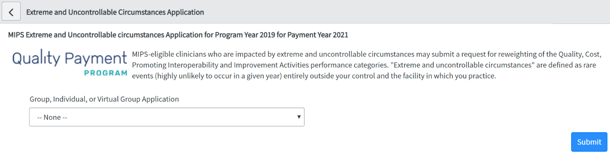

Individual:

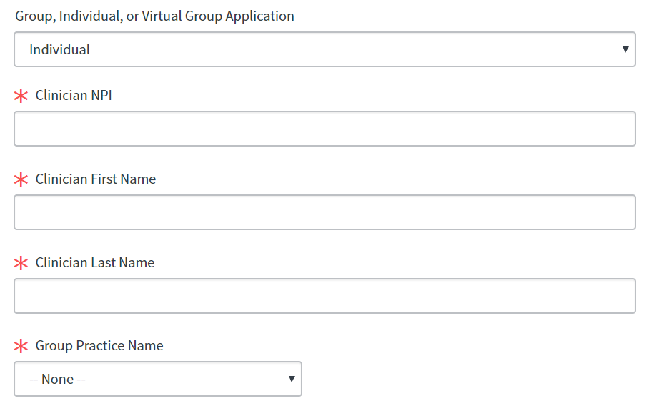

Individual- ‘Group Not Listed’ selected:

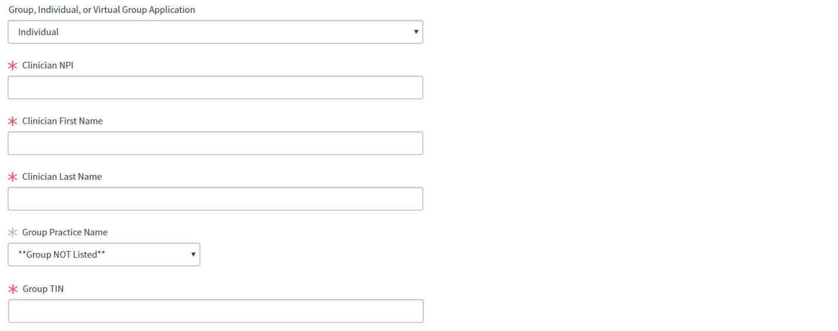

Group:

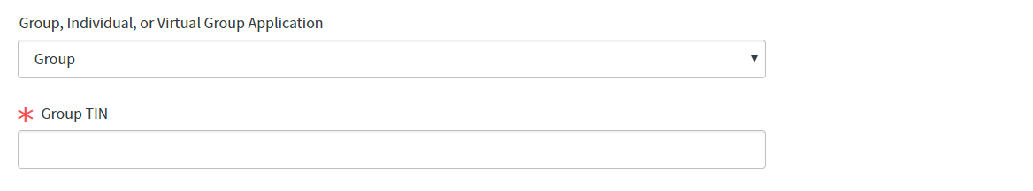

Virtual Group:

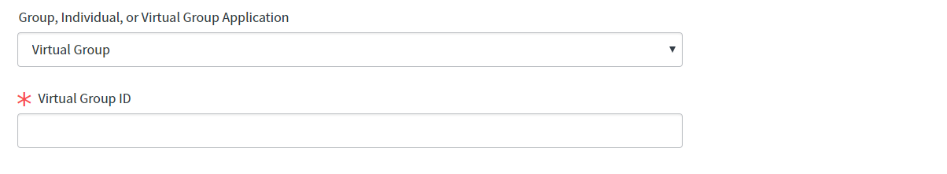

Submitter/Third Party Intermediary:

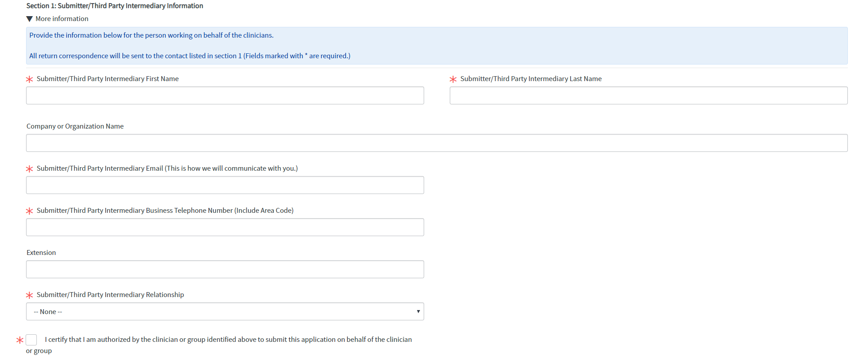

Form:

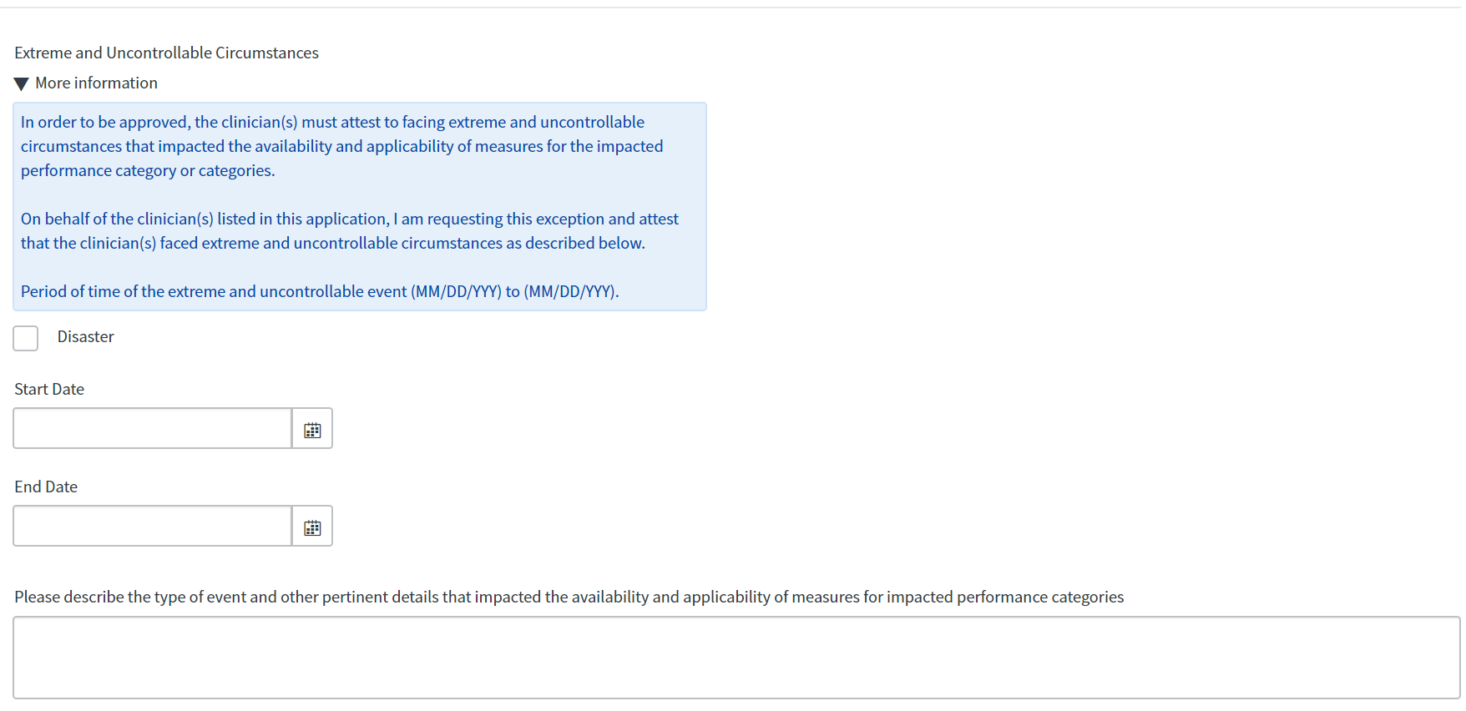

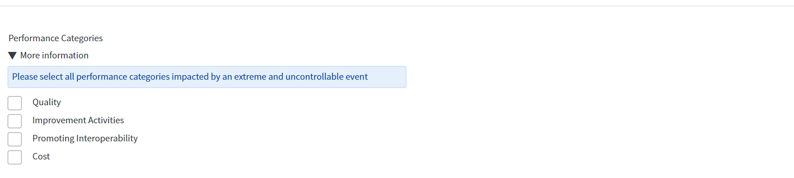

screenshot of certification statement for Q P P application. Includes general notice, checkbox for certification, date, and name of individual completing form.

**PRA Disclosure Statement**

According to the Paperwork Reduction Act of 1995, no persons are required to respond to a collection of information unless it displays a valid OMB control number. The valid OMB control number for this information collection is 0938-1314 (Expiration date: XX/XX/XXXX). The time required to complete this information collection is estimated to average 0.25 hours per response, including the time to review instructions, search existing data resources, gather the data needed, and complete and review the information collection. If you have comments concerning the accuracy of the time estimate(s) or suggestions for improving this form, please write to: CMS, 7500 Security Boulevard, Attn: PRA Reports Clearance Officer, Mail Stop C4-26-05, Baltimore, Maryland 21244-1850. ****CMS Disclosure**** Please do not send applications, claims, payments, medical records or any documents containing sensitive information to the PRA Reports Clearance Office. Please note that any correspondence not pertaining to the information collection burden approved under the associated OMB control number listed on this form will not be reviewed, forwarded, or retained. If you have questions or concerns regarding where to submit your documents, please contact QPP at qpp@cms.hhs.gov.