D O T seal**U.S. Department of Transportation Federal Aviation Administration**

OMB CONTROL NUMBER: 2120-0067 EXPIRATION DATE: 2/29/2020

|  |  |  |  |  |  |  |
| --- | --- | --- | --- | --- | --- | --- |
| **AIRPORT ACTIVITY SURVEY** (By Selected Operators) | | | | | **FAA Certificate Information Number and Date Issued** | |
| **Twelve-Month Period Covered:**  **January 1 through December 31, 2019** | | | | |  | |
| **DO NOT REPORT ACTIVITY PREVIOUSLY SUBMITTED to U.S. DOT on Form T-100** | | | | |
| **Operator Name and Address** | | | | |
| **Page of Pages** | | | | | | |
| **OPERATIONS DURING 12-MONTH PERIOD COVERED** | | | | | | |
| **DEPARTURE AIRPORT** | | | | | **ENPLANEMENTS** | |
| **Airport Location Identifier (LOCID)** | | **State** | **City** | **Airport Name** | **Number of Scheduled Enplanements (See Instructions)** | **Number of Nonscheduled Enplanements (See Instructions)** |
|  | |  |  |  |  |  |
|  | |  |  |  |  |  |
|  | |  |  |  |  |  |
|  | |  |  |  |  |  |
|  | |  |  |  |  |  |
|  | |  |  |  |  |  |
|  | |  |  |  |  |  |
|  | |  |  |  |  |  |
|  | |  |  |  |  |  |
|  | |  |  |  |  |  |
|  | |  |  |  |  |  |
|  | |  |  |  |  |  |
|  | |  |  |  |  |  |
|  | |  |  |  |  |  |
|  | |  |  |  |  |  |
|  | |  |  |  |  |  |
| I certify, under penalty of perjury, that the information provided in this Airport Activity Survey (Form 1800-31) is true and correct to the best of my knowledge, information, and belief. | | | | | | |
| **DATE** | **NAME AND TITLE OF PREPARING OFFICIAL** | | | **SIGNATURE** | | |

FAA Form 1800-31 (2/19) SUPESEDES PREVIOUS EDITION

D O T seal

U.S. Department of Transportation

**FAA Form 1800-31,**

**Airport Activity Survey** (By Selected Operators)

**Paperwork Reduction Act Burden Statement**

A federal agency may not conduct or sponsor, and a person is not required to respond to, nor shall a person be subject to a penalty for failure to comply with a collection of information subject to the requirements of the Paperwork Reduction Act unless that collection of information displays a currently valid OMB Control Number. The OMB Control Number for this information collection is 2120-0067. Public reporting for this collection of information is estimated to be approximately 90 minutes per response, including the time for reviewing instructions, searching existing data sources, gathering and maintaining the data needed, completing and reviewing the collection of information. All responses to this collection of information are voluntary. The FAA will use collected data to help allocate Airport Improvement Program (AIP) funds to airports as required by 49 United States Code (USC). Limited confidentiality is maintained. Send comments regarding this burden estimate or any other aspect of this collection of information, including suggestions for reducing this burden to: Information Collection Clearance Officer, Federal Aviation Administration, 10101 Hillwood Parkway, Fort Worth, TX 76177-1524.

## INSTRUCTIONS FOR FORM 1800-31, AIRPORT ACTIVITY SURVEY

(By Selected Operators)

The information requested on this form is voluntary, but it is needed for the FAA to fairly allocate Airport Improvement Program (AIP) passenger entitlement funds to the airports you serve.

This survey is restricted to on demand operations that are **not** reported to the U.S. Department of Transportation’s Bureau of Transportation Statistics (BTS). Carriers that are not required to report to BTS because they conduct less than five round trips between two points should report revenue enplanements on this form.

**Enplanements**: An enplanement is a revenue passenger who boarded the aircraft at that airport. Report the total scheduled or nonscheduled enplanements conducted at each airport in a calendar year as one line on the form. If the number of lines required is more than those provided on the form, please reproduce it for continued entries or enter your data into an excel file and include that with your submission. For a formatted excel version of the file, visit aep.airports.faa.gov. Note: If submitting enplanement data using the electronic signature method please use the formatted excel sheet for data entry.

**Scheduled or Nonscheduled**: The type of operation determines how enplanements are reported.

* + If you conducted charter operations, enter the number of revenue passengers that boarded those flights as Nonscheduled Enplanements in the last column.
  + If you conducted operations for which you offer in advance the departure location, departure time, and arrival location, enter the number of revenue passengers that boarded those flights in the Scheduled Enplanement column.
  + If you conducted both scheduled and nonscheduled operations, enter the scheduled enplanements in scheduled column and the nonscheduled enplanements in nonscheduled column.

Note that Part 135 on-demand certificates limit the number of scheduled passenger-carrying operations that may be conducted. These operations must be fewer than five round trips per week “on at least one route between two or more points according to published flight schedules,” and must use “airplanes, other than turbojet powered airplanes, having a maximum passenger-seat

FAA Form 1800-31

configuration of 9 seats or less, excluding each crewmember seat, and a maximum payload capacity of 7,500 pounds or less.” See 14 CFR 110.2 for more information.

By signing this form you certify, under penalty of perjury, that the information provided on this Airport Activity Survey Form (1800-31) is true, correct and complete to the best of your knowledge, information and belief. The certification represents that your files, records, documents, and data have not been manipulated or falsified in an effort to receive a more favorable allocation of AIP funds. A false or fictitious certification may be subject to criminal and/or civil prosecution, as well as appropriate administrative action.

If you had no commercial or air taxi activity during the reporting period, please sign and submit a notated form using the electronic submission instructions found at [aep.airports.faa.gov](https://aep.airports.faa.gov/Default.aspx), or indicate this across the face of this form and return it in the self-addressed envelope provided.

If there are any questions regarding the completion of this form, please contact FAA Headquarters, National Planning & Environmental Division, telephone number 202-267-9622.

If your name, address, or FAA Air Taxi/Commercial Operator Certificate Number is different from what is already printed on this form and you are planning to submit your information using this paper form please contact your local FAA Flight Standards District Office (FSDO) to correct the information.

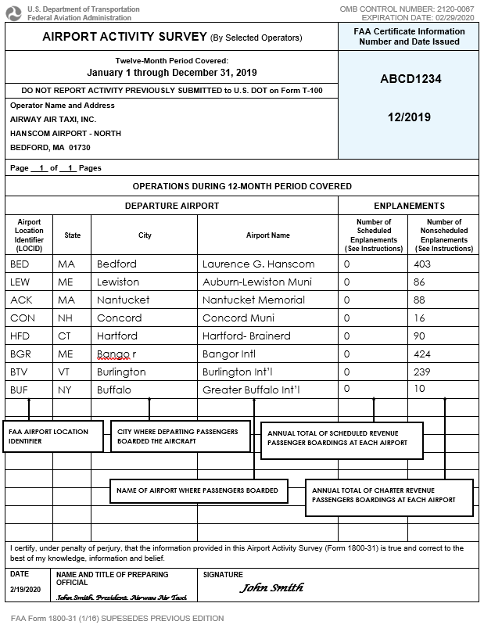



Office of Airport Planning and Programming National Airport Planning & Environmental Division

# ATCO Form (FAA Form 1800-31)

**Download and Submission Instructions**

# Deadline:

* + Calendar Year 2019 enplanement data is due to the FAA by **April 6, 2020**
  + For CY19 required submission password information, please contact [9-FAA-ARP-ACAIS@faa.gov](mailto:9-faa-arp-acais@faa.gov.) and copy [Luis.Loarte@faa.gov](mailto:Luis.Loarte@faa.gov).

**Electronic Submission Instructions (preferred method):**

The preferred method for submission of enplanement data is electronically via the Airports External Portal (AEP) website. Alternate instructions for submission can also be found directly below.

* + Navigate to the Federal Aviation Administration (FAA) Airports External Portal (AEP), at [aep.airports.faa.gov**.**](https://aep.airports.faa.gov/Default.aspx)
  + On the ***Warning Warning Warning*** splash page, please read and if you agree with the statement, click ***Agree*** on the bottom.
* You will be directed to the AEP home page. Do not log-in to AEP from this page. You can access the ***ATCO submission instructions*** directly on the bottom right portion of the page by clicking the ***Submit ATCO Data*** link.
* Follow the instructions on the ATCO Submission Instructions page to enter, certify, and submit your enplanement data.

**Alternate Submission Instructions:**

If you are unable to submit using the instructions above, you can still submit by downloading and printing the Airport Activity Survey form (FAA Form 1800-31) and submit a completed and signed form to the FAA via email or by physical mail.

Once completed and signed, submit the Airport Activity Survey Form 1800-31 by –

* + - Email to: [9-FAA-ARP-ACAIS@faa.gov](mailto:9-faa-arp-acais@faa.gov.)

Subject line: **CY19 Enplanement – Operator Name and FAA Certificate Information Number**

* + Submissions that cannot be submitted electronically can be mailed to:

Booz Allen Hamilton, Inc.

c/o Jeff Fossum

Attn: SOAR (FAA)

575 Herndon Parkway

Herndon, VA 20170

**Please Note:** Submissions **not** adhering to these requirements will be returned for correction.

* CY 2019 enplanement data **must** be accompanied by a Certification Statement and Signature from the authorized representative certifying, under penalty of perjury, that: “*I certify, under penalty of perjury, that the information provided in this Airport Activity Survey (Form 1800-31) is true and correct to the best of my knowledge, information and belief.”* This represents that **the submitted** files, records, documents, and data have not been manipulated or falsified in an effort to receive a more favorable allocation of AIP funds. A false, fictitious, or fraudulent certification may be subject to criminal and/or civil prosecution, as well as appropriate administrative action.