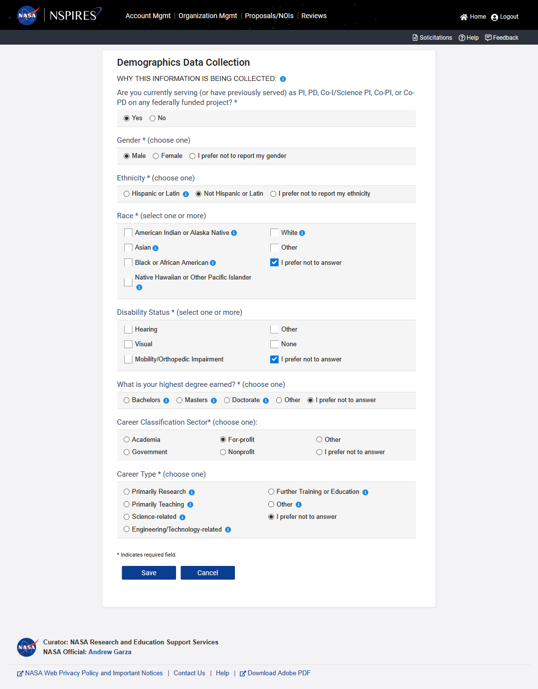

The following table shows the detail TEXT in the icon
icon | TEXT in pop up window
WHY THIS INFORMATION IS BEING COLLECTED: | NASA continually monitors the operation of its review and award processes to identify any inequities based on gender, ethnicity, race, or disability. Therefore, we are requesting additional demographic data to ensure compliance with Title VI of the Civil Rights Act of 1964, 42 U.S.C. § 2000d et seq., Title IX of the Education Amendments of 1972, 20 U.S.C. § 1681 et seq., Section 504 of the Rehabilitation Act of 1973, 29 U.S.C. § 701 et seq. and NASA’s implementing regulations at 14 CFR. §§1250, 1251, and 1253.  Submission of the requested information is voluntary and will not affect the organization's eligibility for an award. However, information not submitted will seriously undermine the usefulness, of information received from others. Any individual not wishing to submit some or all the information should check the box provided for this purpose.  Paperwork Reduction Act Statement  This information collection meets the requirements of 44 U.S.C. § 3507 as amended by section 2 of the Paperwork Reduction Act of 1995. You do not need to answer these questions unless we display a valid Office of Management and Budget (OMB) control number. The OMB control number for this collection is 2700-0161 and this information collection expires on 08/31/2022. We estimate that it will take 5 minutes to read the instructions, gather the facts, and answer the questions.  Send only comments relating to our time estimate to: Louis.M.Barbier@nasa.gov  All information collected is based on: NASA Form 1839 08/19 (1.1) NRRS 8/101  Approved O.M.B. No. 2700-0161 Expires: 08/31/2022
Hispanic or Latino | a person of Cuban, Mexican, Puerto Rican, South or Central American, or other Spanish culture or origin, regardless of race.
American Indian or Alaska Native | a person having origins in any of the original peoples of North or South America (including Central America), and who maintains tribal affiliation or community attachment.
Asian | a person having origins in any of the original peoples of the Far East, Southeast Asia, or the Indian subcontinent, including, for example, Cambodia, China, India, Japan, Korea, Malaysia, Pakistan, the Philippine Islands, Thailand, or Vietnam.
Black or African American | a person having origins in any of the black racial groups of Africa.
Native Hawaiian or Other Pacific Islander | a person having origins in any of the original peoples of Hawaii, Guam, Samoa, or other Pacific islands.
White | a person having origins in any of the original peoples of Europe, the Middle East, or North Africa.
Bachelors | B.A., B.S., etc.
Masters | M.A., M.S., MBA, etc.
Doctorate | Ph.D, Ed.D, etc.
Primarily research | The primary, although not necessarily the only, focus is the conduct or oversight of scientific or technological research.
Primarily teaching | The primary, although not necessarily the only, focus is education and teaching.
Science-related | Career that is relevant to the conduct of scientific research, but does not directly conduct or oversee research activities
Engineering/Technology-related | Career that is relevant to the conduct of engineering or technology.
Further training or education | Postdoctoral research, completing medical residency, or pursuing an additional degree.
Other | Select this if none of the other Career Types matches your career.

