Individual Information Collection Request
Under GSA’s Generic Clearance: Improving Customer Experience - Implementation of Section 280 of OMB Circular A-11
OMB Control No. 3090-0321

QUESTIONS:
Please include all questions and response options (either multiple choice options or free text fields, etc.):
(Page 1)
- I am satisfied with the service I received from the program area.
- Strongly Disagree
- Disagree
- Neutral
- Agree
- Strongly Agree

- This interaction increased my confidence in the program area.
- Strongly Disagree
- Disagree
- Neutral
- Agree
- Strongly Agree

- How could we have made your experience better?
(Free Text Field)

(Page 2)

- Please rate your satisfaction with the accuracy of information found on the FAQ Site (www.hud.gov/answers).
- Very Dissatisfied
- Dissatisfied
- Neutral
- Satisfied
- Very Satisfied

- Please rate your satisfaction with your ability to effectively search the FAQ Site for policy or program information (www.hud.gov/answers).
- Very Dissatisfied
- Dissatisfied
- Neutral
- Satisfied
- Very Satisfied

- My need was addressed.
- Strongly Disagree
- Disagree
- Neutral
- Agree
- Strongly Agree

- It was easy to complete what I needed to do.
- Strongly Disagree
- Disagree
- Neutral
- Agree
- Strongly Agree

- It took a reasonable amount of time to do what I needed to do.
- Strongly Disagree
- Disagree
- Neutral
- Agree
- Strongly Agree

- I was treated fairly.
- Strongly Disagree
- Disagree
- Neutral
- Agree
- Strongly Agree

- Employees I interacted with were helpful.
- Strongly Disagree
- Disagree
- Neutral
- Agree
- Strongly Agree

SCREENSHOTS:
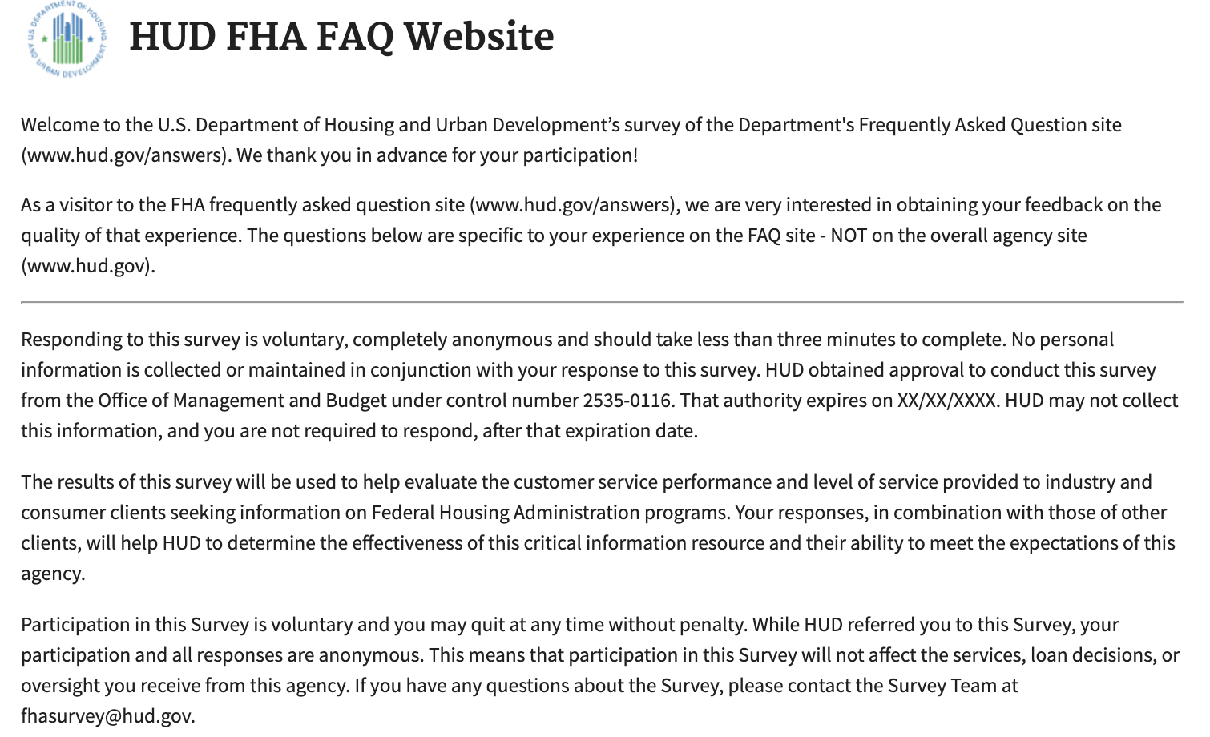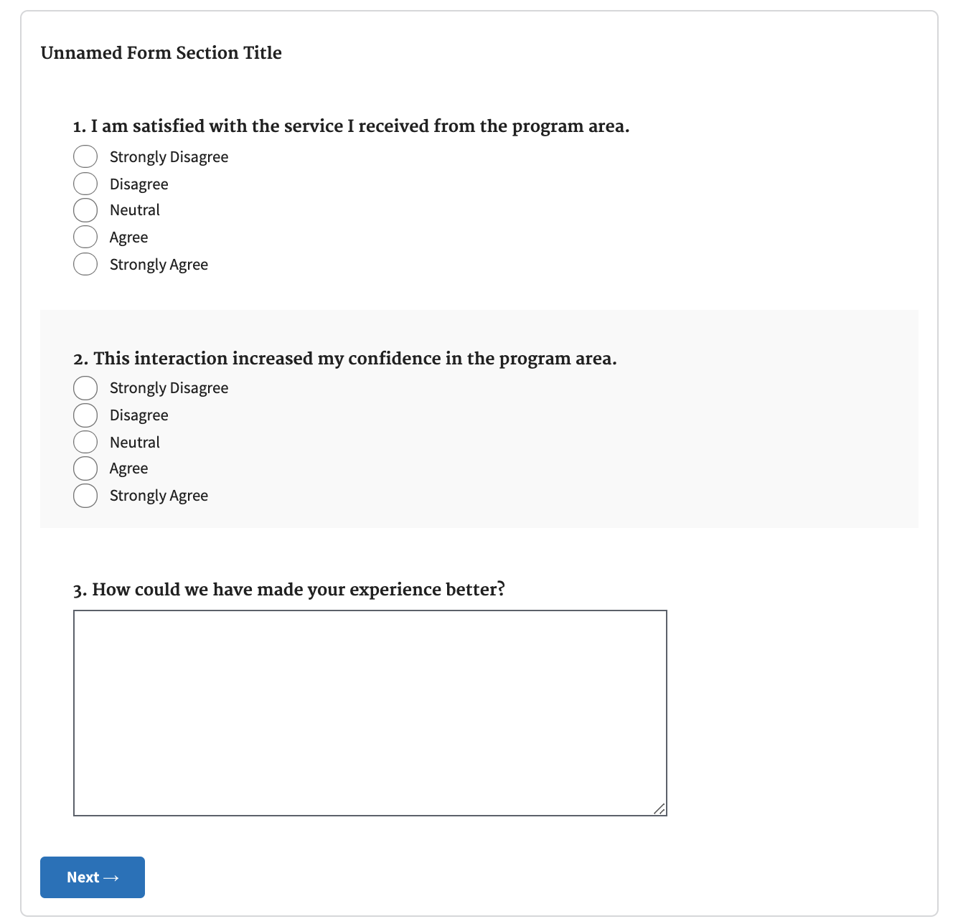
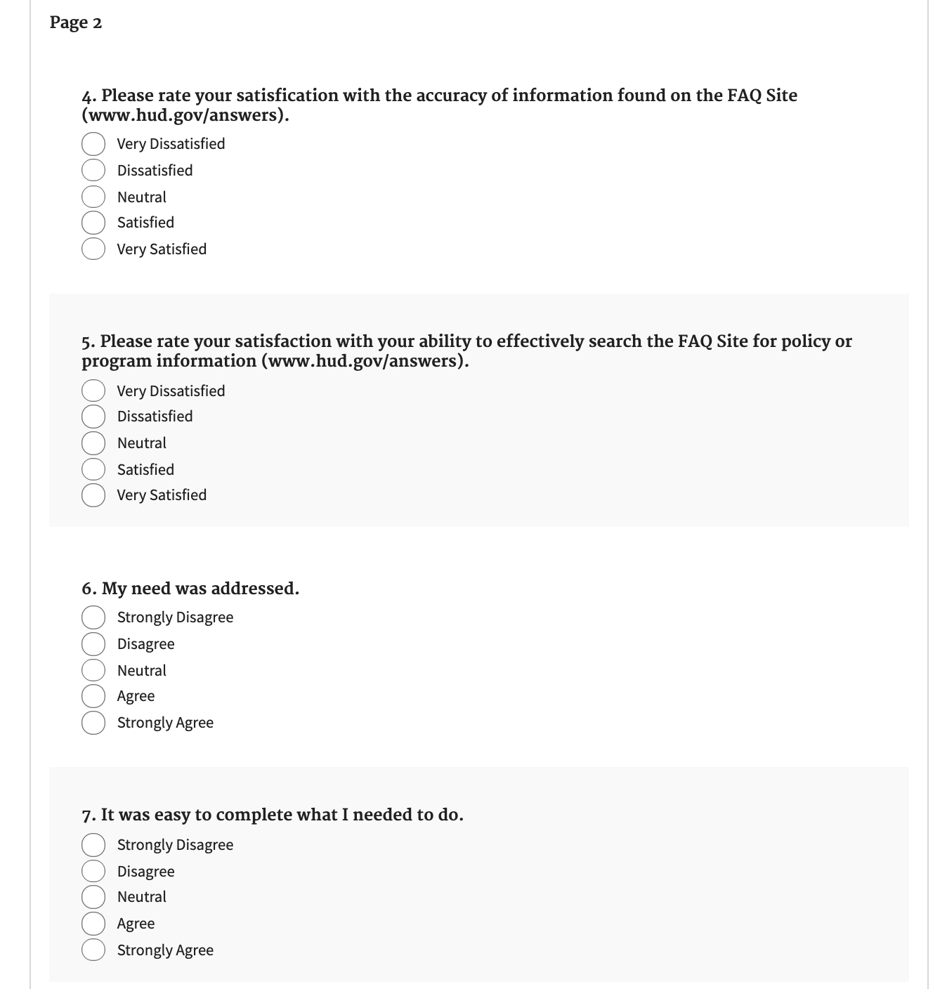
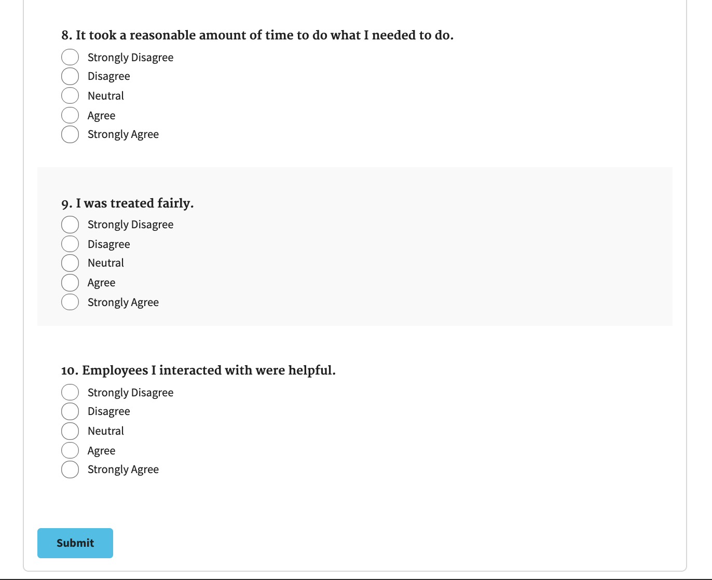

ADMINISTRATION DETAILS:
The following will be displayed on this Touchpoints survey:
OMB Control No. 0690-0030, Expiration Date: XX/XX/XXXX

