Non-substantive Change Request to Ag Land Value Survey and the June Area Survey 0535-0213

NASS is requesting non-substantive changes to two different questionnaires – the Ag Land Value survey and the June Area Survey (JAS). Ag Land Value estimates are published based on data collected from these two surveys. The Ag Land Value Survey is used to supplement the data collected in the JAS. Due to the nature of the JAS survey not enough segments are drawn in some States to be able to collect enough data to set land value estimates. Therefore in ten States (Arizona, Connecticut, Maine, Massachusetts, Nevada, New Hampshire, Rhode Island, Utah, Vermont and Wyoming) the supplemental Ag Land Value Survey will be used. The non-substantive changes that are being requested will be the same in both questionnaires used in each State.

After conducting over 70 debriefing interviews with enumerators, several minor changes were identified for these questionnaires. Historically, NASS has published a land value for total acres operated, cropland acres, irrigated cropland acres, non-irrigated cropland acres, pasture acres, and value of farmland and buildings. NASS used to collect average market values for land owned, land rented in, and land rented out and then derive an average value of land. To simplify the questionnaire NASS will now only ask for the total market value of all land and buildings on the acres operated.

Previously asked questions:

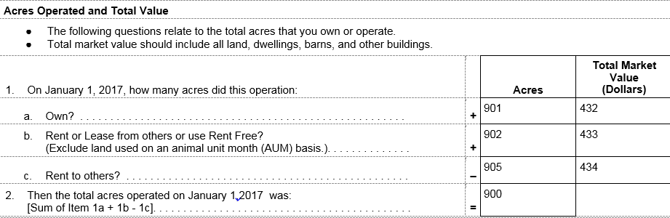

Revised Questions:

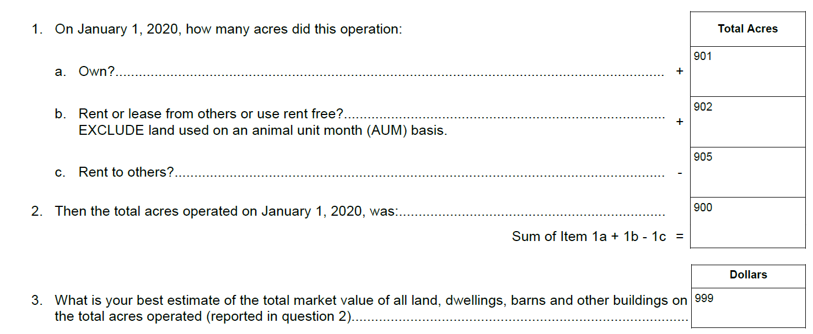

In addition, on both the Land Values and JAS questionnaires the following question is being dropped -

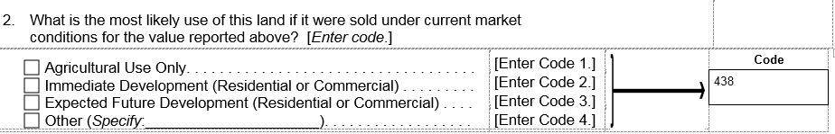

This item was used to assist in editing, but was not published. Many farm operators were not sure what the future owners would be doing with the land.

Changes were made to introduction text, the order of some questions was changed, and some minor grammatical changes have been made to the “include” and “exclude” statements to make the survey easier to understand.

There are no changes to the sample size or respondent burden as a result of these two changes.