Appendix M. Conceptual Framework for MCS Functions Diagram
OMB No. 0584-XXXX
Modernizing Channels of Communication
With SNAP Participants
March 2, 2020
Project Officer: Andrew Burns
Office of Policy Support
Food and Nutrition Service
U.S. Department of Agriculture
1320 Braddock Place
Alexandria, VA 22314
703.305.1091
Andrew.Burns@usda.gov

Modernizing Channels of Communication With SNAP Participants: Conceptual Framework for MCS Functions Diagram
PURPOSE: During the site visits and focus groups, the study team will distribute the framework to interviewees and focus group participants for their review and to gather stakeholder feedback about each step on the path. The goal will be to develop a unique participant “journey map” depicting how participants in each State typically engage with the MCS and the successes and challenges they encounter.
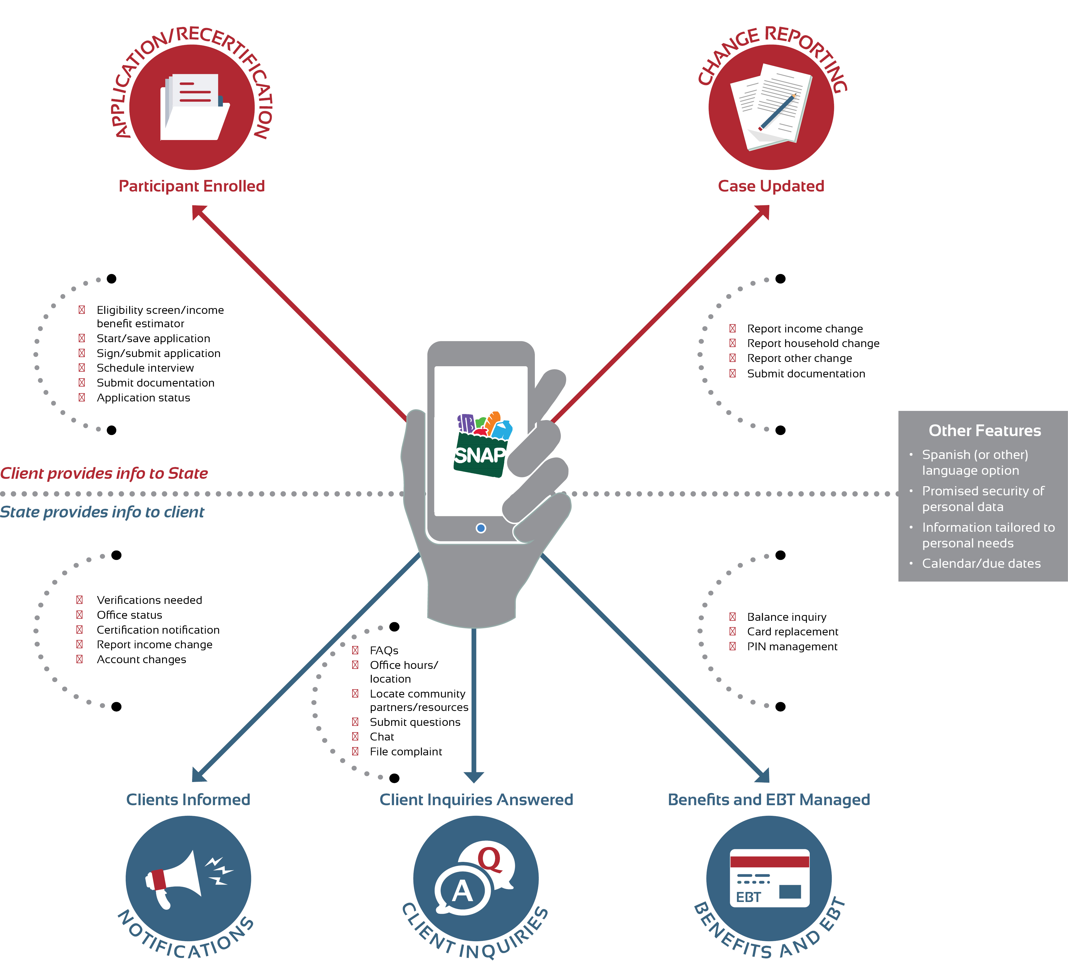
According to the Paperwork Reduction Act of 1995, an agency may not conduct or sponsor, and a person is not required to respond to, a collection of information unless it displays a valid OMB control number. The valid OMB control number for this information collection is 0584-xxxx. The time required to complete this information collection is estimated to average 1 hour per response, including the time for reviewing instructions, searching existing data sources, gathering and maintaining the data needed, and completing and reviewing the collection of information. Send comments regarding this burden estimate or any other aspect of this collection of information, including suggestions for reducing this burden, to the following address: U.S. Department of Agriculture, Food and Nutrition Services, Office of Policy Support, 1320 Braddock Place Alexandria, VA 22314, ATTN: PRA (0584-xxxx). Do not return the completed form to this address.

