NAF Retail Point of Sale System

**Special Orders**



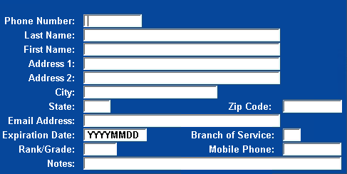

**Rain Checks**

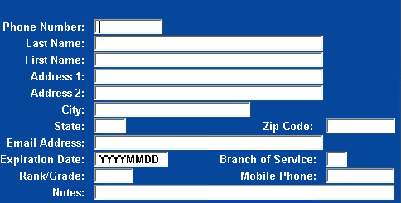

**Send Sales**

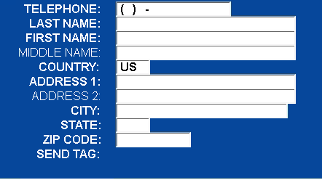

**Returns/Exchanges**

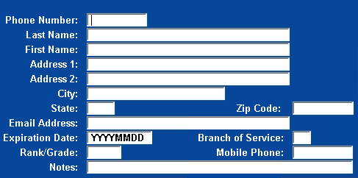

**Check Cashing**









**Check Tendering**









**Recruit Tenders**

