**Attachment G**

**Informed Consent**

|  |  |
| --- | --- |
|  |  |

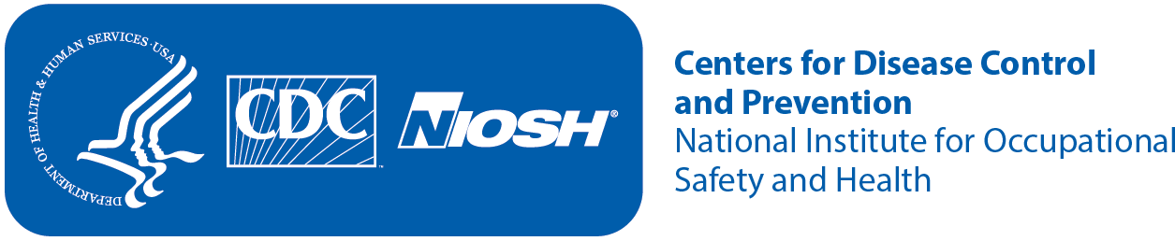

|  |  |  |
| --- | --- | --- |
| **Consent to be in a Research Study**  **Formative Evaluation of an Immersive VRMine Rescue Contest Simulation Exercise** | | |
| **1** | **Key Information** | The National Institute for Occupational Safety and Health (NIOSH) and the Mine Safety and Health Administration (MSHA) have joined forces to collaborate on the development and introduction of an immersive virtual reality (“VRMine”) mine rescue contest simulation exercise at the International Mine Rescue Competition (IMRC) in Beckley, WV. The VRMine simulation activity will be incorporated into the structure of the mine rescue competition to serve as a supplemental team training activity but will not be included in the team performance assessment or official scoring. During the VRMine demonstration, NIOSH will also be conducting research to evaluate the technical feasibility and utility of virtual reality for mine rescue team training as well as its fidelity, usability, and acceptability from the perspective of its end users (mine rescue teams and trainers). |
| **2** | **Who is conducting the study?** | NIOSH is a federal agency that studies worker safety and health. We are part of the Centers for Disease Control and Prevention (CDC). NIOSH is partnering with the MSHA to improve mine rescue team training interventions for the mining industry. |
| **3** | **What is the purpose?** | The purpose of this activity is to gather data from mine rescue teams regarding participation in an immersive VRMine rescue simulation activity. The study objective is to generate the knowledge required to inform decisions surrounding whether and how this technology might be further developed and refined to benefit the mine rescue team community. |
| **4** | **What will I do?** | You will be asked to answer questions designed to capture your reactions to your participation in the VRMine rescue simulation activity and allow researchers to observe your interactions with your team members and the VR technology. These data collections will be conducted in safe, above-ground facilities and the MSHA Academy and your participation will last no longer than 30 minutes. All responses will be combined to inform the improvement of virtual reality for mine rescue training and may be published to benefit the wider mining and VR communities. No individually identifying information will be collected or used. |
| **5** | **When, where, for how long** | We will conduct this study at the International Mine Rescue Competition in Beckley, WV in the Spring of 2021, during your scheduled orientation rotation activities. Your total direct participation in this study will be one-time only and last no longer than 30 minutes and will occur during your planned time for the VRMine demonstration. |

|  |  |  |
| --- | --- | --- |
| **Consent to be in a Research Study**  **Formative Evaluation of an Immersive VRMine Rescue Contest Simulation Exercise** | | |
|  | **will I be needed?** |  |
| **6** | **Are there any risks?** | This data collection does not present any more than minimal risk. If you become uncomfortable answering any of the questions at any time during the study, your consent will be withdrawn immediately.  There is a slight risk that the information we collect about you could be accidently disclosed to someone else, which may cause you to experience psychological or social stress due to your loss of privacy. We will minimize this risk by identifying your samples and data collection forms by code only and by only releasing summaries of all the data to your employer or in publications. |
| **7** | **Is my participation voluntary?** | Your participation in the study is voluntary. You may choose to answer any or all questions. You may decline to participate or drop out at any time, for any reason, with no penalty or loss of benefits to which you are otherwise entitled. Your participation in the research study is not a requirement to continue participation in the VRMine demonstration. The research study and the demonstration are separate activities. |
| **8** | **What if I am injured or harmed at a NIOSH**  **research facility or at another location where the NIOSH research project is being conducted?** | NIOSH will summon emergency medical aid by calling 911. If NIOSH finds your injury was a direct result of participation in the study and if appropriate documentation is provided, NIOSH may provide short-term medical treatment that it deems necessary to treat the immediate medical needs arising from the injury. In general, no long-term medical care or financial compensation of research-related injuries will be provided by NIOSH, the CDC, or the Federal Government. However, if you believe NIOSH has been negligent in conducting the research study and you believe you have suffered a harm as a result, you have the right to pursue a legal remedy under the Federal Tort Claims Act (28 U.S.C. §§ 2671-2680 and 28 U.S.C. § 1346(b)). To learn more about how to file a Federal Tort claim, call the General Law Division of the HHS Office of the General Counsel at (202) 619-2155 or go to [https://](https://www.hhs.gov/about/agencies/ogc/key-personnel/general-law-division/index.html) [www.hhs.gov/about/agencies/ogc/key-personnel/general-law-division/index.html.](https://www.hhs.gov/about/agencies/ogc/key-personnel/general-law-division/index.html) |
| **9** | **Will I be reimbursed or paid?** | You will not be paid or reimbursed for participating. |

|  |  |  |
| --- | --- | --- |
| **Consent to be in a Research Study**  **Formative Evaluation of an Immersive VRMine Rescue Contest Simulation Exercise** | | |
| **10** | **Are there other benefits?** | You will not receive any direct benefits from participating in this study although participation in this research will help scientists to better understand mine rescue team training needs and may help to better prepare mine rescue teams to effectively respond to mine emergencies in the future. |
| **11** | **What alternative procedures might benefit me?** | No alternative procedures are available for this study. |
| **12** | **Will my personal information be kept private?** | The study is anonymous. We will not be collecting or recording any personal identifiable information. |
| **13** | **Will I or anyone else receive study results?** | Anonymous responses will be recorded to develop summary results to inform further development and/or improvement of this virtual reality mine rescue training. Final results may be published as part of stakeholder outreach to describe actions taken as a result of the summary reports. We will not share individual responses with your company or worker representative, such as a union. The summary report will be provided to you upon request. |
| **14** | **Who can I talk to if I have more questions?** | For questions about the research study, contact the principal investigator, Cassandra Hoebbel at [CHoebbel@cdc.gov](mailto:CHoebbel@cdc.gov) or 1.412.386.6133.  For questions about your rights, your privacy, or harm to you, contact the Chair of the NIOSH Institutional Review Board (IRB) in the Human Research Protection Program at 1.513-533-8591. |
| **15** | **Verbal Consent** | The study was explained to me. My questions were answered. By completing the survey and/or interview I agree to be in the study. I understand I can withdraw consent at any time. |