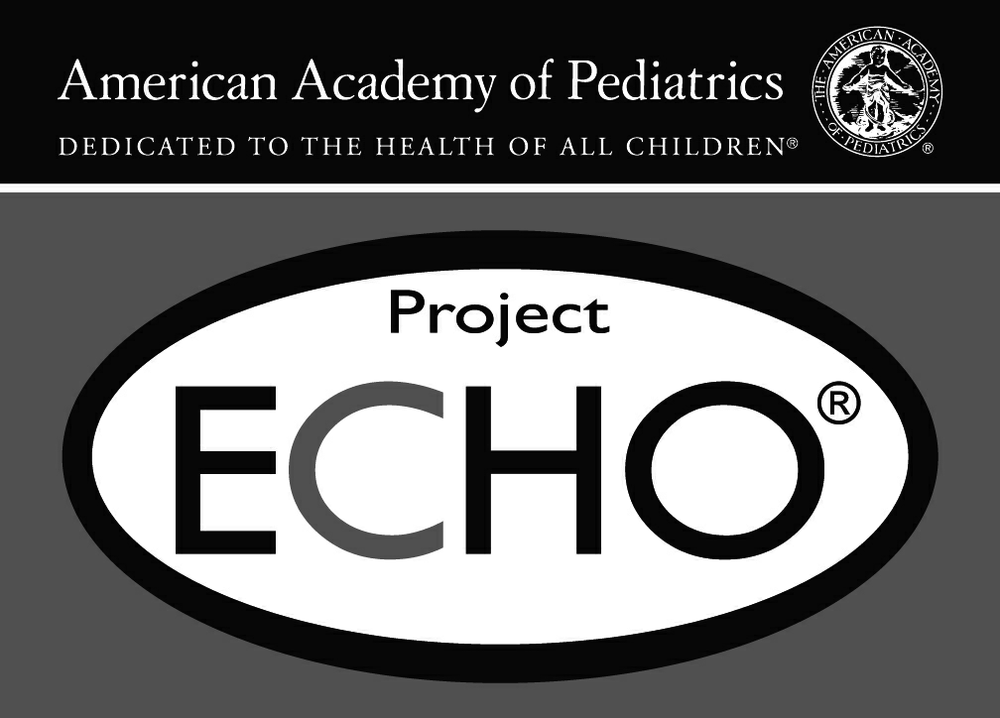
Form Approved
OMB No. 0920-1154
Exp. Date 1/31/2023

AAP Neurodevelopment ECHO Post-Program Survey
Thank you for participating in an evaluation of the AAP Neurodevelopment ECHO program. This program is supported by the Cooperative Agreement Number, NU38OT000282, funded by the Centers for Disease Control and Prevention. Its contents are solely the responsibility of the authors and do not necessarily represent the official views of the American Academy of Pediatrics, Centers for Disease Control and Prevention or the Department of Health and Human Services.

To understand how well this program met the needs of learners and achieved the objectives of increasing participant knowledge and confidence to appropriately identify and care for children with neurodevelopmental delays, we ask you to complete the following survey.

All data collected is confidential and will not be associated with your name or place of work. Data will be stored on password protected computers and responses will be combined with other participants' responses and will be reported in aggregate for dissemination. Your name or any other identifying information will not be disclosed through reports, publications or presentations related to this TeleECHO program.

This program has been reviewed and approved by the AAP Institutional Review Board (IRB). The risks involved with completing this survey are no greater than the risks a person may find in their daily life. You do not have to answer any question that you do not wish to answer, and you may stop completing the survey at any time.

If you have any questions, please contact AAP Program Manager Shannon Limjuco at (630) 626- 6217 or slimjuco@aap.org. Thank you for your time and commitment to the AAP Neurodevelopment ECHO program!
* 1. To take the survey, please select NEXT. To end this survey, please select END.
 NEXT END
Public reporting burden of this collection of information is estimated to average 10 minutes per response, including the time for reviewing instructions, searching existing data sources, gathering and maintaining the data needed, and completing and reviewing the collection of information. An agency may not conduct or sponsor, and a person is not required to respond to a collection of information unless it displays a currently valid OMB control number. Send comments regarding this burden estimate or any other aspect of this collection of information, including suggestions for reducing this burden to - CDC/ATSDR Reports Clearance Officer; 1600 Clifton Road NE, MS D-74, Atlanta, Georgia 30333 ATTN: PRA (0920-1154).

AAP Neurodevelopment ECHO Post-Program Survey
- 2. To date, approximately how many AAP Neurodevelopment ECHO sessions did you attend?
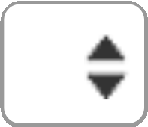

- 3. What is your gender?
Female Male
 Prefer to self-describe

- 4. Please list your state and zip code

- 5. Which of the following best describes your professional training?
Physician (MD/DO) Nurse Practitioner Physician Assistant Nurse
Social Worker
Other (please specify)

* 6. Which of the following best describes your professional position?
Primary care provider who sees children, youth and adults
Primary care provider who exclusively sees children and youth
Specialist/subspecialist in Developmental and Behavioral Pediatrics Specialist/subspecialist in neurology
Administrative/Support Staff Other (please specify)

* 7. Which of the following best describes your primary practice setting?
Solo practice
Two physician practice Pediatric group practice
Family medicine group practice
Multispecialty group practice (other than staff model HMO) Health maintenance organization (staff model)
Medical school or parent university Non-government hospital or clinic
City/county/state government hospital or clinic
U.S. government hospital or clinic Nonprofit community health center Other (please specify)

* 8. Please indicate your practice/organization's location:
Urban, inner city Urban, not inner city Suburban
Rural

- 9. What percentage (%) of your patient population would be considered underserved?

- 10. Please indicate the number of years in practice/profession:

- 11. Please estimate the number of children and youth that you see in an average month.

- 12. Please estimate the number of children and youth that you see in an average month with neurodevelopmental delays.

- 13. FOR HEALTH CARE PROFESSIONALS ONLY: Do you consider your practice to be a medical home? (In a medical home, the care team works in partnership with a child and a child’s family. At a medical home, the medical and non-medical needs of the child are met. Through this partnership, the care team can help the family and child access, coordinate, and understand specialty care, educational services, out-of-home care, family support, and other public and private community services that are important for the overall health of the child and family).
Yes No
Don't know

Not a health care professional

- 14. Is your practice an accredited or certified medical home?

Yes No
Don't know



AAP Neurodevelopment ECHO Post-Program Survey
The questions below ask you to rate your knowledge and confidence in the provision of care for children and youth with neurodevelopmental delays before and after the Neurodevelopment ECHO.

* 15. Please rate your KNOWLEDGE around identification and care for children with neurodevelopmental disorders.
If you did not attend the ECHO session that corresponds to a particular topic or content area, please choose the "N/A" response for both the BEFORE and AFTER question.
Please rate BEFORE participating in Please rate AFTER participating in Neurodevelopment ECHO: Neurodevelopment ECHO:
Understanding AAP practice guidelines for developmental surveillance and screening
The importance of obtaining a birth history or prenatal alcohol and drug exposures
A systematic approach to identifying a neurodevelopmental delay
The general etiologic basis of neurodevelopmental disorders
Common co-morbidities and functional impairments associated with neurodevelopmental disorders
The rationale for distinguishing between ADHD and FASD
Considerations involved in making an appropriate referral for FAS diagnostic assessment
The pediatrician's role as a medical home in
managing the care of children with suspected or   identified neurodevelopmental delays
Recommended treatments and interventions for children with identified neurodevelopmental delays
Support services and resources for providers and
families of children impacted by   neurodevelopmental delays
The specifics of care coordination for children with neurodevelopmental disorders
Strategies, tools and resources to increase family
engagement in the developmental screening 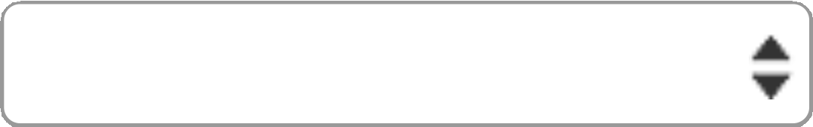  process
Specific support tools to assist parent's access to referred services
Response Scale
Very knowledgeable
Knowledgeable
Not very knowledgeable
Not at all knowledgeable
N/A









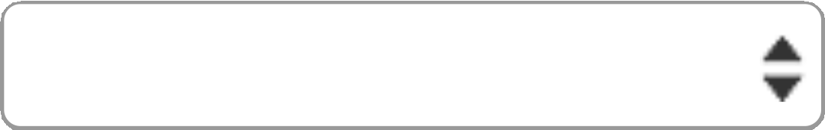

* 16. Please rate your CONFIDENCE around identification and care for children with neurodevelopmental disorders.
If you did not attend the ECHO session that corresponds to a particular topic or content area, please choose the "N/A" response for both the BEFORE and AFTER question.
Please rate BEFORE participating in Please rate AFTER participating in Neurodevelopment ECHO: Neurodevelopment ECHO:
Incorporating developmental and behavioral
surveillance into practice workflow
Incorporating developmental and behavioral
screening into practice workflow
Determining necessary follow-up for children identified at risk for developmental delays based on developmental screening tool results
Developing a network of local intervention, referral and follow-up resources for neurodevelopmental and behavioral concerns
Improving my practice's developmental screening process
Response Scale:
Very confident, Confident, Somewhat confident, Not confident, N/A
* 17. Quality Improvement (QI) for care of children with neurodevelopment disorders in your practice(Select the N/A response if your practice team did not participate in the QI component)
Please rate BEFORE participating in Please rate AFTER participating in Neurodevelopment ECHO: Neurodevelopment ECHO:
I am able to use the Institute for Healthcare Improvement (IHI) model for Quality Improvement in my practice
I am able to explain quality improvement principles, approaches and techniques to colleagues
I understand different data sources and measurement methods that can be used to assess quality of care and essential system functions (e.g. record review, observation, simulation, etc)

I am able to write an aim statement

I am able to interpret/apply QI data in practice

I can implement strategies to sustain improvement efforts

Response Scale
Strongly agree, agree, neutral, disagree, strongly disagree, N/A






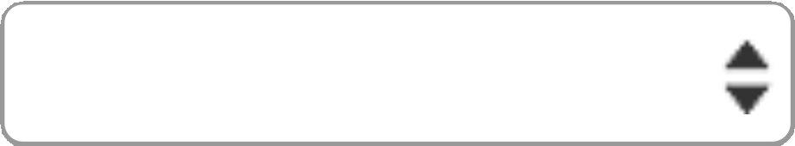











AAP Neurodevelopment ECHO Post-Program Survey
Program Experience
These next questions ask about your Neurodevelopment ECHO program experience. As a reminder, responses are confidential and will be aggregated for analysis with other participant responses.
Results will be used by program developers to improve the training experience.

* 18. Please indicate how much you agree or disagree with the following statements:

Neurodevelopment ECHO provided an appropriate balance between instruction and practice.
Neurodevelopment
ECHO was a valuable 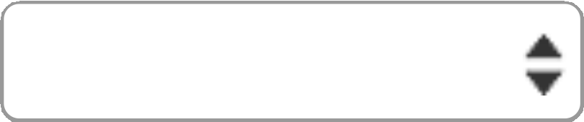 use of my time.
Neurodevelopment ECHO contributed to my professional network.
Neurodevelopment ECHO content was relevant to my patient population.
My understanding of the subject matter has improved as a result of participating
in Neurodevelopment ECHO.
My interest in the subject matter has increased as a
result of participating
in Neurodevelopment
ECHO.
Neurodevelopment ECHO participation made me better at my job.
Neurodevelopment ECHO participation increased my professional satisfaction.
Neurodevelopment ECHO participation made me feel less isolated.
The quality improvement component was a
valuable component of
Neurodevelopment
ECHO.
I was satisfied with the overall training.
Response Scale
Strongly agree, agree, neutral, disagree, strongly disagree



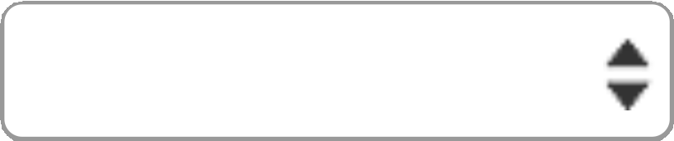
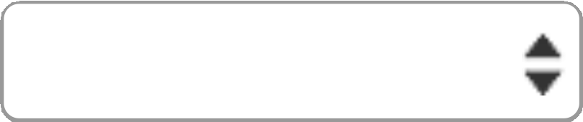

- 19. What change(s), if any, have you made or do you plan to make in your practice as a result of participating in this ECHO? (Select all that apply)
Change in current best practice or guideline in my work Change in my professional practice
Change in a policy or procedure

I do not plan to make any changes in my practice Other (please specify)

- 20. From the list below, please indicate which factors will be barriers in applying what you have learned from this ECHO to your work. (select all that apply)
No barrier

Insufficient knowledge Insufficient skill set
Lack of support from coworkers Lack of support from management Other (please specify)

AAP Neurodevelopment ECHO Post-Program Survey
21. What support do you need to overcome the barrier(s) you selected above?

AAP Neurodevelopment ECHO Post-Program Survey
* 22. Participation in Neurodevelopment ECHO has made my practice's clinical and operational work (eg, scheduling, workflow, patient care):
Much easier
Somewhat easier About the same
Somewhat more difficult Much more difficult
N/A - I did not take part in the QI component

- 23. What was most valuable about the Neurodevelopment ECHO?

- 24. What was least valuable about the Neurodevelopment ECHO?

25. Please provide an example of how your participation in Neurodevelopment ECHO has positively impacted the health and well-being of your patient/patients.

* 26. Have you shared anything you have learned through your participation in the Neurodevelopment ECHO with one or more colleagues?
No

Yes (if yes, please provide an example)

27. AAP ECHO staff are always interested to learn more about the clinical outcomes of Project ECHO. If there is something that you would like to share about yourself or how your participation in this ECHO directly impacted a patient or your subset of patients with neurodevelopmental delays, please use this space. Because this survey is anonymous, your personal information will not be connected with any information you share. NOTE: Because stories may be included in future AAP newsletters, websites, social media posts, etc, please do NOT include any protected patient health information.

Thank you for your participation!

