From: Kelly, Erin <ekelly@aap.org>
Sent: Wednesday, January 30, 2019 12:18 PM
To: Calabrese, Trisha <TCalabrese@aap.org>; Limjuco, Shannon <slimjuco@aap.org>
Cc: Kelly, Erin <ekelly@aap.org>
Subject: AAP IRB Approval for Exempt Submission

American Academy of Pediatrics (AAP)
Institutional Review Board (IRB) Approval Notice
Exempt New Study

PROTOCOL TITLE: AAP Neurodevelopment ECHO

AAP IRB #: 18 CA 02

PRINCIPAL INVESTIGATOR: Trisha Calabrese, MPH

AAP STAFF: Shannon Limjuco, MPH

DATE OF SUBMISSION: 12/3/18

DATE OF APPROVAL: 12/6/18
_____________________________________________________________________

The American Academy of Pediatrics Institutional Review Board (AAP IRB) reviewed and determined, as authorized by 45 CFR 46.101, that the above-named protocol is exempt from federal regulations and meets at least one of the federal exemption categories.

Exempt status does not exempt investigators from performing ethical research nor does it allow investigators to abdicate the responsibility to act in the public good.

No further contact with the IRB is required unless you plan to make significant changes to the approved protocol. Please consult the attached document for guidance on what changes must be submitted in the form of an amendment. Please contact the AAP IRB Administrator, Erin Kelly (ekelly@aap.org or 630-626-6075) with any questions.

Best wishes for a successful project,

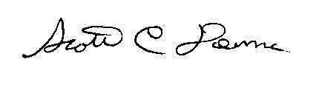

Scott C. Denne, MD
AAP IRB Chair

