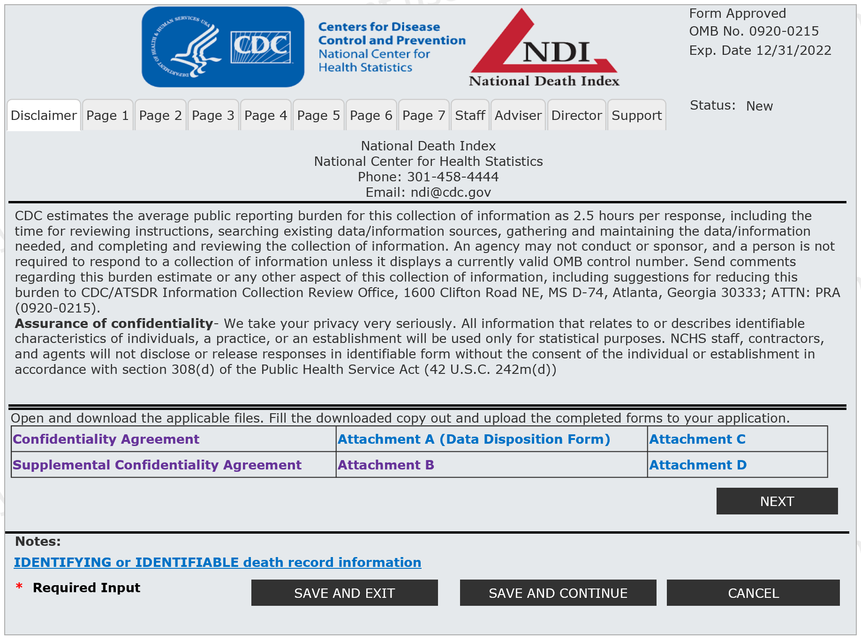

Notice: CDC will keep the information you provide on the NDI application and forms private and secure to the extent permitted by law.

XX/XX/20XX

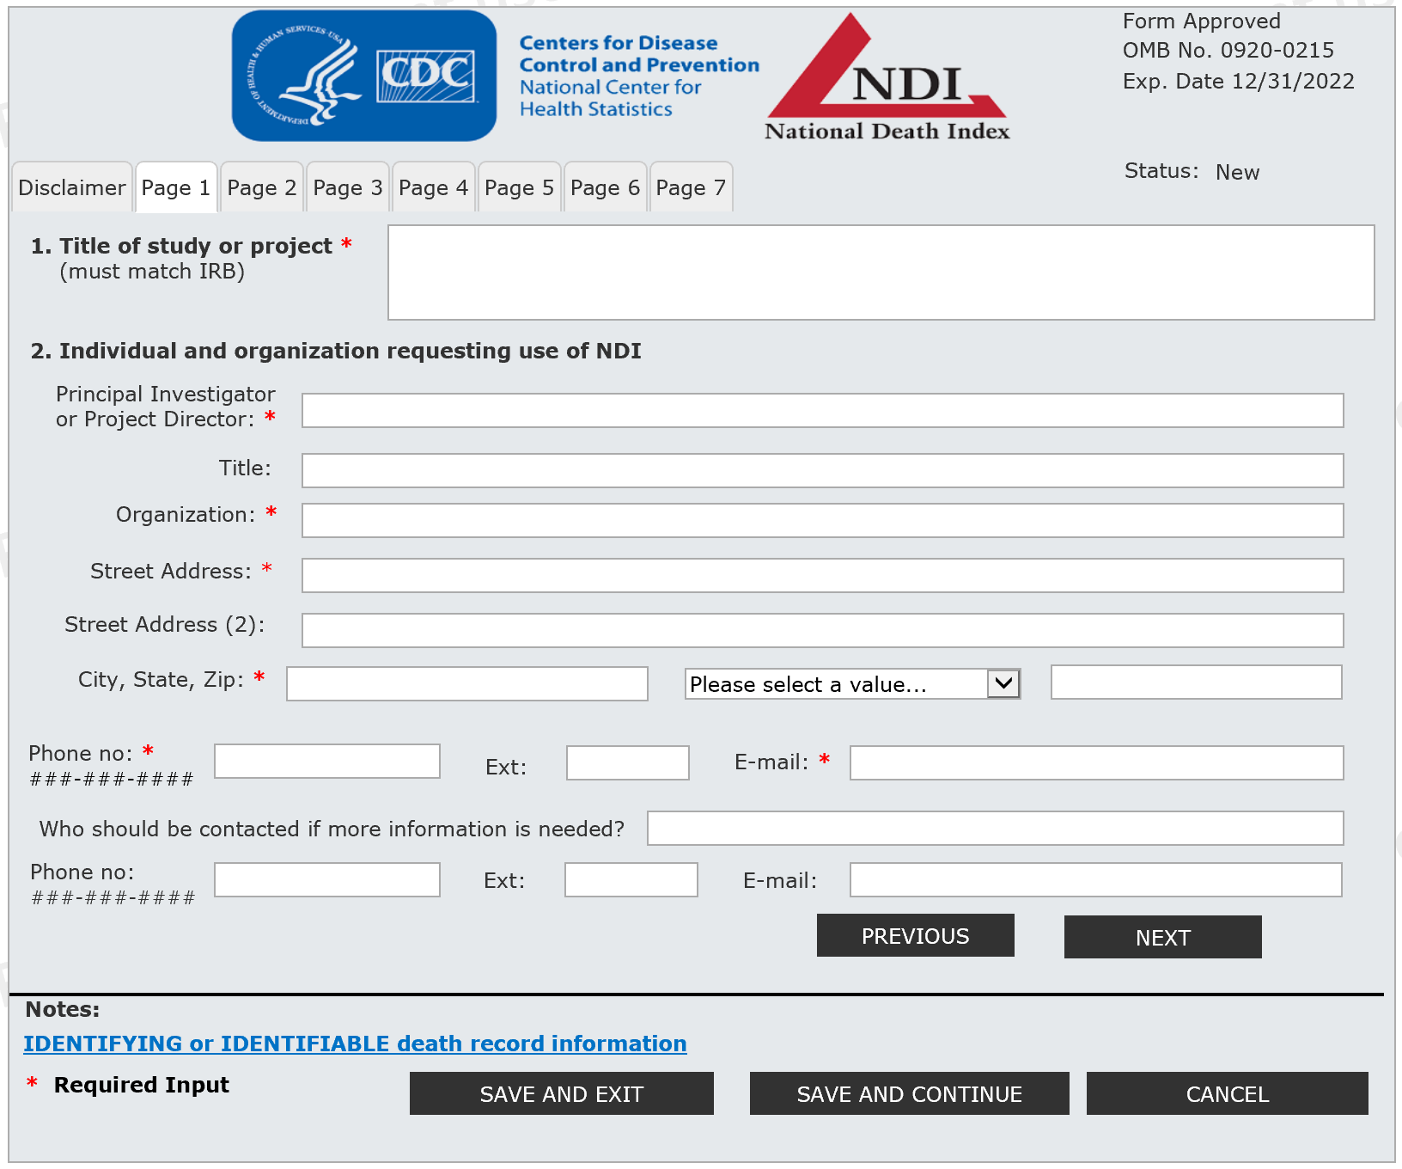

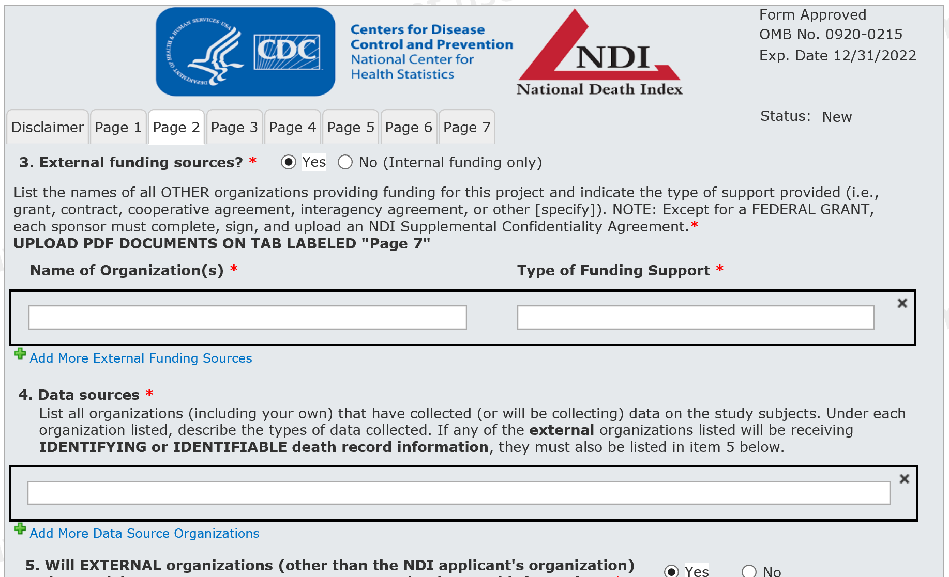

Page 2 – part 1 (Top) – all 1 screen

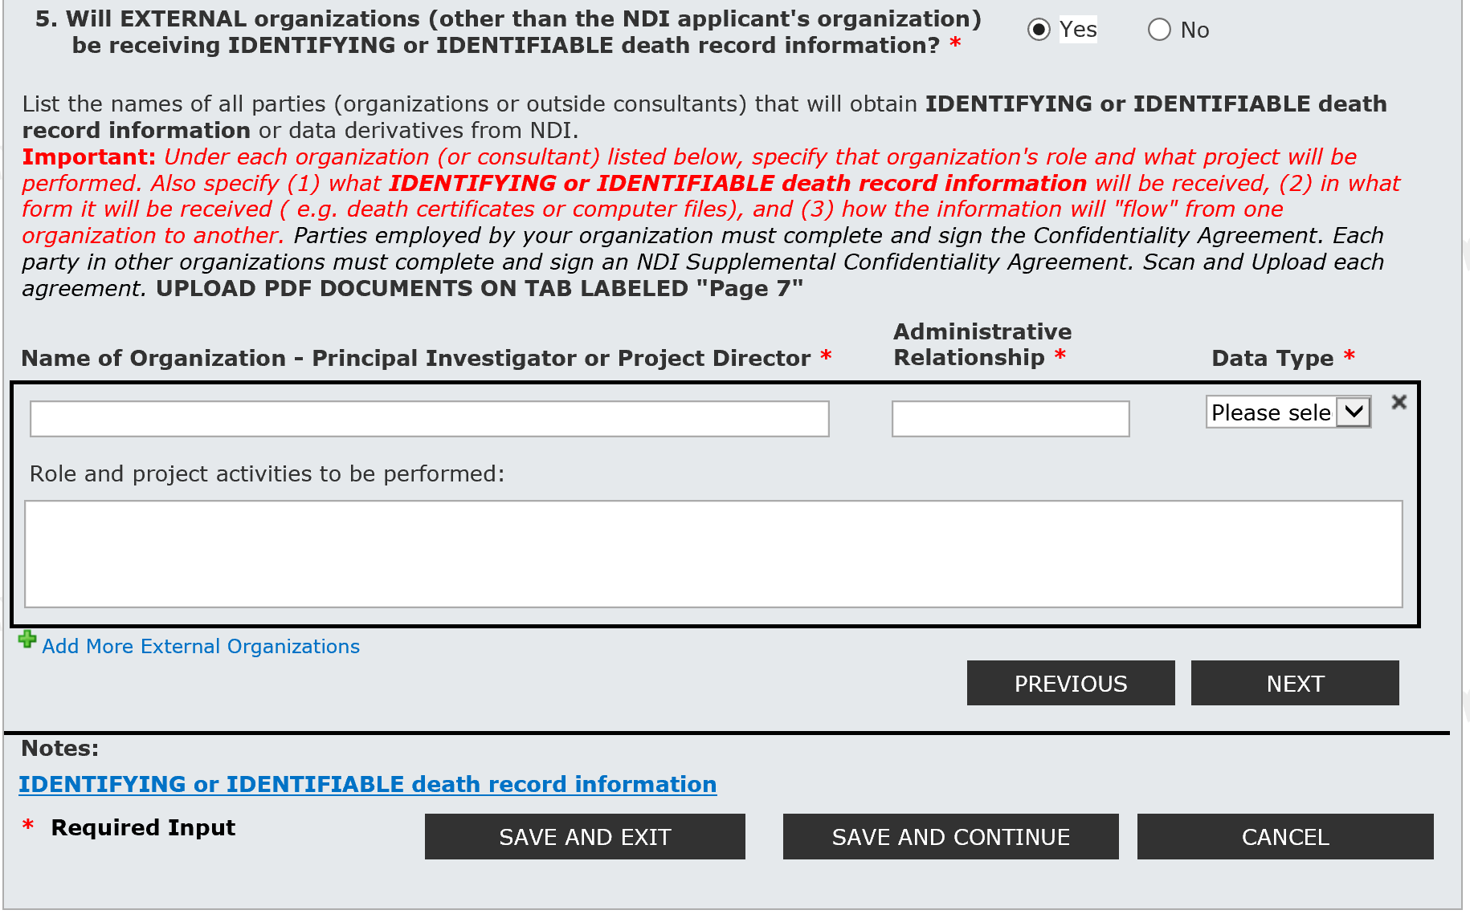

Page 2 – part 2 (Bottom) – all 1 screen

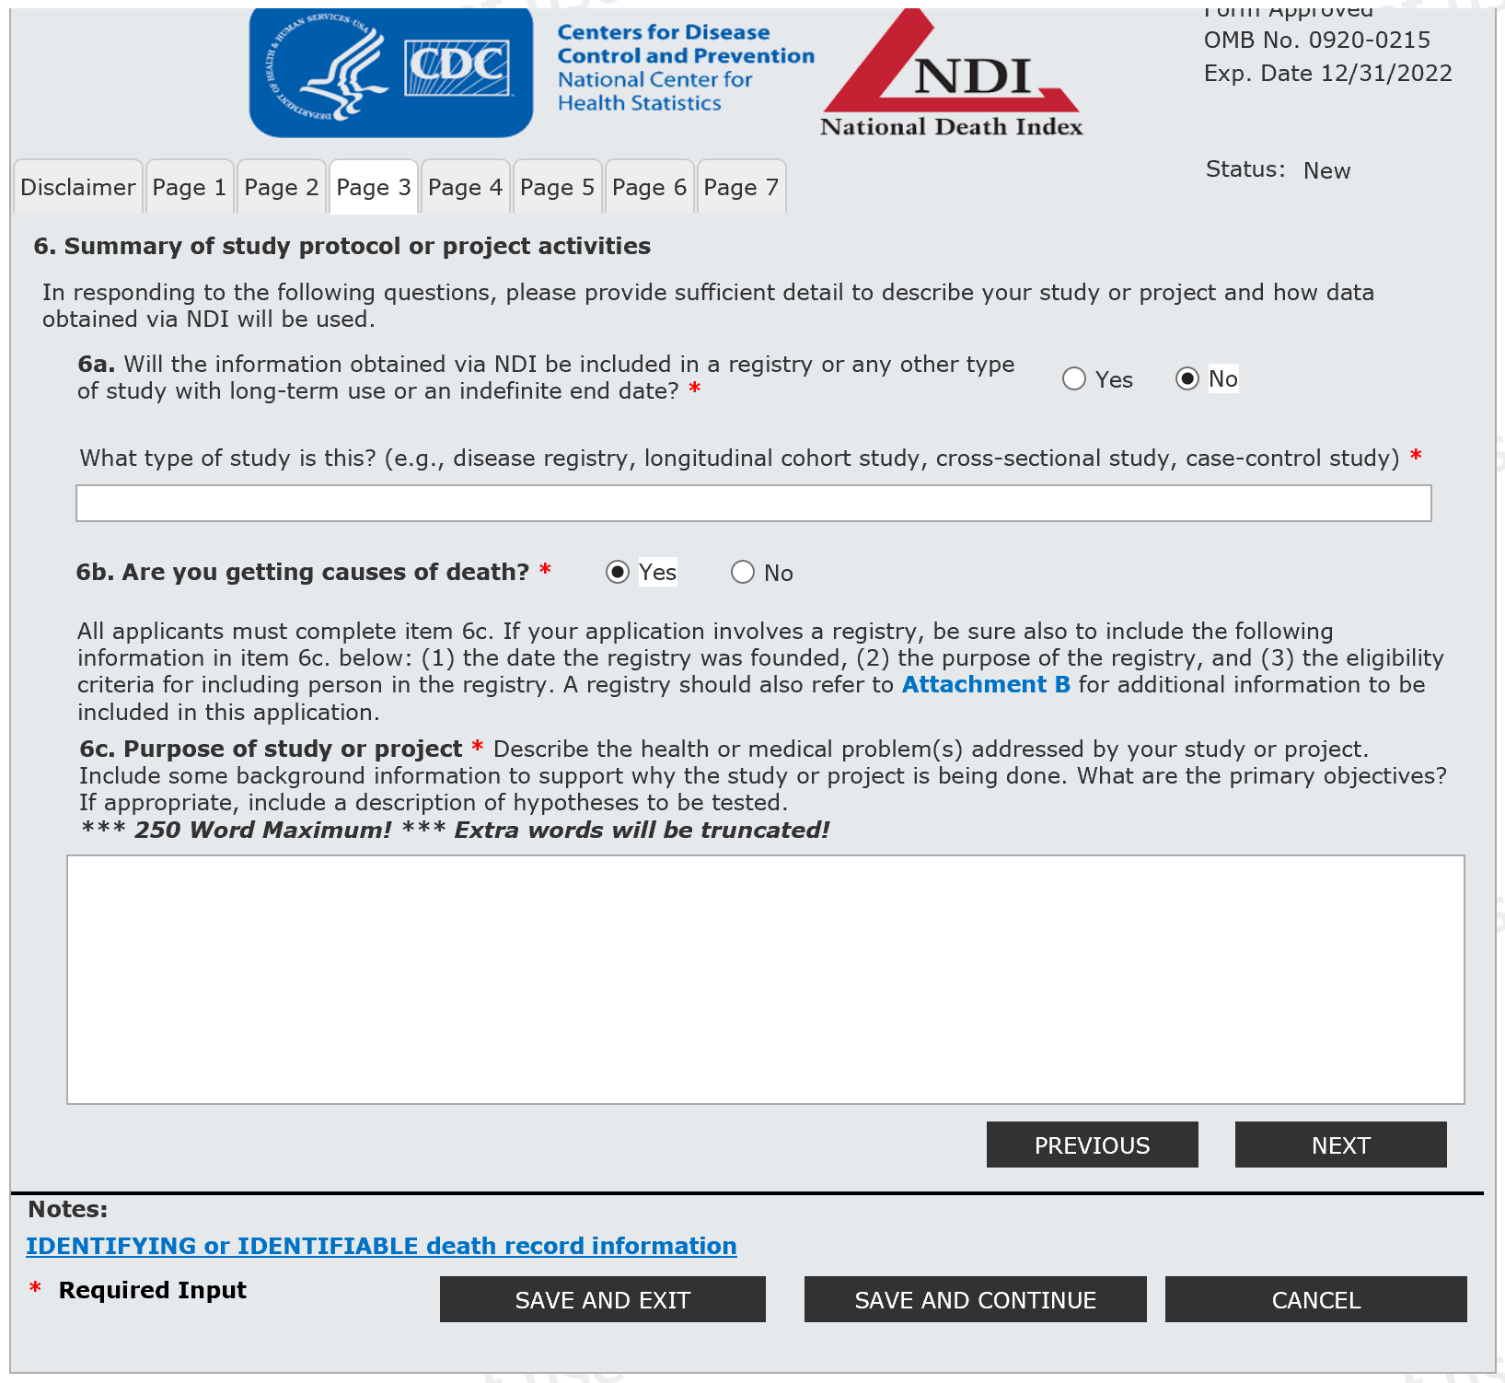

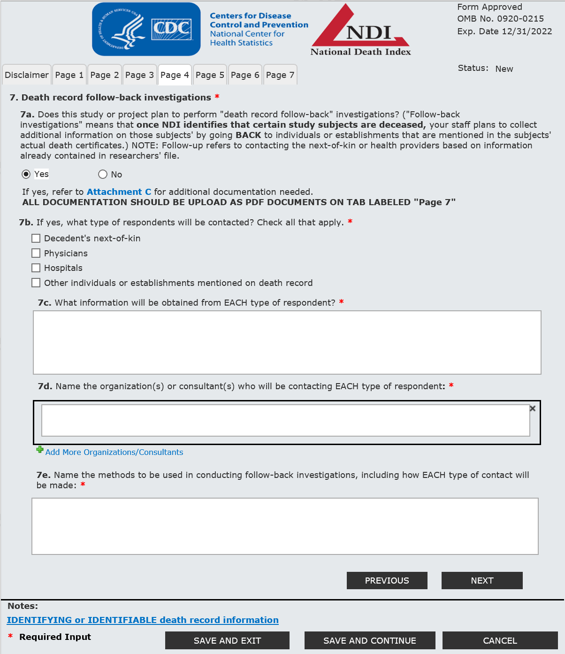

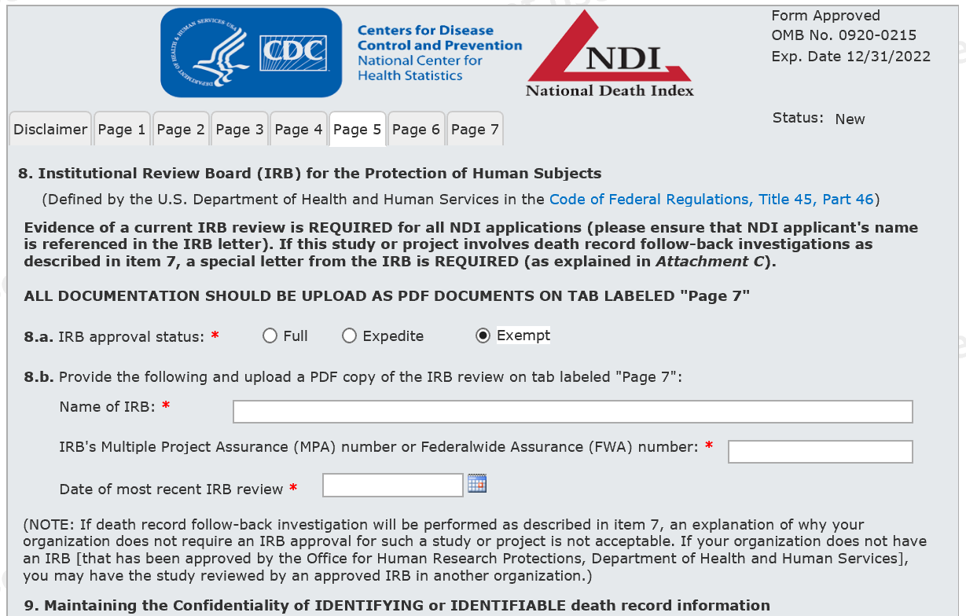

Page 5 – part 1 (Top)

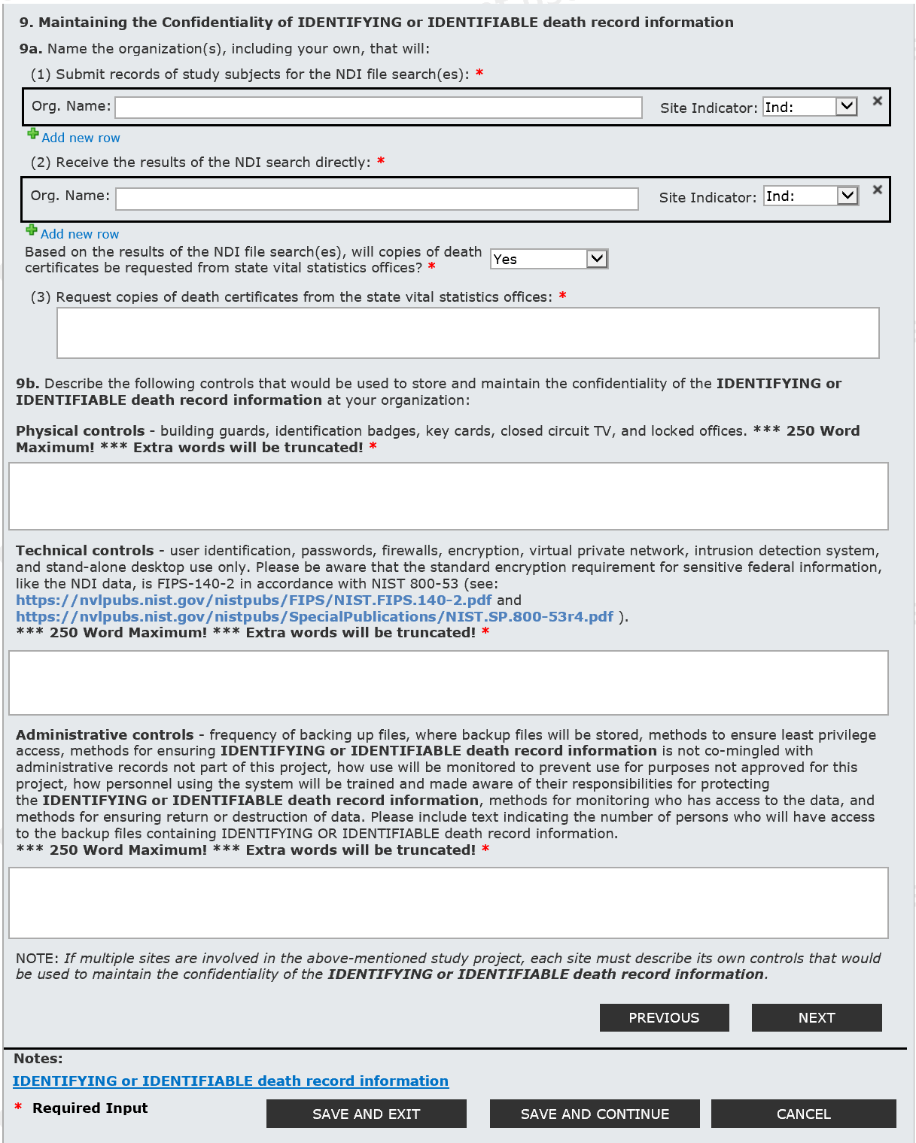

Page 5 – part 2 (bottom section – all 1 screen)

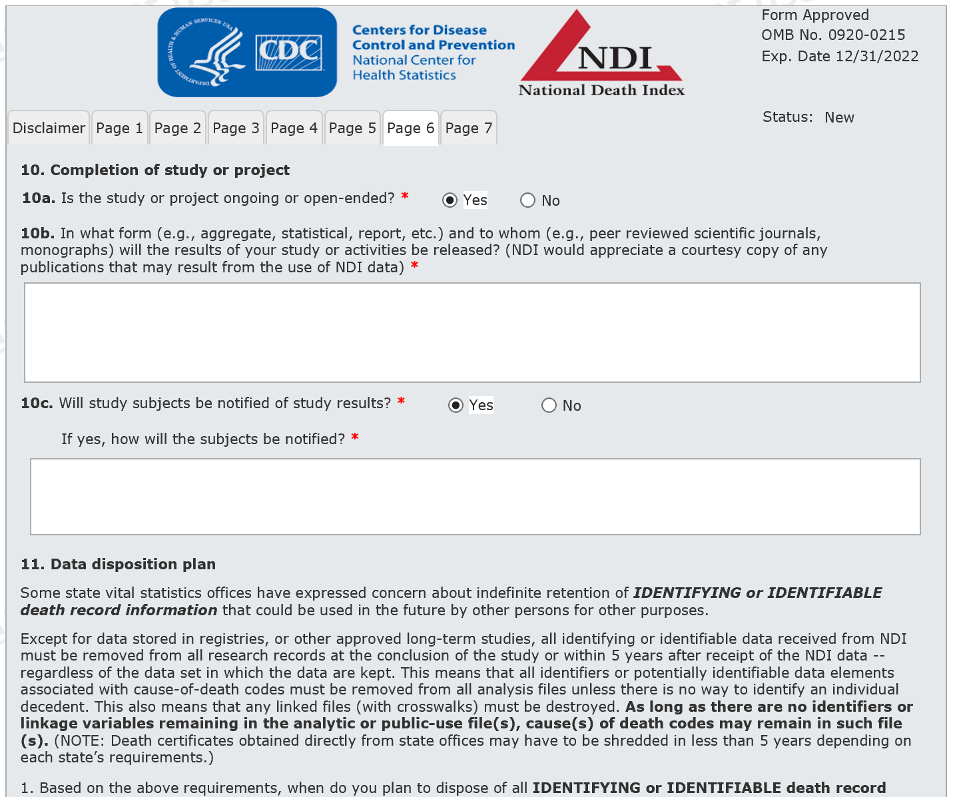

Page 6 – part 1 (Top) – This is expanded view – 10c = Yes. If No, the box vanished below 10c

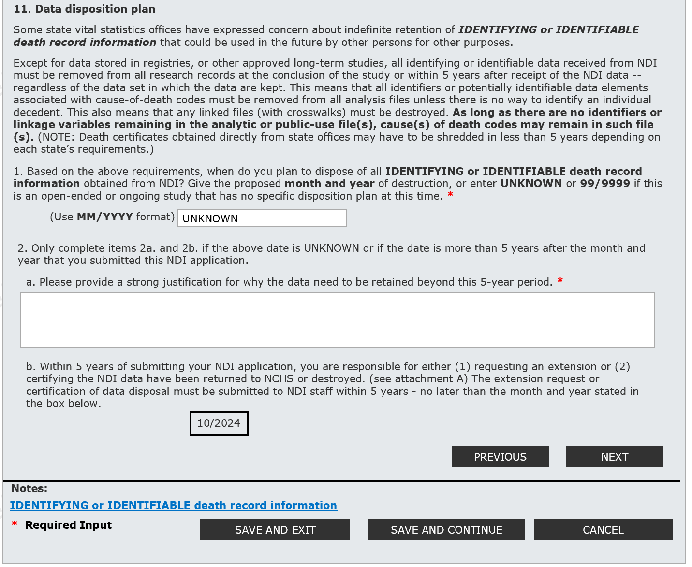

Page 6 – part 2 (bottom – expanded view) – I put “UNKNOWN” in item 1 for date – so it expands by requiring a justification.

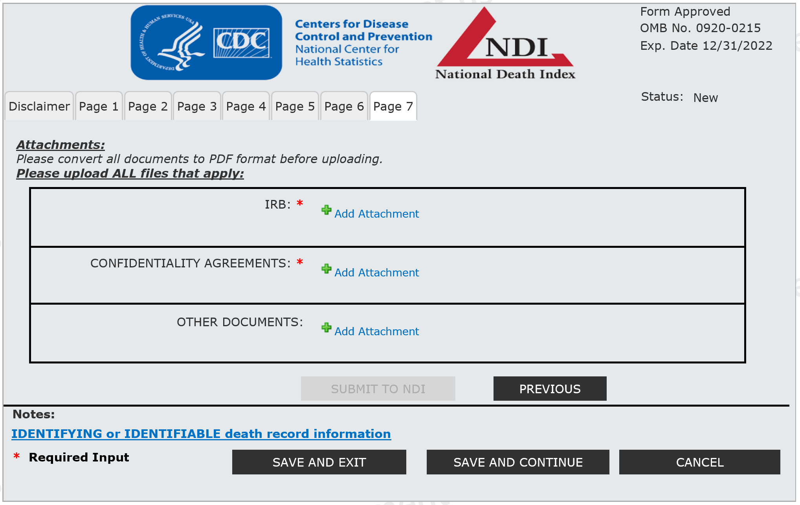

This page required at least two PDF attachments – but users can upload up to 99 attachments.

When IDENTIFYING or IDENTIFIABLE death record information is clicked, the following pops up:

