ESRD QIP Applications (Legacy System):
- ESRD QIP Application Landing Page:
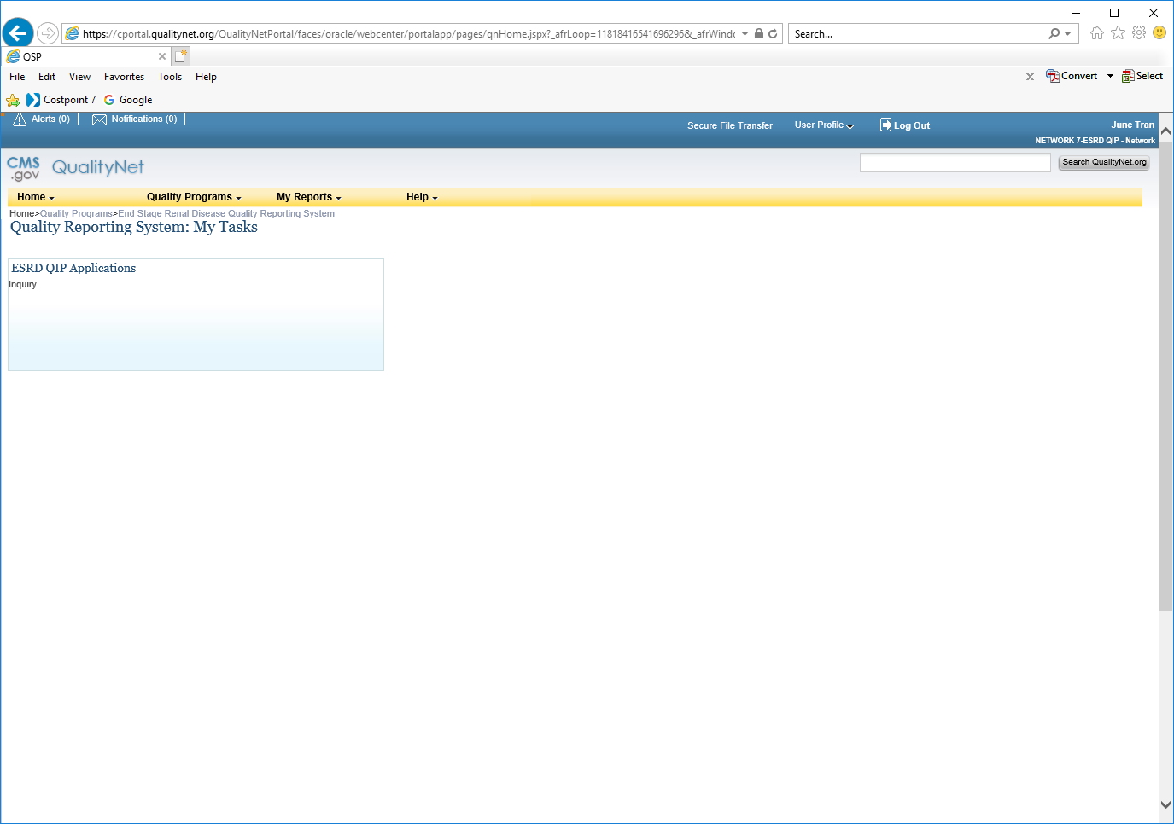
- Inquiry Dashboard to Submit Clarification Question:
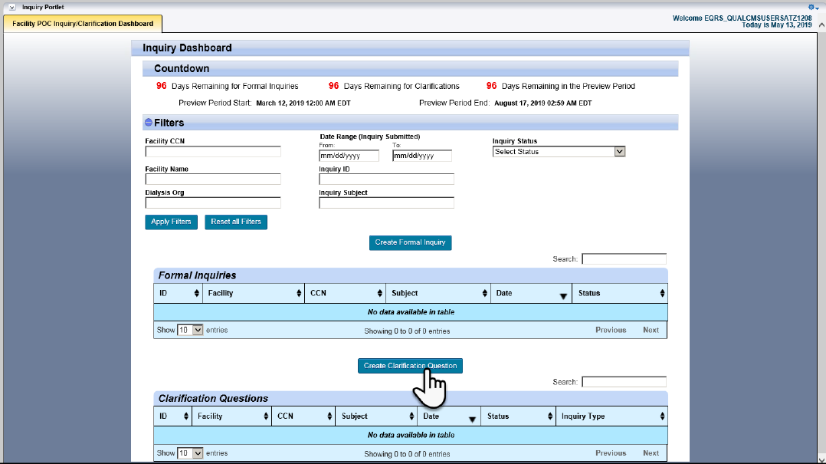

- Clarification Question:
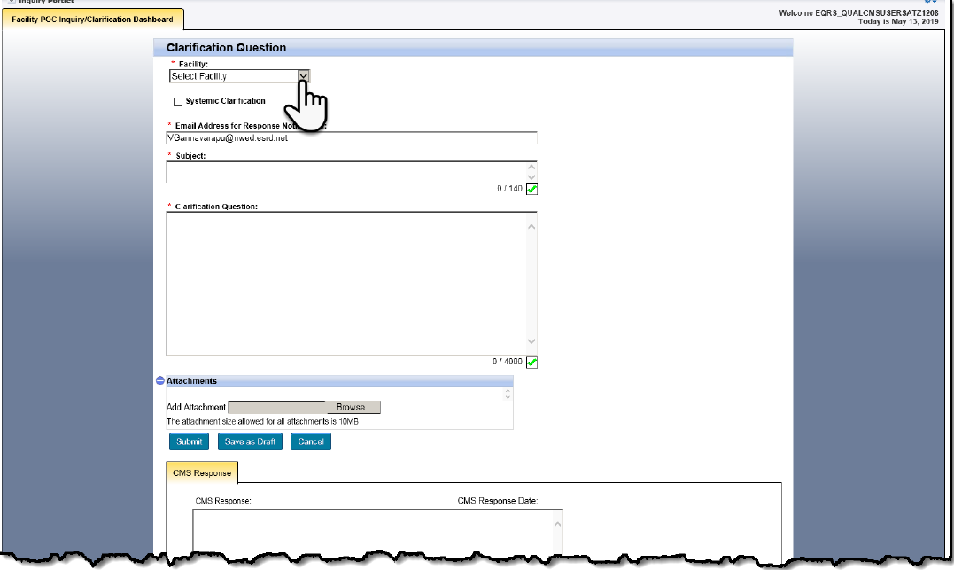

- Inquiry Dashboard for Formal Inquiries:
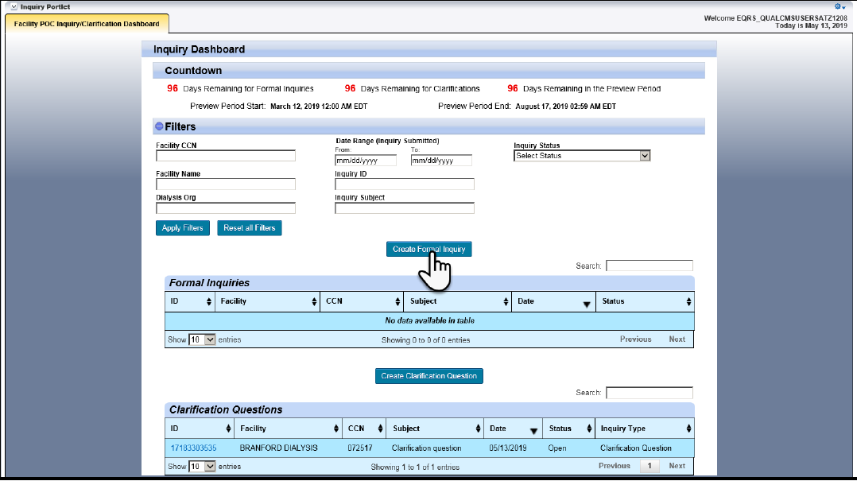

- Formal Inquiry:
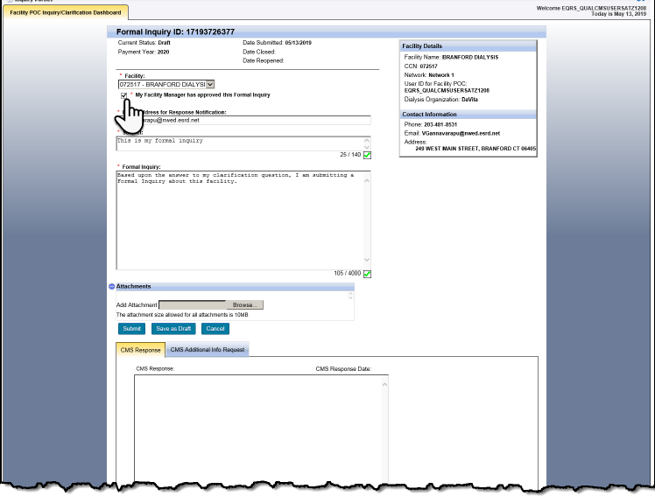

- Inquiry Dashboard with all Formal Inquiries and Clarification Questions Status:
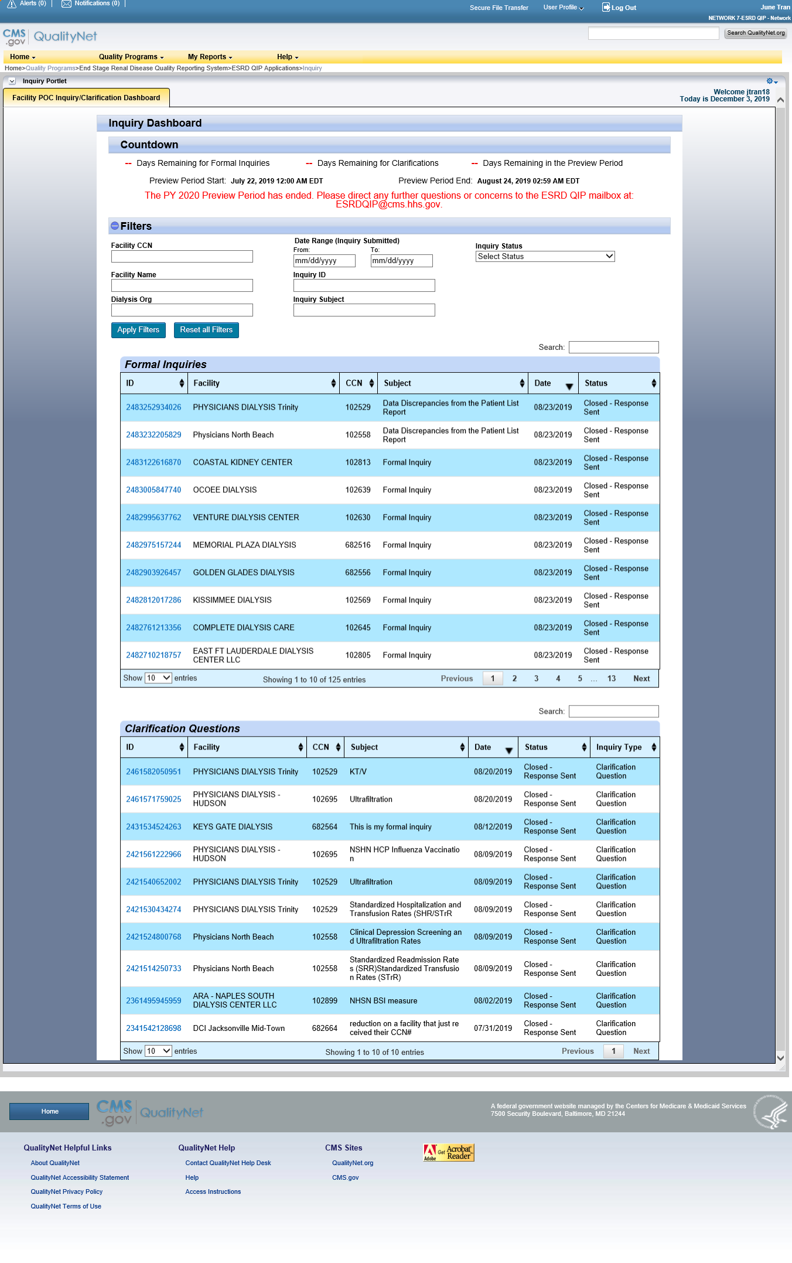
- Run/Search Reports Landing Page:
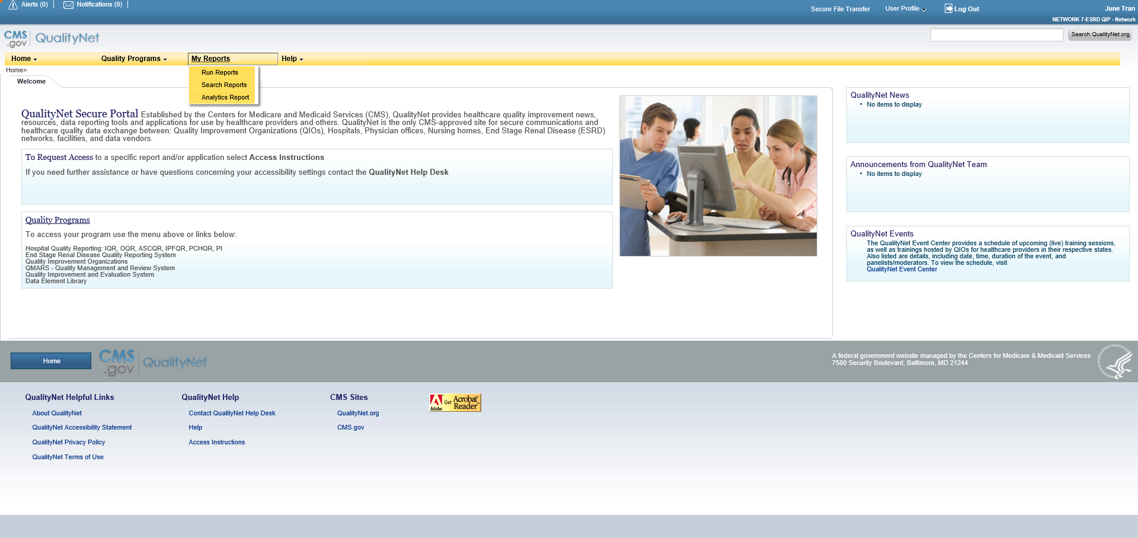

8. Run/Search Reports Landing Page (2nd page): 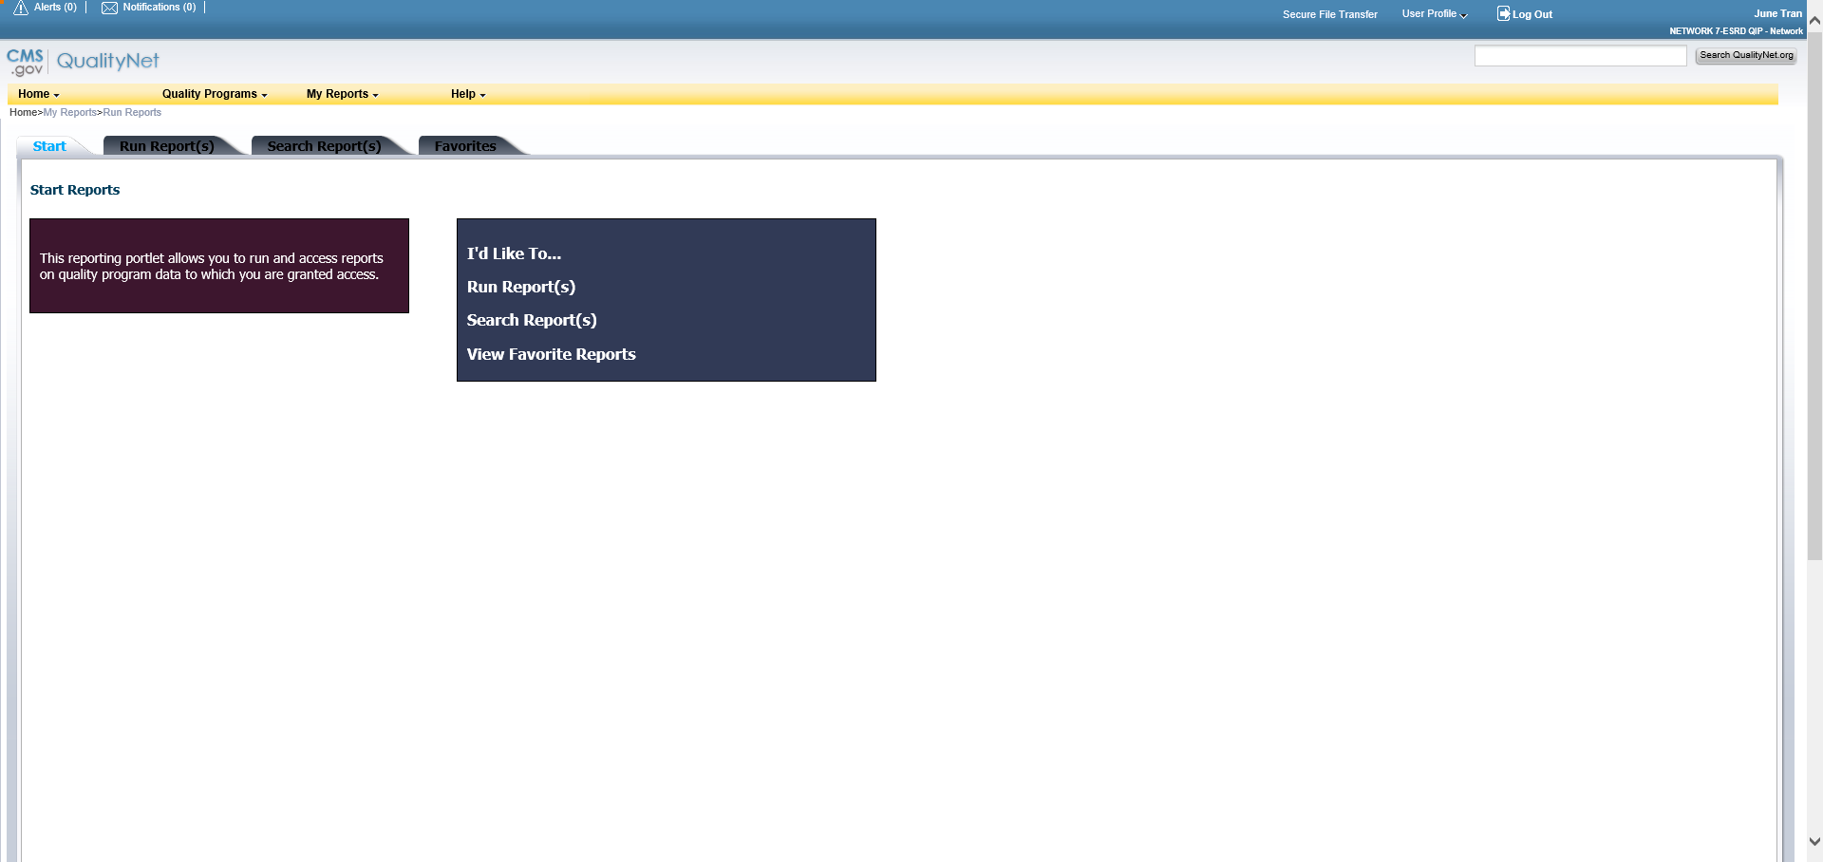

- Run Report:
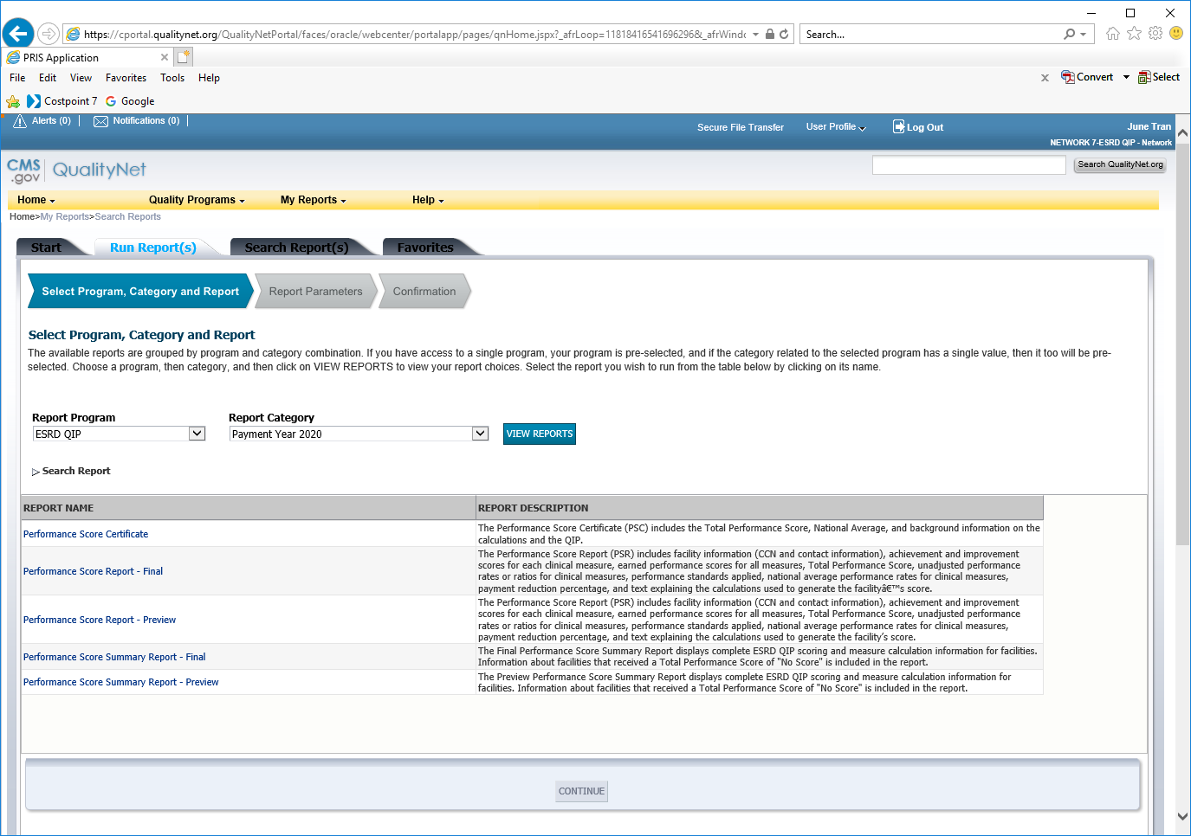

- Search Report(s) Landing Page:
