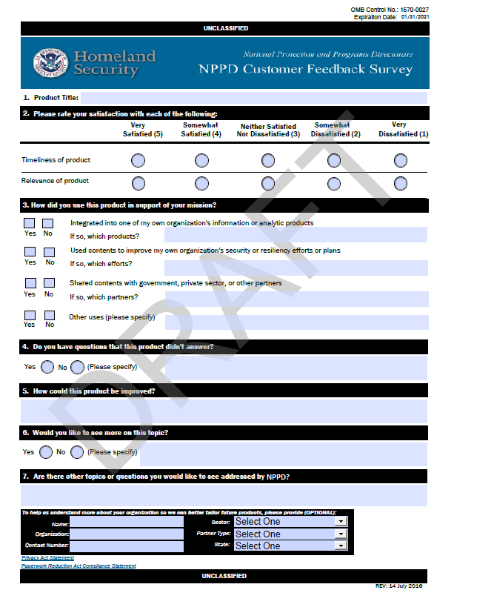

Paperwork Reduction Act Compliance Statement:

The public reporting burden to complete this information collection is estimated at 6 minutes per response, including the time for reviewing instructions, searching existing data sources, gathering and maintaining the data needed, and the completing and reviewing the collected information.  The collection of information is voluntary. An agency may not conduct or sponsor, and a person is not required to respond to a collection of information unless it displays a currently valid OMB control number and expiration date.  Send comments regarding this burden estimate or any other aspect of this collection of information, including suggestions for reducing this burden to DHS/NPPD, PRA Branch, 245 Murray Lane, Mailstop 0380, Arlington, VA 20598-0380, ATTN: PRA [*OMB Control No. 1670-0027*].

Privacy Act Statement:

**Authority**: 5 U.S. C. § 301 and 44 U.S.C. § 3101 authorize the collection of this information.

**Purpose**: DHS will use this information to improve products and contact you regarding your response.

**Routine Use**: This information may be disclosed as generally permitted under 5 U.S.C. §552a(b) of the Privacy Act of 1974, as amended. This includes using the information, as necessary and authorized by the routine uses published in DHS/ALL-002 - Department of Homeland Security (DHS) Mailing and Other Lists System of Records (November 25, 2008, 73 FR 71659).

**Disclosure**: Furnishing this information is voluntary; however failure to provide any of the information requested may prevent the National Protection and Programs Directorate (NPPD) from contacting you regarding your response.