2016/20 Baccalaureate and Beyond (B&B:16/20) Full-Scale Study Panel Maintenance
OMB # 1850-0926 v.9
Appendix C
Sample Member Communication Materials for Panel Maintenance (Carried Over)
Submitted by
National Center for Education Statistics
U.S. Department of Education
March 2019

Appendix C
Sample Member Communication Materials for Panel Maintenance

Contacts Calendar - B&B:16/20 Panel Maintenance

Fielded sample members will first receive an email requesting that they update their contact information, followed by the postcard 2-3 weeks later. These activities are scheduled for late 2019.

Contact Name | Data Collection Phase | Type | Approximate Date
B&B:16/20 Panel Maintenance E-mail | Pre-data collection | Email | Fall 2019 (sent first to all panel members)
B&B:16/20 Panel Maintenance Postcard | Pre-data collection | Postcard | Fall 2019 (sent second to those panel members who have not responded to the email)

The home page and the update contact information page will have the following text in the footer (mock ups included in this document):
NCES is authorized to conduct B&B:16/17 by the Education Sciences Reform Act of 2002 (ESRA 2002, 20 U.S.C. §9543) and to collect students’ education records from education agencies or institutions for the purposes of evaluating federally supported education programs under the Family Educational Rights and Privacy Act (FERPA, 34 CFR §§ 99.31(a)(3)(iii) and 99.35). The data are being collected for NCES by RTI International, a U.S.-based nonprofit research organization.
All of the information you provide may be used only for statistical purposes and may not be disclosed, or used, in identifiable form for any other purpose except as required by law (20 U.S.C. §9573 and 6 U.S.C. §151).
According to the Paperwork Reduction Act of 1995, no persons are required to respond to a collection of information unless it displays a valid OMB control number. The valid OMB control number for this voluntary information collection is 1850-0926. The time required to complete this information collection is estimated to average approximately 3 minutes per response, including the time to review instructions, gather the data needed, and complete and review the information collection. If you have any comments concerning the accuracy of the time estimate, suggestions for improving this survey, or any comments or concerns regarding the status of your individual submission of this survey, please write directly to: The 2016/20 Baccalaureate and Beyond Longitudinal Study (B&B:16/20), National Center for Education Statistics, Potomac Center Plaza, 550 12th St, SW, Room 4004, Washington, DC 20202. OMB Clearance No: 1850–0926 Expiration Date: 5/31/2020.

B&B:16/20 Panel Maintenance E-mail
SUBJECT: Update Your Contact Information for B&B
Dear «fname» «lname»:
The second round of data collection for the 2016/20 Baccalaureate and Beyond Longitudinal Study (B&B:16/20) will be starting in Summer of 2020! The National Center for Education Statistics (NCES) in the U.S. Department of Education’s Institute of Education Science has contracted with RTI International to collect data for B&B on its behalf. Help us inform educators, researchers, and policymakers about how a bachelor’s degree «in [major]» impacts choices for continuing education and employment paths.
Please take about 3 minutes to update your contact information so we can contact you when data collection begins.
You can update your information on our secure website: <<Website URL>> - with your unique study ID.
Study ID = «caseid»
If you have any questions, encounter any difficulty on the website, or would prefer to update this information over the telephone, please call us at 877-225-8470.
Thank you in advance for helping making B&B a success!
OMB Control Number: 1850-0926
Learn more about our confidentiality procedures at <<Website URL>>confidentiality.aspx

B&B:16/20 FS Panel Maintenance Postcard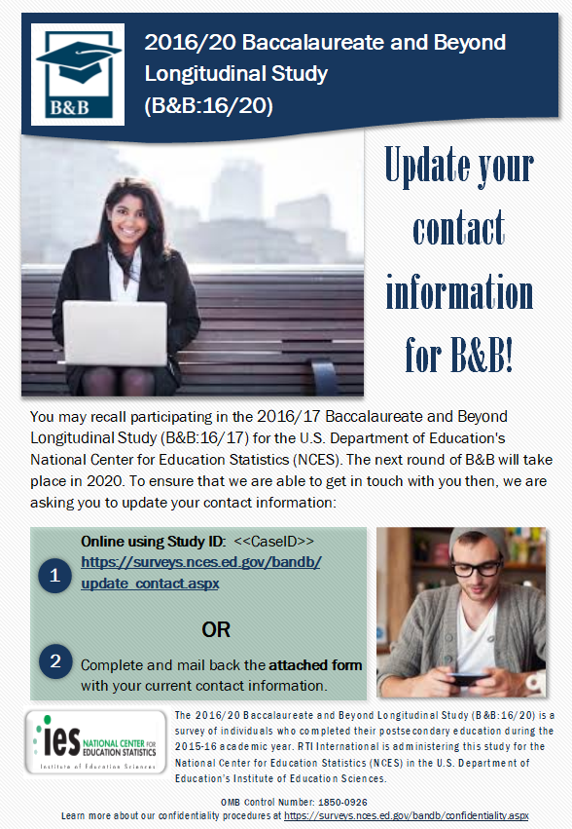

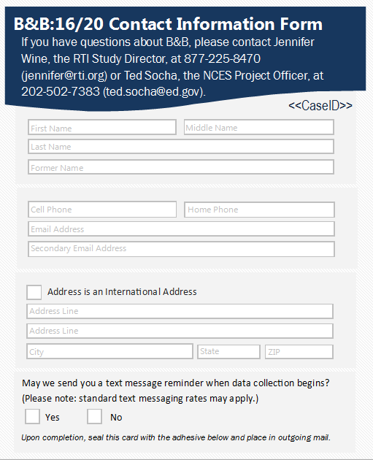

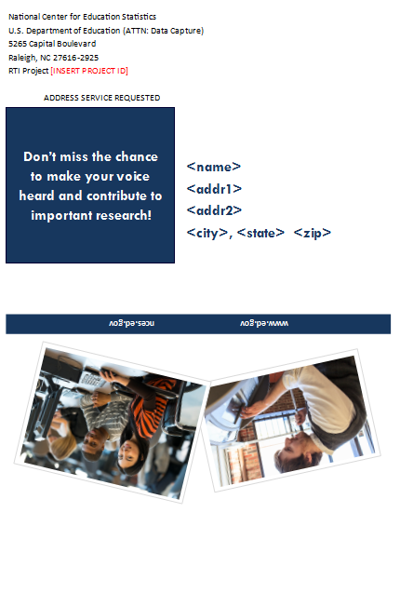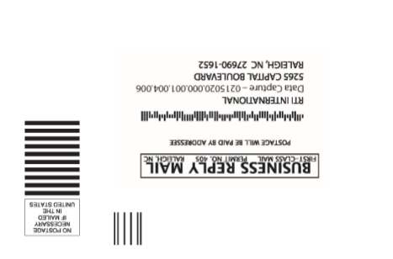

B&B:16/20 Website Panel Maintenance Home Page

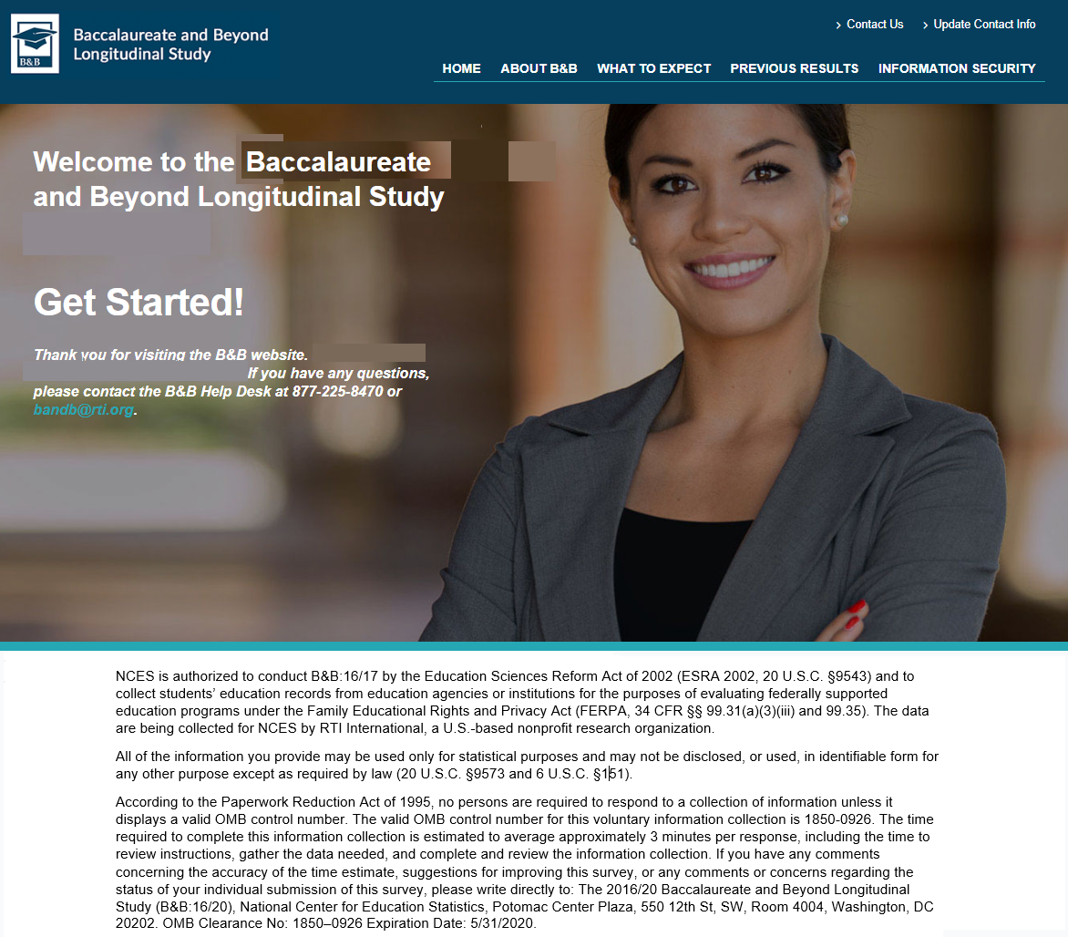

B&B:16/20 Update Contact Information Page
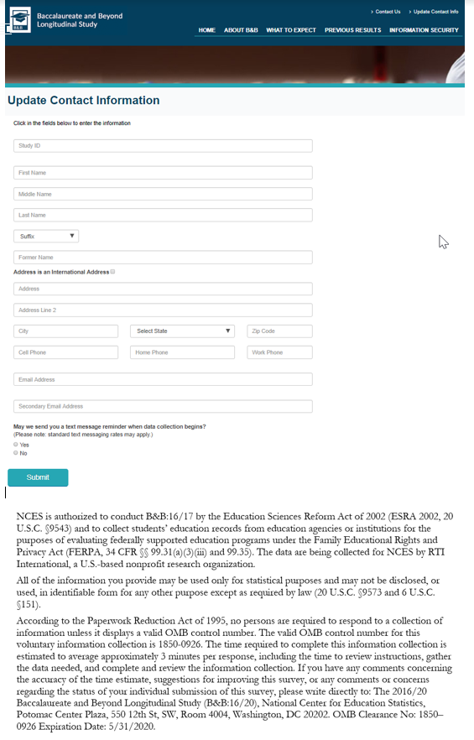

B&B:16/20 Website Confidentiality Page
