Program for International Student Assessment 2021 (PISA 2021) Main Study Recruitment and Field Test

Appendix A-2
Main Study Recruitment Materials

OMB# 1850-0755 v.23

National Center for Education Statistics (NCES)
U.S. Department of Education
Institute of Education Sciences
Washington, DC

October 2019

Throughout this document are screenshots that show the web content of MyPISA.us for schools and school coordinators from the main study in PISA 2018, along with text for PISA 2021. The last section of this document, “MyPISA project website for School Coordinators and schools,” documents the contents of the website most extensively, but MyPISA screenshots also appear throughout the sections, “Instructions for School Coordinators to E-file student lists,” and “PISA 2021 Main Study School Coordinator Handbook”. The systems for the PISA 2021 main study are not yet active, but will not change other than references to the current round of PISA and updates to the specifics of the main study, such as the appropriate birth year of students within the sample, the number of students to be sampled, and removal of teacher information pertaining to teacher participation in the questionnaire. MyPISA.us is described in Part B of the main study package.

Updated screenshots and, if necessary, any updated text will be provided in a change request by December 2019.

TABLE OF CONTENTS

State PISA 2021 Letter 3
School District PISA 2021 Letter 4
School PISA 2021 Letter – Public Schools 5
PISA 2021 Brochure – Public Schools 6
PISA 2021 FAQ for school administrators – Public Schools - Front Page 8
PISA 2021 FAQ for Students – Public Schools 10
PISA 2021 Timeline of Activities – Public and Private Schools 12
School PISA 2021 Letter – Private Schools 13
PISA 2021 Brochure – Private Schools 14
PISA FAQ for school administrators - Private Schools - Front Page 16
PISA 2021 FAQ for Students – Private Schools 18
School Coordinator Email announcing E-Filing for Main Study 20
Instructions for School Coordinators to E-file student lists 21
PISA E-file reminder email to School Coordinator 28
Email to School Coordinator when student and teacher samples are complete and Student Tracking and School
Logon Forms have been posted to MyPISA.us 29
PISA 2021 Main Study School Coordinator Handbook Cover Letter 30
PISA 2021 Main Study School Coordinator Handbook 31
MyPISA project website for School Coordinators and schools 72

[Date]
[Title] [Name First] [Name Last]

State PISA 2021 Letter
[Title/Department]
[State]
[Address 1]
[Address 2]
[City], [State] [Zip code]

Dear [Title] [Name Last]:

The United States is participating in the 2021 Program for International Student Assessment (PISA). As the largest international education study in the world, PISA measures the mathematics, reading, and science literacy of students nearing the end of compulsory education. PISA results are used by researchers and policymakers to chart national progress against international standards and the educational progress of our global economic peers and competitors. The United States and more than 80 other countries and education systems will participate in the next round of PISA. Some schools in your state have been randomly selected to participate in PISA in the fall of 2021, and I am writing to ask your agency to support the participation of those schools.

PISA provides comparative information on the performance of U.S. students in mathematics, reading, and science with their peers in other countries. PISA 2021 will also include an assessment of students’ financial literacy.

PISA is described in more detail in the enclosed materials. PISA is conducted in the United States by the National Center for Education Statistics (NCES) within the U.S. Department of Education and is administered by Westat, a research firm in Rockville, Maryland. The U.S. Office of Management and Budget (OMB) has approved the data collection under OMB# 1850-0755. For information on the confidentiality of the data collected, please see the enclosed FAQ. While participation in this study is voluntary, we ask your agency to support participation in your state so that the United States has a sample of schools that is representative of the entire country.

Within the next few weeks, a representative of Westat will contact sampled school districts and schools to discuss participating in PISA. We are in contact with your state assessment director and NAEP State Coordinator to try to ensure that we are not conflicting with other state efforts and to help districts and schools understand how PISA fits in with other data collections conducted by NCES. The administration of PISA is also coordinated with NAEP and other NCES data collection activities to minimize burden and duplication. In the meantime, if you have questions about the study, please do not hesitate to call David Kastberg at 1-301-294-3811 or send an email to PISAHELP@westat.com. You may also get more information by contacting Patrick Gonzales at NCES at 415-920-9229 or patrick.gonzales@ed.gov, or by visiting the PISA website at http://nces.ed.gov/surveys/pisa.

Thank you for your time and support.

Sincerely,

Peggy Carr, Ph.D.
Associate Commissioner, National Center for Education Statistics
cc: [State assessment coordinator name]

Enclosures
The National Center for Education Statistics (NCES) is authorized to conduct the Program for International Student Assessment (PISA) by the Education Sciences Reform Act of 2002 (ESRA 2002, 20 U.S.C. §9543), and to collect students’ education records from educational agencies or institutions for the purpose of evaluating federally supported education programs under the Family Educational Rights and Privacy Act (FERPA, 34 CFR §§ 99.31(a)(3)(iii) and 99.35). The data are being collected for NCES by Westat, a U.S.-based research organization. All of the information you provide may be used only for statistical purposes and may not be disclosed, or used, in identifiable form for any other purpose except as required by law (20 U.S.C. §9573 and 6 U.S.C. §151).

School District PISA 2021 Letter

[Date]
[Title] [Name First] [Name Last], [Title/Department]
[School District]
[Address 1]
[City], [State] [Zip code]

Dear [Title] [Name Last]:

The United States is participating in the 2021 Program for International Student Assessment (PISA). As the largest international education study in the world, PISA measures the mathematics, reading, and science literacy of students nearing the end of compulsory education. The United States and more than 80 other countries and education systems will participate in the next round of data collection. PISA results are used by researchers and policymakers to chart national progress against international standards and the educational progress of our global economic peers and competitors. Some schools in your district have been randomly selected to participate in PISA in the fall of 2021, and I am writing to ask your agency to support the participation of those schools.

PISA provides comparative information on the performance of U.S. students in reading, mathematics, and science with their peers in other countries. PISA 2021 will also include an assessment of students’ financial literacy.

Schools participating in PISA will receive $250, and each school’s PISA school coordinator (a school staff person designated to liaise with PISA staff) will receive $200 as a thank you for the coordinator’s time and effort. Each student who participates will be eligible to receive $25 and a volunteer service certificate of 4 hours from the U.S. Department of Education.

PISA is conducted in the United States by the National Center for Education Statistics (NCES) within the U.S. Department of Education and is administered by Westat, a research firm in Rockville, Maryland. The U.S. Office of Management and Budget has approved the data collection under OMB# 1850-0755. For information on the confidentiality of the data collected, please see the enclosed FAQ. While participation in this study is voluntary, we ask your agency to support participation in your district so that the United States has a sample of schools that is representative of the entire country.

Within the next few days, a representative of Westat will contact the following school(s) in your district that have been selected for the main study data collection: [LIST SAMPLED SCHOOLS HERE…]. Please include the PISA assessment window (October 4 to November 26, 2021) on your district test calendar.

If you have any questions, please do not hesitate to call 1-888-638-2597 or send an email to PISAHELP@westat.com. You may also get more information about this study by contacting Patrick Gonzales at NCES at 415-920-9229 or patrick.gonzales@ed.gov, or by visiting the PISA website at http://nces.ed.gov/surveys/pisa.

Thank you for your time and support.

Sincerely,

Peggy Carr, Ph.D.
Associate Commissioner, National Center for Education Statistics
Enclosures

The National Center for Education Statistics (NCES) is authorized to conduct the Program for International Student Assessment (PISA) by the Education Sciences Reform Act of 2002 (ESRA 2002, 20 U.S.C. §9543), and to collect students’ education records from educational agencies or institutions for the purpose of evaluating federally supported education programs under the Family Educational Rights and Privacy Act (FERPA, 34 CFR §§ 99.31(a)(3)(iii) and 99.35). The data are being collected for NCES by Westat, a U.S.-based research organization. All of the information you provide may be used only for statistical purposes and may not be disclosed, or used, in identifiable form for any other purpose except as required by law (20 U.S.C. §9573 and 6 U.S.C. §151).

School PISA 2021 Letter – Public Schools

[Date]
[Title] [Name First] [Name Last], [Title/Department]
[School District]
[Address 1]
[City], [State] [Zip code]

Dear [Title] [Name Last]:

The United States is participating in the 2021 Program for International Student Assessment (PISA). As the largest international education study in the world, PISA measures the reading, mathematics, and science literacy of students nearing the end of compulsory education. The United States and more than 80 other countries and education systems will participate in the next round. PISA results are used by researchers and policymakers to chart national progress against international standards and the educational progress of our global economic peers and competitors. Your school is one of about 280 schools across the United States that has been randomly selected to take part in PISA in fall 2021.

Beyond providing comparative information on the performance of students, PISA fosters international engagement across education systems, allowing teachers, education professionals, and policy experts to compare shared experiences in the global learning community. In addition to mathematics, reading, and science literacy, PISA 2021 includes an assessment of students’ financial literacy, and will provide a range of contextual data that offer insight into students’ school and home environments, socioeconomic advantages and disadvantages, sense of well-being, and use of time outside of school.

Schools participating in PISA will receive $250, and each school’s PISA school coordinator (a school staff person designated to liaise with PISA staff) will receive $200 as a thank you for their time and effort. Each student who participates will be eligible to receive $25 and a volunteer service certificate of 4 hours from the U.S. Department of Education. In addition, when the national results of the 2021 assessment are released, your school may also receive a school-level report highlighting the performance of students in your school compared to their peers in other schools like yours, U.S. schools, and high-performing OECD countries (pending sample size and response rate requirements).

The PISA assessment experience and the benefits of participating are described in more detail in the enclosed materials, which I invite you to review. PISA is conducted in the United States by the National Center for Education Statistics (NCES) within the U.S. Department of Education and is administered by Westat, a research firm in Rockville, Maryland. The U.S. Office of Management and Budget (OMB) has approved the data collection under OMB# 1850-0755. For information on the confidentiality of the data collected, please see the enclosed FAQ. While participation in this study is voluntary, each school plays an important role in ensuring that the U.S. sample is representative of the knowledge and skills of all students in our country’s education system.

The PISA assessment window is from October 4 through November 26, 2021. Within the next few days, a representative of Westat will contact you to discuss your school’s participation. If you have any questions, please do not hesitate to call 1-888-638-2597 or send an email to PISAHELP@westat.com. You may also get more information about this study by contacting Patrick Gonzales at NCES at 415-920-9229 or patrick.gonzales@ed.gov, or by visiting the PISA website at http://nces.ed.gov/surveys/pisa.

Your school’s participation in PISA 2021 is vital to ensuring a fair and valid assessment for all U.S. students. Thank you for your time and for supporting this important international education study.

Sincerely,

Peggy Carr, Ph.D.
Associate Commissioner, National Center for Education Statistics
Enclosures
The National Center for Education Statistics (NCES) is authorized to conduct the Program for International Student Assessment (PISA) by the Education Sciences Reform Act of 2002 (ESRA 2002, 20 U.S.C. §9543), and to collect students’ education records from educational agencies or institutions for the purpose of evaluating federally supported education programs under the Family Educational Rights and Privacy Act (FERPA, 34 CFR §§ 99.31(a)(3)(iii) and 99.35). The data are being collected for NCES by Westat, a U.S.-based research organization. All of the information you provide may be used only for statistical purposes and may not be disclosed, or used, in identifiable form for any other purpose except as required by law (20 U.S.C. §9573 and 6 U.S.C. §151).
What is PISA?
PISA 2021 Brochure – Public Schools – Front Cover

The Program for International Student Assessment (PISA) is an international assessment of students nearing the end of compulsory education that measures how well students apply their knowledge and skills in mathematics, reading, science, and financial literacy to problems set in real-life contexts. Conducted every 3 years since 2000, the next round of PISA in 2021 will include students from more than 80 countries and education systems around the world, including the United States. PISA is coordinated by the Organization for Economic Cooperation and Development (OECD) and conducted in the United States by the National Center for Education Statistics (NCES) within the U.S. Department of Education.

Why is PISA important and what are the benefits of participating?
PISA provides a unique opportunity for the United States to understand how well students nearing the end of compulsory education are prepared to enter the workforce or post-secondary education in comparison to their peers from more than 80 countries. Through participating in PISA, schools, and students contribute to ongoing efforts to improve education in our country. PISA helps identify U.S. students’ strengths and weaknesses in the domains of mathematics, reading, science, and financial literacy and offers insights into successful policies and practices in other countries.

Each school and student that participates in PISA plays a vital role in representing other schools and students that are similar. It is essential that sampled schools contribute to this important measurement of educational progress to ensure the U.S. sample reflects the knowledge and skills of all students across the country.

Schools participating in PISA may also receive a school-level report (pending sample size and response rate requirements). The school report, provided only to your school, presents comparisons of your school’s average scores with the average scores of participating education systems, including the United States, and can serve as a benchmark for your students’ performance among other similar U.S. schools based on specific school-level characteristics.

As a token of appreciation for participating, schools will receive $250, the school coordinator will receive $200, students who participate will each receive $25 as well as 4 hours of volunteer service time.

What will schools and students be asked to do in PISA 2021?
The PISA 2021 has three primary components: (1) a computer-based student assessment, (2) a computer-based student questionnaire, and (3) an online school questionnaire.

- Up to 52 students in each school will be selected to participate in the PISA assessment, which takes about 3 hours, including instructions, breaks, and a questionnaire. Students will answer questions in various combinations of mathematics, reading, science, and financial literacy.

- The principal of each school will be asked to appoint a staff member to act as the PISA school coordinator. The school coordinator will work with Westat staff to coordinate the assessment and submit a student list for sampling. The principal of each school will also be asked to complete a 45-minute online questionnaire about school and student body characteristics and policies.

PISA 2021 Brochure – Public Schools – (Continued Inside Cover)

How is PISA developed?
PISA is developed through an international collaborative process involving input from U.S. and international experts in science, reading, mathematics, financial literacy, and educational measurement. The PISA assessment materials are thoroughly reviewed by within-country experts to make sure the materials are appropriate for each country’s students. Finally, the final assessment materials are endorsed by all participating countries.

What do PISA questions look like?
PISA includes a mix of item types: some items require students to select from among possible responses, while others require students solve problems and provide written answers. Examples of PISA assessment questions are available at http://nces.ed.gov/surveys/pisa/educators.asp and https://www.oecd.org/pisa/pisaproducts/pisa-test-questions.htm.

Which countries are participating in PISA 2021?

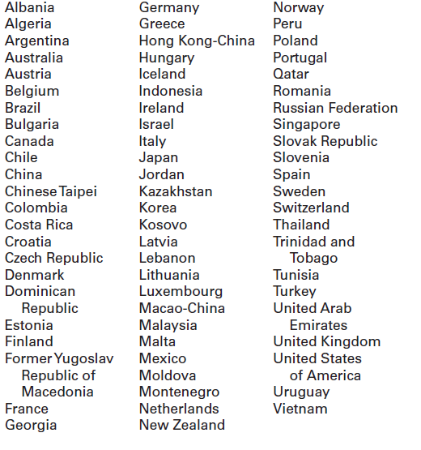

Where do I find more information?

Visit the PISA website at http://nces.ed.gov/surveys/pisa.

For additional questions about PISA 2021, contact the PISA U.S. home office at 1-888-638-2597 or email PISAHELP@westat.com.

The National Center for Education Statistics (NCES) is authorized to conduct the Program for International Student Assessment (PISA) by the Education Sciences Reform Act of 2002 (ESRA 2002, 20 U.S.C. §9543), and to collect students’ education records from educational agencies or institutions for the purpose of evaluating federally supported education programs under the Family Educational Rights and Privacy Act (FERPA, 34 CFR §§ 99.31(a)(3)(iii) and 99.35). The data are being collected for NCES by Westat, a U.S.-based research organization. All of the information you provide may be used only for statistical purposes and may not be disclosed, or used, in identifiable form for any other purpose except as required by law (20 U.S.C. §9573 and 6 U.S.C. §151).

PISA 2021 FAQ for school administrators – Public Schools –Front Page

Program for International Student Assessment
FREQUENTLY ASKED QUESTIONS
PISA 2021 (Fall 2021)
Information for Schools

PISA is an international assessment of students nearing the end of compulsory education that measures how well students apply their knowledge and skills to solve problems related to mathematics, reading, and science, and financial literacy in real-life contexts. In PISA 2021, students will be assessed in mathematics, reading, science, financial literacy, or some combination of these subjects. PISA 2021 will be administered in the fall of 2021.

What does participating in PISA entail?
Each school is asked to designate a school coordinator to work with Westat and to submit a list of all students on or between July 1, 2005 and June 30, 2006. Up to 52 students in each school will be sampled to participate in the PISA assessment, which takes about 3 hours of total time, including instructions, breaks, and a questionnaire. The principal of each school will also be asked to complete a 45-minute online questionnaire about school and student body characteristics and policies.

Why should my school and students participate?
The participation of selected schools in the United States is vital to ensuring an accurate representation of the overall population of students nearing the end of compulsory education across the country—including U.S. public and private schools. Although the assessment is voluntary, we rely on school and student participation to ensure the results are complete and accurate. We cannot do that without the support of schools like yours.

PISA is administered worldwide in order to help participating school systems and countries understand their strengths and areas for improvement, with the ultimate goal of increasing both the quality and equity of education worldwide. As such, PISA fosters engagement among international education systems, allowing teachers, education professionals, and policy experts to compare shared experiences in the global learning community. By taking part in PISA, your school will have the unique opportunity to impact the bigger picture of education in the United States and across the world.

What are the benefits to participating?
Schools participating in PISA may also receive a school-level report (pending sample size and response rate requirements). The school report presents comparisons of your school’s average scores with the average scores of participating education systems including the United States. The report also provides comparisons of your school with other similar U.S. schools based on specific school-level characteristics. The school report is provided only to your school and any published reports from PISA 2021 will not identify participating schools.

As a token of appreciation for participating, schools will receive $250, the school coordinator will receive $200, and students who participate will each receive $25 as well as 4 hours of volunteer service time.

Will all of our students be asked to participate?
Probably not. In each school, all students born between July 1, 2005 and June 30, 2006 and enrolled in grade 7 or higher will have an equal chance of selection. Up to 52 students in each school will be selected to participate. Only in very small schools will the school sample likely include all eligible students. In addition, some students with disabilities or limited English proficiency may be offered a limited set of accommodations to enable their participation; otherwise, they may be excused from the assessment.

PISA 2021 FAQ for school administrators – Public Schools – Back Page

Who conducts the PISA assessment?
The National Center for Education Statistics (NCES), within the U.S. Department of Education, conducts this study as authorized by the Education Sciences Reform Act of 2002 (ESRA 2002, 20 U.S.C. §9543) and with the approval of the U.S. Office of Management and Budget under OMB# 1850-0755. The assessment process will be undertaken by trained staff from Westat, a research organization under contract to NCES. In compliance with standard protocols, Westat field staff undergoes FBI background checks.

How is the school questionnaire administered?
The school questionnaire is administered online from a secure website. The school questionnaire, which looks at school characteristics such as enrollment and school practices, takes about 45 minutes to complete.

Do teachers or other school staff need to help administer the assessment?
No. Westat field staff will visit the school on the day of the assessment, bringing with them all the materials required, and will handle the entire administration of the assessment. Field staff will also bring all of the necessary computer equipment. There is no requirement for school resources such as school computers or access to the internet. All that is required is adequate space to set up the equipment and assess the students.

When will the PISA be conducted?
PISA will be conducted between October 4 and November 26, 2021. Westat will work with schools to identify an assessment date convenient for the school in that time period.

How long does PISA take?
Students will take a computer-based assessment. This approximately 3-hour session includes time for instructions, the assessment, breaks, and a questionnaire that students complete about themselves. The assessment location will be used for about 5 hours total, including setup and breakdown by Westat staff. All assessment activities will take place in one day.

What will happen with the collected data?
The data collected for PISA will be used to report on students’ knowledge and skills as group descriptions at the national level. All of the information provided by school staff and students may be used only for statistical purposes and may not be disclosed, or used, in identifiable form for any other purpose except as required by law (20 U.S.C. §9573 and 6 U.S.C. §151). The U.S. Office of Management and Budget has approved this data collection under OMB# 1850-0755. Reports of the findings from PISA will not identify participating districts, schools, students, or individual staff. Individual responses will be combined with those from other participants to produce summary statistics and reports.

Where can I find more information?
Visit the PISA website at http://nces.ed.gov/surveys/pisa. For additional questions about PISA 2021, contact the PISA U.S. home office at 1-888-638-2597 or email PISAHELP@westat.com.

The National Center for Education Statistics (NCES) is authorized to conduct the Program for International Student Assessment (PISA) by the Education Sciences Reform Act of 2002 (ESRA 2002, 20 U.S.C. §9543), and to collect students’ education records from educational agencies or institutions for the purpose of evaluating federally supported education programs under the Family Educational Rights and Privacy Act (FERPA, 34 CFR §§ 99.31(a)(3)(iii) and 99.35). The data are being collected for NCES by Westat, a U.S.-based research organization. All of the information you provide may be used only for statistical purposes and may not be disclosed, or used, in identifiable form for any other purpose except as required by law (20 U.S.C. §9573 and 6 U.S.C. §151).

PISA 2021 FAQ for Students – Public Schools

Program for International Student Assessment
FREQUENTLY ASKED QUESTIONS
PISA 2021 (Fall 2021)
Information for Students

What is PISA?
The Program for International Student Assessment (PISA) is an international assessment of students nearing the end of compulsory education that measures how well students apply their knowledge and skills in solving problems in reading, mathematics, science, and financial literacy. Conducted every three years, PISA presents problems that students are likely to encounter in the real world. This fall, students like you from more than 80 countries and education systems, including the United States, will participate in PISA.

Why should I participate in PISA?
You are one of up to 52 students in your school who have been selected to participate in PISA. Participation in PISA is voluntary, but each student who participates plays a vital role in ensuring the U.S. results are representative of all types of schools and education environments across the country—including public and private schools. Plus, if you participate in PISA you will…

• Receive a certificate for 4-hours of volunteer service from the U.S. Department of Education;
• Represent students like you across the country; and
• Make an important contribution to this global measurement of educational progress by representing other students just like you across the United States.

Only 6,300 students will have the unique opportunity to participate in PISA across the United States. How often do you get the chance to represent your country? Participating in PISA is a national service. You can have an impact on the bigger picture of education in the United States and around the world.

What subjects are assessed in PISA?
Each student participating in PISA will be assessed in various combinations of the following subjects: reading, mathematics, science, and financial literacy.

How long does PISA take?
The PISA assessment takes approximately 3 hours to complete. This includes time for instructions, the assessment, breaks, and a survey about you.

How did my school get selected to take PISA?
The schools that participate in PISA in the United States are randomly selected from a list of all schools in the country that enroll age-eligible students. This is done to ensure that U.S. participants accurately represent the entire population of students nearing the end of compulsory education and not just particular types of schools or groups of students.

How did I get selected to take PISA?
The only criteria for being eligible to be selected for PISA are being born on or between July 1, 2005 and June 30, 2006 and being enrolled in grade 7 or higher. From a list of all eligible students provided by your school, up to 52 students were randomly selected to participate. Every eligible student enrolled in a PISA selected school has an equal chance of being selected. Students in other countries are selected in the same way to make sure each country is fairly represented and no country is advantaged or disadvantaged because of the types of schools or groups of students selected.

What types of questions will I see on PISA?
PISA questions assess the knowledge and skills students have learned, both in and out of school, based on situations you may encounter in real life. Some PISA questions require that you select from a set of provided answers; other PISA questions require that you write out your response. PISA is administered on computer and many of the items are interactive, where you manipulate different pieces of information. To try PISA items on your own, please visit http://www.oecd.org/pisa/test/.

What is done with the information you collect from me?
PISA is not designed to produce individual test scores and your individual performance is not shared with your teachers, school, or district in any way. Student responses are combined with other student responses and are only used for statistical purposes. The data collected for PISA will be used to report on students’ knowledge and skills as group descriptions at the national level. All of the information you provide may be used only for statistical purposes and may not be disclosed, or used, in identifiable form for any other purpose except as required by law (20 U.S.C. §9573 and 6 U.S.C. §151). The U.S. Office of Management and Budget has approved this data collection under OMB# 1850-0755.

Where can I find more information?
Visit the PISA website at http://nces.ed.gov/surveys/pisa. For additional questions about PISA, contact the PISA U.S. home office at 1-888-638-2597 or email PISAHELP@westat.com.

The National Center for Education Statistics (NCES) is authorized to conduct the Program for International Student Assessment (PISA) by the Education Sciences Reform Act of 2002 (ESRA 2002, 20 U.S.C. §9543), and to collect students’ education records from educational agencies or institutions for the purpose of evaluating federally supported education programs under the Family Educational Rights and Privacy Act (FERPA, 34 CFR §§ 99.31(a)(3)(iii) and 99.35). The data are being collected for NCES by Westat, a U.S.-based research organization. All of the information you provide may be used only for statistical purposes and may not be disclosed, or used, in identifiable form for any other purpose except as required by law (20 U.S.C. §9573 and 6 U.S.C. §151).

PISA 2021 Timeline of Activities – Public and Private Schools

 | March-August 2021 | August-October 2021 Pre-assessment Contact | September-November 2021 Assessment Visit | Benefits
Principal | - Identify a school coordinator. | - Complete an online School Questionnaire on the characteristics of your school. | - Complete an online School Questionnaire on the characteristics of your school. | - Represent other similar U.S. schools.  - Schools will receive $250 for participating.
School  Coordinator | - Select an assessment date convenient for your school.  - Arrange for the use of a classroom or an alternative quiet space for the assessment.  - Determine parent notification procedures.  - Provide a list of eligible students to PISA staff. | - Notify selected students, and students’ parents of the study and importance of participating.  - Arrange time and space for student meeting with PISA representative prior to the assessment.  - Notify teachers of the sampled students of their selection to participate, and request that teachers release students from class on assessment day.  - Coordinate the principal’s completion of the school questionnaire.  - Confirm the date and location of the assessment for PISA staff.  - Collect parental consent forms where required and submit to PISA staff. | - Arrange assessment space.  - Help ensure all sampled students attend the assessment.  - Ensure all sampled students are released from class for the assessment.  - Meet with PISA staff after the assessment. | - Receive $200 as a thank you for time and effort in coordinating the assessment.
Students |  |  | - Take the assessment and complete a student questionnaire. | - Receive a Certificate of Volunteer Service for 4 hours of community service.  - Represent other U.S. students like themselves and contribute to the profile of what our nation’s students know and can do.  - Receive $25 as a thank you for participating.
PISA Staff | - Provide school with materials explaining PISA and its importance.  - Work with the school coordinator to set an assessment date.  - Safeguard data collected from schools, staff, and students. | - Call the school coordinator to discuss assessment day, space, and student participation.  - Select a random sample of eligible students to participate.  - Provide online access information for the school questionnaires to the school coordinator.  - Hold student meeting prior to the assessment | - Conduct assessment from start to finish.  - Furnish all the assessment materials and computers.  - Meet with school coordinator after the assessment.  - Pack up the materials to ensure that the assessments are complete and secure.
Find Out More | http://nces.ed.gov/surveys/pisa

School PISA 2021 Letter – Private Schools

[Date]
[Title] [Name First] [Name Last], [Title/Department]
[School District]
[Address 1]
[City], [State] [Zip code]

Dear [Title] [Name Last]:

The United States is participating in the 2021 Program for International Student Assessment (PISA). As the largest international education study in the world, PISA measures the reading, mathematics, and science literacy of students nearing the end of compulsory education. The United States and more than 80 other countries and education systems will participate in the next round. PISA results are used by researchers and policymakers to chart national progress against international standards and the educational progress of our global economic peers and competitors. Your school is one of about 280 schools across the United States that has been randomly selected to take part in PISA in fall 2021.

Beyond providing comparative information on the performance of students, PISA fosters international engagement across education systems, allowing teachers, education professionals, and policy experts to compare shared experiences in the global learning community. In addition to mathematics, reading, and science literacy, PISA 2021 includes an assessment of students’ financial literacy, and will provide a range of contextual data that offer insight into students’ school and home environments, socioeconomic advantages and disadvantages, sense of well-being, and use of time outside of school.

Schools participating in PISA will receive $250, and each school’s PISA school coordinator (a school staff person designated to liaise with PISA staff) will receive $200 as a thank you for their time and effort. Each student who participates will be eligible to receive $25 and a volunteer service certificate of 4 hours from the U.S. Department of Education. In addition, when the national results of the 2021 assessment are released, your school may also receive a school-level report highlighting the performance of students in your school compared to their peers in other private schools, U.S. schools, and high-performing OECD countries (pending sample size and response rate requirements).

The PISA assessment experience and the benefits of participating are described in more detail in the enclosed materials, which I invite you to review. PISA is conducted in the United States by the National Center for Education Statistics (NCES) within the U.S. Department of Education and is administered by Westat, a research firm in Rockville, Maryland. The U.S. Office of Management and Budget (OMB) has approved the data collection under OMB# 1850-0755. For information on the confidentiality of the data collected, please see the enclosed FAQ. While participation in this study is voluntary, each school plays an important role in ensuring that the U.S. sample is representative of the knowledge and skills of all students in our country’s education system.

The PISA assessment window is from October 4 through November 26, 2021. Within the next few days, a representative of Westat will contact you to discuss your school’s participation. If you have any questions, please do not hesitate to call 1-888-638-2597 or send an email to PISAHELP@westat.com. You may also get more information about this study by contacting Patrick Gonzales at NCES at 415-920-9229 or patrick.gonzales@ed.gov, or by visiting the PISA website at http://nces.ed.gov/surveys/pisa.

Your school’s participation in PISA 2021 is vital to ensuring a fair and valid assessment for all U.S. students. Thank you for your time and for supporting this important international education study.

Sincerely,

Peggy Carr, Ph.D.
Associate Commissioner, National Center for Education Statistics
Enclosures
The National Center for Education Statistics (NCES) is authorized to conduct the Program for International Student Assessment (PISA) by the Education Sciences Reform Act of 2002 (ESRA 2002, 20 U.S.C. §9543), and to collect students’ education records from educational agencies or institutions for the purpose of evaluating federally supported education programs under the Family Educational Rights and Privacy Act (FERPA, 34 CFR §§ 99.31(a)(3)(iii) and 99.35). The data are being collected for NCES by Westat, a U.S.-based research organization. All of the information you provide may be used only for statistical purposes and may not be disclosed, or used, in identifiable form for any other purpose except as required by law (20 U.S.C. §9573 and 6 U.S.C. §151).
PISA 2021 Brochure – Private Schools – Front Cover

What is PISA?
The Program for International Student Assessment (PISA) is an international assessment of students nearing the end of compulsory education that measures how well students apply their knowledge and skills in mathematics, reading, science, and financial literacy to problems set in real-life contexts. Conducted every 3 years since 2000, the next round of PISA in 2021 will include students from more than 80 countries and education systems around the world, including the United States. PISA is coordinated by the Organization for Economic Cooperation and Development (OECD) and conducted in the United States by the National Center for Education Statistics (NCES) within the U.S. Department of Education.

Why is PISA important?
PISA provides a unique opportunity for the United States to understand how well students nearing the end of compulsory education are prepared to enter the workforce or post-secondary education in comparison to their peers from more than 80 countries. Through participating in PISA, schools, and students contribute to ongoing efforts to improve education in our country. PISA helps identify U.S. students’ strengths and weaknesses in the domains of mathematics, reading, science, and financial literacy and offers insights into successful policies and practices in other countries.

Why should private schools participate and what are the benefits?
Each school and student that participates in PISA plays a vital role in representing other schools and students that are similar. It is essential that sampled schools contribute to this important measurement of educational progress to ensure the U.S. sample reflects the knowledge and skills of all students across the country.

Schools participating in PISA may also receive a school-level report (pending sample size and response rate requirements). The school report, provided only to your school, presents comparisons of your school’s average scores with the average scores of participating education systems, including the United States, and can serve as a benchmark for your students’ performance among other similar U.S. schools based on specific school-level characteristics.

As a token of appreciation for participating, schools will receive $250, the school coordinator will receive $200, students who participate will each receive $25 as well as 4 hours of volunteer service time.

What will schools and students be asked to do in PISA 2021?
PISA 2021 has three primary components: (1) a computer-based student assessment, (2) a computer-based student questionnaire, and (3) an online school questionnaire.

- Up to 52 students in each school will be selected to participate in the PISA assessment, which takes about 3 hours, including instructions, breaks, and a questionnaire. Students will answer questions in various combinations of mathematics, reading, science, and financial literacy.

- The principal of each school will be asked to appoint a staff member to act as the PISA school coordinator. The school coordinator will work with Westat staff to coordinate the assessment and submit a student list for sampling. The principal of each school will also be asked to complete a 45-minute online questionnaire about school and student body characteristics and policies.

PISA 2021 Brochure – Private Schools – (Continued Inside Cover)

How is PISA developed?
PISA is developed through an international collaborative process involving input from U.S. and international experts in science, reading, mathematics, financial literacy, and educational measurement. The PISA assessment materials are thoroughly reviewed by within-country experts to make sure the materials are appropriate for each country’s students. Finally, the final assessment materials are endorsed by all participating countries.

What do PISA questions look like?
PISA includes a mix of item types: some items require students to select from among possible responses, while others require students solve problems and provide written answers. Examples of PISA assessment questions are available at http://nces.ed.gov/surveys/pisa/educators.asp and https://www.oecd.org/pisa/pisaproducts/pisa-test-questions.htm.

Which countries are participating in PISA 2021?

Where do I find more information?

Visit the PISA website at http://nces.ed.gov/surveys/pisa.

For additional questions about PISA 2021, contact the PISA U.S. home office at 1-888-638-2597 or email PISAHELP@westat.com.

The National Center for Education Statistics (NCES) is authorized to conduct the Program for International Student Assessment (PISA) by the Education Sciences Reform Act of 2002 (ESRA 2002, 20 U.S.C. §9543), and to collect students’ education records from educational agencies or institutions for the purpose of evaluating federally supported education programs under the Family Educational Rights and Privacy Act (FERPA, 34 CFR §§ 99.31(a)(3)(iii) and 99.35). The data are being collected for NCES by Westat, a U.S.-based research organization. All of the information you provide may be used only for statistical purposes and may not be disclosed, or used, in identifiable form for any other purpose except as required by law (20 U.S.C. §9573 and 6 U.S.C. §151).

PISA 2021 FAQ for school administrators – Private Schools –Front Page

Program for International Student Assessment
FREQUENTLY ASKED QUESTIONS
PISA 2021 (Fall 2021)
Information for Schools

PISA is an international assessment of students nearing the end of compulsory education that measures how well students apply their knowledge and skills to solve problems related to mathematics, reading, and science, and financial literacy in real-life contexts. In PISA 2021, students will be assessed in mathematics, reading, science, financial literacy, or some combination of these subjects. PISA 2021 will be administered in the fall of 2021.

What does participating in PISA entail?
Each school is asked to designate a school coordinator to work with Westat and to submit a list of all students on or between July 1, 2005 and June 30, 2006. Up to 52 students in each school will be sampled to participate in the PISA assessment, which takes about 3 hours of total time, including instructions, breaks, and a questionnaire. The principal of each school will also be asked to complete a 45-minute online questionnaire about school and student body characteristics and policies.

Why should my school and students participate?
The participation of selected schools in the United States is vital to ensuring an accurate representation of the overall population of students nearing the end of compulsory education across the country—including U.S. public and private schools. Although the assessment is voluntary, we rely on school and student participation to ensure the results are complete and accurate. We cannot do that without the support of schools like yours.

PISA is administered worldwide in order to help participating school systems and countries understand their strengths and areas for improvement, with the ultimate goal of increasing both the quality and equity of education worldwide. As such, PISA fosters engagement among international education systems, allowing teachers, education professionals, and policy experts to compare shared experiences in the global learning community. By taking part in PISA, your school will have the unique opportunity to impact the bigger picture of education in the United States and across the world.

What are the benefits to participating?
Schools participating in PISA may also receive a school-level report (pending sample size and response rate requirements). The school report presents comparisons of your school’s average scores with the average scores of participating education systems including the United States. The report also provides comparisons of your school with other similar U.S. schools based on specific school-level characteristics. The school report is provided only to your school and any published reports from PISA 2021 will not identify participating schools.

As a token of appreciation for participating, schools will receive $250, the school coordinator will receive $200, and students who participate will each receive $25 as well as 4 hours of volunteer service time.

Will all of our students be asked to participate?
Probably not. In each school, all students born between July 1, 2005 and June 30, 2006 and enrolled in grade 7 or higher will have an equal chance of selection. Up to 52 students in each school will be selected to participate. Only in very small schools will the school sample likely include all eligible students. In addition, some students with disabilities or limited English proficiency may be offered a limited set of accommodations to enable their participation; otherwise, they may be excused from the assessment.

PISA 2021 FAQ for school administrators – Private Schools – Back Page

Who conducts the PISA assessment?
The National Center for Education Statistics (NCES), within the U.S. Department of Education, conducts this study as authorized by the Education Sciences Reform Act of 2002 (ESRA 2002, 20 U.S.C. §9543) and with the approval of the U.S. Office of Management and Budget under OMB# 1850-0755. The assessment process will be undertaken by trained staff from Westat, a research organization under contract to NCES. In compliance with standard protocols, Westat field staff undergoes FBI background checks.

How is the school questionnaire administered?
The school questionnaire is administered online from a secure website. The school questionnaire, which looks at school characteristics such as enrollment and school practices, takes about 45 minutes to complete.

Do teachers or other school staff need to help administer the assessment?
No. Westat field staff will visit the school on the day of the assessment, bringing with them all the materials required, and will handle the entire administration of the assessment. Field staff will also bring all of the necessary computer equipment. There is no requirement for school resources such as school computers or access to the internet. All that is required is adequate space to set up the equipment and assess the students.

When will the PISA be conducted?
PISA will be conducted between October 4 and November 26, 2021. Westat will work with schools to identify an assessment date convenient for the school in that time period.

How long does PISA take?
Students will take a computer-based assessment. This approximately 3-hour session includes time for instructions, the assessment, breaks, and a questionnaire that students complete about themselves. The assessment location will be used for about 5 hours total, including setup and breakdown by Westat staff. All assessment activities will take place in one day.

What will happen with the collected data?
The data collected for PISA will be used to report on students’ knowledge and skills as group descriptions at the national level. All of the information provided by school staff and students may be used only for statistical purposes and may not be disclosed, or used, in identifiable form for any other purpose except as required by law (20 U.S.C. §9573 and 6 U.S.C. §151). The U.S. Office of Management and Budget has approved this data collection under OMB# 1850-0755. Reports of the findings from PISA will not identify participating districts, schools, students, or individual staff. Individual responses will be combined with those from other participants to produce summary statistics and reports.

Where can I find more information?
Visit the PISA website at http://nces.ed.gov/surveys/pisa. For additional questions about PISA 2021, contact the PISA U.S. home office at 1-888-638-2597 or email PISAHELP@westat.com.

The National Center for Education Statistics (NCES) is authorized to conduct the Program for International Student Assessment (PISA) by the Education Sciences Reform Act of 2002 (ESRA 2002, 20 U.S.C. §9543), and to collect students’ education records from educational agencies or institutions for the purpose of evaluating federally supported education programs under the Family Educational Rights and Privacy Act (FERPA, 34 CFR §§ 99.31(a)(3)(iii) and 99.35). The data are being collected for NCES by Westat, a U.S.-based research organization. All of the information you provide may be used only for statistical purposes and may not be disclosed, or used, in identifiable form for any other purpose except as required by law (20 U.S.C. §9573 and 6 U.S.C. §151).

PISA 2021 FAQ for Students – Private Schools

Program for International Student Assessment
FREQUENTLY ASKED QUESTIONS
PISA 2021 (Fall 2021)
Information for Students

What is PISA?
The Program for International Student Assessment (PISA) is an international assessment of students nearing the end of compulsory education that measures how well students apply their knowledge and skills in solving problems in reading, mathematics, science, and financial literacy. Conducted every three years, PISA presents problems that students are likely to encounter in the real world. This fall, students like you from more than 80 countries and education systems, including the United States, will participate in PISA.

Why should I participate in PISA?
You are one of up to 52 students in your school who have been selected to participate in PISA. Participation in PISA is voluntary, but each student who participates plays a vital role in ensuring the U.S. results are representative of all types of schools and education environments across the country—including public and private schools. Plus, if you participate in PISA you will…

• Receive a certificate for 4-hours of volunteer service from the U.S. Department of Education;
• Represent students like you across the country; and
• Make an important contribution to this global measurement of educational progress by representing other students just like you across the United States.

Only 6,300 students will have the unique opportunity to participate in PISA across the United States. How often do you get the chance to represent your country? Participating in PISA is a national service. You can have an impact on the bigger picture of education in the United States and around the world.

What subjects are assessed in PISA?
Each student participating in PISA will be assessed in various combinations of the following subjects: reading, mathematics, science, and financial literacy.

How long does PISA take?
The PISA assessment takes approximately 3 hours to complete. This includes time for instructions, the assessment, breaks, and a survey about you.

How did my school get selected to take PISA?
The schools that participate in PISA in the United States are randomly selected from a list of all schools in the country that enroll age-eligible students. This is done to ensure that U.S. participants accurately represent the entire population of students nearing the end of compulsory education and not just particular types of schools or groups of students.

How did I get selected to take PISA?
The only criteria for being eligible to be selected for PISA are being born on or between July 1, 2005 and June 30, 2006 and being enrolled in grade 7 or higher. From a list of all eligible students provided by your school, up to 52 students were randomly selected to participate. Every eligible student enrolled in a PISA selected school has an equal chance of being selected. Students in other countries are selected in the same way to make sure each country is fairly represented and no country is advantaged or disadvantaged because of the types of schools or groups of students selected.

What types of questions will I see on PISA?
PISA questions assess the knowledge and skills students have learned, both in and out of school, based on situations you may encounter in real life. Some PISA questions require that you select from a set of provided answers; other PISA questions require that you write out your response. PISA is administered on computer and many of the items are interactive, where you manipulate different pieces of information. To try PISA items on your own, please visit http://www.oecd.org/pisa/test/.

What is done with the information you collect from me?
PISA is not designed to produce individual test scores and your individual performance is not shared with your teachers, school, or district in any way. Student responses are combined with other student responses and are only used for statistical purposes. The data collected for PISA will be used to report on students’ knowledge and skills as group descriptions at the national level. All of the information you provide may be used only for statistical purposes and may not be disclosed, or used, in identifiable form for any other purpose except as required by law (20 U.S.C. §9573 and 6 U.S.C. §151). The U.S. Office of Management and Budget has approved this data collection under OMB# 1850-0755.

Where can I find more information?
Visit the PISA website at http://nces.ed.gov/surveys/pisa. For additional questions about PISA, contact the PISA U.S. home office at 1-888-638-2597 or email PISAHELP@westat.com.

The National Center for Education Statistics (NCES) is authorized to conduct the Program for International Student Assessment (PISA) by the Education Sciences Reform Act of 2002 (ESRA 2002, 20 U.S.C. §9543), and to collect students’ education records from educational agencies or institutions for the purpose of evaluating federally supported education programs under the Family Educational Rights and Privacy Act (FERPA, 34 CFR §§ 99.31(a)(3)(iii) and 99.35). The data are being collected for NCES by Westat, a U.S.-based research organization. All of the information you provide may be used only for statistical purposes and may not be disclosed, or used, in identifiable form for any other purpose except as required by law (20 U.S.C. §9573 and 6 U.S.C. §151).

School Coordinator Email announcing E-Filing for the Main Study

Subject: PISA E-Filing open
Attachment: PISA 2021 E-Filing Instructions

Dear,

Thank you for your time and effort working on the PISA 2021!

We are pleased to announce that WWW.MYPISA.US is now ready to receive student electronic listing files (e-files).

The instructions for preparing and submitting your school’s student listing files are attached to this email. The PISA E-filing Instructions can also be accessed online from the website. Along with the instructions, we’ve prepared a formatted Excel template to make preparing the e-file more convenient.

If you have yet to register on WWW.MYPISA.US, please let us know so we can send you the registration ID for your school.

Reach out to the PISA help desk by phone between 8 a.m. and 8 p.m. Eastern Time at 1-888-638-2597 or email PISAHelp@westat.com.

Thanks again for your support.

All the best,
The U.S. PISA Team

Instructions for School Coordinators to E-file student lists

PREPARE ELECTRONIC STUDENT FILE (E-FILE)........................................................ 1
Step 1: Identify ALL students at your school who meet the eligibility criteria...................................... 1
Step 2: List each of the eligible students................................................................................................ 1

Submitting your Electronic Student File............................................................................................ 2
Student E-File Step 1: Upload your file..................................................................................................... 2
Student E-File Step 2: Identify your column contents.............................................................................. 2
Student E-File Step 3: Match your values to PISA codes.......................................................................... 3
Student E-File Step 4: Verify your E-File............................................................................................... 4
Online Student Data Checks 5

The National Center for Education Statistics (NCES) is authorized to conduct the Program for International Student Assessment (PISA) by the Education Sciences Reform Act of 2002 (ESRA 2002, 20 U.S.C. §9543), and to collect students’ education records from educational agencies or institutions for the purpose of evaluating federally supported education programs under the Family Educational Rights and Privacy Act (FERPA, 34 CFR §§ 99.31(a)(3)(iii) and 99.35). The data are being collected for NCES by Westat, a U.S.-based research organization. All of the information you provide may be used only for statistical purposes and may not be disclosed, or used, in identifiable form for any other purpose except as required by law (20 U.S.C. §9573 and 6 U.S.C. §151). According to the Paperwork Reduction Act of 1995, no persons are required to respond to a collection of information unless such collection displays a valid OMB control number. The valid OMB control number for this voluntary information collection is 1850-0755. The time required to complete this information collection is estimated to average up to 240 minutes per school coordinator, including the time to review instructions, gather the data needed, and complete and review the information collection. If you have any comments or concerns regarding the accuracy of the time estimate(s), suggestions for improving the form, or questions about the status of your individual submission of this form, write directly to: The Program for International Student Assessment (PISA) 2021, National Center for Education Statistics (NCES), Potomac Center Plaza, 550 12th Street, SW, Room 4007, Washington, DC 20202.

PISA 2021: Student Records Collection: 4 hours
OMB Clearance Number 1850-0755
Expiration Date: xx/xx/xxxx

Preparing the PISA Electronic Student File (E-File)

Step 1: Identify ALL students at your school who meet the eligibility criteria
Criteria for PISA student eligibility are:
- Enrolled in Grade 7 or higher, AND
- Born between July 1, 2005 and June 30, 2006.

PISA needs accurate information about all students at your school who meet the above criteria for student eligibility. Include all students, even those students who typically may be excluded from other testing programs, such as students with IEPs or 504 plans (SD), English language learners (ELL), or students with limited English proficiency (LEP). Do not include students who are known to be withdrawn on your list. All other eligible students must be added to your list of students.

Step 2: List each of the eligible students along with their demographic information (see Figure 1 below for an example)
Using the Excel template provided on the MyPISA.us website (www.MyPISA.us), list students in your school who are eligible for PISA along with their demographic information.

- Student first name
- Student middle name (not required)
- Student last name
- Grade in school (Grade 7 – Grade 12 as applicable)
- Month of birth (M or MM; must be submitted in numeric format, not text (1 or 01 for JAN))
- Year of birth (YYYY: 2005 or 2006)
- Sex (numeric or text (1/2, F/M))

Figure 1: Example of Electronic Student File
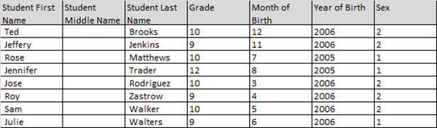

Submitting the PISA Electronic Student File (E-File)

Step 1: Upload file. After you have created and saved your student E-File, proceed to www.MyPISA.us. Once you have logged in, click the ‘Submit Student List’ link on the left side of the page (Box 1 below). Then click the “Browse” button to locate your file (box 2 below). Once you’ve located the file and clicked ok, click “Upload”(box 3 below).

Exhibit 1. Submit Student List - initial screen
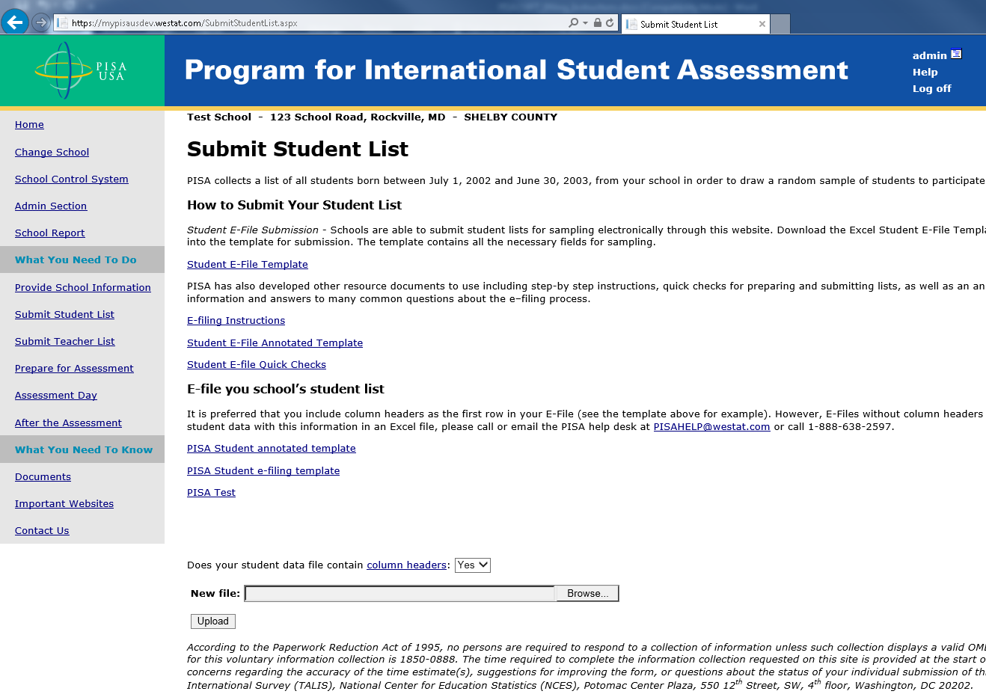
1
3
2

Step 2: Map Columns. The column headings in your file are shown in rows on the left side of the page. In each row, for each heading on the left, click on the down arrow next to the words in the table that read "Column Contains..." on the right. If there is no appropriate description in the drop-down list for your column heading, select N/A.
Exhibit 2. Submit Student List – Identify Your Columns
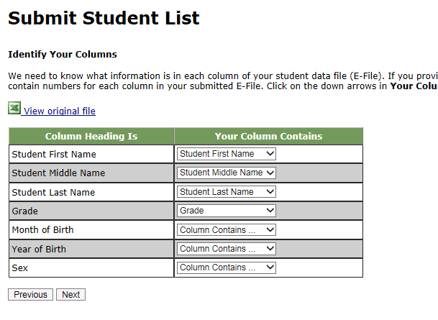

Step 3: Match Values to PISA Codes. The next step is matching the values on your file to PISA codes. The values in your columns will again be displayed on the left. Select the corresponding PISA code from the drop down list on the right (see exhibit 3). If there is no appropriate description in the drop-down list for your column heading, select N/A. When you are finished matching your values to PISA codes, click next. Repeat the above instructions to assign male/female codes and click next (see exhibit 4).
Exhibit 3. Submit Student List - Match your Values to PISA Codes (grade mapping)
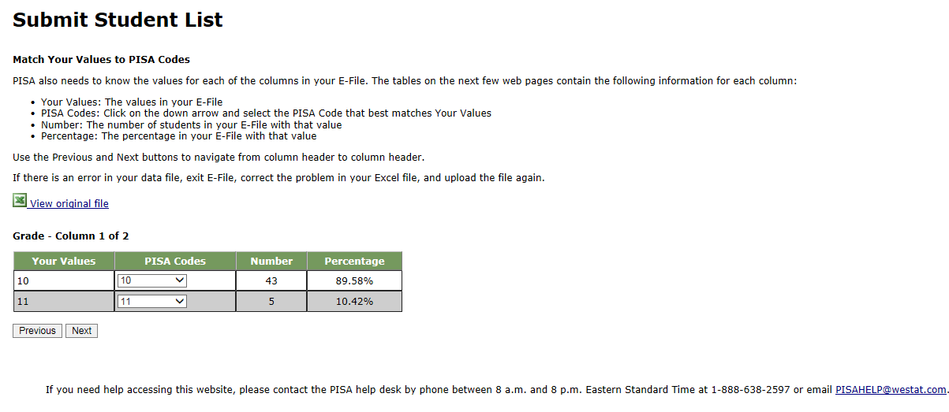
Exhibit 4. Submit Student List - Match your Values to PISA Codes (sex mapping)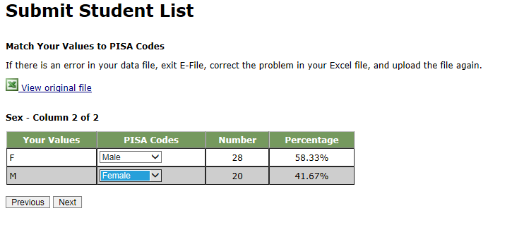

Step 4: Verify your E-file. The final step is to verify that the information is correct and submit your file. Check that the distribution of students by grade and sex match the total number of students you submitted. Indicate whether this information is correct and click “Submit.” If the information is incorrect click “Incorrect” and then click on the “Submit Student List” link on the left side of the screen. This will save your progress and exit the current e-file. You can access this file again or upload a new corrected file and start over using the same file upload process described in Step 1.
Exhibit 5. Submit Student List –Verify your E-file
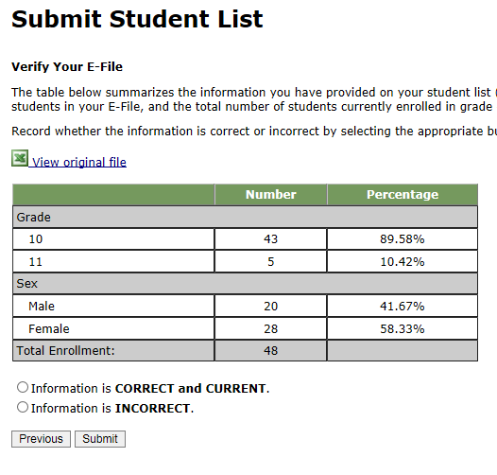

Online Student Data Checks - After you click “Submit” a number of online data validation checks are performed by our programs. These checks include checking the number of listed students against statistical estimates, making sure there is an accurate distribution of students by grade based on statistical estimates, checking that all students included are birth-year eligible (born in 2005 or 2006), and checking for any missing data. If the data fail these online checks, you will be presented with a screen that describes the issue, the location of the row(s) in your file that contains the errant data, and will need to correct the file and upload a new version. Exhibit 6 (below) provides an example of a file with missing data. Notice that the affected row is provided for each instance where the check failed. This is designed to help you efficiently locate and ameliorate any issues. Exhibit 7 provides an example of a file where ineligible students were included.
Exhibit 6. Online data checks
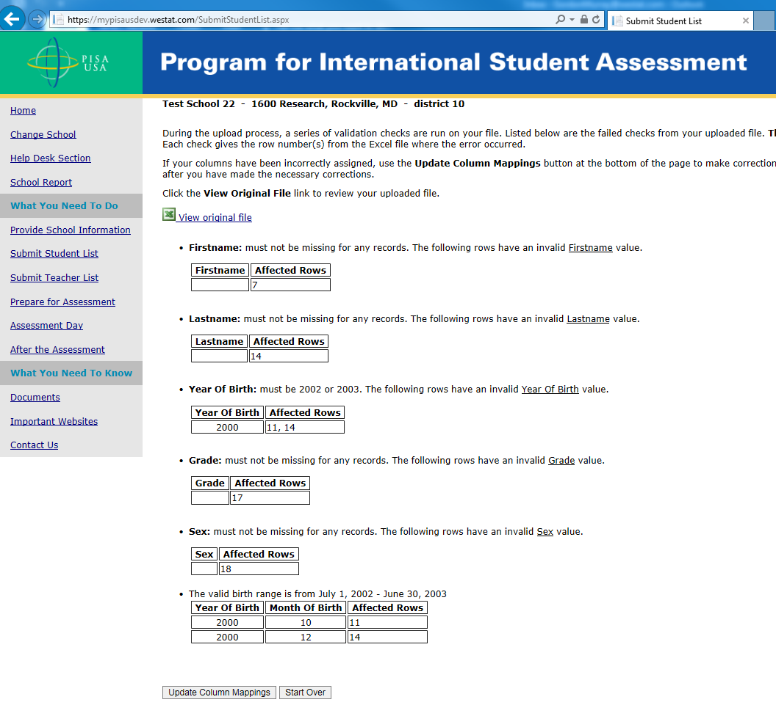

Along with the file validation checks, the total number of students is compared to the statistical estimate of eligible students. If there is a 10% or more difference in enrollment, which is typical for most every school, international standards for data collection require that we ask school coordinators for a possible reason. Typical reasons include redistricting, the schools being located within a growing or shrinking community, or near an army base. Exhibit 8 provides a screen shot of the enrollment verification check and comment box. This check does not prohibit you from completing your e-file. Simply provide a comment in the box and continue.
Exhibit 7. Online data check – enrollment verification
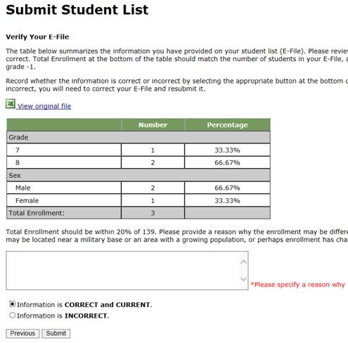
If at any time you realize that every eligible student was not listed, you can exit e-filing, correct the file, and upload a new one. If you have any questions or would like to talk with someone about e-filing, please reach out to the PISA help desk by phone between 8 a.m. and 8 p.m. Eastern Standard Time at 1-888-638-2597 or email PISAHELP@westat.com.
Note that neither students nor teachers can be sampled until your student and teacher lists are both submitted.

PISA E-file reminder email to School Coordinator

Subject: PISA E-File Reminder
Attachment: PISA 2021 E-Filing Instructions

Dear School Coordinator:
Welcome and thank you for your efforts as the school coordinator for the Program for International Student Assessment (PISA) 2021 at your school!
We are nearing the deadline for your student lists to be submitted for sampling (October 1, 2021). Please upload your school’s list as soon as possible so that sampled students can be notified about the study.
Detailed instructions for submitting your list to PISA are included in the enclosed document titled PISA 2021 E-Filing Instructions.
If you have any questions about the instructions, please contact the PISA Help Desk 1-888-638-2597, or send an email to PISAHELP@westat.com. The e-filing instructions are also posted on the MyPISA.us website (www.mypisa.us).

Sincerely,
The PISA USA Team

The National Center for Education Statistics (NCES) is authorized to conduct the Program for International Student Assessment (PISA) by the Education Sciences Reform Act of 2002 (ESRA 2002, 20 U.S.C. §9543), and to collect students’ education records from educational agencies or institutions for the purpose of evaluating federally supported education programs under the Family Educational Rights and Privacy Act (FERPA, 34 CFR §§ 99.31(a)(3)(iii) and 99.35). The data are being collected for NCES by Westat, a U.S.-based research organization. All of the information you provide may be used only for statistical purposes and may not be disclosed, or used, in identifiable form for any other purpose except as required by law (20 U.S.C. §9573 and 6 U.S.C. §151).
Email to School Coordinator when student samples are complete and Student Tracking and School Logon Forms have been posted to MyPISA.us

Subject: PISA Student Sampling Complete

Hello!

We have processed the list of students from your school and selected a sample of students for the assessment. The following materials are now available on www.MyPISA.us:

- Student Tracking Form
- School Questionnaire Logon Form

To access the files:

1. Log into www.MyPISA.us with your username/password.
2. Click the Documents link in the "What you Need to Know" section.
4. Click on the link in the upper center of the page under "Download Your School's materials here:"

To open the files, use the password 1x2y3z45a6

Please review and update the Student Tracking Form following the steps provided in chapter 3, section 3.3 of your School Coordinator Handbook.

Please distribute the School Logon Forms.

Your PISA Test Administrator will be in contact with you to plan for the assessment. He or she can assist you in answering any questions you may have.

If you have any further questions, please feel free to call the PISA Help Desk at 1-888-638-2597, or send an email to PISAHELP@westat.com

Thank you again!

The PISA Team

The National Center for Education Statistics (NCES) is authorized to conduct the Program for International Student Assessment (PISA) by the Education Sciences Reform Act of 2002 (ESRA 2002, 20 U.S.C. §9543), and to collect students’ education records from educational agencies or institutions for the purpose of evaluating federally supported education programs under the Family Educational Rights and Privacy Act (FERPA, 34 CFR §§ 99.31(a)(3)(iii) and 99.35). The data are being collected for NCES by Westat, a U.S.-based research organization. All of the information you provide may be used only for statistical purposes and may not be disclosed, or used, in identifiable form for any other purpose except as required by law (20 U.S.C. §9573 and 6 U.S.C. §151).

PISA School Coordinator Handbook Cover Letter
Welcome and thank you for your efforts as the school coordinator for Program for International Student Assessment (PISA) 2021 at your school. In PISA 2021, the United States will participate along with more than 80 other countries and education systems in a study that produces important international benchmarks in reading, mathematics, science, and financial literacy of 15-year-old students. Your assistance is critical to the success of the study.
If you have not already done so, the first step is to generate an electronic student list of all 15-year-old students in your school and to submit it to PISA via the MyPISA.us secure website. Detailed instructions for how to submit student lists to PISA are included in a document titled PISA 2021 E-Filing Instructions that was emailed to you. These instructions can also be found in Appendix C of the enclosed School Coordinator Handbook. If you would like that document emailed to you again, please contact the PISA Help Desk at PISAHelp@westat.com or by calling 1-888-638-2597. The e-filing instructions are also posted on the MyPISA.us website (www.mypisa.us).
After submitting your student list for e-filing, you will receive an email notifying you that your school’s tracking form, which list the selected students, are ready for you to download from MyPISA.us. Once downloaded, please review and update the information as necessary. The enclosed document, PISA 2021 School Coordinator Handbook, describes what you should do with each form you downloaded.
Your PISA representative will contact you in approximately 2 weeks to review the PISA materials with you, answer any questions you may have, and set up a pre-assessment visit at your school to:
* identify students with special needs who may need accommodations to be tested, or may not be able to participate in the assessment;
* identify other students listed who cannot participate (withdrawn or ineligible for other reasons);
* confirm the date, time, and location for the assessment sessions;
* meet with selected students to introduce them to PISA and motivate them to participate and do their best; and
* review parent/guardian notification.
Thank you for your time and support of this important international study. We look forward to working with you to make PISA a positive experience for your school.

Sincerely,
The PISA USA Team

P
2
I
S
A
0
1
8

PISA 2021
SCHOOL COORDINATOR’S HANDBOOK

If you have any questions, please contact us at:
PISA Help Desk
Phone: 1-888-638-2597
Fax: 240-314-2334
Email: PISAHELP@westat.com
For more information about PISA, visit the PISA website:
http://nces.ed/gov/surveys/pisa

Table of Contents
CHAPTER 1: INTRODUCTION 1
1.1. What is PISA? 1
1.2. Components of PISA 1
1.2.1. PISA assessment day 1
1.2.2. PISA questionnaires 2
1.3. Role of the school coordinator 2
1.3.1. Key activities for the school coordinator 2
1.3.2. PISA forms 4
CHAPTER 2: PRELIMINARY TASKS 5
2.1. Confirm date and location for the assessment sessions 5
CHAPTER 3: BEFORE THE ASSESSMENT DAy 7
3.1. Receive and check PISA materials 7
3.2. Notify school staff, students, and parents of the assessment 7
3.3. Review and update the Student Tracking Form 7
3.3.1. Steps for reviewing and completing the Student Tracking Form 8
3.3.2. Summary of non-participant codes 13
3.3.3. Students to be assessed in PISA 14
3.4. Organize and confirm assessment plans with school staff, students, parents, and test administrator 15
3.5. Distribute School Questionnaire Logon Form to appropriate person at your school 15
3.6. Confirm School Questionnaire completion 16
CHAPTER 4: ASSESSMENT DAY 17
4.1. Meet with the test administrator before the assessment 17
4.2. Arrange for support staff to be present throughout each session (if possible) 17
4.3. Meet with the test administrator after the assessment 18
4.4. Arrange for a makeup session, if needed 18
4.5. Store PISA forms 18

Appendix A. PISA Forms 19
Appendix B. School Questionnaire Questions 24
Appendix C. PISA 2021 E-Filing Instructions 30

CHAPTER 1: INTRODUCTION
Thank you for agreeing to be a school coordinator for PISA 2021. As your school has been selected to represent the United States in this large-scale international assessment program, you will play a very important role in making sure that the assessment is carried out smoothly and in a standard way. In doing so, you will contribute significantly to the PISA objectives of improving the quality of schooling for students in the United States. This manual provides instructions on the tasks you will need to complete for implementing PISA in your school.

1.1. What is PISA?
PISA stands for the Program for International Student Assessment, sponsored by the Organization for Economic Cooperation and Development (OECD). PISA has been conducted every 3 years since 2000 and involves more than 80 participating countries. PISA 2021 will be conducted in fall of 2021.
PISA has the following characteristics:
- The world’s largest international survey in education
- Surveys students who are about 15 years old
- Assesses students’ preparedness for adult life
- Measures students’ literacy in mathematics, reading, science and financial matters
- Collects contextual information about educational practices in participating countries

Undertaking PISA is important because the results of the assessment can be used to
- indicate how well prepared students in the United States are for learning once they leave school;
- identify areas for improvement over time by schools, education systems, and governments;
- allow a comparison of student performance and the learning environment between different countries.
For more details about PISA, refer to the OECD website at https://www.oecd.org/pisa.
Note on Confidentiality
All of the information provided by you, other school staff, and students may be used only for statistical purposes and may not be disclosed, or used, in identifiable form for any other purpose except as required by law (20 U.S.C. §9573 and 6 U.S.C. §151). No participating individual or school will be identified in any report released by the assessment program.

1.2. Components of PISA
The following describes the assessment and the different types of questionnaires.

1.2.1. PISA assessment day
Up to 52 students from your school will be randomly sampled to complete a 2-hour computer-based assessment consisting of combinations of questions in reading, mathematics, and science. They then return after a short break and complete about a 1-hour Student Questionnaire, which consists of questions that examine students’ attitudes towards learning, their experience with money matters in and outside of school, and their activities and familiarity with information/communication technology.

1.2.2. PISA questionnaires
Questionnaires are an important part of PISA and provide valuable information that expands the assessment results. As school coordinator, you are tasked with overseeing the completion of school questionnaire and monitoring the completion on www.MyPISA.us
- The School Questionnaire collects information about how education systems work within and between countries. The School Questionnaire should be completed online by the school’s head administrator using a school-specific login and password. The questionnaire takes about 45 minutes to complete.

1.3. Role of the school coordinator
As a school coordinator, you act as the liaison between your school and the PISA test administrator. The actual assessment will be conducted by the test administrator.

1.3.1. Key activities for the school coordinator
The school coordinator will assist the test administrator with preparations before and on assessment day.
PISA has provided a website, www.MyPISA.us to facilitate the communication between your school and the study. One of the key activities as school coordinator is providing an electronic file of students (student E-File) that lists all eligible students. If you have yet to submit these files, instructions for preparing and submitting the files can be found in the “Documents” section on www.MyPISA.us or see appendix C. Alternatively, send an email to PISAHelp@westat.com and we will be glad to send them to you directly. Once your student and teacher lists have been processed and sampled, download your school’s PISA forms from the “Documents” section on www.MyPISA.us. PISA will provide you with the following:
- The Student Tracking Form (lists the students selected for the PISA assessment).
- The Session Attendance Form (provides the location and date/time of the assessment we have on record). You may use this form when notifying school staff and students of the date, time, and location of the assessment session.
- Instructions for handling the School Questionnaire along with other informational materials.

It is essential that the procedures described in this manual are followed carefully to ensure that the PISA sessions are administered the same way in all participating countries. Failure to do so might invalidate the results of the study.
A summary of the key activities for the school coordinator is presented in exhibit 1.1.

Exhibit 1.1. Key activities for PISA school coordinators
Stage | Date | Activity | Page number
Preliminary tasks | 3-6 weeks prior to the assessment day | Confirm assessment date and  location for the assessment sessions | 5
Before the assessment | 1-2 weeks prior to the assessment day | Receive and check PISA materials | 7
 |  | Notify school staff, students, and parents of the assessment | 7
 |  | Review and update the Student Tracking Form | 7
 | 1-2 weeks prior to assessment | Organize and confirm assessment plans with school staff, students, parents, and test administrator | 15
 |  | Hold pre-assessment call and visit with the test administrator | 15
 |  | Distribute School Questionnaire Logon Form to appropriate person at your school | 15
 | A few days prior to the assessment | Confirm School Questionnaire completion | 15
During and after the assessment | Assessment day | Meet with the test administrator(s) before the assessment | 17
 |  | Arrange for support staff to be present throughout each session | 17
 |  | Meet with the test administrator(s) after the assessment | 18
 | Same week as the main session (if possible) | Arrange for a follow-up session, if needed | 18
 |  | Store PISA forms | 18

If you have any questions, please contact us at:
PISA Help Desk
Phone: 1-888-638-2597
Fax: 240-314-2334
Email: PISAHELP@westat.com
For more information about PISA, visit the PISA website:
http://nces.ed/gov/surveys/pisa

1.3.2. PISA forms
Exhibit 1.2 lists the important forms with which you should be familiar. It is critical that you fill out these forms accurately and completely so that student performance and questionnaire responses can be validly and reliably linked to student demographics. Templates of these forms can be found in appendix A.
Exhibit 1.2. Purpose of forms
Form | Purpose | Completed by
Student List  (student E-File) | Used to list all students eligible for PISA. | School coordinator, submitted via MyPISA.us
Student Tracking Form | To indicate all students sampled from the school participating in PISA and to record demographic information about these students. | PISA home office,  downloaded and updated by school coordinator and test administrator
Session Attendance Form | To document assessment date, time, and location and student participation on assessment day | PISA home office, test administrator
School Questionnaire Logon Form | To give to the head administrator to log onto the online School Questionnaire. | PISA home office, downloaded by school coordinator

CHAPTER 2: PRELIMINARY TASKS

2.1. Confirm date and location for the assessment sessions
PISA will take place between October 4 and November 19, 2021. It is important when confirming the scheduled assessment date with the test administrator to check that there are no other events (e.g., pep rallies, college fairs, school dances) taking place at your school that could interfere with the assessment session or with the attendance of the selected students. You will then set the location and time of the assessment with the test administrator.
Information needed to plan locations and times is presented below.
Exhibit 2.1 presents the assessment timings that you should consider when reserving space for the assessment session. This includes time needed for the PISA team to set up the space before students arrive and time for packing up materials and equipment after the assessment.
It is best to schedule the session to start as early in the school day as possible to allow time to conduct the Student Questionnaire session. Occasionally, it may be necessary to conduct one or more sessions on another day.
When scheduling the assessment times and locations, expect to reserve the location for the assessment for 6 hours. However, if one location is not available for the full 6 hours, reserve 5 hours for the assessment and an additional 2 hours in the second location for the Student Questionnaire. This will give staff time to pack up and set up all 52 laptops in the new location.
PISA staff will bring in all computer equipment needed for the assessment. When considering an assessment location, keep the following factors in mind:
- The assessment should take place in an area free of distractions and interruptions.
- The space will need 2‒4 working electrical outlets.
- If the school is multi-level, we would request that the assessment location be assigned on the ground floor or that access to an elevator is available to facilitate moving equipment around easily.
- There will need to be enough space to set up 52 laptops, although separate rooms with less than 52 spaces are okay.
- If possible, we would prefer to conduct the questionnaire in the same location(s) as the assessment so that we do not have to pack up all of the computer equipment and move it to a new location.

Exhibit 2.1. Timing of assessment
Activity | Student Time | Room Availability Time
Room setup | Not applicable | 60 minutes (approximately)
Student logons, passwords, and introducing the assessment | 15 minutes (approximately) | 15 minutes (approximately)
General Introduction | 5 minutes (approximately) | 5 minutes (approximately)
First 60 minutes of test | 60 minutes (exactly) | 60 minutes (exactly)
Short break | Generally, no more than 5 minutes | Generally, no more than 5 minutes
Introducing Section 2 of test | 5 minutes (approximately) | 5 minutes (approximately)
Second 60 minutes of test | 60 minutes (exactly) | 60 minutes (exactly)
Short break | Generally, no more than 5 minutes | Generally, no more than 5 minutes
Student Questionnaire | 65 minutes (approximately) | 65 minutes (approximately)
Ending the session, collection, and transfer of data | 5 minutes (approximately) | 5 minutes (approximately)
Packing up and resetting room | Not applicable | 40‒60minutes (approximately)
Total | Assessment  2½ hours  Student Questionnaire 1 hour (approximately)  Total time <4 hours | 6 hours (approximately)

CHAPTER 3: BEFORE THE ASSESSMENT DAy

3.1. Receive and check PISA materials
After your student and teacher lists are submitted and sampled, you will be notified via email when you are able to download the following materials from the MyPISA website (www.MyPISA.US):

- Student Tracking Form – lists each student who has been selected to participate in the assessment, including each student’s demographic information. An example of this is shown in exhibit 3.2.
- School Questionnaire Logon Form – provides the principal/designee with the information needed to access the online School Questionnaire.
- Session Attendance Form ‒ provides assessment date, time, and location and is also used to record student participation on assessment day.
The test administrator will contact you to verify that you were able to download these forms and to confirm the date and time of the pre-assessment visit.

3.2. Notify school staff, students, and parents of the assessment
Please inform school staff, students, and parents of the assessment according to the school’s policy. It is very important that parents be notified of their student’s participation in the PISA assessment. The test administrator will collect a dated copy of the letter used to notify parents prior to the assessment. A sample copy of this letter is available for download from the MyPISA website (www.MyPISA.US).

Student meeting
Likewise, it is very important to introduce the aims of PISA to school staff, and students prior to the assessment to help engage students and promote their participation. In addition, the test administrator will work with you to plan a meeting with the students on the day of the pre-assessment visit.
During this student meeting, the test administrator will show a brief presentation that will introduce the importance of PISA as well as motivate students to participate and do their best on the assessment. The test administrator will provide Student Invitations to the assessment and Student FAQs.
Motivating students and achieving a high student participation rate are key to a successful assessment day. If fewer than 90 percent of eligible students participate on the assessment day, it may be necessary to schedule a makeup session to assess students who were absent.
If there is not sufficient time for the test administrator to visit the school in person before assessment day, another possibility is for you or a school staff member to hold the student meeting. The student presentation and instructions will be provided to you along with Student Invitations to the assessment and Student FAQs.

3.3. Review and update the Student Tracking Form
Once you have been notified by email that your school’s materials are available for download from the MyPISA.us website, review and update the Student Tracking Form. The Student Tracking Form lists all sampled students along with their demographic data. Review this form and correct any errors. An example of the Student Tracking Form is shown in exhibit 3.2. The steps for completing the form are detailed on pages 10-17.

3.3.1. Steps for reviewing and completing the Student Tracking Form

Step 1: Check student details and demographics
Having accurate information on this form is vital for data validity and for preparing certificates of service, and student invitations. Please check to make sure that each
- student’s name is spelled correctly,
- student’s grade is properly listed, and
- student’s month of birth (MOB) and year of birth (YOB) is correctly listed.
If you identify incorrect information, correct the information on the Student Tracking Form and relay this information to the PISA test administrator assigned to work with you.

Step 2: Identify students with special education needs (SEN)
PISA uses a coding system to identify students with special education needs (SEN). Students typically referred to as students with disabilities, or English language learners in the United States, may be categorized as SEN for PISA. The SEN column of the form is used to record the special education needs of eligible students. The codes are defined in exhibit 3.1. Please identify any student who has a special education need by placing the appropriate code in the SEN column.
Exhibit 3.1. Codes for special education needs
Description | SEN Code
Functional disability – student has a moderate to severe permanent physical disability | 1
Cognitive, behavioral, or emotional disability – in the opinion of qualified staff, student has a cognitive, behavioral, or emotional disability | 2
Limited assessment language experience – student is not a native speaker of the language of the assessment in the country and has limited proficiency in this language | 3
Home schooled – student is home schooled and does not attend any classes on campus | 4

Examples of using special education needs codes
Please refer to exhibit 3.2 in which the following codes have been applied to the Student Tracking Form:
- José Camacho is not a native English speaker and has less than 1 year of instruction in English. Therefore, he is coded as “3” in the SEN column.
- Roy Edmonds is not a native speaker of English. While he has received instruction in English for more than 1 year, he still has some difficulties with English expression and requires some extra help. Therefore, he is also coded as “3” in the SEN column.
- Sam Fay is blind and is coded as “1” in the SEN column.
- Fred Hunt is deaf, so he is coded as “1” in the SEN column.
- Lisa Jenkins has been professionally assessed as cognitively delayed and is coded as “2” in the SEN column.
- For all other students who do not have any special education needs, the SEN column is left blank. For most students the SEN column will be left blank, meaning they have no special education needs.

Exhibit 3.2. Student Tracking Form (example after completion)
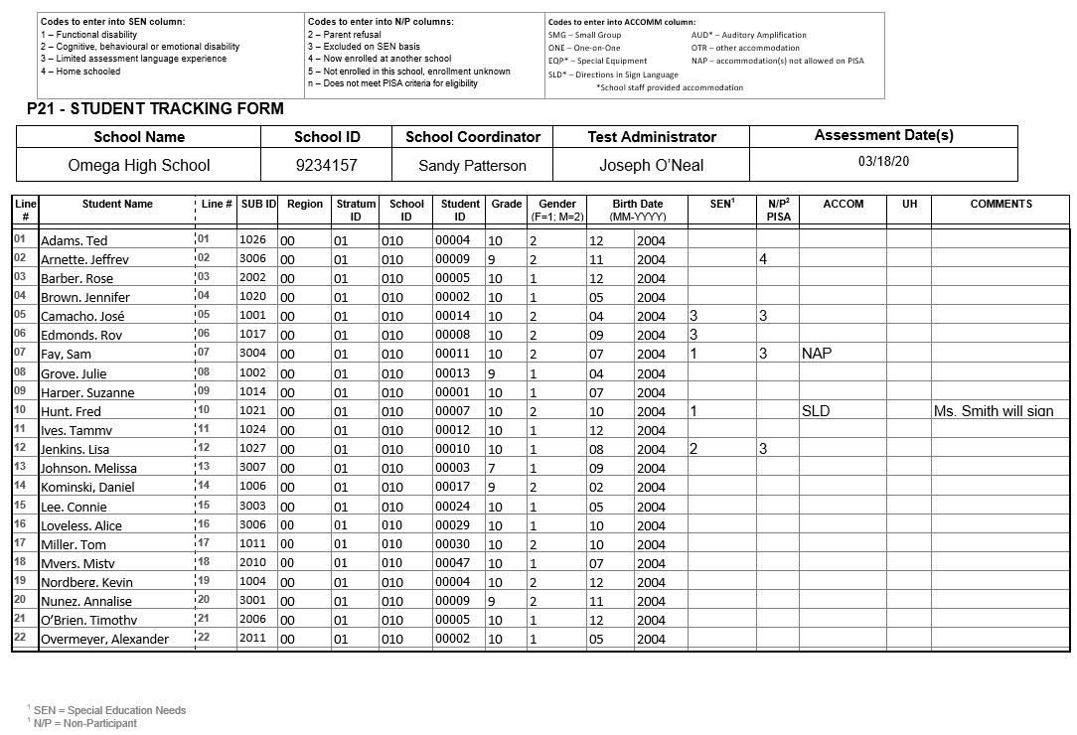

Step 3: Identify accommodations for students who require them
If any SEN students require accommodations to be tested, record those in the ACCOM column on the Student Tracking Form. Exhibit 3.3 lists the accommodations allowed on PISA along with the three-letter accommodation code. Record the three-letter code from the table in exhibit 3.3 in the ACCOM column on the Student Tracking Form.
Note on Including Students
Many students with special education needs can be included in PISA without the accommodations they receive in the classroom or on high-stakes, individual tests used for grades, evaluations, or promotions. PISA is a large-scale assessment administered in a standardized way to all students. Individual scores are not reported but are aggregated across all students.

Exhibit 3.3. PISA-allowed accommodations
Accommodation Name and Code | Description
Small group (SMG) | Generally, a small group session includes no more than five students.
One-on-one (ONE) | This accommodation requires that a student is assessed individually in an area free of distractions.
Special equipment (EQP)* | Special equipment includes the following:  - Lighting devices  - Straightedge/ruler, overlay, or template  - Special writing tool or pencil grip  - Preferential seating  - Study carrel  - Large-screen calculator
Directions in sign language (SLD)* | This accommodation requires that a qualified sign language interpreter at the school sign the instructions included in the session script for the student.
Auditory amplification (AUD)* | This is an earpiece, microphone, speaker or other amplification that allows students with auditory impairments better access to the directions read aloud to students. This would be provided in a way that does not affect or distract other students.
Other (OTR) | If the student requires an accommodation that is not included in either the allowed list above or the non-allowed list below, please record OTR on the Student Tracking Form. The PISA test administrator will discuss these with you during the pre-assessment visit.
*School staff must provide these accommodations.
As part of standard PISA procedure, all students receive the assessment directions read aloud in English and can record their answers directly in the computer. All students will also receive a calculator that can be used during the assessment. These do not need to be recorded as accommodations on the Student Tracking Form.

Accommodations that PISA cannot provide include the following:
- Read aloud of the assessment items
- Scribe
- Extended time
- Braille
- Large-print assessment materials
- Assessment materials in a language other than English
- Bilingual dictionary
- Magnification devices
- Cueing to stay on task
If the student requires any of the accommodations listed above that PISA does not allow, record “NAP” (not allowed on PISA) in the ACCOM column on the Student Tracking Form and record the name of the accommodation that PISA does not allow in the Comments column.

Step 4: Identify students who CANNOT participate in PISA
Column “N/P PISA” on the Student Tracking Form is used to identify students who cannot participate in PISA. PISA is designed to be as inclusive as possible. However, some students may not be able to participate for various reasons. These reasons for non-participation have to be recorded in this column of the Student Tracking Form, using the codes as outlined in exhibit 3.4.
Exhibit 3.4. Non-participation (N/P) codes

Code 2 – Parent refusal
A small number of parents/guardians may refuse to allow their child to participate in PISA. If you have received such notification from parents/guardians, record a code “2” for this student in column “N/P PISA.”

Code 3 – Excluded on SEN (special education needs) basis
The guidelines in exhibit 3.5 will assist you in deciding whether a student identified in the SEN column can be excluded from PISA.
If a student with a special education need is to be excluded from the assessment, record a code “3” for this student in column “N/P PISA.”

Code 4 – Student now enrolled at another school
If it is known that a student has transferred to another school, record a code “4” for this student in column “N/P PISA.”

Code 5 – Student not enrolled in this school, and enrolment is unknown
If a student has left school, but it is not known to which school, if any, the student has transferred, record a code “5” for this student in column “N/P PISA.”

Code n – Does not meet PISA criteria for eligibility
- If a student is enrolled in Grade 6 or lower, he or she is not eligible to participate in PISA. Record a code “n” for this student in column “N/P PISA.”
- If a student was born before July 1, 2005, or after June 30, 2006 (that is, NOT born on or between July 1, 2005, and June 30, 2006), he or she is not eligible to participate in PISA. Record a code “n” for this student in column “N/P PISA.”

Exhibit 3.5. Guidelines – Exclusion/inclusion of students with special education needs
Group | Students who should be included | Students who may be excluded
Functional (physical or sensory) disability  (SEN code 1) | The student can respond to the assessment.  Code SEN as 1, leave N/P PISA blank. | The student has a moderate to severe permanent physical disability such that she or he cannot participate in the PISA testing situation.  Record Code 3 in column N/P PISA.
Cognitive, behavioral, or emotional disability  (SEN code 2) | The student can respond to the assessment. He or she should NOT be excluded solely because of poor academic performance or disciplinary problems.  Code SEN as 2, leave N/P PISA blank. | The student has a cognitive, behavioral, or emotional disability such that in the opinion of qualified staff, she or he cannot participate in the PISA testing situation. This includes students who are cognitively, behaviorally, or emotionally unable to follow even the general instructions of the assessment.  Record Code 3 in column N/P PISA.
Limited assessment language experience  (SEN code 3) | The student meets ONLY one or two of the following criteria:  - not being a native speaker in the assessment language,  - having limited proficiency in the assessment language, and  - having received less than 1 year of instruction in the assessment language.  Code SEN as 3, leave N/P blank. | The student meets ALL of the three criteria.  - Record Code 3 in column “N/P PISA.”
Home schooled  (SEN code 4) | The student is home schooled and attends campus at any time.  This student should be encouraged to participate.  Do NOT assign an N/P code.  Code SEN as 4, leave N/P PISA blank. | The student is home schooled and never attends campus.  Cade SEN as 4, Code n in column N/P PISA.  The student is home schooled because of cognitive or physical impairment and attends campus at any time:  Code SEN as 4, code 3 in column N/P PISA if he/she cannot participate in the PISA testing situation.  However, if this student does not attend campus: Code n in column N/P PISA.

3.3.2. Summary of non-participant codes
All codes to be used in column N/P PISA for non-participants are summarized in exhibit 3.6. If in doubt about which code to use, leave that column blank and insert a brief note in the Comments column.
Note About Column N/P PISA of the Student Tracking Form
The purpose of column N/P PISA is to record the reasons for non-participation of students who have no possibility of participating in PISA under any circumstances. Therefore, you should NOT use a code 2 if a student is unable to attend the PISA assessment; for example, due to a competing activity in/outside the school or illness, the student might be able to attend a makeup session.

Exhibit 3.6. Codes for non-participants
Reason for non-participation | Code
Parent refusal | 2
Excluded on SEN (special education needs) basis | 3
Now enrolled at another school | 4
Not enrolled in this school, and enrollment is unknown | 5
Does not meet PISA criteria for eligibility | n

Examples of using non-participant codes and accommodation codes
Refer to exhibit 3.2 (page 12), in which the following example codes have been applied:
- Jeffrey Arnette has recently transferred to another school. Therefore, he is coded as “4” in column N/P PISA.
- José Camacho is coded as “3” in column SEN. He has been taught in English for less than 1 year and his teachers believe that he will not be able to participate in the assessment. Therefore, he is coded as “3” in column N/P PISA.
- While Roy Edmonds’s experience with English is limited, he has been taught in English for more than 1 year and therefore does not meet the PISA criteria for exclusion on the basis of insufficient language experience. Therefore, column N/P PISA is left blank, and Roy is considered to be able to participate in the assessment.
- Sam Fay is blind and is coded as “1” in column SEN. He requires a Braille version of the test to be assessed. PISA is not offered in Braille. Therefore, he is unable to participate in the assessment and is coded as “3” in column N/P PISA. Additionally, “NAP” is recorded in the ACCOM column and a note about Sam’s Braille accommodation is recorded in the Comments column.
- Even though Fred Hunt is deaf, it does not affect his ability to participate. So, although he is coded as “1” in column SEN, column N/P PISA is left blank. Fred requires someone to sign the directions to him, so “SLD” is recorded in the ACCOM column, and the name of Fred’s signer is recorded in the Comments column.
- The following two students are ineligible according to the PISA eligibility criteria because incorrect demographic information was recorded in the student list originally submitted for sampling. These students were subsequently sampled. The school coordinator corrected the incorrect information on the Student Tracking Form.
  - Tammy Ives’s birth date does not fall in the eligible range for PISA participation. She is coded as “n” in column N/P PISA.
  - Melissa Johnson is in grade 6 and is coded as “n” in column N/P PISA.
- Lisa Jenkins has been professionally assessed as cognitively delayed and is coded as “2” in column SEN. She does not participate in other testing programs. Therefore, she will not participate in the assessment and is coded as “3” in column N/P PISA.
Exhibit 3.7. Session Attendance Form
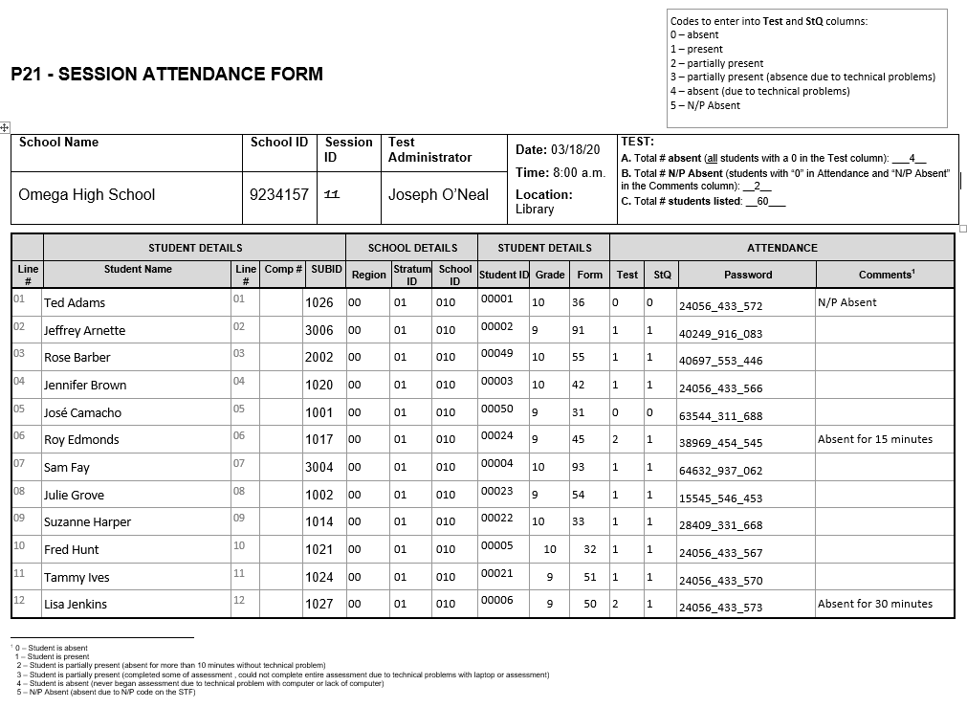

3.3.3. Students to be assessed in PISA
Only those students who do not have any codes placed in column N/P PISA can be assessed in PISA.
Important! Under no circumstances may a sampled student be replaced with another student who has not been selected to participate.

3.4. Organize and confirm assessment plans with school staff, students, parents, and test administrator
During the 2 to 3 weeks preceding the assessment, you will need to confirm these plans as follows:
- confirm assessment plans with the test administrator;
- confirm the date, time, and location for the assessment sessions and inform the test administrator, affected school staff, and students of any changes;
- ensure that the assessment location(s) have been reserved;
- ask participating students to bring a calculator to the assessment (PISA will provide a calculator to students who do not have one);
- arrange for some books or magazines for students who finish the assessment ahead of time; and
- arrange for school staff to assist during the assessment if necessary.

Hold Pre-assessment call and visit with the test administrator
The test administrator(s) assigned to your school will contact you 1 to 3 weeks before the assessment date to set up a pre-assessment visit at your school. During this visit, the test administrator will meet with you to discuss the following:
- the date, time, and location of the assessment sessions;
- any updates you have made to the Student Tracking Form regarding student demographic information, SEN codes, and exclusions;
- details about accommodations for students with special education needs;
- notification of school staff, students, and parents, including
  - verifying that the parents/guardians have been notified,
  - distributing Student Invitations and Student FAQs to sampled students, and
  - informing school staff of the date and time of the assessment;
- details about school protocols, including
  - visitors arriving and checking in at the school,
  - students who arrive too late to the assessment and cannot be included,
  - students who become ill during the assessment and other urgent situations,
  - students who need to use the restroom or temporarily leave the session,
  - emergency drills or other activities that may interrupt the assessment session, and
  - dismissing students after the assessment;
  - time to meet with the test administrator the morning of the assessment; and
  - time to meet after the assessment to discuss any needed makeup sessions and review how the assessment went.

Hold Student meeting and presentation
During this visit the test administrator will also meet with the sampled students for about 20 minutes to show them a brief presentation and answer any questions. The meeting is designed to both inform and motivate students to participate and do their best. This is an important part of the PISA assessment.

3.5. Distribute School Questionnaire Logon Form to appropriate person at your school
The School Questionnaire should be completed online by the school principal or by someone to whom he or she delegates the task. The School Questionnaire provides valuable information about school policies and characteristics. It is important that these be completed in every school. To facilitate this task, appendix B provides nine questions that require looking up statistical information from your school that will be asked in the School Questionnaire (e.g., counts of student enrollment, staff counts, and percentage of students eligible for the National School Lunch Program).

Answers to these questions can be collected in advance to expedite completing the School Questionnaire. As mentioned in section 3.1, you will be notified by email when your school’s materials are available for download from the MyPISA website (www.MyPISA.US). This includes the School Questionnaire Logon Form. Print this form and distribute it to the principal or his/her designee.

3.6. Confirm School Questionnaire completion
Please confirm that the School Questionnaire has been completed and, if necessary, remind the appropriate person to complete the questionnaire. You can update questionnaire status and monitor completion of the questionnaire by viewing the information in the “Provide School Information” section of the MyPISA website.

CHAPTER 4: ASSESSMENT DAY

4.1. Meet with the test administrator before the assessment
The test administrator(s) will arrive 1 to 1½ hours before the assessment is scheduled to begin and will need to meet with you immediately to review assessment day logistics. Give the test administrator(s) the updated Student Tracking Form and discuss any changes to the Student Tracking Form. Make sure that you have updated the forms before the meeting. Do not record anything in the “N/P PISA” column for students who are absent on assessment day but are eligible to participate in the assessment. The test administrator will record student attendance on the Session Attendance Form after the assessment.

4.2. Arrange for support staff to be present throughout each session (if possible)
If it is not possible for you or other school staff to be present throughout the assessment, you or they should be present at least at the beginning of the assessment session. This will help set the tone of the session and demonstrate the importance of the assessment.
School staff, however, are not permitted to administer the assessment or respond to students’ questions related to test or Student Questionnaire items. Only the test administrator should respond to such questions.
Maintaining Security and Confidentiality of Assessment Materials
Because PISA materials will be used in the future, their security is very important and must be maintained at all times.

- It is never permissible for you or school staff to look at students’ computer screens (tests or Student Questionnaires) during or after the assessment.

- You and school staff are allowed to look at sample test and Student Questionnaire items only after the assessment and in the test administrator’s presence. To do this, the test administrator will use a special logon code. You will be asked to sign a document pledging not to reveal the contents of the assessment items.

- DO NOT copy or photograph secure/confidential PISA materials under any circumstances. Do not allow others to do so.

- It is imperative that you guard against students photographing the materials with their mobile telephones or other electronic devices.

- If the test administrator reports any missing assessment materials, you should assist him or her in locating them.

4.3. Meet with the test administrator after the assessment
After the assessment is completed, the test administrator will need to meet with you briefly to discuss the session. He or she will also need to make copies of the assessment forms and give these to you to store should there be any questions about the assessment or if the original documents are lost or damaged.

4.4. Arrange for a makeup session, if needed
PISA requires a high level of participation of the sampled students. The test administrator will calculate the absence rate after the assessment and inform you if a make-up session is needed.
If a make-up session needs to be arranged, please select a mutually agreed upon date and time that will maximize the number of students attending the session. It is preferred that makeup session(s) be held in the same week as the assessment, if possible.
Note on Makeup Sessions
Only one makeup assessment is held for a session. Please make every attempt to ensure that absent students attend the makeup session.

4.5. Store PISA forms
After the assessment, the test administrator will give you an envelope with copies of the completed forms. We ask that you store this envelope securely until the end of the school year.

Your help with PISA is very important to its success in ensuring that the data collected for United States is of the highest quality.

The U.S. PISA and the International Project Team appreciate your time and effort.

Thank you!

Appendix A
PISA Forms

Student List and E-File format
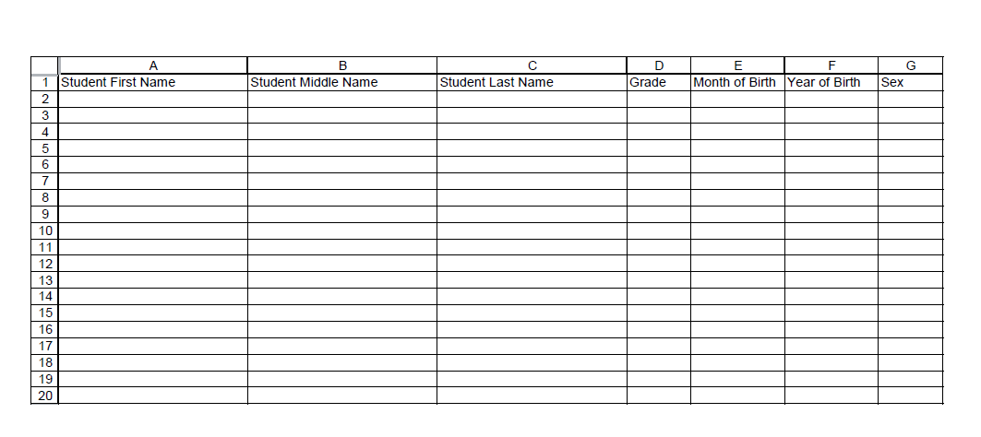

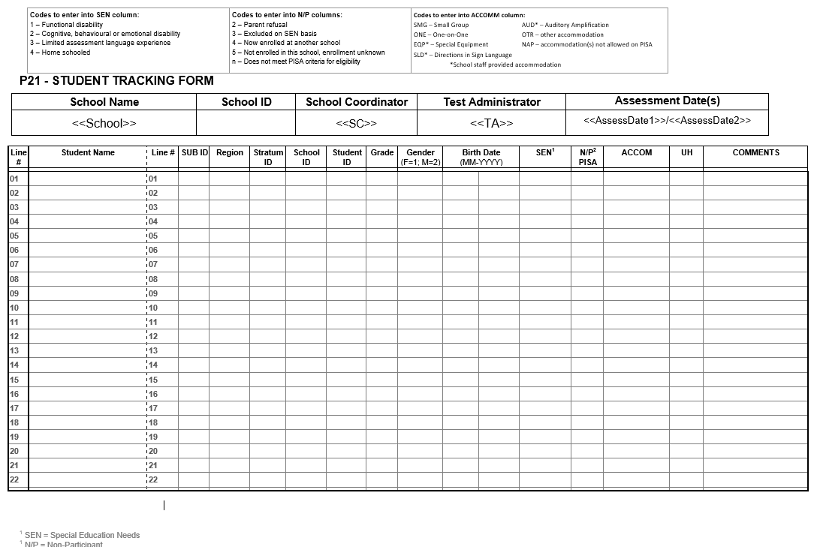
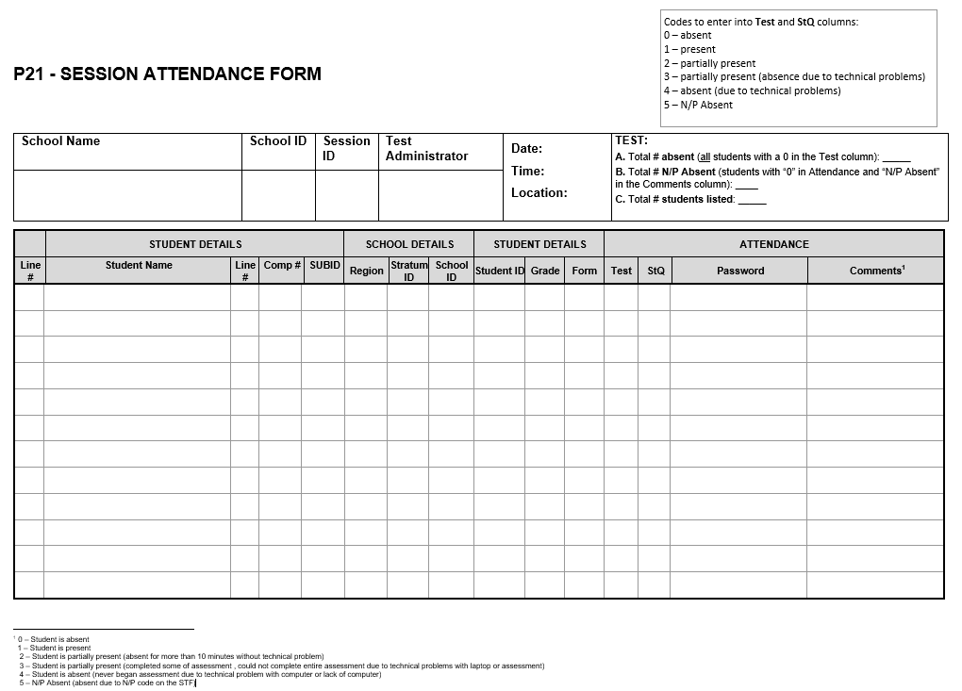

PISA 2021– Principal Questionnaire Invitation
Dear «principal»:
The United States is participating in an important international study: the Program for International Student Assessment (PISA). PISA is the largest international assessment of education in the world, with more than 80 countries and education systems participating in each cycle. It provides comparative information on the performance of U.S. 15-year-old students in science, reading, and mathematics with 15-year-old students in other countries.

Your school is one of 250 schools across the United States that are taking part in PISA 2021. Part of the PISA is an online school questionnaire that the principals of the selected schools complete. The questionnaire takes about 45 minutes to complete. This information, combined with responses students, helps to provide a more complete understanding of student achievement and contexts for learning.

Use the provided link and unique account information below to complete your questionnaire.

Link: https://portal.mypisa.us/SchoolQuestionnaire
Username:840-00-99-001
Password: 1234567
PISA is conducted in the United States by the National Center for Education Statistics (NCES), within the U.S. Department of Education, and is administered by Westat, a firm in Rockville, Maryland. The U.S. Office of Management and Budget has approved the data collection under OMB #1850-0755.
If you have any questions, please do not hesitate to call 1-888-638-2597 or send an email to PISAHELP@westat.com
You may also get more information about this study by visiting the PISA website at http://nces.ed.gov/surveys/pisa
Thank you for your time and for supporting this important international study.
Sincerely,
The PISA USA Team

The National Center for Education Statistics (NCES) is authorized to conduct the Program for International Student Assessment (PISA) by the Education Sciences Reform Act of 2002 (ESRA 2002, 20 U.S.C. §9543), and to collect students’ education records from educational agencies or institutions for the purpose of evaluating federally supported education programs under the Family Educational Rights and Privacy Act (FERPA, 34 CFR §§ 99.31(a)(3)(iii) and 99.35). The data are being collected for NCES by Westat, a U.S.-based research organization. All of the information you provide may be used only for statistical purposes and may not be disclosed, or used, in identifiable form for any other purpose except as required by law (20 U.S.C. §9573 and 6 U.S.C. §151).
Appendix B
School Questionnaire Questions

preparation for the pisa 2021

school questionnaire

This document contains nine questions on the School Questionnaire that involve statistical information from your school. Answers to these questions can be collected in advance by the school principal, or other staff involved in filling out the School Questionnaire. The information collected in this document will then be entered into the electronic questionnaire by the principal/the person filling out the questionnaire. You will find the question number in the lower left corner of the electronic questionnaire screen.

SC016 | About what percentage of your total funding for a typical school year comes from the following sources?
 | (Please enter a number for each response. Enter “0” (zero) if there are none.)
 |  | %
SC016Q01TA | Government (includes, local, , state and federal) | ___________
SC016Q02TA | Student fees or school charges paid by parents or guardians | ___________
SC016Q03TA | Benefactors, donations, bequests, sponsorships, parent fundraising | ___________
SC016Q04TA | Other | ___________
 | Total | 100%

SC002 | As of October 1, 2021, what was the total school enrollment (number of students)?
 | (Please enter a number for each response. Enter “0” (zero) if there are none.)
SC002Q01TA | Number of boys: | ____________
SC002Q02TA | Number of girls: | ____________

SC211 | Please estimate the percentage of students in 10th grade at your school who have the following characteristics.
(Please consider that students may fall into multiple categories.)
(Please write the appropriate percentage in each line.)
SC0211Q01JA | Students whose heritage language is different from English | _________
SC211Q02JA | Students with special needs | _________
SC211Q03JA | Students from socioeconomically disadvantaged homes | _________
SC211Q04JA | Students who are immigrants (not including refugees) | _________
SC211Q53JA | Students who have parents who have immigrated | _________
SC211Q06JA | Students who are refugees | _________
SC211Q07JA | Students who are eligible for free or reduced-price lunch through the National School Lunch Program | _________

SC004 |  | The goal of the following set of questions is to gather information about the student-digital device ratio for students in the 10th grade at your school.
 |  | (Please enter a number for each response. Enter “0” (zero) if there are none.)
 |  |  |  | Number
SC004Q01TA |  | At your school, what is the total number of students in the 10th grade |  | ____________
SC004Q02TA |  | Approximately, how many desktop or laptop computers are available for these students for educational purposes? |  | ____________
SC004Q03TA |  | Approximately, how many of these desktop or laptop computers are connected to the Internet? |  | ____________
SC004Q04NA |  | Approximately, how many tablet devices (e.g. iPad, Galaxy Book, Amazon Fire) or e-book readers (i.e. portable  device for reading books on screen, e.g. Amazon Kindle) are available for these students for educational  purposes? |  | ____________
SC004Q05NA |  | Approximately how many interactive whiteboards are available in the school altogether? |  | ____________
SC004Q06NA |  | Approximately how many data projectors are available in the school altogether? |  | ____________
SC004Q07NA |  | Approximately how many desktop or laptop computers with Internet connection are available for teachers in your school? |  | ____________
SC018 | How many of the following teachers are on the staff of your school?
 | Include both full-time and part-time teachers. A full-time teacher is employed at least 90% of the time as a teacher for the full school year. All other teachers should be considered part-time. Regarding the qualification level, please refer only to the teacher’s highest qualification level.
 | (Please enter a number in each space provided. Enter “0” (zero) if there are none.)
 |  |  | Full-time |  |  | Part-time
SC018Q01TA | Teachers in TOTAL |  | __________₀₁ |  |  | __________₀₂
SC018Q02TA | Teachers fully certified by the state in their main assignment field |  | __________₀₁ |  |  | __________₀₂
SC018Q05NA | Teachers with a bachelor’s degree qualification |  | __________₀₁ |  |  | __________₀₂
SC018Q06NA | Teachers with a master’s degree qualification |  | __________₀₁ |  |  | __________₀₂
SC018Q07NA | Teachers with a doctoral degree or professional degree (e.g., J.D. or M.D.) |  | __________₀₁ |  |  | __________₀₂
SC025 |  | During the last three months, what percentage of teaching staff in your school has attended a program of professional development?
A program of professional development here is a formal program designed to enhance teaching skills or pedagogical practices. It may or may not lead to a recognized qualification. The program must last for at least one day in total and have a focus on teaching and education.
(Please move the slider to the appropriate percentage. If none of your teachers participated in any professional development activities select “0” (zero).)
SC025Q01NA |  | Of all teaching staff at your school |  |  | ______________ % 01
SC025Q02NA |  | Staff who teach mathematics at your  school |  |  | ______________ % 01

SC003  SC003Q01TA | What is the average size of mathematics classes in 10th grade in your school?
 | (Please select one response.)
 | 15 students or fewer | ₁
 | 16-20 students | ₂
 | 21-25 students | ₃
 | 26-30 students | ₄
 | 31-35 students | ₅
 | 36-40 students | ₆
 | 41-45 students | ₇
 | 46-50 students | ₈
 | More than 50 students | ₉

SC164 | In the last full academic year, what proportion of students in your school’s final grade left school without a diploma or alternative credential (e.g., a GED)?
 | (A diploma or alternative certificate allows students to enter post-school destinations such as university, technical, further, or vocational education, apprenticeships or employment.)
 | (Please move the slider to the appropriate percentage. Select “0” (zero) if no students left without such a certificate.)
SC164Q01HA | _________________% 01

Thank you for collecting this information. Please keep this document and enter the respective numbers into the online school questionnaire. You will receive an email from PISAHelp@westat.com when the online questionnaire is available.

Appendix C
PISA 2021 E-Filing Instructions

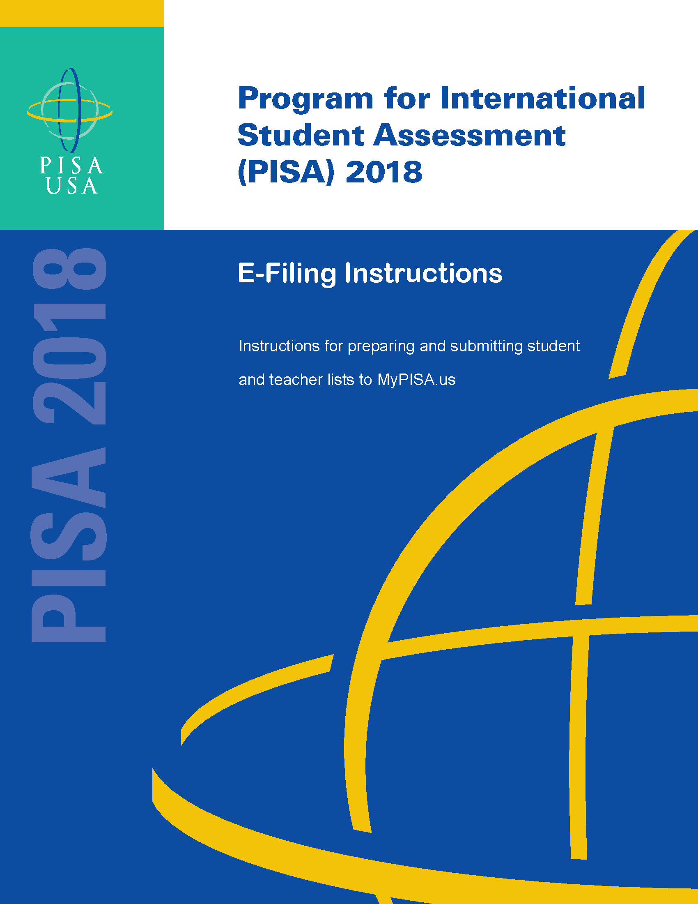
2021

PREPARE ELECTRONIC STUDENT FILE (E-FILE)........................................................ 1
Step 1: Identify ALL students at your school who meet the eligibility criteria...................................... 1
Step 2: List each of the eligible students................................................................................................ 1

Submitting your Electronic Student File............................................................................................ 2
Student E-File Step 1: Upload your file..................................................................................................... 2
Student E-File Step 2: Identify your column contents.............................................................................. 2
Student E-File Step 3: Match your values to PISA codes.......................................................................... 3
Student E-File Step 4: Verify your E-File............................................................................................... 4
Online Student Data Checks 5

The National Center for Education Statistics (NCES) is authorized to conduct the Program for International Student Assessment (PISA) by the Education Sciences Reform Act of 2002 (ESRA 2002, 20 U.S.C. §9543), and to collect students’ education records from educational agencies or institutions for the purpose of evaluating federally supported education programs under the Family Educational Rights and Privacy Act (FERPA, 34 CFR §§ 99.31(a)(3)(iii) and 99.35). The data are being collected for NCES by Westat, a U.S.-based research organization. All of the information you provide may be used only for statistical purposes and may not be disclosed, or used, in identifiable form for any other purpose except as required by law (20 U.S.C. §9573 and 6 U.S.C. §151). According to the Paperwork Reduction Act of 1995, no persons are required to respond to a collection of information unless such collection displays a valid OMB control number. The valid OMB control number for this voluntary information collection is 1850-0755. The time required to complete this information collection is estimated to average up to 240 minutes per school coordinator, including the time to review instructions, gather the data needed, and complete and review the information collection. If you have any comments or concerns regarding the accuracy of the time estimate(s), suggestions for improving the form, or questions about the status of your individual submission of this form, write directly to: The Program for International Student Assessment (PISA) 2021, National Center for Education Statistics (NCES), Potomac Center Plaza, 550 12th Street, SW, Room 4007, Washington, DC 20202.

PISA 2021: Student Records Collection: 4 hours
OMB Clearance Number 1850-0755
Expiration Date: xx/xx/xxxx

Preparing the PISA Electronic Student File (E-File)

Step 1: Identify ALL students at your school who meet the eligibility criteria
Criteria for PISA student eligibility are:
- Enrolled in Grade 7 or higher, AND
- Born between July 1, 2005 and June 30, 2006.

PISA needs accurate information about all students at your school who meet the above criteria for student eligibility. Include all students, even those students who typically may be excluded from other testing programs, such as students with IEPs or 504 plans (SD), English language learners (ELL), or students with limited English proficiency (LEP). Do not include students who are known to be withdrawn on your list. All other eligible students must be added to your list of students.

Step 2: List each of the eligible students along with their demographic information (see Figure 1 below for an example)
Using the Excel template provided on the MyPISA.us website (www.MyPISA.us), list students in your school who are eligible for PISA along with their demographic information.

- Student first name
- Student middle name (not required)
- Student last name
- Grade in school (Grade 7 – Grade 12 as applicable)
- Month of birth (M or MM; must be submitted in numeric format, not text (1 or 01 for JAN))
- Year of birth (YYYY: 2005)
- Sex (numeric or text (1/2, F/M))

Figure 1: Example of Electronic Student File
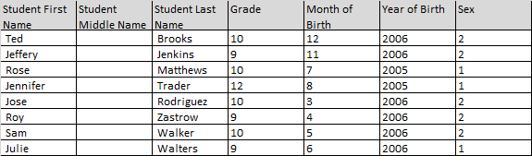

Submitting the PISA Electronic Student File (E-File)

Step 1: Upload file. After you have created and saved your student E-File, proceed to www.MyPISA.us. Once you have logged in, click the ‘Submit Student List’ link on the left side of the page (Box 1 below). Then click the “Browse” button to locate your file (box 2 below). Once you’ve located the file and clicked ok, click “Upload”(box 3 below).

Exhibit 1. Submit Student List - initial screen
1
3
2

Step 2: Map Columns. The column headings in your file are shown in rows on the left side of the page. In each row, for each heading on the left, click on the down arrow next to the words in the table that read "Column Contains..." on the right. If there is no appropriate description in the drop-down list for your column heading, select N/A.
Exhibit 2. Submit Student List – Identify Your Columns

Step 3: Match Values to PISA Codes. The next step is matching the values on your file to PISA codes. The values in your columns will again be displayed on the left. Select the corresponding PISA code from the drop down list on the right (see exhibit 3). If there is no appropriate description in the drop-down list for your column heading, select N/A. When you are finished matching your values to PISA codes, click next. Repeat the above instructions to assign male/female codes and click next (see exhibit 4).
Exhibit 3. Submit Student List - Match your Values to PISA Codes (grade mapping)

Exhibit 4. Submit Student List - Match your Values to PISA Codes (sex mapping)

Step 4: Verify your E-file. The final step is to verify that the information is correct and submit your file. Check that the distribution of students by grade and sex match the total number of students you submitted. Indicate whether this information is correct and click “Submit.” If the information is incorrect click “Incorrect” and then click on the “Submit Student List” link on the left side of the screen. This will save your progress and exit the current e-file. You can access this file again or upload a new corrected file and start over using the same file upload process described in Step 1.
Exhibit 5. Submit Student List –Verify your E-file

Online Student Data Checks - After you click “Submit” a number of online data validation checks are performed by our programs. These checks include checking the number of listed students against statistical estimates, making sure there is an accurate distribution of students by grade based on statistical estimates, checking that all students included are birth-year eligible (born in 2005 or 2006), and checking for any missing data. If the data fail these online checks, you will be presented with a screen that describes the issue, the location of the row(s) in your file that contains the errant data, and will need to correct the file and upload a new version. Exhibit 6 (below) provides an example of a file with missing data. Notice that the affected row is provided for each instance where the check failed. This is designed to help you efficiently locate and ameliorate any issues. Exhibit 7 provides an example of a file where ineligible students were included.
Exhibit 6. Online data checks

Along with the file validation checks, the total number of students is compared to the statistical estimate of eligible students. If there is a 10% or more difference in enrollment, which is typical for most every school, international standards for data collection require that we ask school coordinators for a possible reason. Typical reasons include redistricting, the schools being located within a growing or shrinking community, or near an army base. Exhibit 8 provides a screen shot of the enrollment verification check and comment box. This check does not prohibit you from completing your e-file. Simply provide a comment in the box and continue.
Exhibit 7. Online data check – enrollment verification
If at any time you realize that every eligible student was not listed, you can exit e-filing, correct the file, and upload a new one. If you have any questions or would like to talk with someone about e-filing, please reach out to the PISA help desk by phone between 8 a.m. and 8 p.m. Eastern Standard Time at 1-888-638-2597 or email PISAHELP@westat.com.

MyPISA project website for School Coordinators and schools

The following screenshots show the web content of MyPISA.us for schools and school coordinators from the main study in PISA 2018 with updated text following each screen. The systems for the PISA 2021 main study are not yet active, but will not change other than references to the current round of PISA and updates to the specifics of the main study, such as number of students to be sampled and removal of teacher information pertaining to teacher participation in the questionnaire. MyPISA.us is described in Part B of the main study package.

Updated screenshots and, if necessary, any updated text will be provided in a change request by December 2019. The text displayed below each screenshot in this section is the text as it will appear on MyPISA.us for PISA 2021.

MyPISA.us – Login page

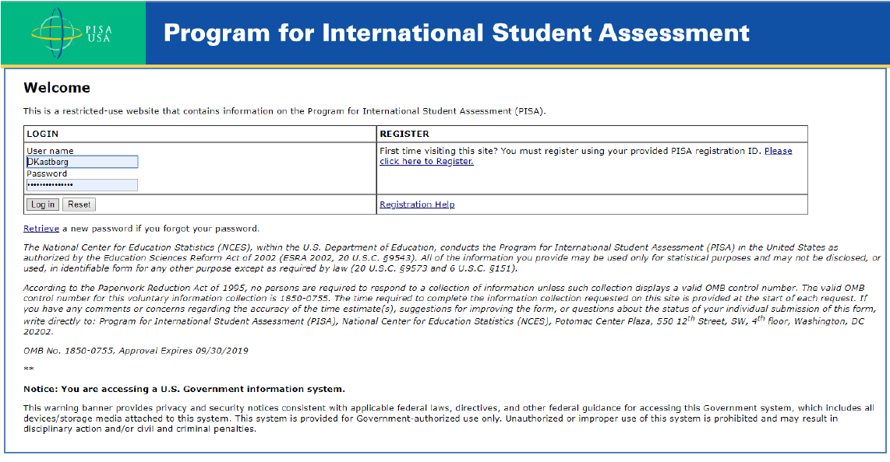
This screen is the login page for the MyPISA.us site. It provides a login function, a way for new users to register on the site using supplied credentials, and a way to retrieve a password. The text of the page as it will appear for MyPISA 2021 is shown below.

Welcome
This is a restricted-use website that contains information on the Program for International Student Assessment (PISA).
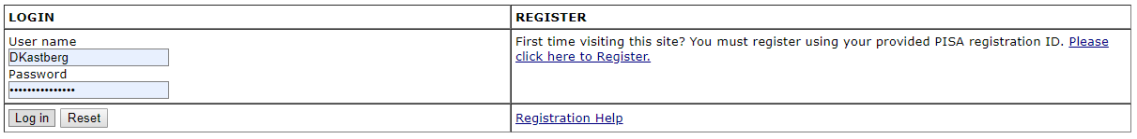

Retrieve a new password if you forgot your password.

The National Center for Education Statistics (NCES) is authorized to conduct the Program for International Student Assessment (PISA) by the Education Sciences Reform Act of 2002 (ESRA 2002, 20 U.S.C. §9543), and to collect students’ education records from educational agencies or institutions for the purpose of evaluating federally supported education programs under the Family Educational Rights and Privacy Act (FERPA, 34 CFR §§ 99.31(a)(3)(iii) and 99.35). The data are being collected for NCES by Westat, a U.S.-based research organization. All of the information you provide may be used only for statistical purposes and may not be disclosed, or used, in identifiable form for any other purpose except as required by law (20 U.S.C. §9573 and 6 U.S.C. §151).
According to the Paperwork Reduction Act of 1995, no persons are required to respond to a collection of information unless such collection displays a valid OMB control number. The valid OMB control number for this voluntary information collection is 1850-0755. The time required to complete this information collection is estimated to average up to 240 minutes for school coordinators or 45 minutes for school administrators, including the time to review instructions, gather the data needed, and complete and review the information collection. If you have any comments or concerns regarding the accuracy of the time estimate(s), suggestions for improving the form, or questions about the status of your individual submission of this form, write directly to: The Program for International Student Assessment (PISA) 2021, National Center for Education Statistics (NCES), Potomac Center Plaza, 550 12th Street, SW, Room 4007, Washington, DC 20202.
OMB No. 1850-0755, Approval Expires xx/xx/2022

Notice: You are accessing a U.S. Government information system.

This warning banner provides privacy and security notices consistent with applicable federal laws, directives, and other federal guidance for accessing this Government system, which includes all devices/storage media attached to this system. This system is provided for Government-authorized use only. Unauthorized or improper use of this system is prohibited and may result in disciplinary action and/or civil and criminal penalties.
If you need help accessing this website, please contact the PISA help desk by phone between 8 a.m. and 8 p.m. Eastern Standard Time at 1-888-638-2597 or email PISAHELP@westat.com.

MyPISA.us – Home – Welcome to PISA

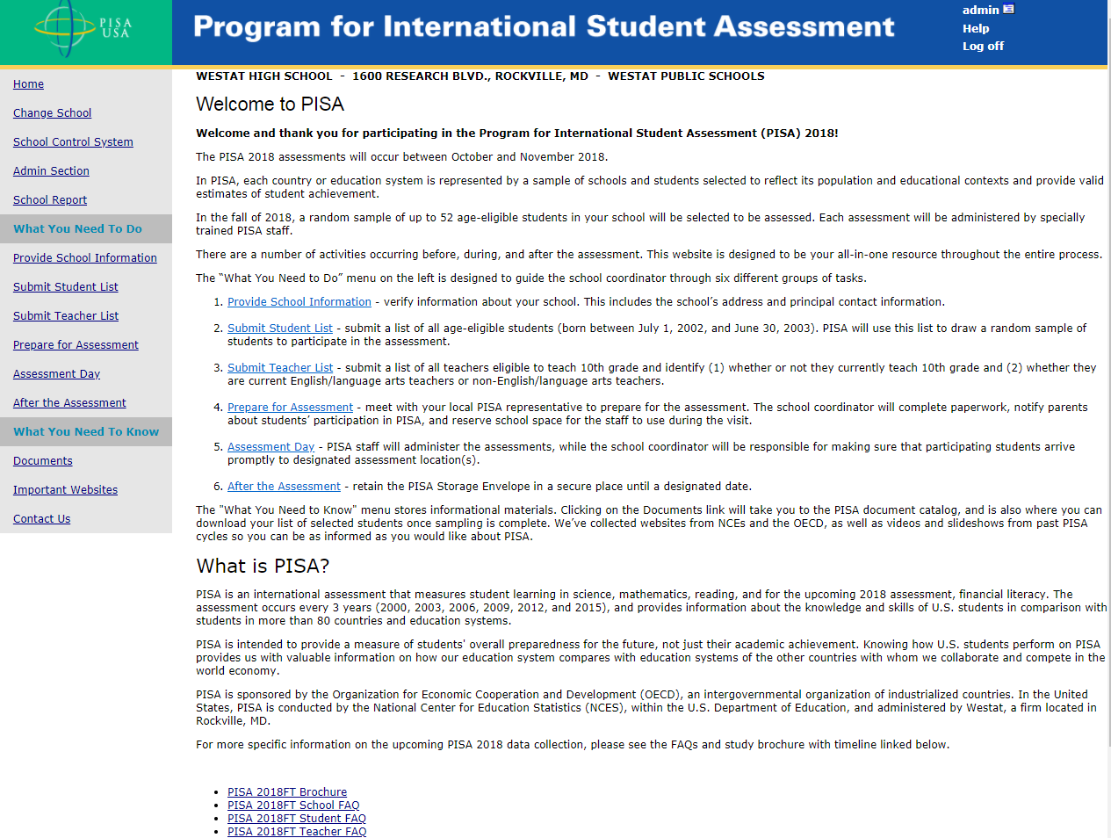

This screen is the Welcome page for the MyPISA.us site. It provides overview information about the survey and navigation to specific areas of the site. For the main study, references to the teacher list and the teacher FAQ will be removed. The text of the page as it will appear for MyPISA 2021 is shown on the following page.

Welcome to PISA
Welcome and thank you for participating in the Program for International Student Assessment (PISA) 2021!
The PISA 2021 assessments will occur between October and November 2021.
In PISA, each country or education system is represented by a sample of schools and students selected to reflect its population and educational contexts and provide valid estimates of student achievement.
In the fall of 2021, a random sample of up to 52 age-eligible students in your school will be selected to be assessed. Each assessment will be administered by specially trained PISA staff.
There are a number of activities occurring before, during, and after the assessment. This website is designed to be your all-in-one resource throughout the entire process.
The “What You Need to Do” menu on the left is designed to guide the school coordinator through six different groups of tasks.
- Provide School Information - verify information about your school. This includes the school’s address and principal contact information.
- Submit Student List - submit a list of all age-eligible students (born between July 1, 2005 and June 30, 2006). PISA will use this list to draw a random sample of students to participate in the assessment.
- Prepare for Assessment - meet with your local PISA representative to prepare for the assessment. The school coordinator will complete paperwork, notify parents about students’ participation in PISA, and reserve school space for the staff to use during the visit.
- Assessment Day - PISA staff will administer the assessments, while the school coordinator will be responsible for making sure that participating students arrive promptly to designated assessment location(s).
- After the Assessment - retain the PISA Storage Envelope in a secure place until a designated date.
The "What You Need to Know" menu stores informational materials. Clicking on the Documents link will take you to the PISA document catalog, and is also where you can download your list of selected students once sampling is complete. We’ve collected websites from NCES and the OECD, as well as videos and slideshows from past PISA cycles so you can be as informed as you would like about PISA.

What is PISA?
PISA is an international assessment that measures student learning in mathematics, science, reading, and for the upcoming 2021 assessment, financial literacy. The assessment occurs every 3 years (2000, 2003, 2006, 2009, 2012, 2015, and 2018), and provides information about the knowledge and skills of U.S. students in comparison with students in more than 80 countries and education systems.
PISA is intended to provide a measure of students' overall preparedness for the future, not just their academic achievement. Knowing how U.S. students perform on PISA provides us with valuable information on how our education system compares with education systems of the other countries with whom we collaborate and compete in the world economy.
PISA is sponsored by the Organization for Economic Cooperation and Development (OECD), an intergovernmental organization of industrialized countries. In the United States, PISA is managed and conducted by the National Center for Education Statistics (NCES) in the U.S. Department of Education.
For more specific information on the upcoming PISA 2021 data collection, please see the FAQs and study brochure with timeline linked below.
Edit
- PISA 2021 Brochure
- PISA 2021 Information Sheet
- PISA 2021 School FAQs
- PISA 2021 Student FAQs
- PISA E-file Instructions

MyPISA.us – Provide School Information
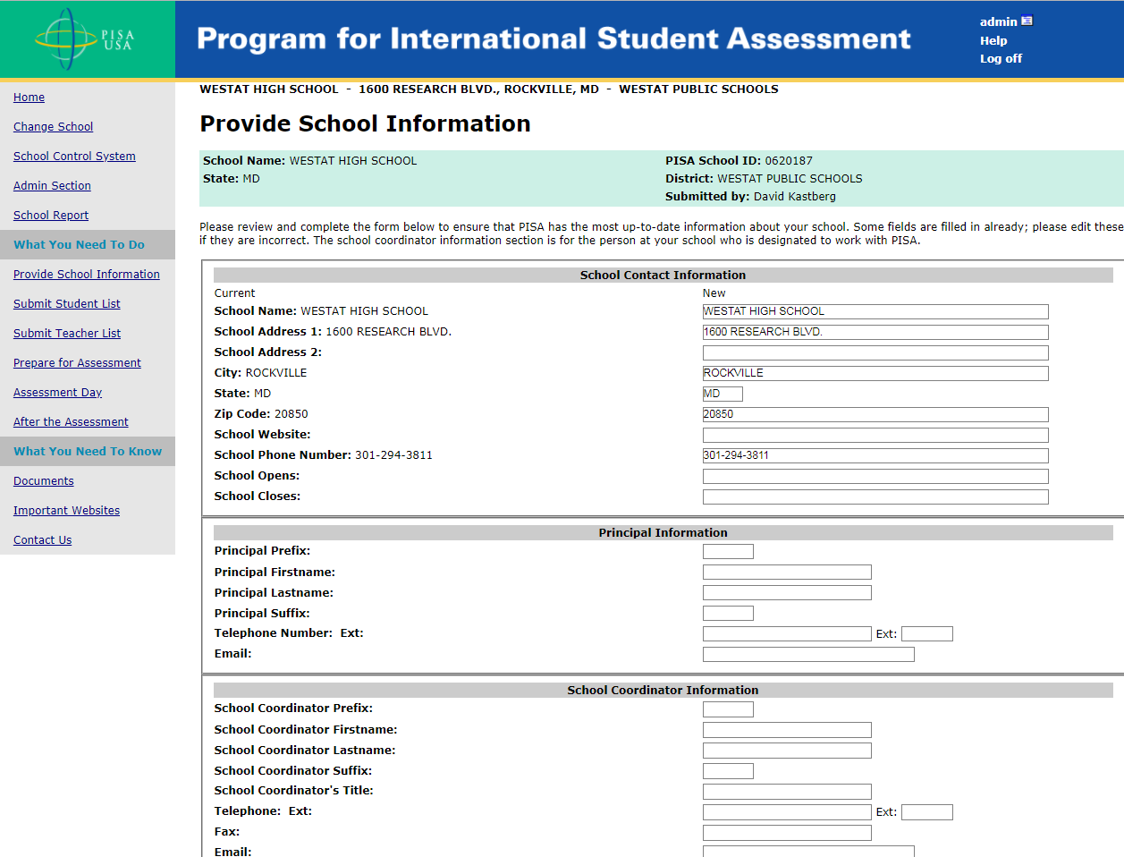
This screen provides information about the school. This information is already populated first from the sampling information and then updated by the NAEP State Coordinators or PISA Recruiters. The text of the page as it will appear for MyPISA 2021 is shown on the following page.

Provide School Information
School Name: School name | PISA School ID: 1234567
State: State | District: District
 | Submitted by:

Please review and complete the form below to ensure that PISA has the most up-to-date information about your school. Some fields are filled in already; please edit these if they are incorrect. The school coordinator information section is for the person at your school who is designated to work with PISA.
School Contact Information
Current | New
School Name: School
School Address 1: Address
School Address 2:
City: City
State: State
Zip Code: 12345-6789
School Website:
School Phone Number: 555-555-5555
School Opens:
School Closes:

Principal Information
Principal Prefix: Mr.
Principal Firstname: First
Principal Lastname: Last
Principal Suffix:
Telephone Number: Ext: | Ext:
Email: email@district.edu

School Coordinator Information
School Coordinator Prefix: Ms
School Coordinator Firstname: First
School Coordinator Lastname: Last
School Coordinator Suffix:
School Coordinator's Title: Coordinator
Telephone: 555 555 5555 Ext: | Ext:
Fax:
Email: email@district.edu

School Characteristics
First Day of School (2019-2020 school year):
Year Round School:
Date school returns from spring break (2020):
Last day of school for the year (2020):

According to the Paperwork Reduction Act of 1995, no persons are required to respond to a collection of information unless such collection displays a valid OMB control number. The valid OMB control number for this voluntary information collection is 1850-0755. The time required to complete this information collection is estimated to average 15 minutes per school coordinator, including the time to review instructions, gather the data needed, and complete and review the information collection. If you have any comments or concerns regarding the accuracy of the time estimate(s), suggestions for improving the form, or questions about the status of your individual submission of this form, write directly to: Program for International Student Assessment (PISA), National Center for Education Statistics (NCES), Potomac Center Plaza, 550 12th Street, SW, 4th floor, Washington, DC 20202.

MyPISA.us – Submit Student List – How to Submit Your Student List
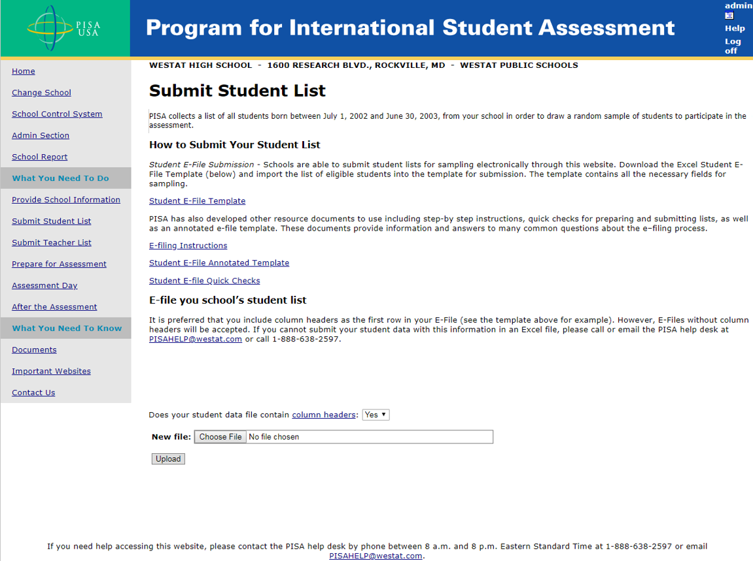
This screen provides the E-file instructions and template and is where the school coordinator will securely upload the completed student list. The birth date range will be changed to “born on or between July 1, 2005 and June 30, 2006”.

Submit Student List
PISA collects a list of all students born on or between July 1, 2005 and June 30, 2006, from your school in order to draw a random sample of students to participate in the assessment.

How to Submit Your Student List
Student E-File Submission - Schools are able to submit student lists for sampling electronically through this website. Download the Excel Student E-File Template (below) and import the list of eligible students into the template for submission. The template contains all the necessary fields for sampling.
E-file you school’s student list
It is preferred that you include column headers as the first row in your E-File (see the template above for example). However, E-Files without column headers will be accepted. If you cannot submit your student data with this information in an Excel file, please call or email the PISA help desk at PISAHELP@westat.com or call 1-888-638-2597. PISA has also developed other resource documents to use including step-by step instructions, quick checks for preparing and submitting lists, as well as an annotated e-file template. These documents, linked to below, provide information and answers to many common questions about the e–filing process.
PISA E-file Instructions
PISA Student e-filing template
Student E-file - Annotated Template
Student E-file Quick Steps
The following statement will be added to the screen above to state the estimated time to complete and submit the student list.
According to the Paperwork Reduction Act of 1995, no persons are required to respond to a collection of information unless such collection displays a valid OMB control number. The valid OMB control number for this voluntary information collection is 1850-0755. The time required to complete this information collection is estimated to average 45 minutes per school coordinator, including the time to review instructions, gather the data needed, and complete and review the information collection. If you have any comments or concerns regarding the accuracy of the time estimate(s), suggestions for improving the form, or questions about the status of your individual submission of this form, write directly to: Program for International Student Assessment (PISA), National Center for Education Statistics (NCES), Potomac Center Plaza, 550 12th Street, SW, 4th floor, Washington, DC 20202.

MyPISA.us – Prepare for Assessment
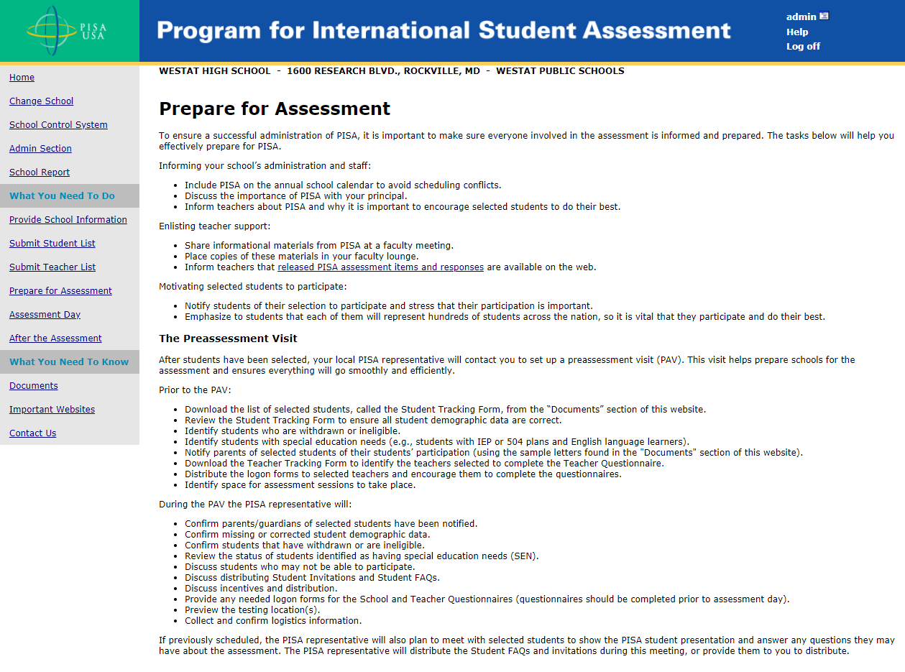
This screen provides information and suggestions for preparing for the survey including discussing the survey with school staff, and providing materials. The text of the page as it will appear for MyPISA 2021 is shown on the following page.

Prepare for Assessment
To ensure a successful administration of PISA, it is important to make sure everyone involved in the assessment is informed and prepared. The tasks below will help you effectively prepare for PISA.
Informing your school’s administration and staff:
- Include PISA on the annual school calendar to avoid scheduling conflicts.
- Discuss the importance of PISA with your principal.
- Inform teachers about PISA and why it is important to encourage selected students to do their best.
Enlisting teacher support:
- Share informational materials from PISA at a faculty meeting.
- Place copies of these materials in your faculty lounge.
- Inform teachers that released PISA assessment items and responses are available on the web.
Motivating selected students to participate:
- Notify students of their selection to participate and stress that their participation is important.
- Emphasize to students that each of them will represent hundreds of students across the nation, so it is vital that they participate and do their best.

The Preassessment Visit
After students have been selected, your local PISA representative will contact you to set up a preassessment visit (PAV). This visit helps prepare schools for the assessment and ensures everything will go smoothly and efficiently.
Prior to the PAV:
- Download the list of selected students, called the Student Tracking Form, from the “Documents” section of this website.
- Review the Student Tracking Form to ensure all student demographic data are correct.
- Identify students who are withdrawn or ineligible.
- Identify students with special education needs (e.g., students with IEP or 504 plans and English language learners).
- Notify parents of selected students of their students’ participation (using the sample letters found in the "Documents" section of this website).
- Identify space for assessment sessions to take place.
During the PAV the PISA representative will:
- Confirm parents/guardians of selected students have been notified.
- Confirm missing or corrected student demographic data.
- Confirm students that have withdrawn or are ineligible.
- Review the status of students identified as having special education needs (SEN).
- Discuss students who may not be able to participate.
- Discuss distributing Student Invitations and Student FAQs.
- Discuss incentives and distribution.
- Provide any needed logon forms for the School Questionnaires (questionnaires should be completed prior to assessment day).
- Preview the testing location(s).
- Collect and confirm logistics information.
If previously scheduled, the PISA representative will also plan to meet with selected students to show the PISA student presentation and answer any questions they may have about the assessment. The PISA representative will distribute the Student FAQs and invitations during this meeting, or provide them to you to distribute.

MyPISA.us –Assessment Day
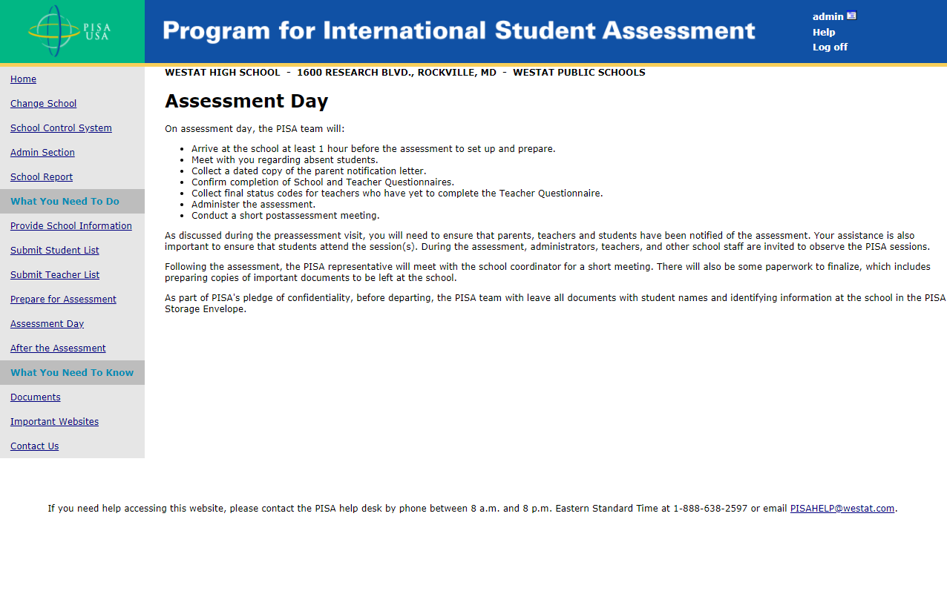
This page lists the activities of the PISA assessment team on assessment day. References to completion of the teacher questionnaire will be removed. The text of the page as it will appear for MyPISA 2021 is shown below.

Assessment Day
On assessment day, the PISA team will:
- Arrive at the school at least 1 hour before the assessment to set up and prepare.
- Meet with you regarding absent students.
- Collect a dated copy of the parent notification letter.
- Confirm completion of School Questionnaires.
- Administer the assessment.
- Conduct a short postassessment meeting.
As discussed during the preassessment visit, you will need to ensure that parents and students have been notified of the assessment. Your assistance is also important to ensure that students attend the session(s). During the assessment, administrators, teachers, and other school staff are invited to observe the PISA sessions.
Following the assessment, the PISA representative will meet with the school coordinator for a short meeting. There will also be some paperwork to finalize, which includes preparing copies of important documents to be left at the school.
As part of PISA's pledge of confidentiality, before departing, the PISA team with leave all documents with student names and identifying information at the school in the PISA Storage Envelope.
MyPISA.us – After the Assessment
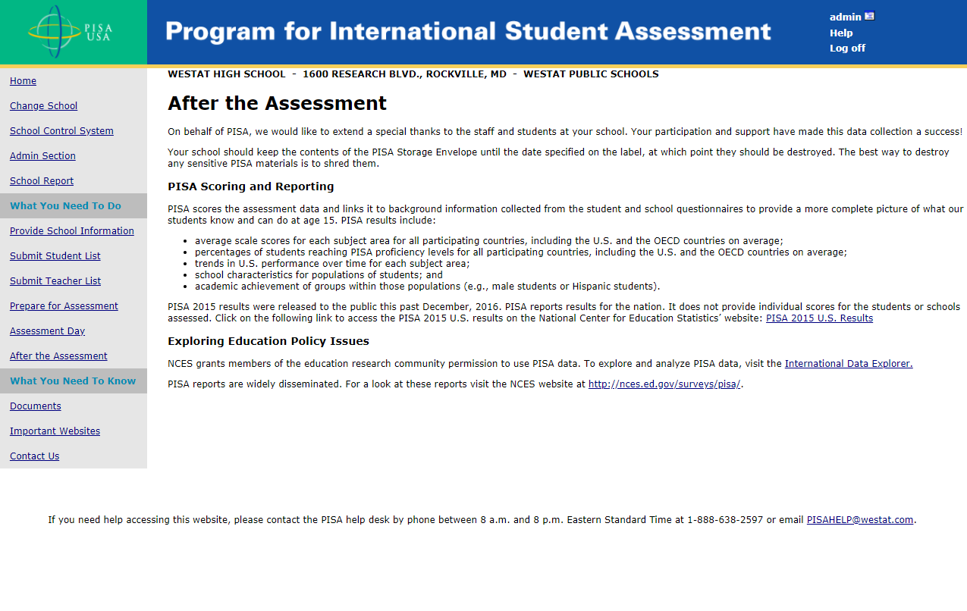
This screen provides information about post-assessment activities such as scoring of assessment data and reporting plans. If the PISA 2018 results are available the links will be updated for PISA 2018. The text of the page as it will appear for MyPISA 2021 is shown on the following page.

After the Assessment
On behalf of PISA, we would like to extend a special thanks to the staff and students at your school. Your participation and support have made this data collection a success!
Your school should keep the contents of the PISA Storage Envelope until the date specified on the label, at which point they should be destroyed. The best way to destroy any sensitive PISA materials is to shred them.

PISA Scoring and Reporting
PISA scores the assessment data and links it to background information collected from the student and school questionnaires to provide a more complete picture of what our students know and can do at age 15. PISA results include:
- average scale scores for each subject area for all participating countries, including the U.S. and the OECD countries on average;
- percentages of students reaching PISA proficiency levels for all participating countries, including the U.S. and the OECD countries on average;
- trends in U.S. performance over time for each subject area;
- school characteristics for populations of students; and
- academic achievement of groups within those populations (e.g., male students or Hispanic students).
The PISA 2018 results were released to the public this past December, 2019. PISA reports results for the nation. It does not provide individual scores for the students or schools assessed. Click on the following link to access the PISA 2018 U.S. results on the National Center for Education Statistics’ website: PISA 2018 U.S. Results

Exploring Education Policy Issues
NCES grants members of the education research community permission to use PISA data. To explore and analyze PISA data, visit the International Data Explorer.
PISA reports are widely disseminated. For a look at these reports visit the NCES website at http://nces.ed.gov/surveys/pisa/.

MyPISA.us – Documents
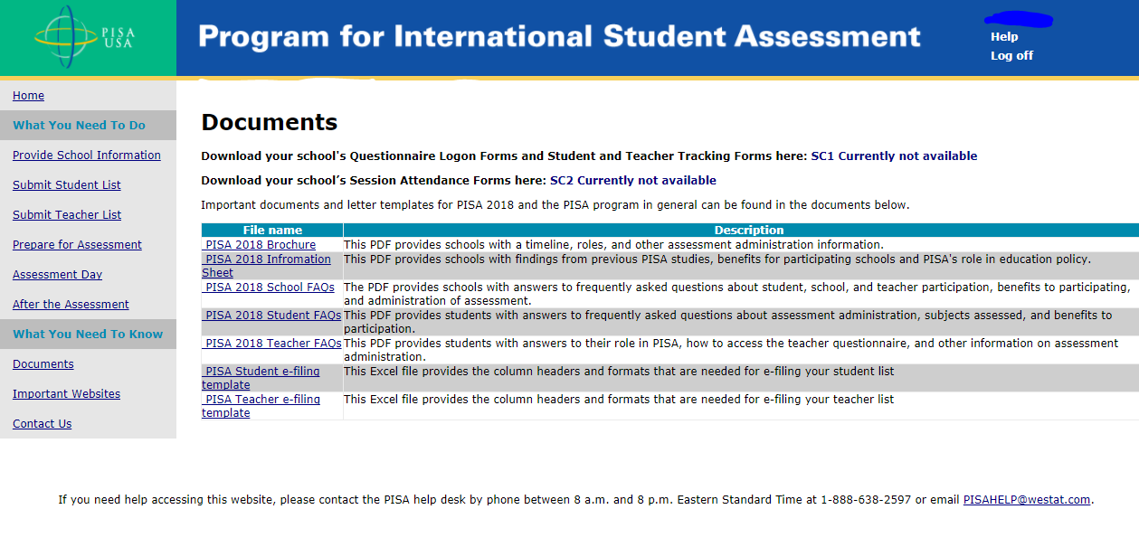
This screen provides links to documents for PISA. These documents will be updated to reference and point to PISA 2021 documents. The text of the page as it will appear for MyPISA 2021 is shown on the following page.

Documents
Download your school's Questionnaire Logon Forms and Student and Teacher Tracking Forms here: Download SC1
Download your school’s Session Attendance Forms here: Download SC2
Important documents and letter templates for PISA 2018 and the PISA program in general can be found in the documents below.
Edit
File name | Description
Facts for Parents | This document is an editable FAQ for parents that is designed accompany the notification letter.
Parent Implicit Consent Letter and Form | This editable document provides a template for parent implicit consent letter and form for schools to edit based on their local policies.
Parent Notification Letter | This editable document provides a template parent notification letter for schools to edit based on their local policies. PISA requires all parents to be notified prior to assessment day.
PISA 2021 Brochure | This PDF provides schools with a timeline, roles, and other assessment administration information.
PISA 2021 School FAQs | The PDF provides schools with answers to frequently asked questions about student, school, and teacher participation, benefits to participating, and administration of assessment.
PISA 2021 Student FAQs | This PDF provides students with answers to frequently asked questions about assessment administration, subjects assessed, and benefits to participation.
PISA E-file Instructions | This document provides step-by-step instructions for preparing and submitting your student and teacher e-files.
PISA Student e-filing template | This Excel file provides the column headers and formats that are needed for e-filing your student list
Student E-file Quick Steps | This document provides quick steps and checks for preparing and submitting your student efile. This is designed to be used as an aide in addition to the e-file instructions.

MyPISA.us – Important Websites
` 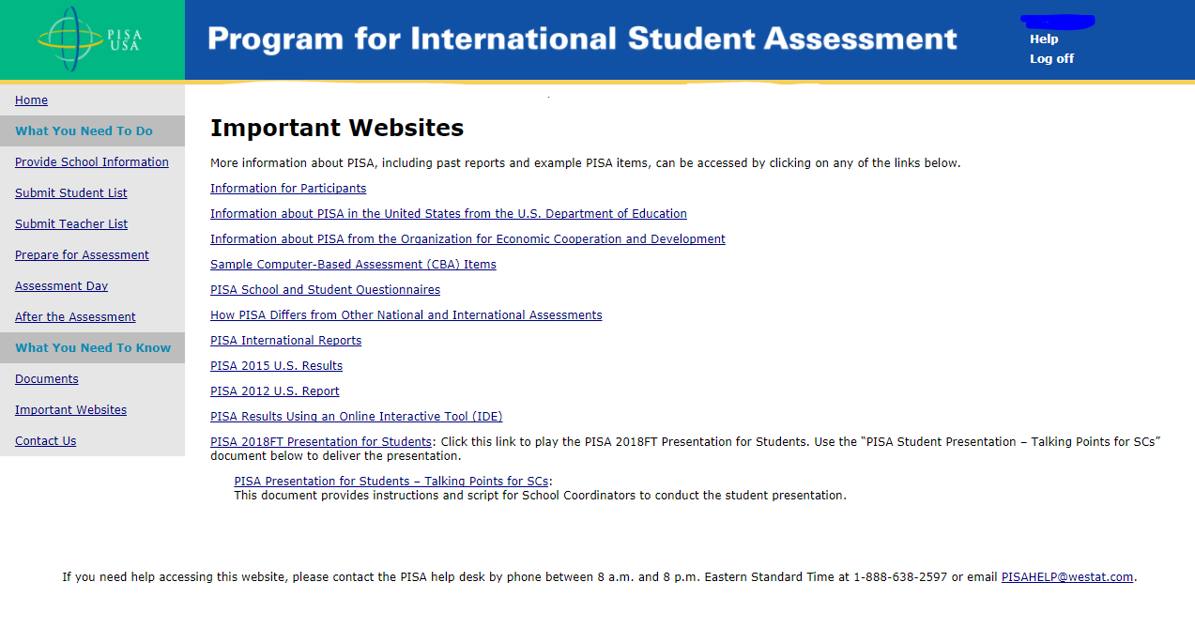

Important Websites
More information about PISA, including past reports and example PISA items, can be accessed by clicking on any of the links below.
Information for Participants
Information about PISA in the United States from the U.S. Department of Education
Information about PISA from the Organization for Economic Cooperation and Development
Sample Computer-Based Assessment (CBA) Items
PISA School and Student Questionnaires
How PISA Differs from Other National and International Assessments
PISA International Reports
PISA 2018 U.S. Results
PISA 2015 U.S. Results
PISA Results Using an Online Interactive Tool (IDE)
Presentation for Students - PISA 2021: Click this link to play the PISA 2021 Presentation for Students.

MyPISA.us – Contact Us
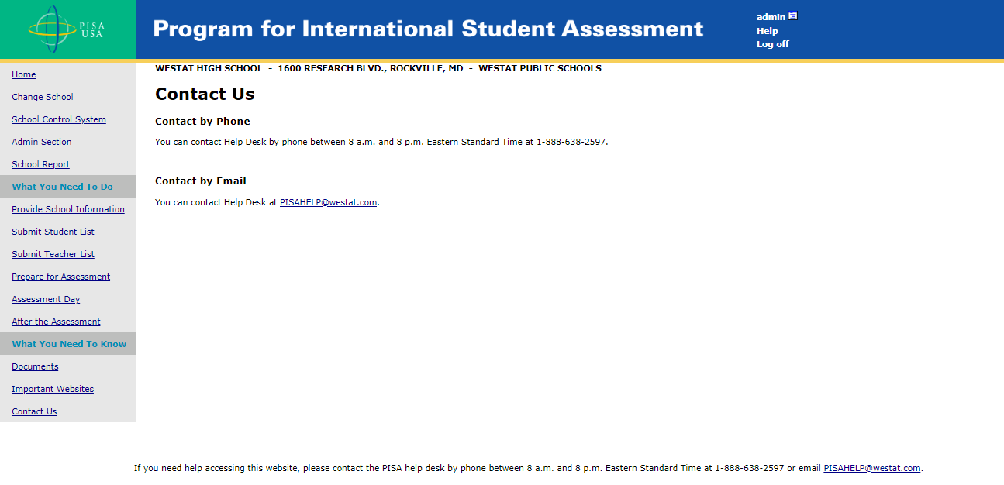

Contact Us

Contact by Phone
You can contact Help Desk by phone between 8:00 am and 8:00 pm Eastern Standard Time at 1-888-638-2597.
Contact by Email
You can contact Help Desk at PISAHELP@westat.com.

