Supporting Statement: Programs for Improving Energy Efficiency in Buildings

Justification
OMB No. 1910-5184

July 2020
U.S. Department of Energy
Washington, DC 20585

Table of Contents
Justification i
Introduction 3
A.1. Legal Justification 6
A.2. Needs and Uses of Data 6
A.3. Use of Technology 6
A.4. Efforts to Identify Duplication 20
A.5. Provisions for Reducing Burden on Small Businesses 21
A.6. Consequences of Less-Frequent Reporting 21
A.7. Compliance with 5 CFR 1320.5 26
A.8. Summary of Consultations Outside of the Agency 27
A.9. Payments or Gifts to Respondents 28
A.10. Provisions for Protection of Information 28
A.11. Justification for Sensitive Questions 29
A.12A. Estimate of Respondent Burden Hours 29
A.12B. Estimate of Annual Cost to Respondent for Burden Hours 29
A.13. Other Estimated Annual Cost to Respondents 38
A.14. Annual Cost to the Federal Government 39
A.15. Reasons for Changes in Burden 44
A.16. Collection, Tabulation, and Publication Plans 45
A.17. OMB Number and Expiration Date 45
A.18. Certification Statement 45

Introduction
Provide a brief introduction of the Information Collection Request. Include the purpose of this collection, note the publication of the 60-Day Federal Register Notice, and provide the list of forms within this collection.
This supporting statement provides information regarding the Department of Energy (DOE) request for processing of the proposed information collection, “Programs for Improving Energy Efficiency in Buildings.” This Information Collection Request (ICR) is not rule related. This ICR is a reinstatement, OMB Control 1910-5184. All participation in the programs is voluntary.
The numbered questions correspond to the order shown on the Office of Management and Budget Form 83-I, “Instructions for Completing OMB Form 83-I.” Under each numbered question, this supporting statement provides answers and indicates where the answers are specific to each program.
This ICR includes the following DOE programs:
- Zero Energy Ready Home (ZERH);
- Home Energy Score (HEScore);
- Better Buildings Residential Network (BBRN); and
- Home Performance with ENERGY STAR (HPwES)
The collection instruments for each program are described below.

A.1. Legal Justification
Explain the circumstances that make the collection of information necessary. Identify any legal or administrative requirements that necessitate the collection. Attach a copy of the appropriate section of each statute and regulation mandating or authorizing the information collection.
The Department of Energy Organization Act, P.L. 95-91 of August 17, 1977, authorizes DOE to create a coordinated national energy program. The Energy Policy Act of 2005, Sec 911, also authorizes DOE to conduct programs to increase the energy efficiency of buildings. The DOE Building Technologies Office develops and implements programs that encourage and assist organizations that voluntarily participate in them to build and renovate new and existing buildings to use less energy. The DOE programs that are part of this ICR include the Zero Energy Ready Home Program, the Better Buildings Residential Network, the Home Energy Score (HEScore), and the Home Performance with ENERGY STAR Program (HPwES). The information gathered by DOE in these programs is necessary for DOE to run each of these programs effectively.
DOE is collecting information from partners to understand the activities of organizations participating in these voluntary programs.

A.2. Needs and Uses of Data
Indicate how, by whom, and for what purpose the information is to be used. Except for a new collection, indicate the actual use the agency has made of the information received from the current collection
The Building Technologies Office’s overarching long-term goal is to reduce the energy use per square foot of U.S. buildings by 50% compared to 2010 levels. Based on current analysis of the building sector and BTO program planning, BTO has established a goal of reducing building energy use intensity by 30% by 2030. The programs included in this ICR are designed to help achieve BTO’s goal of reducing energy use in buildings.
DOE, with support from authorized contractors, will collect information from program partners to better understand the participating partners’ activities and progress toward achieving milestones and objectives. This will allow DOE to make better decisions about the best way to run the programs, improve outreach to make the programs more widely known, and better respond to partners’ needs.
The programs for improving the energy efficiency of buildings are administered by the Building Technologies Office in the Office of Energy Efficiency and Renewable Energy. Most of the work described in the ICR pertains to residential buildings. Some activities may also involve commercial buildings, as activity by participating partners may involve residential and commercial buildings.
DOE is limiting the information collection to what is necessary to run the programs. The information collection instruments that DOE will use, including relevant forms and web page screenshots, are attached to this Information Collection Request.

ZERO ENERGY READY HOME PROGRAM. The Zero Energy Ready Home program is a voluntary labeling and recognition program for new homes that encourages home builders to build homes that are so efficient that their energy consumption can be offset by renewable energy systems. Its goal is to achieve 5% market penetration among home builders by 2025.
The organizations and individuals who decide to participate in the Zero Energy Ready Home program are home owners, home builders, home builder trades and associations, home design professionals, students in architecture and related building construction industries, home energy raters, home energy auditors, home inspectors, building consultants, manufacturers of building products, professional trainers, utility companies, home building and manufacturing industry associations, consumer and home building industry advocacy organizations, and financial institutions.
The Zero Energy Ready Home program will collect information using the collection instruments and activities listed below through the Zero Energy Ready Home web site. Some are required for full participation in the program while others are optional.
The Zero Energy Ready Home program has the collection instruments listed below.
File name (Adobe PDF format) | Form Name | DOE Form number
registration1 | Partner Agreement Form | DOE HQ F 413.4
ZERH Verifier PA Final_0.pdf | VERIFIER PARTNER AGREEMENT | Instruction for DOE HQ F 413.4
ZERH_innovation_partner_agreement_9-15-15.pdf | INNOVATION PARTNER AGREEMENT | Instruction for DOE HQ F 413.4
ZERH Arch Designer PA Final_0.pdf | ARCHITECT / DESIGNER PARTNER AGREEMENT | Instruction for DOE HQ F 413.4
ZERH Builder PA Final.pdf | BUILDER PARTNER AGREEMENT | Instruction for DOE HQ F 413.4
ZERH_lender_pa_011615.pdf | LENDER PARTNER AGREEMENT | Instruction for DOE HQ F 413.4
ZERH Logo Use Guidelines.pdf | ZERH Logo Use Guidelines | Instruction for DOE HQ F 413.4
Zero Energy Ready Home Verification Report | Zero Energy Ready Home Verification Report | DOE HQ F 413.5 (not a DOE form)
2019 HIA Application.xlsx | Housing Innovation Award Application | DOE HQ F 413.7
PV-Ready ZERH Checklists | PV-Ready Checklist | DOE HQ F 413.12 (replacement form)
QM Checklist.pdf | QA/QC Checklist | DOE HQ F 413.35

Partner Agreement Form
Organizations can join the Zero Energy Ready Home by registering on-line using form DOE HQ F 413.4. Registering is done by submitting basic contact information, reading the DOE Zero Energy Ready Home National Program Requirements, and by reading and agreeing to one of the partner agreements depending on the type of partner. The Agreements explain the requirements of the program for the respective partner types. The information that is collected through the registration form is needed for DOE to be able to communicate with the partners and to categorize partners so DOE can target outreach, appropriately assist partners, and analyze participation.

DOE estimates that 207 partners will join each year among five different kinds of partners: Builders (100), Raters/verifiers (55), Innovation Partners (30), Architects and Designers (20), and Lenders (2). Exhibit 1 in section A.12A. Estimate of Respondent Burden Hours shows these numbers and the burden calculations.

Verifier Partner Agreement & Innovation Partner Agreement
The six page form (Instruction for DOE HQ F 413.4) explains the reporting requirements of the program for partners who verify homes to meet the ZERH program requirements. This form also includes reporting requirements of the program for partners who are particularly interested in educating consumers about the benefits of zero energy ready homes.
Architect/Designer Partner Agreement
The six page form (Instruction for DOE HQ F 413.4) explains that partners accepting this agreement are expected to design homes to meet the DOE Zero Energy Ready Home National Program Requirements.
Builder Partner Agreement
The six page form (Instruction for DOE HQ F 413.4) explains that partners accepting this agreement are expected to construct and certify homes to meet the DOE Zero Energy Ready Home National Program Requirements.
Lender Partner Agreement
The six page form (Instruction for DOE HQ F 413.4) explains that partners accepting this agreement are expected to facilitate green mortgage appraisals to certified homes under the DOE Zero Energy Ready Home Program.
ZERH Logo Use Guidelines
The five page instructions (Instruction for DOE HQ F 413.4) show and describe how logos and words are best used so that participants in the ZERH program can reference the government as a source of authority and maintain the value and benefits of the program. The burden for this form is part of the registration burden in Exhibit 1.
Zero Energy Ready Home Registry Report (DOE HQ F 413.5)
Home builders and home raters commonly conduct detailed analyses of homes as part of a home energy rating. This analysis is separate form, (DOE HQ F 413.5) and not a requirement of, the Zero Energy Ready Home program. However, the results of the rating can be used to certify a home as a DOE Zero Energy Ready Home. Many other voluntary publicly and privately-run home certification programs use this same rating system. When they complete the analyses their computer software automatically generates the Zero Energy Ready Home Verification Summary, which is automatically reported to DOE through a database download sent to DOE by RESNET, the home rater’s oversight organization. This information is the large majority of information collection responses for the Zero Energy Ready Home program. DOE will use it to evaluate, modify, and publicize the program. DOE needs the data from every home to ensure partners are meeting the requirements and to analyze program achievements, including energy savings and energy cost savings.
DOE estimates that 3500 reports per year will be sent to DOE as shown in Exhibit 1 in section A.12A. Estimate of Respondent Burden Hours.
Housing Innovation Award Application
Home builders and energy raters who compete for the Housing Innovation Award complete the Housing Innovation Award Application on-line (DOE HQ F 413.7). The annual award program provides publicity for the winners and for the program. Winners will receive recognition at the Housing Innovation Awards Ceremony and their accomplishments will be featured in:
- The U.S. Department of Energy website;
- National conferences visited by hundreds of stakeholders;
- National press and journal articles; and
- Workshops and webinars.

DOE estimates that 40 organizations per year will participate and the burden calculation is shown in Exhibit 1 in section A.12A. Estimate of Respondent Burden Hours.
Recommended Quality Management Provisions
The DOE Zero Energy Ready Home Quality Management Checklist (DOE HQ F 413.5) is a voluntary aspect of the program that may one day be a requirement. Builders who use the Quality Management checklist receive recognition on the DOE Zero Energy Ready Home website. Currently, DOE does not collect checklists but does collect information from Verifier Partners that indicates when a builder uses the Quality Management checklist on a home. The checklist requires some documentation as part of the checklist process. Due to the fact that DOE does not collect the actual completed checklist, no time is allotted for DOE review.
DOE estimates that 500 organizations per year will complete the checklist and the burden calculation is shown in Exhibit 1 in section A.12A. Estimate of Respondent Burden Hours.
PV-Ready Checklist
The Photovoltaic (PV)-Ready Checklist (DOE HQ F 413.12) is required for homes participating in the program in portions of the country with significant solar resources. These checklists ensure that a home is built ready for photovoltaic or solar hot water systems should a homeowner wish to install these technologies in the future. The actual checklists are not collected by DOE but a copy of the checklist must be provided to the home owner. Since DOE does not collect the actual completed checklist, no time is allotted for DOE review.
DOE estimates that 2000 organizations per year will complete the checklist and the burden calculation is shown in Exhibit 1 in section A.12A. Estimate of Respondent Burden Hours.
HOME ENERGY SCORE
The Home Energy Score (HEScore) allows homeowners to compare the energy performance of their homes to other homes nationwide and provides homeowners with cost-effective recommendations for improving their homes' efficiency. It is similar to a vehicle's mile-per-gallon rating. Homebuyers can use the Score to compare the efficiency of different homes, get an estimate of how much utility bills are likely to run in a specific house, and be advised of home improvements that can improve their score.
DOE partners with state and local governments, utilities, and non-profit organizations across the country to make the Home Energy Score widely available to homeowners. Home Energy Score partners work closely with Assessors who have met prerequisite professional credential requirements and have passed a free DOE test on the HE Score to implement local programs. In addition, consumers can also access guidance on how to ensure quality energy efficiency improvements through Home Improvement Expert (HIE) branded materials. Organizations are invited to HIE partners to show consumers that they follow best practices when installing and commissioning energy efficiency upgrades. While anyone can access the HIE content online, HIE partners can co-brand the best practices materials applicable HEScore recommended efficiency improvements. Organizations that use the HEScore program and HIE content together provide consumers with both high quality information about their homes and assure higher quality installation.
To score a home, the process starts when an Assessor collects energy information during a brief home walk-through. Once the data has been collected, the Assessor enters it into the online scoring tool. The Assessor generates a score on a scale of 1 to 10, with a score of 10 indicating that the home has excellent energy performance. A score of 1 indicates the home needs extensive energy improvements. DOE can access the inputted house data through the Scoring Tool software.
Software providers interested in linking their software to the Home Energy Scoring Tool can do so via an application programming interface (API). By licensing the Home Energy Score API, third-party software can generate a Home Energy Score along with any other outputs the software already produces. This capability reduces data entry burdens for Home Energy Score Certified Assessors™ already using other software tools. Interested API users will need to satisfy DOE testing requirements to ensure that scoring through the API results in the same score outputs as scoring directly through the Home Energy Scoring Tool interface online.
DOE estimates about 77,000 homes will be evaluated in the HEScore program per year with at least 5% of homes scored twice for quality assurance checks. The program partners do the evaluations under three different scenarios that require different amounts of time and effort to complete the Home Energy Scoring Tool Data Collection Form. One scenario is when the Score is offered to the home owner as part of an energy audit. In this case, not including the time it takes for the Assessor to collect data for the audit, it takes the Assessor about ten minutes to collect very few additional data points to create the Home Energy Score. In another scenario the Score is offered as part of a home inspection where it takes the Assessor an additional 30 minutes to collect the data to create the Score. Sometimes the program partners give homeowners a Score without doing either an audit or inspection. In this case, all the collected data is for the purpose of creating a Score. It takes about 60 minutes to collect the data and 30 minutes for the Assessor to travel to and from the home.
The Home Energy Score program has the collection instruments listed below.
File name (MS Word format) | Form Name | DOE Form number
Home Energy Score Partnership Agreement v2019 OMB | Partnership Agreement | DOE HQ F 413.26
Home Energy Score Partner Implementation Plan Template v2019 OMB | Implementation Plan Template | DOE HQ 413.24
Home Energy Score Remote Service Provider Implementation Plan v2019 OMB | Home Energy Score Remote Service Provider Implementation Plan v2019 | DOE HQ F 413.40
New Candidate Enrollment Form (v.2019) OMB | New Candidate Enrollment Form (v.2019) OMB | DOE HQ F 413.27 (replacement form)
A3 - Tool Data Collection Form v.2019 OMB | Home Energy Scoring Tool Data Collection Form | DOE HQ F 413.25
HEScore Data Entry Guidelines v.2019 OMB | Home Energy Score Data Entry Guidelines | Instruction for DOE HQ F 413.25
HIE Partner Agreement MTV Final Clean.wpd | Home Improvement Expert Partner Agreement | DOE HQ F 413.39
HIE Partner Quarterly Reporting Form | Home Improvement Expert Quarterly Reporting Form | DOE HQ F 413.41

Partners Joining Home Energy Score - Partnership Agreement
Home Energy Score partners are required to submit a Partnership Agreement (DOE HQ F 413.26) to participate in the program. The Partnership Agreement outlines the partner requirements and is signed by interested organizations that agree to meet the requirements to offer the Home Energy Score. Interested partners also provide basic contact information in the Partnership Agreement. While the Home Energy Score program is voluntary, DOE requires partners to agree to score 500 homes a year and meet basic quality assurance requirements. The Partnership Agreement is vital to program participation because partners must agree to meet the program requirements as well as provide DOE with basic contact information to support program operations.
DOE estimates that 15 organizations will become partners per year and the burden calculation is shown in Exhibit 2 in section A.12A. Estimate of Respondent Burden Hours.
Partners Joining Home Energy Score Template - Implementation Plan Template
DOE requires new partners to complete an Implementation Plan template (DOE HQ 413.24) that outlines how each program will implement the Home Energy Score program and complete 500 scores per year. Partners will describe their strategy for overcoming market barriers and ensure program success. DOE reviews the plans and uses the score to assess the viability of the potential partner. Without the Implementation Plans, DOE will not be able to determine how effective their effort will be in promoting the Home Energy Score.
In addition to the 15 organizations per year that become partners and complete the implementation plans, DOE estimates that 2 of the Partners will be Remote Service Partners who complete an additional implementation plan. The burden calculations are shown in Exhibit 2 in section A.12A. Estimate of Respondent Burden Hours.
Software Providers Becoming API Compliant
There is no form for this activity. DOE estimates that 3 organizations per year will become API compliant and an additional 12 per year will update their software to remain compliant. The burden calculations are shown in Exhibit 2 in section A.12A. Estimate of Respondent Burden Hours.
New Candidate Enrollment Form
Partners are responsible for testing and training interested Assessors to become qualified to score homes. Partners must complete and submit a New Candidate Enrollment Form, DOE HQ F 413.27, which provides DOE with basic contact and credentialing information, as well as user IDs for the testing site and Scoring Tool. The information is necessary for tracking users’ access to the Scoring Tool and necessary for granting access to the testing site.
DOE estimates that 400 home assessors will join per year. The burden calculations are shown in Exhibit 2 in section A.12A. Estimate of Respondent Burden Hours.
Data Collection - Home Energy Scoring Tool Data Collection Form
Home Energy Score Assessors are required to complete the Home Energy Scoring Tool Data Collection Form (DOE HQ F 413.25) from which the Home Energy Score is created. Instructions for the form are in a separate document called Home Energy Score Data Entry Guidelines.

Home Energy Score Data Entry Guidelines
These are instructions for the Home Energy Score Assessors to complete the Home Energy Scoring Tool Data Collection form (DOE HQ F 413.25).
DOE estimates that 77,000 home scores will be done per year for the three home scoring scenarios. DOE also estimates that 4,500 homes will be scored again for quality assurance. The burden calculations are shown in Exhibit 2 in section A.12A. Estimate of Respondent Burden Hours.
Assessor Training and Certification Procedures
To ensure that scores are calculated consistently, DOE maintains quality assurance requirements for the Home Energy Score program as well as qualification criteria for the individual assessors.
DOE currently relies on third-party professional certifications as a prerequisite for individuals interested in becoming Assessors. To supplement the professional certification requirements, DOE provides free online training and requires assessor candidates to pass its Home Energy Score online test before approving them as Assessors. DOE estimates that it takes eight to twelve hours for assessors to study for and take the test.
DOE estimates that 400 home assessors will join per year. The burden calculations are shown in Exhibit 2 in section A.12A. Estimate of Respondent Burden Hours.
Home Improvement Expert (HIE) Partnership Agreement
HIE partners are required to submit a Partnership Agreement (DOE HQ F 413.39) to participate in the program. The Partnership Agreement outlines the partner requirements and is signed by interested organizations that agree to meet the requirements to promote HIE content. Interested partners also provide basic contact information in the Partnership Agreement. DOE requires partners to promote HIE content in at least three public-facing communications and to provide DOE quarterly reports (described below) on their progress. The Partnership Agreement is vital to program participation because partners must agree to meet the program requirements as well as provide DOE with basic contact information to support program operations.
DOE estimates that 83 organizations will join per year. The burden calculations are shown in Exhibit 2 in section A.12A. Estimate of Respondent Burden Hours.
Home Improvement Expert (HIE) Partner Quarterly Reporting Form
HIE partners are required to provide DOE quarterly reports (DOE HQ F 413.41) on their program promoting HIE content to consumers. This helps DOE track how the resource is being used and informs how to continuously improve the content.
The 83 organizations of the HIE will complete 4 quarterly reports per year. The burden calculations are shown in Exhibit 2 in section A.12A. Estimate of Respondent Burden Hours.
BETTER BUILDINGS RESIDENTIAL NETWORK. The Better Buildings Residential Network (BBRN) is a voluntary group of residential energy efficiency programs and partners whose purpose is to share best practices and learn from one another to increase the number of homes that are energy efficient. Network membership is open to all organizations that are committed to accelerating the pace of home energy upgrades. Membership benefits include peer-exchange calls on issues like workforce partners, marketing and outreach, data and evaluation, financing and revenue generation, multifamily/low-income housing, and program sustainability. In addition, members receive access to program tools, templates, resources, newsletters, and recognition opportunities.
The organizations expected to participate in the Better Buildings Residential Network include financial institutions; Federal, state, and local governments; academic and educational institutions; nonprofit organizations; energy program administrators and implementers; utilities; Home Performance with ENERGY STAR sponsors; Home Energy Score Partners; and other organizations that believe peer sharing will help them improve their effectiveness in encouraging homeowners to complete home energy upgrades.
Partner organizations participate as much or as little as they like, provided they meet the minimum membership commitments. These include a commitment to provide DOE with an annual update of the number of residential energy efficiency upgrades they completed, and to share information about the benefits associated with completed upgrades.
The Better Buildings Residential Program (BBRP) Solution Center, which BBRN members are encouraged to access and use, is an online repository of valuable resources for energy efficiency programs and partners, including case studies, various templates, instructional handbooks, and examples of program best practices. The Solution Center represents a sizable investment in documenting the most effective strategies employed by residential energy efficiency program implementers. DOE is committed to understanding if the Solution Center is proving valuable to its intended stakeholders.
DOE intends to have phone conversations with about 126 utility energy service providers about their energy management programs to identify and characterize the energy demand management programs that exist and learn about their flexibility, participation rates, challenges, and opportunities. With this information, DOE will be able to create the research questions and agenda that will improve energy management programs.
The BBRN has goals of 40 new members and about 20,000 homes with energy efficiency upgrades per year.
The Better Buildings Residential Network has the collection instruments listed below.
File name (MS Word or Excel) | Form Name | DOE Form number
ICR_BB_MembershipForm_MASTER_8-21-14_1.5.15 | Membership Form | DOE HQ F 413.16
Template_2015 Better Buildings Residential Network Reporting Form_0 | Annual Progress Form | DOE HQ F 413.18
User Survey, ICR_BBRP Solution Center_Survey_10-15-14_1.5.15 | Solution Center Online User Survey | DOE HQ F 413.20
ICR_BBRP Solution Center Rating Comment Form_12-18-14_1.5.15 | The Solution Center Rating & Comment Form | DOE HQ F 413.21
GEB_DataCollection_w form number | Phone Survey for Grid-interactive Efficiency Building Data Collection | DOE HQ F 413.36

The Membership Form
The Membership Form (DOE HQ F 413.16) explains the requirements of the BBRN program and gives DOE the basic information it needs to identify the applicant, to understand what type of work the applicant does, to identify the primary point of contact within the organization applying, and to identify the types of information and help that the applicant would be interested in receiving. This information also provides DOE with member contact information and enables DOE to create a profile of the member for website publication. Furthermore, by collecting this information, DOE can provide advice and resources to the partner to make the most of its participation in the program. DOE is able to invite them to the relevant peer sharing calls, connect them to colleagues in other programs who have the same topical interests, and create a web profile for them so other members can find them to offer support and ask questions where they have expertise. Membership information also provides DOE with useful information about the kinds of peer calls members want to participate in, enabling DOE to design targeted event schedules.
DOE estimates that 24 organizations will join per year with 12 of them choosing to submit information in addition to the minimum required in response to the question “What topics would you like to see the Residential Network address?” The burden calculations are shown in Exhibit 3 in section A.12A. Estimate of Respondent Burden Hours.

The Annual Progress Form
The Annual Progress Form (DOE HQ F 413.18) is collected once per year. The one page form contains information that DOE may use to highlight successes and best practices. Programs that realize exceptional annual results may be showcased in residential network peer-exchange calls and on DOE websites as models for other programs to consider following as they also strive for realized energy savings. The form asks for contact information, the number of home energy upgrades completed in the year, and the benefits associated with the upgrades with the suggestion from DOE that benefits could include the following: energy saved, money saved by consumers, economic impacts, jobs created or workers trained, environmental benefits, and health benefits.
By collecting this information, DOE will have a more complete understanding of the current residential energy efficiency marketplace. As the national agency charged with energy expertise, DOE is routinely called upon to provide snapshots of the industry, which exist in various forms, but none focused only on residential energy upgrades. Collecting annual progress data from the most active programs across the country will enable a better market understanding, which leads to greater understanding of areas where successful strategies may be underway and should be amplified to help others, and also where there are barriers that DOE can help overcome.
DOE estimates that 30 organizations will submit the annual progress form per year. The burden calculations are shown in Exhibit 3 in section A.12A. Estimate of Respondent Burden Hours.
The Solution Center Online User Survey
The Solution Center User Survey (DOE HQ F 413.20) will be collected once from each user and will be used to gather information that can help DOE determine if the Solution Center is providing information as intended to help users establish and implement successful energy efficiency programs by to helping programs avoid past mistakes, and encouraging the use of best practices. The survey will determine the level of awareness of the Solution Center website, users’ experience with use of the website, and the extent to which users have changed their behavior as a result of the information found in the website. The survey will also be used to collect feedback on content, layout, and functionality, so DOE can consider changes that would enhance the usability of the Solution Center
DOE estimates that 400 organizations per year will submit the user survey 5 or 10 times. The burden calculations are shown in Exhibit 3 in section A.12A. Estimate of Respondent Burden Hours.
The Solution Center Rating & Comment Form
The Solution Center Rating & Comment Form (DOE HQ F 413.21) is an optional feature that allows users to rate and/or comment on content based upon how useful they find it, once the user logs into the solution Center. The rating scale will probably be 1-5 star scale similar to an online shopping website. The intent of this functionality is to give users the ability to provide feedback on content they use which allows them to engage with the site and help others. Content receiving high ratings can be highlighted in the Solution Center, making it easier for users to identify helpful materials. Users can read the comments that other users leave behind. Users can share with other users what they did, and did not find useful in a particular piece of content. This information will also help DOE identify what content users find unhelpful, based upon consistent low ratings and comments. With this knowledge, DOE can proactively remove or revise such content and/or develop new content that meets users’ stated needs.
DOE estimates that 200 organizations per year will submit the user survey twice per year. The burden calculations are shown in Exhibit 3 in section A.12A. Estimate of Respondent Burden Hours.
Optional Solution Center Example Submissions
This function will allow users to submit their own documents for inclusion in the Solution Center. Submissions will be limited to documents that provide useful, replicable examples of program activities. For DOE to develop all material would be very costly, potentially duplicative of existing resources, and would place burdens on our stakeholders since we would likely reach out to them for assistance. By giving Solution Center users the option of adding relevant material, many of whom already have this material on file, DOE is being cost conscious while cultivating an environment of cooperation and collaboration. Furthermore, material provided by Solution Center users will be of higher value since these will be field tested examples. The DOE will be responsible for reviewing and approving all submissions before they are made publically available.
DOE estimates that 100 organizations per year will submit the supplemental documents. The burden calculations are shown in Exhibit 3 in section A.12A. Estimate of Respondent Burden Hours.
Phone Survey for Grid-interactive Efficiency Building Data Collection
This one time data collection effort (DOE HQ F 413.36) is focused on advancing the development of demand flexibility across utility programs. This data collection, to be done through phone calls, will clarify research questions that need to be addressed to realize the potential of an electrical grid-interactive efficient building.
It will identify and characterize national and regional existing demand management programs today. This research will describe the source of flexibility offered through current programs (LED lighting, smart thermostats, etc.), participation rates and challenges, and opportunities related to cybersecurity and interoperability.
Information for this data set will provide the foundation for a national study that scopes the potential provided by grid-interactive buildings, moving beyond the existing demand management programs offer today to the full capability of demand flexibility.
DOE estimates that 42 organizations per year will participate in this voluntary survey. The burden calculations are shown in Exhibit 3 in section A.12A. Estimate of Respondent Burden Hours.
HOME PERFORMANCE WITH ENERGY STAR. The Home Performance with ENERGY STAR (HPwES) program provides homeowners with resources to identify trusted contractors that can help them understand their home's energy use, as well as to identify home improvements that increase energy performance and improve comfort. Participating contractors can recommend and perform energy improvements, such as air sealing and insulation that can fix drafty and uncomfortable rooms, and install high efficiency heating and cooling equipment. These improvements can lower utility bills. Contractors that participate in HPwES are qualified by local sponsors such as utilities, state energy offices, and other organizations to ensure that they can offer high-quality, comprehensive energy assessments (also known as "energy audits") using sophisticated equipment to diagnose a home's energy, health, and safety issues. HPwES is unique because local sponsors independently verify the quality of participating contractors' work. As a result, homeowners can feel confident in their contractors’ recommendations and in the effectiveness of the work they are paying for.
The organizations that decide to participate in the HPwES program are state or local government energy offices or agencies, utilities, clean energy non-profits with existing residential energy programs, and industry trade groups.
DOE’s goals for HPwES are 20% market share of energy efficiency related home improvements by 2030 equaling roughly one million projects per year.
The Home Performance with Energy Star Program has the collection instruments listed below.
Electronic File name (Adobe PDF format) | Form Name | DOE Form number
ENERGY_STAR_Participation_Form_EEPS | Partnership Agreement | DOE HQ F 413.28
HPwES_Program_Plan_Template | Implementation Plan Template | DOE HQ F 413.29
HPwES_Biannual_Report_Template | HPwES Sponsor Biannual Report Template | DOE HQ F 413.30
HPwES_Annual_Report_Template | HPwES Sponsor Annual Report Template | DOE HQ F 413.31
2019ESAwards_Part 2-APP EnergyEfficiencyProgramDelivery | Partner of the Year Application: Energy Efficiency Program Delivery Template | DOE HQ F 413.32
2019ESAwards_Part 2-APP HPwESContractorOftheYear | Partner of the Year Application: Home Performance with ENERGY STAR Contractor of the Year Template | DOE HQ F 413.34

Partnership Agreement Form
Organizations can join the HPwES program by registering on-line (DOE HQ F 413.28). Registering is done by submitting basic contact information and reading the partnership agreement. The Agreement explains the requirements of the program. The information that is collected through the registration form is needed for DOE to be able communicate with the partners and to categorize partners so DOE can target outreach, appropriately assist partners, and analyze participation.
Implementation Plan Template
New Partners complete an Implementation Plan template (DOE HQ F 413.29) that outlines how each program will design and execute their HPwES program. Partners will provide general contact information, budget and goals, details of their program design, how they work with their contractors, how they ensure program quality, and their marketing strategy. DOE reviews the plans to assess the viability of the potential partner. Without the Implementation Plans, DOE will not be able to determine how effective their effort will be in implementing and promoting HPwES.
DOE estimates that 3 organizations per year will join HPwES and complete the Implementation Plan. The burden calculations are shown in Exhibit 4 in section A.12A. Estimate of Respondent Burden Hours.
HPwES Sponsor Biannual Reporting Template. DOE collects quarterly reports (DOE HQ F 413.30) to keep track of the progress of program participants. Partners describe how many contractors, inspections, and projects they completed.
DOE estimates that 40 organizations per year will send Bi-annual reports to DOE. The burden calculations are shown in Exhibit 4 in section A.12A. Estimate of Respondent Burden Hours.
HPwES Sponsor Annual Reporting Template. The Annual Reporting Template (DOE HQ F 413.31) is collected once per year to verify compliance with program requirements and help DOE support program growth. Partners provide such information about the number of home assessments they have done and metrics of their program results such as energy savings and types of measures installed.
DOE estimates that 40 organizations per year will send Annual reports to DOE. The burden calculations are shown in Exhibit 4 in section A.12A. Estimate of Respondent Burden Hours.
Partner of the Year and Contractor of the Year Award Application Template. Partners who want to distinguish themselves in the housing energy efficiency market may apply for the Partner of the Year award (DOE HQ F 413.34). This award recognizes organizations that have demonstrated leadership and best practices in implementing energy efficiency program and/or program portfolios that incorporate ENERGY STAR as a key strategy. Winners will receive recognition at the ENERGY STAR Awards Ceremony and in other venues. Their accomplishments will be featured on the ENERGY STAR website and in press releases and other publications.

DOE estimates that 25 organizations per year will participate. The burden calculations are shown in Exhibit 4 in section A.12A. Estimate of Respondent Burden Hours.
HPwES Participating Contractors may compete in a subset of the Partner of the Year Award called the Contractor of the Year Award by completing the Contractor of the Year Award Application through the ENERGY STAR website. The annual award program provides publicity for the winners and for the program. Winners have typically received recognition at the Housing Innovation Awards Ceremony and the HPC National Home Performance Conference and their accomplishments will be featured in:
- The U.S. Department of Energy website;
- The ENERGY STAR website;
- National press and journal articles; and
- Workshops and webinars.

DOE estimates that 15 organizations per year will participate. The burden calculations are shown in Exhibit 4 in section A.12A. Estimate of Respondent Burden Hours.

A.3. Use of Technology
Describe whether, and to what extent, the collection of information involves the use of automated, electronic, mechanical, or other technological collection techniques or other forms of information technology, e.g., permitting electronic submission of responses.
To reduce burden, DOE will collect as much information as possible electronically, by email, and through internet web sites. The collection requests can also be submitted by postal mail for Partners who prefer that method. Reports may also be submitted by facsimile, in-person, or by phone. DOE expects in-person and phone submittals to be rare. When people wish to give information requested on a form by phone or in-person, DOE will use the particular form as the script for the conversation with the submitter. The collection requests do not require a specific collection technique be used. Additional information about how information is collected for each program can be found in the answers to questions 4 and 5.
ZERO ENERGY READY HOME PROGRAM
Wherever possible, the Zero Energy Ready Home program uses systems that automatically populate forms with previously gathered information which minimizes the amount of time needed to submit information. All the participants in the program use computer software tools to create home ratings. To submit information to DOE for the DOE Zero Energy Ready Home Verification Summary, the Home Energy Rating System Index software automatically takes the previously collected data and completes the form for the user. Without the software, it would take the participant about 15 minutes to complete the form for DOE. The largest reporting burden for the Zero Energy Ready Home program is the Zero Energy Ready Home Registry Report.
HOME ENERGY SCORE
All the collection activities for Home Energy Score are automated and electronic.
BETTER BUILDINGS RESIDENTIAL NETWORK
Wherever possible, the Better Buildings Residential Network and Solution Center will use systems that automatically populate forms with previously gathered information which minimizes the amount of time needed to submit information. Specifically, information collected about users on either the Residential Network membership form or Solution Center User Profile Customized Experience addendum can be used to auto-populate online-profiles in both websites.
HOME PERFORMANCE WITH ENERGY STAR
Wherever possible, the Home Performance with ENERGY STAR Program will use systems that automatically populate templates with previously gathered information which minimizes the amount of time needed to submit information. All responses are submitted electronically through email or web-based systems. To illustrate this point, DOE has published an HPXML Implementation Guide to assist programs adopt a common data taxonomy and transfer protocol in order to ease the burden of multiple data entries for the same information by Sponsor contractors and associated stakeholders. Additionally, DOE is integrating Home Energy Score reporting into the HPwES process to leverage that data and replace some data reporting for those Sponsors who also implement Home Energy Score.

A.4. Efforts to Identify Duplication
Describe efforts to identify duplication.
The ZERH Program and HPwES Program both work closely with EPA’s ENERGY STAR programs. Where there is overlap in the programs and the participants in these two DOE programs submit information to EPA, DOE always uses the same information the participants submit to EPA and does not ask participants to submit the same checklists to DOE that they already submitted to EPA.
EPA manages the database for the ENERGY STAR program and the DOE HPwES program has access to it and coordinates with EPA.
The DOE HPwES Program operates an award and recognition program in conjunction with EPA’s ENERGY STAR Programs. Participants in the award program need apply only one time to both EPA and DOE. The two forms that are part of the Energy Star awards are the Partner of the Year Application Template and the Contractor of the Year Application Template.
In the case of the ZERH program, DOE requires participation in the EPA Indoor airPLUS Program and Energy Star 3.0 for New Home Program as a prerequisite. DOE asks participants only to say if they comply with those EPA requirements and does not ask for the information that the participants gave to EPA.
Except for registering with the programs where participants submit basic corporate contact information, the coordination with EPA is not duplicative. The information DOE requests has not been collected by DOE or other Federal agencies. There are no other databases that collect this information.
DOE coordinates with EPA on the HPwES program on some forms and activities.
HPwES and Home Energy Score is investigating common attributes for the two programs and seeks to integrate Home Energy Score reporting into HPwES to reduce reporting burden for those programs implementing the score.

A.5. Provisions for Reducing Burden on Small Businesses
If the collection of information impacts small businesses or other small entities, describe any methods used to minimize burden.
Electronic collection and reporting of data will minimize the impact on small entities. All of today’s small entities have the computer and web-based equipment and systems and knowledge of how to use them to submit the requested information. None of the information collection activities will require specialized equipment or training. DOE and its representatives will be available to discuss difficulties in submitting information and can collect the information by regular mail when necessary.
For the Zero Energy Ready Home program, the majority of information responses to DOE will be home energy ratings submitted by home energy raters using the DOE Zero Energy Ready Home Verification Summary form. The raters will use software they already own that automatically generates the Summary. The home energy rating industry exists apart from DOE and in order to maximize efficiency DOE worked with the industry so that the information they already collect can be easily reported to DOE. DOE believes that zero organizations participating with the Zero Energy Ready Home program will purchase the software for the sake of participating in the ZERH program.

A.6. Consequences of Less-Frequent Reporting
Describe the consequence to Federal program or policy activities if the collection is not conducted or is conducted less frequently, as well as any technical or legal obstacles to reducing burden
To be successfully implemented, the programs require the collection of some unique and specific participant information. DOE is requesting the minimum level of information required to fully support and implement the programs. If this information were to not be collected, the Zero Energy Ready Home Program, the Home Energy Score Program, Better Buildings Residential Network, and the Home Performance with ENERGY STAR Program could not exist. The goals and purpose of these programs are described in the answer to question 2 above.
These programs assist in the implementation of two governing statutes applicable to DOE. The DOE Organization Act of 1977 authorizes energy conservation functions, including development of comprehensive energy conservation strategies for the Nation, planning and implementation of major R&D programs for development of technologies and processes to reduce total energy use, administration of voluntary and mandatory energy conservation programs, and dissemination to the public of all available information on energy conservation programs and measures. Under EPACT 2005, subtitle A, Section 911 (a)(2)(B): Programs under this subtitle shall include research, development , demonstration, and commercial application of cost-effective technologies, for new construction and retrofit, to improve the energy efficiency and environmental performance of buildings, using a whole buildings approach, including onsite renewable energy generation.

The programs described within this ICR are directed toward two of the goals of these two statutes: the commercial application of cost-effective technologies in new and existing homes, as well as the administration of voluntary energy conservation programs.

Further needs for each collection instrument are described below.
ZERO ENERGY READY HOME PROGRAM.
Registration and Partner Agreement Forms
The Partner Agreements are submitted to DOE one time per partner; less frequent collection is not possible.

Zero Energy Ready Home Registry Report
This information constitutes the largest reporting burden for the Zero Energy Ready Home program and is reported for each of the 1,500 to 5,000 homes per year. DOE needs the data from every home to ensure the quality of the homes and to analyze program achievements, including energy savings and energy cost savings. Less frequent collection would hinder DOE’s ability to verify the energy efficiency of each home and would have a negative influence on the Zero Energy Ready Home’s brand value as a symbol for energy efficiency. The very large variations in design, size, and energy use among homes make it difficult to sample fewer homes and use statistical analysis to accurately understand all homes.
Training Evaluation Form
If DOE asks for the information less frequently the training sessions will be less effective resulting in more time needed for program participants and DOE to interact to understand how to best participate in the program.
Housing Innovation Award Application
DOE collects this information annually. Less frequent collection would prevent DOE from obtaining current information and would prevent DOE from providing annual public recognition to outstanding partners.
Recommended Quality Management Provisions
The DOE Zero Energy Ready Home Quality Management Checklist is a voluntary aspect of the program. Currently DOE does not collect checklists but does collect information from Verifier Partners that indicates when a builder uses the Quality Management checklist on a home. The quality of construction of homes is very important to the success of the program. The checklists outline how to make high quality homes, and DOE’s knowledge of the use of the checklists allows DOE to ensure the quality of homes for a successful program.
PV- Ready Checklist
DOE does not collect the completed checklists but use of the Renewable Energy Ready Checklist ensures that the home was constructed to high quality standards.
HOME ENERGY SCORE
Partnership Agreement
The Partnership Agreements are submitted to DOE one time per partner; less frequent collection is not possible.
Partner Implementation Plan
The Partner Implementation Plans are submitted to DOE one time per Partner; less frequent collection is not possible.
Remote Service Provider Implementation Plan
The Service Provider Implementation Plans are submitted to DOE one time per Service Provider; less frequent collection is not possible.
New Candidate Enrollment Form
The Partnership Agreements are submitted to DOE one time per partner; less frequent collection is not possible.
Home Energy Scoring Tool Data Collection Form
DOE collects data on the Home Energy Scoring Tool Data Collection Forms once per home so less frequent collection is not possible.
Home Energy Score Data Entry Guidelines
This form helps ensure that scores are calculated consistently and teaches the Assessors how to do the job.
Assessor Training and Certification Procedures
The professionals who conduct the Home Energy Scores take one training session and pass one test. This helps ensure that scores are calculated consistently and teaches the Assessors how to do the job.
Home Improvement Expert (HIE) Partnership Agreement
HIE partners are required to submit a Partnership Agreement to participate in the program and renew their participation once per year. If DOE does not collect this information the program will be unable to measure DOE’s impact and that of its member partners.
Home Improvement Expert (HIE) Partner Quarterly Reporting Form
Quarterly reports enable DOE to monitor partners’ progress in delivering the materials of the Home Improvement Expert to consumers. This helps DOE track how the resource is being used and informs how to continuously improve the content. Less frequent collection of this data would not allow DOE to manage the program as well.
BETTER BUILDINGS RESIDENTIAL NETWORK.
The Membership Form
The Membership Forms are submitted to DOE one time per partner; less frequent collection is not possible. Without a membership form, DOE cannot operate this program.
The Annual Progress Form
If DOE does not collect this information the program will be unable to measure DOE’s impact and that of its member partners. In addition, DOE will not have national or local market insights that prove valuable when trying to help other programs succeed. Collection will be once per year; less frequent collection is not feasible for tracking trends and results.
The Solution Center User Survey
This information will give DOE the opportunity to use direct feedback to improve Solution Center content, design, and functionality. DOE will conduct the survey once per year; less frequent collection will not offer feedback in a timely manner.
Without this information, DOE will have to rely on intuition without actual, quantitative, and qualitative information directly from customers. The result could mean wasted time, missed opportunities, and unhappy program participants.
This data request originated from the Office of Management and Budget’s request that DOE demonstrate the value of its programs, and to highlight the relative value of energy efficiency investments.
The Solution Center Rating & Comment Form
The consistent ratings and comments provided through the rating and comment form will provide DOE with information to identify which content users find helpful and should promote, and which content users find unhelpful and should remove. Program participants decide how often to complete the Solution Center Rating & Comment Form.
The Optional Solution Center Example Submissions
The Solution Center Example Submissions are an important part of keeping the Solution Center current, relevant, and high value for users. DOE’s ability to operate the program would be hindered without it. Users decide how often they will submit information to DOE, requesting its inclusion.
The Phone Survey for Grid-interactive Efficiency Building Data Collection
The Phone Survey for Grid-interactive Efficiency Building Data Collection is to be performed only once.
HOME PERFORMANCE WITH ENERGY STAR.
Partnership Agreement Template
The Membership Templates are submitted to DOE one time per partner; less frequent collection is not possible. Without a membership form, DOE cannot operate this program.
Implementation Plan Template
The Implementation Plans are submitted to DOE one time per Partner; less frequent collection is not possible.
HPwES Sponsor Biannual Reporting Template
Biannually reports are reported to enable DOE to monitor: Sponsors’ progress in delivering projects; Sponsors’ compliance with DOE’s quality assurance requirements; and Participating Contractors’ status as active, probationary, or inactive. Less frequent collection of this data would result in less accurate lists of contractors who have access to and permission to use the ENERGY STAR brand.
HPwES Sponsor Annual Reporting Template
If DOE does not collect this information, the program will be unable to measure DOE’s impact and that of its member partners. Furthermore, this information aides DOE in evaluating sponsors’ compliance with program requirements. In addition, collection will be once per year; less frequent collection is not feasible for tracking trends and results.
Partner of the Year Application Template
The information for the Partner of the Year award is submitted to DOE one time per annual competition; less frequent collection would limit the competition to a less frequent event.
Contractor of the Year Award Application
DOE collects this information one time per annual competition. Less frequent collection would prevent DOE from obtaining current information and would prevent DOE from providing annual public recognition to outstanding contractors.

A.7. Compliance with 5 CFR 1320.5
Explain any special circumstances that require the collection to be conducted in a manner inconsistent with OMB guidelines. (a) requiring respondents to report information to the agency more often than quarterly; (b) requiring respondents to prepare a written response to a collection of information in fewer than 30 days after receipt of it; (c) requiring respondents to submit more than an original and two copies of any document; (d) requiring respondents to retain records, other than health, medical government contract, grant-in-aid, or tax records, for more than three years; (e) in connection with a statistical survey, that is not designed to product valid and reliable results that can be generalized to the universe of study; (f) requiring the use of statistical data classification that has not been reviewed and approved by OMB; (g) that includes a pledge of confidentially that is not supported by authority established in stature of regulation, that is not supported by disclosure and data security policies that are consistent with the pledge, or which unnecessarily impedes sharing of data with other agencies for compatible confidential use; (h) requiring respondents to submit proprietary trade secrets, or other confidential information unless the agency can demonstrate that it has instituted procedures to protect the information’s confidentiality to the extent permitted by law.
There are no inconsistencies with the OMB guidelines.

A.8. Summary of Consultations Outside of the Agency
If applicable, provide a copy and identify the date and page number of publication in the Federal Register of the agency’s notice, required by 5CFR 320.8(d), soliciting comments on the information collection prior to submission to OMB. Summarize public comments received in response to that notice and describe actions taken in response to the comments. Specifically address comments received on cost and hour burden. Describe efforts to consult with persons outside DOE to obtain their views on the availability of data, frequency of collection, the clarity of instructions and recordkeeping, disclosure, or reporting format (if any), and on the data elements to be recorded, disclosed, or report.
The Department published a 60 day Federal Register Notice and request for comment on August 16, 2019 (volume 84, number 159, and page numbers 41987 and 41988. The notice described the collection and invited interested parties to submit comments or recommendations regarding the collection. No comments were received.
ZERO ENERGY READY HOME PROGRAM
Based on past operations of the programs and similar programs, DOE staff running the Zero Energy Ready Home Program have a good understanding of how long it takes and how much it costs to complete the information collection activities and was able to accurately estimate how much time and effort it takes participants to complete the activities. The response information is based on EPA’s ENERGY STAR Program for Homes. The Program coordinators have frequent meetings and phone calls with partners where aspects of the programs are discussed including how to effectively submit information to DOE. Program coordinators hold between 2 and 3 meetings each year and industry events where we proactively seek feedback on our information collection efforts and the administrative burden experienced by program partners. After each Housing Innovation Award process, Newport discusses the process with participants in order to gauge the response time burden and to gain feedback on ways to streamline the process and reduce the burden. Program coordinators are in constant contact throughout the year with program partners and get a continual stream of feedback related to the administrative burden of the program.
HOME ENERGY SCORE
The Home Energy Score program coordinators also have had, and will continue, to have frequent meetings, individual phone calls, and conference calls with the partners that participate in the programs, to discuss aspects of the programs, including how to operate the programs most effectively and to discuss submitting information to DOE. The Home Energy Score program polled six of its partners about time invested to complete each of the tasks involved in participating in the program and received useful responses. In response to the comments we revised the estimate of hours people participate in the program downward by 1705 hours to 6718 hours.
BETTER BUILDINGS RESIDENTIAL NETWORK
The Better Buildings Residential Network and BBRP Solution Center polled their partners to receive comment on the accuracy of the cost and hour burden estimates and their views on the data collections. The most recent request during a September 2019 phone conference received no responses.
HOME PERFORMANCE WITH ENERGY STAR.
The HPwES program has polled a limited set of its partners to receive comments on the accuracy of the cost and hour burden estimates and their views on the data collections. Three partners responded and their information changed our burden estimates. In response to their comments we increased our estimates of how long it takes participants to apply for the Contractor and Partner of the Year awards. Increasing the estimate by 425 hours for those two activities.

A.9. Payments or Gifts to Respondents
Explain any decision to provide any payment or gift to respondents, other than remuneration of contractors or grantees.
DOE will give no payments or gifts to respondents.

A.10. Provisions for Protection of Information
Describe any assurance of confidentiality provided to respondents and the basis for the assurance in statute, regulation, or agency policy.
DOE does not collect sensitive information such as medical information or social security numbers. The personally identifiable information that DOE collects are business contact information, names, and addresses. All the requests for information are voluntary; people and organizations may decline to participate. DOE will aggregate the data when reporting it to ensure that no individual organization or person can be identified. HPwES publishes a table on a quarterly basis that conveys the total projects each Sponsor reports to DOE for that quarter. DOE does not publish the personally identifiable information of home owners and does obtain company permission before using any data or information in case studies and other publications. All DOE employees take Privacy Act training. Contractors are involved with handling the information. Privacy Act clauses are included in their contracts. Only approved DOE employees and contractors who have a clear need will access and see the information. DOE’s Records Management Program, DOE Order 243.1B, sets the requirements for records management, including maintaining confidentiality.
When responding to a Freedom of Information Act (FOIA) Request DOE is careful to remove personally identifiable information from the information that is released in accordance with exemption 6 in the FOIA. Information releases are reviewed by DOE employees trained in FOIA and the law.

A.11. Justification for Sensitive Questions
Provide additional justification for any questions of a sensitive nature, such as sexual behavior and attitudes, religious beliefs, and other matters that are commonly considered private. This justification should include the reasons why DOE considers the questions necessary, the specific uses to be made of the information, the explanation to be given to persons from whom the information is requested, and any steps to be taken to obtain their consent.
There are no forms or surveys in this package that involve questions of a sensitive, personal, or private nature.

A.12A. Estimate of Respondent Burden Hours
Provide estimates of the hour burden of the collection of information. The statement should indicate the number of respondents, frequency of response, annual hour burden, and an explanation of how the burden was estimated. Unless directed to do so, DOE should not conduct special surveys to obtain information on which to base hour burden estimates. Consultation with a sample fewer than 10 potential respondents is desirable.
For the Programs for Improving Energy Efficiency in Residential Buildings and the Energy Consumption Survey, the estimate of hour burden of the information collection is as follows:
- Total annual responses: 92,584
- Total annual burden hours: 14,383
- Total number of unduplicated respondents: 962

Of the 962 unduplicated respondents we estimate that the types of organizations are as follows:
- Individuals and households - 0
- For Profit Organizations - 363
- Not for profit Organizations - 253
- State and Local Governments – 219
- Utility Companies - 127

ZERO ENERGY READY HOME PROGRAM
- Total annual responses: 6,247
- Total annual burden hours: 5,545
- Total number of unduplicated respondents: 193

Of the 193 unduplicated respondents we estimate that the types of organizations are as follows:
- Individuals and households - 0
- For Profit Organizations - 171
- Not for profit Organizations - 20
- State and Local Governments - 2
The table below gives details on how these amounts were determined.

Exhibit 1. Zero Energy Ready Home Program: Estimated Annual Respondent Burden and Cost for Joining and Related Activities.
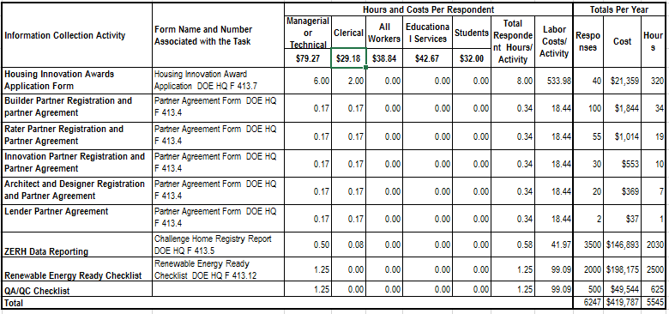
HOME ENERGY SCORE PROGRAM
- Total annual responses: 82,407
- Total annual burden hours: 6718
- Total number of unduplicated respondents: 607

Of the 607 unduplicated respondents we estimate that the types of organizations are as follows:
- Individuals and households - 0
- For Profit Organizations - 140
- Not for profit Organizations - 165
- State and Local Governments – 175
- Utilities - 127
The table below gives details on how these amounts were determined.
Exhibit 2. Home Energy Score Program: Estimated Annual Respondent Burden and Cost for Joining and Related Activities.

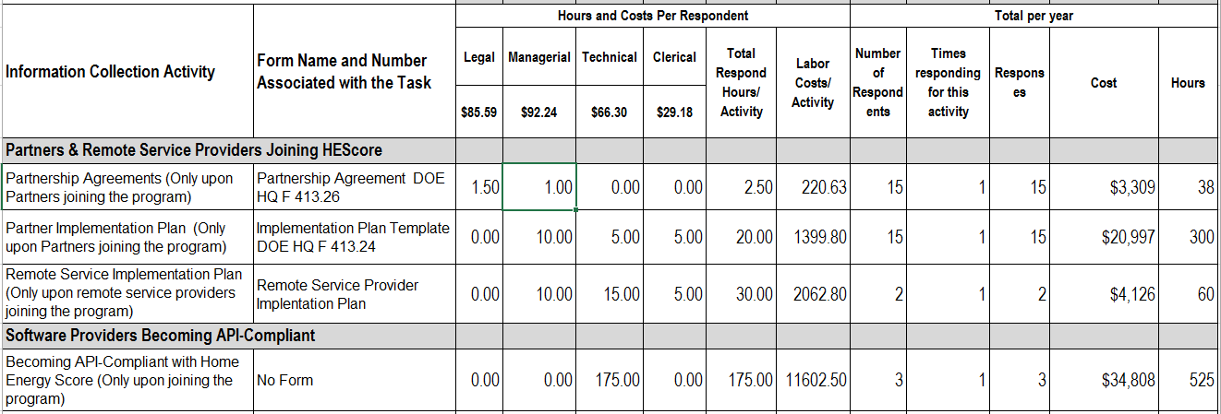
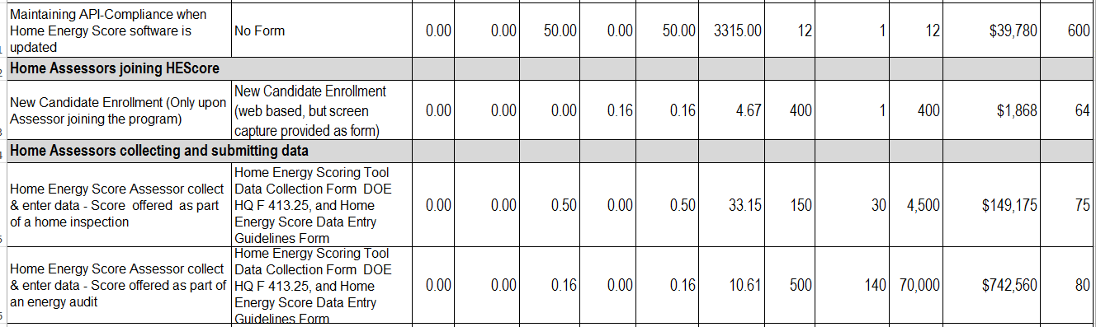
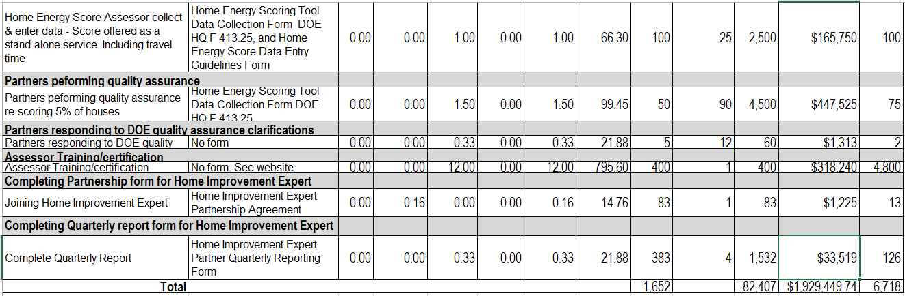
BETTER BUILDINGS RESIDENTIAL NETWORK
- Total annual responses: 3762
- Total annual burden hours: 977
- Total number of unduplicated respondents: 133

Of the 133 unduplicated respondents we estimate that the types of organizations are as follows:
- Individuals and households - 0
- For Profit Organizations - 33
- Not for profit Organizations - 60
- State and Local Governments – 40
The table below gives details on how these amounts were determined.

Exhibit 3. Better Buildings Residential Network: Estimated Annual Respondent Burden and Cost for Joining and Related Activities.

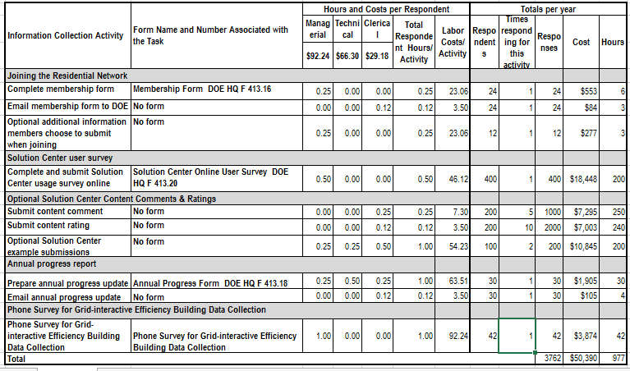
HOME PERFORMANCE WITH ENERGY STAR
- Total annual responses: 168
- Total annual burden hours: 1,143
- Total number of unduplicated respondents: 29

Of the 29 unduplicated respondents we estimate that the types of organizations are as follows:
- Individuals and households - 0
- For Profit Organizations - 19
- Not for profit Organizations - 8
- State and Local Governments - 2
The table below gives details on how these amounts were determined.

Exhibit 4. Home Performance with Energy Star: Estimated Annual Respondent Burden and Cost for Joining and Related Activities.

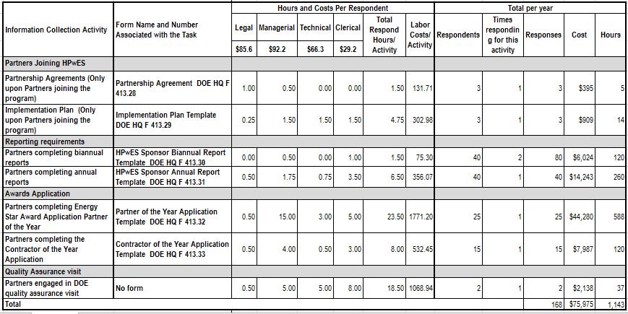

A.12B. Estimate of Annual Cost to Respondent for Burden Hours
DOE estimates that the hours spent on the forms costs respondents $2,475,602. The breakout for each program is as follows: $419,787 for the Zero Energy Ready Home Program, $1,929,450 for the Home Energy Score Program, and $50,390 for the Better Buildings Residential Network, and $75,975 for the Home Performance with Energy Start Program.
The tables in A.12.A Estimate of Respondent Burden Hours above show how DOE calculated these costs for respondents. DOE used wage estimates from the Department of Labor. Specifically, May 2018 National Occupational Employment and Wage Estimates from this web page https://www.bls.gov/oes/current/oes_nat.htm referenced on March 26, 2019. The wage estimates are mean hourly wages times 1.6 to add overhead and benefits. (Except, for student a DOL wage is not used. $20 is used times 1.6 = $32)
From the Department of Labor:
- All occupations $24.34 x 1.6 = 38.94
- Management- 57.65 x 1.6 = 92.24
- Arch and Engr (technical)– 41.44 x 1.6 = 66.30
- Legal – 51.62 x 1.6 = 85.59
- Office and Admin support (clerical) 18.24 x 1.6 = 29.18
- Student 20 x 1.6 = 32.00
- Educational – 26.67 x 1.6 = 42.67
DOE applied the above wage rates to these occupations:
- Homeowner/other - $38.94
- Management- 92.24
- Technical– 66.30
- Management or technical – 79.27
- Legal –85.59
- Clerical- 29.18
- Student - 32.00
- Educational – 42.67

A.13. Other Estimated Annual Cost to Respondents
Provide an estimate for the total annual cost burden to respondents or recordkeepers resulting from the collection of information.
DOE estimates there are no capital, startup, or operating and maintenance costs for respondents to collect and send the information to DOE. DOE believes that respondents use computer equipment and software that are customary and usual business practice to have and that these are not additional costs associated with the information collection.

A.14. Annual Cost to the Federal Government
Provide estimates of annualized cost to the Federal government.
The annual cost to the Federal government resulting from the collection of information for the three Programs for Improving Energy Efficiency in Residential Buildings is estimated to be about $178,618. The cost is for the government time to review the data received for completeness and accuracy. The hourly labor rates for government employees used in this ICR were obtained from the 2018 GS pay schedule available from the Office of Personnel Management. DOE estimates an average hourly labor cost of $117.50 for legal staff, $99.89 for managerial staff, $84.54 for technical staff, and $25.23 for clerical staff. The labor costs are based on the following GS levels and steps: legal labor rates were based on GS Level 15, Step 5, managerial labor rates were based on GS Level 14, Step 5, technical labor rates were based on GS Level 13, Step 5, and clerical labor rates were based on GS Level 5, Step 5. To derive hourly estimates, DOE divided annual compensation estimates by 2,080, which is the number of hours in the Federal work-year. DOE then multiplied hourly rates by the standard government overhead factor of 1.6. Calculations for total annual Agency burden and costs are presented in the tables below.
ZERO ENERGY READY HOME PROGRAM. The annual cost to the Federal government resulting from the collection of information for the Zero Energy Ready Home program is estimated to be about $61,078.

Exhibit 5. Zero Energy Ready Home Program: Estimated Annual DOE Burden and Cost.

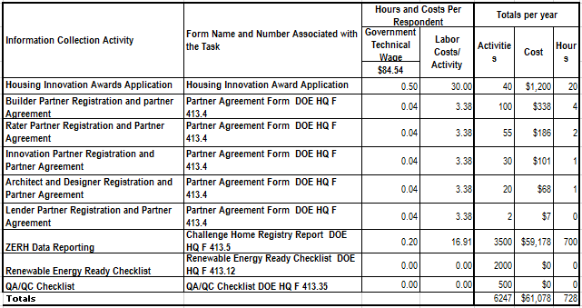

HOME ENERGY SCORE PROGRAM. The annual cost to the Federal government resulting from the collection of information for the Home Energy Score program is estimated to be about $26,712.
Exhibit 6. Home Energy Score Program: Estimated Annual DOE Burden and Cost.
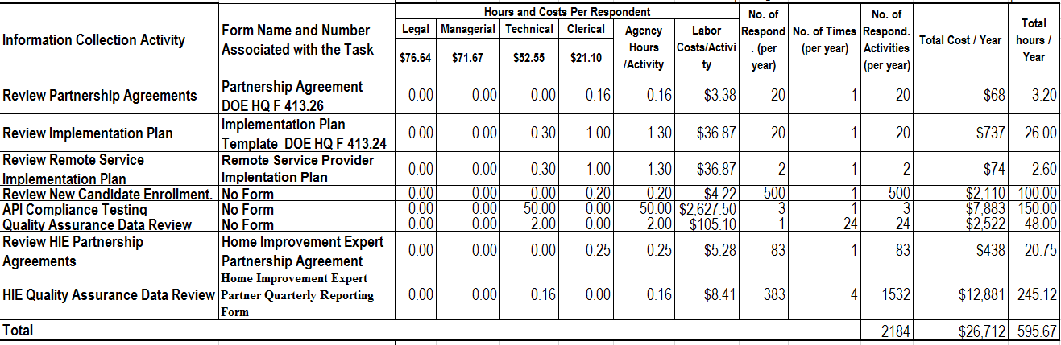
BETTER BUILDINGS RESIDENTIAL NETWORK. The annual cost to the Federal government resulting from the collection of information for the Better Buildings Residential Network is estimated to be about $89,445.

Exhibit 7. : Better Buildings Residential Network Estimated Annual DOE Burden and Cost.
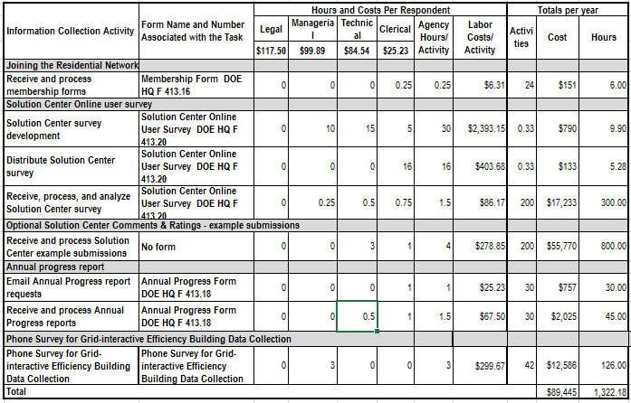
HOME PERFORMANCE WITH ENERGY STAR
The annual cost to the Federal government resulting from the collection of information for the Home Performance with Energy Star program is estimated to be about $11,765.
Exhibit 8. : Home Performance with Energy Star Estimated Annual DOE Burden and Cost.
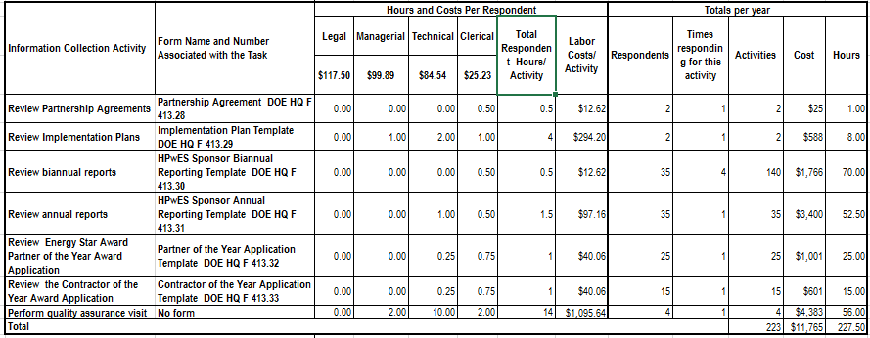

A.15. Reasons for Changes in Burden
The program changes are minor. There is one adjustment/re-estimate that is significant. There are three changes in how programs operate that are the result of DOE discretion and result in small increases in burden hours.
Three of the programs in this ICR have slight decreases in our estimates of the hours and persons involved in them mostly because of changes in how many people and organizations participate but also with small changes in how the programs operate. One program has substantial increases and decreases. The reason for those increases are mostly because many more people/organizations are expected to participate in the Home Energy Score Program. The reason for the decreases have to do with a change in our method of estimating burden instead of a change in how the program operates. DOE will no longer count the time and instances that homeowners are home during the time that their homes are being assessed by Home Assessors as the Assessors calculate the score of the homes. The homeowners do not take part in this activity or fill out forms or respond to DOE. The Assessors’ activities are included in the burden estimates. In the burden estimates of the previously approved ICR the homeowner time was included but should not have been included. This adjustment is the largest reason for the decrease in burden hours and number of respondents.
For increases in burden due to DOE discretion and not due to adjustments in estimates we have three changes. In the Home Energy Score Program there is something new that enhances the program that we are counting as a burden in this ICR. The activity of software providers becoming compliant with API regulations results in 15 additional responses and 1125 hours. Another change in the Home Energy Score Program increasing burden is the introduction of the Home Improvement Expert, increasing the burden by 1615 responses and 139 hours. Finally, the GEB survey in the Better Buildings Residential network increases burden by 42 responses and 42 hours.
ICR Summary of Burden
 | Requested | Program Change Due to Agency Discretion | Change Due to Adjustment in Agency Estimate | Previously Approved
Total Number of Responses | 92,584 | +1672 | +44,153 | 46,759
Total Time Burden (Hr) | 14,383 | +1306 | -9782 | 22,859

Additional detail can be found in the following table of the changes in burden hours.

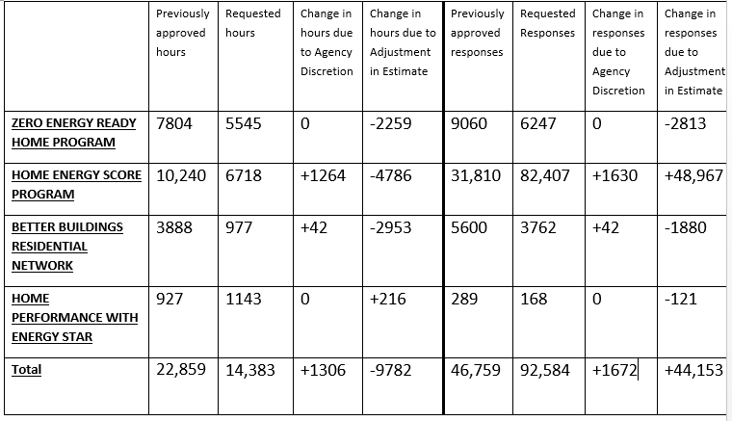

A.16. Collection, Tabulation, and Publication Plans
For collections whose results will be published, outline the plans for tabulation and publication.
DOE does not intend to do any complex statistical analysis of the data it collects. DOE publicizes the success of the four programs in various venues such as web pages, email newsletters, and press releases for the public. The HPwES program does identify correlations and trends and reports them to stakeholders through presentations, webinars, and the website.
When DOE publishes case studies for the purpose of promoting the ZERH Program, DOE does not publish personally identifiable information of the homeowners with the case studies. DOE uses the case studies to give positive recognition to builders participating in the program and to publicize the type of homes that are being built under the program. These builders do give DOE permission to publish their names and contact information and often promote the case studies themselves for positive marketing.

A.17. OMB Number and Expiration Date
If seeking approval to not display the expiration date for OMB approval of the information collection, explain the reasons why display would be inappropriate.
DOE will display the OMB Control No. and expiration date on the associated information collections.

A.18. Certification Statement
Explain each exception to the certification statement identified in Item 19 of OMB Form 83-I.
DOE has no exceptions to the certification statement in Item 19 of Form 83-I.

