HOME ENERGY SCORE
Partnership Agreement v2.0 for Participating Organizations

Home Energy Score Partners include various types of organizations (e.g., utilities, state agencies, local governments, non-profits, contractor associations) that administer the delivery of the Score on a local, state, or national basis. This Partnership Agreement outlines the responsibilities of DOE and the participating Partner. Additional requirements are provided in an addendum entitled “Terms of Participation.”

Prior to providing the Home Energy Score, both DOE and its Partner must sign this agreement. DOE may modify this agreement or terms of participation to address lessons learned and future programmatic goals. DOE will notify all Partners at least 30 days prior to making any changes to either the Partnership Agreement or terms of participation. A Partner or DOE can terminate the Partnership at any time by notifying the other party.

DOE Responsibilities
DOE will oversee and maintain the Home Energy Score program, and carry out functions including but not limited to monitoring of Partners, data analysis, development of training and outreach materials, and updates to the Home Energy Scoring Tool (Scoring Tool). DOE agrees to provide the following support to its Partners:

- Provide Assessors working under a Partner organization with access to the Scoring Tool.
- Provide access to standard outreach and educational materials for homeowners and Assessors, including online information and training.
- Provide them access to the Scoring Tool once certification and testing requirements are met.
- Serve as a technical aid in resolving issues (e.g., software questions) that may arise during implementation.
- Host webinars and other forums to assist Partners with implementation and to encourage information exchange.
- Carry out evaluation efforts to measure effectiveness of the Home Energy Score and promote ongoing improvement of the program. Communicate findings to Partners to assist in more effective program delivery.
- Implement upgrades to the Scoring Tool and other program features as needed and with appropriate notice and communication with Partners.

Partner Organization Responsibilities
Partner organizations and individuals will deliver the Home Energy Score to homeowners through a variety of channels. Partners may provide the Score as part of a home performance program or as an independent service.

Partners agree to meet the following program requirements:

- Set a target goal for number of houses to be scored in the first year and beyond. Partners must commit to a minimum of 500 homes per year.
- Develop an implementation plan outlining how the program will be delivered and integrated into other Partner efforts. Partners should incorporate some type of evaluation in their implementation plan.
- Designate a primary point of contact for participating Assessors and facilitate the delivery of required contact information to DOE.
- Verify that Assessor candidates meet credential requirements and provide DOE with the names of the candidates.
- Inform DOE whenever an Assessor ceases participation under the Partner’s program.
- Adhere to rules regarding use of programmatic materials and the Scoring Tool, as set forth in the program’s “Terms of Participation”; monitor participation and performance of Assessors in the program; provide mentoring as required.
- Carry out quality assurance in accordance with the conditions set forth in the program’s “Terms of Participation.”
- Provide feedback on the implementation of Home Energy Score and check in on a regular basis with your DOE Home Energy Score account manager to discuss plans, issues and findings.

Partner Representative: __________________________________________________________
Organization Name: _____________________________________________________________
Title: _________________________________________________________________________
Email: ____________________________________________Phone: ______________________
Signature: ____________________________________________ Date: ____________________

The signing representative must have authority to commit the organization to the terms of this agreement. If your organization is implementing the Home Energy Score on behalf of or sponsored by a state, utility, or local program, a representative from your sponsoring agency must sign below. The sponsoring agency is ultimately responsible for ensuring that the Partner organization (listed above) conduct quality assurance in a timely manner in accordance with the conditions set forth in the program’s “Terms of Participation.”

Sponsoring Agency: _____________________________________________________________
Sponsoring Agency Representative (Name): __________________________________________
Title: _________________________________________________________________________
Email: _____________________________________________Phone: _____________________
Signature: _______________________________________________Date: _________________

U.S. Department of Energy Representative: __________________________________________
Title: _________________________________________________________________________
Signature: _______________________________________________Date: _________________

HOME ENERGY SCORE
Addendum: Terms of Participation
Please read this addendum in its entirety.

The Home Energy Score Partner Agreement sets forth the principal responsibilities of DOE and its Partners. This addendum to the Partner Agreement provides more detailed requirements related to the following aspects of program delivery:

- Confidential Information
- Assessor Qualifications and Restrictions
- Quality Assurance
- Eligible Homes
- Linking to Other Software Tools
- Home Energy Score Updates
- Use of DOE Materials and the DOE Seal

1. Confidential Information
As part of the Home Energy Score Program and to facilitate the scoring of homes, the Partners will provide certain data and information regarding individual residences (“Confidential Information”) to DOE. DOE shall protect all data collected and generated to score homes and shall retain and store all confidential information furnished by the Partners in a secure and confidential manner, subject to applicable law. DOE agrees to share confidential information and scoring calculations for individual homes with its Home Energy Score Partners and their affiliates if applicable (e.g. a state agency that has an agreement with a Partner to share data for homes scored in their state), and each Partner and affiliate will receive only data for homes scored by Assessors working through that Partner. Assessors will only have access to data which they have provided to DOE and to Home Energy Score Reports generated for those homes which the Assessor scored. DOE may develop and release papers and presentations that include information regarding homes scored. However, DOE may only present aggregated data and DOE agrees it will not publicly share any information regarding individual homes, subject to applicable law. If DOE becomes legally compelled to disclose any of the confidential information to a federal or state governmental agency, DOE shall inform Partner of such disclosure promptly after such agency’s request so that Partner may contact DOE and/or seek another appropriate remedy. DOE will not disclose any information DOE believes to be confidential information produced pursuant to this Partnership Agreement to any third party, except as may be mutually agreed upon in writing by Partner and, if so agreed, by the execution of a mutually acceptable nondisclosure agreement, or in the case in which DOE is required by law to disclose the information. Unless restricted through other contracts (e.g. with Assessors or customers), Partners are free to use and share information on the homes scored under their Partnership. The rights and obligations arising under this Partnership Agreement with respect to Confidential Information disclosed hereunder, particularly the confidentiality obligations, shall survive any termination of this Agreement.

2. Assessor Qualifications and Restrictions
All Assessors must meet ALL of the following requirements in order to use the Home Energy Scoring Tool and provide Home Energy Scores.

- Hold a relevant credential. Individuals interested in becoming Assessors must hold a relevant credential from one of the residential trade organizations listed on the Home Energy Score website. The Home Energy Score program recognizes those credentials as well as more comprehensive certifications offered by these organizations. To see a full list of qualifying credentials offered by these organizations, contact them directly.

- Pass the online Home Energy Score tests.

Once an Assessor meets these requirements, DOE will provide a user ID and password in order to access the Scoring Tool. The Assessor can ONLY provide Home Energy Scores as part of services rendered through one of DOE’s official Home Energy Score Partners. Assessors cannot score homes that are outside of their Partner’s service area.

Exceptions: Assessors working under one of DOE’s Home Energy Score Partners may score homes outside the Partner’s service area IF either of the following conditions is met:

- The Partner agrees to extend the same quality assurance services required by the Partner agreement to these additional homes; and the Partner informs the DOE Home Energy Score Program Manager prior to such an arrangement.

OR

- Prior to scoring homes outside the Partner’s service area, the DOE Home Energy Score Program Manager approves the Assessor’s plan to secure adequate quality assurance services from a different Home Energy Score Partner.

3. Quality Assurance (QA)
To ensure consistent scoring practices across Assessors, the Partner agrees to re-score, on a quarterly basis, a minimum of five percent (5%) of all homes scored by a Quality Assurance Auditor. There are two approved pathways for completing this requirement: (1) in-field Quality Assurance, or (2) desktop Quality Assurance.

Selection of Homes for QA
Quality assurance scores (QA checks) should be random, distributed across all Assessors within the program, and focused primarily on work performed by the newer and less experienced Assessors. QA checks on work performed by experienced Assessors who have consistently scored homes accurately should be a lower priority, but still performed periodically.

QA checks should reflect the make-up of the homes scored. For example, if 75% of a program’s scores are completed on homes before improvements are made, then 75% of the QA checks should be performed on homes before improvements are made and only 25% on homes after improvements are made. If the QA check is conducted in-field, each home must be in the same condition for its initial score and the QA check; otherwise, results will likely not correspond.

QA Service Providers
QA checks should be performed by a Quality Assurance Auditor who works for an independent third-party service provider or for the Partner directly as approved by DOE. In cases where the Home Energy Score Partner is a private for-profit company with no binding implementation contract with a utility, state, or local government, QA checks must be performed by a third-party QA provider. The Quality Assurance Auditor must meet the following requirements:

- Must be an active Home Energy Score Assessor
- Must qualify through one of the following paths:
  - Hold either a current BPI Building Analyst or RESNET HERS credential for at least two years (credentials must be current or expired for no more than 1 year); AND, have conducted a minimum of 4 Home Energy Scores
    - DOE’s Home Energy Score Team must review and sign off on at least 4 of these scores through in-field QA or Desktop Quality Assurance (DTQA)
    - Issues relating to above assessments must be resolved by Home Energy Score Team, which may include additional QA’d assessments
  - Hold a BPI BSP credential AND have conducted a minimum of 20 Home Energy Scores
    - DOE’s Home Energy Score Team must review and sign off on 10 of these scores through in-field QA or DTQA
    - Issues relating to above assessments must be resolved by Home Energy Score Team, which may include additional QA’d assessments
- Must receive phone and/or webinar training from the DOE Home Energy Score Team or an approved provider. Training for prospective QA Auditors will include –
  - An overview and discussion of relevant information and tools
    - Purpose and goals of Quality Assurance
    - QA protocol, whether in-field or through desktop quality assurance
    - Quality Assurance Guidance documentation
    - Home Energy Score Assessor Calculator
  - Joint completion of one or more example DTQA reviews
  - An opportunity to ask questions

There should be no conflict of interest between the third-party quality assurance provider and the Home Energy Score Partner. This includes, but is not limited to, installation services in houses assessed as part of the Home Energy Score Program. Prior to initiating its quality assurance efforts, the Partner must provide documentation regarding the QA Auditor’s qualifications to their DOE account manager.

Any Service Provider seeking to offer Desktop Quality Assurance instead of in-field Quality Assurance must also meet the following minimum requirements:

- In business for 5 years or more providing quality assurance administrative services.
- Proven ability to meet IT needs:
  - Must have an information system to track, monitor, and store the data files from Remote Mentor and DTQA sessions.
  - The Home Energy Score Team must have access to data from sessions if requested, including but not limited to photos/videos from QA and remote mentoring.
  - Must be able to ensure data protection and IT security, including but not limited to data encryption, password aging, transaction logging, security breach policies, disaster planning, and backup protocols.
  - Must be able to maintain all Home Energy Score API integration needs and future changes as necessary.
  - Must be able to provide reports to the Home Energy Score Team of Scores and DTQA data entry, and at least monthly reports on QA trending and score analysis.
- Proven ability to fulfill the DTQA and/or Remote Mentoring process requirements.
- Proven training, mentoring, and credentialing ability, such that Remote Mentors and DTQA Auditors can consistently comply with protocols in this document.
- Must participate in regular Home Energy Score meetings, webinars, and conferences as directed by DOE.

QA Process
There are two acceptable pathways for a QA Auditor to check a Home Energy Score: either through an in-field assessment, or through Desktop Quality Assurance (DTQA). The Service Provider must be pre-approved by the Home Energy Score Team to conduct QA through either of these pathways.

If conducted in-field, the QA assessment may occur concurrently with the Assessor initially scoring the home but it must be done independently. The QA Auditor must not discuss his or her findings or calculations with the Assessor who scored the home until after each has completed data entry and produced a score. However, after independent scoring is completed, discussion between the QA Auditor and Assessor is recommended to identify differences in interpretation or measurement and agree on a preferred approach going forward.

For Desktop Quality Assurance (DTQA), rather than performing a second, independent, in-field assessment, the DTQA Auditor reviews 20-35 photos of the home’s key features submitted by the Assessor. See the document, “Updated Quality Assurance and Mentoring Protocols for Home Energy Score” for more detailed information about the DTQA Protocols. Using these photos and other supporting information, the Auditor enters QA assessment for the home and verifies the data entered by the Assessor compared to the photo evidence. Any points of contention can be discussed over the phone or through email between the Assessor and QA Auditor.

Reviewing QA Results
The Score results of the Assessor and the QA check must be comparable. If results for the same home differ by more than one point (on the 10-point scale), the house must receive a “Corrected” Score. If an Assessor consistently produces scores that are not comparable to the QA check scores, re-training is required and must be completed before the Assessor can score more homes. If there is a consistent discrepancy between a QA Auditor’s results and various Assessors’ results, the QA Auditor will require re-training. The Partner is responsible for monitoring and identifying these issues.

In addition to the QA checks, all Partners should perform quality assurance checks on data (desk reviews). While reviewing their Home Energy Score data, Partners should look for discrepancies between Assessors to ensure consistent scoring across the program. For example:

- Is an Assessor consistently scoring houses high or low?
- Are there multiple Home Energy Score sessions for the same house? (Only one official Score Report for a specific assessment date should be associated with each house.)
- Is an Assessor repeatedly using the same values irrespective of house age or other house characteristics?
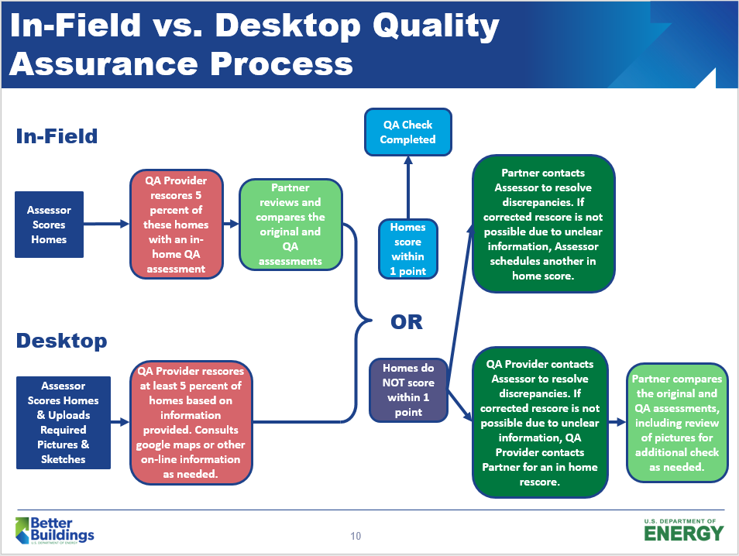

Mentoring Requirements
The Partner also agrees to provide field mentoring for each new Assessor during their first home scoring session. Mentoring can be performed by anyone who meets the following minimum requirements:
- Must be an active Home Energy Score Assessor
- Must qualify through one of the following paths:
  - Hold either a current BPI Building Analyst or RESNET HERS credential for at least two years (credentials must be current or expired for no more than 1 year); AND, have conducted a minimum of 4 Home Energy Scores
    - DOE’s Home Energy Score Team must review and sign off on at least 4 of these scores through in-field QA or Desktop Quality Assurance (DTQA)
    - Issues relating to above assessments must be resolved by Home Energy Score Team, which may include additional QA’d assessments
  - Hold a BPI BSP credential AND have conducted a minimum of 20 Home Energy Scores
    - DOE’s Home Energy Score Team must review and sign off on 10 of these scores through in-field QA or DTQA
    - Issues relating to above assessments must be resolved by Home Energy Score Team, which may include additional QA’d assessments
- Must receive phone and/or webinar training from the DOE Home Energy Score Team or an approved provider. Training for prospective mentors will include –
  - An overview and discussion of relevant information and tools
    - Purpose and goals of mentoring
    - “Mentoring Guide”
    - “Assessor Tips” fact sheet
    - Home Energy Score Assessor Calculator
  - A mock remote mentoring session
  - An opportunity to ask questions
During mentored sessions, the new Assessor and mentor are encouraged to communicate throughout the walk-through as well as during the scoring so that the mentor can share their experience and correct the Assessor should there be any misunderstandings of inputs, measurements, assumptions, etc. If in-field mentoring is performed on a one-on-one basis on a house that has not been previously scored, this assessment counts toward the Partner’s five percent QA requirement.

The Home Energy Score Team developed a procedure for Remote Mentoring in which a candidate Assessor can be mentored through a video-conferencing application or a software allowing for photos and videos of the home to be uploaded and shared with the Remote Mentor. Using these technologies, a Mentor can deliver an educational experience similar to live, in-person mentorship for an Assessor in another part of the country. See the document, “Updated Quality Assurance and Mentoring Protocols for Home Energy Score” for more detailed information about Mentoring Protocols.
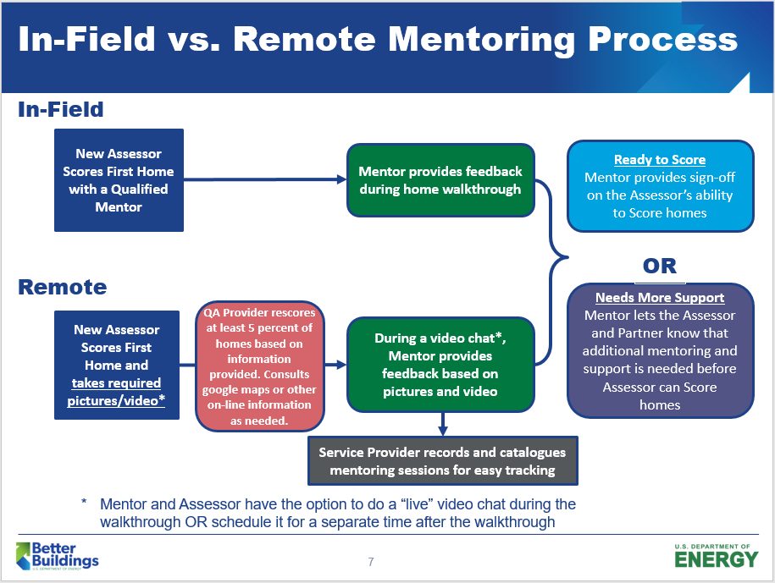

4. Eligible Homes
The Scoring Tool is currently only available to score single family homes, including semi-attached homes (i.e., duplexes, townhouses). Note: Multi-family units cannot be scored using this tool. Partners interested in scoring multifamily buildings should contact DOE’s commercial building energy asset score program (asset.score@ee.doe.gov). If questions arise concerning the application and/or use of the Scoring Tool, please contact homeenergyscore@ee.doe.gov or your DOE account manager for clarification and assistance.

5. Linking to Other Software Tools
Software developers can license an application programming interface (API) in order to seamlessly link their tools to the Home Energy Scoring Tool. This capability reduces data entry burdens for Assessors already using other software tools. Software programs that make use of the API will need to satisfy DOE testing requirements to ensure that scoring through the API results in the same calculations as scoring directly through the Home Energy Scoring Tool online.

6. Home Energy Score Updates
In addition to providing homeowners with a Score at the time of the original energy assessment, Assessors and Partners can issue updated Home Energy Scores after the time of assessment.

A home can be rescored if an Assessor performs an energy assessment after the improvements are made to the home.

7. Use of DOE Materials and DOE Seal
The Home Energy Scoring Tool generates a report with three pieces of information:

- The Home Energy Score graphic, including the home’s current Score, its anticipated Score after recommended improvements are made, and estimated savings from improvements. Partners that choose to use the semi-customizable label option may have other information included on the Score page, e.g. estimated costs instead of savings. Partners may include their organization’s logo on the Home Energy Score report.
- Home facts, or the home’s asset summary that lists each data point input into the Scoring Tool to generate a Home Energy Score, as well as the home’s estimated energy use per year broken down by total MBtu, Score basis MBtu, and fuel type, e.g. electricity in kWh and natural gas in therms.
- Cost-effective energy improvement recommendations that are broken down as “Repair Now” and “Replace Later.” If the Partner chooses to use its own energy upgrade recommendations rather than those generated by the Scoring Tool, a generic Home Energy Score Recommendations page should be included in the final report. The blank recommendation page indicates the Assessor will provide recommendations separately from the report.

In addition to the Home Energy Score report, DOE provides several other documents Partners or Assessors are STRONGLY encouraged to provide at the time of the assessment or when the Score is delivered to the homeowner.

- What Does My Score Mean? An explanation of how to interpret a home’s Score, background on the scoring program, etc.
- Be a Smart and Engaged Homeowner: Guidance on what to look for when undertaking home energy improvements, pitfalls to avoid, etc.

In its implementation plan, the Partner must describe what information homeowners will receive, and when and how they will receive it. If the Partner elects not to use some of the DOE-provided materials, other information should be provided with the Score.

If the Partner would like to incorporate portions of materials provided by the Scoring Tool and/or DOE into its own materials, the Partner must adhere to the following rules. Partners must share an advanced copy of materials that incorporate DOE generated information with their account manager.

- If a Partner wants to incorporate the DOE seal into any of its materials, it must first receive permission from DOE, UNLESS the seal is to be used in the exact context as it is used on the Home Energy Score graphic (the first page of the Home Energy Score report).
- If a Partner refers to the Home Energy Score in its materials, the following standard language must appear on that document (on or near the page in which the Home Energy Score is mentioned):
“The U.S. Department of Energy’s Home Energy Score lets homeowners quickly and affordably know how their homes compare to others in terms of energy performance and what steps they can take to improve their home’s efficiency.”
- If a Partner wants to incorporate the Home Energy Score (i.e., how a home scored on the 10-point scale) in its own homeowner packet, the Partner is encouraged to provide a context for the Score (e.g., show the entire 10-point scale or state that the home scored a “6 out of 10”).
In all cases, Partners are strongly encouraged to work in advance with their DOE Home Energy Score account manager to ensure that a consistent message and clear, accurate information is provided to homeowners. Partners are also encouraged to explain that they are working in partnership with DOE. DOE will work with its Partners to draft acceptable language as needed. Partners are also welcome to use information directly off of the DOE Home Energy Score website to help explain the Score or the program to homeowners.

Public reporting burden for this collection of information is estimated to average 2.5 hours per response, including the time for reviewing instructions, searching existing data sources, gathering and maintaining the data needed, and completing and reviewing the collection of information. Send comments regarding this burden estimate or any other aspect of this collection of information, including suggestions for reducing this burden, to Office of the Chief Information Officer, Records Management Division, IM-23, Paperwork Reduction Project (1910-5184), U.S. Department of Energy, 1000 Independence Ave SW, Washington, DC, 20585-1290; and to the Office of Management and Budget (OMB), OIRA, Paperwork Reduction Project (1910-5184), Washington, DC 20503.

Requirements apply to new Partners signing onto this agreement only; existing Partners are grandfathered in to the requirements outlined on their existing Partner Agreement document.
Requirements apply to new Partners signing onto this agreement only; existing Partners are grandfathered in to the requirements outlined on their existing Partner Agreement document.

