Home Energy Scoring Tool

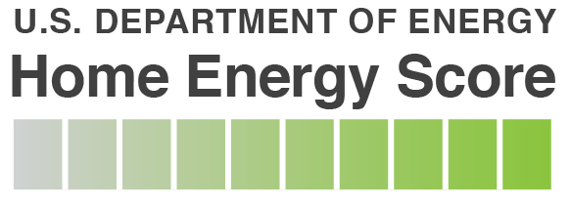

Assessor Candidate Enrollment

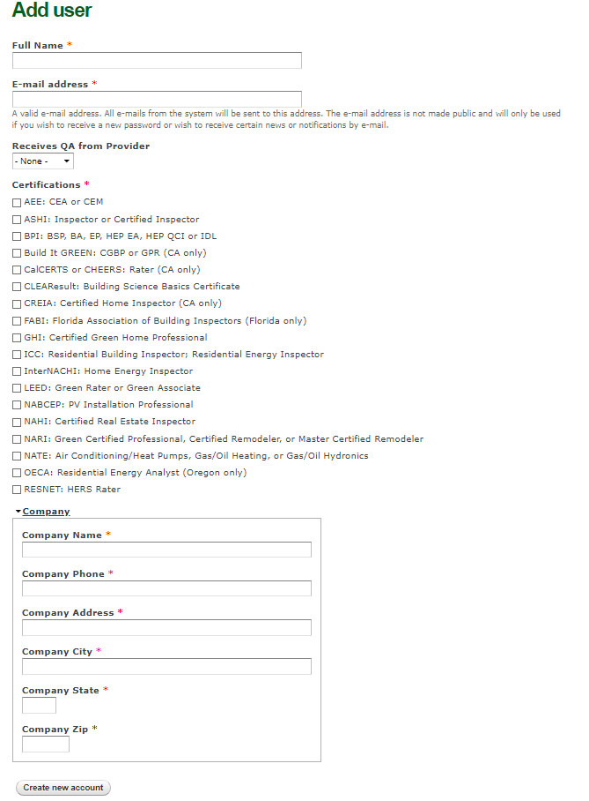
Public reporting burden for this collection of information is estimated to average 10 minutes per response, including the time for reviewing instructions, searching existing data sources, gathering and maintaining the data needed, and completing and reviewing the collection of information. Send comments regarding this burden estimate or any other aspect of this collection of information, including suggestions for reducing this burden, to Office of the Chief Information Officer, Records Management Division, IM-23, Paperwork Reduction Project (1910-5184), U.S. Department of Energy, 1000 Independence Ave SW, Washington, DC, 20585-1290; and to the Office of Management and Budget (OMB), OIRA, Paperwork Reduction Project (1910-5184), Washington, DC 20503.

