Farmers.gov Customer Experience Feedback Survey

Start of Block: Survey Options

Embedded Data Collected Upon Entry into Survey:

Browser (1)

Version (2)

Operating System (3)

Screen Resolution (4)

Flash Version (5)

Java Support (6)

User Agent (7)

Display This Question:

If FeedbackButton = Yes

Responses are randomized

|  |
| --- |
|  |

OMB control number: 0503-0024

Expiration Date: 04/30/2023

What kind of feedback do you have?

* I have feedback about farmers.gov (2-minute survey with 4 questions) (1)
* I'm having an issue with the website (tech support) (2)
* I have general questions about USDA programs (3)

End of Block: Survey Options

Start of Block: Tech Support

Display This Question:for unauthenticated website –can add a form to transmit via email

If CurrentPageURL Contains farmers.gov

Please email us at [usdafpacbc@servicenowservices.com](mailto:usdafpacbc@servicenowservices.com?subject=Tech%20Support) to receive tech support.

Display This Question for authenticated website:

If CurrentPageURL Contains force.fsa

If you need IT support or USDA assistance, get in touch with our Service Desk. Once we review your help request, a member of our support team will get back to you as soon as possible.

[Submit Help Request](https://usdafpacbc.servicenowservices.com/farmers)

End of Block: Tech Support

Start of Block: AskUSDA

You can [search for answers](https://gcc02.safelinks.protection.outlook.com/?url=https%3A%2F%2Fask.usda.gov%2Fs%2F&data=04%7C01%7C%7C1a9ca938548f4d929df708d8a2bace8f%7Ced5b36e701ee4ebc867ee03cfa0d4697%7C0%7C0%7C637438270648836372%7CUnknown%7CTWFpbGZsb3d8eyJWIjoiMC4wLjAwMDAiLCJQIjoiV2luMzIiLCJBTiI6Ik1haWwiLCJXVCI6Mn0%3D%7C0&sdata=Tj2NStfjKrgB8rN%2FMPq9JxOsx8ALnNXWFTzweRLAo%2Bs%3D&reserved=0) at AskUSDA

End of Block: AskUSDA

Start of Farmers.gov Survey:

Embedded Data Collected from the User upon entry:

Browser (1)

Version (2)

Operating System (3)

Screen Resolution (4)

Flash Version (5)

Java Support (6)

User Agent (7)

1.  How satisfied are you with your visit to farmers.gov today?

* Satisfied (5)
* Somewhat satisfied (4)
* Neutral (3)
* Somewhat dissatisfied (2)
* Dissatisfied (1)

2.  Please indicate your level of agreement with the following statement:  
  
  
This visit increased my trust in farmers.gov.

* Agree (5)
* Somewhat agree (4)
* Neutral (3)
* Somewhat disagree (2)
* Disagree (1)

3.  Which of these statements apply to your experience? (please select any/all that apply)

* I was **able to find** or complete what I needed to today.
* **It was easy** to find or complete what I needed to today.
* **It took a reasonable amount of time** to find or complete what I needed to today.
* **I understood the information** on farmers.gov today.
* Other, please specify: ________________________________________________
* ⊗None of these (0)

4.  Please share any additional feedback you have about your visit to farmers.gov today:  (may leave blank and submit response below)

________________________________________________________________

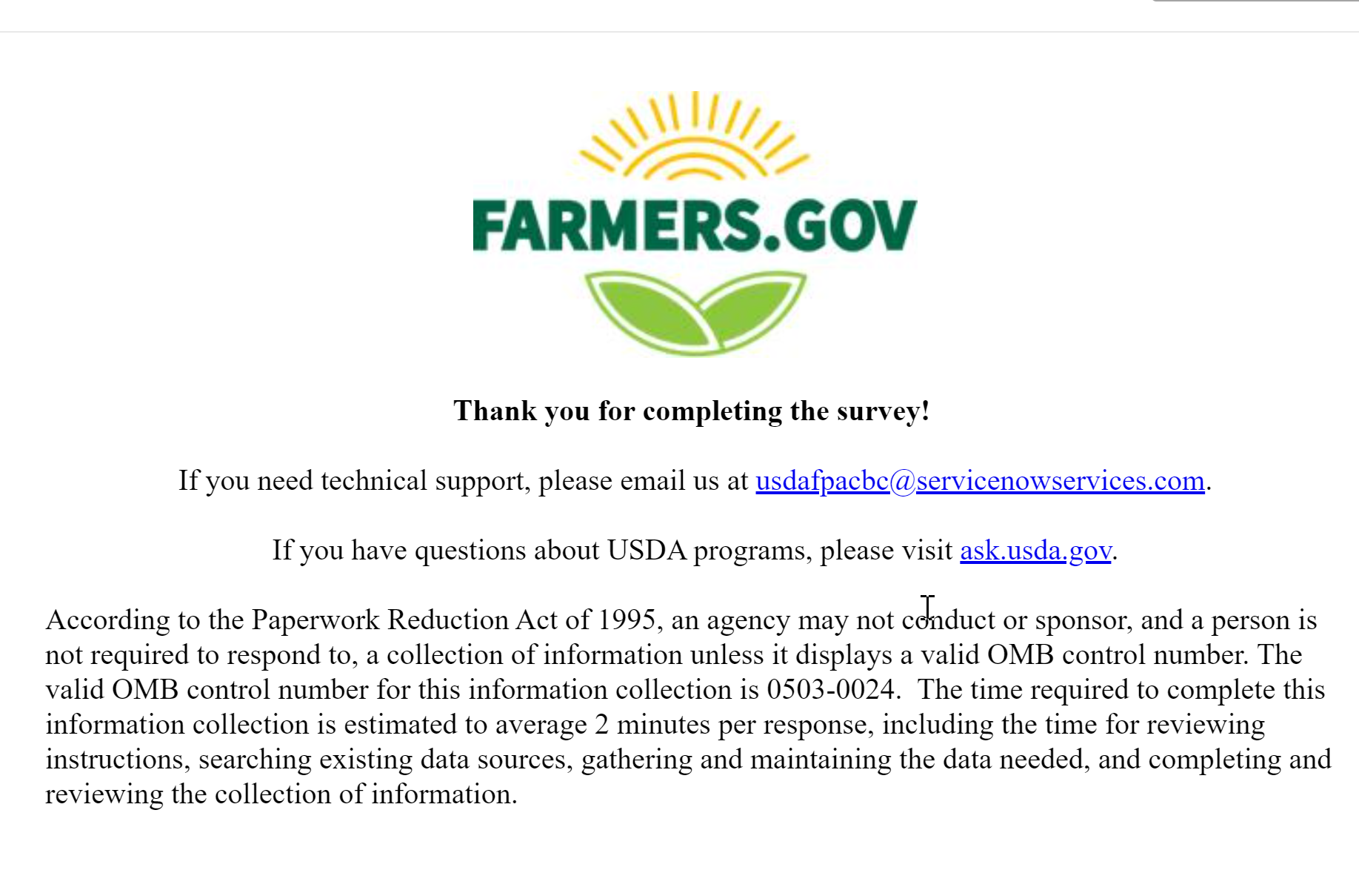

Survey Flow

EmbeddedData

CurrentPageURLValue will be set from Panel or URL.

FeedbackButtonValue will be set from Panel or URL.

PageReferrerValue will be set from Panel or URL.

TotalPageCountValue will be set from Panel or URL.

TimeSpentOnSiteValue will be set from Panel or URL.

SiteReferrerValue will be set from Panel or URL.

Block: Survey Routing Options for Feedback Button Only (2 Options: Authenticated and Unauthenticated)

Branch: New Branch

If

If What kind of feedback do you have? I'm having an issue with the website (tech support) Is Selected

Standard: Tech Support (2 Options)

EndSurvey:

Branch: New Branch

If

If What kind of feedback do you have? I have general questions about USDA programs Is Selected

Standard: AskUSDA (1 Option)

EndSurvey:

Standard: OMB control number: 0503-0024 (5 Questions)