Farmers.gov Customer Experience Feedback Survey

Start of Block: Survey Options

Embedded Data Collected Upon Entry into Survey:

Browser (1)
Version (2)
Operating System (3)
Screen Resolution (4)
Flash Version (5)
Java Support (6)
User Agent (7)

Display This Question:
If FeedbackButton = Yes
Responses are randomized
OMB control number: 0503-0024
Expiration Date: 04/30/2023

What kind of feedback do you have?
- I have feedback about farmers.gov (2-minute survey with 4 questions) (1)
- I'm having an issue with the website (tech support) (2)
- I have general questions about USDA programs (3)

End of Block: Survey Options

Start of Block: Tech Support
Display This Question:for unauthenticated website –can add a form to transmit via email
If CurrentPageURL Contains farmers.gov

Please email us at usdafpacbc@servicenowservices.com to receive tech support.

Display This Question for authenticated website:
If CurrentPageURL Contains force.fsa

If you need IT support or USDA assistance, get in touch with our Service Desk. Once we review your help request, a member of our support team will get back to you as soon as possible.

Submit Help Request

End of Block: Tech Support

Start of Block: AskUSDA

You can search for answers at AskUSDA

End of Block: AskUSDA

Start of Farmers.gov Survey:

Embedded Data Collected from the User upon entry:

Browser (1)
Version (2)
Operating System (3)
Screen Resolution (4)
Flash Version (5)
Java Support (6)
User Agent (7)

1. How satisfied are you with your visit to farmers.gov today?
- Satisfied (5)
- Somewhat satisfied (4)
- Neutral (3)
- Somewhat dissatisfied (2)
- Dissatisfied (1)

2. Please indicate your level of agreement with the following statement:
This visit increased my trust in farmers.gov.
- Agree (5)
- Somewhat agree (4)
- Neutral (3)
- Somewhat disagree (2)
- Disagree (1)

3. Which of these statements apply to your experience? (please select any/all that apply)
- I was able to find or complete what I needed to today.
- It was easy to find or complete what I needed to today.
- It took a reasonable amount of time to find or complete what I needed to today.
- I understood the information on farmers.gov today.
- Other, please specify: ________________________________________________
- ⊗None of these (0)

4. Please share any additional feedback you have about your visit to farmers.gov today: (may leave blank and submit response below)
________________________________________________________________
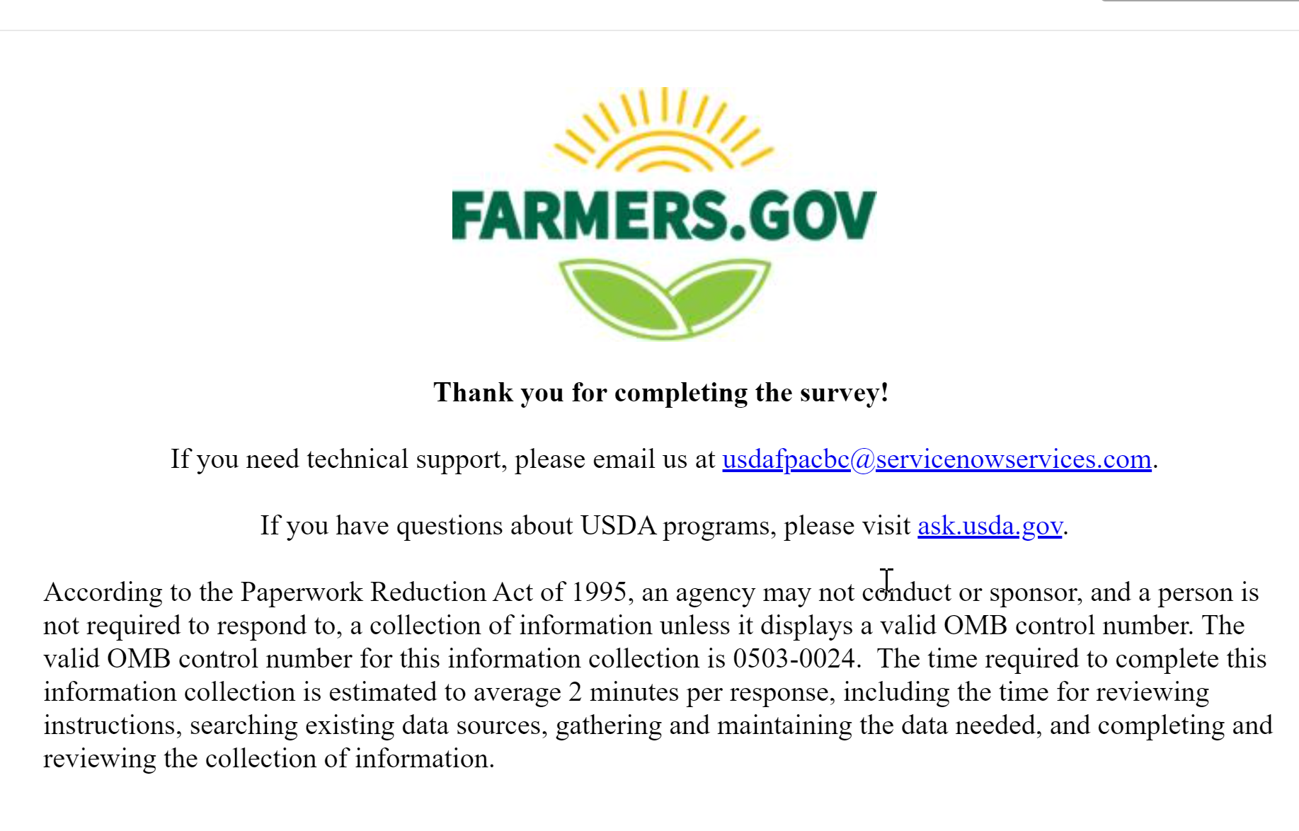

Survey Flow
EmbeddedData
CurrentPageURLValue will be set from Panel or URL.
FeedbackButtonValue will be set from Panel or URL.
PageReferrerValue will be set from Panel or URL.
TotalPageCountValue will be set from Panel or URL.
TimeSpentOnSiteValue will be set from Panel or URL.
SiteReferrerValue will be set from Panel or URL.
Block: Survey Routing Options for Feedback Button Only (2 Options: Authenticated and Unauthenticated)
Branch: New Branch
If
If What kind of feedback do you have? I'm having an issue with the website (tech support) Is Selected
Standard: Tech Support (2 Options)
EndSurvey:
Branch: New Branch
If
If What kind of feedback do you have? I have general questions about USDA programs Is Selected
Standard: AskUSDA (1 Option)
EndSurvey:
Standard: OMB control number: 0503-0024 (5 Questions)

