**United States Department of Agriculture**

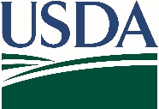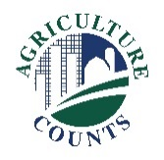

National Agricultural Statistics Service

July 8, 2019

**What should I do when I receive a questionnaire?**

Complete your survey **online** at [www.agcounts.usda.gov](http://www.agcounts.usda.gov). ***Online reporting is fast, cost-effective, and secure.*** All you need is the 17-digit survey code on the enclosed form to begin.

By **fax**: complete the survey questionnaire and fax it to   
(855) 415-3687.

**Why am I getting this letter?**

Beginning in September 2019, USDA’s National Agricultural Statistics Service (NASS) will collect cotton gin data throughout the ginning season - generally every two weeks. Your information is important – we know your time is valuable so we offer two simple options to respond.

**How will the data be used?**

Cotton ginning reports provide a measure of the size of production or inventories so that prices can move in line with supply. Without good information, risks of doing business increase and costs rise. Once you and your fellow ginners respond, NASS will publish the combined results in *Cotton Ginnings*reports every two weeks during the survey season. All NASS reports are available online free of charge at [www.nass.usda.gov](http://www.nass.usda.gov).

The results of this survey will be kept confidential and available in aggregate form only, ensuring that no individual operation or producer can be identified, as required by federal law.

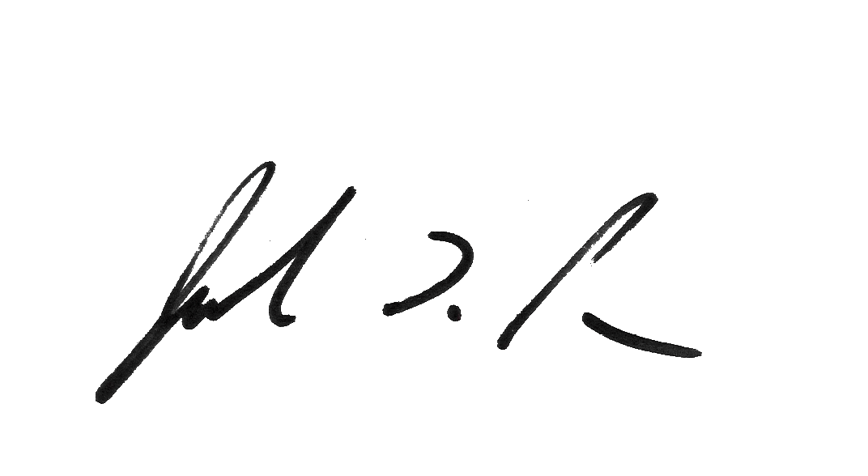Thank you for participating and for your support of our programs and U.S. agriculture. If you have any questions, please feel free to contact us at 1-888-424-7828.

We are once again offering free copies of the *Cotton Ginnings Record Book*. If you would like one or several copies, please use the enclosed “Ginnings Record Book Order” form and envelope to place your order. You can also use the form to request a copy of the *Cotton Ginnings 2018 Summary* by email. If you prefer to make your request by email, send your mailing info to Neil Probst at [NProbst@nass.usda.gov](mailto:NProbst@nass.usda.gov).

Sincerely,

Joseph L. Parsons

Chair, Agricultural Statistics Board

Enclosure

**GINNINGS RECORD BOOK ORDER**

​ **YES** - Please provide me with ____________copies of the Cotton Ginnings Record Book.

​ **YES** - Please provide me with a digital copy of the *Cotton Ginnings 2018 Summary* by email.

Please enter the address where you would like the books sent:

Operation /Name:__________________________________________

Street Address:___________________________

City_________________State_______Zip_________

Phone: [______] ________ - __________

Email: ____________________________