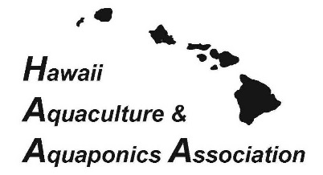
Sample Letter of Support for HI State Survey

June 14, 2018

Re: Annual Aquaculture Survey from USDA NASS

Aloha Hawaii Aquaculture and Aquaponic Industry Members:

The USDA’s Hawai’i Field Office of the National Agricultural Statistics Service (NASS) is conducting its annual aquaculture industry survey of 2017 production data. Your participation in this survey is very important to our industry since the survey data will result in a report providing official documentation for the size and growth of our industry, and aquaculture’s importance to Hawai’i. This report can then be used to encourage increased support of our industry by the Federal and State Administration, Legislature, the Counties, our Congressional delegation, and the Universities serving Hawaii. In 2016, Hawaii aquaculture sales totaled $75.7 million. Your response will help determine the 2017 sales. If you would like a copy of the results, please check the box on the last page of the survey.

Please be assured that the collected data will be used to provide unbiased and accurate agricultural estimates. USDA assures all producers that the information collected in the survey is kept confidential and protected by Chapter 55, Section 2276 of the U.S. code. Another level of protection is provided by the Confidential Information Protection and Statistical Efficiency Act. Inquires or concerns regarding the survey can be directed to Kathy King, State Statistician, USDA – NASS Hawaii Field Office, or Regina Hidano, who will be handling the aquaculture surveys, at (800) 804-9514, or, if calling from Oahu, at (808) 522-8080.

In order to help lower data collection costs, please respond promptly via mail in the provided postage paid envelope. Thank you in advance for your time, attention, and participation regarding this survey.

Sincerely,
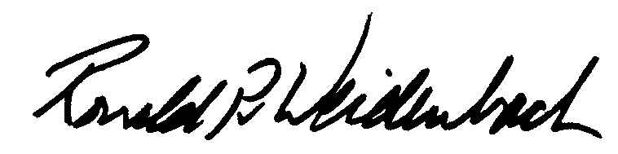
Ronald P. Weidenbach, HAAA President

