Attachment 3e
Household Interview Hand Cards

Table of Contents
Sample Person (SP) Hand Cards 2
Family Hand Cards 60

Sample Person (SP) Hand Cards

SP Hand Cards; 7/1/2018
Introductory Hand Card
Suggested script: (example)
During the interview, I will ask if I can see the containers for all the dietary supplements and prescription medication (you take/SP NAME takes) to enter them in my computer. To save time, would you please collect the containers for all of the items in this list that you take, while I set up my computer for the interview? Thank you. (Present the laminated card to the SP or proxy)

(Laminated card for participants 2 years and older)

Containers from past 30 days

Vitamins, minerals, herbals, or other dietary supplements

Antacids

Prescription medications

(Laminated card for participants 0-24 months)

Containers from past 2 weeks
Infant formulas
Toddler formulas

Containers from past 30 days
Vitamins, minerals, herbals, or other dietary supplements

Antacids

Prescription medications

MCQ1

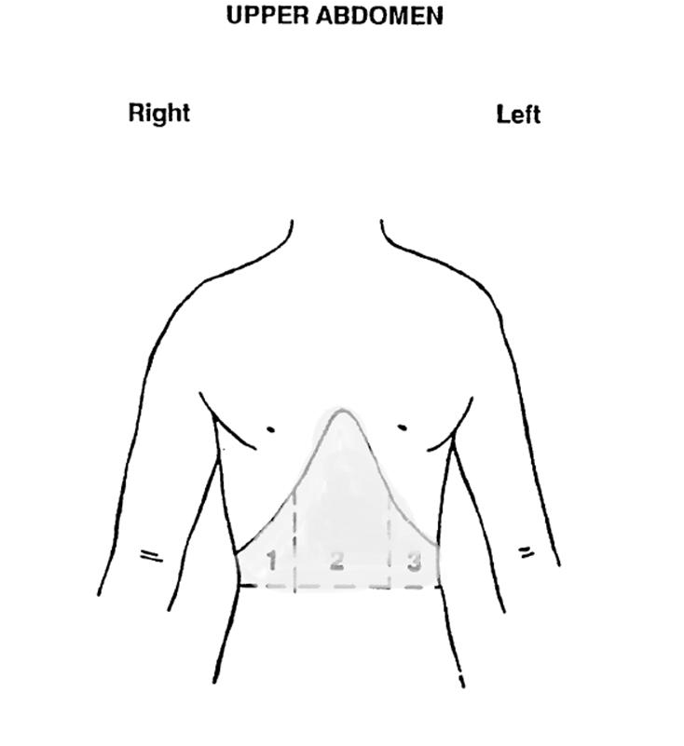

MCQ2

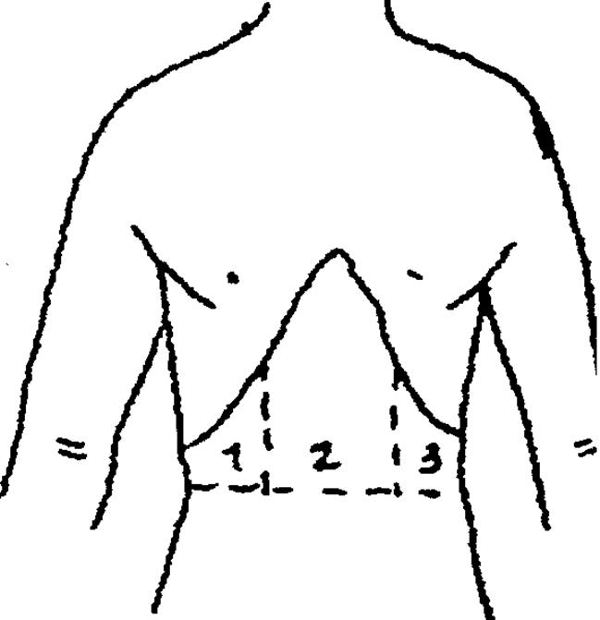

FNQ1

No difficulty

Some difficulty

A lot of difficulty

Cannot do at all

FNQ2

Some difficulty

A lot of difficulty

Cannot do at all

FNQ3

No difficulty

Some difficulty

A lot of difficulty

Cannot do at all

OSQ3

Hip replacement

Knee replacement
Plates or pins to fix a broken bone
Dental implants (posts)
Metal sutures or clips Stents
Pacemakers

HEQ1

Prescribed Medicines for Hepatitis B

Adefovir

Alinia

Baraclude Entecavir

Epivir

Epivir HBV

Hepsera
Interferon / Peginterferon
Intron A
Lamivudine
Nitazoxanide
Olysio (simeprevir) Pegasys
Pegintron
Roferon-A
Sovaldi (sofosbuvir) Telbivudine
Tenofovir
Tyzeka
Vemlidy
Viread

HEQ2

Prescribed Medicines for Hepatitis C
Alinia
Boceprevir
Copegus
Daklinza (Daclatasvir)
Epclusa
Harvoni
Incivek
Infergen
Interferon / Peginterferon
Intron A
Ledipasvir
Mayvret
Nitazoxanide
Olysio (simeprevir)
Pegasys
Pegintron
Rebetol
Rebetron
Ribapak
Ribasphere
Ribatab
Ribavirin
Roferon-A
Sovaldi (sofosbuvir)
Sylatron
Technivie
Telaprevir
Victrelis
Viekira Pak
Virazole
Vosevi
Zepatier
DLQ1

No difficulty
Some difficult
A lot of difficulty
Unable to do

DIQ1

Prediabetes

Impaired fasting glucose

Impaired glucose tolerance

Borderline diabetes

DIQ3

Less than 6
Less than 7
Less than 8
Less than 9
Less than 10
Provider did not specify a goal

CDQ1

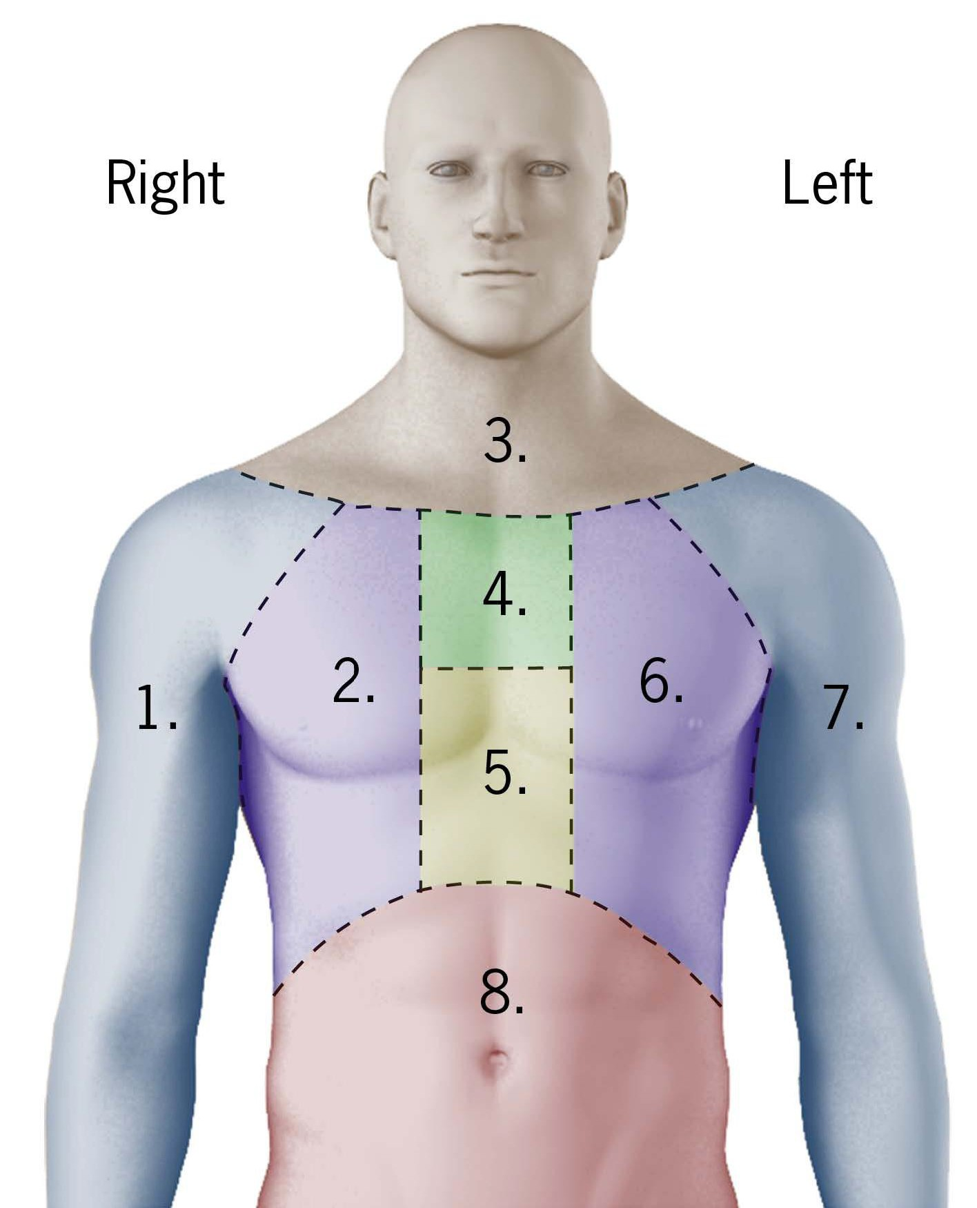

OSQ1
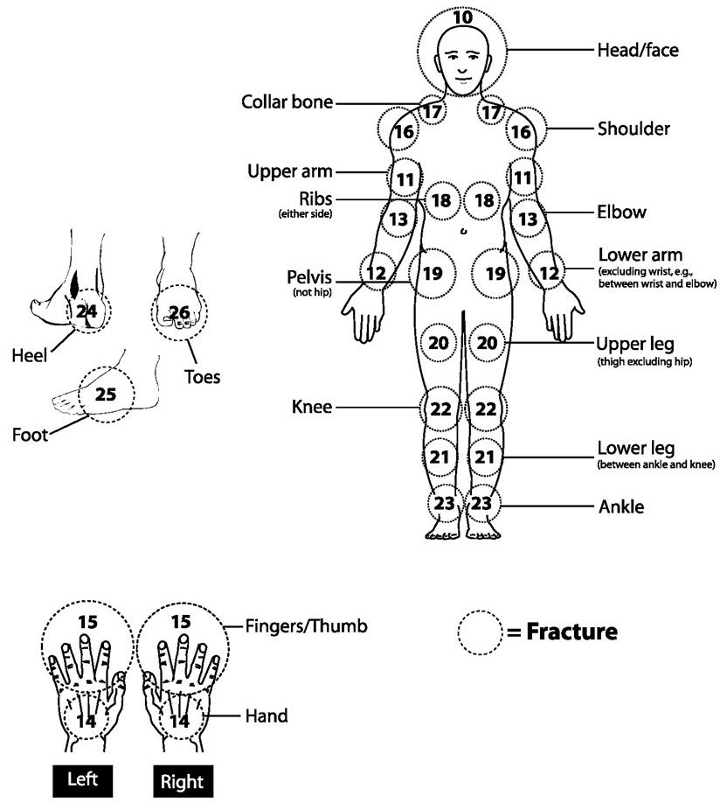

OSQ2

Prescribed Medicines for Osteoporosis

Fosamax, Alendronate
Boniva, Ibandronate
Actonel, Atelvia, Risedronate Reclast, Zoledronic acid
Fortical, Miacalcin, Calcitonin Evista, Raloxifene
Forteo, Teriparatide
Duavee, Bazedoxifene
Prolia, Denosumab

AUQ1

Genetic/hereditary causes

Ear infections (including fluid in ears)

Ear diseases (otosclerosis, menieres, tumor) Illness/infections (measles, meningitis, mumps) Drugs/medications
Head or neck injury/trauma

Loud brief explosive noise sounds

Noise exposure, long-term (machinery, etc.) Aging, getting older

AUQ2

Speech-language Reading
Hearing or listening skills Intellectual disability
Movement or mobility difficulties

Other developmental or disability problems

AUQ3

Always

Usually
About half the time Seldom
Never

AUQ4

Always

Usually
About half the time Seldom
Never
No noise exposure past 12 months

DEQ2

Always

Most of the time

Sometimes

Rarely

Never

OHQ1

Went in on own for check-up, examination or cleaning

Was called in by the dentist for check-up, examination or cleaning

Something was wrong, bothering or hurting

Went for treatment of a condition that dentist discovered at earlier check-up or examination

OHQ2

Could not afford the cost
Did not want to spend the money
Insurance did not cover recommended procedures
Dental office is too far away
Dental office is not open at convenient times Another dentist recommended not doing it
Afraid or do not like dentists
Unable to take time off from work
Too busy
I did not think anything serious was wrong/expected dental problems to go away

OHQ3

Very often

Fairly often Occasionally Hardly ever

Never

OHQ4

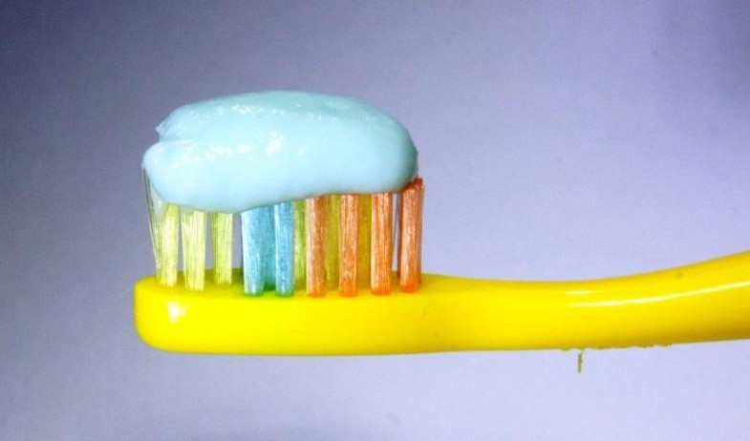
- Full load

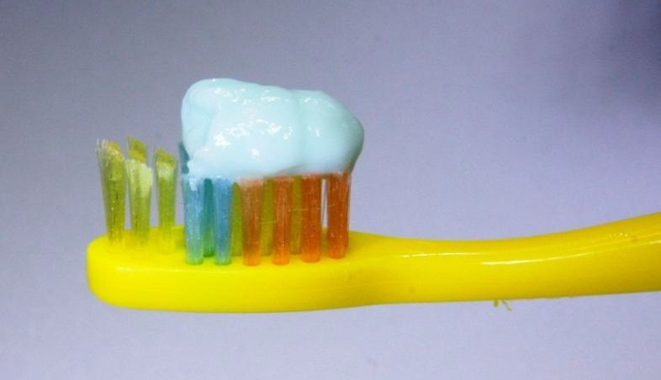
- Half load

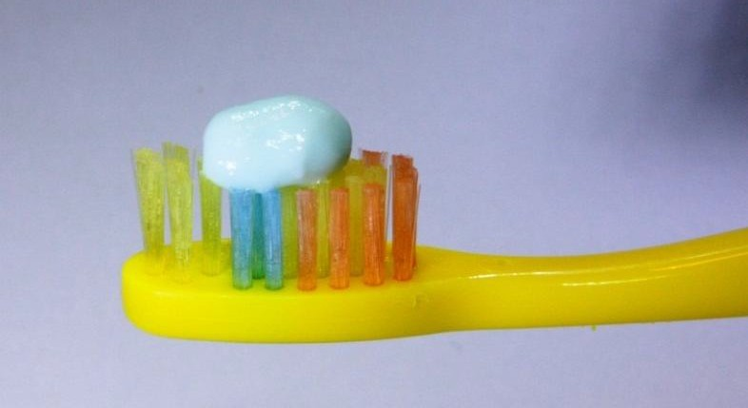
- Pea size

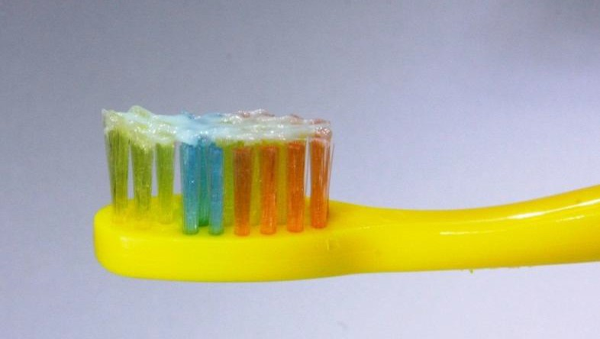
- Smear

BAQ 1

Getting up after sitting or lying down

Bending down or leaning over

Looking up or leaning head back

Looking at moving objects – passing traffic or a train

Being in a place with a lot of people moving around

Being in wide-open spaces

Motion sickness from riding in a car or moving vehicle

Quick head movement from side-to-side

Rolling over in bed

Standing on your feet for a long time

BAQ 2

Nausea or vomiting

Migraine or severe headache

Tinnitus (ringing, buzzing or roaring in ears or head)

Sinus congestion

Depression

Ear fullness, pressure or stuffed-up feeling, without pain

Hearing trouble (worse hearing)

BAQ 3

Anemia

Anxiety or panic attacks

Diabetes

Heart disease

Hormonal changes (including pregnancy)

Low blood pressure or hypotension

Low blood sugar or hypoglycemia

Stroke

None of these

BAQ 4

Auto-immune disease, such as rheumatoroid arthritis, lupus, sjogren’s

Benign positional vertigo (bpv or bppv)

Crystals—loose or dislodged in ear

Head or neck trauma or concussion

Inner ear infection, viral labrynthitis

Ménière’s (men-e-airz) disease

Migraines or headaches

Neurological condition, such as multiple sclerosis, parkinson’s

Side effects from medications, such as cancer treatments, antibiotics

None of these
BAQ 5

Exercises at home, which were not begun in a clinic

Exercises or physical therapy begun in a clinic

Bed rest for several hours or days

Head rolling or epley maneuver by a doctor or therapist

Steroid injections into the ear

Gentamicin (jen-tah-mi-sin) injections into the ear

Prescription medicines

Psychiatric or psychological treatment

Surgery to the ear

Some other type of surgery
None of these
BAQ 6

Over-the-counter medicines or drugs
Dietary restrictions: slow salt diet, avoiding certain foods or drinks, such as chocolate, coffee, or alcohol

Quitting or reducing use of tobacco or cigarettes

Massage therapy or chiropractic treatments or manipulations

Herbal remedy: feverfew leaf, ginger, ginkgo biloba, etc

Wearing magnets or acupressure wristband

Counseling or stress management

Acupuncture

None of these

BAQ 7

Anxiety or panic attacks

Auto-immune disease, such as rheumatoroid arthritis, lupus, sjogren’s

Cognitive problems, such as memory, attention, learning

Depression

Head injury or concussion

Heart rythem problems or heart failure

Migraine(s) or severe headaches

Numbness in the hands or feet lasting days or longer

Neurological disorder, such as parkinson’s, multiple scherosis, seizures

Severe head injury or concussion (with or without loss of consciousness)

No—none of these
SLQ1

Never

Rarely – 1 time a month
Sometimes – 2 to 4 times a month Often – 5 to 15 times a month
Almost always – 16 to 30 times a month

DEQ1

Always

Most of the time

Sometimes

Rarely

Never

DBQ2

Never
0-3 months
4-5 months
6-7 months
8-9 months
10-11 months
12 months or older

DBQ3
Nut butters
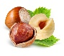
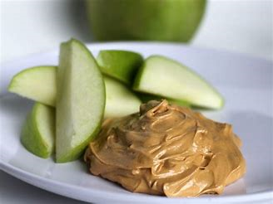
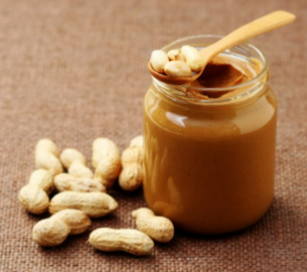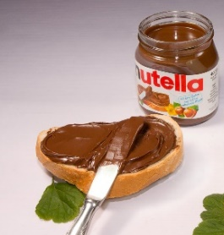
_________________________________________________
Nut and seed products
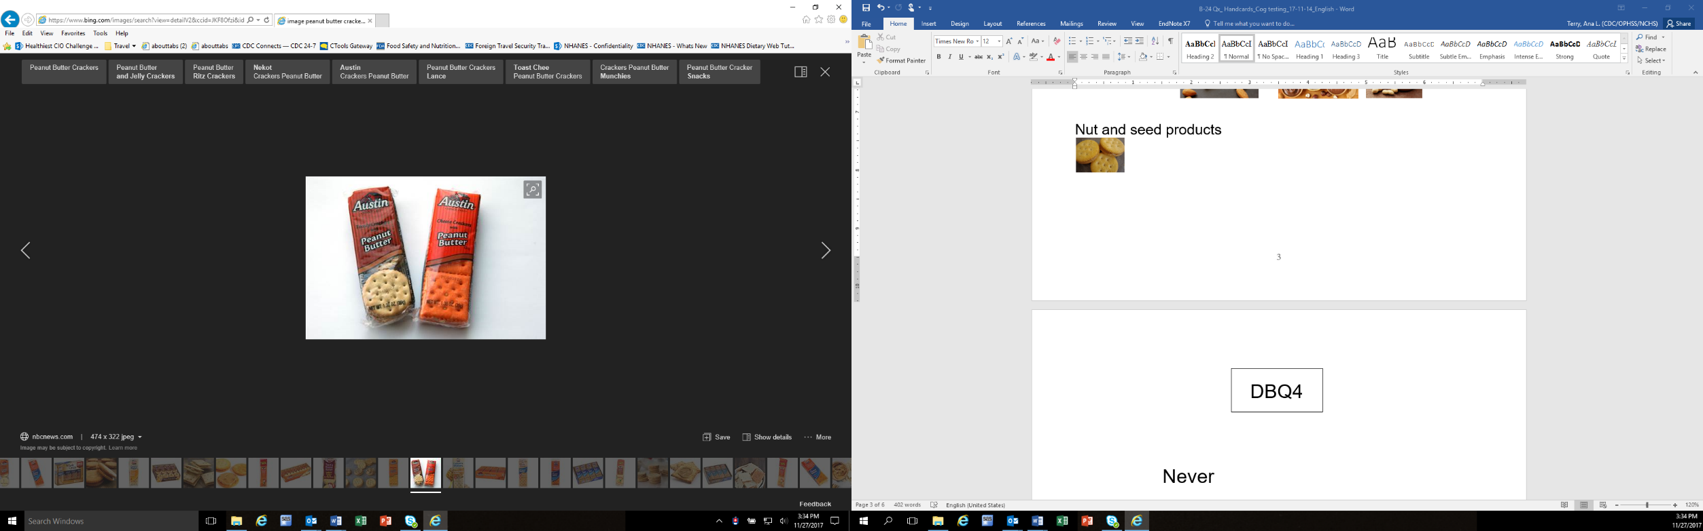
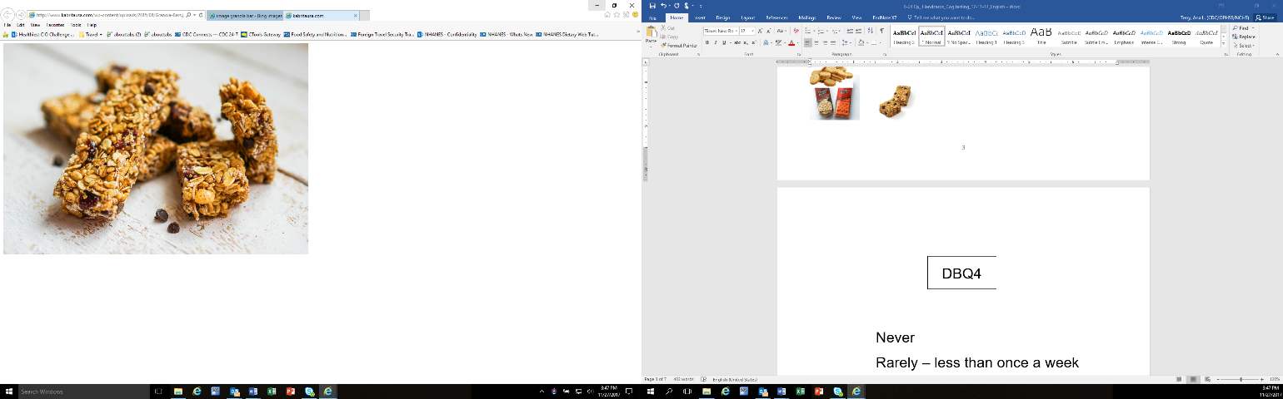
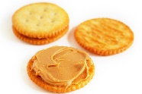

______________________________________________________
Nuts
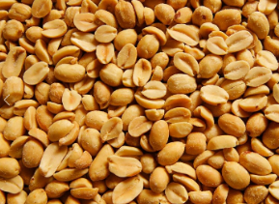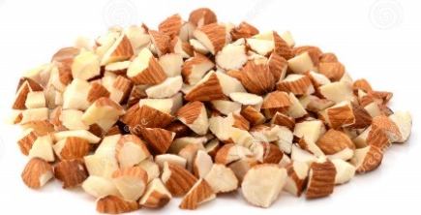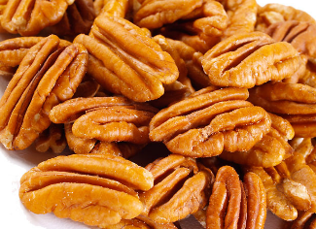
__________________________________________________
Seeds
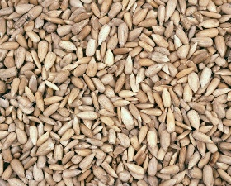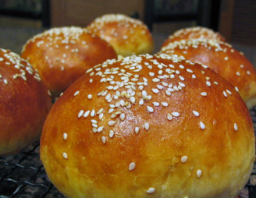

DBQ4

Never
Rarely – less than once a week
Sometimes – once a week or more, but
less than once a day
Often – once a day or more

DBQ5

A regular milk drinker for most or all
of lifetime, including childhood

Never has been a regular milk drinker

Milk drinking has varied over lifetime – sometimes has been a regular milk drinker and sometimes has not been a regular milk drinker

DBQ6

Never
Rarely – less than once a week Sometimes – once a week or more,
but less than once a day
Often – once a day or more

FSQ1

Child does not qualify for WIC (family income too high)
Child does not need WIC because family receives support from relatives or friends
Child does not need WIC because family receives support SNAP, a food bank, or another program
Never thought about applying for WIC
Parent/caregiver cannot find time to get to the WIC clinic
Parent/caregiver does not have transportation to get to WIC
The stores that accept WIC are not close to family’s home
WIC foods are difficult to find in the grocery store
Using WIC at the grocery store is uncomfortable
Another reason (describe)

FSQ2

Child no longer qualifies for WIC (family income too high)
Child no longer needs WIC because family receives support from relatives or friends
Child no longer needs WIC because family receives support from SNAP, a food bank, or another program
Parent/caregiver could not find time to go to the WIC clinic
Parent/caregiver could not find transportation to get to WIC
WIC clinic wait times were too long
The stores that accept WIC were not close to family’s home
WIC foods were difficult to find in the grocery store
Using WIC at the grocery store was uncomfortable
Checking out at the store with WIC foods took a long time
Child did not like the WIC foods
Another reason (describe)

DBQ74DBQ7

EXAMPLES OF FROZEN MEALS & FROZEN PIZZAS

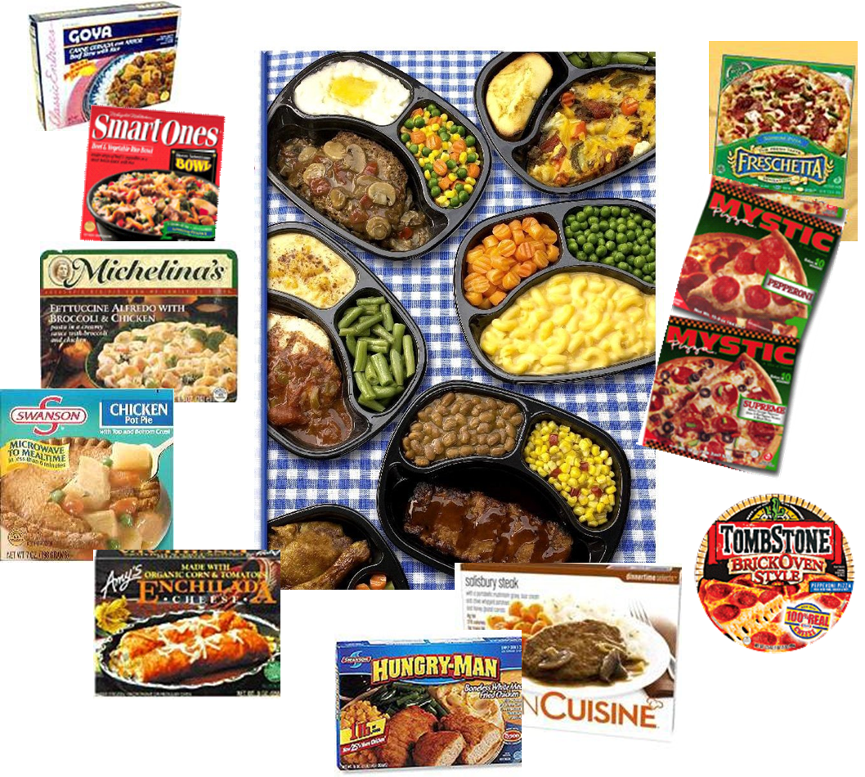

WHQ1

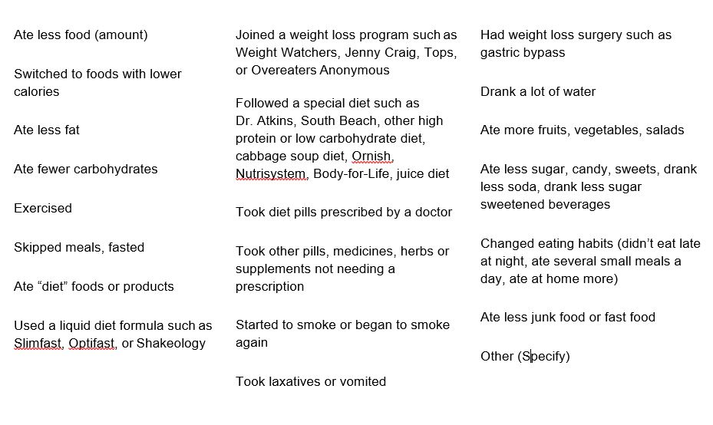

SMQ1
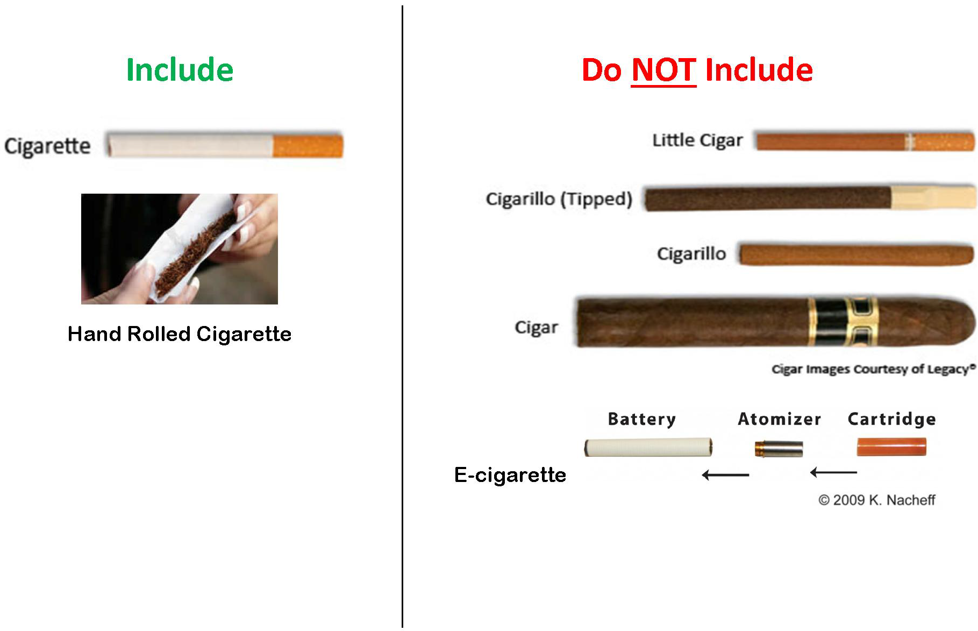

ACQ1

Only Spanish

More Spanish than English

Both equally

More English than Spanish

Only English

ACQ2

English

Chinese Farsi/Persian

Hindi

Japanese
Khmer/Cambodian Korean
Tagalog/Filipino
Urdu
Vietnamese Other

DMQ1

Never attended/kindergarten only
1st grade
2nd grade
3rd grade
4th grade
5th grade
6th grade
7th grade
8th grade
9th grade
10th grade
11th grade
12th grade, no diploma High school graduate GED or equivalent
Some college, no degree
Associate degree: Occupational, technical, or vocational program
Associate degree: Academic program
Bachelor’s degree (example: BA, AB, BS, BBA)
Master’s degree (example: MA, MS, MEng, MEd, MBA)
Professional school degree (example: MD, DDS, DVM, JD)
Doctoral degree (example: PhD, EdD)

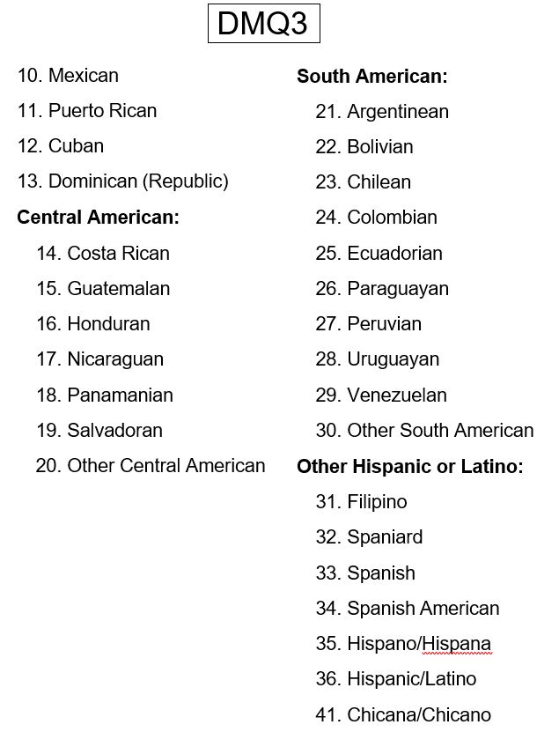

DMQ4

American Indian or Alaska

Native Asian
Black or African American

Native Hawaiian or Pacific Islander
White

DMQ5

  - Native Hawaiian

  - Guamanian or Chamorro

  - Samoan

  - Other Pacific Islander

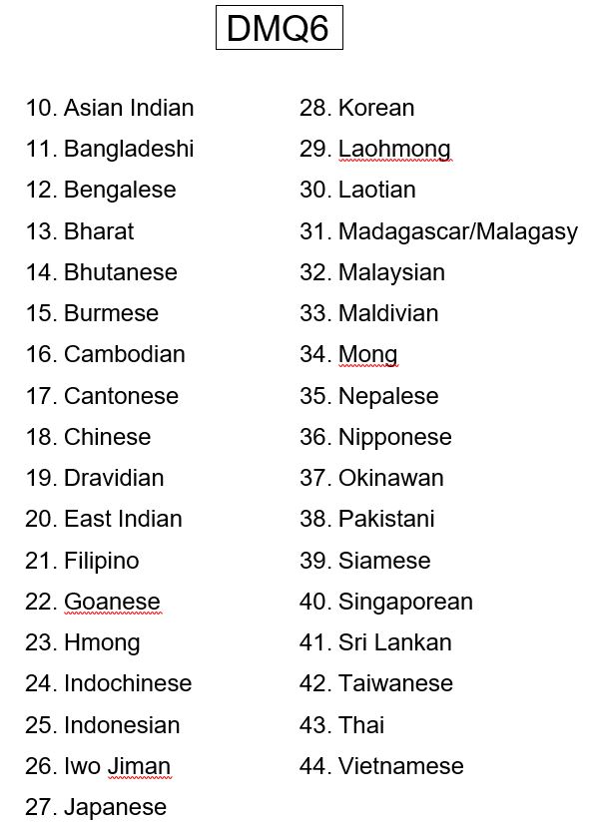

DMQ8

Examples of what we learned when matching NHANES data to other data sources such as Medicare and Medicaid:

  - How housing environment may affect the levels of lead in children’s blood
  - Higher vitamin D in the blood lowers the risk of broken bones
  - Consuming high amount of sugar can increase the risk of heart diseases
  - People who live or work with smokers have a higher risk of heart attack
  - Adults who exercise, eat healthy diets, and do not smoke have a lower chance of dying

HIQ1

Private health insurance

Medicare

Medi-gap

Medicaid

Children’s Health Insurance Program (CHIP)

Military Related Health Care: Tricare (CHAMPUS)/VA HEALTH CARE/ Champ-VA

Indian Health Service

State-sponsored health plan

Other government program

No coverage of any type

HIQ2

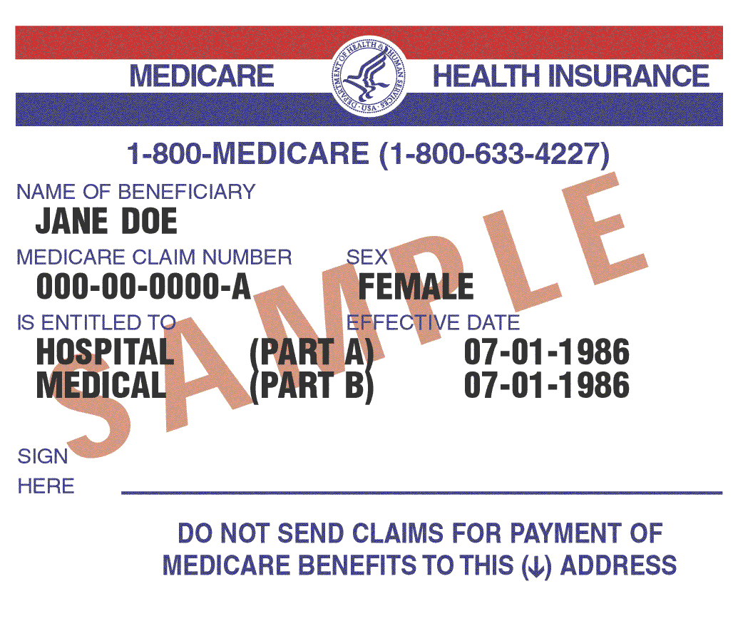

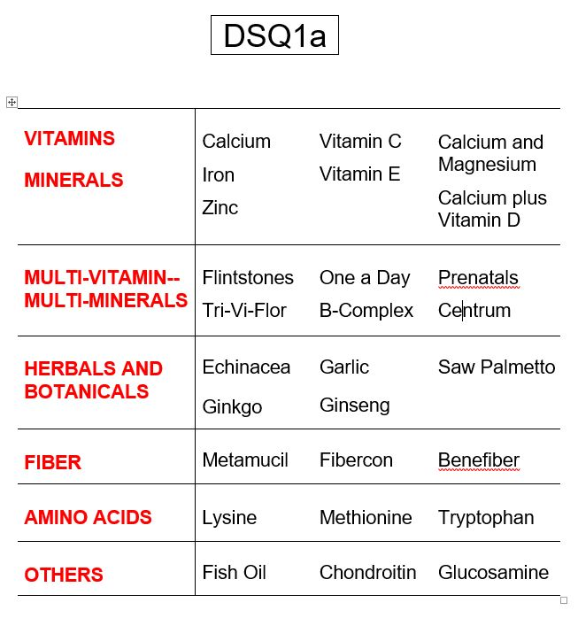

DSQ1b

EXAMPLES OF ANTACIDS

Tums
Rolaids Maalox Mylanta

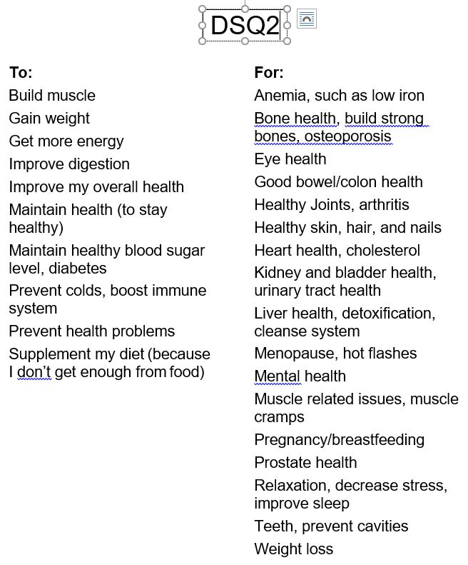

Family Hand Cards

DMQ1

Never attended/kindergarten only
1st grade
2nd grade
3rd grade
4th grade
5th grade
6th grade
7th grade
8th grade
9th grade
10th grade
11th grade
12th grade, no diploma
High school graduate
GED or equivalent
Some college, no degree
Associate degree: Occupational, technical, or vocational program
Associate degree: Academic program
Bachelor’s degree (example: BA, AB, BS, BBA)
Master’s degree (example: MA, MS, MEng, MEd, MBA)
Professional school degree (example: MD, DDS, DVM, JD)
Doctoral degree (example: PhD, EdD)

HOQ1

A one-family house detached from any other house
A one-family house attached to one or more houses
A building with 2 apartments
A building with 3 or 4 apartments
A building with 5 to 9 apartments
A building with 10 to 19 apartments
A building with 20 to 49 apartments
A building with 50 or more apartments

A mobile home, trailer, or manufactured home
A dormitory or similar boarding house

HOQ2

Brita or other pitcher water filter
Ceramic or charcoal filter
Water softener
Aerator
Reverse osmosis

CBQ1

EXAMPLES OF PLACES OTHER THAN GROCERY STORES

Convenience Stores (7-11, Mini Mart)

Wholesale Stores (Costco, Sam’s Club,
BJ’s)

Target/ Wal-Mart/ Kmart

Dollar Store

Bakeries

Meat Markets

Vegetable stands

Farmer’s Markets

INQ1

U. | $20,000 - $20,999 | JJ. | $35,000 - $39,999
V. | $21,000 - $21,999 | KK. | $40,000 - $44,999
W. | $22,000 - $22,999 | LL. | $45,000 - $49,999
X. | $23,000 - $23,999 | MM. | $50,000 - $54,999
Y. | $24,000 - $24,999 | NN. | $55,000 - $59,999
Z. | $25,000 - $25,999 | OO. | $60,000 - $64,999
AA. | $26,000 - $26,999 | PP. | $65,000 - $69,999
BB. | $27,000 - $27,999 | QQ. | $70,000 - $74,999
CC. | $28,000 - $28,999 | RR. | $75,000 - $79,999
DD. | $29,000 - $29,999 | SS. | $80,000 - $84,999
EE. | $30,000 - $30,999 | TT. | $85,000 - $89,999
FF. | $31,000 - $31,999 | UU. | $90,000 - $94,999
GG. | $32,000 - $32,999 | VV. | $95,000 - $99,999
HH. | $33,000 - $33,999 | WW. | $100,000 and over
II. | $34,000 - $34,999

INQ2

A. | Less than $1,000 | K. $10,000 - $10,999
B. | $1,000 - $1,999 | L. $11,000 - $11,999
C. | $2,000 - $2,999 | M. $12,000 - $12,999
D. | $3,000 - $3,999 | N. $13,000 - $13,999
E. | $4,000 - $4,999 | O. $14,000 - $14,999
F. | $5,000 - $5,999 | P. $15,000 - $15,999
G. | $6,000 - $6,999 | Q. $16,000 - $16,999
H. | $7,000 - $7,999 | R. $17,000 - $17,999
I. | $8,000 - $8,999 | S. $18,000 - $18,999
J. | $9,000 - $9,999 | T. $19,000 - $19,999

INQ3

Cash
Checking account Saving accounts
CDs (Certificates of deposit)
Retirement accounts (such as IRAs, 401K, etc.) Stocks
Bonds Mutual funds

INQ4

A: $0 - $3,000

B: $3,001 - $5,000
C: $5,001 - $10,000
D: $10,001 - $15,000 E: $15,001 - $20,000

Cash
Checking account Saving accounts
CDs (Certificates of deposit)
Retirement accounts (such as IRAs, 401K, etc.) Stocks
Bonds
Mutual funds

INQ5

In my car

In a car that belongs to someone I live with

In a car that belongs to someone who lives
elsewhere

Walk

Ride bicycle

Bus, subway or other public transit

Taxi or other paid driver

Someone else delivers groceries

Other

FSQ1

Often true

Sometimes true

Never true

