Attachment 3k

Hand Card Booklet Title Page
Hand Card
Booklet

5/3/2018

Hand Card 1

Fast-food or pizza places
Restaurants with waiter or waitress service
All-you-can-eat buffets
Places that sell mostly beverages such as a coffee shop or juice bar
Movie theaters, sports arenas, or other places of recreation
Grocery stores
Convenience stores

Hand Card 2

- Less than 500 Calories
- 500-1000 Calories
- 1001-1500 Calories
- 1501-2000 Calories
- 2001-2500 Calories
- 2501-3000 Calories
G. More than 3000 Calories

Hand Card 3

Always
Most of the time
Sometimes
Rarely
Never

Hand Card 4

Sample health claim in food labels
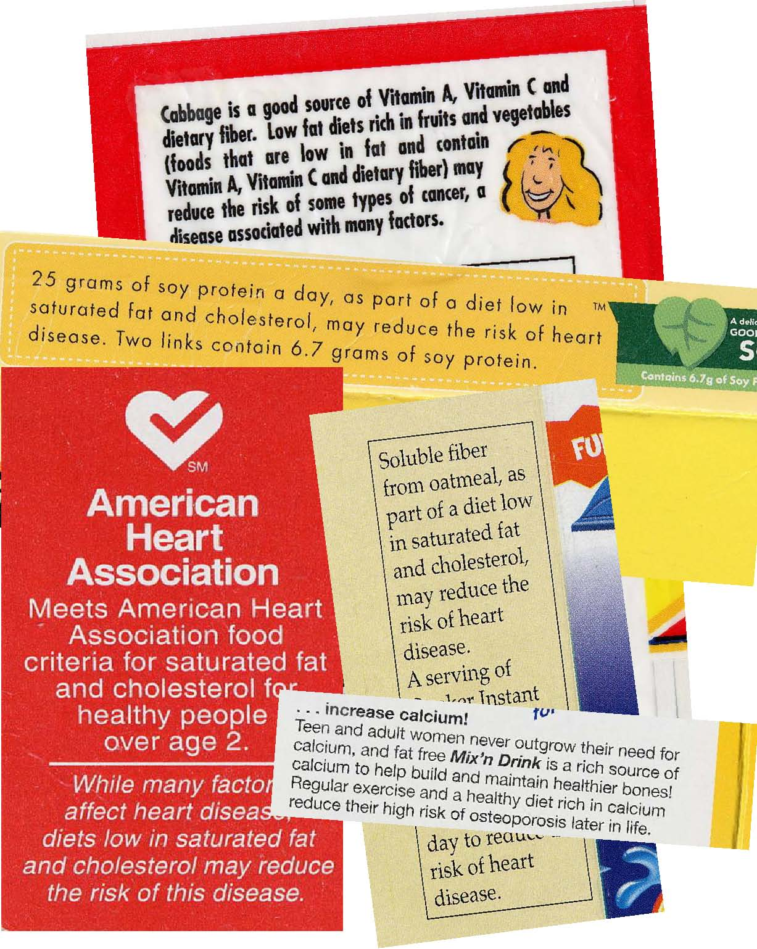
Low fat diets rich in fruits and vegetables (foods that are low in fat and contain Vitamin A, Vitamin C
and dietary fiber) may reduce the risk of some types of cancer, a disease associated with many factors.

Hand Card 5

Always
Most of the time
Sometimes
Rarely
Never

Sample Food Label

Hand Card 6

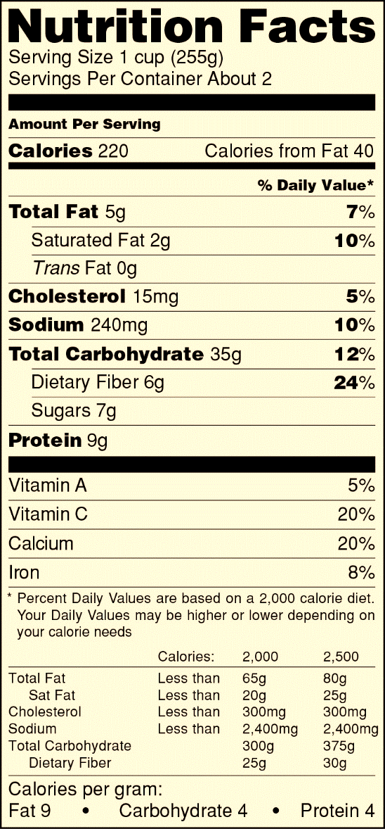
Nutrition Facts Panel

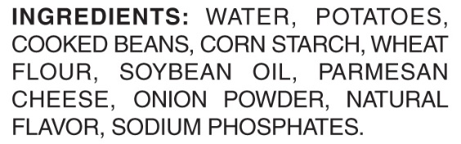

Hand Card 6

Always
Most of the time
Sometimes
Rarely
Never

Hand Card 7

Hand Card 8

Sample Food Label

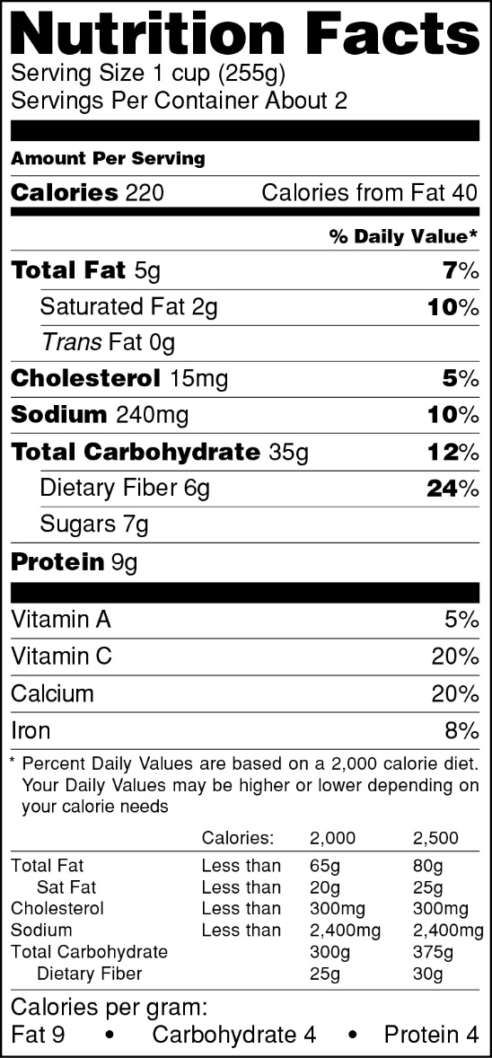

List of Ingredients

Hand Card 9

Always
Most of the time
Sometimes
Rarely
Never

Hand Card 10

Sample Food Label

Serving Size

Hand Card 11

Always
Most of the time
Sometimes
Rarely
Never

Hand Card 12

Sample Food Label

Number of servings per package

Hand Card 13

Always
Most of the time
Sometimes
Rarely
Never

Hand Card 14

Sample Food Label

Footnote

Hand Card 15

Always
Most of the time
Sometimes
Rarely
Never

Hand Card 15

Hand Card 16

Sample Food Label

Percent
Daily Value

Hand Card 17

Always
Most of the time
Sometimes
Rarely
Never

Hand Card 18

Hand Card 18

Sample Food Label

Amount of the nutrient
Percent
Daily Value

Hand Card 19

When deciding to buy a food product, between the percent daily value and the amount of nutrients on a food label

I use….

- Only percent daily value

- Percent daily value more often

- Both percent daily value and the amount of nutrients about the same

- The amount of nutrients more often

- Only the amount of nutrients

Hand Card 20

Sample Food Label

Percent
Daily Value

Amount of the nutrient

Hand Card 21

When deciding to buy a food product, between the percent daily value and the amount of nutrients on a food label

I use….

- Only the amount of nutrients

- The amount of nutrients more often

- Both the amount of nutrients and percent daily value about the same

- Percent daily value more often

- Only percent daily value

Hand Card 22

Sample Food Label

Hand Card 23

5 percent of the calories in one serving of the product come from Vitamin A

One serving of the product contains 5 percent Vitamin A by weight

One serving of the product supplies 5 percent of the Vitamin A you should have in a day

Hand Card 24

Sample Food Label

Hand Card 25

One serving of the product supplies 5 percent of the Vitamin A you should have in a day

One serving of the product contains 5 percent Vitamin A by weight

5 percent of the calories in one serving of the product come from Vitamin A

Hand Card 26

Sample Food Label

Hand Card 27

Always
Most of the time
Sometimes
Rarely
Never

Hand Card 28

Sample Food Label

Hand Card 29

Always
Most of the time
Sometimes
Rarely
Never

Hand Card 30

Sample Food Label

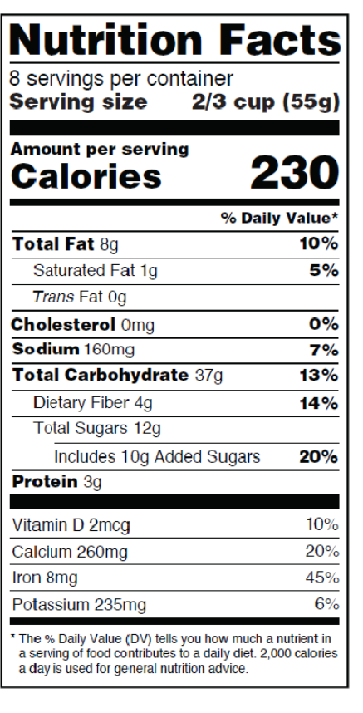

Hand Card 31

Always
Most of the time
Sometimes
Rarely
Never

Hand Card 32

Sample Food Label

Hand Card 33

Always
Most of the time
Sometimes
Rarely
Never

Hand Card 32

Hand Card 34

Sample food label with two columns
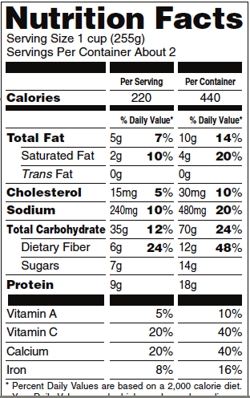

Hand Card 35

Always
Most of the time
Sometimes
Rarely
Never
Never seen

Hand Card 36

The reason(s) that I check the food label when deciding to buy a food product is/are…
- To watch my weight/lose weight
- A family member is trying to watch weight/lose weight
- To watch for diabetes, high triglycerides, high cholesterol, high blood pressure or other health conditions
- A family member has a health condition (for example, diabetes, high triglycerides, high cholesterol, high blood pressure, etc)
- I am allergic to certain food(s)
- A family member has food allergies
- To avoid certain ingredients (such as MSG, high fructose corn syrup, color dyes, artificial preservatives, or hydrogenated oils, etc)
- To increase certain nutrients in my/family’s diet (such as fiber, calcium, etc)
- To compare which brand/food is better/healthier
- To make better/healthier choices for me/my family
- To watch for calorie content or certain nutrients (such as sodium, trans fat, sugar, carbohydrates, or protein, etc.)
- Other (please specify)

Hand Card 37

The reason(s) that I check the food label when deciding to buy a food product is/are…
- To compare which brand/food is better/healthier
- To make better/healthier choices for me/my family
- To avoid certain ingredients (such as MSG, high fructose corn syrup, color dyes, artificial preservatives, or hydrogenated oils, etc)
- A family member has a health condition (for example, diabetes, high triglycerides, high cholesterol, high blood pressure, etc)
- I am allergic to certain food(s)
- A family member has food allergies
- To watch for diabetes, high triglycerides, high cholesterol, high blood pressure or other health conditions
- To increase certain nutrients in my/family’s diet (such as fiber, calcium, etc)
- To watch my weight/lose weight
- A family member is trying to watch weight/lose weight
- To watch for calorie content or certain nutrients (such as sodium, trans fat, sugar, carbohydrates, or protein, etc.)
- Other (please specify)

Hand Card 38

The reason(s) that I rarely or never check the food label when deciding to buy a food product is/are…

- I don't have the time
- The print is too small for me to read
- I’m satisfied with my health so there is no need for me to check
- I have a good diet so there is no need to check labels
- I usually buy foods that I'm used to, so I don’t feel that I need to check labels
- I buy what I/my family like, I don’t care about the labels
- I don’t think the food labels are important to me
- I won’t know what to look for even if I read the labels
- I can’t read English that well
- Other (please specify)

Hand Card 39

The reason(s) that I rarely or never check the food label when deciding to buy a food product is/are…

- I don't have the time
- I won’t know what to look for even if I read the labels
- I’m satisfied with my health so there is no need for me to check
- I can’t read English that well
- I have a good diet so there is no need to check labels
- I buy what I/my family like, I don’t care about the labels
- I don’t think the food labels are important to me
- The print is too small for me to read
- I usually buy foods that I'm used to, so I don’t feel that I need to check labels
- Other (please specify)

Hand Card 40

Sample Food Label

Serving Size

Hand Card 41

Serving size is...

The amount of this food that people should eat

The amount of this food that people usually eat

Something that makes it easier to compare foods

Hand Card 42

Sample Food Label

Serving Size

Hand Card 43

Serving size is...

The amount of this food that people usually eat

The amount of this food that people should eat

Something that makes it easier to compare foods

