Attachment 16

Report of Findings

Attachment 16 - Reports of Findings

The contractor’s advance arrangements team will contact county health officials and other community groups at each survey location to obtain lists of health clinics and/or doctors that are both acceptable and accessible to survey participants who do not have a source of health care.

There will be three circumstances in which communication between NCHS and a sample person and possibly source of health care will be made, based on the importance of the survey findings. This discussion describes three levels of referrals.

LEVEL I

A Level I referral is made in situations in which a medical emergency is discovered by a member of the NHANES exam team and verified by the staff physician, who further determines that the medical findings require immediate attention by a health care provider.

An emergency medical kit will be kept in each MEC so that emergency aid can be provided when necessary to stabilize the individual’s health status. The preferred manner of handling medical emergencies that occur at the examination center will be to contact local rescue squads, ambulance services and hospital emergency rooms. Contact information for all of these groups is kept at the NHANES examination centers. Level I contacts with a health care provider on behalf of a sample person occur infrequently.

An in-house NCHS response team is available to answer calls from NHANES participants regarding the results from the Report of Findings System. The response team effort works both as a triage mechanism and a surveillance system. A receipt and control record is kept on all sample person inquiries. Also available at no cost to sample persons, is a toll-free telephone number which can be accessed during normal business hours. The response team members consist of a physician and other staff who are Health Educators and have been trained to answer specific questions. Attachment 16-1 is used for MEC exams in which a participant refuses further medical attention.

LEVEL II

Level II contacts occur frequently. An example of a Level II contact is when the examination center staff determines that there are major medical findings that can be expected to cause adverse effects within two or three weeks. When such a condition is identified based upon the information collected during the survey, the NHANES physician will do the following: explain the health concern to the participant, provide the participant with a written report of the findings, and encourage the respondent to see their personal medical provider within the next two weeks. If the survey participant does not have a health care provider or usual source of health care, the NHANES physician will assist the participant by reviewing the list of health care providers that are listed on the referral list for their community. The same procedure will be used for referrals that are needed for oral health care.

A second type of Level II contact occurs when abnormal findings are reported by a contract laboratory or consultant reviewing the examination data for a particular component off-site. The consultant or laboratory will contact NCHS staff immediately. The survey participant will be notified by mail (see Level II letter - Attachment 16-2). The letter will describe the findings and will encourage the survey participants to see medical care from their personal health care provider. This type of Level II contact with a sample person can occur as early as several days after the exam, but usually within two to three weeks of it. Attachments 16-3 and 16-4 shows other examples of a Level II report.

LEVEL III

Level III refers to the routine Report of Findings that are sent to all examinees whether or not any extremely abnormal findings were present. The Report does not include the results of every test and exam that was performed but it will include a complete summary of findings that are of clinical interest (see Level III Routine Report of Findings – page 11). The Report will also remind the participant to consult their personal health care provider when the results include abnormal findings. The report includes height and weight results, and, depending on the age of the participant, blood pressure and the results from special studies and laboratory tests. The report packet will also contain the medical referral listing for the specific community and a list of health information resources. See Attachments 7a and 16-5 for the laboratory and examination results which will be given to survey participants.

For examinees under 18 years of age, the reports of findings will be given to their parents or guardians, except for the results of testing for sexually transmitted diseases.
16-1. NHANES MEC RELEASE FORM

Date ________________________

This is to certify that, against the advice of the medical doctor, I:

 am leaving the Mobile Exam Center.

 am removing ____________________________ from the Mobile (Name of Sample Person)

Exam Center.

 choose no further medical referral or follow-up.

By so doing, I assume all responsibility for my act.

_________________________ Signed

_________________________
Relationship

____________________________
Witness

SP ID _ _ _ _ _ _

Attachment 16-2 – Early Reporting Letter – General laboratory

NHANES Early Reporting Letter Example

Sample person name
Address

Telephone number
Sample Number:

Dear,

Recently, you participated in a voluntary health examination at special mobile facilities operated by the National Center for Health Statistics, part of the Centers for Disease Control and Prevention. We reviewed your test results from your examination on <insert date>, and found that some values were abnormal and require your immediate attention.

We cannot be sure whether or not these test results represent illness. Only your doctor can determine that. We strongly recommend that you talk to your doctor and give him or her your test results on the enclosed sheet. He or she can evaluate your findings and help you understand what they mean for your health. The NHANES program will not pay for further tests or treatment you may require.

The examination was not intended to be a complete physical examination nor a substitute for a visit to a doctor. Our survey physicians are not authorized to administer treatment or engage in any follow-up with examinees.

You will receive a full report of your examination findings in the future, but we thought you should know about these results right away.

If you have any questions, you may call me at our toll-free number,
1-800-452-6115, between 8:30 AM and 6 PM Eastern Time, Monday through Friday.

Sincerely yours,

Duong T. Nguyen, DO
Senior Medical Officer

Enclosure

Laboratory

Test Result Units Flag Reference Range

Abnormal value(s)

Glucose 156 mg/dL High 60-109

Other values
Glycohemoglobin 6.8 % 0 -6.9
ALT 22 U/L 0 -31
AST 26 U/L 0 -31
Alkaline Phosphatase 41 U/L 39-117
Albumin 4.1 g/dL 3.2 -5.2
Bicarbonate 24 mmol/L 22-29
BUN 8.0 mg/dL 6.0 -19.0
Calcium 9.4 mg/dL 8.4 -10.2
Cholesterol 198 mg/dL 0 -199
Triglycerides 146 mg/dL 0 -149
HDL ^^^ mg/dL >= 40.0
LDL ^^^ mg/dL 0 -129
Serum Creatinine 0.8 mg/dL 0.4 -1.2
GGT 20 U/L 7-33
LDH 100 U/L 94.0 -250.0
Phosphorus 4.2 mg/dL 2.6 -4.5
Sodium 137 mmol/L 133.0 -145.0
Potassium 3.6 mmol/L 3.3 -5.1
Chloride 103 mmol/L 96.0 -108.0
Total Protein 6.8 g/dL 5.9 -8.4
Uric Acid 4.0 mg/dL 2.4 -5.7
Bilirubin 0.9 mg/dL 0 -1.0
Serum Folate ^^^ ng/mL 1.7 -20.6
RBC Folate ^^^ ng/mL RBC 70-424
Iron ^^^ ug/dL 22.0 -163.0
Serum Ferritin ^^^ ng/ML 15-570
Blood Lead ^^^ ug/dL 0 -20.0
Cadmium 0.4 μg/L 0.3 - 1.2
Total Blood Mercury 0.6 μg/L < 10.0

*** Test not done on this age group
^^^ Result still pending
--- Test not done
<< Lower than the limit of detection Number of hours fasted prior to blood draw: 6 hours

Attachment 16-3 – Early Reporting Letter – Hepatitis C

Sample person name
Address
Sample Number:

Date

Dear <insert name>,

Recently, you participated in a voluntary health examination at special mobile facilities operated by the National Center for Health Statistics, part of the Centers for Disease Control and Prevention. As part of this examination your blood was tested for hepatitis C virus. Your blood sample collected on <insert exam date>, indicates you were infected with the hepatitis C virus even though you may never have felt sick.

If no one has told you before that you have the virus, we strongly recommend you take this letter to your doctor as soon as you can. You will want to talk with your doctor about possible treatment for hepatitis C and how to prevent spreading the disease to other people. Your doctor may want to do more tests to find out if the virus has done any damage to your liver.

Almost four million Americans are infected with hepatitis C virus. Most persons who are infected carry the virus for the rest of their lives. The infection can lead to liver damage, although many people with the virus never feel sick. We have enclosed a fact sheet with information on hepatitis C. You may obtain other information on hepatitis C by calling toll free:

American Liver Foundation 1-800-223-0179
Hepatitis Foundation International 1-800-891-0707
Centers for Disease Control and Prevention 1-888-4HEPCDC
or the CDC web site: http://www.cdc.gov/hepatitis

We want to give you this important information and urge you to see your doctor. The NHANES program will not pay for any follow-up tests or care you may require, but we will be available to talk with you or your physician about this letter and to answer any questions you may have. You can reach me on our toll-free number 1-800-452-6115 between 9 AM and 6 PM Eastern Time, Monday through Friday.

Sincerely yours,
Duong T. Nguyen, DO
Senior Medical Officer

Enclosure

Enclosure:

http://www.cdc.gov/hepatitis/hcv/pdfs/hepcgeneralfactsheet.pdf
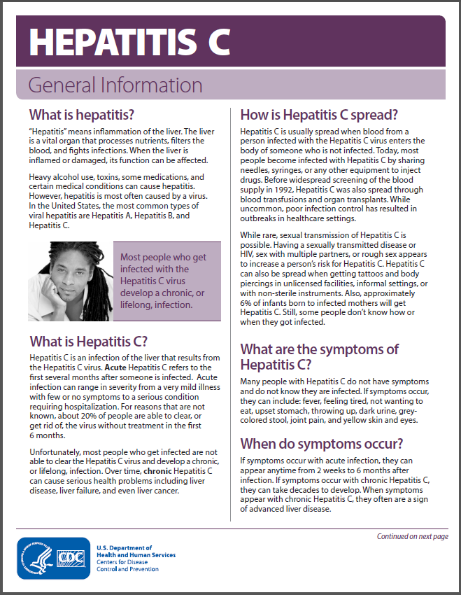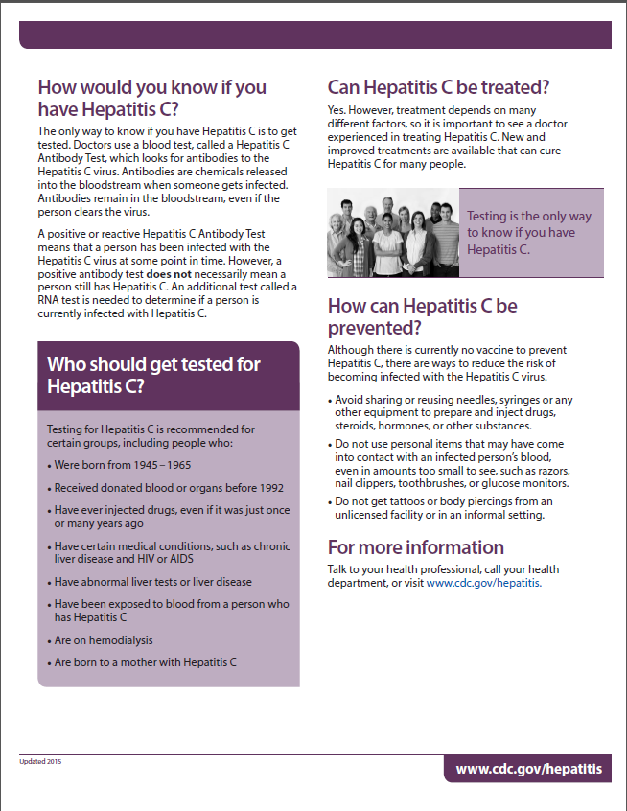

Attachment 16-4

{NCHS/NHANES Letterhead}

Date

Dear Parent/guardian,
Recently, your child participated in the National Health and Nutrition Examination Survey conducted by the National Center for Health Statistics, part of the Centers for Disease Control and Prevention. We reviewed your child’s test results from your examination on <insert date>, and found that some values were abnormal and require your immediate attention.

As part of this examination your child’s blood was tested for cytomegalovirus (CMV) infection. Your child’s blood sample collected on <insert exam date>, was positive for CMV infection.
CMV is a very common infection that most people get. Once a person is infected with CMV, the virus stays in their body for life. Nearly all healthy children infected with CMV have no symptoms and parents will likely not even know that their child has been infected. If your child has serious medical problems including a weakened immune system, CMV can cause more serious problems and we recommend you take this letter to your doctor.
Although CMV infection will not likely harm your child, children with a CMV infection can pass the infection to pregnant women. If a woman gets a new infection while pregnant, her baby can be harmed. If your child has CMV and you are pregnant or planning to get pregnant, we recommend you learn about CMV. There are simple steps you can take to lower your risk of infection at this website http://www.cdc.gov/cmv/index.html. You may also call the number below for this information.

The NHANES program will not pay for any follow-up tests or care you may require, but we will be available to talk with you or your physician about this letter and to answer any questions you may have. You can reach me on our toll-free number 1-800-452-6115 between 8:30 AM and 5:30 PM Eastern Time, Monday through Friday.

Sincerely yours,

Duong T Nguyen, DO
Senior Medical Officer

Enclosure

Cytomegalovirus Fact Sheet
Am Fam Physician. 2003 Feb 1;67(3):526.

What is cytomegalovirus?
Cytomegalovirus (say: “si-toe-meg-ah-low-vi-russ”) or CMV is a virus that infects cells and causes them to become enlarged. Many people are infected with CMV and don't even know it. People are usually infected by the time they are two years old or during their teenaged years. CMV usually causes no long-term problems. However, CMV can cause problems in a newborn if the mother gets the infection during pregnancy.
CMV is only spread through contact with an infected person's body fluids (such as saliva, blood, urine, semen, or breast milk). It can also be sexually transmitted. Careful handwashing with soap and water can help prevent the spread of CMV.

What are the symptoms of CMV?
Usually, there are no symptoms. A few people will have symptoms that are similar to mononucleosis (such as a sore throat, fever, headache, and being tired). People who have weakened immune systems because of human immunodeficiency virus (HIV) or because they received an organ transplant may have severe symptoms.

How will my doctor know if I have CMV?
Because usually there are no symptoms, your doctor won't know that you have CMV. If you do have symptoms, your doctor may test your blood to look for CMV. People who have HIV should be seen by an eye doctor as recommended by their doctor to make sure the virus hasn't infected their eyes. Also, people with HIV should let their doctor know if they are having any painless blurring of their vision, “floaters” only in one eye, light flashes, areas of blindness, and shortness of breath.

Is there a treatment for CMV?
There is no vaccine for CMV. Because CMV is a virus, antibiotics won't work. If your body's immune system is normal, your body should be able to control the infection. If your immune system is weakened, your doctor may use one of several different medicines to treat CMV infection.

Attachment 9-5 – Final Report of Finding
These measurements were obtained as part of a survey and do not represent a medical diagnosis. Interpretation of these measurements must be made by a physician.

Date of Examination: January 1, 2017
Participant Name: John Q. Public
Participant Age: xxx
Participant Gender: Male
SP ID: 123456

Body Measurements

Height: 5 ft. 8 in

Weight: 174 lbs.

Body Mass Index (BMI) 26.5

For a person of your height, your weight is above the range of a healthy weight, and you may be overweight.

Waist circumference 37 in.

For men, a waist circumference greater than 40 inches is associated with an increased risk of health problems such as type 2 diabetes, high blood pressure, and cardiovascular disease. This is based on guidelines from the National Heart, Lung and Blood Institute, NIH, 1998.

Blood Pressure & Heart Rate

Normal
Systolic Blood Pressure: 128 mm Hg < 120
Diastolic Blood Pressure: 88 mm Hg < 80
Resting Pulse Rate: 64 bpm
Cuff Size: Adult

Your blood pressure today is within the normal range. Based on the Seventh Report of the Joint National Committee on the Prevention, Detection, Evaluation, and Treatment of High Blood Pressure. NIH Publication, 2003.

Oral Health

The dental examination you received today is not, and is not intended to be, a substitute for the examination usually given to persons seeking care from their own dentists. Neither a dental history nor x-rays are taken, and therefore the findings are solely the result of what can be seen at the time of the examination.

The examining dentist recommends that you: Should see a dentist within the next 2 weeks

The examining dentist observed the following conditions: Decayed Teeth
Gum disease/problems
Oral hygiene

Hearing

The softest sounds you are able to hear are called hearing thresholds. Your thresholds at different frequencies (pitches) are reported in the table below. The lower pitched sounds are towards the left of the table and the higher pitched sounds are toward the right. Values of 25 dB or less are considered normal hearing.

Hearing Levels by Ear and Frequency (Air Conduction)

 | Frequency (Hz)
 | 500 | 1000 | 2000 | 3000 | 4000 | 6000 | 8000
Right Ear (dB HL) | 0 | 0 | 5 | 5 | 5 | 15 | 30
Left Ear (dB HL) | 5 | 0 | 10 | 5 | 10 | 25 | 10

Your hearing was tested by a trained examiner. Results indicate a slight hearing loss (a few thresholds outside normal limits) in your right ear. In your left ear, results indicate that your hearing is entirely within normal limits.

Laboratory

Complete Blood Count Result Units Flag Reference Range

White Blood Count 7.4 (x10⁹/L) 3.9 - 12.1
Lymphocytes 23.5 (%) 17.8 - 52.8
Monocytes 7.2 (%) 0 - 12
Neutrophils 67.4 (%) 39.7 - 77.8
Eosinophils 1.9 (%) 0 - 8
Basophils 0.1 (%) 0 - 2
Red Blood Count 3.8 (x10¹²/L) 3.7 - 5.2
Nucleated Red Blood Count 0.0 /100 WBC 0.0 – 0.6
Hemoglobin 10.0 (g/dl) Low 10.4 - 15.2
Hematocrit 35.0 (%) 32 - 45
MCV 78.9 (fL) 73.4 - 98.3
MCH 28.9 (pg) 23.2 - 33.3
MCHC 32.2 (g/dL) 31.4 - 35.1
RDW 12.0 (%) 11.8 - 16.6
Platelet Count 217.0 (x10⁹/L) 172 – 453

Laboratory – Blood Tests

Laboratory Test Result Units Flag Reference Range

Glucose 96 mg/dL 60 - 109
Glycohemoglobin 5.3 % < 6.5
AL T 22 U/L < 40
AST 26 U/L < 31
Alkaline Phosphatase 41 U/L 39 - 117
Albumin 4.1 g/dL 3.2 - 5.2
Bicarbonate 24 mmol/L 22 - 29
BUN 8 mg/dL 6 - 19
Calcium 9.4 mg/dL 8.4 - 10.2
Cholesterol 246 mg/dL High < 200
Triglycerides 129 mg/dL < 150
HDL 107 mg/dL > 39
LDL 83 mg/dL < 130
Serum Creatinine 0.8 mg/dL 0.4 - 1.2
GGT 20 U/L 11 - 51
LDH 100 U/L 94 - 250
Phosphorus 4.2 mg/dL 2.6 - 4.5
Sodium 137 mmol/L 133 -145
Potassium 3.6 mmol/L 3.3 -5.1
Chloride 103 mmol/L 96 - 108
Total Protein 6.8 g/dL 5.9 - 8.4
Uric Acid 4.0 mg/dL 3.4 – 7.0
Bilirubin 0.9 mg/dL 0 -1.0
Serum Folate 9 ng/mL 2 - 21
RBC Folate 245 ng/mL RBC 70 - 424
Blood Lead 1.7 μg/dL 0 - 20
Cadmium <<< μg/L 0.3 - 1.2
Manganese 4.2 μg/L 4-15
Selenium 76 μg/dL 104-187
Copper 122 μg/dL 70-140
Zinc 113 μg/dL 80-120
Total Blood Mercury 0.6 μg/L < 10.0
Fluoride 3.00 mmol\L 0.50-4.00

^^^ Results Still Pending
--- Test not done
<<< Lower than the limit of detection
<<< Above the limit of detection Number of hours fasted prior to blood draw: 12 hours

Laboratory – Urine Tests

Result Units Flag Reference Range

Total Urinary Arsenic 6 μg/L <50

Albumin Creatinine Ratio – 1st collection 33 mg/g High < 30

Laboratory – Other Blood Tests

Kidney Health

Your kidneys filter your blood and help control blood pressure. We checked how healthy your kidneys are by doing a blood test that measures how much blood is being filtered. This test is called eGFR (estimated glomerular filtration rate).

Your estimated glomerular filtration rate (eGFR) was 121 mL/min/1.73m²

This indicates normal function.

Body Composition

Bone Density
The bone density measurement can help spot persons who may be at greater risk for fracture because they have weaker bones. In general, a lower bone density means that the bone is weaker. Yet, not all men or women with low bone density will have fractures.

The results from your hip (left or right) scan show:
Hip bone density 0.5980 g/cm2
T-score -2.30

Based on diagnostic criteria as recommended by the World Health Organization¹ and the International Society of Clinical Densitometry², your hip bone density is low.

The results from our spine (lumbar) scan show:
Spine bone density 0.7860 g/cm2
T-score -2.80

Based on diagnostic criteria as recommended by the World Health Organization¹ and the International Society of Clinical Densitometry², your spine bone density is very low.

Most people develop low bone density over many years. We recommend you discuss these results with your doctor as soon as possible, since fractures due to osteoporosis often occur at sites with very low bone density. Your doctor can review your diet and lifestyle and tell you what you can do to prevent more bone loss.

¹Kanis J, Melton LJ, Christiansen C, Johnstron C, Khaltaev N. The diagnosis of osteoporosis. J Bone Mineral Research 1994;9:1137-1141. http://onlinelibrary.wiley.com/journal/10.1002/(ISSN)1523-4681

² International Society for Clinical Densitometry. Official positions 2015 Adult and pediatric. Middletown CT http://www.iscd.org/official-positions/2015-iscd-official-positions-adult/

Liver Elastography

Liver elastography measures the stiffness of your liver. In general, having liver stiffness may indicate liver damage.

Information from your liver ultrasound exam showed a value of 2.50 kiloPascals (kPa).

A scoring system, was used to interpret your result. Using this recommended scoring system, the result showed you have little or no liver stiffness. No additional follow-up regarding this test is recommended at this time.

Published in GASTROENTEROLOGY 2005;128:343–350

Laboratory - Test on Water

Fluoride is added to public drinking water to prevent tooth decay. For information on community water fluoridation see: http://www.cdc.gov/fluoridation/fact_sheets

Tap water was collected from your home on December 1, 2017

The level of fluoride in your tap water was 1.00 mg/L.

Fluoride levels under 4 mg/L are considered to be safe, according to the U.S. Environmental Protection Agency (EPA). Fluoride levels over 2 mg/L may cause tooth discolorations.

If your water’s fluoride level is 4 mg/L or higher, we suggest you contact your water utility provider for more information. You can find the name and contact information of the water utility on your water bill.

Attachment 16-5. List of Exam Measurements Noting Which Results Will Be Given to
Respondent

Health Measurements:
*Blood Pressure
*Heart Rate
*Bone Density Measurement (low dosage x-ray of spine)
*Oral Health Exam
*Height, Weight, and Other Body Measures
*Liver Elastography

Laboratory Tests on Urine:
*Kidney Tests
*Pregnancy Test
*Sexually Transmitted Diseases (STDs)
*Exposure to environmental chemicals
*

Laboratory Tests on Blood:
*Sexually Transmitted Diseases (STDs)
*Anemia
*Cholesterol
*Glucose Measures
**Infectious Diseases
*Kidney Tests
**Environmental chemicals
*Liver Tests
*Nutritional Status
* Markers of immunization status
* Bone Status Test

Laboratory Tests on Swabs:
Human Papillomavirus (HPV)

Private Health Interviews:
Health Habits
Mental Health
Nutrition
Physical Activity
Reproductive Health
Sexual Experience

*You will receive results
**You will receive results only if abnormal
Attachment 16-6. Referral for participants who may have suicidal thoughts

Information volunteered or reported during the Depression Questionnaire can prompt a referral to the Mobile Examination Center (MEC) physician. MEC interviewers send a mental health observation to the physician if the participant’s response to question 05DPQ.090 is 1, 2 or 3 – or if the participant becomes visibly upset while answering the question about suicide. The system will alert the physician and coordinator that the examinee needs to be seen by the physician prior to leaving the exam center. The physician is responsible for assessing the mental health concern and facilitating referral as needed.

As evidenced by the presence of CMV IgM and IgG antibodies.

