OMB CLearance: Summarized discussion of form revisions
As discussed at the April 10th meeting with OCS, NASCSP and OCS will put forward only technical changes to Modules 1-4 of the CSBG Annual Report for inclusion in an OMB Clearance package. The projected approval date is January 15, 2020. This document outlines the proposed changes for each Module of the CSBG Annual Report for the upcoming OMB Clearance process.

Proposed changes: General technical changes
The OMB Clearance should:
- Include Numbering in forms submitted in the Clearance Package
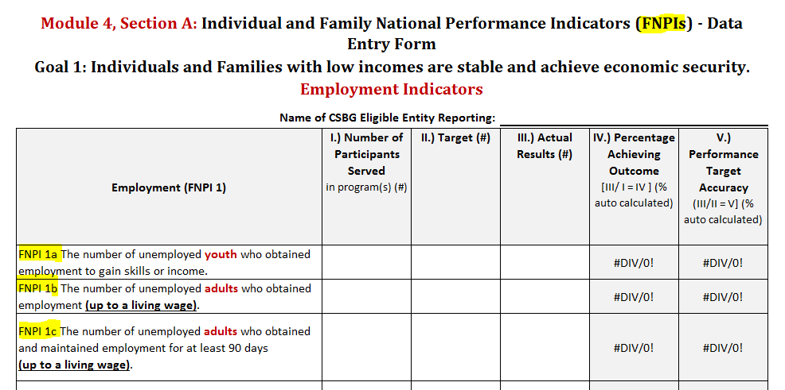
- Correct typos
  - FNPI Xz.x: remove the word “households” from each “other” indicator; example:
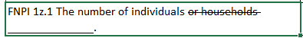
  - FNPI 4: Remove “households” from each FNPI 4 indicator and replace with the word “individuals”.
  - FNPI 4g: Correct “carbon dioxide” with “carbon monoxide”.
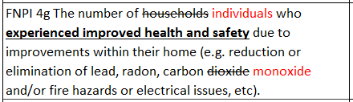
  - FNPI 5h: Correct typo by adding an “a” to the indicator.
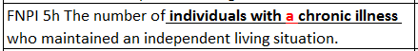

proposed changes: Technical changes to module 2
There are no proposed changes to Module 2 for this clearance process.

proposed changes: Technical changes to module 3
There are no proposed changes to Module 3 for this clearance process.

proposed changes: Technical changes to module 4
- Update each tab throughout Module 4 to include a header for easier identification.
- Align language throughout Module 4.
- Change Participants to Individuals.
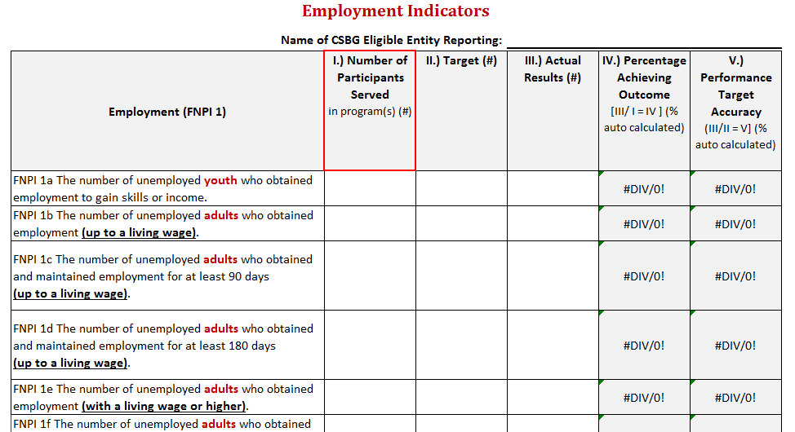

- Revise language to FNPI 4 to better understand the impact that housing outcomes have on individuals and families.
- As mentioned in the General Section, remove “household” and add “individual” to indicators in FNPI 4.
- Update language in Outcomes Across Multiple Domains to align with the understanding of the indicator. The indicator should read “…who achieved one or more outcomes in the identified NPIs in one or more domains”.
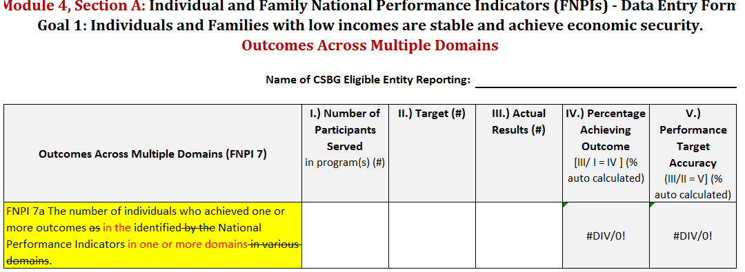
- Update language in Education Levels on the All Characteristics.

- Add “Never Served in the Military” to the All Characteristics Report, #7.
- Add “or” to Migrant Seasonal Farm Worker in Work Status.
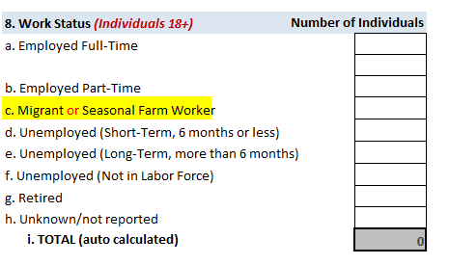
- Update income brackets.
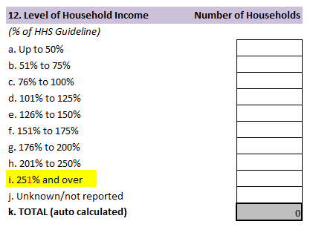

- Update language in Section E&F of the All Characteristics Report to read “Number of Individuals who may or may not be included in the totals above”.
