To: | Sarah Kriz | Date: | 18 March 2020
From: | Elizabeth Fallace | Memo No: | A080-M20-076
Subject: | OASH Teen Pregnancy Prevention Replication Study (MIRB 2020003)

Thank you for your submission of New Project materials for the OASH Teen Pregnancy Prevention Replication Study (MIRB 2020003). The MITRE Institutional Review Board (MIRB) has approved your submission. This submission has received Full Committee Review based on applicable federal regulations, including 45 C.F.R. § 46.406.

Please note that other sponsor approvals, in addition to MIRB approval, may be required to conduct your research.

Finally, the MIRB did not review corresponding risks related to COVID-19 restrictions. Therefore, any anticipated risks to the subjects related to evolving COVID-19 restrictions represent a revision to previously approved materials and require MIRB approval prior to initiation.

If you have any questions, please don’t hesitate to call me on (703) 983-1482.
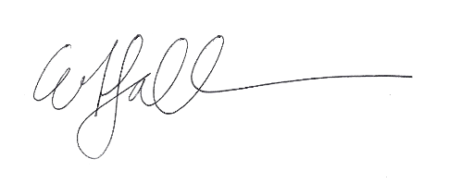

Elizabeth M. Fallace
Chair
MITRE Institutional Review Board

EMF/tb

