|  |  |  |  |  |  |  |  |  |
| --- | --- | --- | --- | --- | --- | --- | --- | --- |
| Form 4130-4 | UNITED STATES | | | | | FORM APPROVED | | |
| (XXX 20XX) | DEPARTMENT OF THE INTERIOR | | | | | OMB NO. 1004-0041 | | |
|  | BUREAU OF LAND MANAGEMENT | | | | | Expires:XXXXX, 2017 | | |
|  | **APPLICATION FOR EXCHANGE-OF-USE GRAZING AGREEMENT** | | | | |  | | |
|  | **(43 CFR 4130.6-1)** | | | | | *For BLM Use Only* | | |
| 1. Name *(last, first, middle initial)* | | | | | |
|  | | | | | | Date Filed __________________________ | | |
| 1. Address *(include street, city, State, and zip code)* | | | | | | State Code __________________________ | | |
|  | | | | | | Office Code _________________________ | | |
|  | | | | | | Auth. Number _______________________ | | |
| 1. I own/lease the following-described lands *(List by legal subdivision and for those lands which are leased, indicate the effective and expiration dates of the lease. You may also use the location plat on page 2 to display the lands that you are offering for exchange of use).* | | | | | | | | |
| 1. The estimated average livestock carrying capacity (expressed in Animal Unit Months (AUMs)) of all lands described above is ________________ AUMs, as rated for ❒ cattle ❒ sheep or goats ❒ horses or burros ❒ other _______________________________________________ (list animal kind). | | | | | | | | |
| 1. These lands are situated within the _______________________________________ Allotment, ________________________________ Field Office/District, and are accessible and suitable for livestock grazing the same periods as the public lands. I understand that the grazing use allowed on public lands cannot exceed the average livestock carrying capacity of the private lands offered. I will confine my livestock to the number, kind, period or periods of time, and areas of use authorized. I herein grant administrative access to these private lands to employees of the Bureau of Land Management (BLM) for the purposes of administering this agreement. | | | | | | | | |
| 1. I hereby apply for the following grazing use on intermingled and adjacent public lands within the above-named allotment to be effective for a period of   ______ years from ____________________________________ , 20____ to __________________________________ , 20____ , unless sooner terminated by either part written notification. | | | | | | | | |
| ALLOTMENT NAME AND NUMBER | | LIVESTOCK NUMBER AND KIND | | GRAZING PERIOD | | | FORAGE AMOUNT (ANIMAL UNIT MONTH) | |
| BEGIN DATE (mm/dd) | END DATE (mm/dd) | |
|  | |  | |  |  | |  | |
|  | |  | |  |  | |  | |
|  | |  | |  |  | |  | |
|  | |  | |  |  | |  | |
| NOTICE TO APPLICANT – BLM may issue an exchange-of-use grazing agreement (otherwise referred to as an EOU) to authorize use of public lands to the extent of the livestock carrying capacity of the lands offered in exchange-of-use so long as the lands offered in exchange-of-use: (a) occur within the same allotment as the grazing use to be authorized under the EOU, (b) the use authorized by the EOU is in harmony with the management objectives for the allotment and is compatible with existing livestock operations, and (c) the EOU specifies terms and conditions that ensure orderly administration of the range, including the fair and equitable sharing of the operation and maintenance of range improvements. No fee shall be charged for this grazing use. An EOU has no priority for renewal and cannot be transferred or assigned. (43 CFR 4130.6 and 4130.6-1 (a) and (b)). If your application is approved, BLM will issue you an EOU Grazing Agreement Authorization. | | | | | | | | |
| REQUESTED BY:  Signature of Application | | | Printed Name of Applicant | | | | | Date |
| Title 18 U.S.C., Section 1001, makes it a crime for any person knowingly and willfully to make to any department or agency of the United States any false, fictitious, or fraudulent statements or representations as to any matter within its jurisdiction. | | | | | | | | |
| FOR BLM USE ONLY – In accordance with 43 CFR 4130.6-1, BLM has examined the private lands described in Part 1 of this agreement and has determined that: (a) they are not fenced and are intermingled with public lands in the allotment(s); (b) the use of these lands will be in harmony with the management objectives of the allotment(s); (c) the use of these lands is compatible with existing livestock operations on the allotment(s); and (d) the estimated average livestock carrying capacity of these lands, as indicated by the applicant, is accurate.  APPLICATION APPROVED BY (Signature): ________________________________________________________________________________  (BLM Manager)  ___________________________________________ _______________________________________________________ _____________________________  (Printed Name) (Title) (Date) | | | | | | | | |

(Continued on page 2)

LOCATION PLAT

*(Location Plat may be used to display the lands offered in Exchange-of-Use)*

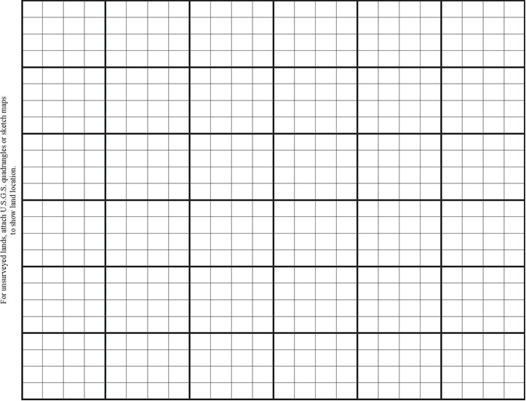

Scale: inch(es) equals one mile

|  |
| --- |
| **NOTICES**  **The Privacy Act** and 43 CFR 2.48(d) require that you be furnished with the following information in connection with information requested by this form.  **AUTHORITY:** 43 U.S.C. 315, 316, 1181d, and 43 CFR 4100.  **PRINCIPAL PURPOSE:** The BLM will use the information you provide to process your application to graze livestock on the public lands.  **ROUTINE USES:** In accordance with the Bureau of Land Management’s (BLM) System of Records Notice published in the Federal Register on December 29, 2010 [Bureau of Land Management’s Range Management System—Interior, LLM–2; Notice To Amend an Existing System of Records; Privacy Act of 1974; as Amended], names and addresses provided by the applicant on this form will be publically available in reports on the BLM public website.  **EFFECT OF NOT PROVIDING INFORMATION:** Disclosure of the information is required to obtain or retain a benefit. Failure to submit all of the requested information or to complete this form may result in delay or the rejection and/or denial of your application.  **The Paperwork Reduction Act** requires us to inform you that: BLM collects this information to determine if you are eligible to enter into an Exchange-of-Use Agreement with BLM. Response to this request is required to obtain or retain a benefit. You do not have to respond to this or any other Federal agency-sponsored information collection unless it displays a currently valid OMB control number.  **BURDEN HOURS STATEMENT:** Public reporting burden for this form is estimated to average 18 minutes per response, including the time for reviewing instructions, gathering and maintaining data, and completing and reviewing the form. Direct comments regarding the burden estimate or any other aspect of this form to: U.S. Department of the Interior, Bureau of Land Management (1004-0041), Bureau Information Collection Clearance Officer (WO-630), 1849 C Street, N.W., Room 2134LM, Washington, D.C. 20240. |

(Form 4130-4, page 2)