Contents
IDCF Log in and registration screens 2
Welcome page: 4
Dear employer page: 5
Contact preference page: 5
Add establishment page: 6
Help request form: 6
Section 1: 7
Section 2: 8
Section 3 and case entry: 9
Case entry screen: 10
Alternative Section 3 and case entry wording: 14
Additional Section 3 wording alternative: 15
Section 4: 16
Page asking for OSHA ID: 18
Thank you page: 21

IDCF Log in and registration screens
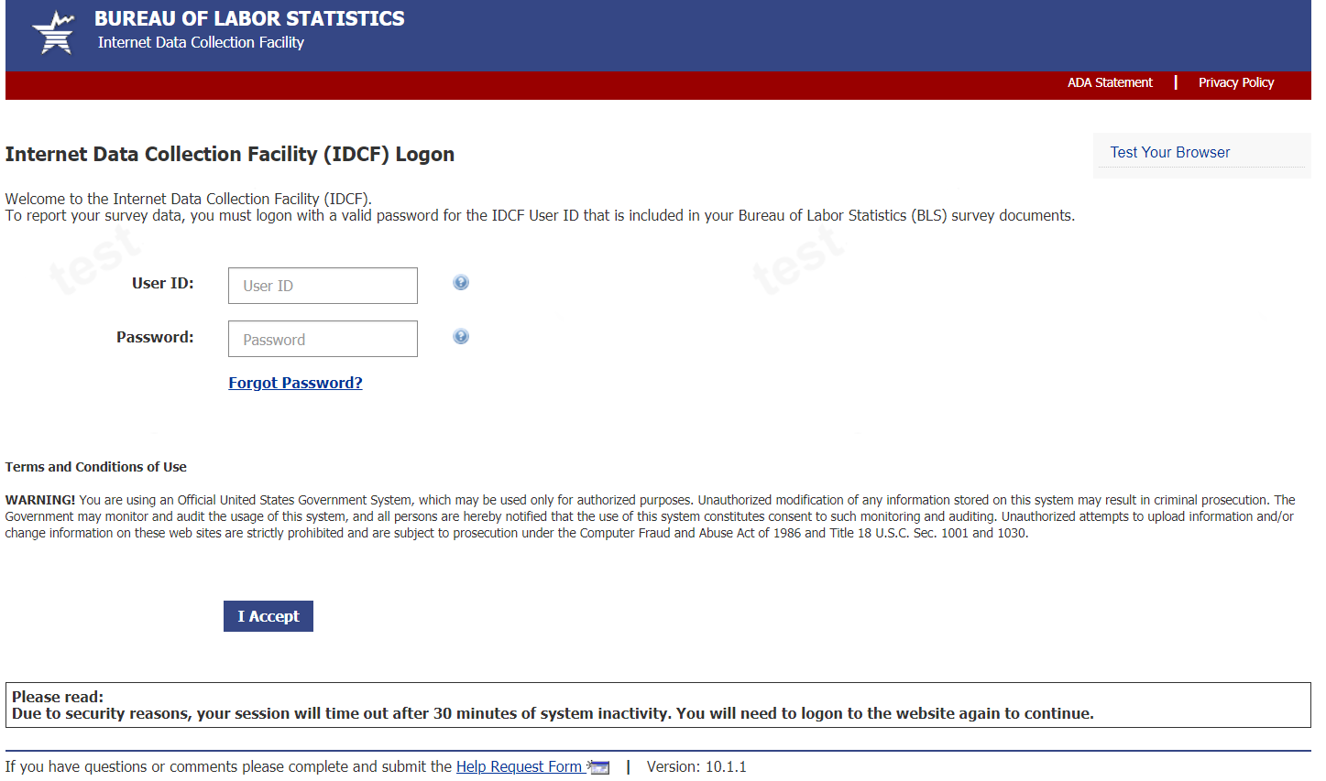

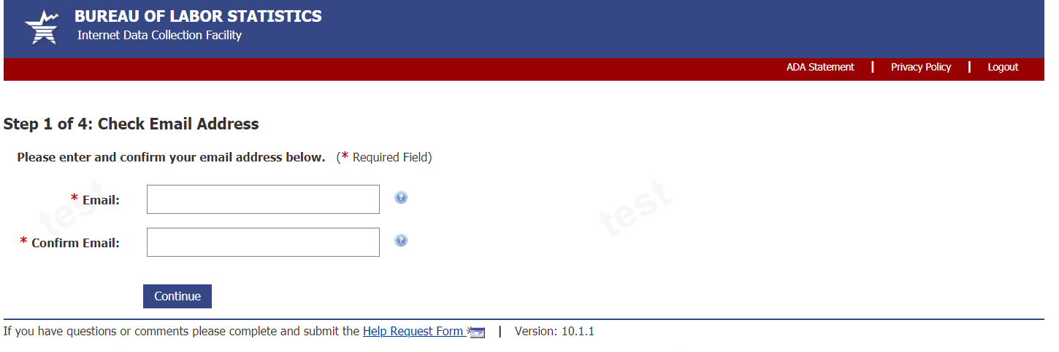

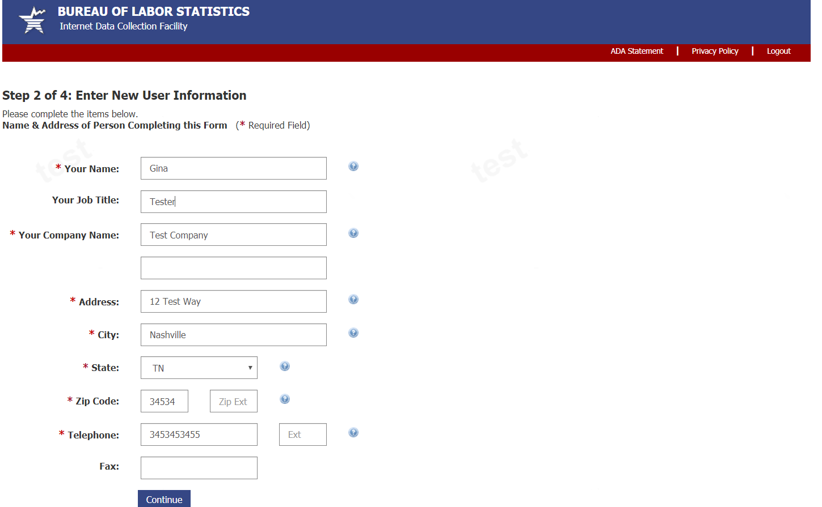

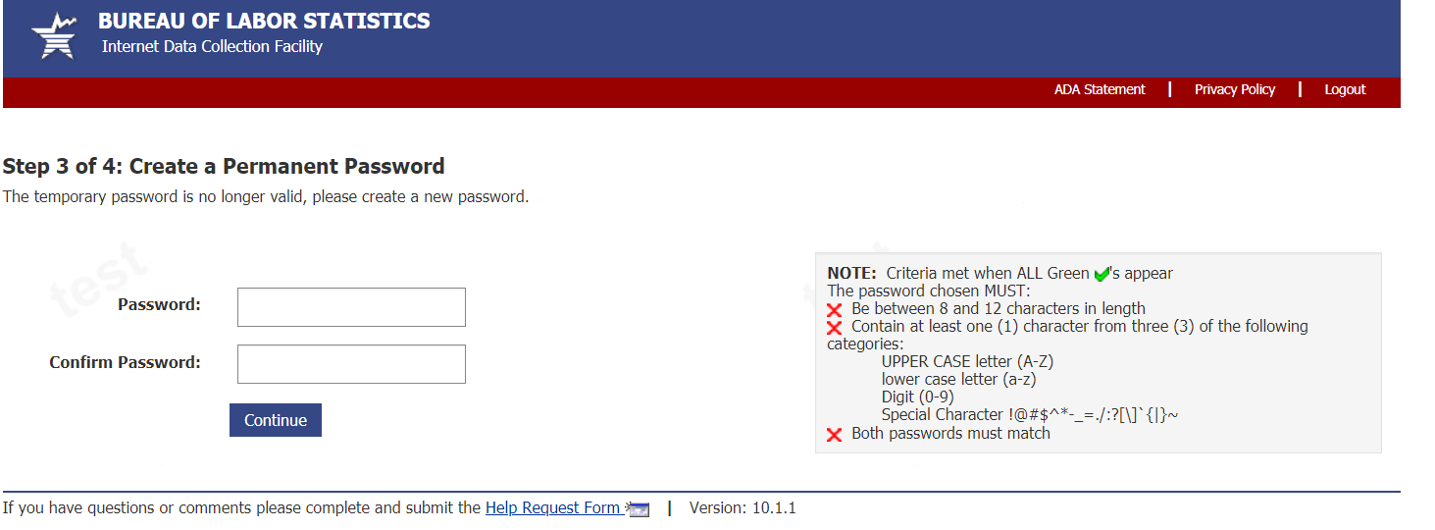

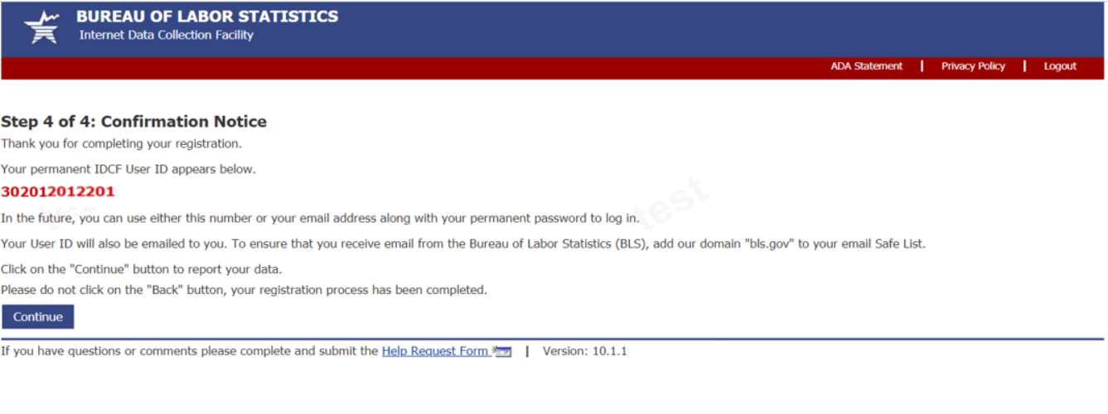

Welcome page:
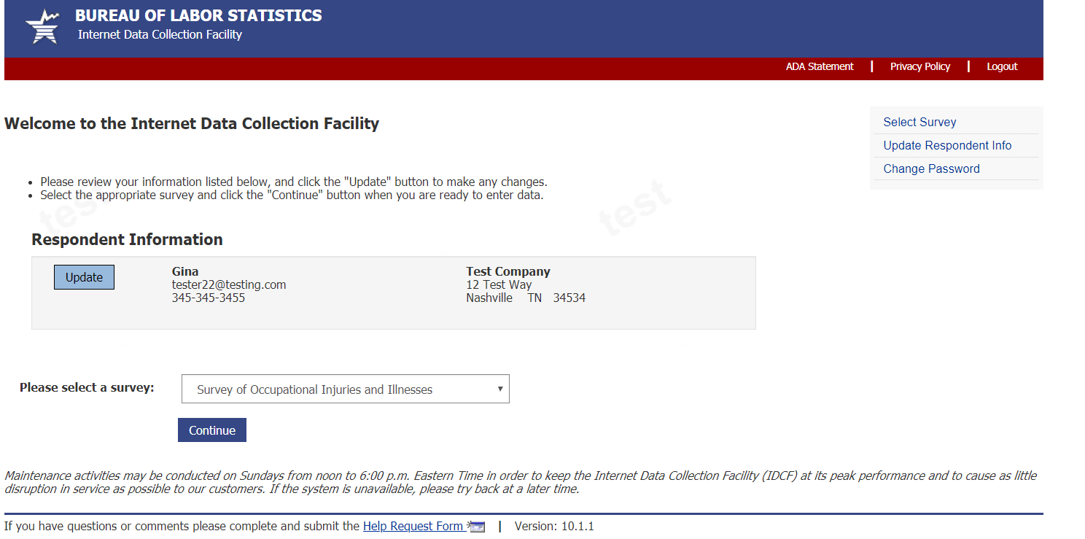

Dear employer page:
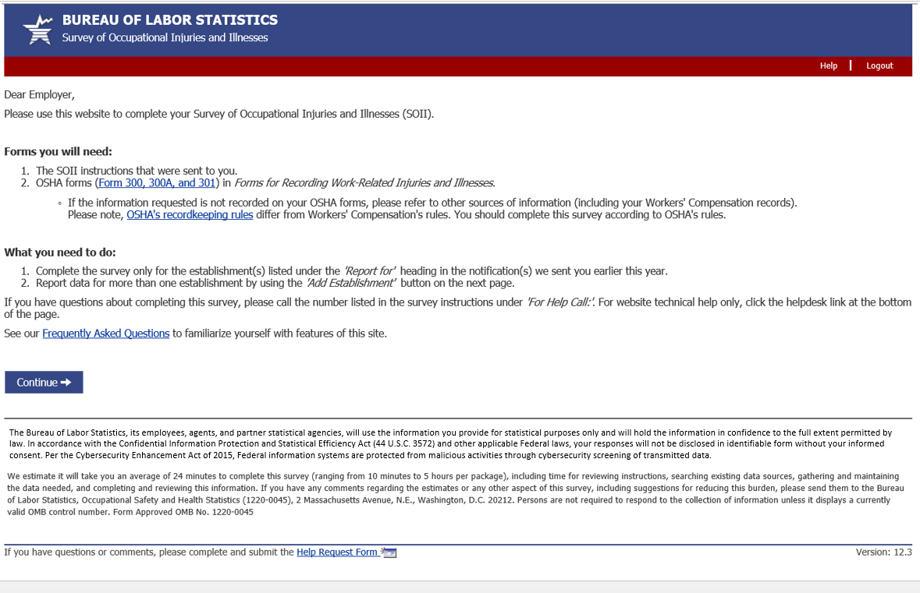

Contact preference page:
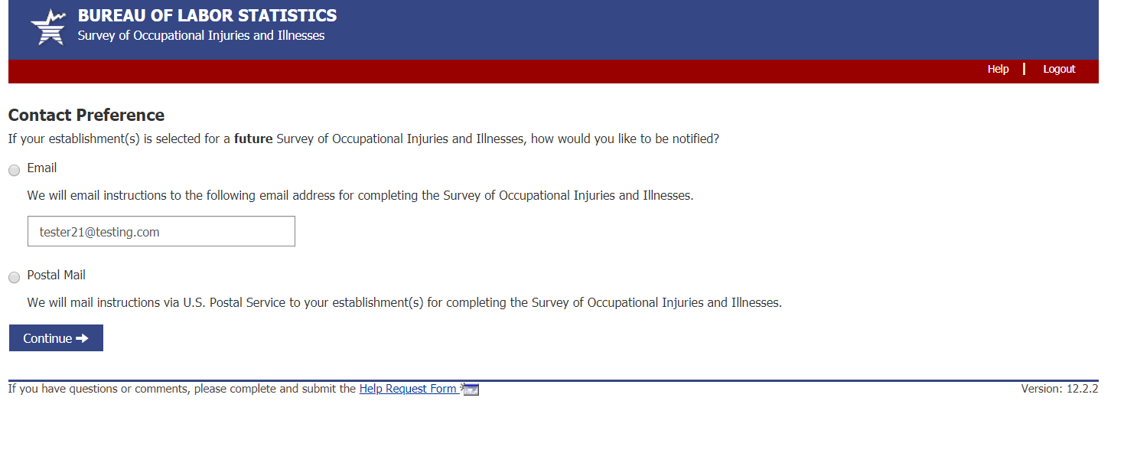

Add establishment page:
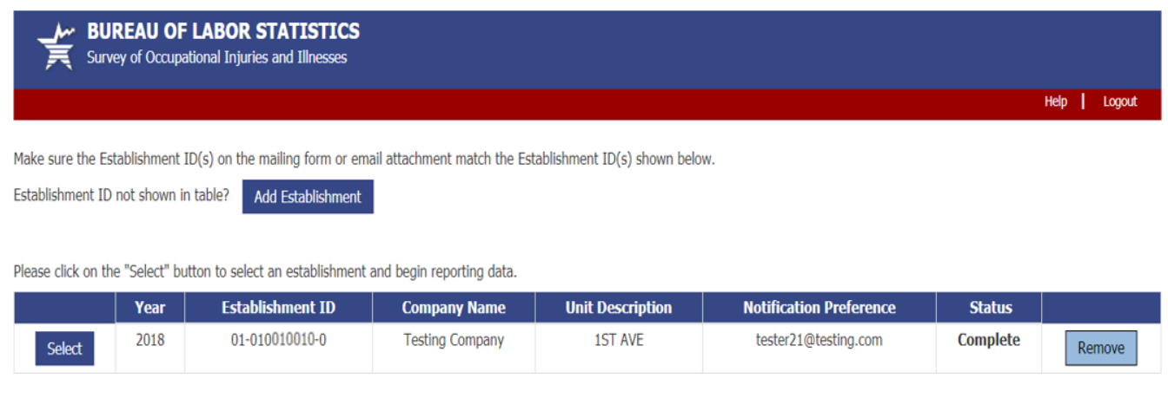

Help request form:
From screen above, or any screen within the survey, users can click on the “Help Request Form” link on the bottom of the page to send a question to the helpdesk. The Help Request Form is shown below. This year we added a Salutation drop down so that our helpdesk staff can address users properly:
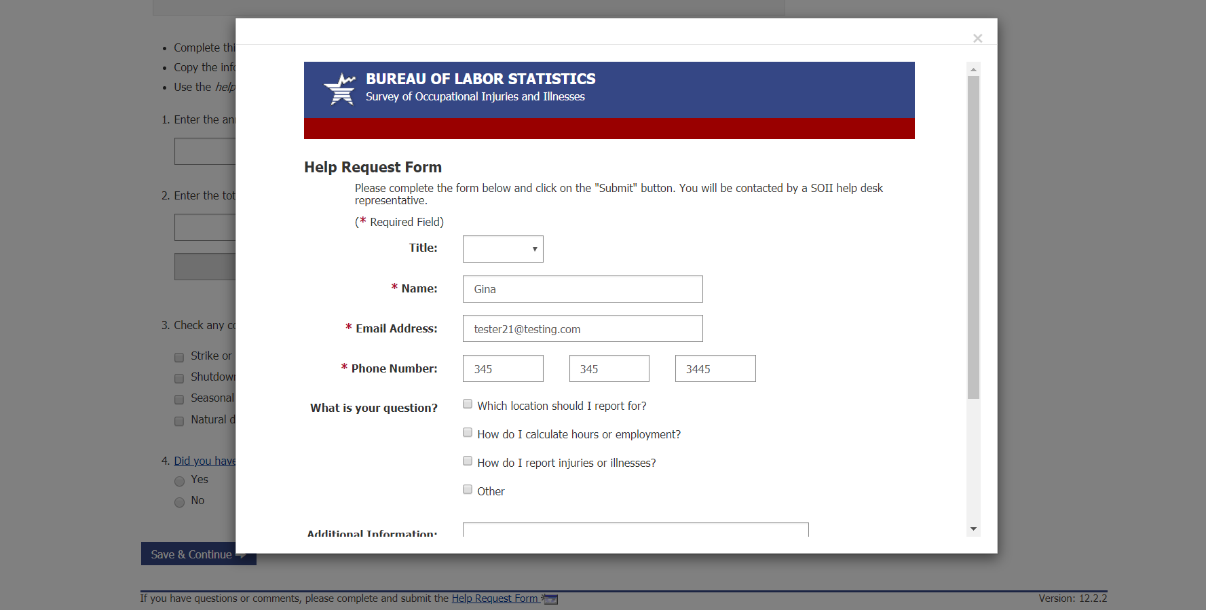

After submitting the help request, the user will return to the section they are on and press “Save and Continue” to proceed through the survey.

Section 1:
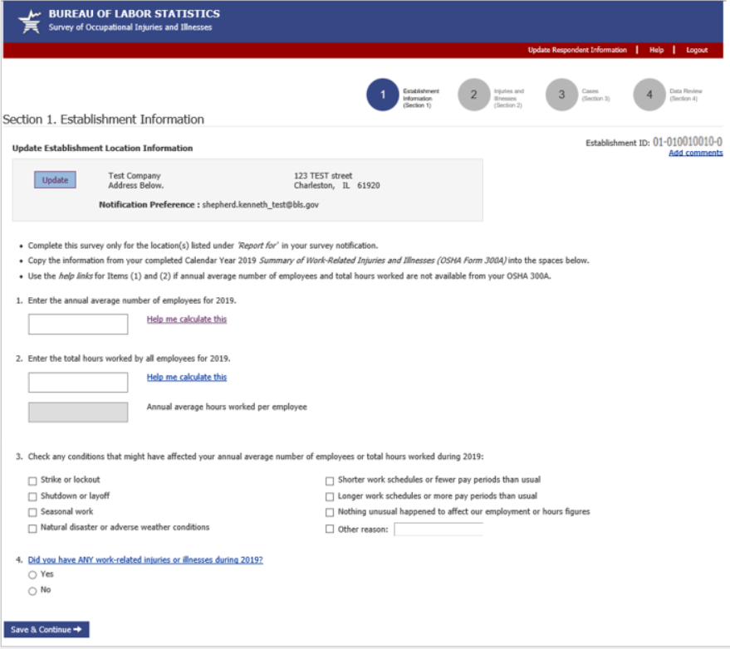

Section 2:
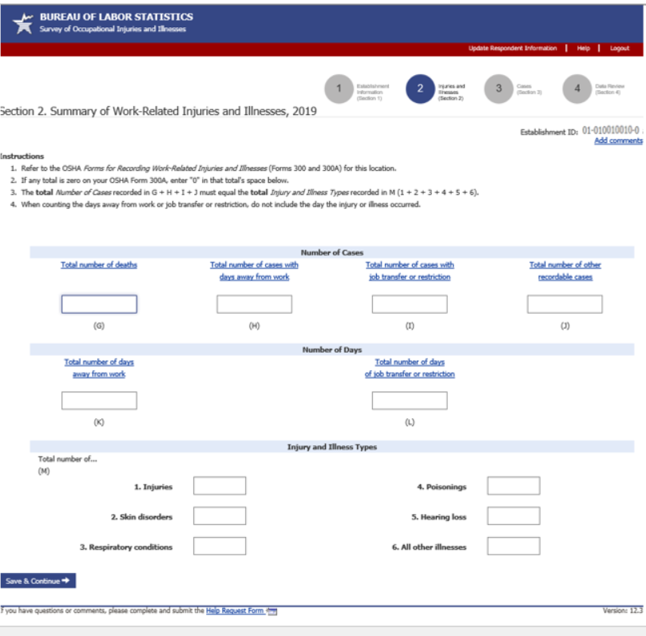

If you report a death the bottom of section 2 looks like this:
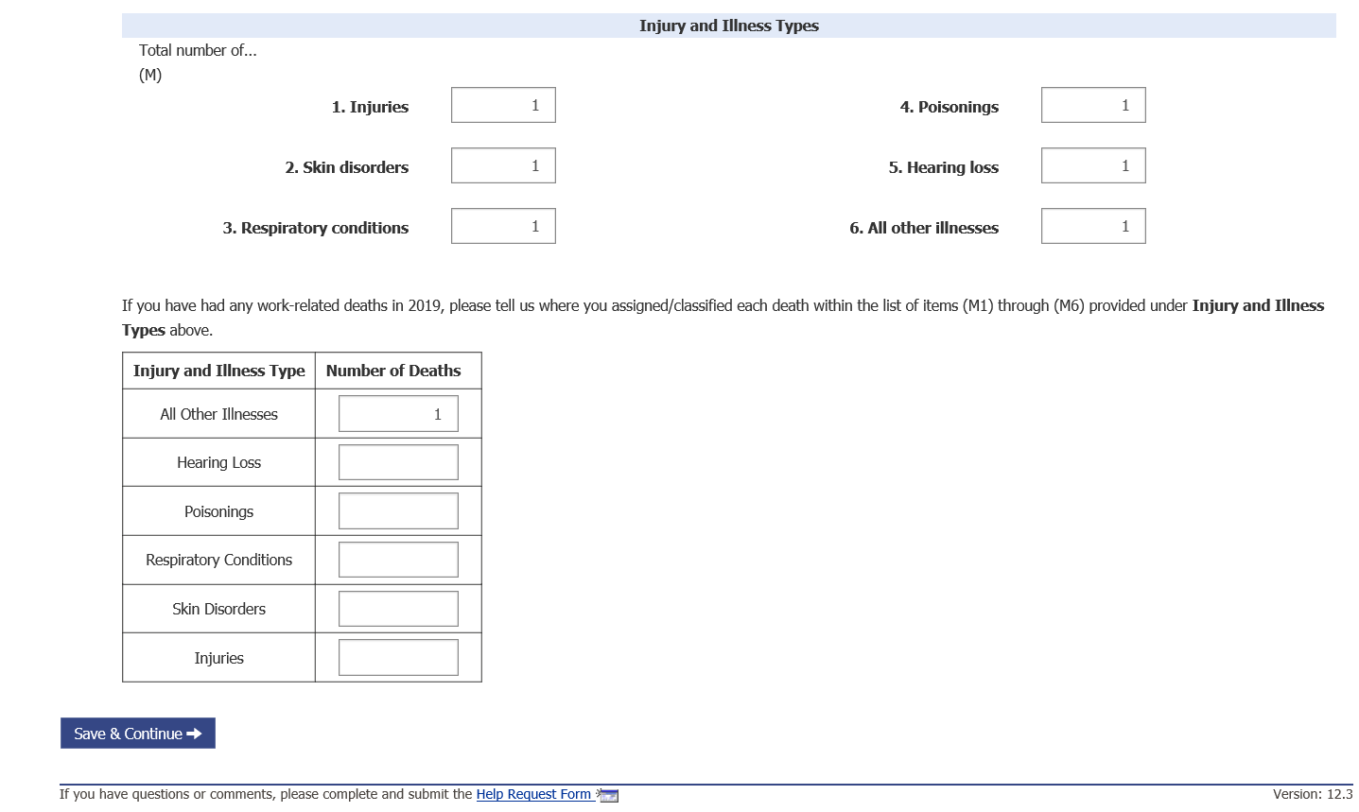

Section 3 and case entry:
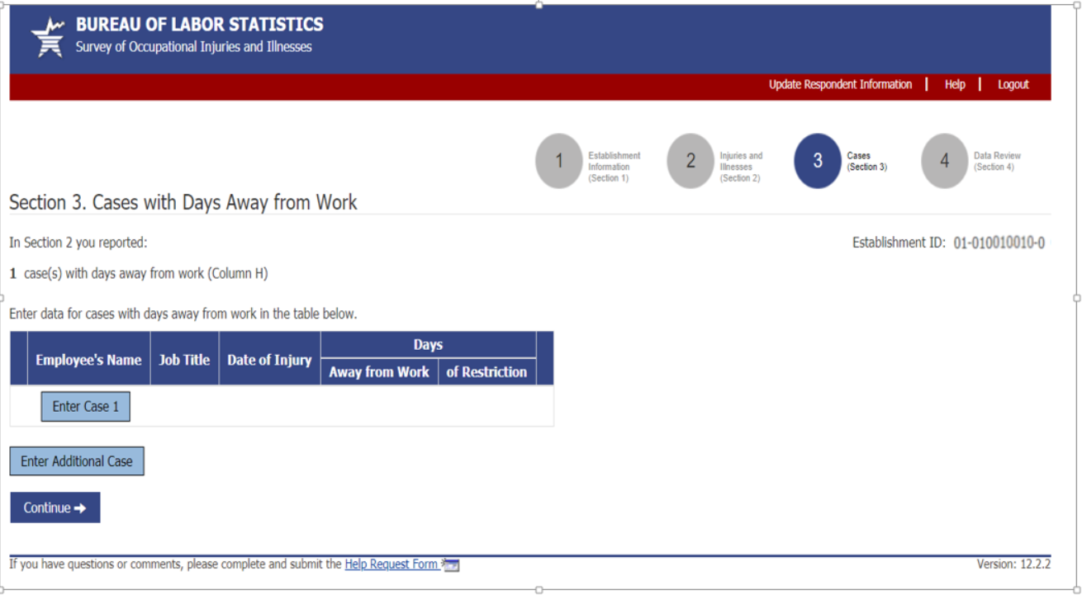

Case entry screen:
(1 of 3):
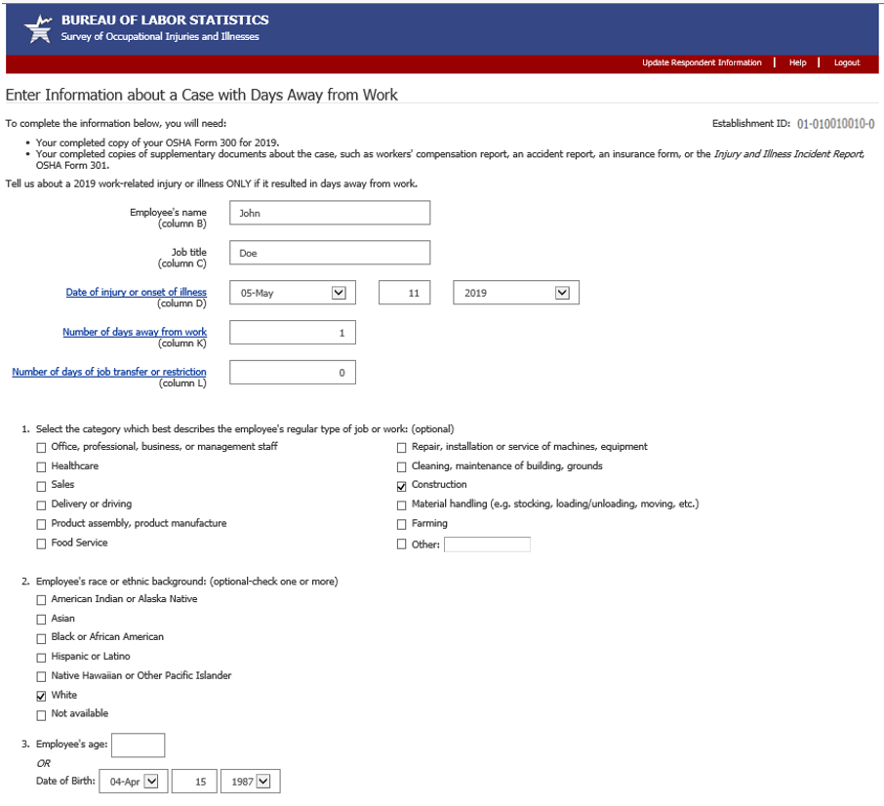

Case entry screen (2 of 3):
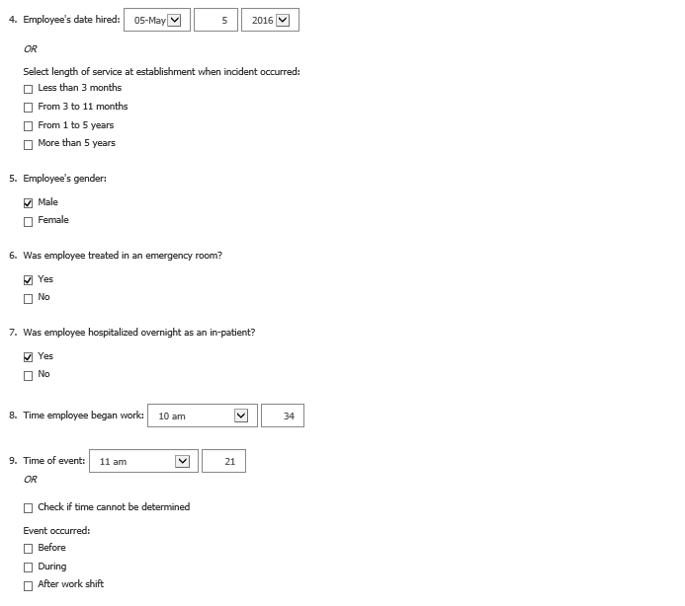

Case entry screen (3 of 3):
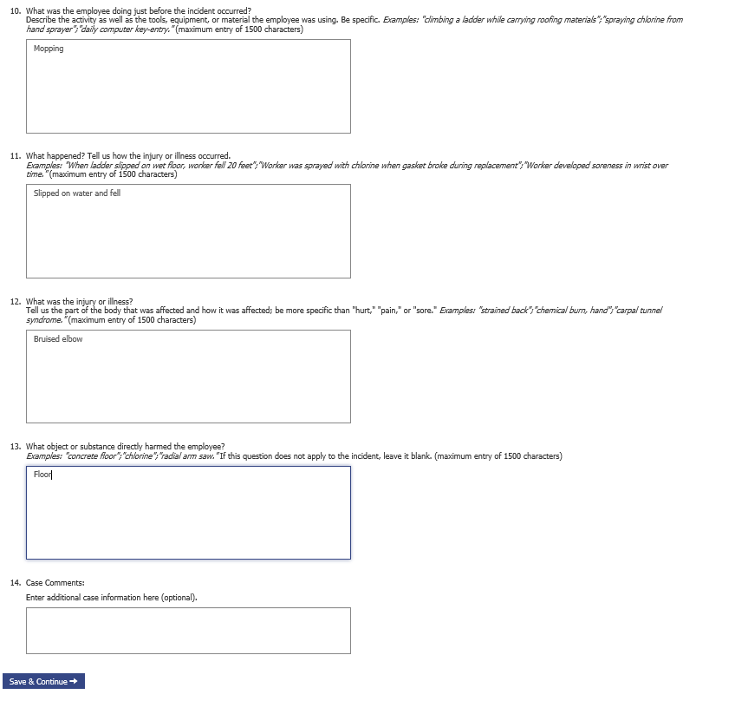

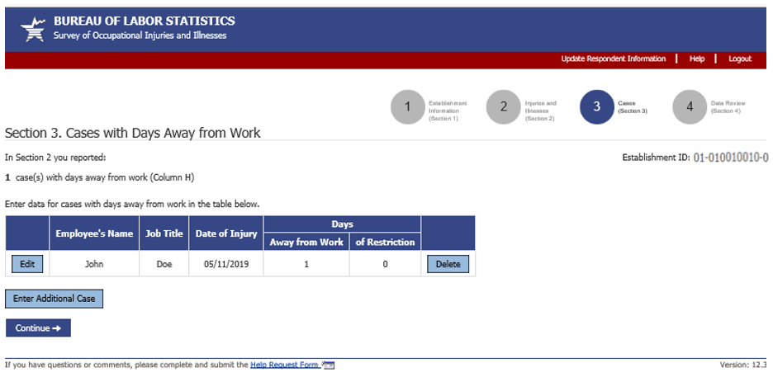

Alternative Section 3 and case entry wording:
Alternative section 3 and case screen for if establishment has to report case details for days of job transfer or restriction cases in addition to their days away from work cases:
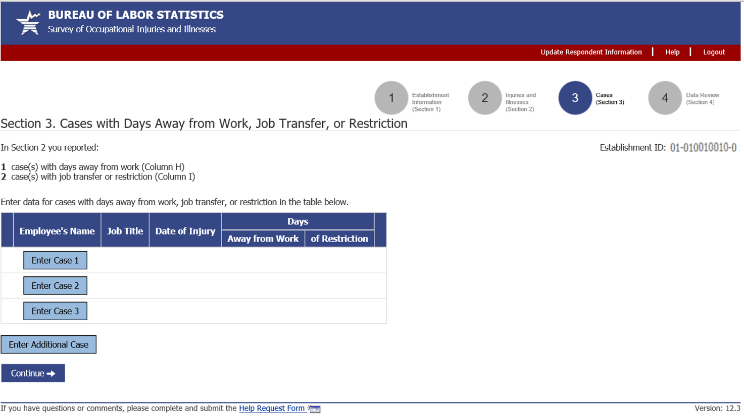

Case screen:
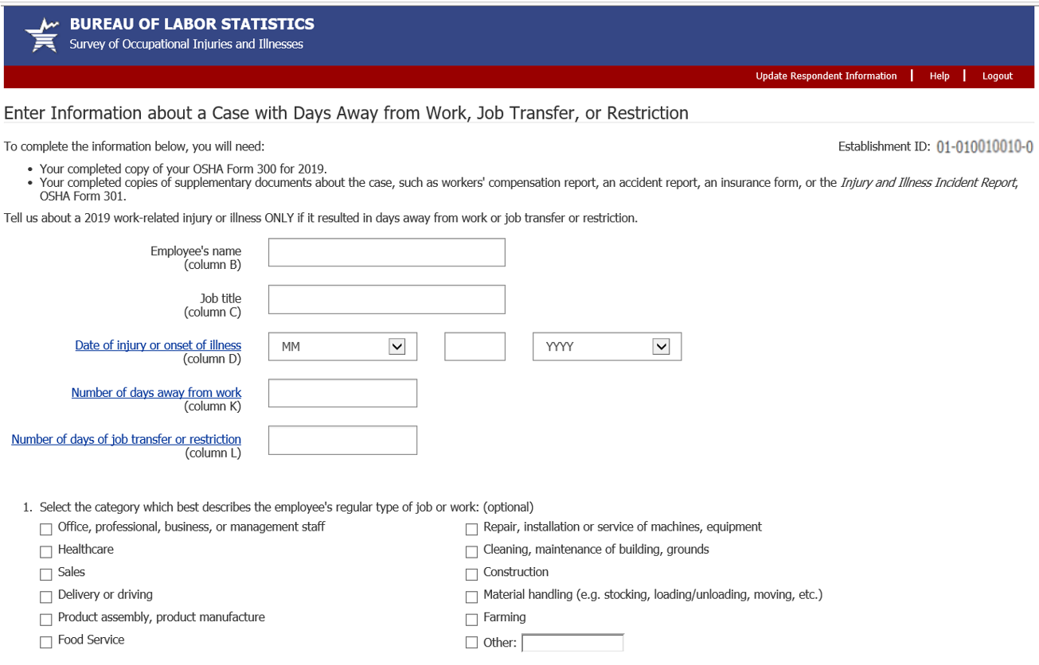
Rest of case screen is the same as other section.

Additional Section 3 wording alternative:
Alternative section 3 screen where user is only asked to report case details for cases that occurred during the indicate date ranges:
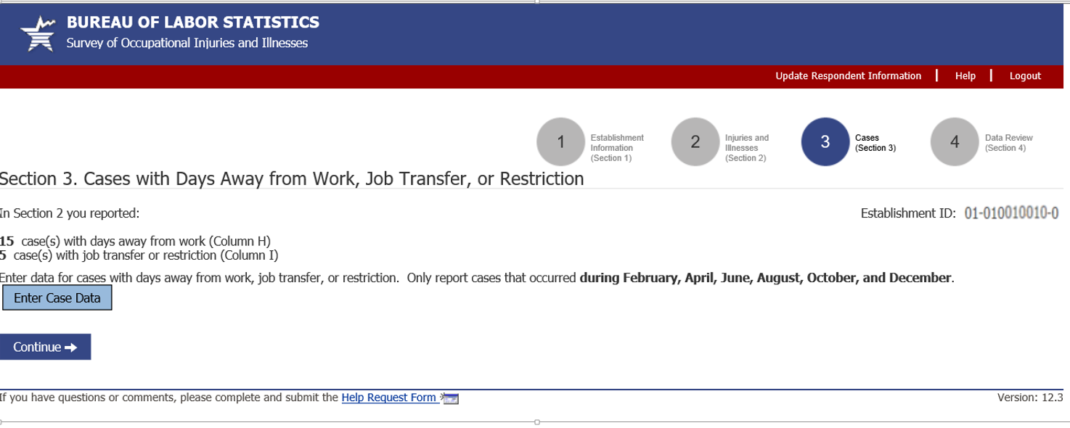

Section 4:
(1 of 2)
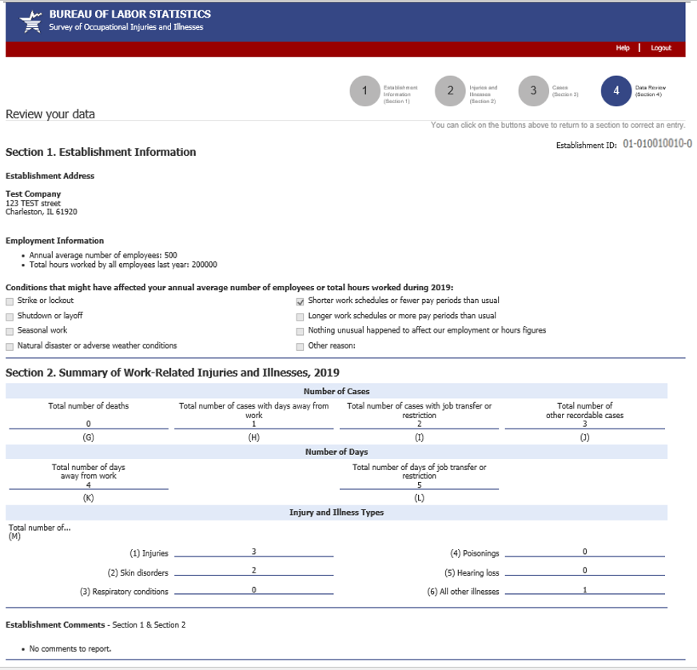

Section 4 (2 of 2): 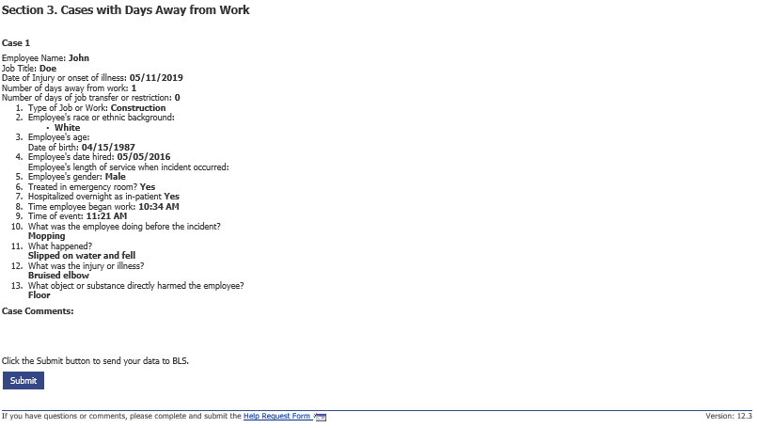

Page asking for OSHA ID:
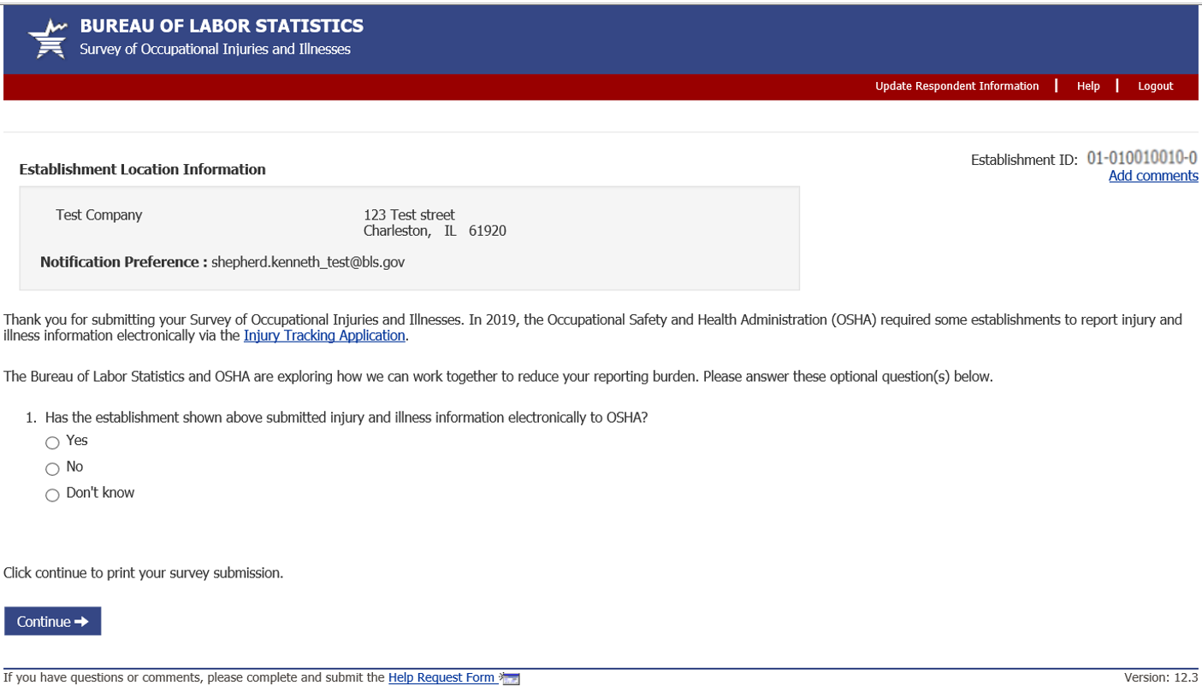

Selecting ‘Yes’ radio button dynamically displays question 2.

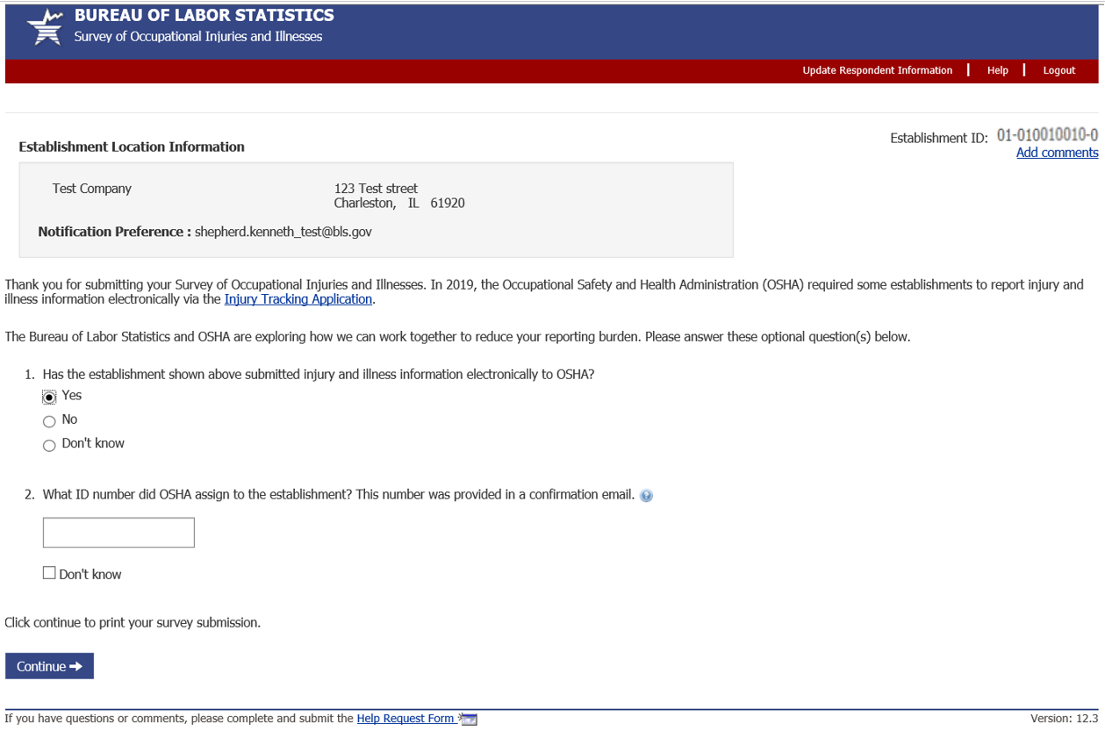

Clicking on the ‘Injury Tracking Application’ hyperlink opens up the ITA landing page on a separate browser tab.
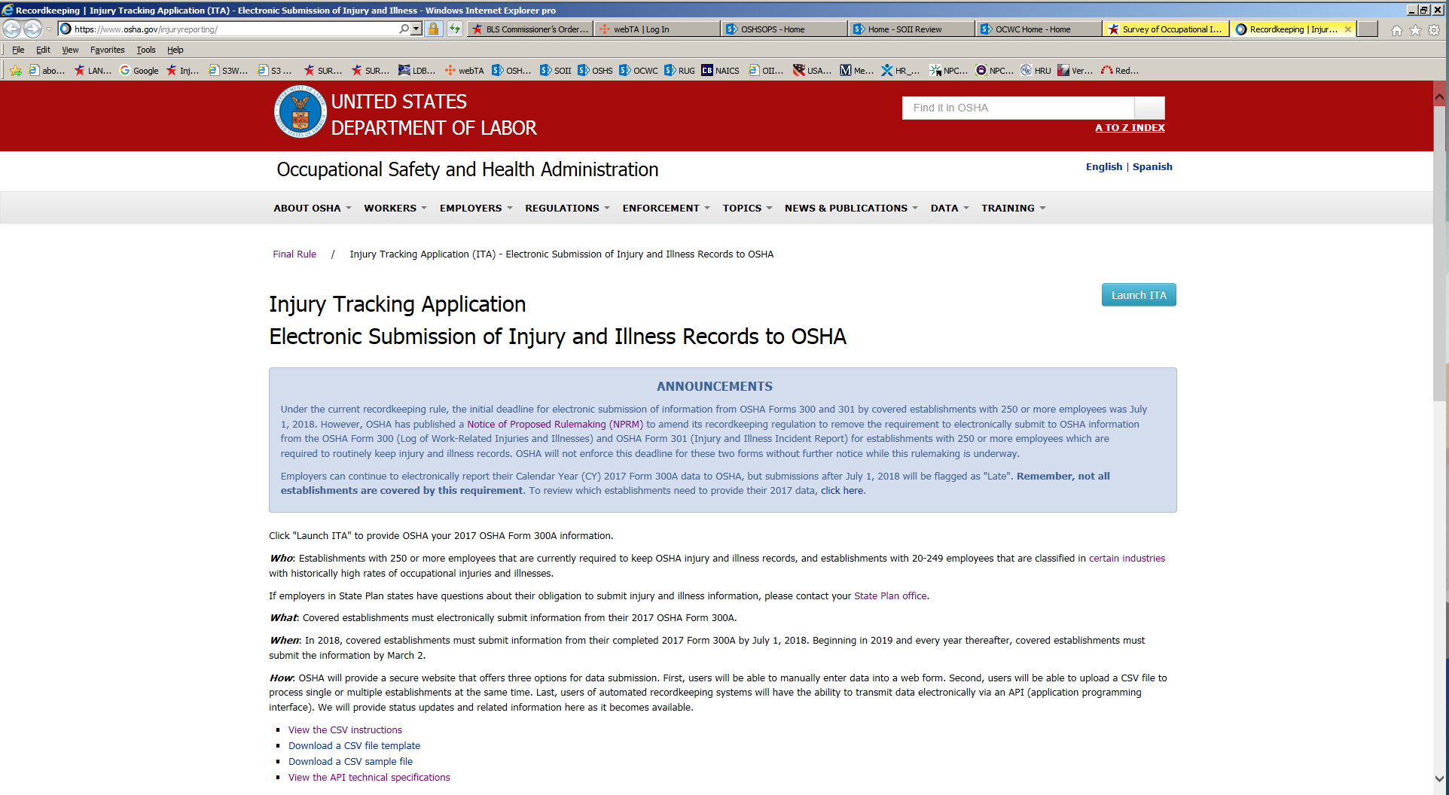

Sample OSHA ITA submission reply: Clicking on the ? icon at the end of question 2 provides a sample email that OSHA ITA respondents received upon successful submission to ITA. (Note: this example opens on a separate browser tab.)

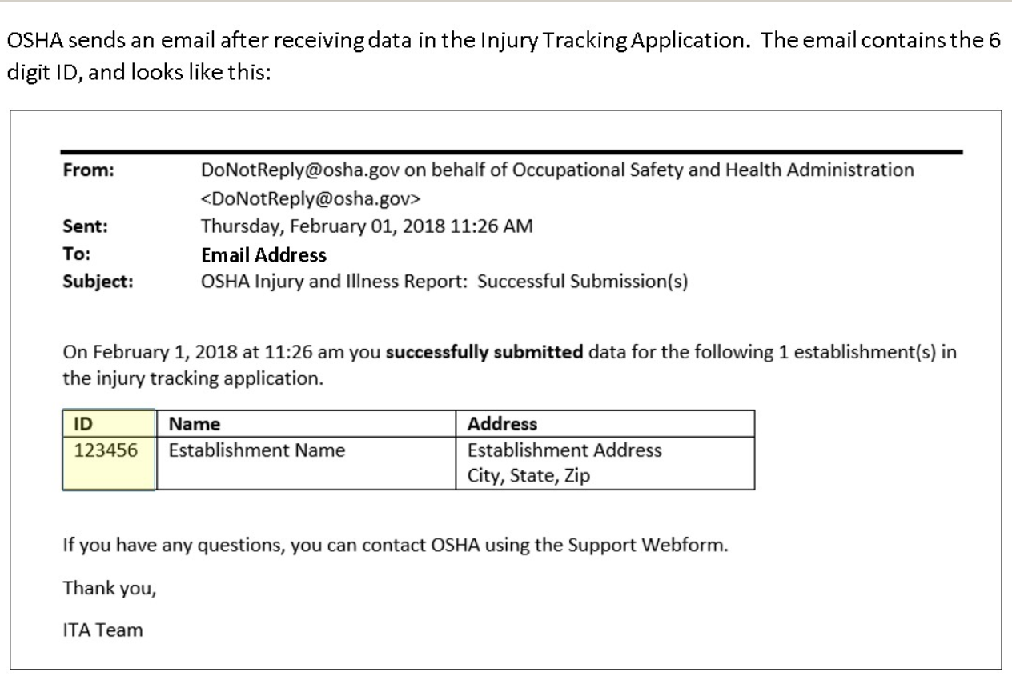

Thank you page:
Seen either after the OSHA ID page or directly after section 4.
