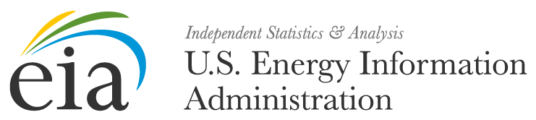

Date:

Dear Form EIA-860 Respondent:

The U.S. Energy Information Administration (EIA) will soon be conducting the EIA-860, Annual Electric Generator Report Survey for 2016. It is essential for you to respond to this survey between January 1st and the last day of February 2017 in order for EIA to prepare accurate and timely reports.

The data collected from the EIA-860 provides information on the status of existing electric generating plants and associated equipment in the United States, and those scheduled for initial commercial operation within 10 years. These data are essential to EIA to perform analyses and projections that are relied upon by the U. S. Congress to prepare for legislative actions, by the U.S. Department of Energy to set policy, and by the electric power industry to analyze supply, economic, and reliability conditions. The data will appear in a number of EIA publications, such as the Annual Energy Outlook, the Electric Power Annual, and the Annual Energy Review. The data will also be used in other EIA products, such as the State Energy Data System and for EIA forecast models.

Response to this survey is mandatory and required pursuant to 15 U.S.C., Sections 764(b), 772(b) and 790a of the Federal Energy Administration Act of 1974. Your company’s mandatory participation will continue annually unless otherwise stated by EIA. EIA estimates that the average reporting burden for this survey is approximately 9.26 hours per response. The following information reported on Form EIA-860 will be protected and not disclosed to the public to the extent that it satisfies the criteria for exemption under Freedom of Information Act (FOIA), 5 U.S.C. §552, the DOE Regulations, 10 C.F.R. §1004.11, implementing the FOIA and the Trade Secrets Act, 18 U.S.C. §1905:

• All information associated with the “Survey Contact” and the “Supervisor of Contact
Person for Survey” on Schedule 1

• Information reported for the data element “Tested Heat Rate” on Schedule 3, Part B, Generator Information – Existing Generators

• All data reported on Parts A and B of Schedule 5, Generator Cost Information

All other information reported on Form EIA-860 will be treated as non-sensitive and may be publicly released in identifiable form.

More detailed reporting information will be emailed to you in a reminder approximately 2 weeks before the opening date. If you have any questions, or need assistance in responding to this survey, contact the survey manager at EIA-860@eia.gov. Again, thank you for your cooperation in responding to this survey request so that EIA can provide timely and accurate information.

Sincerely,

EIA-860 Survey Manager
EIA-860@eia.gov
U.S. Energy Information Administration

