Supporting Statement
Application for Employment with the Federal Aviation Administration
2120-0597

Justification

1. Explain the circumstances that make the collection of information necessary. Identify any legal or administrative requirements that necessitate the collection.

Under the provisions of Public Law 104-50, the Federal Aviation Administration (FAA) was given the authority and the responsibility for developing and implementing its own personnel system without regard to most of the provisions of Title 5, United States Code, except those that apply to veteran’s preference and various benefits.
This collection of information is pertinent for gathering data concerning potential new hires for the Federal Aviation Administration (FAA). The information collected is essential to establish basic eligibility for employment and potential eligibility for Veteran’s Preference, Veteran’s Readjustment Act, and People with Disability appointments. In addition, there are specific occupation questions that assist FAA’s Office of Human Resource Management (AHR) in concluding candidates' qualifications to ascertain the best-qualified candidates are hired for the many FAA occupations. Without this collection of information, reliable means to evaluate accurately applicants' skills, knowledge, and abilities to perform the duties of these positions are limited. The questions asked of the applicant are taken directly from the Office of Personnel Management Qualification Standard found at:
https://www.opm.gov/policy-data-oversight/classification-qualifications/general-schedule-qualification-policies/#url=General-Policies

2. Indicate how, by whom, and for what purpose the information is to be used. Except for a new collection, indicate the actual use the agency has made of the information received from the current collection.

Applicants interested in applying for jobs with the FAA voluntarily complete the online Web based application (USAJOBS/AVIATOR) process. The information is reported on occasion. AVIATOR facilitates the FAA hiring process with instant certification of qualified candidates for employment. It allows simultaneous online application submittal; screening and testing; scoring and notification; eligibility list placement; and referral for interview. Once applicants electronic application form is complete and the job announcement date expires, FAA AHR performs its Qualification Reviews process:

- AHR specialists perform qualification reviews on submitted applications for a job vacancy announcement on which they have access. The AHR specialist will select the job vacancy, and navigate to the list of applicants’ names and profiles. The AHR specialist can select a particular applicant, review the submitted questionnaire, review the attached documents, and perform any adjudications or exclusions.
- The adjudication and exclusions process entails a review by staff within AHR of the application and supplementary documentation and making a determination based on AHR best practices, AHR standards, and federal law. This is an initial AHR vetting process to ensure applications are complete and that individuals meet basic qualifications before an application is submitted to hiring officials.
- There are no outputs or reports generated during this review process within the system. In this step, the following applicant’s profile information is reviewed by the AHR specialist:
Full Name
Full Address
Phone number
Citizenship status
Selective Service status
Military Service status (for military preference)
Employment history (i.e. resume)
Applicable Documents required to be submitted

Following the Qualification Reviews process is the Referral List Creation:
- The AHR specialist can create a referral list of qualified applicants for a job vacancy announcement on which they have access.
- The AHR specialist will then select the particular case vacancy announcement, and navigate to create referral list module and enter the criteria required to create the list of referred applicants.

In summary, the data gathered from the Federal Aviation Administration (FAA) Application for Employment is analyzed and evaluated by AHR specialists to identify applicants with required qualifications for a variety of positions within the FAA. While the FAA is exempt from provisions relating to normal competitive examination processing within Title 5, USC, Sections 3302-3305, this process enables the FAA to establish a selection pool of best-qualified candidates to fulfill its many critical safety-related jobs.

3. Describe whether, and to what extent, the collection of information involves the use of automated, electronic, mechanical, or other technological collection techniques or other forms of information technology, e.g., permitting electronic submission of responses, and the basis for the decision for adopting this means of collection. Also, describe any consideration of using information technology to reduce burden.

In accordance with the Government Paperwork Elimination Act, 100% of this information is submittable electronically. The employment application forms are automated and completed by applicants online via a Web based system. The application forms are collected and processed within a database that utilizes innovative Web tools and enhanced code scripting/efficient database (DB) process flow. This allows for overall enhancement of user input/output DB processing time. In conjunction with individualized job announcements tailored to specific job requirements, the applicants’ reporting burden is minimized; FAA is able to maximize the reliability and validity of the rating process.

4. Describe efforts to identify duplication. Show specifically why any similar information already available cannot be used or modified for use for the purposes described in Item 2 above.

This information is not gathered by any other collection entity. The FAA Automated Vacancy Information Access Tool for Online Referral (AVIATOR) is integrated with the Office of Personnel Management’s USAJOBS system, which has its own data collection processes and authority. Applicants must complete a profile containing their contact information, resumes, supporting documents, etc. via USAJOBS. The profile information is automatically collected from USAJOBS by AVIATOR data services when an applicant applies on an FAA announcement. The profile data as well as resume and other documentation are stored in AVIATOR as part of the job application. Subsequent changes or updates by the applicant to their profile or documentation in USAJOBS are not collected by AVIATOR unless the applicant re-applies. This profile can be used repeatedly to apply for numerous jobs of interest. This relieves the burden for the applicant to duplicate this information each time they apply for job.

5. If the collection of information impacts small businesses or other small entities (Item of OMB Form 83-I), describe any methods used to minimize burden.

The collection of information does not impact small business or other small entities.

6. Describe the consequence to Federal program or policy activities if the collection is not conducted or is conducted less frequently, as well as any technical or legal obstacles to reducing burden.

The information collection is utilized in the evaluation and qualification hiring process of job applicants for various critical aviation safety positions, including other aviation regulations, certifications, as well as other essential positions. Void of the collection, the FAA would have limited reliable methods to analyze and evaluate accurately applicant’s skills to ensure attainment of best-qualified candidates for FAA positions.

The frequency of the collection is not determined by the FAA. It is determined by the desire of the individual to apply for a job with the FAA. If the frequency of the collection was, otherwise, limited, the FAA would not be able to fill FAA positions.

7. Explain any special circumstances that would cause an information collection to be conducted in a manner inconsistent with the general information collection guidelines.

There are no special circumstances.

8. If applicable, provide a copy and identify the date and page number of publication in the Federal Register of the agency's notice, required by 5 CFR 1320.8(d), soliciting comments on the information collection prior to submission to OMB

A Federal Register Notice published on July 9, 2019 (84 FR 32826) solicited public comment. No comments were received.

9. Explain any decision to provide any payment or gift to respondents, other than remuneration of contractors or grantees.

No payment or gifts will be provided to respondents.

10. Describe any assurance of confidentiality provided to respondents and the basis for the assurance in statute, regulation, or agency policy.

Assurance of confidentiality is that applicable to the Privacy Act notice pursuant to the Privacy Act of 1974, as amended. Information becomes part of the Privacy Act System of Records OPM/GOVT-5, Recruiting, Examining, and Placement Records.

11. Provide additional justification for any questions of a sensitive nature, such as sexual behavior and attitudes, religious beliefs, and other matters that are commonly considered private.

No questions of a sensitive or private nature are asked.

12. Provide estimates of the hour burden of the collection of information including the number of respondents, frequency of response, annual hour burden and how the burden was estimated.

It is estimated that no more than 180,000 respondents will complete an application form on an annual basis. Based on this sample of potential applicants, it is estimated that the average respondent requires approximately 1 hour to read the instructions and complete the application form, although the range could be as little as .25 hours to as much as 2 hours per respondent. The total burden is estimated to be 180,000 hours annually.
The estimated total annualized labor cost to respondents for the hour burdens for collecting the information is approximately 3.9 million. This figure is determined by multiplying the total hourly burden (180,000) by the average hourly starting pay ($21.86 / hour) of the positions for which individuals are applying (FG-9 level, equivalent of the GS-9 grade level in the Civil Service).

Copy of FY 2020 Salary Chart from Office Of Personnel Management (OPM) is as follows:

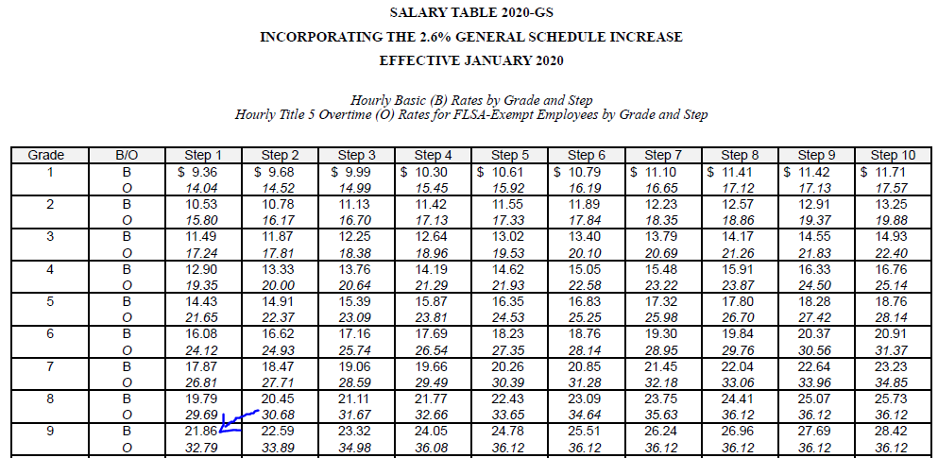

13. Provide an estimate for the total annual cost burden to respondents or record keepers resulting from the collection of information. (Do not include the cost of any hour burden shown in Items 12 and 14). Provide an estimate of the total annual cost burden to respondents or recordkeepers resulting from the collection of information.

There are no material costs for the respondents.

14. Provide estimates of annualized costs to the Federal government. Also, provide a description of the method used to estimate cost, which should include quantification. Provide an estimate of the annualized cost to the Federal government.

Annualized costs associated with the collection of this information are binding via a best interest determination Interagency Agreement (IAA) between Federal Aviation Administration (FAA) and the US Office of Personnel Management (OPM). The purpose of the IAA is to provide necessary funds to support services furnished by the US Office of Personnel Management. OPM coordinates efforts concerning implementation and maintenance of the Automated Vacancy Information Access Tool for Online Referral System, (AVIATOR), which the FAA uses to interface with USAJOBS application. The annualized cost of the IAA for FY20 is $349,329.00; estimate of the annualized cost is established by OPM.

Respondent involvement is limited to technical and functional system support services; applicants; i.e., advising applicants on the application process and/or status of their applications where automation does not suffice, correcting/updating applicant records, etc. 1 FTE of a staffing assistant, FV-E, at a cost of $51,917 per annum will be dedicated to providing functional support to applicants.

The FAA Office of Human Resource Management’s staff (HR staff) are tasked with reviewing and evaluating the applications that were not screened out by the automation in the AVIATOR system. Statistics show that approximately 75% of applications pass the automated screening process and require further review by HR staff. It is estimated that this equates to 135,000 applications needing review. A HR staff member takes approximately 15 minutes to review an application; hence, it is estimated that HR staff spend approximately 33,750 hours per year reviewing applications. The average hourly salary of a HR staff at the FV-H level is $38.15, including Locality Pay. This was calculated by running a report in the FAA’s payroll system of the HR Staff’s average salary per hour. Given such, the estimated cost to review 75% of the applications would be $1,287,562.

The total cost to the government is $349,329.00+ $51,917 + $1,287,562 = $1,688,808
Any other expenses are considered customary and usual.

15. Explain the reasons for any program changes or adjustments reported in Items 13 or 14 of the OMB Form 83-I.

The difference in total burden is due to an estimate adjustment for the number of respondents. The number of respondents is being decreased from 220,000 to 180,000 per year. The cost to the government adjustment is based OPM’s program service fees, cost of living/inflation, system operation and maintenance requirements.

16. For collections of information whose results will be published, outline plans for tabulation and publication.

The information collected will not be published.

17. If seeking approval to not display the expiration date for OMB approval of the information collection, explain the reasons that display would be inappropriate.

Such approval is not being pursued.

18. Explain each exception to the certification statement identified in Item 19, "Certification for Paperwork Reduction Act Submissions," of OMB Form 83-I.

There are no exceptions to the certification statement.

