**APPENDIX G**

**STIMULI**

**TITLE OF INFORMATION COLLECTION: Creative Concept Testing Designed to Prevent Youth ENDS Use in General and Hip-Hop Audiences**

**ADDICTION ISN’T PRETTY - TOILET**

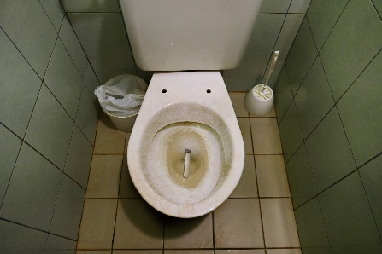

*An anxious girl frantically taking something out of her purse and accidentally dropping it into the toilet. She’s dismayed and considers fishing it out of the disgusting toilet.*

**VO: What drug is so addictive that you’d fish into this toilet to retrieve your paraphernalia?**

*She retrieves it and we see that it’s a vape. She vapes.*

**VO: The most popular vapes contain seriously addictive levels of nicotine.**

**VO: Whether you’re addicted to vapes or something else, addiction isn’t pretty.**

**CARD: Know the real cost of vapes.**

**ADDICTION ISN’T PRETTY – PURSE**

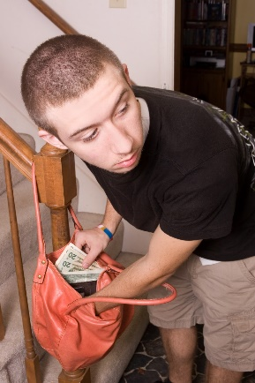

*A boy in the kitchen with his family during breakfast. He’s nervously glancing at his mom’s purse, waiting for her to turn her back.*

**VO: What drug is so addictive that you’d take money from your mom’s purse to buy more?**

*We see the kid vaping at school.*

**VO: The most popular vapes contain seriously addictive levels of nicotine.**

**VO: Whether you’re addicted to vapes or something else, addiction isn’t pretty.**

**CARD: Know the real cost of vapes.**

** These two concepts will be rotated in groups as one slot **

**GREAT WAYS TO UNPREPARE FOR THE SAT**



*Two students hanging out after school.*

**STUDENT 1: Man, I can’t believe I’m getting into college next year.**

**STUDENT 2: Have you thought about trying CrapPlan? It totally helped me lower my score.**

*She shows us a vape that says CrapPlan on it.*

**VO: Now’s the time to start *unpreparing* for the standardized tests. With CrapPlan! The secret to CrapPlan is Nicotine Cravings. It works like this: the test is *here*, but your mind is over *there*!**

SUPER: Re-enactment.

We see a student in the test room obviously jonesing for his vape, looking at the door as everyone else is busy scribbling away.

**STUDENT 2 (proudly): I’m sorry, what were you saying? I was distracted by nicotine cravings.**

**VO: We believe in CrapPlan so much, if your score does not go down, we’ll give you your money back! And then take your money again when you need more pods.**

**STUDENT 3: I could barely get through one question before obsessing over my vape.**

**STUDENT 1: Hasta la vista, college!**

**AVO: Nicotine cravings can be a huge distraction. So if you want to go to college, vaping is a CrapPlan.**

**CARD: Know the real cost of vapes.**

**BLACK BAR**



Open on a history teacher addressing her high school class.

**HISTORY TEACHER: Your Revolutionary War papers are due __________.**

*After she says the word “due,” she goes silent for a moment as a JUUL-like vape appears over her mouth. It’s like a black bar that blocks something — in this case, her next words. When she resumes speaking, the vape disappears.*

**HISTORY TEACHER: And don't forget ___________. It counts toward your grade too.**

*After she says the word “forget,” the vape appears and blocks her mouth again.*

*Cut to a math teacher tapping the chalkboard while addressing his class.*

**TEACHER: Make sure you know these formulas for Friday’s final exam.**

*We see that JUUL-like vapes block two or three of the many formulas on the chalkboard, with each vape blocking a single formula.*

**AVO: Nicotine cravings from vapes can distract you from the important stuff.**

*Cut to a chemistry teacher addressing her class during a lab. The students are mixing various chemicals.*

**TEACHER: Be careful mixing the __________. It can explode if you pour...**

*After a moment, as the kids start the experiment, there’s a big explosion at one lab counter.*

CARD: Know the real cost of vapes.

**VAPE BRAIN**



**SFX: A musical interlude.**

*We’re in a high school gym during a big basketball game. An inbounds pass goes to nobody as a player has cut left instead of right.*

**PLAYER SINGS:  
Coach called a play, but I went the wrong way, they call it Vape Brain.**

**CROWD SINGS: Vape Brain**

*A student is surprised when she’s called on by the teacher, but her mind was elsewhere.*

**STUDENT SINGS:**

**Can’t concentrate in class, with my eyes on the hall pass, they call it Vape Brain.**

**CLASS SINGS: Vape Brain.**

*A performer on stage during the school play.*

**PERFORMER: I’ve never felt so low, then when I flaked on my solo…**

*The spotlight is on her but she’s unaware.*

**AUDIENCE SINGS: Because of Vape Brain.**

**PERFORMER (sadly): Right, Vape Brain.**

*We see our three “heroes” in the bathroom finally getting their fix.*

**VO: Nicotine cravings can be a huge distraction. Getting in the way of the things that are most important.**

**CHORUS: They call it Vape Brain.**

**CARD: Know the real cost of vapes.**

**GRADUATION**



**SFX: A slow, poorly played version of “Pomp and Circumstance” by the high school band.**

We open on a high school senior in her cap and gown. She’s seated and sneaking puffs on her vape device while listening to the commencement speaker.

**COMMENCEMENT SPEAKER: Today, you are stepping into a different world. There will be enormous challenges. Challenges that, frankly, you may find difficult to overcome. There will be setbacks. And sadness. Perhaps most poignant, when you look back, there will be regret. And for some of you, even disease. Congratulations, graduates. Good luck.**

She stands, and we follow her up onstage. Once she’s there, the principal hands her a pack of cigarettes, not a diploma. He gets ready to hand out the next pack, too.

**AVO: Research shows that teens who vape are more likely to start smoking cigarettes.**

**CARD: Know the real cost of vapes.**

**VAPING 2.0**



**SFX: An under-the-radar pop song. Think an Apple new product song.**

Open on a rectangular object against a black background. It’s in the distance and shrouded in darkness. It slowly rotates and moves closer.

**SUPER: Introducing**

**SUPER: the next generation**

**SUPER: of vapes.**

As light hits the object in the foreground, it’s revealed to be a pack of cigarettes.

**SUPER: Nearly weightless.**

The lid slowly opens.

**SUPER: Totally wireless.**

A cigarette slides up and out of the pack.

**SUPER: The ultimate downgrade.**

The cigarette lights up and a stream of smoke rises from the end.

**SUPER: If you vape, you’re more likely to start smoking cigarettes.**

**Card: Know the real cost of vapes.**

**MODERN METAL WEAPON – MEDIEVAL KNIGHT**

Modern Metal Weapon



Open on a medieval knight with a long spear lodged in his chest.

He casually approaches teens who are vaping in a park. The teens stare at him and the protruding spear.

**TEEN: Mister, you’ve got a spear in your chest.**

**KNIGHT: (bold, British accent) Indeed I do! Begotten during the siege of Trufflebury, as the light faded from mine enemy’s eyes!**

The knight gazes into the distance for a moment, recalling the great battle.

**TEEN 2: (deadpan) Wow.**

The knight turns his attention back to the teens.

**KNIGHT: But ye young lads, great queen of Scots! Ye hath put metal into thine own lungs… by ye own hand!**

He gestures toward the vapes that the teens are holding.

**KNIGHT: Nickel. Chromium. And lead! Metal particles that not even the great Merlin could remove!**

He yanks the spear out of his chest, drops it, and walks away as the teens look at him and then concerningly at their vapes.

**SUPER: If ye vape, ye can inhale toxic metals into thy lungs.**

**Card: Know the real cost of vapes.**

**SCIENCE EXPERIMENT ON YOURSELF**

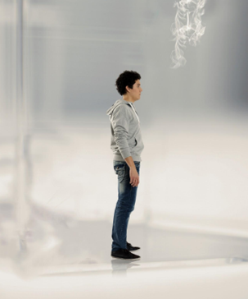

We open on a high school chemistry lab, where students — wearing lab coats, goggles, and gloves — are listening to their teacher as they prepare to conduct an experiment.

**TEACHER: All right, everyone. This may be the most dangerous experiment you do.**

We see a student nod.

**TEACHER: Careful, now. You don’t want to spill that stuff.**

We see a second student use an eyedropper to transfer liquid from a small bottle to a metal cylinder.

We see a third student press a button on a device. A green LED light turns on.

**TEACHER: Okay, when you’re ready, apply the stimulus to the test subjects.**

We then see many students, with vapes in hand, standing around a glass cage. They puff on their vapes and lean down to blow the vapor into the cage. As they lean down, we pan down to see that the cage is filled with mini versions of the students. And as the vapor fills the cage, the mini versions wander aimlessly, while looking up and around.

**AVO: If you vape, you’re experimenting on yourself. You could be inhaling cancer-causing chemicals, like formaldehyde, and toxic metals, like lead — right into your lungs.**

**CARD: Know the real cost of vapes.**

**WAKE UP**



**Visual:** *The camera is high overhead. Middle of a city street. Daytime. Wide shot of our hero standing in an ocean of people rushing past him.*

*His head pointed down in a sea of muted color hoodies and other drab wardrobe choices.*

*His wardrobe is bold and colorful standing out against the ocean of people walking past him as he stands in the middle of this bustling current of people. The camera cranes down to close-up of our hero.*

**Copy:** Some still sleepin’...

**Visual:** *Our hero walks forward, maneuvering through the crowd. He’s on a mission.*

**Copy;** ...I’m awake.

**Visual:** *The camera trucks back even further, coming out to an epically wider shot.*

**Copy:** Wise to the fact,

**Visual:** *We can see the ocean of people continuing down the street, off into the horizon.*

**Copy:** If you vape, you can become addicted.

**Visual:** *In this wide shot we reveal several more young heroes maneuvering their way toward our first hero*

**Copy:** Addiction to vapes can just get in your way.

**Visual:** *The camera tracks in to medium shot of the group. Our hero group come together and acknowledge each other positively.*

**Copy:** So if addiction ain’t in the plan for you,

**Visual:** *Cut to a frontal wide shot, as the heroes start converging, making it to the front.*

**Copy:** Don’t sleep on the facts.

**Visual:** *The group stops and stares straight at the camera as we rise up into the air with a drone, pulling up and back to a super-high angle.*

*We see the cityscape stretching off into the distance, as the endcard and supers come up.*

**Copy:** Wake up. Live tobacco-free.

**Visual:** *CARD*

**Copy:** Fresh Empire Logo

**EPIDEMIC**

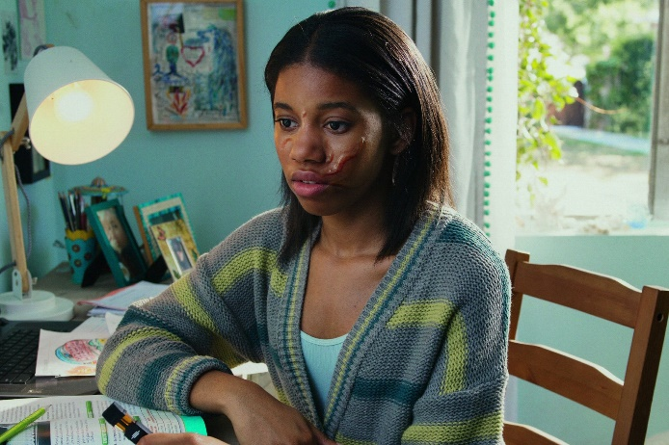

**VO:** There’s an epidemic spreading.

**VO:** Scientists say it can change your brain.

**VO**: It can release dangerous chemicals, like formaldehyde, into your bloodstream.

**VO:** It can expose your lungs to acrolein, which can cause irreversible damage.

**VO:** It’s not a parasite. It’s not a virus. It’s not an infection.

**VO:** It’s vaping.

**VO:** Know the Real Cost of vaping.

END CARD/TRC LOGO

**Sources Used to Provide Scientific Support for Each Concept**

**ADDICTION ISN’T PRETTY**

* Ramamurthi D, Chau C Jacklet RK. JUUL and other stealth vaporisers: hiding the habit from parents and teachers. Tob. Control. 2018; 0:1-7. Doi: 10.1136/tobaccocontrol-2018-054455.
* Wynne C, Waaka DS & Cohen G. (2018, February). Acute Use of Nicotine Salt-based ENDS and Combusted Cigarettes. Poster session presented at the Annual Meeting of the Society for Research on Nicotine and Tobacco, Baltimore, MD.
* PAX Labs, Inc. (2015, December 22). PAX Labs, Inc. granted U.S. patent for nicotine salt e-cigarette [Press release]. Retrieved from https://www.prnewswire.com/news-releases/pax-labs-inc-granted-us-patent-for-nicotine-salt-e-cigarette-300196459.html
* Jackler R K & Ramamurthi D. Nicotine arms race: JUUL and the high-nicotine product market. Tob Control. Published Online First: 06 February 2019. doi: 10.1136/tobaccocontrol-2018-054796.

**GREAT WAYS TO UNPREPARE FOR THE SAT**

* Connor DA, Gould TJ. Chronic fluoxetine ameliorates adolescent chronic nicotine exposure-induced long-term adult deficits in trace conditioning. Neuropharmacology. 2017; 125:272-283.
* Holliday ED, Gould TJ. Chronic Nicotine Treatment During Adolescence Attenuates the Effects of Acute Nicotine in Adult Contextual Fear Learning. Nicotine & Tobacco Research. 2017; 19(1):87-93.
* Counotte DS, Spijker S, Van de Burgwal LH, et al. Long-lasting cognitive deficits resulting from adolescent nicotine exposure in rats. Neuropsychopharmacology. 2009 34(2), 299-306.
* Fountain SB, Rowan JD, Kelley BM, Willey AR, Nolley EP. Adolescent exposure to nicotine impairs adult serial pattern learning in rats. Exp Brain Res. 2008; 187(4):651-656.

**BLACK BAR and VAPE BRAIN**

* Connor DA, Gould TJ. Chronic fluoxetine ameliorates adolescent chronic nicotine exposure-induced long-term adult deficits in trace conditioning. Neuropharmacology. 2017; 125:272-283.
* Holliday ED, Gould TJ. Chronic Nicotine Treatment During Adolescence Attenuates the Effects of Acute Nicotine in Adult Contextual Fear Learning. Nicotine & Tobacco Research. 2017; 19(1):87-93.
* Counotte DS, Spijker S, Van de Burgwal LH, et al. Long-lasting cognitive deficits resulting from adolescent nicotine exposure in rats. Neuropsychopharmacology. 2009 34(2), 299-306.
* Fountain SB, Rowan JD, Kelley BM, Willey AR, Nolley EP. Adolescent exposure to nicotine impairs adult serial pattern learning in rats. Exp Brain Res. 2008; 187(4):651-656.
* Goniewicz ML, Hajek P, McRobbie H. Nicotine content of electronic cigarettes, its release in vapour and its consistency across batches: regulatory implications. Addiction. 2014; 109(3)500-7.
* Marynak KL, Gammon DG, Rogers T, Coats EM, Singh T, King BA. Sales of nicotine-containing electronic cigarette products: United States, 2015. American Journal of Public Health. 2017; 107(5):702-705.

**GRADUATION and VAPING 2.0**

* National Academies of Sciences, Engineering, and Medicine (NASEM). 2018. Public Health Consequences of E-cigarettes. Washington, DC: The National Academies Press. Doi: https://10.17226/24952
* Berry KM, Fetterman JL, Benjamin EJ, Bhatnagar A, Barrington-Trimis JL, Leventhal AM, Stokes A. Association of Electronic Cigarette Use With Subsequent Initiation of Tobacco Cigarettes in US Youths. JAMA Network Open. 2019; 2(2): e187794-e187794.

**MODERN METAL WEAPON – MEDIEVAL KNIGHT and SCIENCE EXPERIMENT ON YOURSELF**

* Williams M, Villarreal A, Bozhilov K, Lin S, Talbot P. Metal and silicate particles including nanoparticles are present in electronic cigarette cartomizer fluid and aerosol. PLoS One. 2013; 8(3):e57987.
* Olmedo P, Goessler W, Tanda S, et al. Metal concentrations in e-cigarette liquid and aerosol samples: the contribution of metallic coils. Environmental Health Perspectives (Online). 2018; 126(2).

**WAKE UP**

* Hiler M, Breland A, Spindle T, et al. Electronic cigarette user plasma nicotine concentration, puff topography, heart rate, and subjective effects: Influence of liquid nicotine concentration and user experience. Experimental and clinical psychopharmacology. 2017; 25(5), 380.

**EPIDEMIC**

* Goniewicz ML, Knysak J, Gawron M, et al. Levels of selected carcinogens and toxicants in vapour from electronic cigarettes. Tobacco Control. 2014; 23(2):133-139.
* Cheng T. Chemical evaluation of electronic cigarettes. Tobacco Control. 2014; 23:ii11–ii17.
* Bein K, Leikauf GD. Acrolein–a pulmonary hazard. Molecular Nutrition & Food Research. 2011;55(9):1342-1360.
* Occupational Safety and Health Administration (OSHA). Occupational Safety and Health Standards. Medical surveillance – Formaldehyde. Washington, DC: U.S. Department of Labor, Occupational Safety and Health Administration. https://www.osha.gov/pls/oshaweb/owadisp.show_document?p_table=STANDARDS&p_id=10078. Accessed May 8, 2018.