**Public Burden Statement:**

The purpose of the Nurse Corps Loan Repayment Program (NURSE CORPS LRP) is to assist in the recruitment and retention of professional Registered Nurses (RNs) dedicated to working in health care facilities with a critical shortage of nurses or working as nurse faculty in eligible schools of nursing, by decreasing the economic barriers associated with pursuing careers at such critical shortage facilities or in academic nursing. An agency may not conduct or sponsor, and a person is not required to respond to, a collection of information unless it displays a currently valid OMB control number. The OMB control number for this information collection is 0915-0140 and it is valid until XX/XX/202X. This information collection is voluntary. Public reporting burden for this collection of information is estimated to average xx hours per response, including the time for reviewing instructions, searching existing data sources, and completing and reviewing the collection of information. Send comments regarding this burden estimate or any other aspect of this collection of information, including suggestions for reducing this burden, to HRSA Reports Clearance Officer, 5600 Fishers Lane, Room 14N136B, Rockville, Maryland, 20857 or [paperwork@hrsa.gov](mailto:paperwork@hrsa.gov).

**Nurse Corps Loan Repayment Program – Application Form Updates**

This document includes the changes from the existing application form, which is documented in the current Application User Guide (see included in the OMB clearance package).

Multiple Sites

Figure 1: Employment Search Results

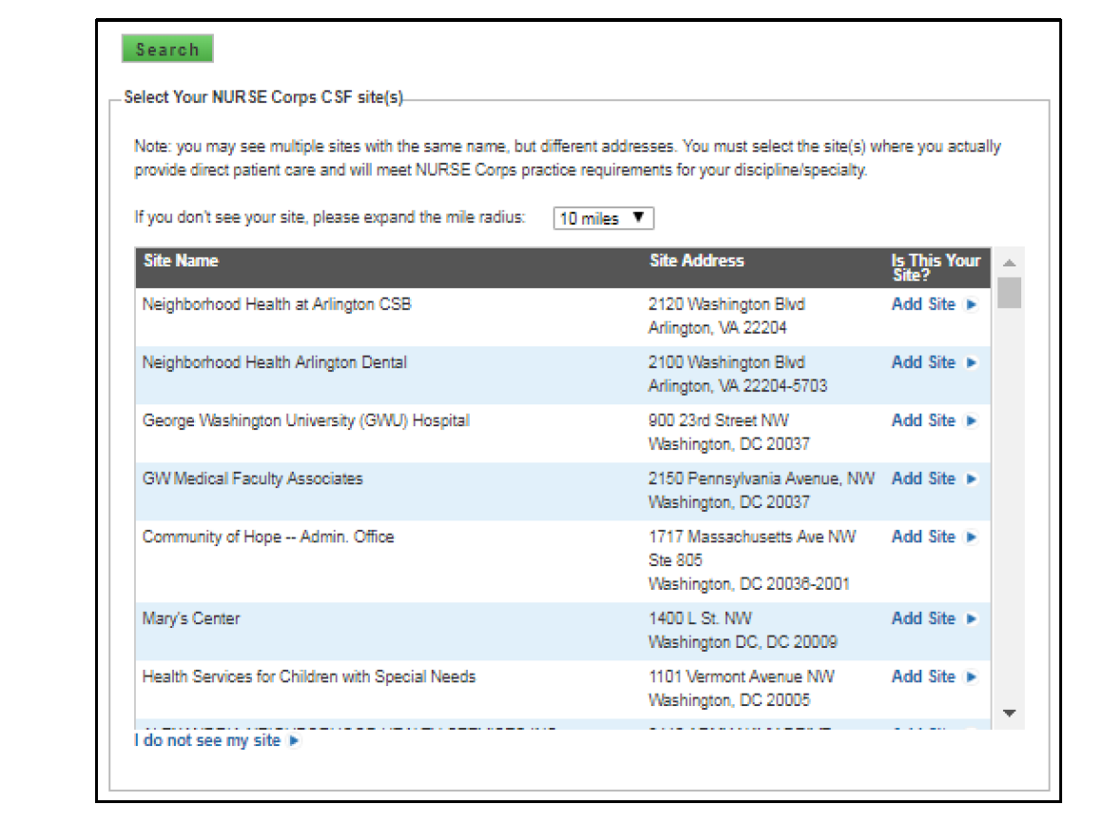

Figure 2: CSF sites table and sites verification

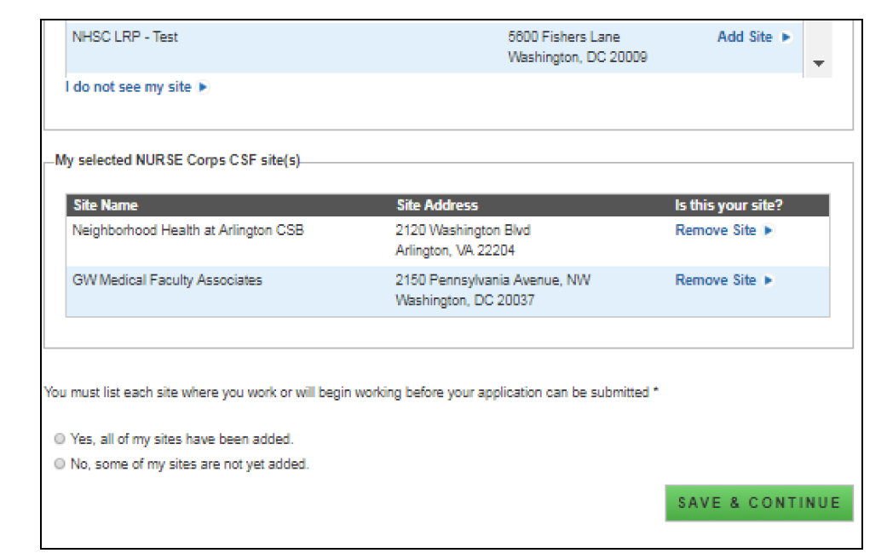

Telehealth Questions

**Figure 1** – Telehealth Questions on Application

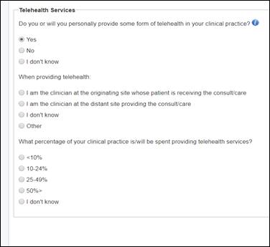

**Figure 2** - Telehealth Questions on Applicant Profile

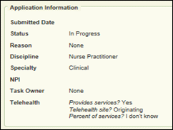

Psychiatric Nurse Practitioner

Figure 1: Additional Specialty for Psychiatric Nurse Practitioner drop down menu

