FY20 Site Application Relaunch Content

Table of Contents
POC Portal 2
Start NHSC Site Application 3
Section 1. General Information 7
Section 2. Site Location 8
Section 3. POC Information 10
Section 4. NHSC Information 12
Section 5. HPSA Scores 14
Section 6. Support Documents 15
Section 7. NHSC Site Agreement 17
Site Application Messages sent to POCs 18
Site POC Site Application Information 21
Appendix 25
1. Site Type/ Sub Site Type drop-down options 26
2. NHSC Site Agreement 28

POC Portal
OMB Number: 0915-0127
Expiration Date: 02/29/2020
Public Burden Statement:
The purpose of this information collection is to obtain information through the National Health Service Corps (NHSC) Loan Repayment Program (LRP), NHSC Substance Use Disorder (SUD) Workforce LRP, and the NHSC Rural Community LRP applications, which are used to assess an LRP applicant’s eligibility and qualifications for the LRP and to obtain information for NHSC site applicants. Clinicians interested in participating in a NHSC LRP must submit an application to the NHSC to participate in one of the NHSC programs, and health care facilities must submit an NHSC Site Application and Site Recertification Application to determine the eligibility of sites to participate in the NHSC as an approved service site. An agency may not conduct or sponsor, and a person is not required to respond to, a collection of information unless it displays a currently valid OMB control number. The OMB control number for this information collection is 0915-0127 and it is valid until XX/XX/202X. This information collection is required to obtain or retain a benefit (Section 333 [254f] (a)(1) of the Public Health Service Act). Public reporting burden for this collection of information is estimated to average 0.5 hours per response, including the time for reviewing instructions, searching existing data sources, and completing and reviewing the collection of information. Send comments regarding this burden estimate or any other aspect of this collection of information, including suggestions for reducing this burden, to HRSA Reports Clearance Officer, 5600 Fishers Lane, Room 14N136B, Rockville, Maryland, 20857 or paperwork@hrsa.gov.

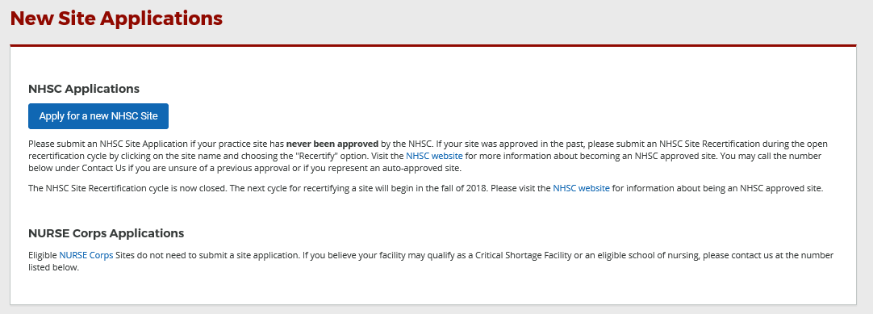

Start NHSC Site Application
Type of Site Tool Tip-

This table to is use to show the different site types/ sub site types and their eligibility. This is NOT displayed in the application
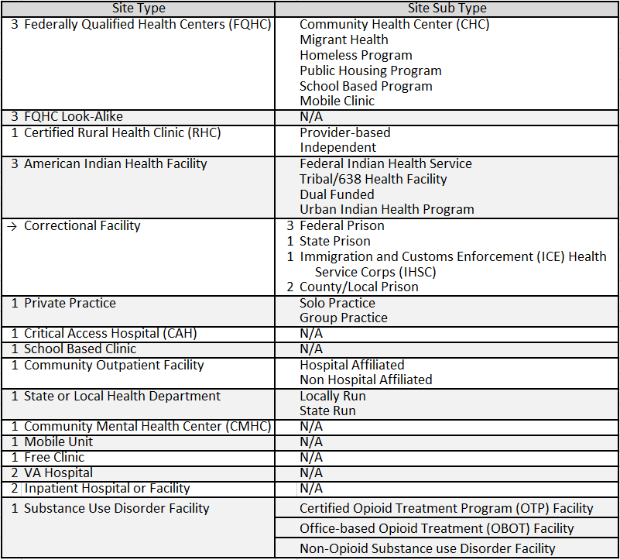
Table: Site Type & Sub Site Type Eligibility
Note: See appendix to view all Site Type/ Sub Site Type Drop down menus
Based on the site type and/or sub site type will determine if the site is:

1 – Eligible

2 - Not Eligible

3 - Eligible for automatic approval

Eligible sites will display a section of questions
Not Eligible sites will display a “This site is not Eligible Message”
Eligible for automactic approval will display a “Eligible for automatic approval Message”

Eligible Site Type/Sub Site Type Questions
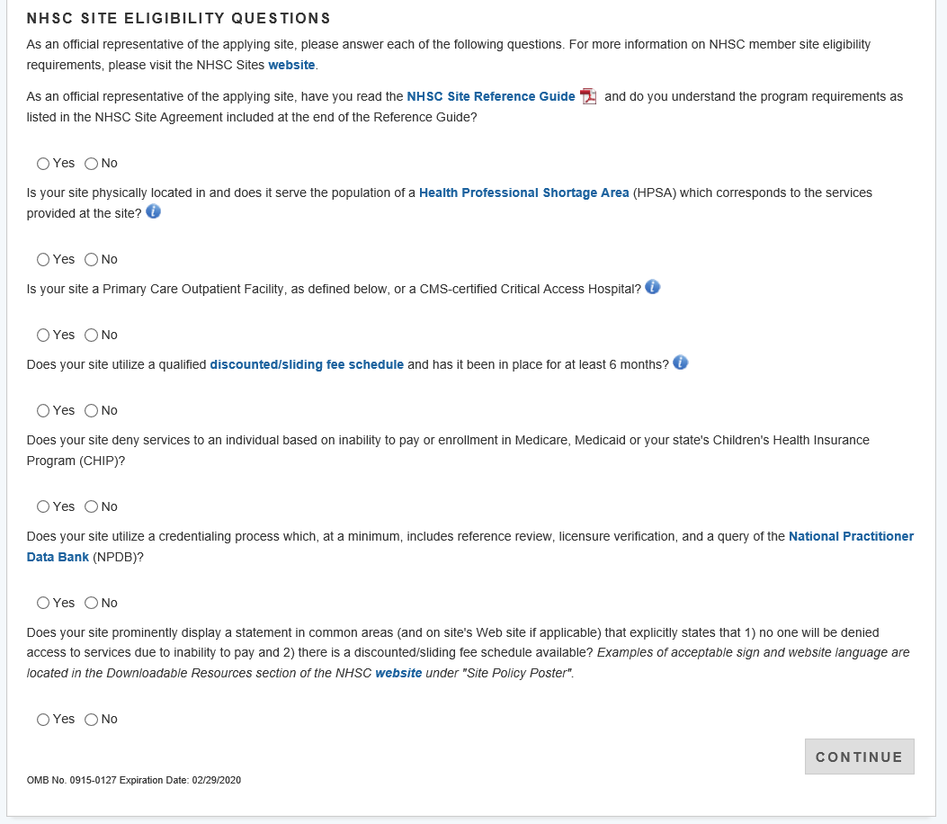
Not Eligible sites will display a “This site is not Eligible Message”
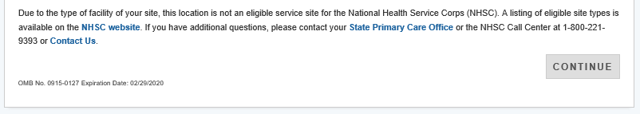

Eligible for automatic approval Message
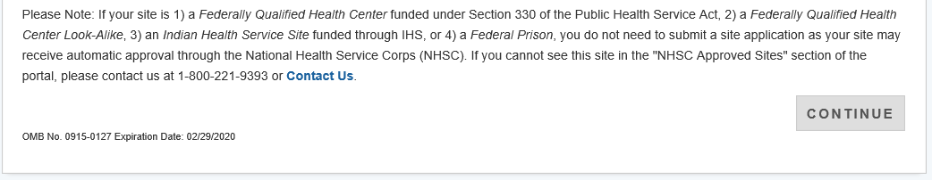

Message displays when answering “Yes” to the question #5 regarding denying services to an individaul based on inability to pay
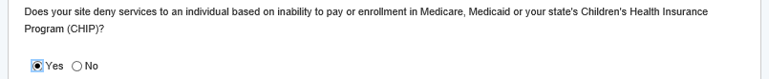
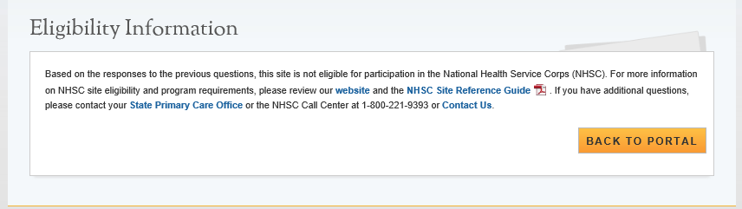
The Tool Tips for the Instructions Page is the same of all applications that display these questions
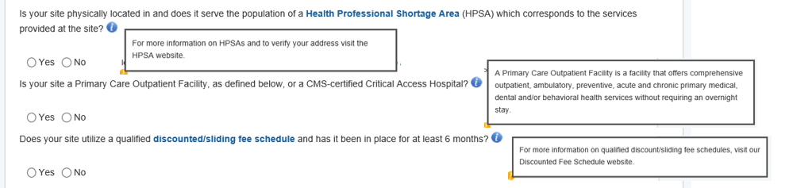

Section 1. General Information
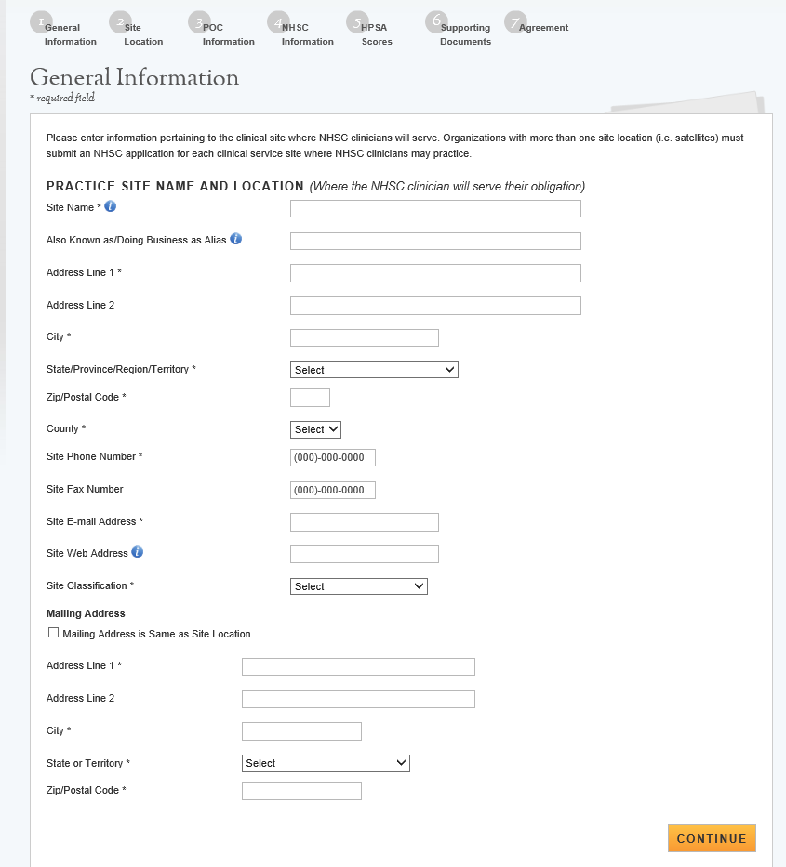
Site Name Tool Tip- Site Wed Address Tool Tip-
Also Known as/Doing Business as Alias Tool Tip-

Section 2. Site Location
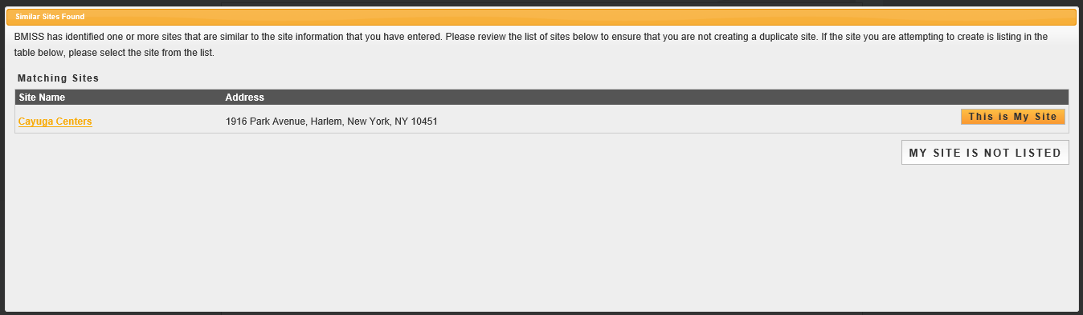
Screen below appears when selecting “This is My Site”
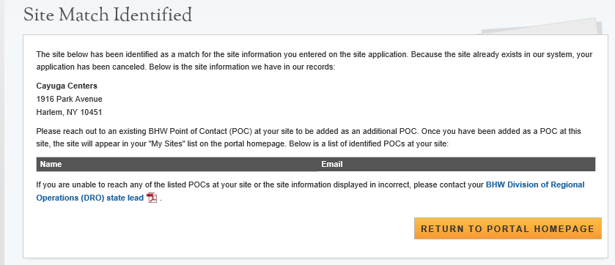

This screen is displayed when selecting “My Site is Not Listed”
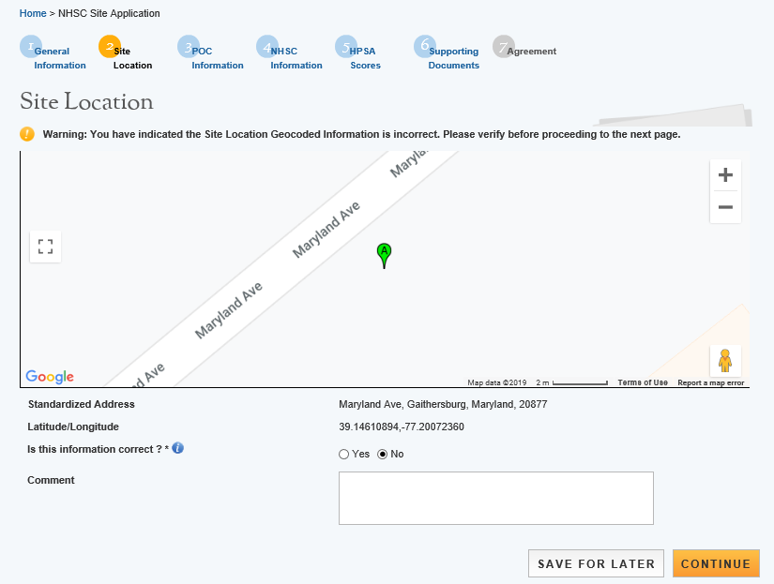

The Comment box for question “Is this information correct” only appears if answered “No”.
Comment is required

Site Location Tool Tip-

Section 3. POC Information
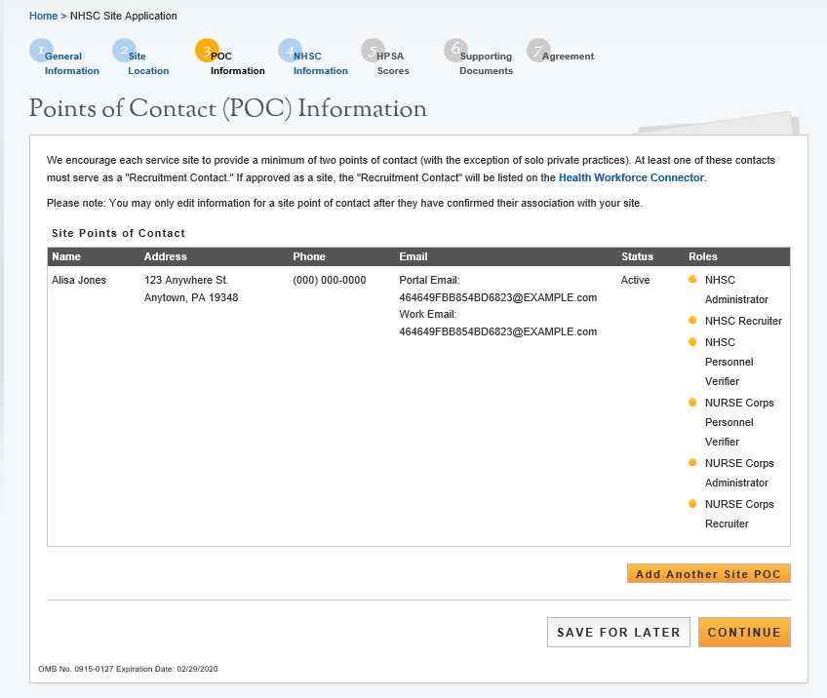

The screen below appears when the POC selects “Add another POC” button.
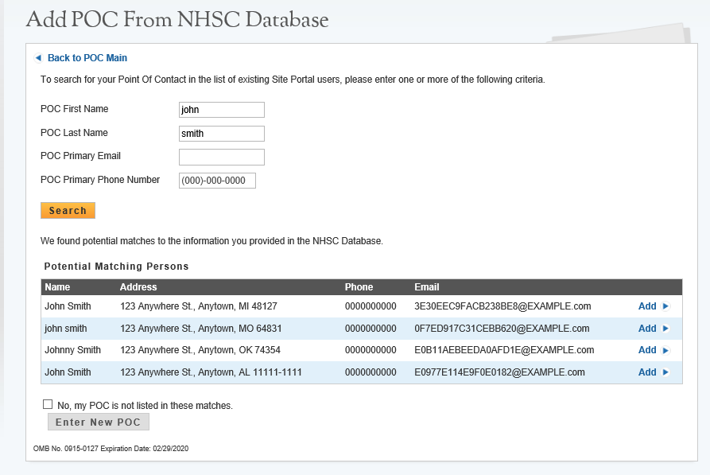
The screen below will appear if the POC checks the “No, my POC is not listed in these matches” question and clicks Enter New POC. The Button will turn yellow after checking off the question.
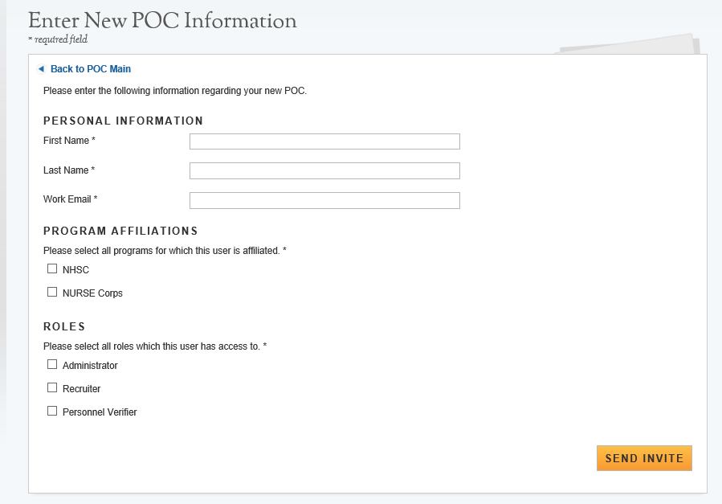
Section 4. NHSC Information
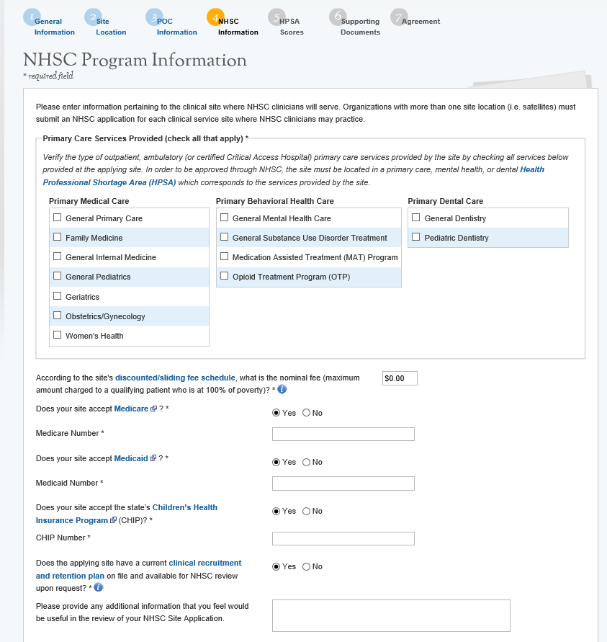
The Number fields only appear if you answer “yes” to the questions.
Error message will display if the text boxes are empty if applicant trys on continue.

Discounted/slideing fee schedule Tool Tip- Clinical Recruitment and rentention plan Tool Tip-
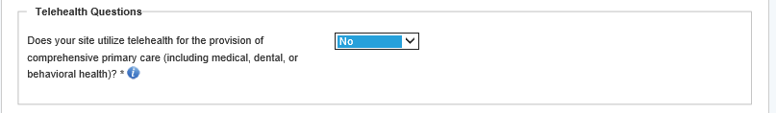
Additional Fields will appear if you answer “Yes” or “I Don’t Know” to the first Telehealth Question
Additional questions will appear if you answer “Distant and/or Originating” to the third Telehealth Question
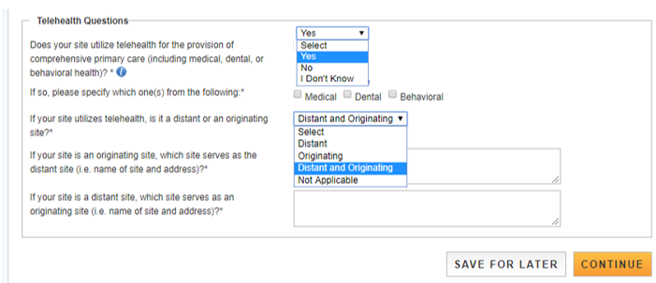
Telehealth Question Tool Tip-

Section 5. HPSA Scores
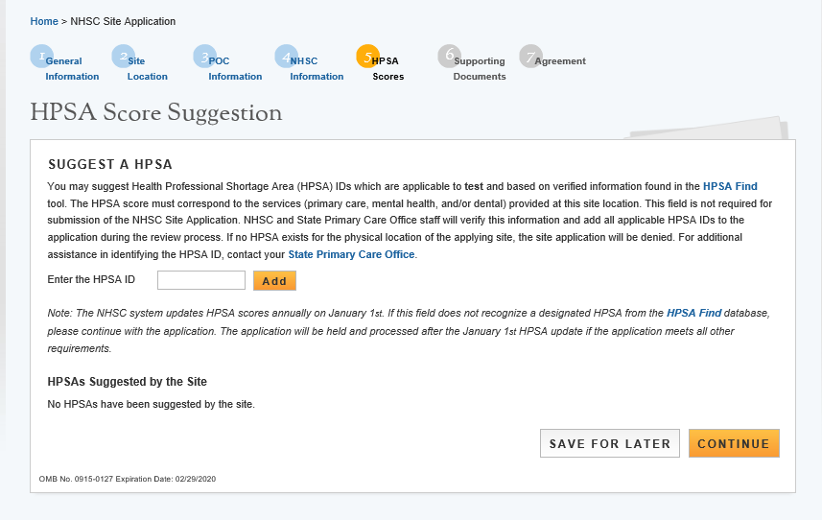
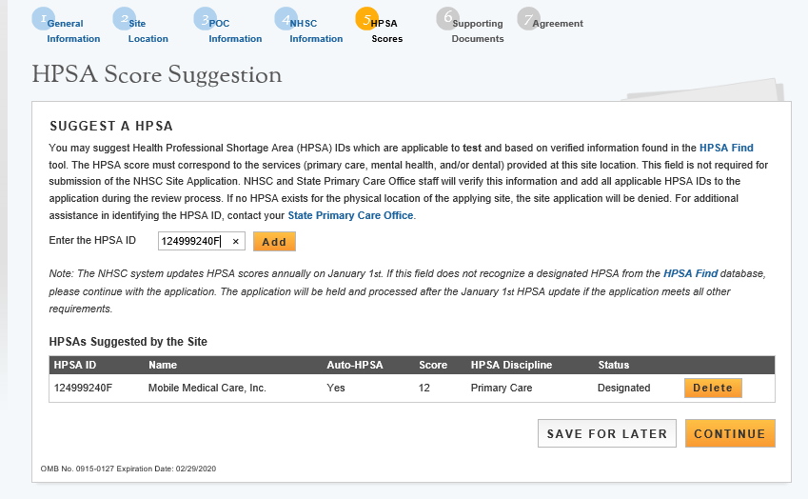

Section 6. Support Documents
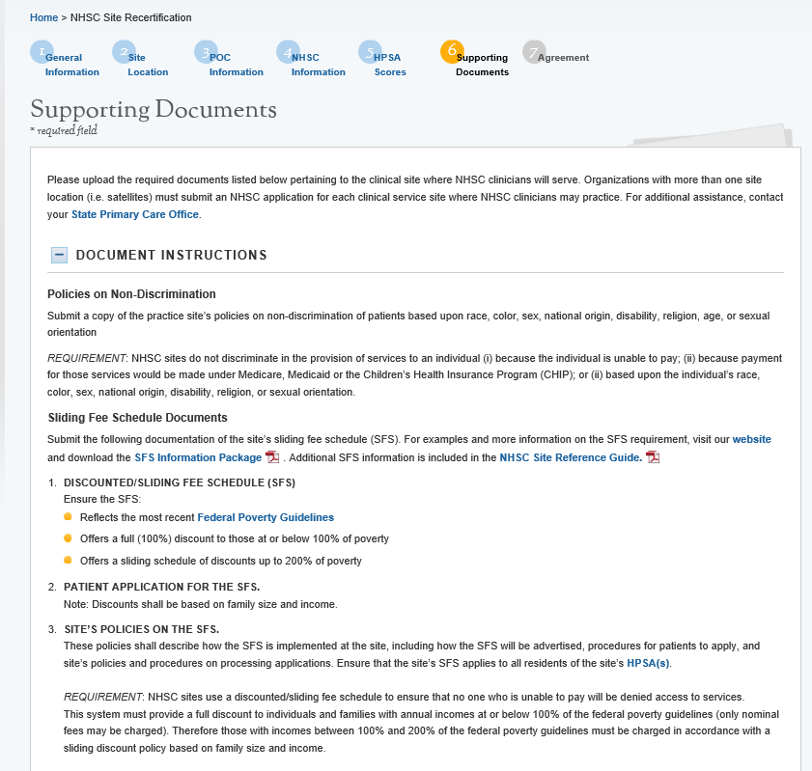
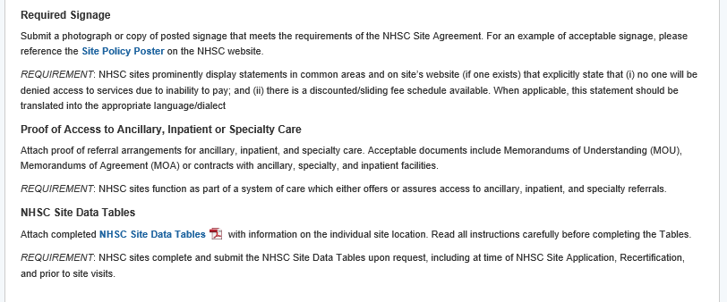
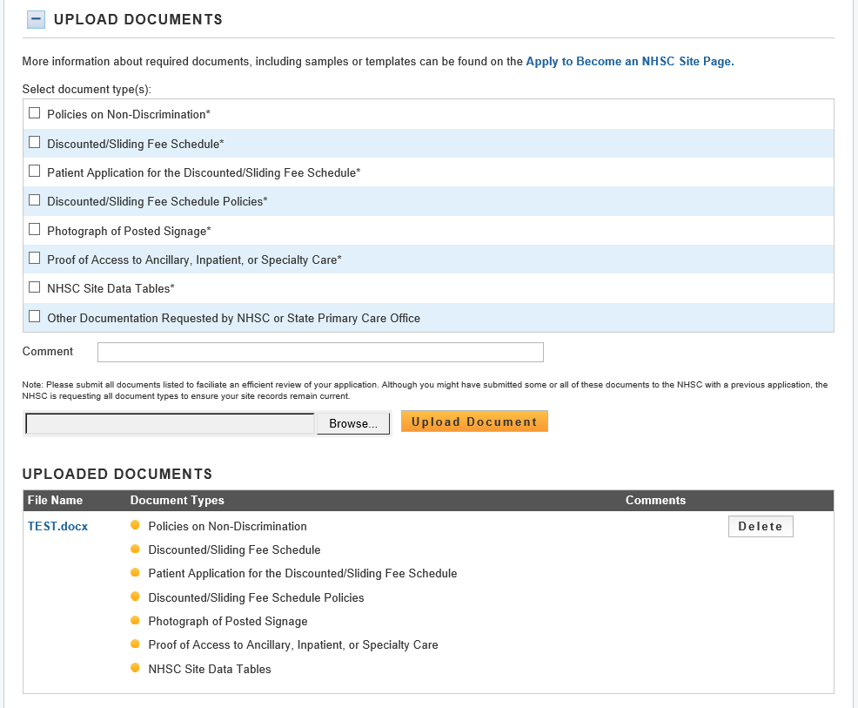

Section 7. NHSC Site Agreement
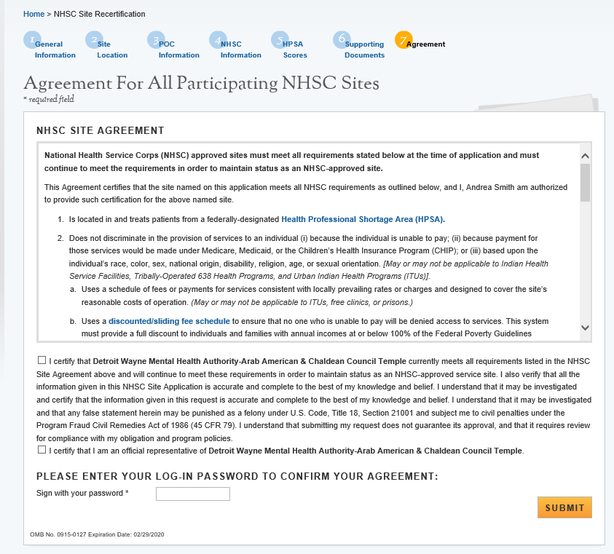
POC must scroll through the Site Agreement or they will receive an error message
Note: See appendix for NIH Site Agreement

Site Application Messages sent to POCs
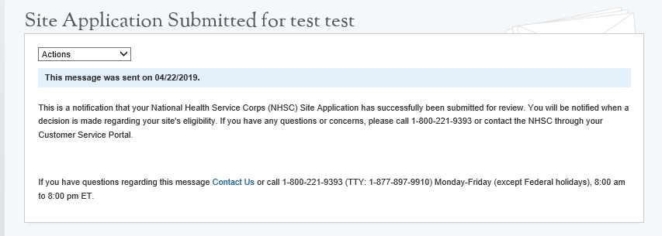
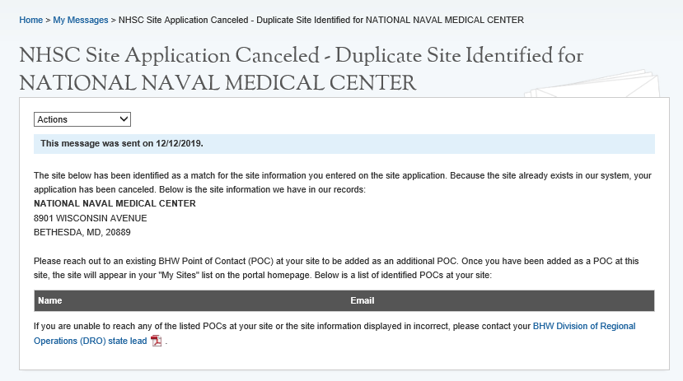

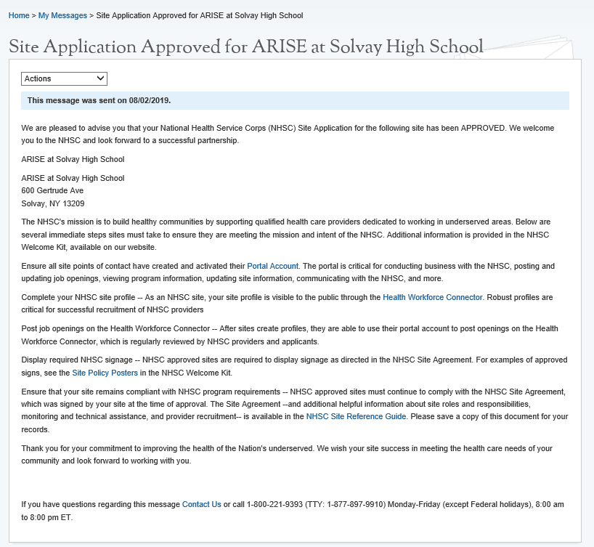
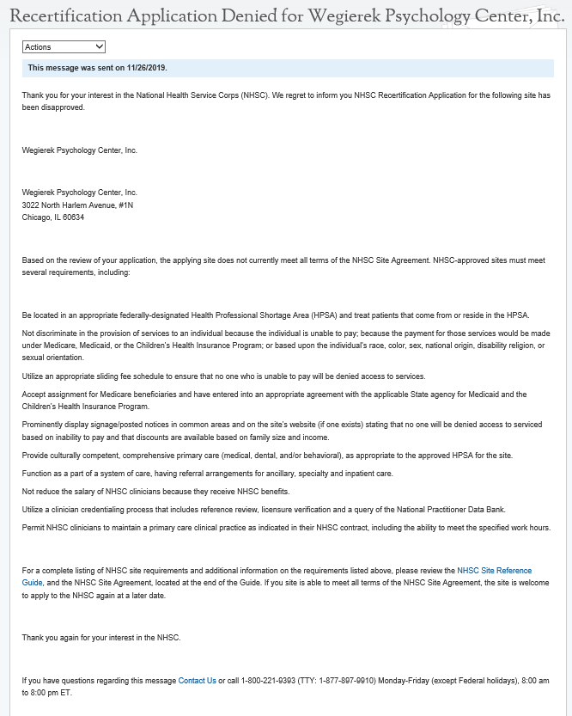

Site POC Site Application Information
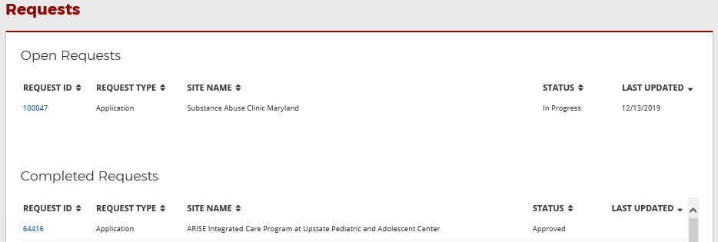
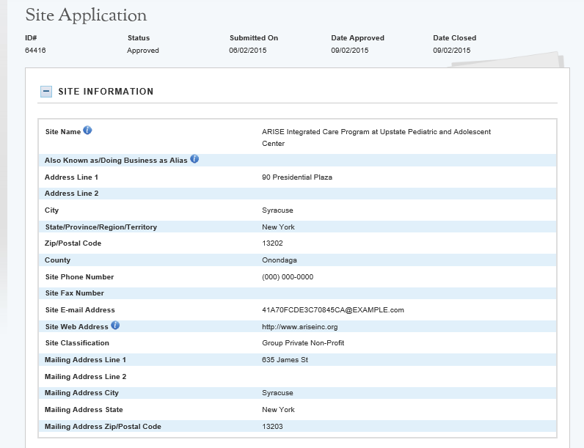

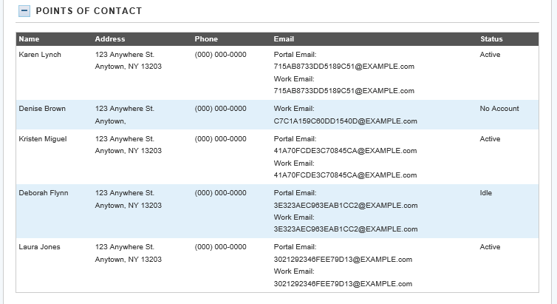
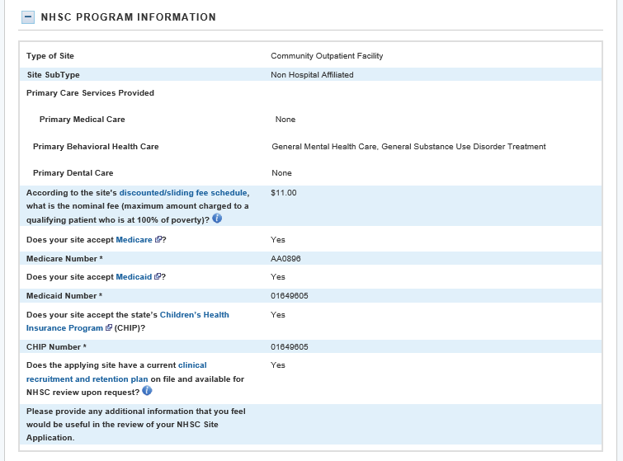
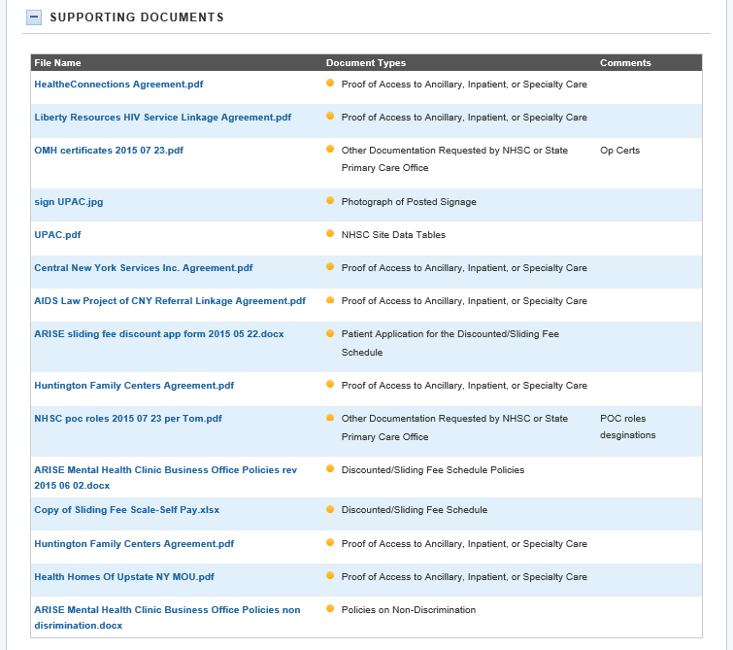
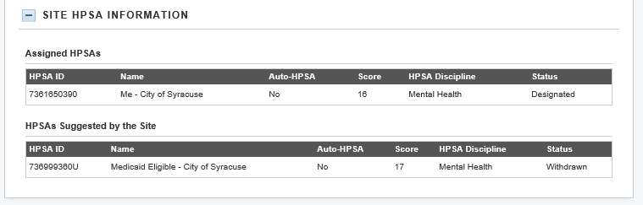

Appendix
- Site Type / Sub Site Type drop down options
- NHSC Site Agreement

Site Type/ Sub Site Type drop-down options
See

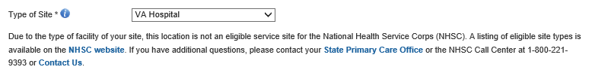
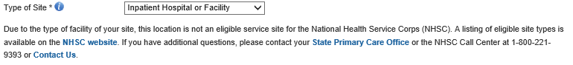

NHSC Site Agreement
National Health Service Corps (NHSC) approved sites must meet all requirements stated below at the time of application and must continue to meet the requirements in order to maintain status as an NHSC-approved site.
This Agreement certifies that the site named on this application meets all NHSC requirements as outlined below, and I, Karen Lynch am authorized to provide such certification for the above named site.
- Is located in and treats patients from a federally-designated Health Professional Shortage Area (HPSA).
- Does not discriminate in the provision of services to an individual (i) because the individual is unable to pay; (ii) because payment for those services would be made under Medicare, Medicaid, or the Children’s Health Insurance Program (CHIP); or (iii) based upon the individual’s race, color, sex, national origin, disability, religion, age, or sexual orientation. [May or may not be applicable to Indian Health Service Facilities, Tribally-Operated 638 Health Programs, and Urban Indian Health Programs (ITUs)].
  - Uses a schedule of fees or payments for services consistent with locally prevailing rates or charges and designed to cover the site’s reasonable costs of operation. (May or may not be applicable to ITUs, free clinics, or prisons.)
  - Uses a discounted/sliding fee schedule to ensure that no one who is unable to pay will be denied access to services. This system must provide a full discount to individuals and families with annual incomes at or below 100% of the Federal Poverty Guidelines (only nominal fees may be charged). Therefore, those with incomes between 100% and 200% of the Federal Poverty Guideline must be charged in accordance with a sliding discount policy based on family size and income. (May or may not be applicable to ITUs, free clinics, or prisons.)
  - Makes every reasonable effort to secure payment in accordance with the schedule of fees or schedule of discounts from the patient and/or any other third party. (May or may not be applicable to ITUs, free clinics, or prisons.)
  - Accepts assignment for Medicare beneficiaries and has entered into an appropriate agreement with the applicable State agency for Medicaid and CHIP beneficiaries. (May or may not be applicable to ITUs, free clinics, or prisons.)
  - Prominently displays a statement in common areas and on site’s website (if one exists) that explicitly states that (i) no one will be denied access to services due to inability to pay; and (ii) there is a discounted/sliding fee schedule available. When applicable, this statement should be translated into the appropriate language/dialect. (May or may not be applicable to ITUs, free clinics, or prisons.)
- Provides culturally competent, comprehensive primary care services (medical, dental, and/or behavioral) which correspond to the designated HPSA type.
- Uses a credentialing process which, at a minimum, includes reference review, licensure verification, and a query of the National Practitioner Data Bank (NPDB) of those clinicians for whom the NPDB maintains data.
- Functions as part of a system of care which either offers or assures access to ancillary, inpatient, and specialty referrals.
- Adheres to sound fiscal management policies and adopts clinician recruitment and retention policies to help the patient population, the site, and the community obtain maximum benefits.
- Maintains a clinician recruitment and retention plan, keeps a current copy of the plan onsite for review, and adopts recruitment policies to maintain clinical staffing levels needed to appropriately serve the community.
- Does not reduce the salary of NHSC clinicians because they receive or have received benefits under the NHSC Loan Repayment or Scholarship programs.
- Requires NHSC clinicians to maintain a primary care clinical practice (full-time or half-time) as indicated in their contract with NHSC and described in part below. The site administrator must review and know the clinician’s specific NHSC service requirements. Time spent on call will not count toward a clinician’s NHSC work hours. Participants do not receive service credit hours worked over the required hours per week, and excess hours cannot be applied to any other work week. Clinicians must apply for a suspension if their absences per year are greater than those allowed by NHSC. If a suspension is requested and approved, the participant’s service obligation end date will be extended accordingly. Please refer to the NHSC Loan Repayment Program Application and Program Guidance for definitions of NHSC service requirements.
- Communicates to the NHSC any change in site or clinician employment status for full-time and half-time, including moving an NHSC clinician to a satellite site for any or all of their hour work week, termination, etc.
- Supports clinicians with funding and arrangements, including clinical coverage, for their time away from the site to attend NHSC-sponsored meetings, webinars, and other continuing education programs.
- Maintains and makes available for review by NHSC representatives all personnel and practice records associated with an NHSC clinician including documentation which contains such information that the Department may need to determine if the individual and/or site has complied with NHSC requirements.
- Completes and submits NHSC Site Data Tables to NHSC at time of site application, recertification, and NHSC site visits.
- Complies with requests for a site visit from NHSC or the State Primary Care Office with adherence to all NHSC requirements.

